Supplementary Information

Quest of New Molecular Frameworks for Carbon Monoxide-Releasing Molecules: A Computation Prospective

Ritu Seth¹, Amilan D. Jose² and Ajeet Singh¹*
e-mail: ajeetmolecule@gmail.com
¹Department of Chemistry, Prof. Rajendra Singh (RajjuBhaiya) Institute of Physical Sciences for Study and Research, V.B.S. Purvanchal University Jaunpur-222003, U.P., India

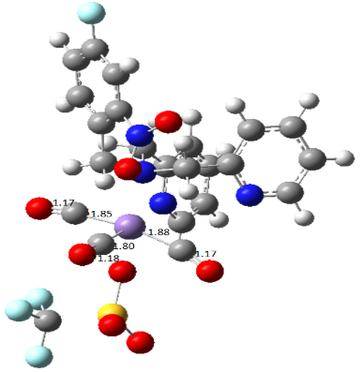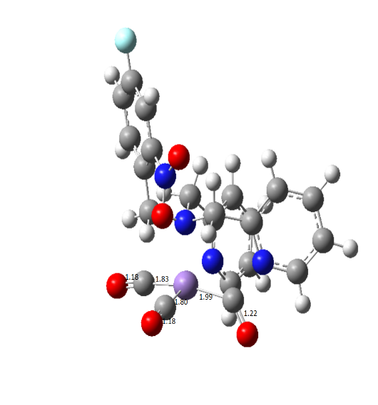
6 6’
Figure S1. Optimized structure of studied complex system with and without anion.

Frontier Molecular Orbital
The crucial excited states of all complex systems correspond to the transition from HOMO-1 to LUMO+1 and LUMO+2, also seen with all transition probabilities. HOMO- LUMO transitions are more dominant in all complexes from 1–8. Themolecular orbital contribution percentage for the HOMO-LUMO transition is more prominent than other transitions in all complexes.
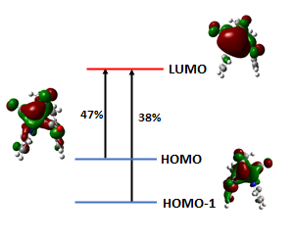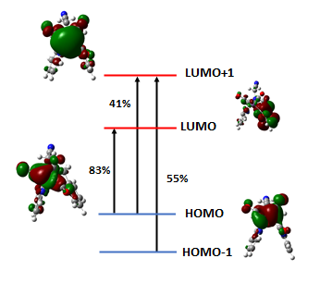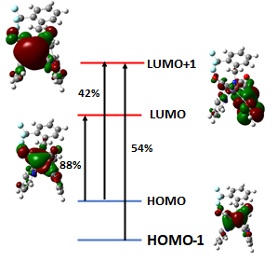
1 2 3
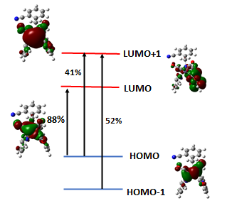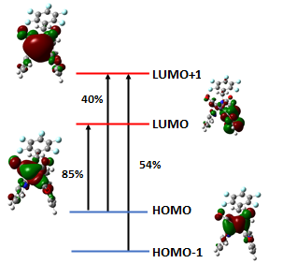
4 5
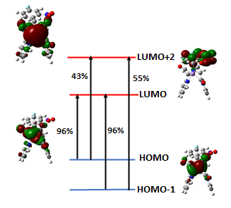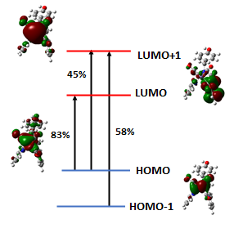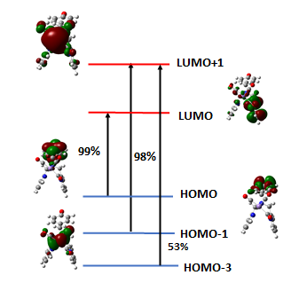
6 7 8
Figure S2. Electronic transition and molecular orbitals involved along with the transition of all complexes.
IR Spectroscopy
Measurement of CO release with the help of IR spectroscopy was done by density functional theory (DFT) calculations were performed on all CORMs using Gaussian 09. The DFT geometry optimization was carried out with the B3LYP/LANL2DZ level of theory in the solvent phase. The fully optimised geometry was used to calculate the harmonic frequencies and IR intensities. IR frequencies for all complexes are shown in figure S4.
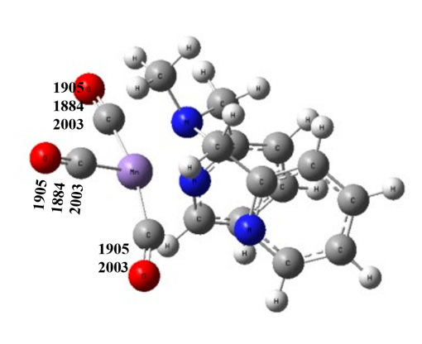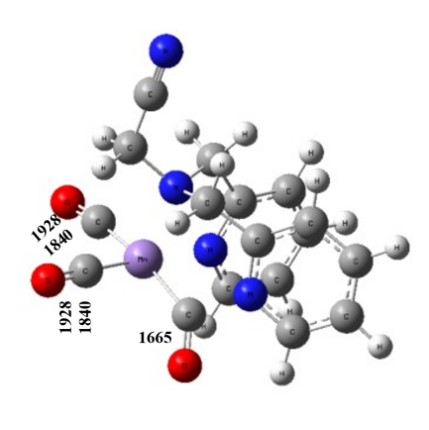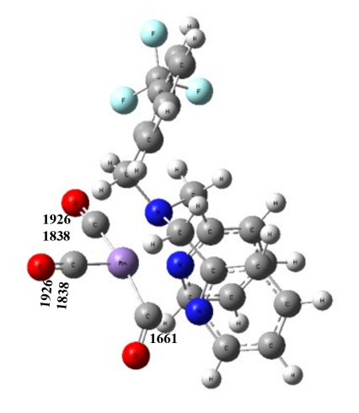
1 2 3
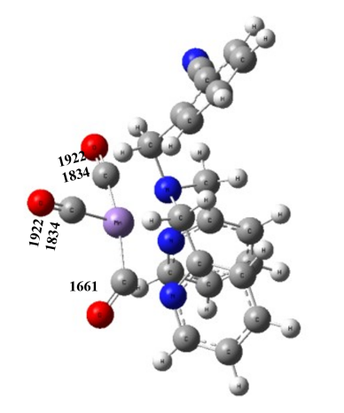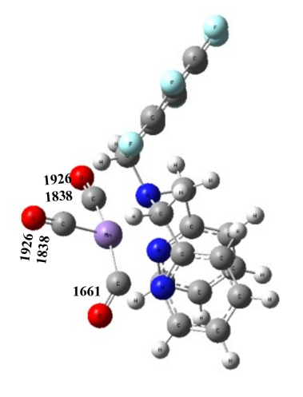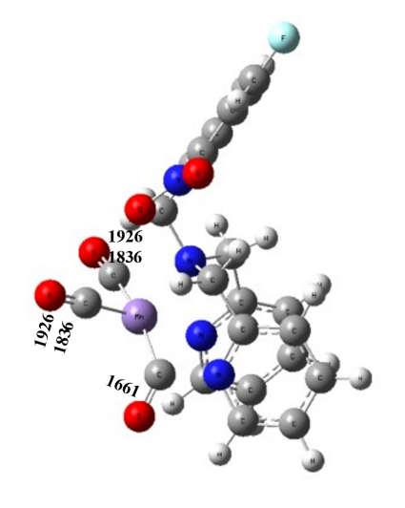
4 5 6
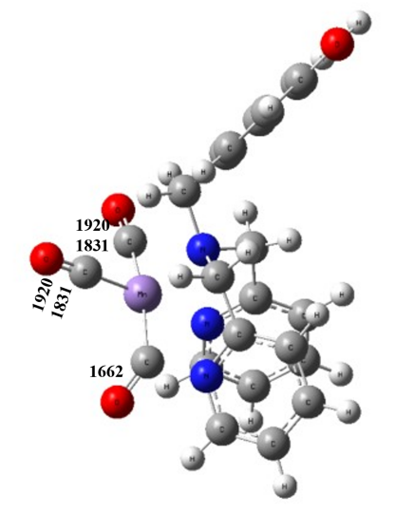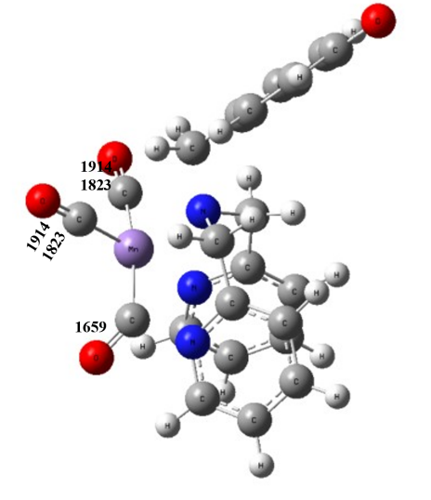
7 8
Figure S3. IR frequencies for all complexes.
Percentage of MLCT
We have calculated the MLCT percentage of all designed complexes. We have specifically calculated the MLCT percentage of our designed molecules using multiwfn 3.8 software ⁴⁴ at the B3LYP/LANL2DZ TD (nstates=40) level of theory to estimate the charge transfer behaviour that happens in between the lower and middle energy peaks. The MLCT percentage for all 40 states is shown in table 2.

Table S 2. Metal to ligand charge transfer percentage of all complexes.
State | 1 | 2 | 3 | 4 | 5 | 6 | 7 | 8
1 | 9.69 | 4.65 | 5.22 | 5.53 | 4.85 | 5.92 | 5.53 | -1.73
2 | 5.29 | 2.28 | 2.72 | 3.49 | 2.44 | 4.25 | 1.15 | 6.75
3 | 7.12 | 0.51 | -0.03 | 0.51 | -0.18 | 73.73 | 1.32 | 3.26
4 | 0 | 71.40 | 70.86 | 71.03 | 71.37 | 82.6 | 70.81 | -55.29
5 | 41.25 | 78.34 | 78.46 | 78.57 | 78.41 | 69 | 78.23 | -2.05
6 | 47.37 | 64.40 | 64.43 | 64.33 | 64.31 | 2.71 | 64.1 | 1.55
7 | 47.28 | 15.30 | 7.57 | 13.96 | 16.77 | 71.04 | -0.98 | -2.14
8 | -25.54 | 45.64 | 49.58 | 51.08 | 47.43 | 79.15 | 13.5 | -0.01
9 | 36.11 | 58.56 | 59.25 | 60.8 | 61.85 | 64.81 | 51.73 | 71.78
10 | 60.87 | 50.92 | 52.17 | 53.37 | 51.81 | 1.21 | 50.9 | 78.31
11 | -42.7 | 55.09 | 59.78 | 61.91 | 57.41 | 10.61 | 58.29 | -54.98
12 | 60.48 | 71.31 | 69.96 | 68.04 | 56.43 | -0.05 | 63.28 | 58.92
13 | 33.59 | 46.95 | 50.47 | 57.46 | 72.3 | 13.55 | 68.59 | 2.24
14 | 79.65 | 71.29 | 67.58 | 68.89 | 74.02 | 0.33 | 54.01 | -19.68
15 | 67.56 | 59.45 | 69.89 | 66.33 | 66.08 | 49.54 | -42.54 | -2.02
16 | -45.98 | 20.70 | 45.86 | 69.16 | 59.05 | 57.17 | 38.3 | -2.44
17 | 54.76 | 15.84 | 52.99 | 73.04 | 45.39 | 54.84 | 71.21 | -0.69
18 | 57.84 | 46.16 | 12.09 | 61.31 | -1.93 | 0.06 | 57.11 | -38.28
19 | 31.59 | 76.86 | 49.43 | -20.26 | 54.85 | 62.3 | 81.96 | 13.05
20 | 43.88 | 61.46 | 69.62 | 79.54 | 69.64 | 69.04 | -14.02 | 55.39
21 | 59.76 | 48.65 | 49.23 | 55.38 | 68.19 | 64.53 | 46.93 | 6.75
22 | 46.55 | 0.94 | 72.05 | 64.65 | 57.21 | 45.1 | -2.22 | 57.44
23 | -19 | 62.10 | 34.56 | 40.07 | 59.21 | 71.09 | 40.03 | -12.11
24 | 37.43 | 62.81 | 24.48 | 28.45 | 3.29 | 48.04 | 47.46 | 64.72
25 | 52.56 | 60.62 | 66.51 | 21.64 | 54.12 | 1.19 | 5.27 | 59.82
26 | -7.39 | 63.13 | -1.56 | -1.79 | 75.59 | 1.9 | 67.69 | -7.74
27 | 46.98 | 65.39 | 64.05 | -1.42 | 67.23 | 68.85 | -1.3 | 50.22
28 | 3.93 | 73.52 | 67.73 | 66.09 | 80.34 | 43.53 | 56.04 | 72.46
29 | 18.25 | 64.69 | 55.08 | 63.99 | 66.95 | 0.01 | 1.81 | -55.19
30 | 41.66 | 62.38 | 60.73 | 55.27 | 55.52 | 46.29 | 53.27 | -2.06
31 | 42.29 | 43.87 | 66.41 | 60.65 | 61.76 | 50.8 | 60.31 | -1.86
32 | 64.82 | 4.81 | 75.74 | 65.99 | 71.18 | 2.87 | 65.25 | 27.71
33 | 49.17 | 55.17 | -2.0 | 75.83 | 65.64 | 35.28 | 76.22 | 57.31
34 | 26.6 | 26.99 | 65.1 | 65.66 | 75.1 | 43.31 | 64.15 | 82.27
35 | 29.71 | 42.13 | 61.68 | 59.74 | 64.37 | 60.41 | -49 | -24.8
36 | 23.21 | -1.95 | 73.98 | 72.94 | 61.75 | 56.1 | 50.68 | -10.07
37 | -11.2 | 1.25 | 15.7 | 14.98 | 14.65 | 61.74 | 15.83 | 1.19
38 | 12.97 | 71.08 | 78.59 | -55.4 | -2.25 | 71.31 | -55.15 | 50
39 | 20.03 | 53.66 | -54.77 | 73.53 | -55.81 | 66.09 | 54.39 | 32.6
40 | -16.21 | 9.82 | 58.28 | -16.55 | 65.37 | 79.19 | 32.61 | 46.9

Density of State
The electronic spectrafor the studied complexes were calculated by TD-DFTusing the same hybrid functionals and basis sets as used forthe optimization. The 50 lowest excitation energies werecalculated. The information of the MOs was evaluated bytotal, partial and overlap population density of states(DOS) using the GaussSum 2.2 software package. As well, the GaussSum 2.2 softwarewas used for the comprehensive analysis of theatomic orbital’s contributions to the molecular orbitals.
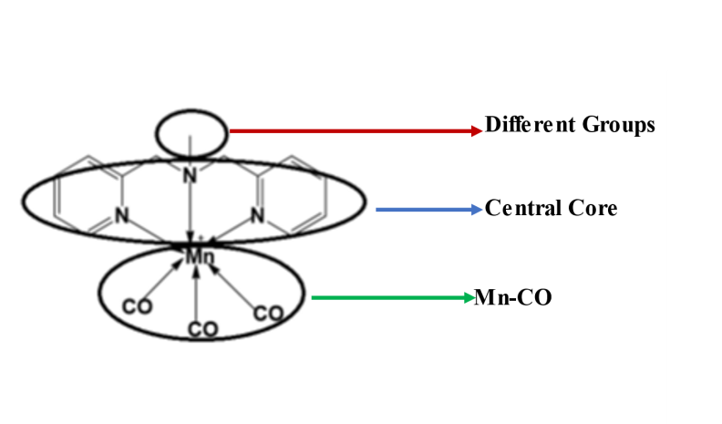
Figure S4. Graphical representation of different fragments.

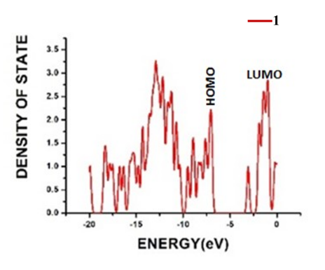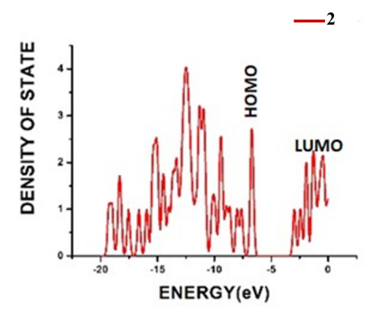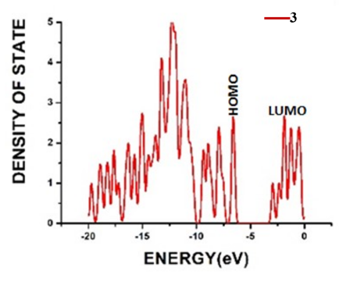
1 2 3

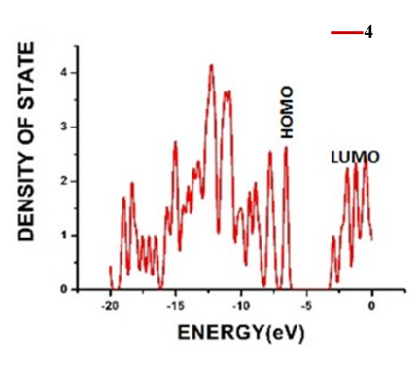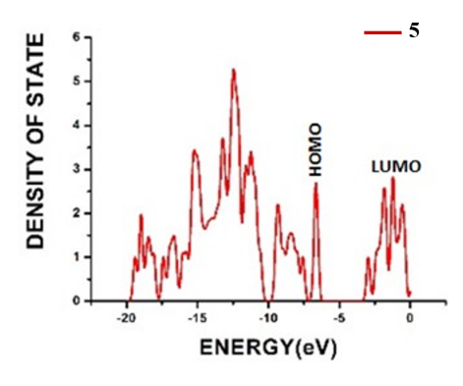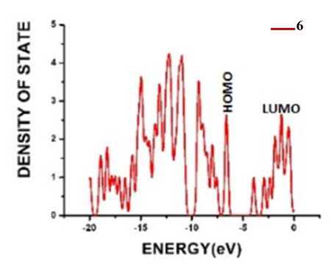
4 5 6

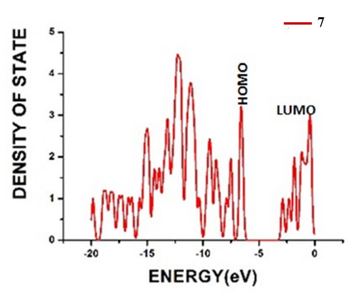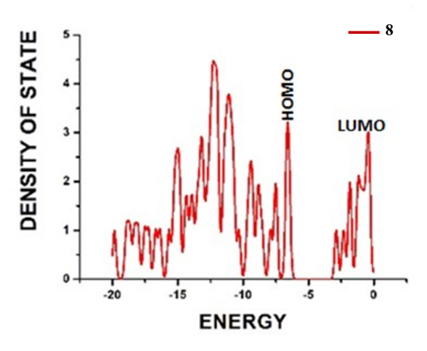
7 8
Figure S5.Graphical representation of TDOSs of all given complexes(1-8).
Transition Density of Matrix
We have specifically calculated the coloured 3D TDM plots of our designed molecules using multiwfn 3.8 software at the B3LYP/LANL2DZ level of theory to estimate the charge transfer behaviour that happens in between the lower and middle energy peaks. Moreover, it also provides information related to the specific positioning of electrons, holes, and electron–hole overlap.
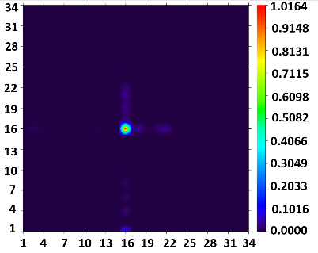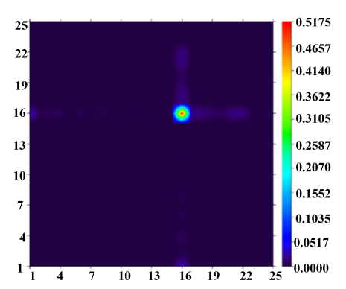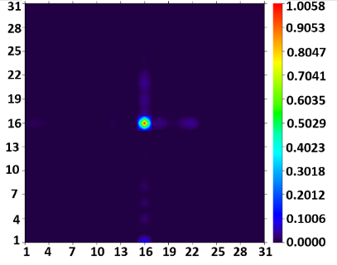
1 2 3
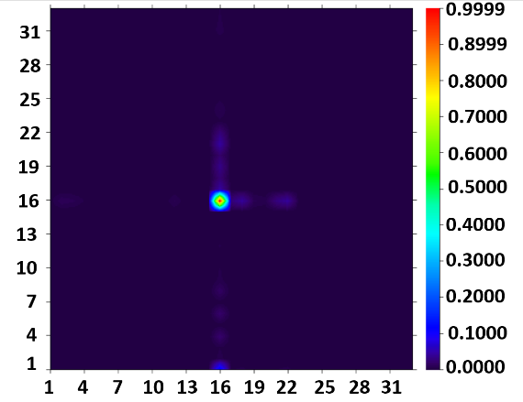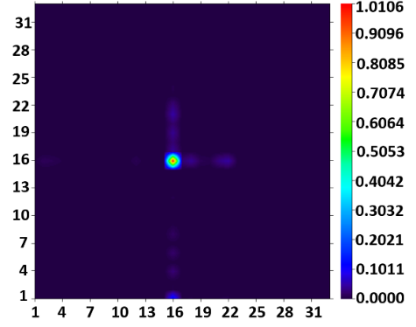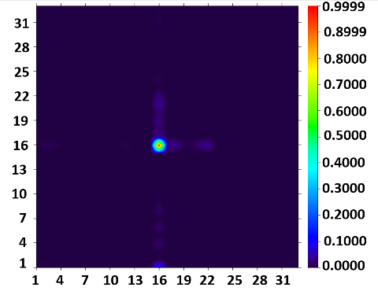
4 5 6
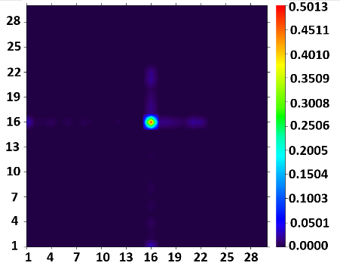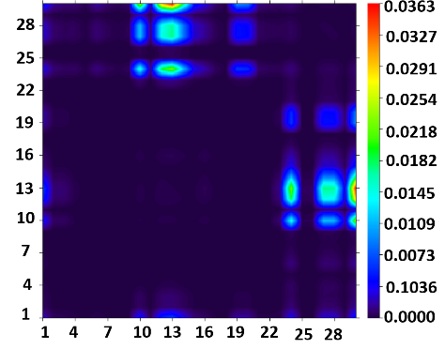
7 8
Figure S6. Transition density matrix graph for all complexes.

