Table 2. Estimated PET and DCE kinetic parameters.

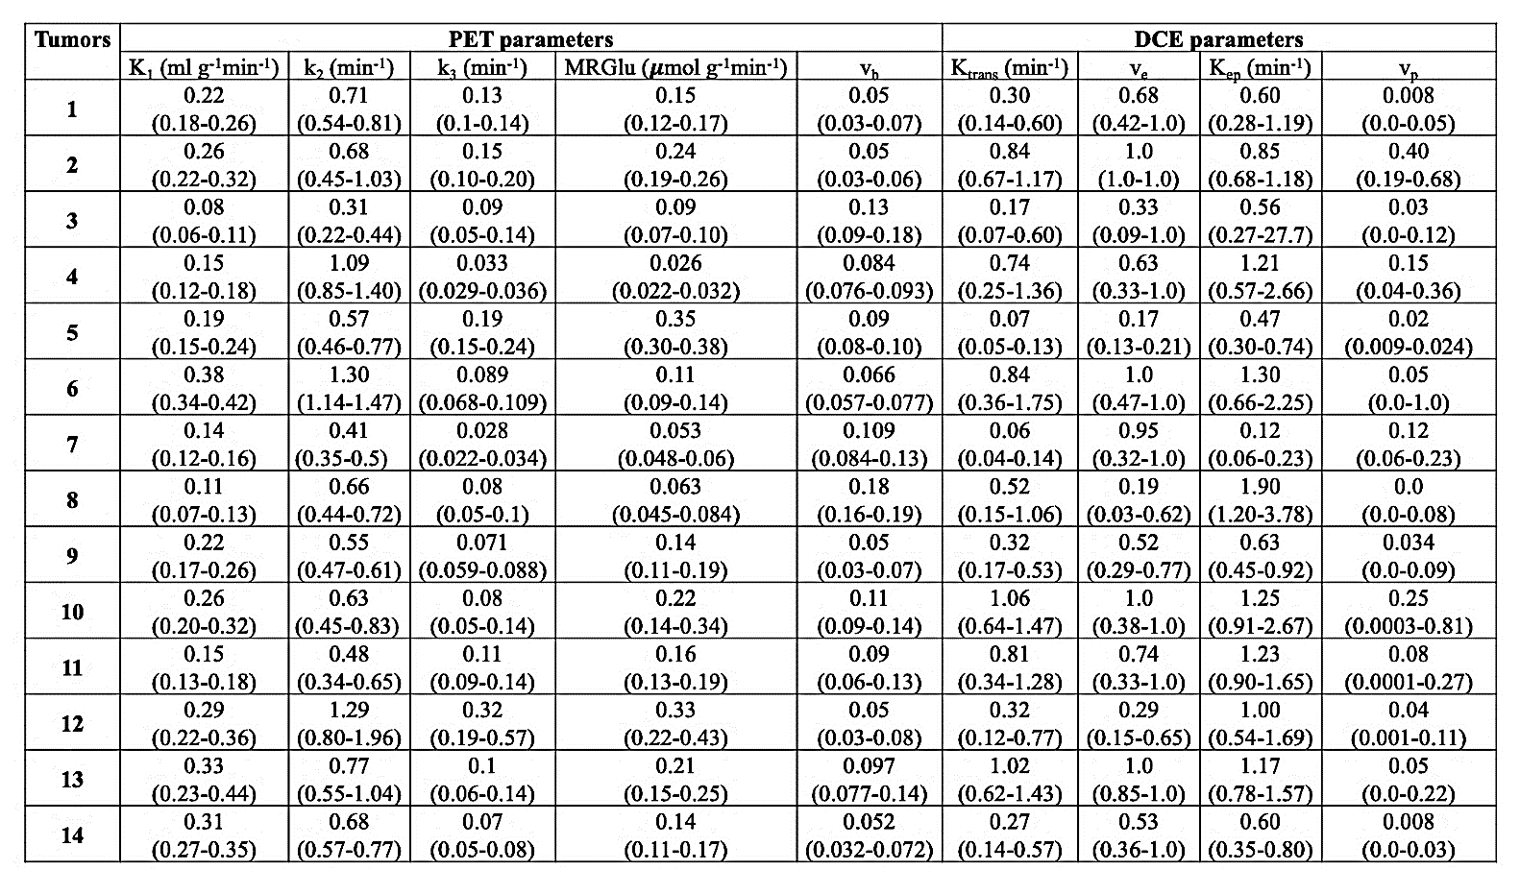

Kinetic parameters are expressed as median (IQR).

