Supplementary Table 1. Details of samples used in this analysis
GEO Accession No. | No. of Samples | Control  Samples | Stress  Samples | Genotypes | Stress
GSE6908 | 4 | 2 | 2 | Nipponbare | Drought
GSE6901 | 12 | 3 | 9 | IR64 | Drought
GSE21651 | 16 | 8 | 8 | Vandana, IR64 | Drought
GSE23211 | 12 | 6 | 6 | Wildtype, PSARK::IPT | Drought
GSE24048 | 12 | 6 | 6 | Bala, Azucena | Drought
GSE25176 | 8 | 2 | 6 | IRAT109, Zhenshan 97 (ZS97) | Drought
GSE26280 | 36 | 18 | 18 | DK151 | Drought
GSE83378 | 36 | 18 | 18 | MILT1444, Ematayin, Douradoagulha, Khaumeo, Huhan3, Nipponbare | Drought
GSE92883 | 8 | 4 | 4 | IR20, Nootripathu | Drought
GSE3053 | 11 | 5 | 6 | FL478, IR29 | Salinity
GSE4438 | 24 | 12 | 12 | M103, IR29, Agami | Salinity
GSE13735 | 11 | 5 | 6 | FL478, IR29 | Salinity
GSE14403 | 23 | 11 | 12 | FL478, IR29, IR63731, Pokkali | Salinity
GSE16108 | 16 | 8 | 8 | MI48, CSR27 | Salinity
GSE58603 | 39 | 6 | 33 | IR64 | Salinity
GSE14275 | 6 | 3 | 3 | ZhongHua 11 | Heat
GSE41647 | 18 | 6 | 12 | Dagaddeshi, IR20 | Heat
GSE41648 | 18 | 6 | 12 | Annapurna, IR64 | Heat
GSE56779 | 12 | 6 | 6 | TGMS-Co27, Wild-type(H1493) | Heat
GSE83542 | 12 | 6 | 6 | HTL252, HSL082 | Heat
GSE136746 | 12 | 6 | 6 | IR64, N22 | Heat
GSE37940 | 36 | 6 | 30 | K354, C418 | Cold
GSE38023 | 36 | 6 | 30 | LTH, IR29 | Cold
GSE71680 | 23 | 7 | 16 | C145, C153, C147, C063, C070, C079, C087, C148 | Cold

Supplementary Table 2. R Packages and its functions
R Packages | Uses | References
BiocManager | Statistical analysis and comprehension of high-throughput genomic data. | Yu et al.,2020
randomForest | Breiman’s Random forest algorithm for classification and regression problems. | Speiseret al.,2019
ggfortify | Data Visualization Tools for Statistical Analysis | Tang et al., 2016
preprocessCore | Analysis of low- and high-throughput genomic data | Bolstadet al., 2013
factoextra | Visualize the output of multivariate data analysis | Lemenkovaet al.,2019
Boruta | Feature selection | Kursa et al.,2010
Metrics | Metrics analysis for regression, time series, binary classification, classification, and information retrieval problems | Hauser., 1997
BBmisc | Miscellaneous helper package | Rieder et al., 2017

Supplementary Table 3. Gene specific primers used in the study
Primer for the locus | Gene name (RGAP Locus Id) | Primer sequence (5’-3’) | Tm (ºC) | An (ºC) | Amplicon size (bp)
Os.15784.1.A1_s_at | LOC_Os05g43860.1 | FP: GCTGCCGTCGATGAAGT  RP: GAGGTGGAGACTGCTTCTTG | 62  62 | 62 | 125
Os.27688.1.A1_at | LOC_Os04g21350.1 | FP: TGCCTCCTCCAGTTCCA  RP: AAGACGTTGCGGGTCTTG | 62  62 | 62 | 116
Os.39552.1.A1_s_at | LOC_Os06g48300.1 | FP: TGCCTCCTCCAGTTCCA  RP: AAGACGTTGCGGGTCTTG | 62  62 | 62 | 116
Os.54874.1.S1_at | LOC_Os09g27040.1 | FP: GATGGACTACTCGTGGGTGTT  RP: ACCTGCCGCTGCTCATC | 63  64 | 62 | 96
Os.9653.1.S1_at | LOC_Os05g04360.1 | FP: GGTGATCGTCGTCTGCTTC  RP: CAGAGAGGCTCTTGCAACTC | 62  62 | 62 | 104
OsAffx.12370.2.S1_at | LOC_Os02g36200.1 | FP: ACACCAAGGAATCCAAGGC  RP: CCTATTTCGTCGATACCGTGAG | 62  62 | 62 | 98
OsAffx.3920.1.S1_s_at | LOC_Os04g27670.1 | FP: TGAATGGAGAACCACGAACC  RP: GCATCATTCCTGTCATCGTAGA | 62  62 | 62 | 117
OsAffx.6874.1.S1_at | LOC_Os10g35340.1 | FP: CCTACGAATGTGCTGCCTAT  RP: AATGCTGACCCTGAGCTG | 62  62 | 62 | 102

Supplementary Fig.1
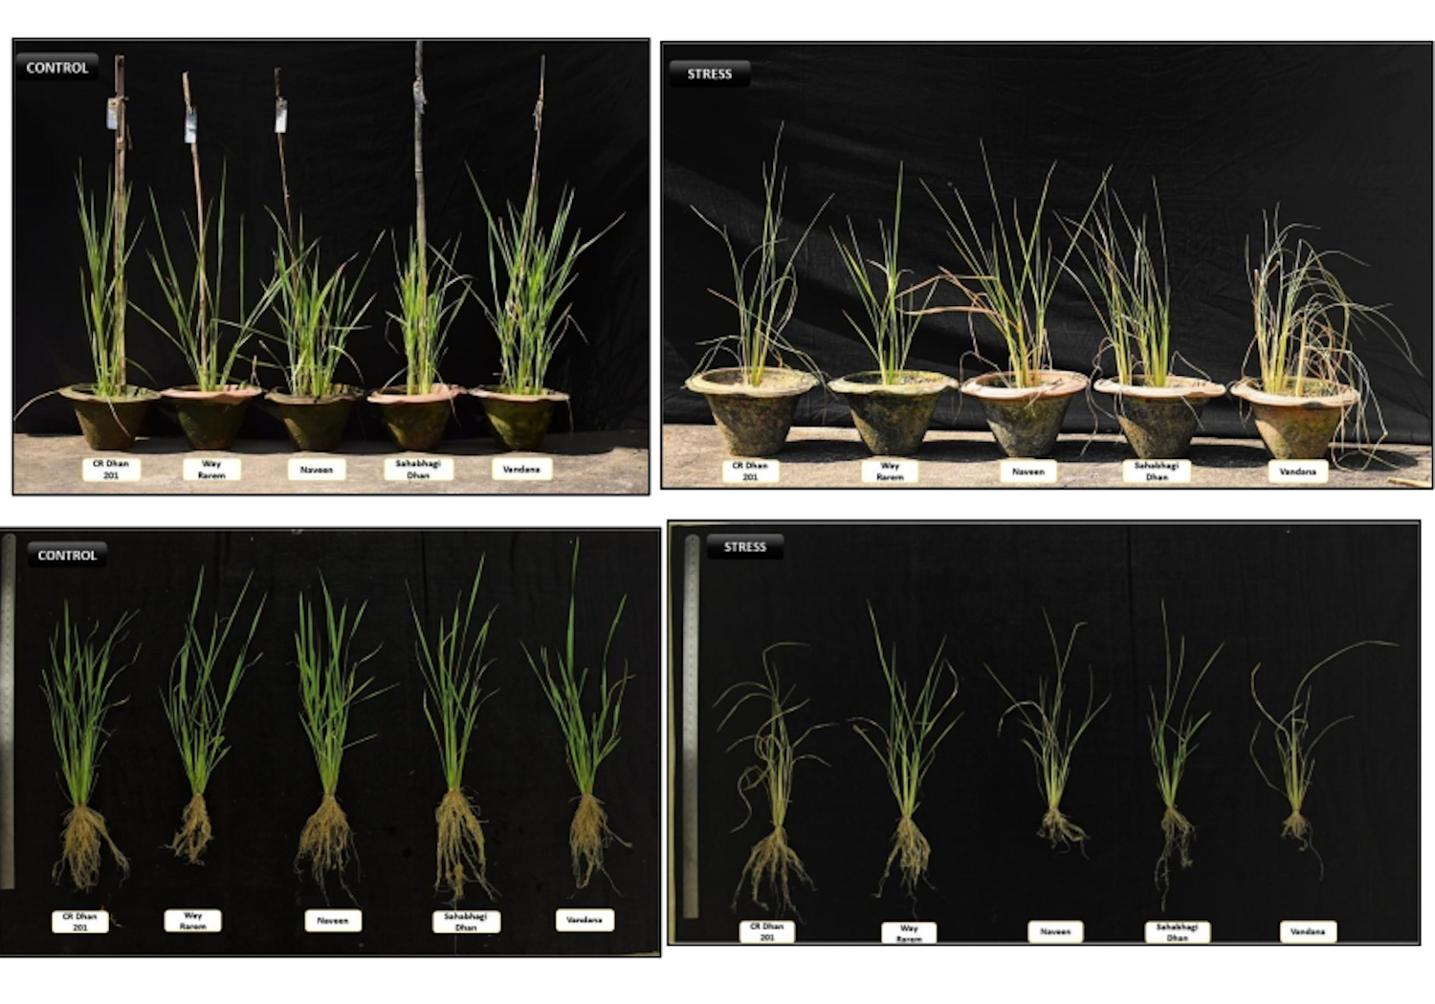

Supplementary Fig.2
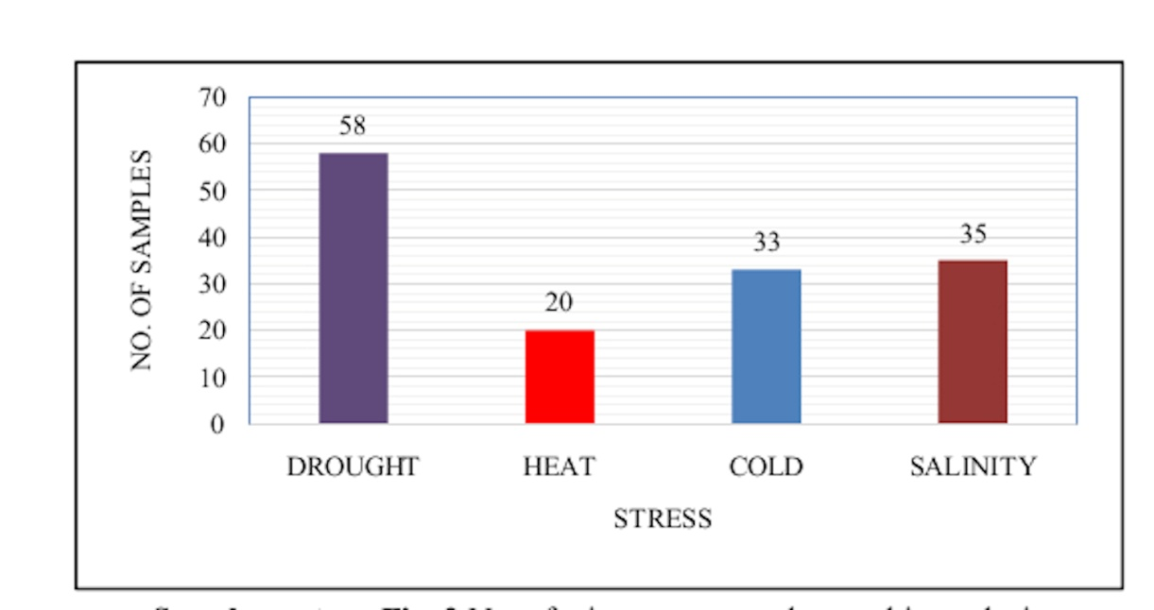

Supplementary Fig.3
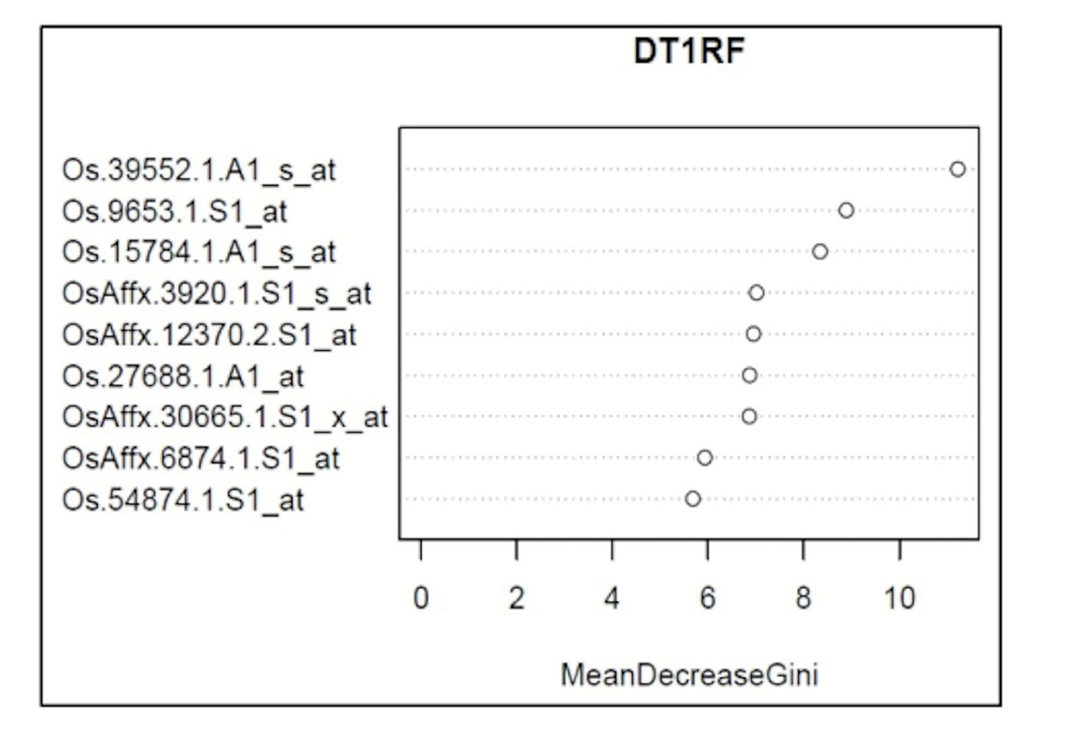

Supplementary Fig.4
