NOVEL COMPOSITES POLYMER ELECTROLYTES BASED ON METHYLCELLULOSE-PECTIN BLEND COMPLEXED WITH POTASSIUM PHOSPHATE AND ETHYLENE CARBONATE
Abdullahi Abbas Adam^{1,2,3}*, Hassan Soleimani¹, Muhammad Fadhlullah Bin Abd. Shukur^{1,2}, John Ojur Dennis¹, Yarima Mudassir Hassan^{1,2}, Bashir Abubakar Abdulkadir^{1,2}, Jemilat Yetunde Yusuf¹, Omar Sami Sultan Ahmed^{2,4} Saba Ayub¹, Suleiman Shuaibu Abdullahi ³
¹Department of Fundamental and Applied Sciences, Universiti Teknologi PETRONAS, Seri Iskandar, Perak 32610, Malaysia
²Centre of Innovative Nanoscience and Nanotechnology (COINN), Universiti Teknologi PETRONAS, Seri Iskandar, Perak 32610, Malaysia
³Department of Physics, Al-Qalam University Katsina, Katsina 820252, Nigeria
⁴Electrical and Electronics Engineering Department, Universiti Teknologi PETRONAS, Seri Iskandar, Perak 32610, Malaysia

*Correspondence: abbasabdullah17@hotmail.com

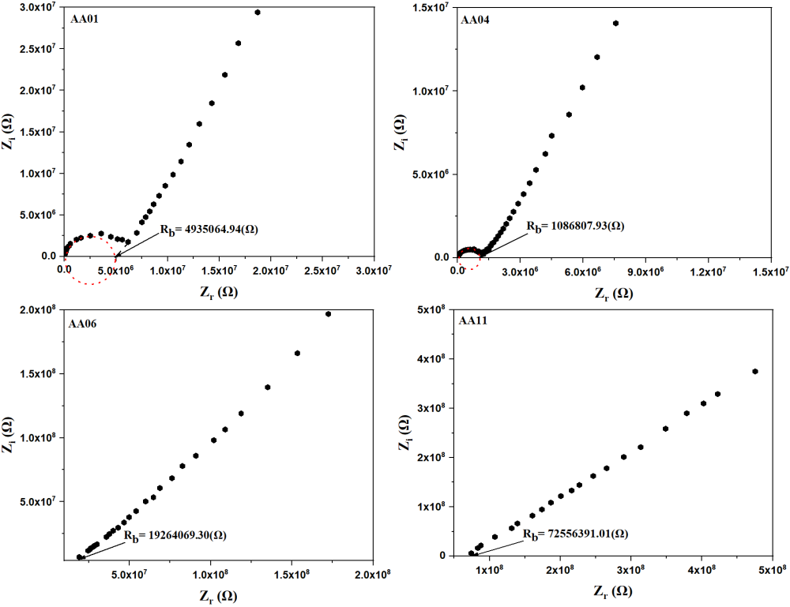
Figure S1. EIS plots of some selected MC/PC films
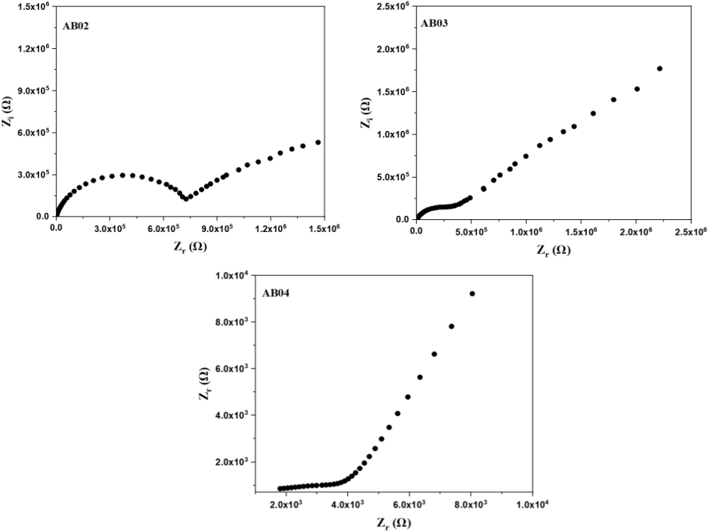
Figure S2. EIS plots of some selected MC/PC/K₃PO₄ SPE
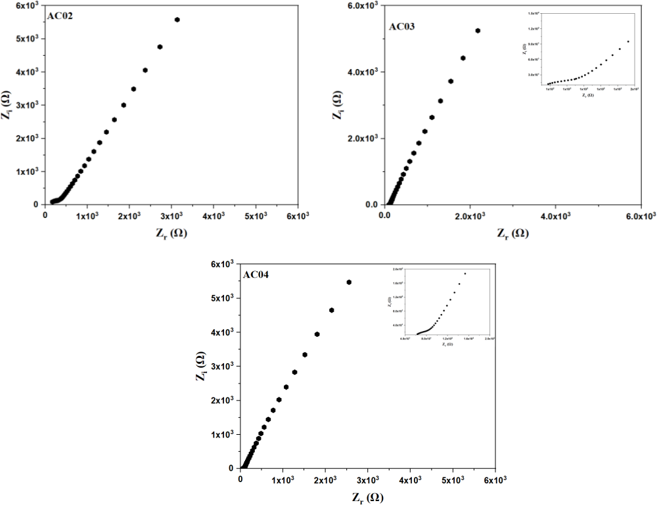
Figure S3. EIS plots of some selected MC/PC/K₃PO₄/EC SPE

