MarrowQuant 2.0: a digital pathology workflow assisting bone marrow evaluation in clinical and experimental hematology
Authors
Rita Sarkis^{1,2}, Olivier Burri^{3*}, Claire Royer-Chardon^{4*}, Frédérica Schyrr¹, Sophie Blum¹, Mariangela Costanza⁵, Stephane Cherix⁶, Nathalie Piazzon⁴, Carmen Barcena ^{4,7}, Bettina Bisig⁴, Valentina Nardi⁸, Rossella Sarro^{4,9}, Olivier Spertini⁵, Sabine Blum⁵, Giovanna Ambrosini¹⁰, Martin Weigert¹¹, Bart Deplancke¹², Arne Seitz³, Laurence de Leval^{‡4}, Olaia Naveiras^{‡1,5}.

List of Supplementary Materials:
- Extended Methods: Sample processing, histology, immunohistochemistry, code parameter tuning, error quantification, and confusion matrix
- Supplementary Video 1: MarrowQuant 2.0 demo with output data example
- Supplementary Figure S1: MarrowQuant 2.0 classification, quantification steps, and logic
- Supplementary Figure S2: MarrowQuant 2.0 code parameter tuning for adipocyte detection
- Supplementary Figure S3: MarrowQuant 2.0 error quantification
- Supplementary Figure S4: Training set quantification and classification rate of MarrowQuant 2.0 masks
- Supplementary Figure S5: Development and adaptation of Stardist for adipocyte detection
- Supplementary Figure S6: Multiclass ROC curves for accuracy and precision measurement of MarrowQuant 2.0
- Supplementary Figure S7 Covariance of marrow compartments
- Supplementary Figure S8 Naïve vs expert annotation for MarrowQuant 2.0
- Supplementary Table S1: Patient characteristics for the test data set
- Supplementary Table S2: Interclass correlation coefficient for MarrowQuant 2.0 estimation of cellularity ,non-expert versus expert annotation
- Supplementary Table S3: Sensitivity, specificity, and area under the ROC curve (AUC) for cellularity estimation in the experimental set
- Supplementary Table S4: Comparative table for the different digital pathology tools for BM tissue compartments quantification

MarrowQuant 2.0: a digital pathology workflow assisting bone marrow evaluation in clinical and experimental hematology

Extended Methods:
Sample processing, histology, and immunohistochemistry
For control specimens, control BM samples from aged-matched hip replacement surgical pieces were placed in histology cassettes. The samples were fixed (10% neutral buffered formalin [VWR 11699404] 48 h at room temperature) and decalcified using a 20% sodium citrate (Sigma Aldrich 71405) and formic acid (ROTH 4724.3) solution (v/v) for 48 h. Samples were submitted for stepwise dehydration and then embedded in paraffin blocks for sectioning with a rotary microtome (RM, Leica microsystems) at 4 µm thickness. The slides were either stained for H&E with the Tissue-Tek Prisma automate (Sakura) and permanently mounted with the Tissue-Tek glass G2-coverslipper (Sakura) or were used for immunohistochemistry (IHC). For IHC, dewaxed and rehydrated paraffin sections underwent pre-treatment in 10 mM sodium citrate (pH 6.0) at 60°C overnight. A 1% BSA solution (Sigma Aldrich, 9048-46-8) was used to block for 30 min. The primary antibodies used were Perilipin-1 (rabbit- α-Perilipin-1, clone EPR3753(2), Abcam; dilution 1/200) and CD34 Class II epitope (mouse α-CD34 Class II, clone QBend10, DAKO; dilution 1/50). Goat anti-rabbit or anti-mouse biotinylated were used as secondary antibodies (Vector Laboratories, Burlingame, CA, USA; dilution 1/200). The chromogenic development was performed with 3,3′-diaminobenzidine (DAB) (in brown, Roche Diagnostics, Switzerland). All sections were counterstained with Harris hematoxylin using the Tissue-Tek Prisma automate (Sakura) and permanently mounted with the Tissue-Tek glass G2-coverslipper (Sakura). For each stained slide, a control staining with the corresponding secondary antibody alone was performed. In most of the sections, background staining of secondary antibody controls was negligible. The IHC-stained slides were then scanned with the slide scanner (Olympus VS120 whole slide scanner) using the 20× objective, and the images were loaded into QuPath 0.2.3 or 0.3.2.

MarrowQuant 2.0 code parameter tuning and error quantification
The hematopoietic and bone compartments were adapted using the training set by optimizing the threshold to maximize each human BM compartment mask segmentation (code published on GitHub, see Code and data availability section). Then, to determine the minimum human BM adipocyte size for the adipocyte mask, we first ran MarrowQuant on the full training and experimental sets so as to approximate a distribution of adipocyte size applicable to steady-stade, leukemic diagnosis and extreme BM remodelling upon ablative chemotherapy. We concluded on the existence of very small adipocytes covering an area of < 500 µm² (Supplementary Fig. S2A) whose identity required validation through specific stains as in(39). Six representative specimens were then chosen to subclassify small adipocytes based on IHC with anti-Perilipin-1 and anti-CD34 staining, so as to distinguish small adipocytes (perilipin-1+) from microvessel lumens (CD34+) (Supplementary Fig. S3A-D). We loaded the full IHC-stained images in QuPath, annotated the perilipin-1+ small adipocytes, and measured their respective sizes, which ranged from 180–460 µm² (Supplementary Fig. S3B-D) with a high frequency of very small adipocytes clustering around 300 µm² (Supplementary Fig. S3D). In parallel, we annotated the very small areas of round traces of vasculature on the CD34 images and measured their respective sizes (ranging from 50–300 µm²) (Supplementary Fig. S3C-D). Accordingly, based on the median values, we selected 300 µm² as the recommended threshold for minimum adipocyte size detection by MarrowQuant 2.0.
Several sources of errors were detected: the nuclei of adipocytes are detected as part of the hematopoietic mask (arrows in Supplementary Fig. S4A, scale bar = 50 µm), white round empty artifactual spaces are sometimes considered as adipocytes (arrows for false adipocytes in Supplementary Fig. S4B, scale bar = 50 µm), and parts of the cytoplasm of megakaryocytes could be misclassified as IMV or bone (arrows Supplementary Fig. S4C, scale bar = 20 µm). To quantify the error, a set of 13 images with a wide range of cellularity was selected from the training set and manually annotated as follows.
For the adipocyte nuclei (Supplementary Fig. S4A), measurements of the area of the nuclei were performed on 15 adipocytes per image to generate the mean area of an adipocyte nucleus: 14.95 ± 2.65 µm². Having calculated with MarrowQuant 2.0 the number of adipocytes per image, we multiplied the average size of the adipocyte nucleus by the number of adipocytes to generate the area that should be subtracted from the hematopoietic area and from the total marrow area to account for adipocyte nuclei miscounted as hematopoietic nuclei, and performed the new set of calculations. Each compartment was affected as follows: % cellularity: -0.79% p = 0.99; %hematopoietic area : -0.99% p = 0.99; % adiposity: +1.08% p = 0.99; %IMV +0.2% p = 0.99.
For the small artifact regions that were not manually excluded on the user annotations, and that were segmented by MarrowQuant 2.0 as “adipocyte ghosts”, (Supplementary Fig. S4B) the same set of images was used to select the false-positive adipocytes and reannotated as an artifact, thus not counted in the calculations. Then, the MarrowQuant 2.0 workflow was rerun for new output. Each compartment was affected as follows: % cellularity: +1.5% p = 0.96; % hematopoietic area +0.65% p = 0.99; % adiposity: -2.03% p = 0.97; % IMV: -1.1% p = 0.56.
Finally, to quantify the error generated by MarrowQuant 2.0 sometimes misclassifying megakaryocyte cytoplasm as IMV (pink) or exceptionally as bone (cyan, arrow in Supplementary Fig. S4C), we determined the average area of megakaryocyte cytoplasm by manually annotating all megakaryocytes in the error quantification image set: 545±56µm². Counting the number of false-negative megakaryocyte cytoplasms, we multiplied the average size of the cytoplasm by the number of false negatives to generate the area that should be added to the hematopoietic area to perform the new set of calculations. Each compartment was affected as follows: % cellularity: +1.55% p = 0.99; % hematopoietic area: +1.25% p = 0.99; % adiposity: -0.44% p = 0.99; %IMV -0.5% p = 0.99.
Post-error correction, MarrowQuant 2.0 was re-run, and the new quantification showed that these errors did not significantly affect the percent of each detected compartment, with the overall error estimation as follows: % cellularity: +2.26% (p = 0.97), % hematopoietic area: +0.91% (p = 0.99), % adiposity: -1.39% (p = 0.96), % IMV -1.4% (p = 0.97).
Confusion matrix
To evaluate each BM compartment and compare the classification via MarrowQuant 2.0 with our manual/visual predictions, we selected a set of 12 H&E images covering a wide range of cellularity from the training set and designated two ROIs per image for manual/visual predictions. ROI of interest were picked such that all the BM compartment classes were equally presented and the total number of pixels counted per class was the same for each class. The evaluation was performed on a classification mask-wise basis by measuring the number of cells within each compartment that were correctly segmented for their corresponding class for 80% or more of their area (pixel-wise quantification). A true positive (value = 1) was considered as a correct match between the cell and its corresponding compartment. Else it was considered a false positive (value = 0). The results were reported as a normalized confusion matrix (values ranging from 0 [not detected mask] to 1 [well detected mask]) (Supplementary Fig. S2B).

Validation of “StarDist for adipocytes”

The accuracy [(true positive + true negative]/total detections) and the precision (true positive/ [ [true positive + false positive]) for varying intersection over union (IoU) thresholds as shown in Supplementary Fig. S5C-D. For a fixed threshold τ (e.g τ = 0.7) a detected object is counted as a true positive only if its IoU with an annotated object is larger than τ (e.g. 70%). Although the performance was lower at the borders of the selected ROIs and in regions with traces of blood vessels, we found that StarDist exhibited a high precision (0.87) and accuracy (0.8) for an IoU threshold range from 0.1–0.7.

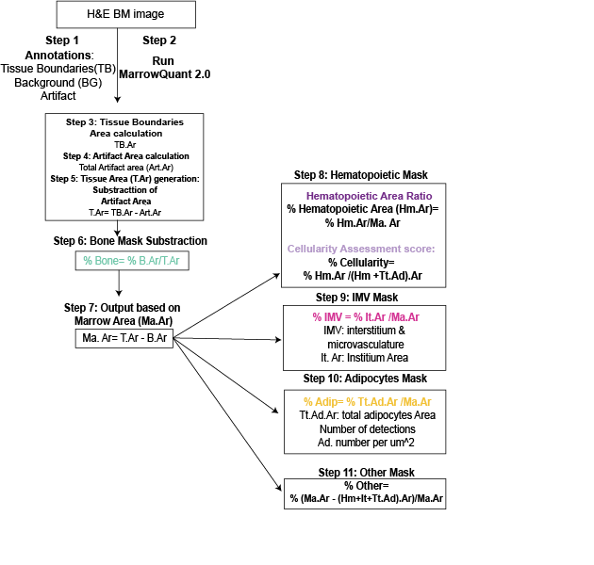
Figure. S1: MarrowQuant 2.0 classification, quantification steps, and logic. MarrowQuant 2.0 user-defined parameters are set at recommended values for human BM analysis: minimum adipocyte size = 300 µm², maximum adipocyte size = 2,500 µm², minimum circularity = 0.3. Abbreviations: TB, tissue boundaries; BG, background; TB.Ar, tissue boundaries area; Art.Ar, artifact area; T.Ar, tissue area; B.Ar, bone area; Ma.Ar, marrow area; Hm.Ar, hematopoietic area; Tt.Ad.Ar, total adipocyte area; IMV, interstitial and microvasculature; It.Ar, interstitial area.
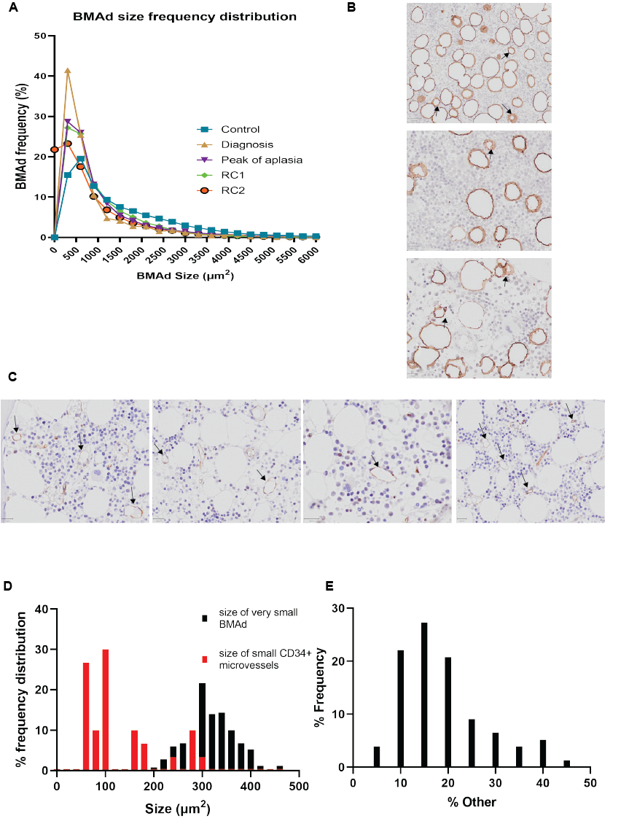

Figure S2: MarrowQuant 2.0 code parameter tuning for adipocyte detection. a Total adipocyte size distribution in controls and at the four time points (training and experimental set, n = 161 H&E images). b-d Minimum adipocyte size is set to 300 µm² based on the measurement of the area of n = 150 small adipocytes performed on perilipin-1-stained IHC human BM biopsies as compared to CD34-stained biopsies (c). b,d Perilipin-1 staining and measurement of very small adipocytes (black arrows, size range 250–300 µm²) (scale bar = 50 µm) c,d CD34 staining targeting microvasculature and measurement of microvasculature white traces (black arrows, size range 50–300 µm²) (scale bar = 20 µm). e The frequency of % “other” area used to set the threshold for the error message based on the Bonferroni outlier test and on visual inspection for expanded stroma cases.

Figure S3: MarrowQuant 2.0 error quantification. For error adjustments, a set of 13 H&E images were selected from the training set with different cellularity scores (“Before” refers to the MarrowQuant 2.0. quantification prior to error correction, “after” is the MarrowQuant 2.0 quantification after the error correction. a Quantification of error from adipocyte nuclei counted as hematopoietic cells. For each image, the area of the nuclei of 15 adipocytes was measured to calculate the average area of an adipocyte nucleus: 14.95 µm²± 3.46). After calculating the number of adipocytes per image, we multiplied the average size of the adipocyte nucleus by the number of adipocytes to generate the area that should be subtracted from the hematopoietic area and from the total marrow area to correct for the error. b False adipocytes (arrow) are fragmented artifact regions detected as adipocyte ghosts (scale bar = 50 µm). For each image, the false-positive adipocytes were selected as an artifact (thus excluded from the calculations), then the MarrowQuant workflow was rerun for new output (scale bar = 50 µm) c The nuclei of megakaryocytes are detected within the hematopoietic area (purple), but sections of their cytoplasm are often either detected as IMV (pink) (arrow) or exceptionally as bone (cyan) (arrow). Here, a set of 10 H&E images were selected from non-neoplastic and leukemic biopsies with different cellularity scores. On each selected image, the cytoplasmic area of every megakaryocyte was measured to generate the average area of a megakaryocyte cytoplasm: 545 ± 56 µm². Counting the number of false-negative megakaryocyte cytoplasm events, we multiplied the average size of the cytoplasm by the number of false negatives to generate the area that should be added from the hematopoietic area to correct for the error. a-c Error quantifications were performed using a two-tailed t statistical test, and P > 0.05 was considered as non-significant (ns).

Figure S4: Training set quantification and classification rate of MarrowQuant 2.0 classification masks. a Correlation between clinical reference and MarrowQuant 2.0 (Eq.1) cellularity estimation from 4 pathologists on the training set (pathologists n = 4; images n = 36; R² = 0.94). b Normalized confusion matrix for the classification rate of masks for each BM compartment in the training set (values ranging from 0 to 1, where is 0 means no correlation and 1 high correlation). Manual predictions represent the classification based on visual estimations, whereas predicted classifications are those performed by MarrowQuant. When incorrectly classified, the “IMV” and “Other” areas were most often misclassified as one another. The normalized confusion matrix was performed on a set of 12 H&E images from BM trephine biopsies from the training set, where 2 ROIs per image were selected for manual/visual predictions.

Figure S5: Development and adaptation of “Stardist for adipocytes” detection. a Adipocyte density (number of adipocytes per mm² of marrow space) follows the same trend as the % adiposity score (% adipocyte area over the total marrow area, Fig. 4b), with the highest density at the peak of aplasia (n = 28 AML patients, n = 15 control patients, *P < 0.05, **P < 0.01, ****P < 0.0001 by multiple comparison test). b Stardist workflow and annotation pipeline (scale bars = 250 µm and 50 µm). On a training set of 14 H&E BM images, 2 ROIs per image were selected, the adipocytes were manually drawn (red circles), and the model was trained. After four rounds of training and correction, the detected adipocytes (red filled circles) were categorized as the output of Stardist in QuPath. Post-Stardist detections, the adipocytes were classified by size (colored circles, each color corresponding to a size range). c-d Precision, recall, accuracy, f1, mean true score, mean matched score, and panoptic quality for different intersection over union (IoU) thresholds for the validation dataset, as reported by metric values or detected number of true positives, true negatives, and false positives. The IoU threshold is measured as a comparison between the area of the annotated objects and same objects predicted by Stardist. (fp = false positive, tp = true positive, fn = false negative). For detailed definitions refer to (44,45).

Figure S6: Figure S6: Multiclass ROC curves for accuracy and precision measurement of MarrowQuant 2.0. a Sensitivity, specificity, and area under the ROC curve (AUC) for a broad range of cellularity estimation in the experimental set (n = 172 H&E images). b Corresponding ROC curves for sensitivity and specificity measurements. c Mismatch heatmap corresponding to each of the cellularity categories defined in (a).

Figure S7: Covariance of marrow compartments. Specificity of reciprocity among marrow compartments as quantified by MarrowQuant 2.0 (n = 79 H&E images from timepoints Dx, A, RC1, RC2 on the experimental set, annotated in a non-expert manner). Note than only the hematopoietic and adipocytic compartments are reciprocal. Reciprocal compartments (% Adiposity, % Hematopoietic area, cellularity) are presented in the main figures (Fig. 5a-b).

Figure S8: Naïve vs expert annotation for MarrowQuant 2.0. Correlation of % cellularity generated by MarrowQuant 2.0 with the clinical reference % cellularity scoring estimation by four independent pathologists and by the clinical diagnosis pathology report. Three rounds of annotations for the same set of H&E images were performed: a Two rounds of unsupervised (non-expert) annotations after exclusion of heterogeneous marrow cases) tissue boundaries, BG, and artifact annotations) were performed by two individuals without any background in BM histopathology (independent reviewers n = 4 along with the pathology report score, H&E biopsies n = 118, average R² [ = 0.95]). b One round of supervised MarrowQuant 2.0 annotations was performed by a highly qualified hematopathologist and compared to cellularity estimations by four independent reviewers along with the pathology report as clinical reference (H&E biopsies n = 125, R² = 0.98). c Two rounds of unsupervised annotations including the heterogeneous marrow cases (tissue boundaries, BG, and artifact annotations) were performed by two individuals without any background in BM histopathology and compared to the cellularity estimation by four independent reviewers along with the pathology report score, H&E biopsies n = 125, average R² [ = 0.92]).
Table S1: Patient characteristics for the test data set. See Methods for further details
Diagnosis Category | Number of patients | Average age ±STD | Gender distribution
Normal BM | 10 | 57.3 ±23 | 30% F; 70%M
Plasma cell neoplasias | 8 | 60 ± 5 | 38%F; 62%M
Lymphoma | 1 | 74 | 100%F
Lymphoproliferative disorders | 4 | 63.8 ± 11 | 50%F; 50%M
AML | 4 | 68.5 ± 10 | 25%F; 75%M
MDS | 2 | 79.5 ± 10 | 50%F; 50%M
MDS/MPN | 6 | 49.5 ± 24 | 50%F; 50%M
MPN | 4 | 47 ± 6 | 80%F; 20%M
Medullary aplasia | 1 | 77 | 100%M
Reactive Marrow | 1 | 60 | 100%F
Non representative marrow | 1 | 35 | 100%M

Table S2: Interclass correlation coefficient for MarrowQuant 2.0 estimation of cellularity and comparison between, non-expert versus expert annotation. Interclass correlation for cellularity estimation among the different reviewers after either 2 rounds of non-expert (unsupervised) annotations of the validation set (top), or one round of expert (supervised) annotation of the same set (bottom). (n = 157 H&E images). Interclass Correlation Coefficient (ICC), Confidence Interval (CI), MarrowQuant (MQ). (Abbreviation: AML (acute myeloid leukemia), MDS (myelodysplastic syndrome), MPN (Myeloproliferative neoplasm).

ICC (95% CI)
Inter-observervariability
MQ 2.0 avg for non-expert annotation
+ all individual reviewers | 0.947 (0.922–0.967)
+ average score of reviewers | 0.934 (0.884–0.963)
MQ 2.0 avg for expert annotation
+ all individual reviewers | 0.956 (0.935–0.973)
+ average score of reviewers | 0.978 (0.955–0.989)
MQ 2.0 avg unsupervised and supervised scores | 0.979 (0.971–0.984)

Table S3: Sensitivity, specificity, and area under the ROC curve (AUC) for cellularity estimation in the experimental set (n = 172 H&E images) and comparison between non-expert versus expert annotation. Supervised scores refer to the score generated when the selection of ROI was performed by an expert hematopathologist (MarrowQuant 2.0 operated by expert). Unsupervised scores refer to the score generated when the selection of ROI was performed by a non-expert (naïve) user without any hematophathology background (MarrowQuant 2.0 operated by non-expert).

 | Sensitivity |  | Specificity |  | AUC
Annotations | Supervised | Unsupervised | Supervised | Unsupervised | Supervised | Unsupervised
Low cellularity <25% | 0.81 | 0.77 | 0.93 | 0.99 | 0.98 | 0.97
Medium Cellularity 25 ≤ x < 50% | 0.88 | 0.91 | 0.89 | 0.87 | 0.98 | 0.97
High cellularity ≥ 50% | 0.99 | 0.93 | 1 | 0.98 | 0.98 | 0.97

Table S4: Comparative table for the different digital pathology tools for BM tissue compartments quantification
Digital Pathology tools | MarrowQuant 2.0 | van Eekelen et al. 2021 | Nielson et al. 2019 | Hagiya et al. (2018) | Kim et al (2014)
Open-source tool | Yes | No | No | No | No
Preprocessing annotations | tissue boundaries, background, artifact selections | None | None | Tissue boundaries selection | Tissue boundaries selection
Compartments detected | Areas:  . bone  . hematopoietic  . adipocytic bone  . interstitial & MV  . other (stromal expansion, MV <300μm², unclassified pixels)  Counts: adipocytes | Lipocytes, bone, megakaryocyte, erythrocytes, myelopoiesis, erythropoeisis | Red and yellow marrow, erythrocytes, | Bone, fat, hematopoietic | Nucleated cells
Number of processed BM H&E images | N=250 | N=157 | N=8 | N=165 | N=325
Output | Area quantification  Individual counts of adipocytes | Counts | Heatmap based on region size | Area quantification | Counts

