[Extended Data for]
Anthropogenic fingerprints in daily precipitation
revealed by deep learning

Yoo-Geun Ham^{1†*}, Jeong-Hwan Kim^{1†}, Seung-Ki Min^{2,3}, Daehyun Kim⁴, Tim Li^{5,6,7}, Axel Timmermann^{8,9}, and Malte F. Stuecker^{6,10}

1Department of Oceanography, Chonnam National University, Gwangju, South Korea
2 Division of Environmental Science and Engineering, Pohang University of Science and Technology (POSTECH), Pohang, South Korea
3 Institute for Convergence Research and Education in Advanced Technology, Yonsei University, Incheon, South Korea
4 Department of Atmospheric Sciences, University of Washington, Seattle, Washington, USA
5 Key Laboratory of Meteorological Disaster, Ministry of Education/Joint International Research Laboratory of Climate and Environmental Change/Collaborative Innovation Center on Forecast and Evaluation of Meteorological Disasters, Nanjing University of Information Science and Technology, Nanjing, China
6 International Pacific Research Center, School of Ocean and Earth Science and Technology, University of Hawai‘i at Mānoa, Honolulu, HI, USA
7 Department of Atmospheric Sciences, School of Ocean and Earth Science and Technology, University of Hawai‘i at Mānoa, Honolulu, HI, USA
8 Center for Climate Physics, Institute for Basic Science, Busan, South Korea
9 Pusan National University, Busan, South Korea
10 Department of Oceanography, School of Ocean and Earth Science and Technology, University of Hawai‘i at Mānoa, Honolulu, HI, USA

*Corresponding authors. Email: ygham@jnu.ac.kr
†: These authors contributed equally to this work

 | Precipitation | 2m  temperature | 2m  Specific humidity
Ratio of  Trend to Variability | 0.031 | 0.276 | 0.260
Extended Data Table 1. Excessive day-to-day precipitation variability. The ratio of the linear trend (unit : change per a decade) to the standard deviation of the daily 2m temperature, 2m specific humidity, and precipitation anomaly during 1950-2020.

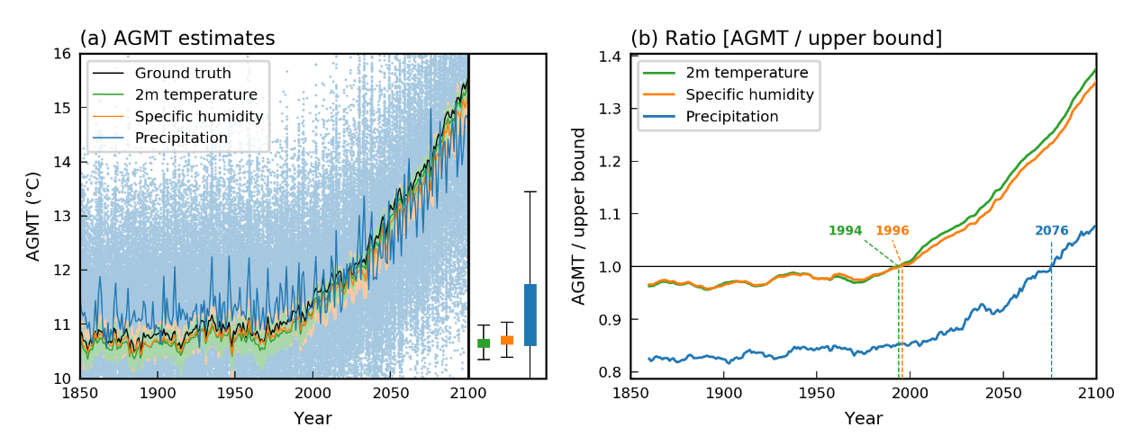
Extended Data Figure 1. Climate change detection using the ridge regression method in the CESM2 LE. (a) Time-series of the simulated annual global mean 2m-air temperature (AGMT) from 1850 to 2100 in the CESM2 LE (black line), and the annual average of the estimated daily AGMT by prescribing 2m temperature (T2m, green line), 2m specific humidity (SH2m, orange line), and precipitation (Pr, blue line) in the ridge regression model (Sippel et al., 2020). Each dots denote daily estimated AGMTs. The green, orange, and blue bar on the right side denote the one standard deviation of estimated daily AGMT using the T2m, SH2m, and Pr during the historical period (i.e., 1850-1950), respectively. The black error bar denotes the 2.5th-97.5th percentile of the daily estimated AGMT in 1850-1950. (b) Time-series of the ratio of the annually-averaged AGMT to the AGMT of upper limit of test statistics (i.e., 97.5th percentile of the daily estimated AGMT in 1850-1950). The first year that the ratio exceeds 1 is referred as a number.

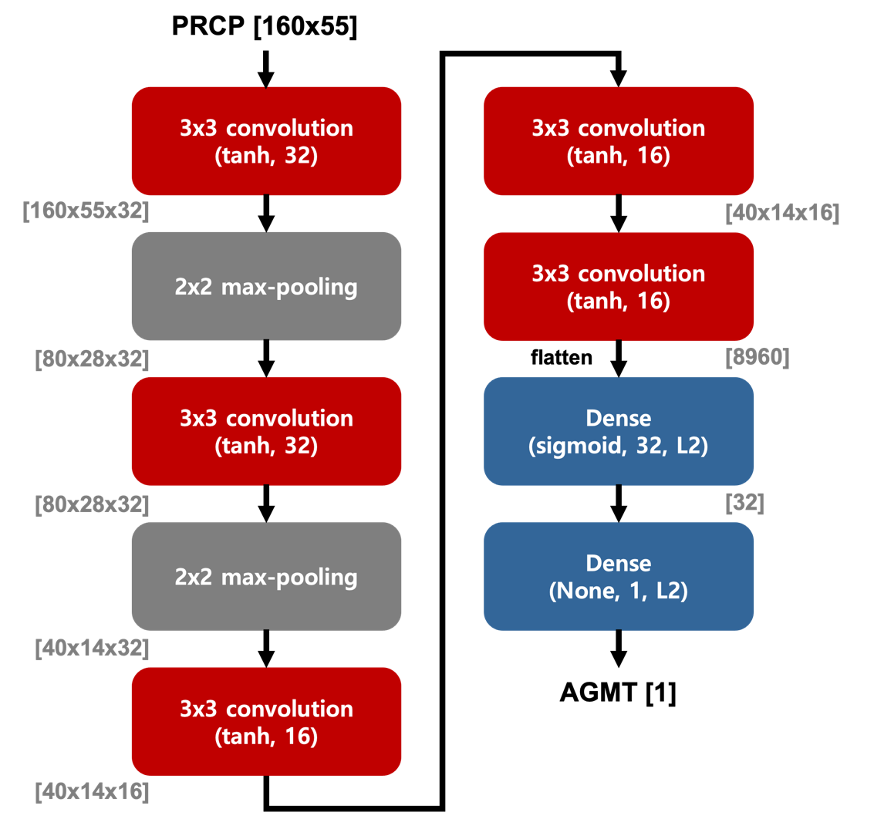
Extended Data Figure 2. The architecture of the deep learning model for the climate change detection. The red, gray, and blue box denotes the convolutional layer, max-pooling layer, and dense layer, respectively. The dimension of the product at each layer is denoted in the square brackets. The parenthesis in the red box denotes an activation function and the number of convolutional filter in the convolutional layer, and number in the parenthesis in the blue box denotes a number of neuron in the dense layer.

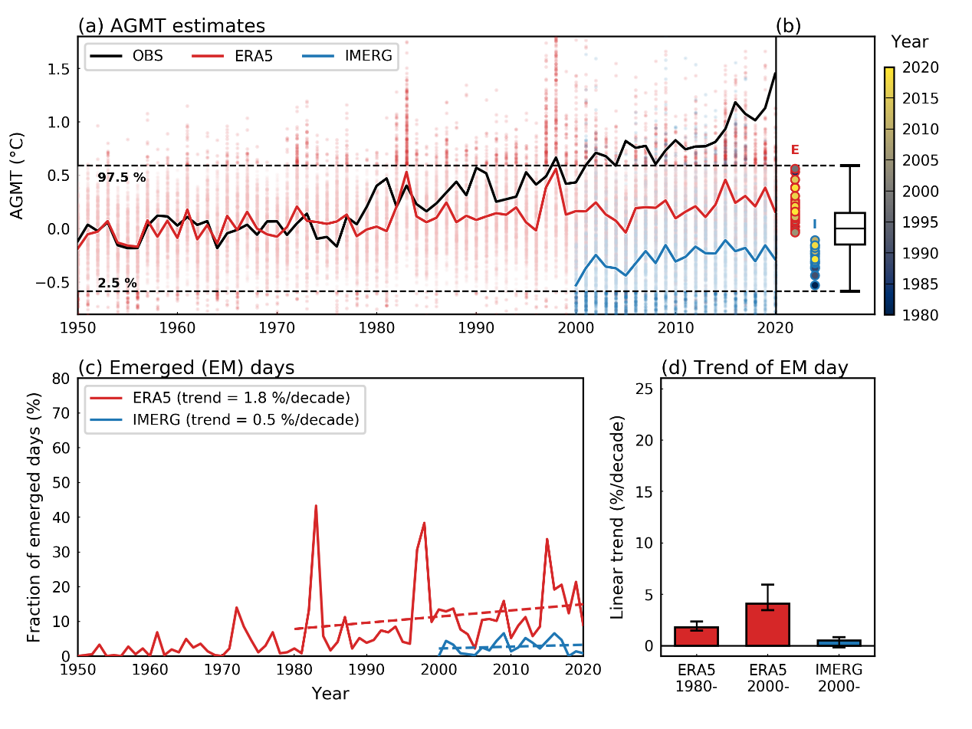
Extended Data Figure 3. Climate change detection using the ridge regression method. (a) Time-series of the observed annual global mean 2m-air temperature (AGMT) anomaly from 1950 to 2020 (black line), and the annual average of the estimated AGMT by prescribing the daily precipitation fields from the IMERG satellite observation (blue line), and ERA5 reanalysis (red line) in the deep detection (DD) model. Blue, and red dots denote daily estimated AGMTs by prescribing the IMERG, and ERA5 precipitation data, respectively. The dotted lines denote a natural variability range during the historical period defined as the 2.5th-97.5th percentile of the daily estimated AGMT in 1950-1980. (b) Blue-, and red-colored open dots denotes the annual average of the estimated AGMT from the IMERG, and ERA5 data from 1980 to 2020, respectively. The yellow colors in the inner circle denote the year corresponding to each dots. The error bar denotes the mean (centered line), one standard deviation (bound of a box), and 2.5th-97.5th percentile (bound of the error bar) of the daily estimated AGMT in 1950-1979. (c) Number of emerged days within a corresponding year from 1950 to 2020 whose estimated AGMT is greater than the upper bound of 95 % confidence range during the historical period in IMERG (blue), and ERA5 (red). The linear trend during 2000-2020 for IMERG, and 1980-2020 for ERA5 is denoted as a dotted line. (d) Linear trend of the number of the emerged days during 1980-2020 in ERA5, 2000-2020 in ERA5, and 2000-2020 in IMERG. The error-bar denotes a 95 % confidence level based on the bootstrap method (See Methods and Materials).
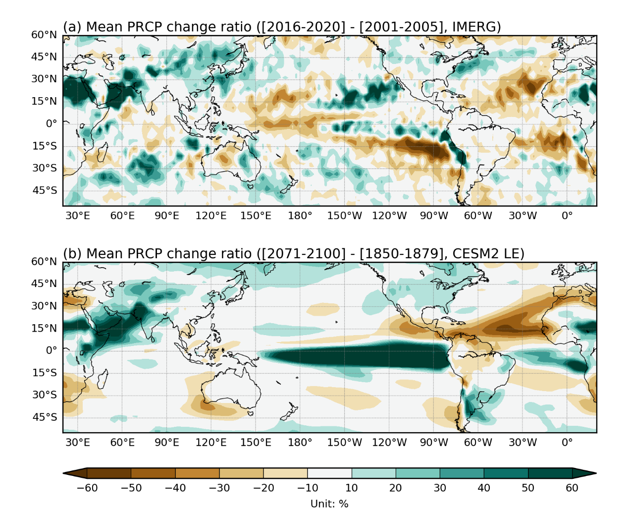
Extended Data Figure 4. The changes in the climatological precipitation due to the global warming in CESM2 LE. (a) The observed difference of the climatological precipitation ratio during 2016-2020 from that during 2001-2005 from the IMERG dataset (unit : %). (b) The difference of the climatological precipitation ratio during 2071-2100 from that during 1850-1879 simulated in CESM2 LE (unit : %).

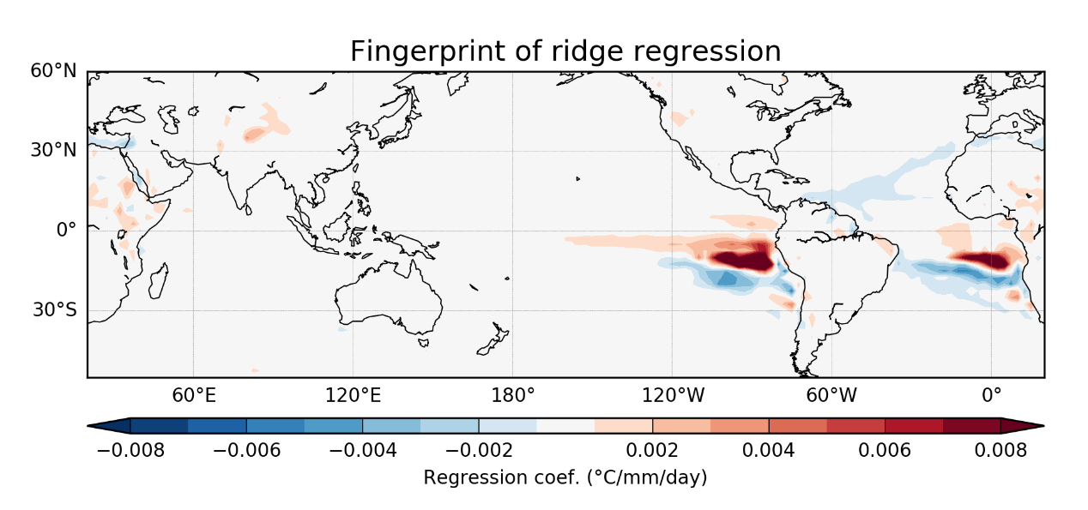
Extended Data Figure 5. Fingerprint pattern for the ridge regression method. The regression of the daily precipitation anomalies with respect to the AGMT (unit : ºC/mm/day) during 1850-2100 simulated in CESM2 LE.

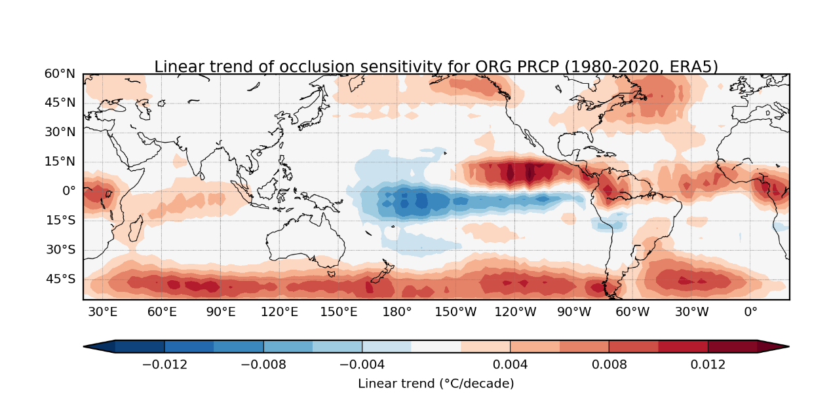
Extended Data Figure 6. Occlusion sensivity using original unfiltered precipitation anomalies. Linear trend of the AGMT occlusion sensitivity (unit: ºC/decade) to given original unfiltered ERA5 precipitation anomalies from 1980 to 2020.
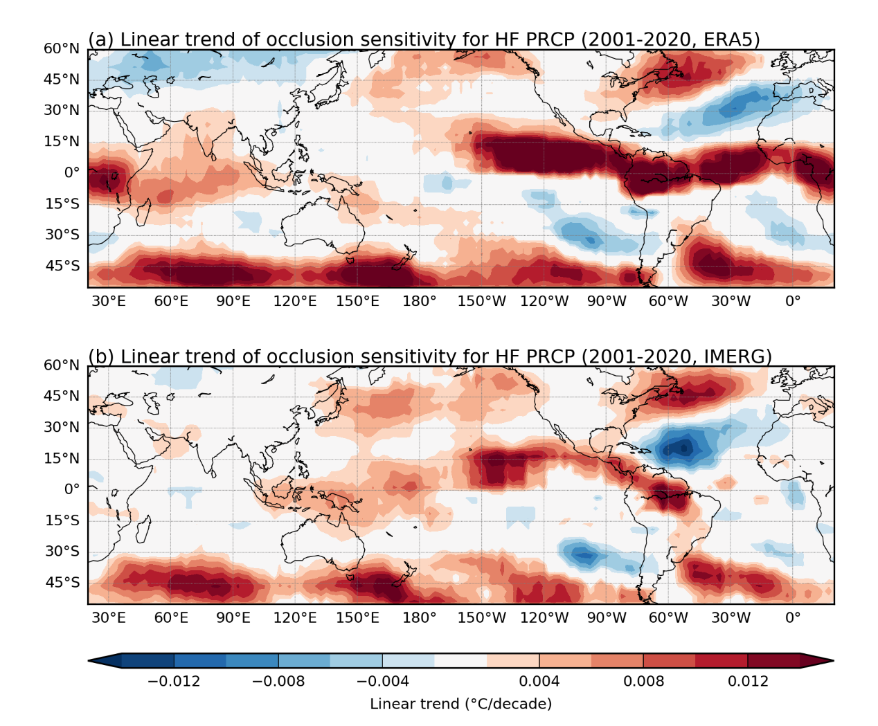
Extended Data Figure 7. Occlusion sensivity using high-pass filtered precipitation anomalies. Linear trend of the AGMT occlusion sensitivity (unit: ºC/decade) to given 10 day high-pass filtered (a) ERA5, or (b) IMERG precipitation anomalies from 2001 to 2020.

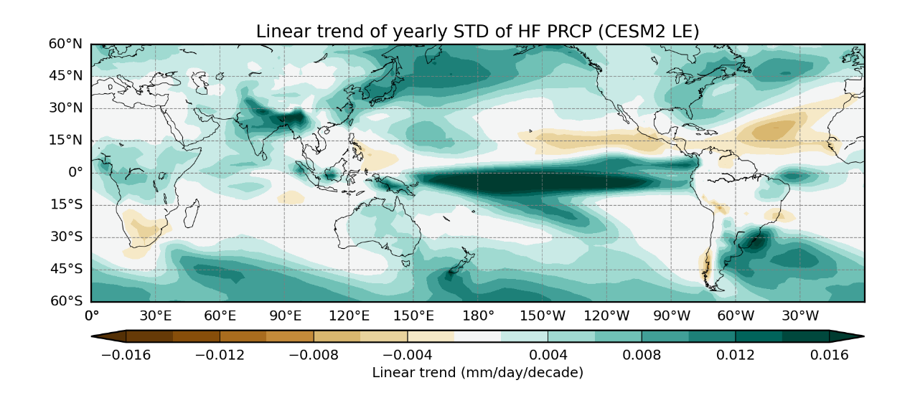
Extended Data Figure 8. Increased high-frequency precipitation variability in global warming scenarios. Linear trend of the yearly standard deviation of the 10 day high-pass filtered precipitation anomalies (unit: mm/day/decade) in 1850 to 2100 of the CESM2 large-ensemble (LE) simulations. Note that simulations during 1850–2014 were obtained from the historical simulations, and the rest from the SSP3-7.0 scenario simulations.

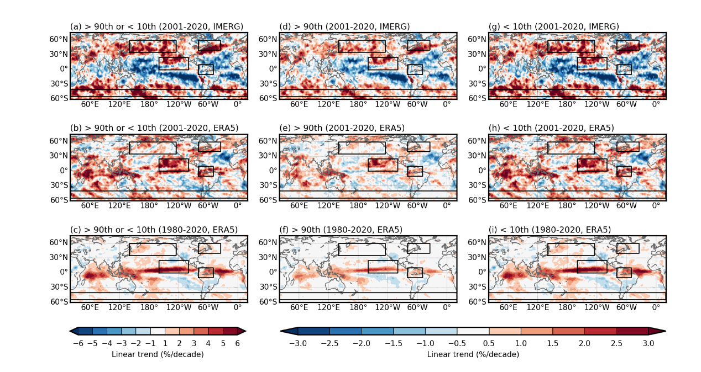
Extended Data Figure 9. Amplification of the high-frequency precipitation variability in the observational dataset. The linear trend of the occurrence frequency of HF anomalies whose value is either larger than 90 percentiles, or smaller than 10 percentile (a) during 2001-2020 in IMERG, (b) during 2001-2020 in ERA5, and (c) during 1980-2020 in IMERG dataset. Same, but for HF anomalies > 90 percentile is shown in (b), (e), and (f), and for HF anomalies < 10 percentile is given in (g), (h), and (i).

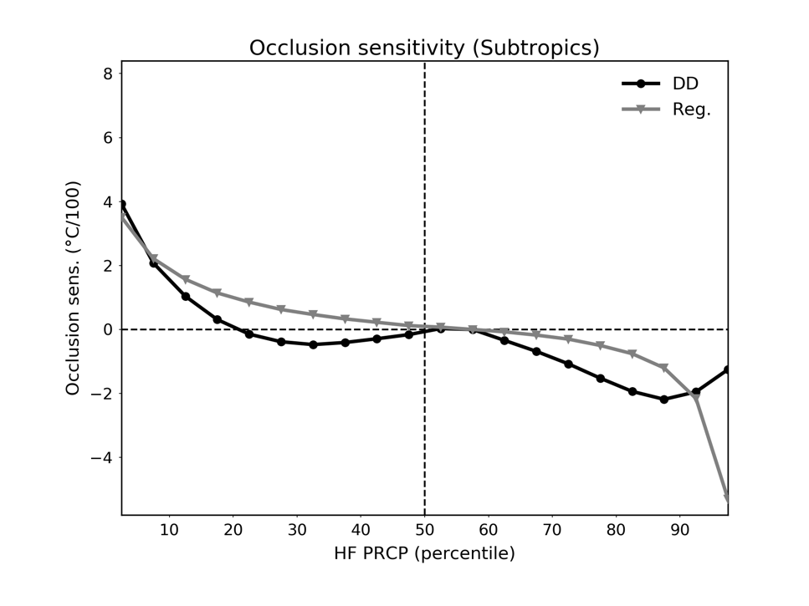
Extended Data Figure 10. Subtropical drying captured in the DD model. The occlusion sensitivity (ºC/100) with respect to the percentile of the high-frequency (i.e., 10 day high-pass filtered) precipiation anomalies in the DD model (black), and the ridge regression model (gray) in the subtropical Atlantic (40-0ºW, 20-35ºN) and southeastern Pacific (110-80ºW, 35-20ºS).

