Appendix 1. Recommendations in Vietnamese before the surgery: Do NOT remove patient hair, or if absolutely necessary; remove with a clipper, do not shave; Patient bathes or showers prior to surgery with either plain or antimicrobial soap.
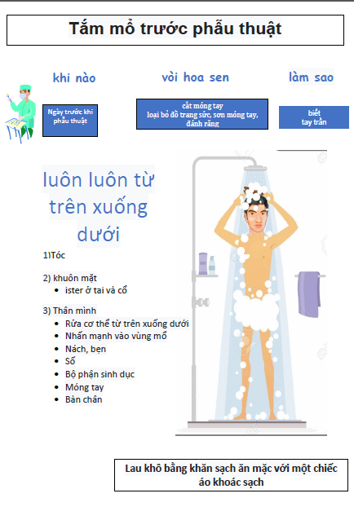
Appendix 2. A sterile set for skin preparation implemented in operatory room including, the antiseptic (yellow bottle), the soap (pink bottle), the sterile water (clear bottle), the gloves and three cups for skin preparation. The sterile wipe are not present in the picture.
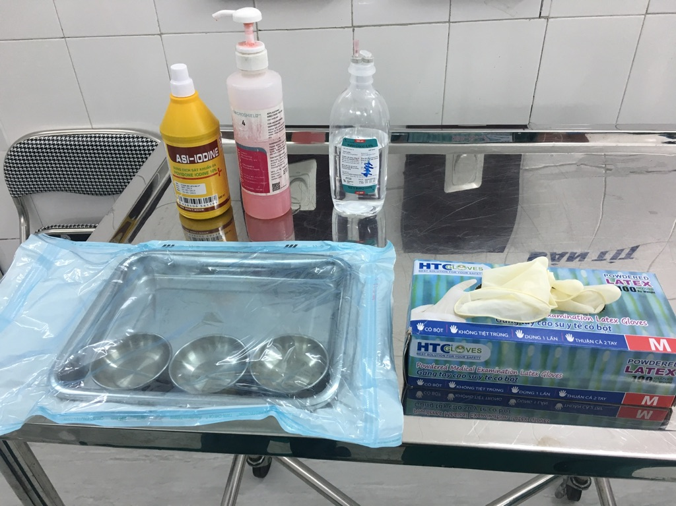

Appendix 3. Assessment of the preoperative skin preparation.
Record ID

Date……………………….. Auditor………………………………..
Surgical specialty:
- Orthopedic
- Digestive
- Vascular
- Urology
- Ophthalmology
- Oral Surgery
- Plastic surgery
- Neurosurgery

Number of surgical room:

Patient name: Sex: Age:

Kind of surgery:
- Programmed
- Programmed (<24h)
- Emergency

Intervention
- Hip prosthesis
- Knee prosthesis
- Osteosynthesis material
- Other

Septic surgery
- Yes No

Depilation // Preoperative washing
Has the patient undergone depilation?
- Yes
- No
- Not necessary

Where was this depilation performed?
- At home
- In service
- Operating room
- Preparation room

How was it done?
- Clipper
- Chemical depilation
- Shaver
- Other:

Did the patient have a pre-operative shower?
- Yes No

When?
- The day before
- The morning

Before skin preparation
How was hand hygiene performed before wearing gloves?
- Completed and compliant
- Completed but not compliant
- Not carried out

Debridement
How was debridement carried out on the operating site?
- With non-sterile gloves
- With sterile gloves
Which product was used?
- PVPI scrub
- Chlorhexidine scrub
- Mild soap
- Other
Was rinsing performed?
- Yes No
Was drying performed?
- Yes No
Were gloves changed after cleaning?
- Yes No
How was hand hygiene performed upon removing gloves?
- Completed and compliant
- Completed but not compliant
- Not carried out

Antiseptis
Were sterile gloves used for the first antiseptic application of the operating?
- Yes No
Who performed the first antiseptic application?
- Surgeon
- Operating aid
- Instrumentalist / Nurse
- Circulating
Which product was used?
- PVPI
- Alcoholic PVPI
- Alcoholic chlorhexidine
- Other
Was the drying time respected?
- <30 seconds
- >30 seconds
Was the wide operative field respected?
- Yes No
Who performed the second antiseptic application?
- Surgeon
- Operating aid
- Instrumentalist / Nurse
- Circulating
Was the second antiseptic application performed?
- Yes No
Were sterile gloves used for the second antiseptic application?
- Yes No
Which product was used?
Povidone iodine
Povidone iodine alcohol
Chlorhexidine alcohol
Other antiseptic
Was drying time respected?
<30 seconds
> 30 seconds
Did the antiseptic drips be noticed?
- Yes No

Appendix 4: A perioperative checklist assessed the preoperative shower, the medical and surgical treatment and clinical data
Appendix 4 : Vietnamese version
Ngày:
Chuẩn bị mổ ngày:
- Giải thích bệnh nhân và gia đình
- Ký cam đoan mổ
- Hoàn thiện hồ sơ xét nghiêm
- Vệ sinh vùng mổ
- Thụt tháo phân nếu cần: - Có - Khong
- Ngủ sớm, nhịn ăn sáng ngay phẫu thuật
- Khám tiền mê trước phẫu thuật
- Đo Mạch, nhiệt độ, huyết áp sáng ngày phẫu thuật
- …….
Appendix 4B : English version
Date:
Date of surgery :
- Explain to patient and family
- Sign a commitment to surgery
- Completing the examination file
- Cleaning the surgical area
- Enema if necessary: ​​Yes No
- Sleep early, fast for breakfast right after surgery
- Pre-surgery pre-anesthesia examination
- Measure pulse, temperature, blood pressure on the morning of surgery
- ….

