A contextual association between malaria and urbanization: Temporal and spatial analysis in Ghana

Merveille Koissi Savi, Bhartendu Pandey, Anshuman Swain, Jeongki Lim, Daniel Callo-Concha, Mohammed Wahjib, Christian Borgemeister

S1. Text : Data and statistical analyses
Data

Census and satellite data
Due to differences in the number of districts over time, we merged the two datasets using spatial join and spatial intersection tools in QGIS. To correct for differences in the number of districts, we calculated a weighted average of population counts for each district, where built intensities for the year 2014 (built area/tota area) derived from the Global Human Settlement Layer (GHSL) were used as weights¹. This approach yielded a combined spatially explicit census and clinical malaria cases dataset. In further analysis, we assumed that the cross-sectional distribution of population counts and urbanization levels did not significantly change since the last population census.
For each district, we calculated the total built area (km²) and built intensity (built area/total area) as two additional measures of urbanization.

Statistical analysis
Malaria incidence across space, time, and socio-demographic groups
We fit a single-level model, also denoted unconditional means model, (Eq. 1) to estimate the overall incidence during the period of data collection for the period of 2015-2018. Here we evaluated the proportion of variation in the incidence due to the location using the intraclass correlation coefficient (ICC).
(1)
where I is the malaria incidence of the district i (i=1, …, 216) for the year j (j=2015,…, 2018), is the average incidence across districts, and is the residual for a specific district and year (difference between the mean value of incidence and the observed value).
We extended the single-level to a two-level model, also known as the unconditional growth model (Eq. 2), where the effect of time (random effect) was measured as nested to the district. We computed the ICC of the unconditional growth model, to malaria incidence way across time and location (district).
(2)
Where represents the average incidence per year associated with the fixed effect. the variation due to the district is considered as the random effect together with the residual of the model. Both are the random effects of the models assumed to be independent and identically distributed, i.e. assumed to follow a normal distribution with the mean 0 and variance, respectively and
We further extended the previous model to a three-level model while adding sex (dummy variable) and age groups (with eleven levels) as fixed effects to compare and contrast the effect of sex and age on malaria incidence. in Eq. 3 becomes
(3)
where represents the average incidence associated with either sex or age; the effects associated with either the sex at the location or the age group on the location. We selected the better-fit model between the additive and multiplicative using a chi-square test where the additive model was the best fit. Similarly, we used the same test to select the better-fit structure of the matrix of variances-covariance for both the residual and the random components of the model (Eq. 3). Then, the matrix of variances-covariance of residuals selected was the first-order autoregressive indicating that the correlation between two observations gets weaker as the distance between them increases, whereas, the unstructured matrix fitted better for the random effects, indicating that there is no constraint across random effects. The statistical difference between socio-demographic groups and location was visualized using histograms and maps. To examine the statistical difference across years, we decomposed malaria incidence time-series using an additive decomposition into seasonality, trend, and remainder components, also denoted seasonal-trend decomposition using LOESS (STL)⁴.
To check the consistency in the spatial structuring of malaria incidence, we computed the Global Moran’s I statistic using the Queen’s contiguity matrix (Eq. 4).
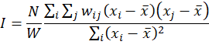 (4)
where$N$is the number of districts, $x$ the incidence of malaria, their mean, $w_{ij}$ the Queen’s contiguity matrix (where $w_{ij}= 0$), and $W$ the sum of all $w_{ij}$.
Contextual association between malaria incidence and urbanization
The clusters of incidences were defined using k-means of district-level data on median monthly incidence across various age and sex groups. The number of clusters and their membership (districts) was optimized using the Bayesian Information Criterion (BIC). The outcome was used for a cluster-specific RF, i.e., RF regression of health and hygiene and education (mortality of children under five, the proportion of literate men and women, the rate of immunization, the proportion of insecticide-treated bed-net possession, the proportion of households that lack toilet facilities, and the proportion of household using an improved water source), environmental (rainfall, and vegetation coverage) and urbanization measures against median monthly malaria incidence. Each RF regression was done using 10,000 trees to identify which parameters are the strongest predictors of malaria incidence. We optimized the number of parameters available for splitting at each tree node in the RF using out-of-box error (OBE).

S2. Tables and figures
Table 1. Distribution of malaria median incidence from 2015-2018 per region in Ghana

Region | Median | Mean | Standard deviation
Ashanti | 12.952 | 22.489 | 28.188
Brong Ahafo | 20.359 | 36.111 | 44.424
Central | 17.663 | 28.034 | 29.580
Eastern | 17.042 | 27.519 | 28.847
Greater Accra | 9.477 | 16.272 | 21.100
Northern | 6.318 | 14.735 | 24.912
Upper East | 18.746 | 39.661 | 58.977
Upper West | 12.525 | 22.694 | 28.685
Volta | 10.598 | 17.703 | 19.330
Western | 20.359 | 36.342 | 44.399

Fig. 1: Incidence decomposition showing the seasonality and the trend in each region and the overall country

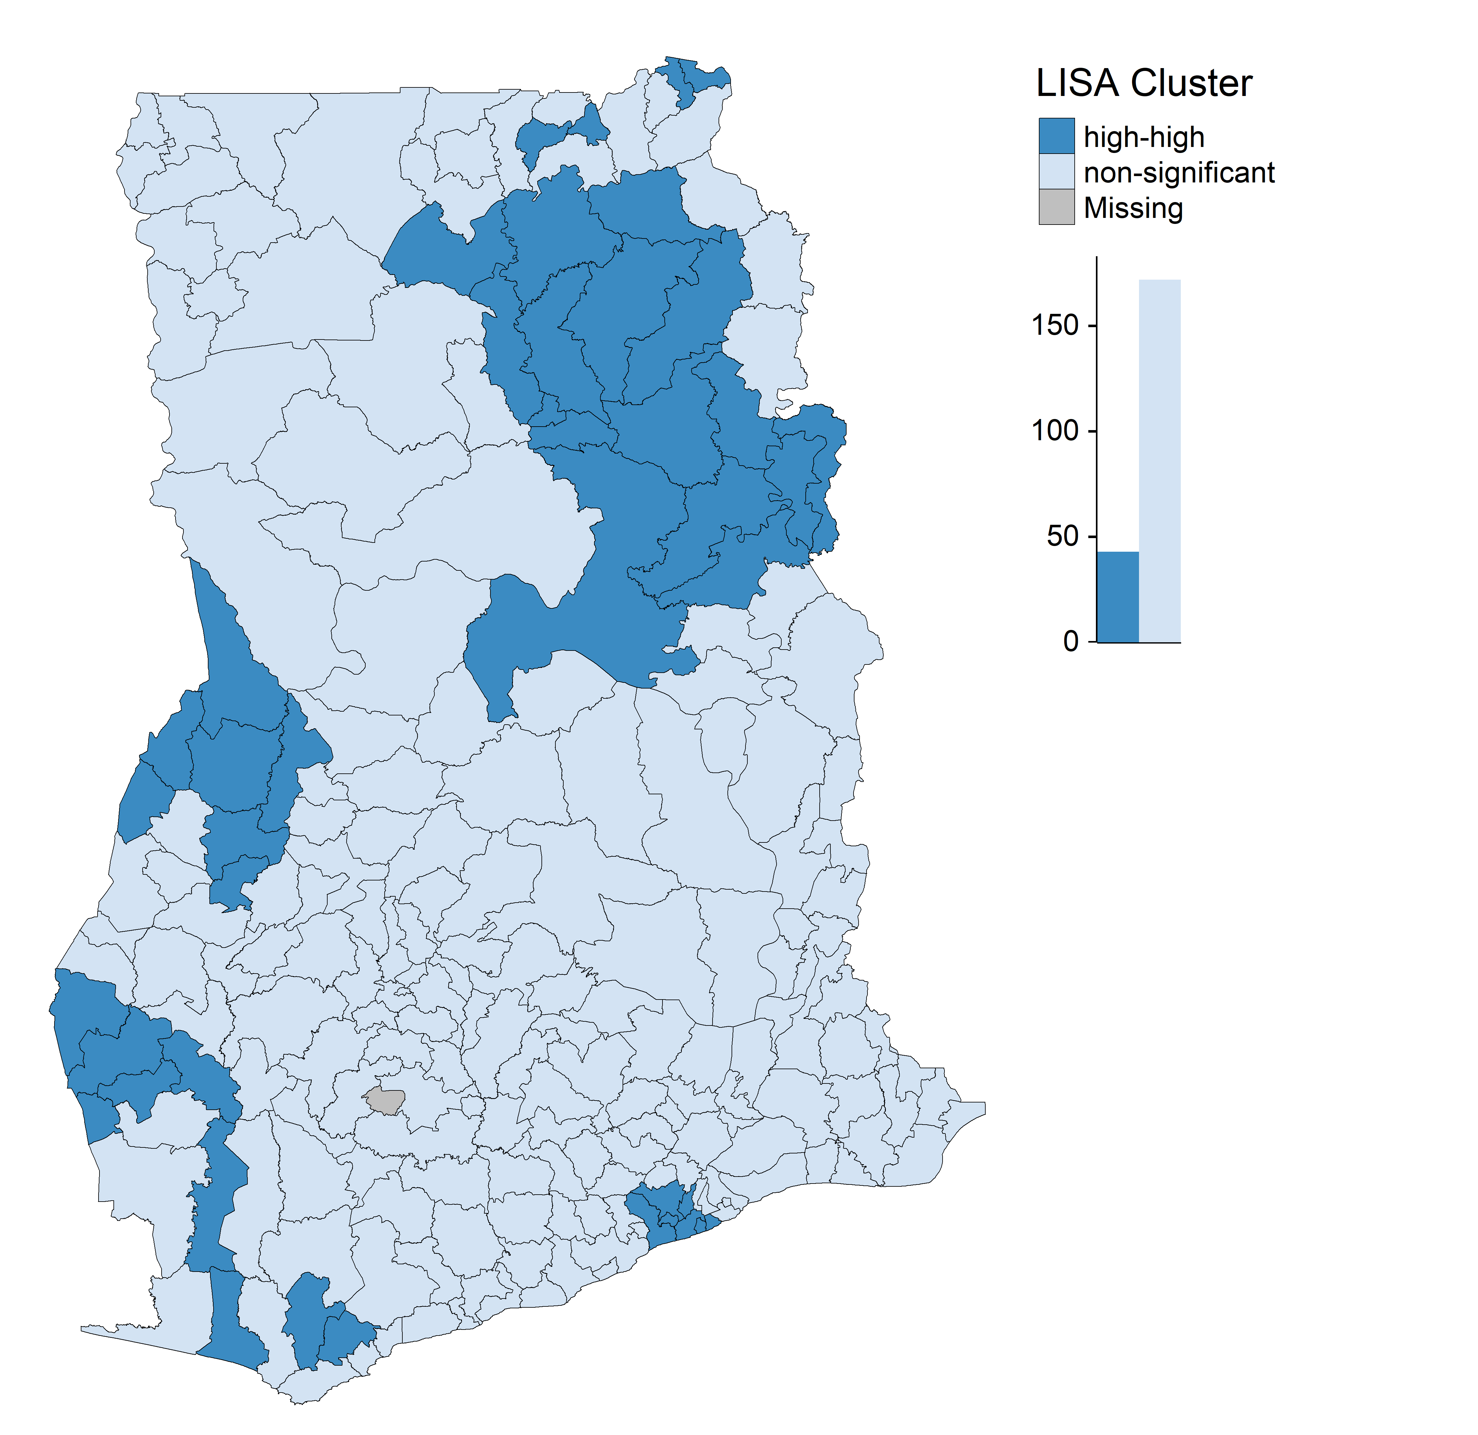
Fig. 2: Local Indicator of the spatial association cluster map
The following map (Fig. 4) projects the spatial location of the urban areas in Ghana. Based on the proxy of urbanization used the location of urban areas varied.
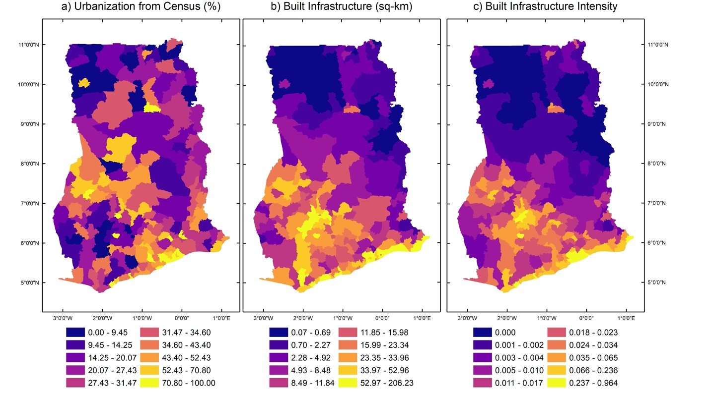
Fig. 3: Spatial repartition of urban areas according to the three definitions

Figure 4: Bayesian information criterion (BIC) values from k-means clustering for different numbers of components/clusters and for different multivariate mixture models of clustering. Legend reference:- "EII" spherical, equal volume; "VII" spherical, unequal volume; "EEI" diagonal, equal volume and shape; "VEI" diagonal, varying volume, equal shape; "EVI" diagonal, equal volume, varying shape; "VVI" diagonal, varying volume and shape; "EEE" ellipsoidal, equal volume, shape, and orientation; "EVE" ellipsoidal, equal volume and orientation; "VEE" ellipsoidal, equal shape and orientation; "VVE" ellipsoidal, equal orientation; "EEV" ellipsoidal, equal volume and equal shape; "VEV" ellipsoidal, equal shape; "EVV" ellipsoidal, equal volume; and "VVV" ellipsoidal, varying volume, shape, and orientation. Among these models, VEE model with 3 components/clusters performed the best.

References
1. Pesaresi, M. et al. A global human settlement layer from optical HR/VHR RS data: Concept and first results. IEEE J. Sel. Top. Appl. Earth Obs. Remote Sens. 6, 2102–2131 (2013).
2. GeoData Institute, U. of S. WorldPop population database. . (2020). Available at: https://www.worldpop.org/geodata. (Accessed: 11th November 2020)
3. USAID. Demographics and Health Survey: Spatial Data Repository - Modeled Surfaces. (2015). Available at: https://spatialdata.dhsprogram.com/modeled-surfaces/#survey=GH%7C2014%7CDHS. (Accessed: 11th November 2020)
4. Cleveland, R. B., Cleveland, W. S. & Terpenning, I. STL: A Seasonal-Trend Decomposition Procedure Based on Loess - ProQuest. J. Off. Stat. 6, 3–73 (1990).

