Extended Data Fig. 1 | Key data filtering steps to determine species Likely threatened by international trade on the Red List and of those species which are, and are not, included in CITES.
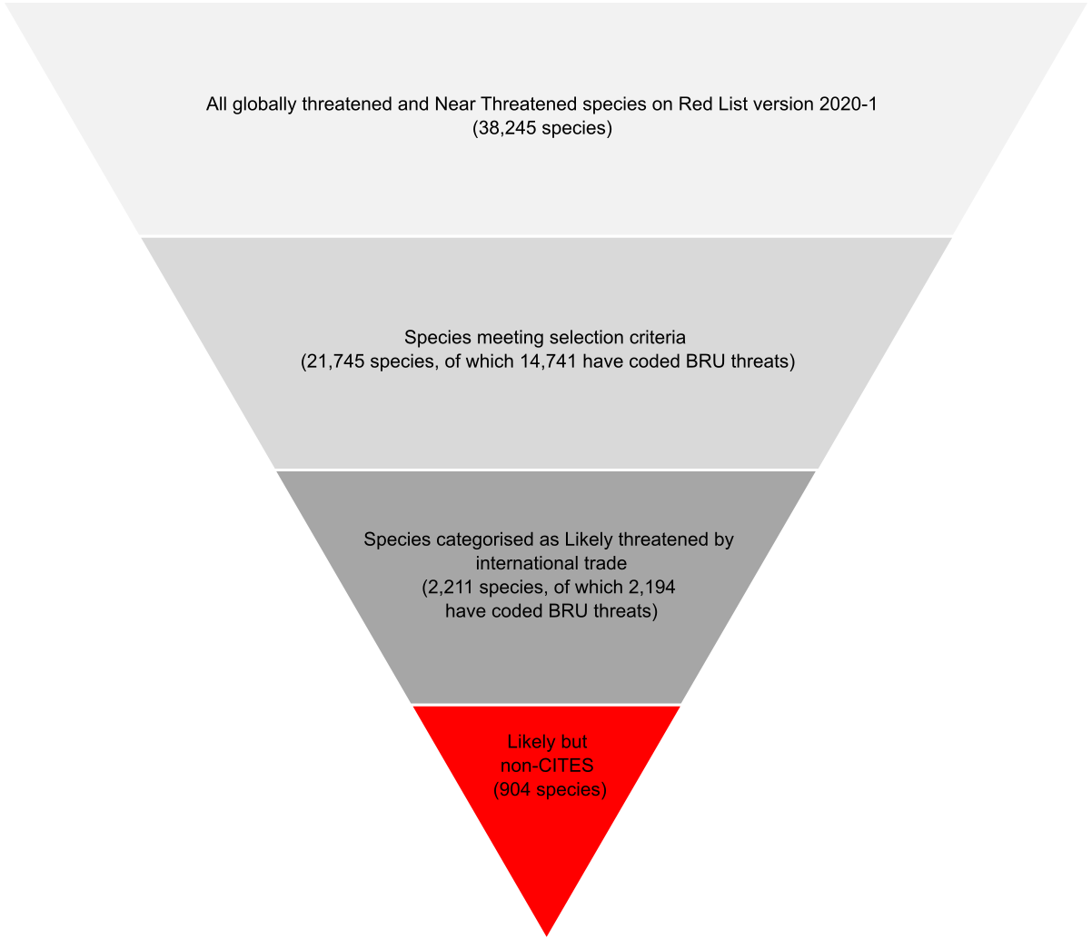

Extended Data Table 1 | Number of threatened and Near Threatened species in categories Likely, Insufficient information and Unlikely.
Class | Total species | Category
Class | Total species | Likely | Insufficient  information | Unlikely
Actinopterygii | 2007 | 260 | 632 | 1115
Agaricomycetes | 65 |  | 3 | 62
Amphibia | 1640 | 97 | 88 | 1455
Andreaeopsida | 1 |  |  | 1
Anthocerotopsida | 1 |  |  | 1
Anthozoa | 404 | 200 | 199 | 5
Arachnida | 42 | 18 | 1 | 23
Arthoniomycetes | 1 |  |  | 1
Aves | 1423 | 202 | 335 | 886
Bivalvia | 101 | 2 | 15 | 84
Branchiopoda | 2 |  |  | 2
Bryopsida | 81 |  | 17 | 64
Cephalaspidomorphi | 1 |  |  | 1
Cephalopoda | 7 | 1 | 1 | 5
Chondrichthyes | 317 | 129 | 114 | 74
Clitellata | 34 |  | 32 | 2
Cycadopsida | 225 | 106 | 108 | 11
Diplopoda | 55 |  |  | 55
Enopla | 1 |  |  | 1
Entognatha | 1 |  |  | 1
Florideophyceae | 9 |  |  | 9
Gastropoda | 1078 | 43 | 148 | 887
Ginkgoopsida | 1 |  | 1
Gnetopsida | 10 | 2 | 4 | 4
Holothuroidea | 16 | 11 | 4 | 1
Hydrozoa | 6 | 6
Insecta | 881 | 15 | 103 | 763
Jungermanniopsida | 35 |  | 2 | 33
Lecanoromycetes | 12 |  | 6 | 6
Leotiomycetes | 1 |  |  | 1
Liliopsida | 2150 | 343 | 839 | 968
Lycopodiopsida | 17 |  | 2 | 15
Magnoliopsida | 7745 | 402 | 3267 | 4076
Malacostraca | 299 | 20 | 95 | 184
Mammalia | 1189 | 134 | 169 | 886
Marchantiopsida | 3 |  |  | 3
Merostomata | 2 | 1 | 1
Myxini | 8 | 1 | 4 | 3
Onychophora | 4 |  | 2 | 2
Pezizomycetes | 2 |  |  | 2
Phaeophyceae | 5 |  |  | 5
Pinopsida | 254 | 22 | 72 | 160
Polypodiopsida | 126 |  | 29 | 97
Polytrichopsida | 1 |  |  | 1
Reptilia | 1477 | 196 | 289 | 992
Sarcopterygii | 2 |  | 1 | 1
Sordariomycetes | 1 |  |  | 1
Sphagnopsida | 2 |  |  | 2
TOTAL | 21,745 | 2,211 | 6,583 | 12,951

Extended Data Fig. 2 | Number of species in categories Likely (L), Insufficient Information (I) and Unlikely (U) by Red List Category. CR=Critically Endangered, EN=Endangered, VU=Vulnerable, NT=Near Threatened.
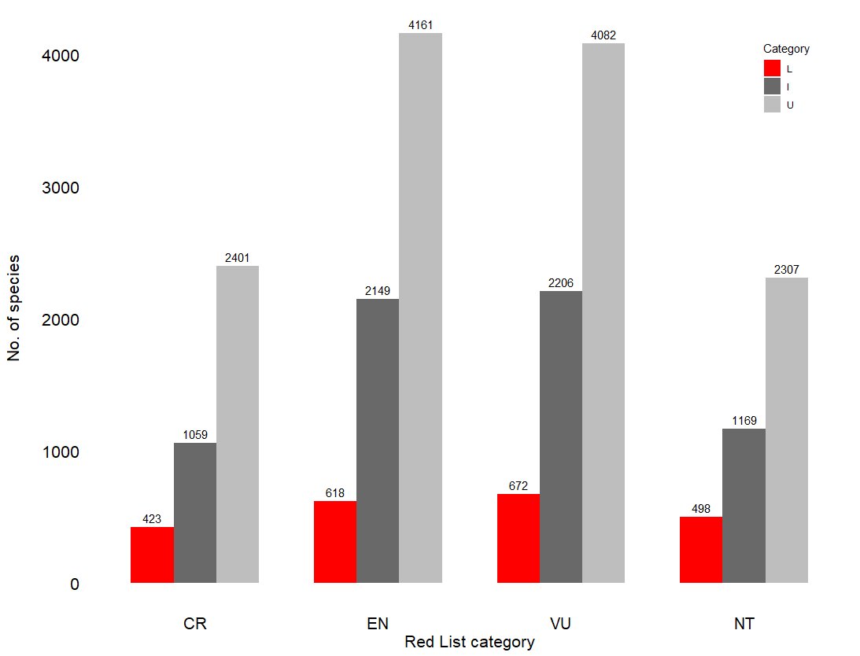

Extended Data Table 2 | Number of species in each class categorised as Likely threatened by international trade included in the three CITES Appendices and not included in CITES.
Class | Species Likely threatened by international trade |  |  | CITES status
Class | Species Likely threatened by international trade | Appendix I | Appendix II |  | Appendix I/II | Appendix III | Non-CITES
Actinopterygii | 260 | 3 | 26 |  |  |  | 231
Amphibia | 97 | 2 | 37 |  |  | 3 | 55
Anthozoa | 200 |  | 200
Arachnida | 18 |  | 14 |  |  |  | 4
Aves | 202 | 49 | 85 |  |  | 5 | 63
Bivalvia | 2 |  |  |  |  |  | 2
Cephalopoda | 1 |  |  |  |  |  | 1
Chondrichthyes | 129 | 3 | 37 |  |  |  | 89
Cycadopsida | 106 | 53 | 53
Gastropoda | 43 |  | 1 |  |  |  | 42
Gnetopsida | 2 |  |  |  |  |  | 2
Holothuroidea | 11 |  | 3 |  |  | 1 | 7
Hydrozoa | 6 |  | 6
Insecta | 15 | 1 | 10 |  |  |  | 4
Liliopsida | 343 | 100 | 147 |  |  |  | 96
Magnoliopsida | 402 | 33 | 181 |  |  |  | 188
Malacostraca | 20 |  |  |  |  |  | 20
Mammalia | 134 | 74 | 38 |  | 4 | 6 | 20
Merostomata | 1 |  |  |  |  |  | 1
Myxini | 1 |  |  |  |  |  | 1
Pinopsida | 22 | 1 | 4 |  |  |  | 17
Reptilia | 196 | 29 | 97 |  | 1 | 10 | 61
TOTAL | 2,211 | 343 | 934 |  | 5 | 25 | 904

Extended Data Table 3 | Number and Red List Category of species in each class categorised as Likely threatened by international trade and included in CITES.
Class | Total species | Red List Category
Class | Total species | Critically Endangered | Endangered | Vulnerable | Near Threatened
Actinopterygii | 29 | 13 | 3 | 12 | 1
Amphibia | 42 | 4 | 14 | 19 | 5
Anthozoa | 200 |  | 8 | 92 | 100
Arachnida | 14 | 2 | 6 | 2 | 4
Aves | 139 | 18 | 34 | 43 | 44
Chondrichthyes | 40 | 20 | 10 | 9 | 1
Cycadopsida | 106 | 27 | 35 | 28 | 16
Gastropoda | 1 |  |  |  | 1
Holothuroidea | 4 |  | 3 | 1
Hydrozoa | 6 | 1 | 2 | 2 | 1
Insecta | 11 |  | 2 | 3 | 6
Liliopsida | 247 | 95 | 104 | 35 | 13
Magnoliopsida | 214 | 55 | 74 | 63 | 22
Mammalia | 114 | 23 | 35 | 43 | 13
Pinopsida | 5 | 1 | 3 | 1
Reptilia | 135 | 36 | 43 | 39 | 17
TOTAL | 1307 | 295 | 376 | 392 | 244

Extended Data Table 4 | Number and Red List Category of species in each class categorised as Likely threatened by international trade but not included in CITES.
Class | Total species | Red List Category
Class | Total species | Critically Endangered | Endangered | Vulnerable | Near Threatened
Actinopterygii | 231 | 25 | 56 | 68 | 82
Amphibia | 55 | 6 | 19 | 15 | 15
Arachnida | 4 |  | 1 | 2 | 1
Aves | 63 | 6 | 7 | 25 | 25
Bivalvia | 2 | 1 | 1
Cephalopoda | 1 |  |  | 1
Chondrichthyes | 89 | 7 | 18 | 29 | 35
Gastropoda | 42 | 6 | 17 | 8 | 11
Gnetopsida | 2 |  |  |  | 2
Holothuroidea | 7 |  | 4 | 3
Insecta | 4 |  | 3 |  | 1
Liliopsida | 96 | 30 | 26 | 26 | 14
Magnoliopsida | 188 | 27 | 57 | 66 | 38
Malacostraca | 20 | 11 | 7 | 2
Mammalia | 20 |  | 7 | 6 | 7
Merostomata | 1 |  |  | 1
Myxini | 1 |  |  |  | 1
Pinopsida | 17 | 1 | 2 | 7 | 7
Reptilia | 61 | 8 | 17 | 21 | 15
TOTAL | 904 | 128 | 242 | 280 | 254

Extended Data Fig. 3 | Threatened and Near Threatened species categorised as Likely threatened by international trade (red) as a proportion of species in these Red List categories with intentional BRU threats coded (grey), by class. Numbers in parentheses are species Likely threatened by international trade. Excludes 118 species Likely threatened by international trade that do not have BRU threats coded (17 species) or intentional BRU threats coded (101 species).
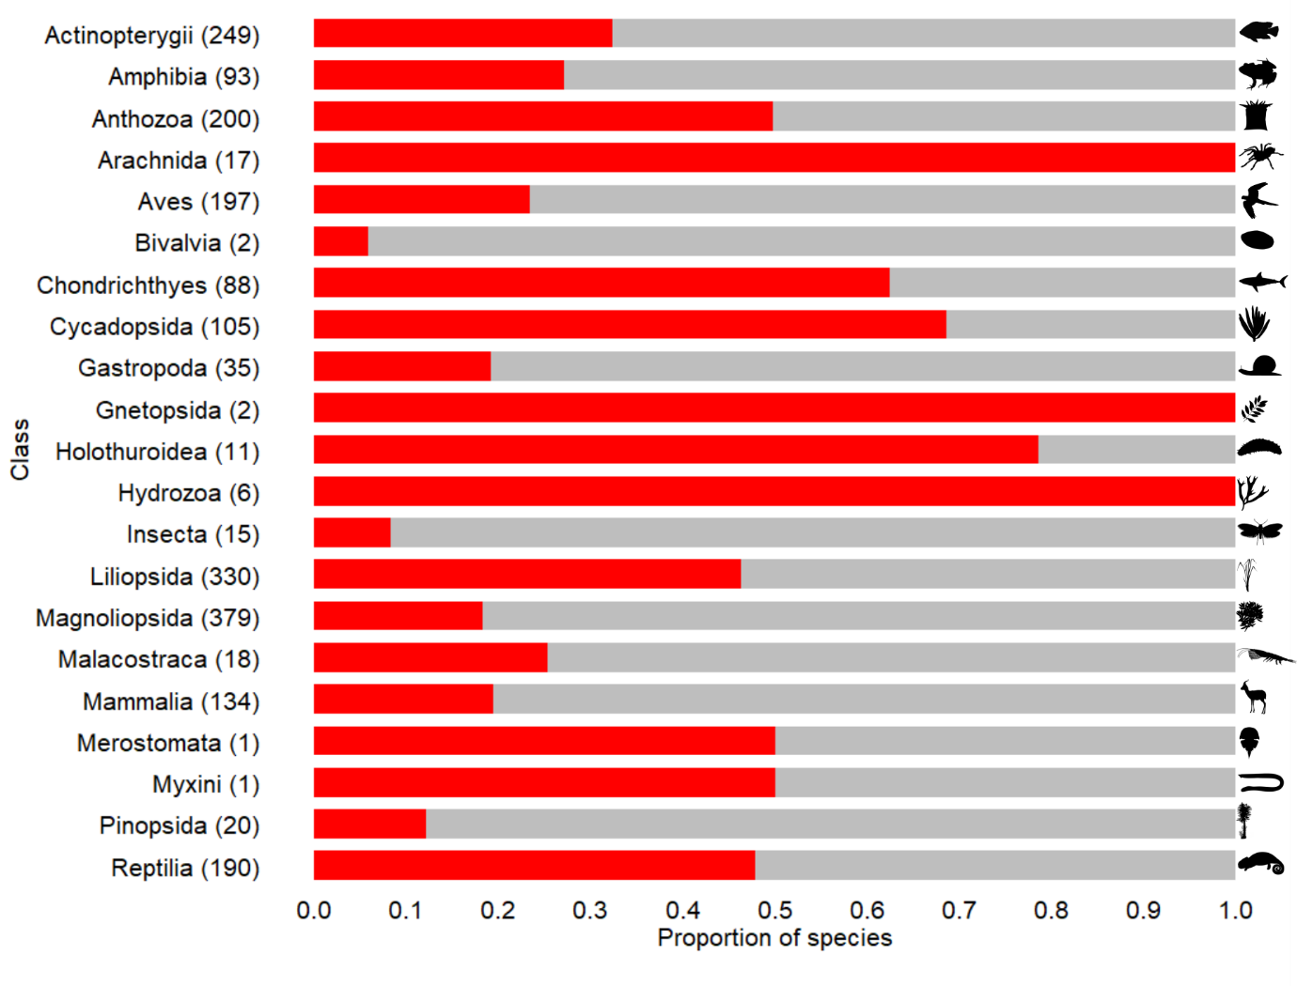

Extended Data Fig. 4 | Decision tree for automated coding of species.
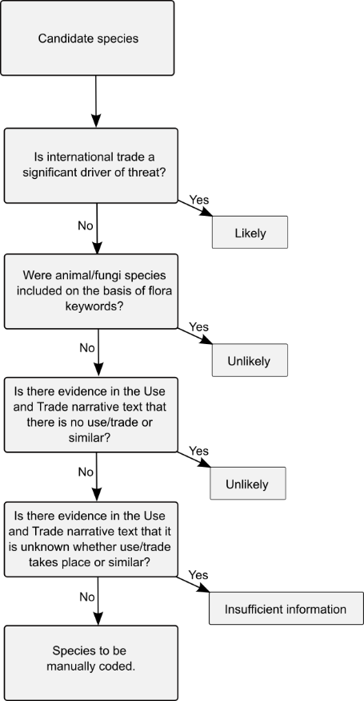

Extended Data Fig. 5 | Decision tree for manual coding of species.
