Supplementary Materials

ANGPTL4 is a potential driver of HCV-induced peripheral insulin resistance
Diana Gomes, Cyril Sobolewski, Stéphanie Conzelmann, Tifany Schaer, Etienne Lefai, Dulce Alfaiate, Eirini Tseligka, Nicolas Goossens, Francesco Negro, Michelangelo Foti and Sophie Clément
Table of Contents
I- Supplementary materials and methods 3
Antibodies, primers, plasmids and reagent 3
Primary and secondary antibodies 3
Human and mouse PCR primers 3
Plasmids and constructs 4
Specific reagents 4
II- Supplementary Figure 5
Supplementary Figure S1 5
Supplementary Figure S2 6
Supplementary Figure S3 7
Supplementary Figure S4 8
Supplementary Figure S5 9
Supplementary Figure S5 Cont. 10
Supplementary Figure S6 12
Supplementary Figure S6 Cont. 13
Supplementary Figure S6 Cont. 14
Supplementary Figure S7 15
Supplementary Figure S8 16
Supplementary Figure S9 17
III- Supplementary references 18

I- Supplementary materials and methods

Antibodies, primers, plasmids and reagent

Primary and secondary antibodies
Targeted protein | Host | Clone | Provider
pAkt Ser473 | Rabbit | 193H12 | Cell signaling
pAkt Thr308 | Rabbit | C31E5E | Cell signaling
Akt2 | Rabbit | 5B5 | Cell signaling
HCV-core | Mouse | C7-50 | Covalab (Lyon France)
β-cytoplasmic actin | Mouse | C4 | A gift from C. Chaponnier, Geneva, Switzerland
GFP | Rabbit | D5.1 | Cell signaling
HRP-conjugated anti-mouse | Goat |  | Bio-Rad Laboratories AG (Cressier, Switzerland)
HRP-conjugated anti-rabbit | Goat |  | Bio-Rad Laboratories AG (Cressier, Switzerland)

Human and mouse PCR primers
Primers | Forward | Reverse
Human ANGPTL4 | agcctgcagacacaactcaa | ctaggtgcttgtggtccagg
Human ANGPTL6 | GATGGCTTCTCCCTGGAACC | ACAGGGCACAGTTACCAGAA
Human Vaspin | GCCAGGTGGAAACATGAGTT | CCCTCATCAGGAAGGATGAA
Human IGFBP7 | ATCCCGACACCTGTCCTCAT | CCCAGCCAGTTACTTCATGCT
Human Chemerin | AACTGGGCTCTGAGGACAAA | CTTGGAGAAGGCGAACTGTC
Human Visfatin | ggccacaaattctAGAGAGCAG | ccaagtGagcagaTgctcctat
Human SEPP1 | GCACCRRGGCAGCAGTGAGCTT | ATGAAGGCCTGGAGGAGCAGGA
Human EEF1A1 | AGCAAAAATGACCCACCAATG | GGCCTGGATGGTTCAGGATA
Mouse cyclophilin | CAAATGCTGGACCAAACACAA | GCCATCCAGCCATTCAGTCT
HCV-core | TCCTAAACCTCAAAGAAAAACCAAA | TCCTGTGGGCGGCG
Mouse ANGPTL4 | CAAAACAGCAAGATCCAGCA | CCTCTTTCCCCTCGAAGTCT
Primers for GeneArt® Genomic Cleavage Detection Kit | GCCTCAGCGGATGGAGATTT | AGGTGGACCTGACAAGGAGA

Plasmids and constructs
Plasmid name | Plasmid insert | Backbone | References/sources
pLenti-GFP / pLenti-HCV-3a core | GFP / HCV-2a core / HCV-3a core | 2K7 (Invitrogen AG, Basel Switzerland) | (1)
LentiCRISPRv2 | Cas9 |  | A gift from Feng Zhang, Addgene plasmid # 52961 (2)
pFK-J6/C3 (Jc1) | Full length HCV genotype 2a |  | A gift from R. Bartenschlager, Heidelberg, Germany (3)
pFK-H77/C3 | Full length HCV genotype 1a |  | A gift from R. Bartenschlager, Heidelberg, Germany (3)
pFK-JFH1/Con1 | Full length HCV genotype 1b |  | A gift from R. Bartenschlager, Heidelberg, Germany (3)
pFK-452/C6 | Full length HCV genotype 3a |  | A gift from R. Bartenschlager, Heidelberg, Germany (3)
pED43/JFH1γ(A2819G/A3269T) | Full length HCV genotype 4a |  | A gift from J. Bukh, Copenhagen, Denmark (4)

Specific reagents
Reagents | Company | Reference
GSK 0660 (PPARδ antagonist) | Tocris Bioscience | 1014691-61-2
SR 202 (PPARγ antagonist) | Tocris Bioscience | 76541-72-5
Rosiglitazone (PPARγ agonist) | Tocris Bioscience | 122320-73-4
Fenofibrate (PPARα agonist) | Tocris Bioscience | 49562-28-9
GW 501516 (PPARδ agonist) | Tocris Bioscience | 317318-70-0
Mifepristone (glucocorticoid receptor antagonist) | Tocris Bioscience | 84371-65-3
Dexamethasone | Sigma | D2915
Recombinant ANGPTL4 (full-length) | R&D systems | AF3485
Recombinant ANGPTL4 (c-terminal) | R&D systems | 3485-AN
Insulin Humalog | Lilly | VL7510
Ultrasensitive Mouse Insulin ELISA | Mercodia | 10-1249-01
Customized human magnetic luminex assay | R&D systems

II- Supplementary Figure

Supplementary Figure S1
HCV-mouse model characterization. (a) Adeno-associated virus serotype 8 (AAV8) vectors used in the study; (b) experimental design of mice injection (created with BioRender.com); (c) GFP immunohistochemical staining of liver, heart, pancreas and epididymal white adipose tissue (eWAT) of AAV8-3a infected mouse; (d) HCV-core RNA expression in liver and gastrocnemius of mice; (e) body weight and (f) blood glycemia and (g) plasma insulin in fed and fasting conditions.

Supplementary Figure S2
ANGPTL4 gene expression in each cell type of the liver. Publicly available data at Tabula muris, https://tabula-muris.ds.czbiohub.org/. t-SNE map and cell ontology class representation highlighting the expression of ANGPTL4 in the hepatocytes.

Supplementary Figure S3
(a) ANGPTL4 mRNA expression in Huh-7 cells transduced with either GFP or HCV‐3a core. (b) ANGPTL4 mRNA expression in Huh-7 cells transfected with different HCV intra- and intergenotypic chimeras.

Supplementary Figure S4
Characterization of ANGPTL4 KO HepG2 cell lines. (a) Sequence of the PCR amplified region encompassing the guide RNA target in exon 2 of human ANGPTL4 gene. The positions of the two primers (Fwd and Rv primers) used for PCR amplification are highlighted in blue. Exons 2 and 3 are shown in yellow. (b) Representative agarose gel showing that PCR products of the polyclonal pool of cells transduced with ANGPTL4 guide RNA display a cleavage band (red arrows), whereas DNA from Cas9 expressing cells (control) is not cleaved. (c) Sanger PRC chromatogram of one clone of KO cells (clone 2-3) showing a 6bp deletion when compared with the wildtype sequence. The corresponding amino acid sequence is shown below the nucleotide codon sequences. (d) ANGPTL4 secretory levels in non-edited (CTRL-Cas9) and edited (ANGPTL4 KO) HepG2 cells.

Supplementary Figure S5
a
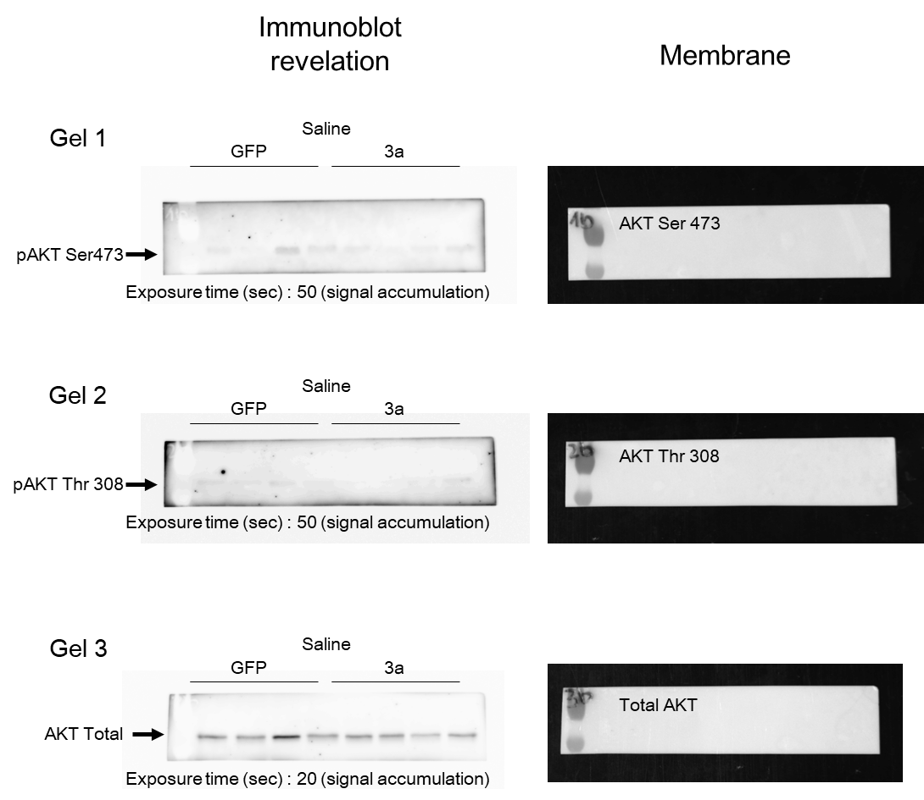

Supplementary Figure S5 Cont.
b
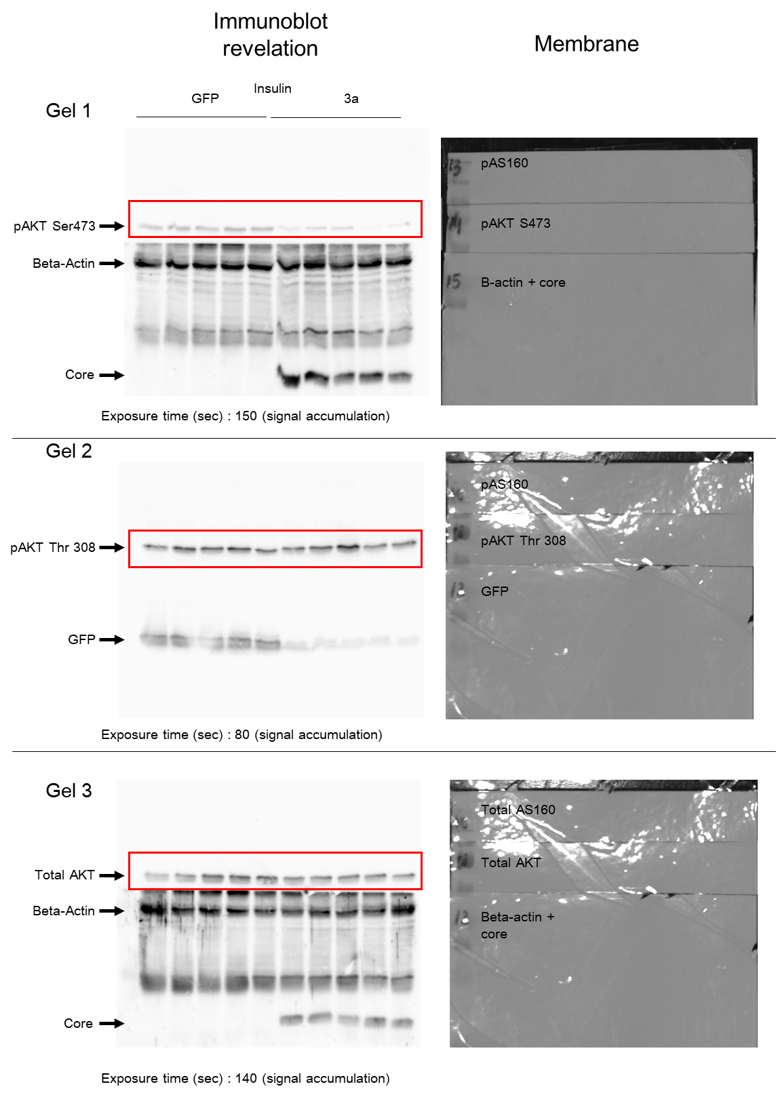
Full immunoblots related to Figure 2c. (a) Liver samples of mice treated with saline (0.9% NaCl) were loaded on 3 separate SDS-PAGE gels for Akt signaling analysis. Membranes were cut prior blotting with the different antibodies: total Akt, pAkt (Ser473 or Thr307). (b) Liver samples of mice challenged with insulin were loaded on 3 separate SDS-PAGE gels for Akt signaling analysis. Membranes were cut prior blotting with the different antibodies: total Akt, pAkt (Ser473 or Thr307), AS160, HCV-core, GFP and beta-actin. Beta-actin was used as loading control, and HCV-core and GFP antibodies were used to determine HCV-core and GFP expression levels induced by AAV8. Only the bands highlighted by a red rectangle are shown in the final figure.

Supplementary Figure S6
a

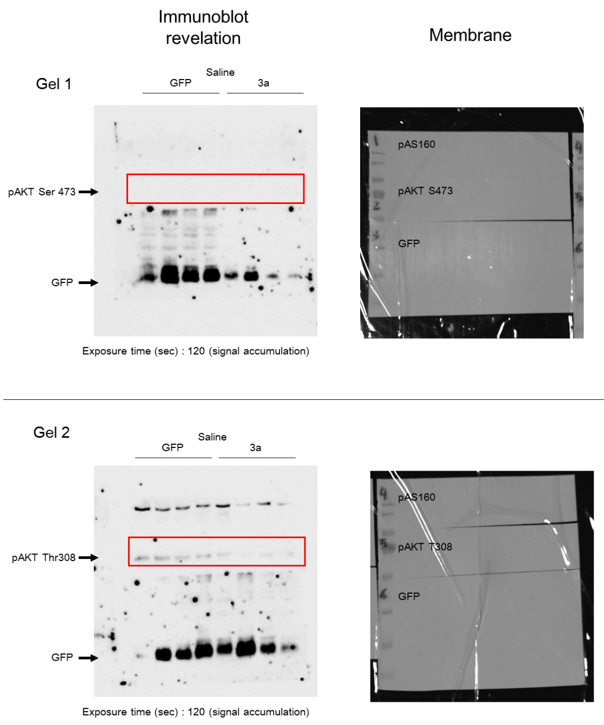

Supplementary Figure S6 Cont.
b
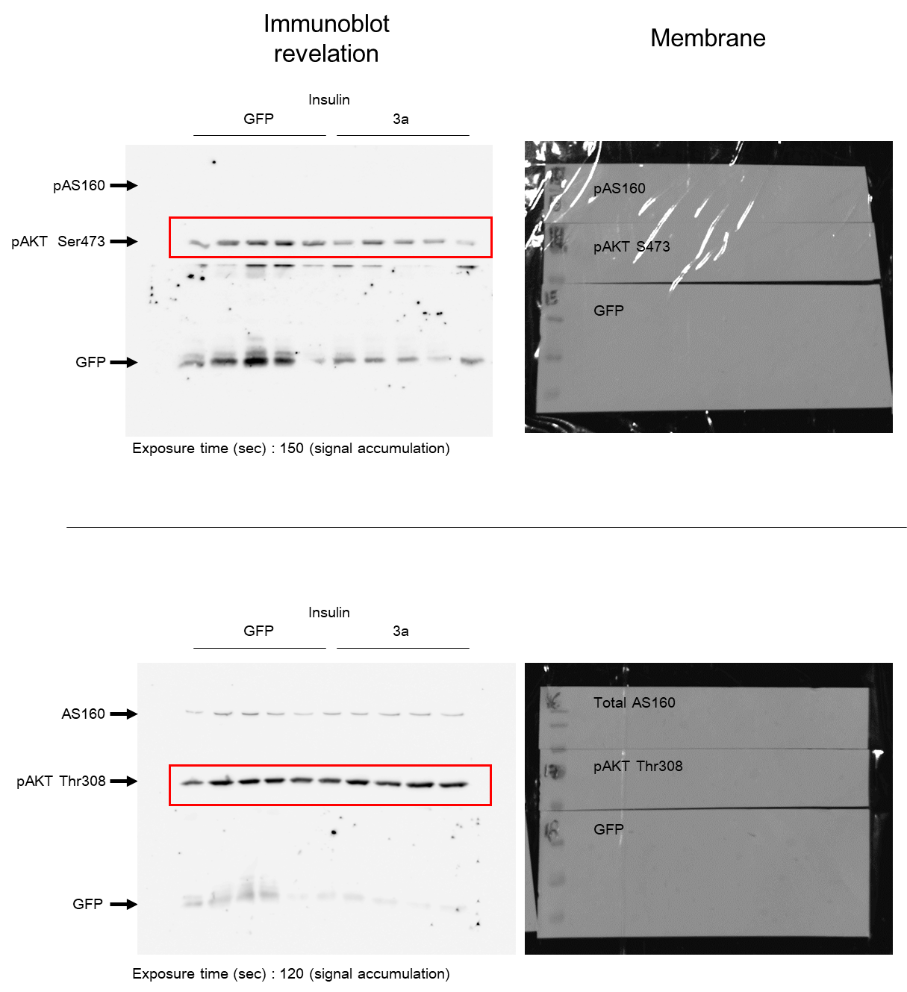

Supplementary Figure S6 Cont.
c
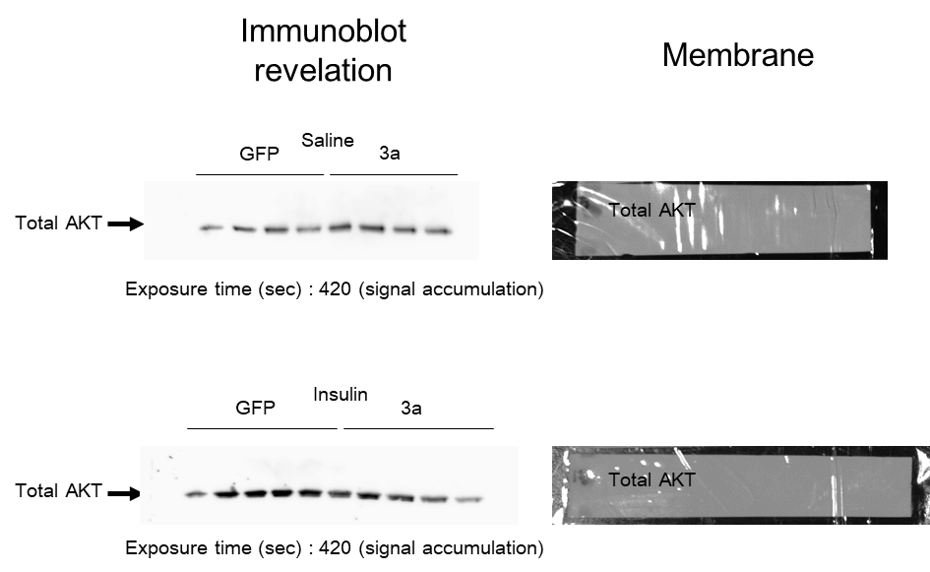

Full immunoblots related to Figure 2d. (a) Gastrocnemius samples of mice treated with saline (0.9% NaCl) were loaded on 2 separate SDS-PAGE gels for Akt signaling analysis. Membranes were cut prior blotting with the different antibodies: pAkt (Ser473 or Thr307) and GFP. GFP antibody was used to determine GFP expression levels induced by AAV8. Only the bands highlighted by a red rectangle are shown in the final figure. (b) Gastrocnemius samples of mice treated with insulin were loaded on 2 separate gels for Akt signaling analysis. Membranes were cut prior blotting with the different antibodies: Total AS160, pAS160, pAkt (Ser473 or Thr307) and GFP. GFP antibody was used to determine GFP expression levels induced by AAV8. Only the bands highlighted by a red rectangle are shown in the final figure. (c) Total Akt levels in gastrocnemius samples of mice treated with saline or insulin were assessed after stripping and reblotting of pAkt membranes with an antibody specific to total Akt.

Supplementary Figure S7

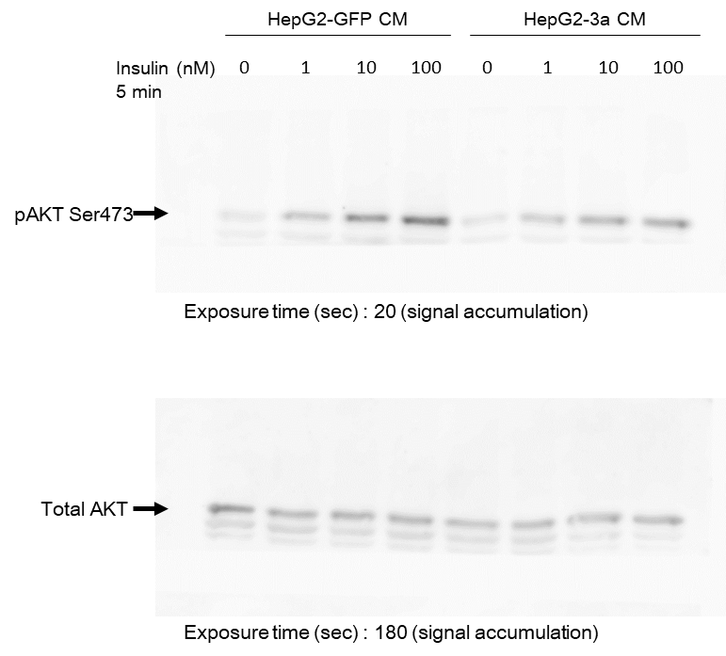

Full immunoblots related to Figure 3b. Lysates of C2C12 cells incubated with conditioned media (CM) from HepG2-GFP and HepG2-3a and treated with different concentrations of insulin for 5 minutes were loaded on 2 separate SDS-PAGE gels. Membranes were cut prior blotting with the different antibodies: Total Akt and pAkt Ser473.

Supplementary Figure S8

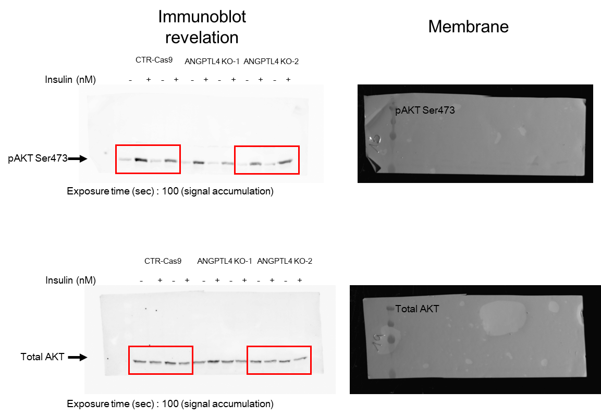

Full immunoblots related to Figure 3e. Samples of C2C12 cells treated with CM from non-edited (CTRL-Cas9) and edited (ANGPTL4 KO) HepG2 cells transduced with GFP or HCV-3a core were loaded on 2 separate SDS-PAGE gels. Membranes were cut prior blotting with the different antibodies: Total Akt and pAkt Ser473. Only the data of CTR-Cas9 and ANGPTL4 KO2 (guide RNA 2) were shown in the final figure as the editing with the guide RNA 1 was not efficient.

Supplementary Figure S9

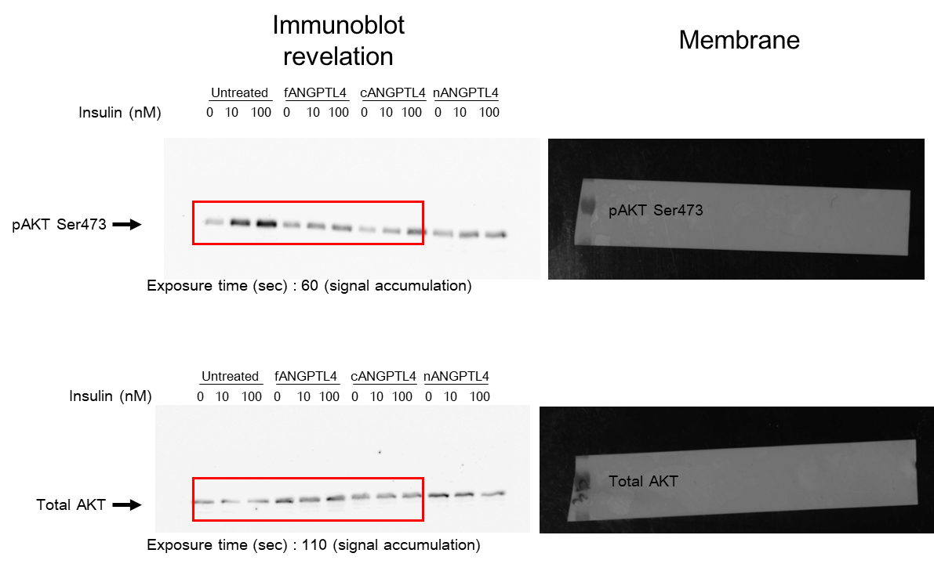

Full immunoblots related to Figure 3f. Lysates of human differentiated myocytes incubated with different forms of human recombinant ANGPTL4 (2.5µg/mL) and treated with different concentrations of insulin were loaded on 2 separate gels. Membranes were cut prior blotting with the different antibodies: Total Akt, pAkt Ser473. Results from nANGPTL4 were excluded from the final figure.

III- Supplementary references
1. Clement S, Pascarella S, Conzelmann S, Gonelle-Gispert C, Guilloux K, Negro F. The hepatitis C virus core protein indirectly induces alpha-smooth muscle actin expression in hepatic stellate cells via interleukin-8. J Hepatol 2010;52:635-643.
2. Sanjana NE, Shalem O, Zhang F. Improved vectors and genome-wide libraries for CRISPR screening. Nat Methods 2014;11:783-784.
3. Pietschmann T, Kaul A, Koutsoudakis G, Shavinskaya A, Kallis S, Steinmann E, Abid K, et al. Construction and characterization of infectious intragenotypic and intergenotypic hepatitis C virus chimeras. Proc Natl Acad Sci U S A 2006;103:7408-7413.
4. Scheel TK, Gottwein JM, Jensen TB, Prentoe JC, Hoegh AM, Alter HJ, Eugen-Olsen J, et al. Development of JFH1-based cell culture systems for hepatitis C virus genotype 4a and evidence for cross-genotype neutralization. Proc Natl Acad Sci U S A 2008;105:997-1002.

