Supplemental Material

Simultaneous enhancement in electrical conductivity and Seebeck coefficient by single- to double-valley transition in a Dirac-like band

Yu Dai¹, Wenjiang Zhou¹, Hyun-Jung Kim², Qichen Song³, Xin Qian¹, Te-Huan Liu^{1,}*, and Ronggui Yang^{1,*}

¹School of Energy and Power Engineering, Huazhong University of Science and Technology, Wuhan, Hubei 430074, China.
²Peter Grünberg Institut and Institute for Advanced Simulation, Forschungszentrum Jülich and JARA, D-52425 Jülich, Germany
³Department of Chemistry and Chemical Biology, Harvard University, Cambridge, Massachusetts 02138, USA.

SI. The details of the tight-binding calculations
In this section, we present detailed information about the tight-binding analysis for the SnTe conduction-band transition. The full Hamiltonian matrix and the spin-orbit parts are referred to as Eq. (5) and Eq. (6) in the main text, respectively. The remaining unperturbed crystal Hamiltonian, h⁰, is given by
$${\text{h}}_{\text{νν}}^{\text{0}}\left(\text{k}\right)\text{ = }\left[\begin{matrix}{\text{h}}_{\text{ν}\text{_}\text{s}\text{, }\text{ν}\text{_}\text{s}}\left(\text{k}\right) & {\text{h}}_{\text{ν}\text{_}\text{s}\text{, }\text{ν}\text{_}\text{p}\text{x}}\left(\text{k}\right) & {\text{h}}_{\text{ν}\text{_}\text{s}\text{, }\text{ν}\text{_}\text{p}\text{y}}\left(\text{k}\right) & {\text{h}}_{\text{ν}\text{_}\text{s}\text{, }\text{ν}\text{_}\text{p}\text{z}}\left(\text{k}\right) \\ {\text{h}}_{\text{ν}\text{_}\text{p}\text{x}\text{, }\text{ν}\text{_}\text{s}}\left(\text{k}\right) & {\text{h}}_{\text{ν}\text{_}\text{p}\text{x}\text{, }\text{ν}\text{_}\text{p}\text{x}}\left(\text{k}\right) & {\text{h}}_{\text{ν}\text{_}\text{p}\text{x}\text{, }\text{ν}\text{_}\text{p}\text{y}}\left(\text{k}\right) & {\text{h}}_{\text{ν}\text{_}\text{p}\text{x}\text{, }\text{ν}\text{_}\text{p}\text{z}}\left(\text{k}\right) \\ {\text{h}}_{\text{ν}\text{_}\text{p}\text{y}\text{, }\text{ν}\text{_}\text{s}}\left(\text{k}\right) & {\text{h}}_{\text{ν}\text{_}\text{p}\text{y}\text{, }\text{ν}\text{_}\text{p}\text{x}}\left(\text{k}\right) & {\text{h}}_{\text{ν}\text{_}\text{p}\text{y}\text{, }\text{ν}\text{_}\text{p}\text{y}}\left(\text{k}\right) & {\text{h}}_{\text{ν}\text{_}\text{p}\text{y}\text{, }\text{ν}\text{_}\text{p}\text{z}}\left(\text{k}\right) \\ {\text{h}}_{\text{ν}\text{_}\text{p}\text{z}\text{, }\text{ν}\text{_}\text{s}}\left(\text{k}\right) & {\text{h}}_{\text{ν}\text{_}\text{p}\text{z}\text{, }\text{ν}\text{_}\text{p}\text{x}}\left(\text{k}\right) & {\text{h}}_{\text{ν}\text{_}\text{p}\text{z}\text{, }\text{ν}\text{_}\text{p}\text{y}}\left(\text{k}\right) & {\text{h}}_{\text{ν}\text{_}\text{p}\text{z}\text{, }\text{ν}\text{_}\text{p}\text{z}}\left(\text{k}\right)\end{matrix}\right]\text{,} \text{(S1)}$$
in which the matrix element ${\text{h}}_{\text{ν}\text{_}\text{α}\text{, }\text{ν}\text{_}\text{β}}$ can be calculated with
$${\text{h}}_{\text{ν}\text{_}\text{α}\text{, }\text{ν}\text{_}\text{β}}\left(\text{k}\right)\text{ = }\sum_{\text{R}}{{\text{t}}_{\text{ν}\text{_}\text{α}\text{,} \text{ν}\text{_}\text{β}}}\left(\text{R}\right){\text{e}}^{\text{i}\text{k}\text{∙}\text{R}}\text{, } \text{ (S2)}$$
where α (β) = $\left\{\text{s}\text{, }\text{p}\text{x}\text{, }\text{p}\text{y}\text{, }\text{p}\text{z}\right\}$, R is the vector connecting the α and β atomic orbital in real space. ${\text{t}}_{\text{ν}\text{_}\text{α}\text{,} \text{ν}\text{_}\text{β}}$ is the hopping integral, which is given by ${\text{t}}_{\text{ν}\text{_}\text{α}\text{, }\text{ν}\text{_}\text{β}}\left(\text{R}\right)\text{ = }\int{{\text{ϕ}}_{\text{ν}\text{_}\text{α}}^{\text{*}}}\left(\text{r}\right)\text{H}{\text{ϕ}}_{\text{ν}\text{_}\text{β}}\left(\text{r} - \text{R}\right)$, and ${\text{ϕ}}_{\text{ν}\text{_}\text{α}}\left(\text{r}\right)$ and ${\text{ϕ}}_{\text{ν}\text{_}\text{β}}(\text{r} - \text{R})$ are the atomic orbitals on the sites at the origin and R, respectively.
We use a non-orthogonal sp³ tight-binding Hamiltonian to perform the Slater-Koster (SK) fit. Thus, the full overlap Hamiltonian matrix is written as
$$\text{S}\left(\text{k}\right)=\left[\begin{aligned}{\text{s}}_{\text{aa}}^{\text{0}}\left(\text{k}\right) \\ {\text{s}}_{\text{ca}}^{\text{0}}\left(\text{k}\right) \\ \text{0} \\ \text{0} \end{aligned}\begin{aligned}{\text{s}}_{\text{a}\text{c}}^{\text{0}}\left(\text{k}\right) \\ {\text{s}}_{\text{cc}}^{\text{0}}\left(\text{k}\right) \\ \text{0} \\ \text{0}\end{aligned} \begin{aligned}\text{0} \\ \text{0} \\ {\text{s}}_{\text{aa}}^{\text{0}}\left(\text{k}\right) \\ {\text{s}}_{\text{ca}}^{\text{0}}\left(\text{k}\right)\end{aligned} \begin{aligned}\text{0} \\ \text{0} \\ {\text{s}}_{\text{a}\text{c}}^{\text{0}}\left(\text{k}\right) \\ {\text{s}}_{\text{cc}}^{\text{0}}\left(\text{k}\right)\end{aligned}\right]\text{,} \text{(S3)}$$
in which the unperturbed overlap matrix, s⁰, is given by
$${\text{s}}_{\text{νν}}^{\text{0}}\left(\text{k}\right)\text{ = }\left[\begin{matrix}{\text{s}}_{\text{ν}\text{_}\text{s}\text{, }\text{ν}\text{_}\text{s}}\left(\text{k}\right) & {\text{s}}_{\text{ν}\text{_}\text{s}\text{, }\text{ν}\text{_}\text{p}\text{x}}\left(\text{k}\right) & {\text{s}}_{\text{ν}\text{_}\text{s}\text{, }\text{ν}\text{_}\text{p}\text{y}}\left(\text{k}\right) & {\text{s}}_{\text{ν}\text{_}\text{s}\text{, }\text{ν}\text{_}\text{p}\text{z}}\left(\text{k}\right) \\ {\text{s}}_{\text{ν}\text{_}\text{p}\text{x}\text{, }\text{ν}\text{_}\text{s}}\left(\text{k}\right) & {\text{s}}_{\text{ν}\text{_}\text{p}\text{x}\text{, }\text{ν}\text{_}\text{p}\text{x}}\left(\text{k}\right) & {\text{s}}_{\text{ν}\text{_}\text{p}\text{x}\text{, }\text{ν}\text{_}\text{p}\text{y}}\left(\text{k}\right) & {\text{s}}_{\text{ν}\text{_}\text{p}\text{x}\text{, }\text{ν}\text{_}\text{p}\text{z}}\left(\text{k}\right) \\ {\text{s}}_{\text{ν}\text{_}\text{p}\text{y}\text{, }\text{ν}\text{_}\text{s}}\left(\text{k}\right) & {\text{s}}_{\text{ν}\text{_}\text{p}\text{y}\text{, }\text{ν}\text{_}\text{p}\text{x}}\left(\text{k}\right) & {\text{s}}_{\text{ν}\text{_}\text{p}\text{y}\text{, }\text{ν}\text{_}\text{p}\text{y}}\left(\text{k}\right) & {\text{s}}_{\text{ν}\text{_}\text{p}\text{y}\text{, }\text{ν}\text{_}\text{p}\text{z}}\left(\text{k}\right) \\ {\text{s}}_{\text{ν}\text{_}\text{p}\text{z}\text{, }\text{ν}\text{_}\text{s}}\left(\text{k}\right) & {\text{s}}_{\text{ν}\text{_}\text{p}\text{z}\text{, }\text{ν}\text{_}\text{p}\text{x}}\left(\text{k}\right) & {\text{s}}_{\text{ν}\text{_}\text{p}\text{z}\text{, }\text{ν}\text{_}\text{p}\text{y}}\left(\text{k}\right) & {\text{s}}_{\text{ν}\text{_}\text{p}\text{z}\text{, }\text{ν}\text{_}\text{p}\text{z}}\left(\text{k}\right)\end{matrix}\right]\text{,} \text{(S4)}$$
where the matrix element ${\text{s}}_{\text{ν}\text{_}\text{α}\text{, }\text{ν}\text{_}\text{β}}$ is evaluated by
$${\text{s}}_{\text{ν}\text{_}\text{α}\text{, }\text{ν}\text{_}\text{β}}\left(\text{k}\right)\text{ = }\sum_{\text{R}}{{\text{s}}_{\text{ν}\text{_}\text{α}\text{,} \text{ν}\text{_}\text{β}}}\left(\text{R}\right){\text{e}}^{\text{i}\text{k}\text{∙}\text{R}}\text{, } \text{ (S5)}$$
where the overlap integral ${\text{s}}_{\text{ν}\text{_}\text{α}\text{, }\text{ν}\text{_}\text{β}}$ is calculated by ${\text{s}}_{\text{ν}\text{_}\text{α}\text{, }\text{ν}\text{_}\text{β}}\left(\text{R}\right)\text{ = }\int{{\text{ϕ}}_{\text{ν}\text{_}\text{α}}^{\text{*}}}\left(\text{r}\right){\text{ϕ}}_{\text{ν}\text{_}\text{β}}\left(\text{r} - \text{R}\right)$.
The adjustable SK parameters, which include first and second near-neighbor interactions, are determined by fitting to the density-functional theory (DFT) results. Then the hopping integral ${\text{t}}_{\text{ν}\text{_}\text{α}\text{,} \text{ν}\text{_}\text{β}}$ and the overlap integral ${\text{s}}_{\text{ν}\text{_}\text{α}\text{,} \text{ν}\text{_}\text{β}}$ can be acquired using the SK parameters, which are listed in Table S1.
SⅡ. Simulation details of strained silicon
The electronic band structures and phonon band dispersions of silicon (Si) are computed using the Quantum ESPRESSO package [S1], with the benchmarks of DFT and density perturbation functional theory (DFPT), respectively. An Optimized Norm-Conserving Vanderbilt pseudopotential is used for the exchange-correlation energy functional [S2]. In the DFT calculations, the cutoff energy of the plane wave is 60 Ry and a 12 × 12 × 12 Monkhorst-Pack k-mesh is used for self-consistent and non-self-consistent field calculations. The convergence threshold is set to 10^{–12} Ry. For the DFPT calculations, a 6 × 6 × 6 q-mesh with a convergence threshold of 10^{–19} Ry is used to obtain the dynamical matrices and phonon perturbations. After this, our in-house EPW package [S3] is employed to compute the electron-phonon scattering rates on a dense 200 × 200 × 200 k-mesh and a 100 × 100 × 100 q-mesh.

References
- Giannozzi, P. et al. QUANTUM ESPRESSO: a modular and open-source software project for quantum simulations of materials. J. Phys.: Condens. Matter 21, 395502 (2009).
- Schlipf, M. & Gygi, F. Optimization algorithm for the generation of ONCV pseudopotentials. Comp. Phys. Comm. 196, 36-44 (2015).
- Poncé, S., Margine, E. R., Verdi, C. & Giustino, F. EPW: Electron-phonon coupling, transport and superconducting properties using maximally localized Wannier functions. Comput. Phys. Commun. 209, 116-133 (2016).

Table S1. The relationship between the hopping integral ${\text{t}}_{\text{ν}\text{_}\text{α}\text{,} \text{ν}\text{_}\text{β}}$ (or the overlap integral ${\text{s}}_{\text{ν}\text{_}\text{α}\text{,} \text{ν}\text{_}\text{β}}$) and SK parameter. l, m, n are the direction cosines, where l = R_{x}/$\left|\text{R}\right|$, m = R_{y}/$\left|\text{R}\right|$, and n = R_{z}/$\left|\text{R}\right|$.
α | β | SK parameter | ${\text{t}}_{\text{ν}\text{_}\text{α}\text{,} \text{ν}\text{_}\text{β}}$ (${\text{s}}_{\text{ν}\text{_}\text{α}\text{,} \text{ν}\text{_}\text{β}}$)
s | s | (ssσ) | (ssσ)
s | p_{x} | (spσ) | l(spσ)
s | p_{y} | (spσ) | m(spσ)
s | p_{z} | (spσ) | n(spσ)
p_{x} | s | (spσ) | –l(spσ)
p_{y} | s | (spσ) | –m(spσ)
p_{z} | s | (spσ) | –n(spσ)
p_{x} | p_{x} | (ppσ), (ppπ) | l²(ppσ) + (1 – l²)(ppπ)
p_{x} | p_{y} | (ppσ), (ppπ) | lm(ppσ) – lm(ppπ)
p_{x} | p_{z} | (ppσ), (ppπ) | ln(ppσ) – ln(ppπ)
p_{y} | p_{x} | (ppσ), (ppπ) | lm(ppσ) – lm(ppπ)
p_{y} | p_{y} | (ppσ), (ppπ) | m²(ppσ) + (1 – m²)(ppπ)
p_{y} | p_{z} | (ppσ), (ppπ) | mn(ppσ) – mn(ppπ)
p_{z} | p_{x} | (ppσ), (ppπ) | ln(ppσ) – ln(ppπ)
p_{z} | p_{y} | (ppσ), (ppπ) | mn(ppσ) – mn(ppπ)
p_{z} | p_{z} | (ppσ), (ppπ) | n²(ppσ) + (1 – n²)(ppπ)

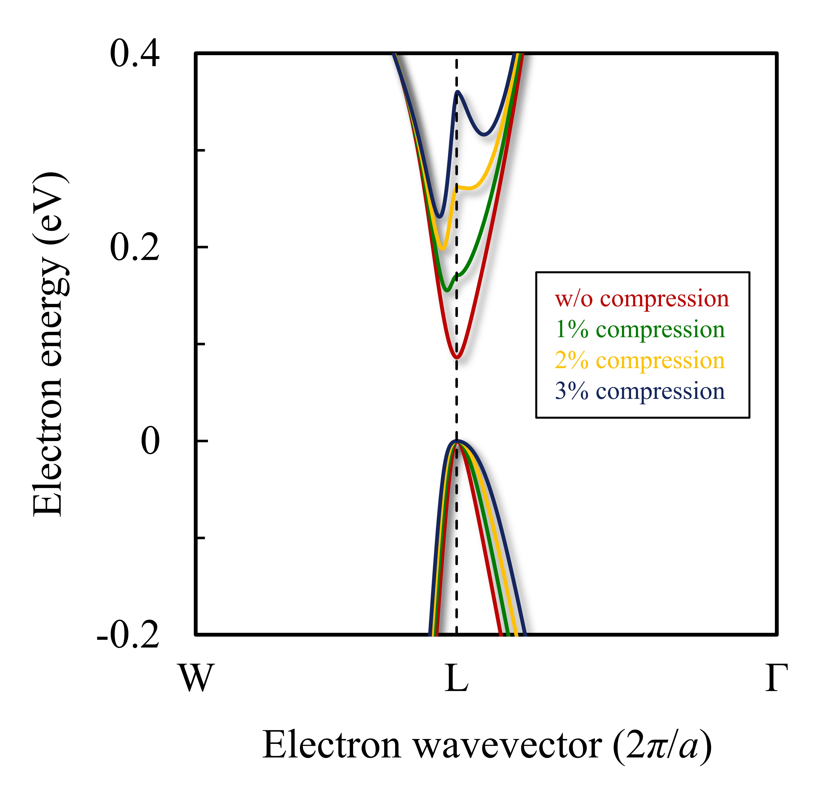
Figure S1. Electron band structure evolution of SnTe without compression (red), with 1% compression (green), with 2% compression (yellow), and with 3% (blue) compression.
Figure S2. Electron band structures (a) without a compressive strain and (b) with 3% compression. The black lines are the results of the DFT calculations. The red dotted lines are calculated by tight-binding approximations, and the dot size indicates the strength of the contribution of the Sn-5p orbitals to the density of states.

Figure S3. (a) Electron band structures, and (b) energy-dependent electron scattering rates without compressed Si, with 1% compressed Si, and with 3% compressed Si, indicated by green, red, and yellow, respectively.

*Authors to whom correspondence should be addressed; Email: thliu@hust.edu.cn (T.-H. Liu) and ronggui@hust.edu.cn (R. Yang).

