Supporting Information

Selective Extraction of Gold from Strong Acid e-waste Leachate Through H⁺ -Triggered Cascade Reaction of Thiolated β-Cyclodextrin
Liming Yangª, Difan Fangª, Guang Yang^{b,}*, Penghui Shaoª, Zan Hua^{b}, Feihu Bi^{b}, Hanchen Wei^{b}, Yunyun Tuª, Changli Chenª, Xubiao Luo^{a,}*

ª National-Local Joint Engineering Research Center of Heavy Metals Pollutants Control and Resource Utilization, Nanchang Hangkong University, Nanchang 330063, P. R. China
^{b} Biomass Molecular Engineering Center and Department of Materials Science and Engineering, School of Forestry and Landscape Architecture, Anhui Agricultural University, Hefei, 230036, P. R. China

* Corresponding authors
Tel.: +86 73183953371, Fax: +86 73183953373
E-mail: luoxubiao@126.com (X. B. Luo)

Supplementary Information Text
Text 1.
Materials. All commercial chemicals were used without further purification. β-cyclodextrin (β-CD, ≥98%), copper nitrate (Cu(NO₃)₂), cadmium nitrate (Cd(NO₃)₂), zinc nitrate (Zn(NO₃)₂) and nickel nitrate (Ni(NO₃)₂) were purchased from J&K Scientific Ltd. (Shanghai, China). Sodium hydroxide (97%) was purchased from Xilong Chemical Co., Ltd. (Shantou, China).
Methods.
Synthesis of T-CD. Dissolve 3 g of β-CD-I in 30 mL of DMF, add 1.2 g of thiourea under N₂ protection, and react for 19 h at 70 ℃. Blow the reaction liquid dry, add 120 mL of water and 1.2 g of NaOH at 100 ℃. Reflux for 1 h, remove one-third of the water, cool to room temperature, add hydrochloric acid to enable the solution neutral, draw and filter to obtain a solid and wash with plenty of water and dried, then the T-CD was obtained.
Characterization. Fourier transform infrared (FT-IR) spectra were recorded on a Nicolei 6670FT-IR spectrometer. Solid-state ¹³C NMR measurement was performed on AVANCE III HD NMR. X-ray diffraction (XRD) measurements were carried out at the 2θ range of 5-60° on a X’ Pert Powder X-ray diffractometer system with Cu Kα source (1.54056 Å). The specific surface area was calculated by measuring the adsorption/desorption isotherms of N₂ on an AUTOSORB-1 system. X-ray photoelectron spectroscopy (XPS) were measured on an Axis Ultra (Kratos, XSAM800) through using Al target (1486.6 eV) X-ray source. Gel permeation chromatography (GPC, Agilent) data was obtained in DMF containing 1 mM NH₄BF₄ with a flow rate of 1.0 mL min⁻¹ on a set of a PL gel 5 μm Mixed-C column and a guard column.
Adsorption Experiments. The typical adsorption experiments were conducted to acquire the adsorption isotherms. With initial concentrations of Au(III) ranging from 20 to 600 mg/L, 5 mg T-CD was added into 20 mL Au(III) aqueous solution, then the Au(III) was removed by an oscillation rate of 180 rpm for 12 h at 25 ± 0.1 °C in an incubator shaker (Jingqi, IS-RDD3). After that, the adsorption suspension was filtered through 0.45 μm membrane filter (Whatman), and the solution were tested by atomic absorption spectrometry (AAS, ContrAA 700, Germany) to acquire residual Au³⁺ concentrations.
The experiments of adsorption kinetics for Au(III) was conducted by a time-controlled dynamic adsorption assay. In this process, 100 mg T-CD material was added to 400 mL Au(III) water solution with an initial Au(III) concentration at 400 mg/L. The suspension solution was steadily shaken at 180 rpm and 25 °C. An aliquot of 1 mL of the mixed suspension was taken out at specified time intervals. The adsorption suspension was filtered through 0.45 μm membrane filter (Whatman), and then the concentration of Au(III) was determined with AAS.
In a ternary solution of Au(III) and Pd(II), and Pt(II), the specific adsorption of T-CD for Au(III) was evaluated. 5 mg T-CD was put to 20 mL of Au(III) with one of the six ions mentioned above. The pH of these mixed solutions was adjusted to 1, 2, 4 and 7, and the concentration of the mixed solution was adjusted to 0.2, 0.5, 1 and 2 mM. After adsorption for 24 h with 180 rpm at 25℃, the solution was filtered by a 0.45 μm membrane filter, then the residual ion concentrations were determined by AAS. All the metal ions were nitrate salts.
Theoretical calculations. All the DFT calculations were carried out with the code of DMol3 in Materials studio. The spin-unrestricted polarization DFT was used to geometrically optimize the calculated molecule, based on generalized gradient approximation with the correlation energy function of Becke-Lee-Parr (BLYP). The convergence thresholds of energy, gradient and displacement for the optimization were set to 10⁻⁵, 1 × 10⁻³, and 5 × 10⁻³, respectively. The adsorption energy (ΔE) between the segment of T-CD (T-CD) and three kind of metal ions, was calculated according to the following equation:
Text 2. In this work, the preparation of T-CD involves a two-step substitution (Figure S1a). The structure of CD is conducive to the mass transfer of the solution, and the multiple OH sites on CD are replaced by I to facilitate the grafting of thiol groups. The specific surface area of T-CD was confirmed to be 11.229 m²/g through N₂ adsorption-desorption experiment (Figure S1d). And most of the pores are between 2-7 nm (inert of Figure S1d), the morphology and microstructure of T-CD from SEM images illustrated that the T-CD surface is distributed with a high density of rough pores (Figure S1c), which corresponds to the result of BET, facilitating adhesion and mass transfer of gold ions.
Text 3. In a mixture of gold, palladium and platinum solutions with different initial concentrations (0.2, 0.5, 1 and 2 mM) at pH 2, the removal efficiency of gold is maintained at 97.6% under various concentration, and palladium and platinum do not interfere with the capture of gold (Figure S20b). At low concentrations such as 0.2 mM, the adsorption sites may not be fully occupied, thus the removal of Pd can be 28.8%, while there is no significant removal of platinum.

Figures and Tables
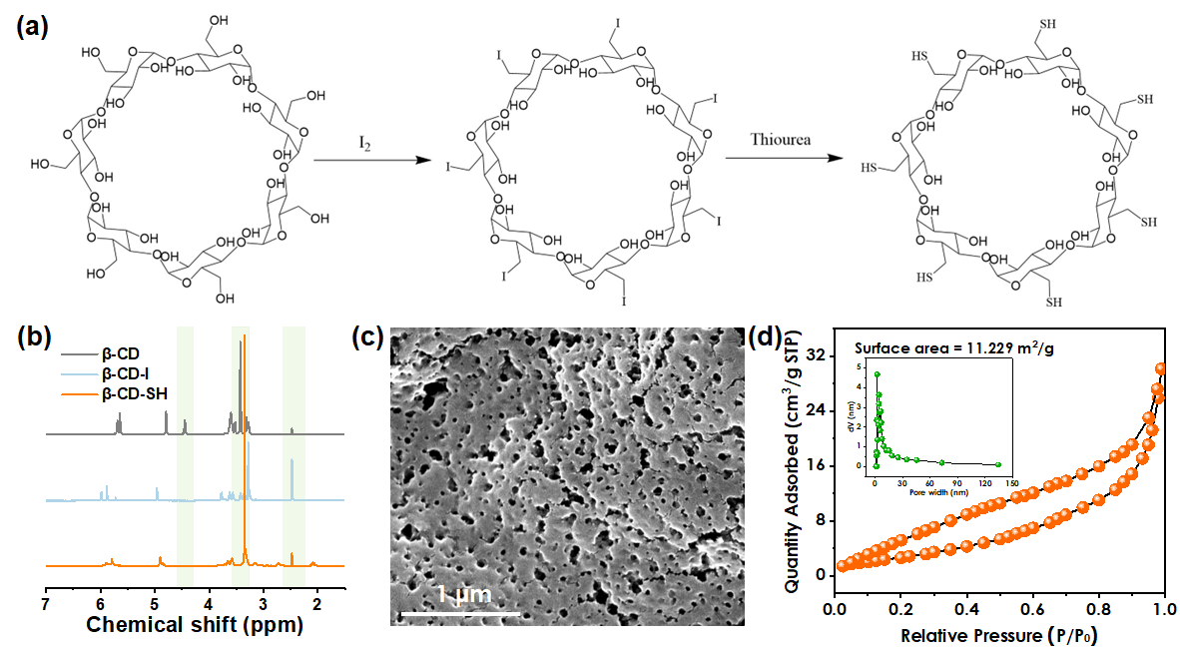
Figure S1 (a) Synthetic schematic of T-CD; (b) ¹³C CP-MARS solid state NMR; (c) SEM microscopic morphology of T-CD; (d) N₂ adsorption-desorption isotherm of T-CD; inset is the pore size distribution.
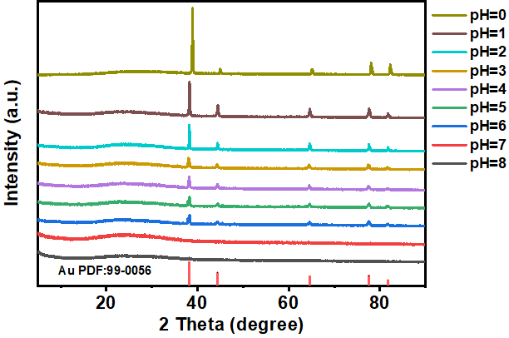
Figure S2 The XRD patterns of Au-load-T-CD at different pH.

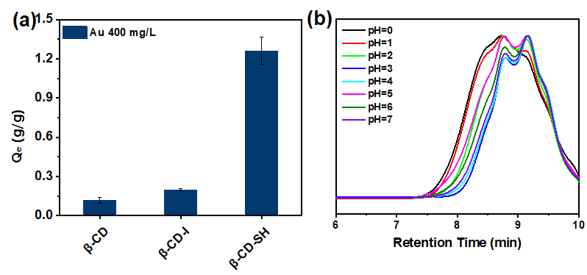
Figure S3 (a) Adsorption capacity of β-CD, β-CD-I, and T-CD on gold; (b) GPC of T-CD after immersion in different pH solutions.
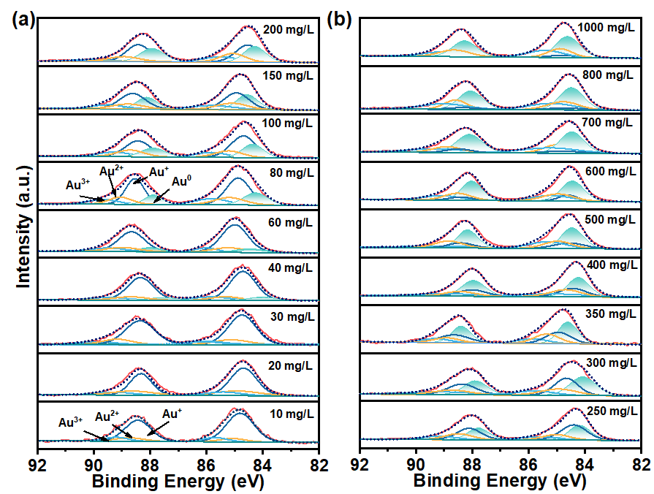
Figure S4 The XPS spectrum of Au 4f at different adsorption concentrations.
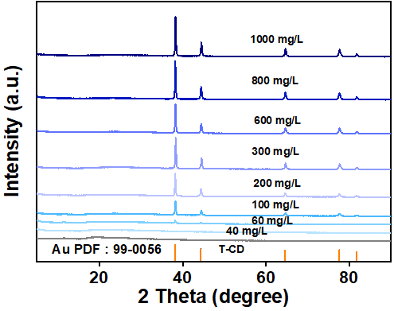
Figure S5 The XRD patterns of Au-load-T-CD at different adsorption concentrations.
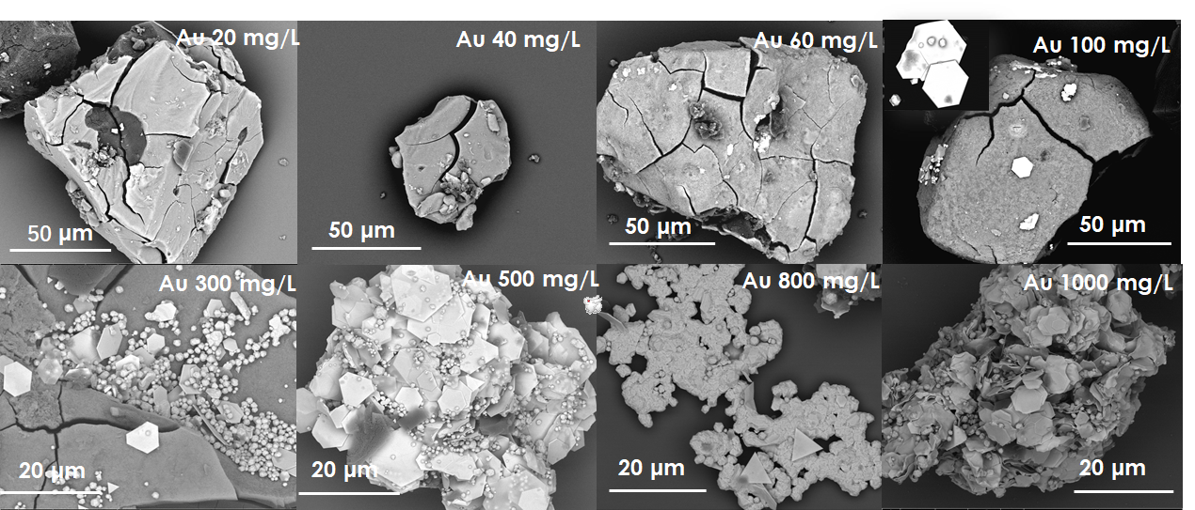
Figure S6 The SEM images of Au-load-T-CD at different adsorption concentrations.
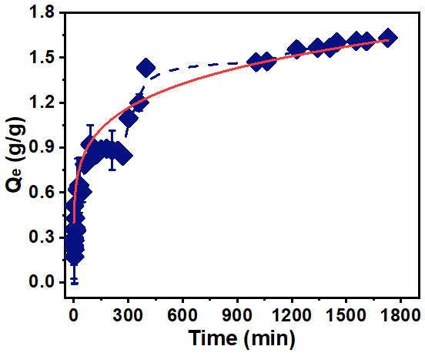
Figure S7 The adsorption capacity of Au³⁺ uptake by T-CD as time.
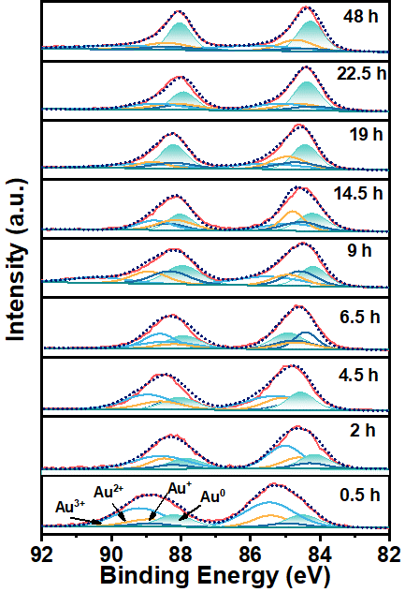
Figure S8 The XPS spectrum of Au 4f at different adsorption times.
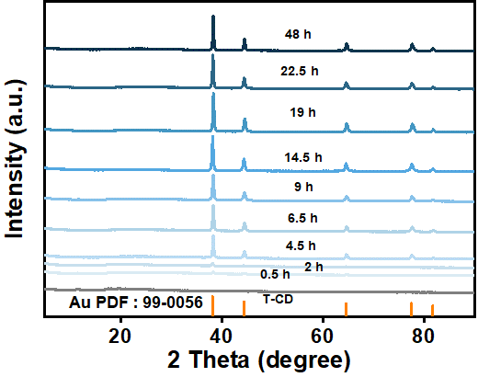
Figure S9 The XRD patterns of Au-load-T-CD at different adsorption times.
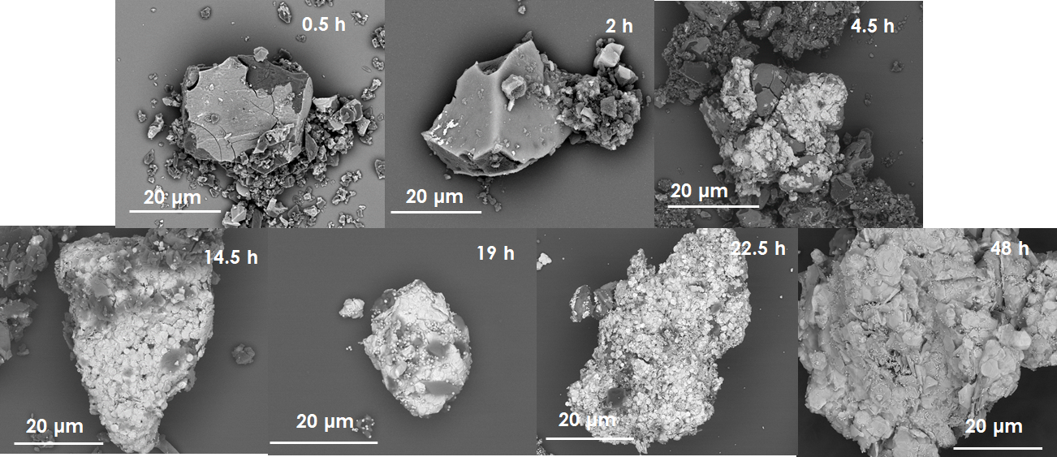
Figure S10 The SEM images of Au-load-T-CD at different adsorption time.
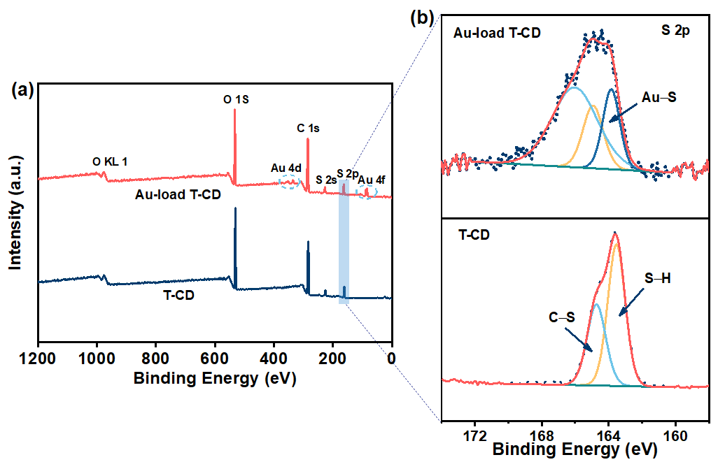
Figure S11 (a) The wide XPS spectrum of T-CD and Au-load-T-CD. (b) The XPS spectrum of S 2p in the T-CD and Au-load-T-CD.
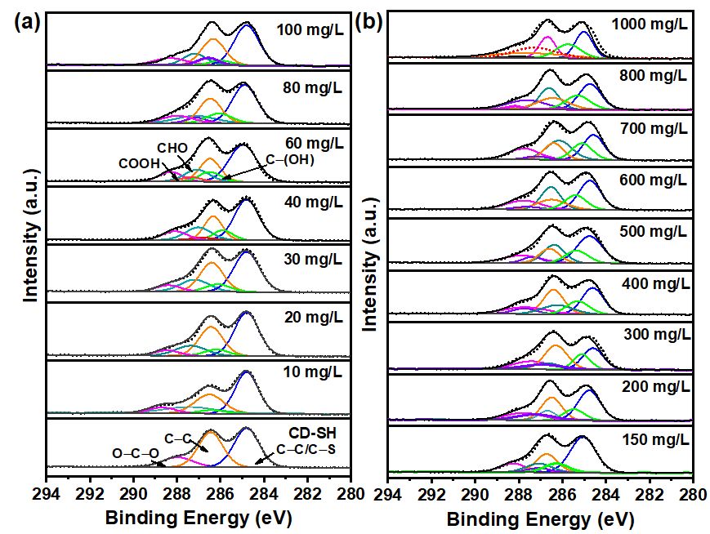
Figure S12 The XPS spectrum of C 1s at different adsorption concentrations.
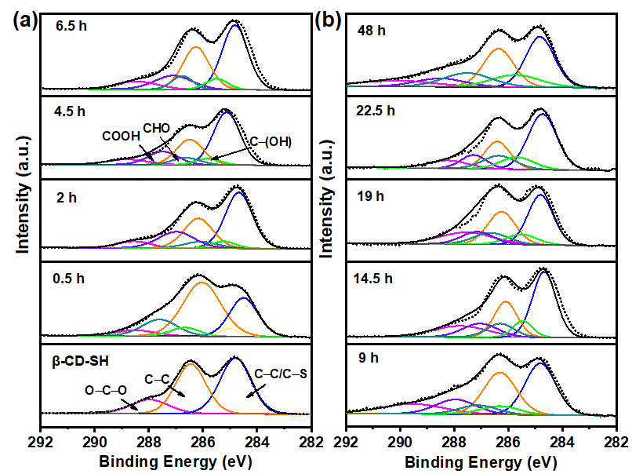
Figure S13 The XPS spectrum of C 1s at different adsorption times.
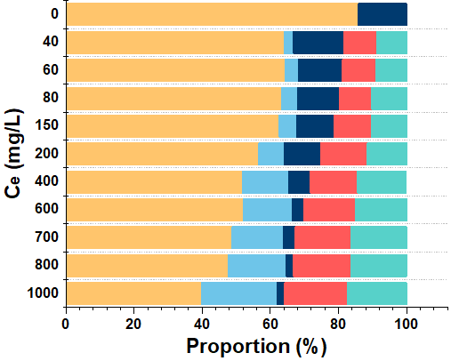
Figure S14 The changes of C in T-CD with adsorption concentration.
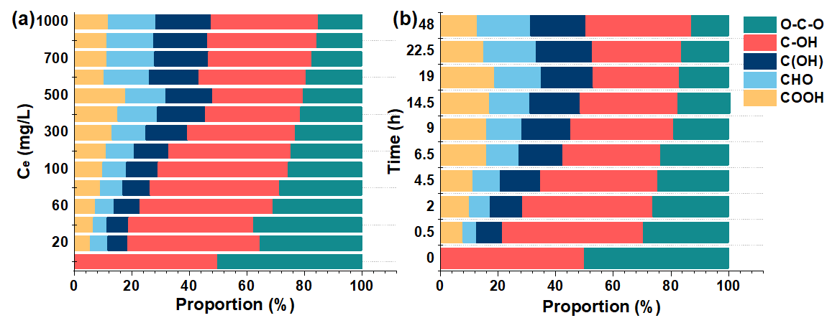
Figure S15 The changes of O in T-CD with adsorption concentration (a), and with adsorption time (b).
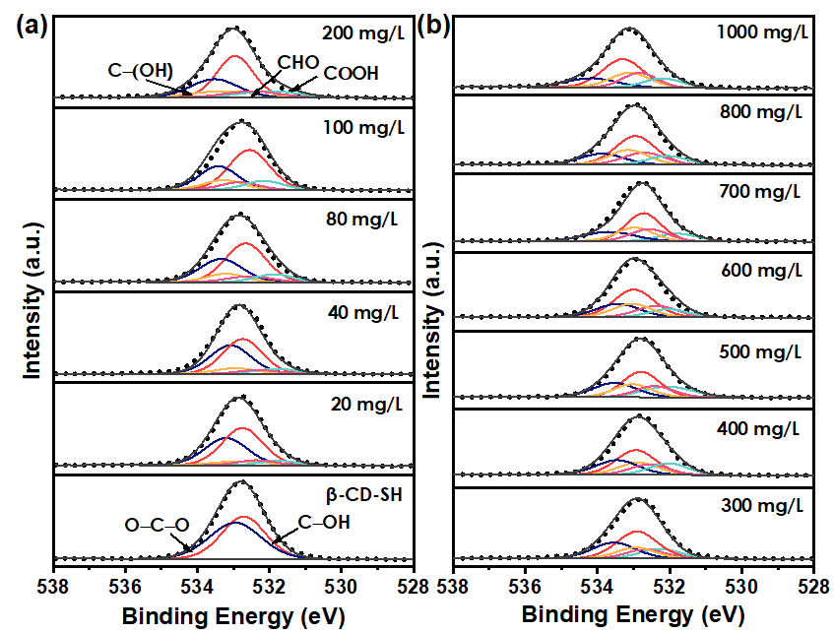
Figure S16 The XPS spectrum of O 1s at different adsorption concentrations.
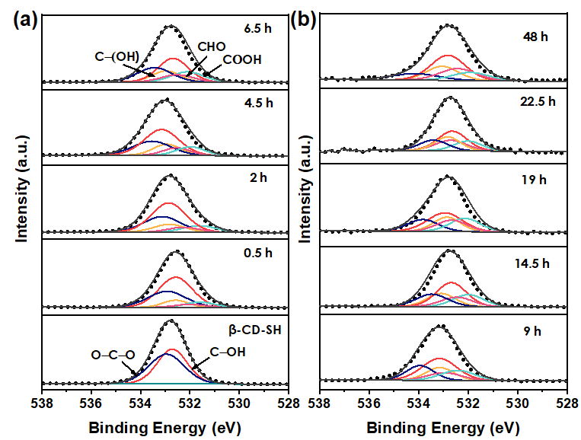
Figure S17 The XPS spectrum of O 1s at different adsorption times.
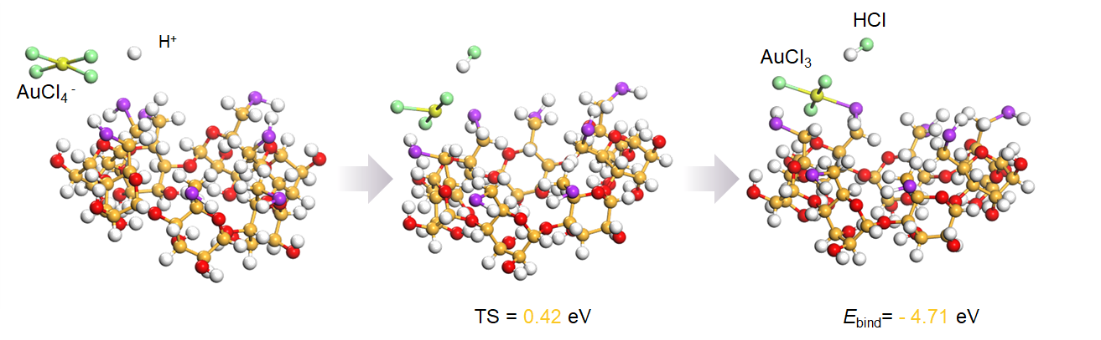
Figure S18 Energy of binding in adsorption of AuCl₄⁻.
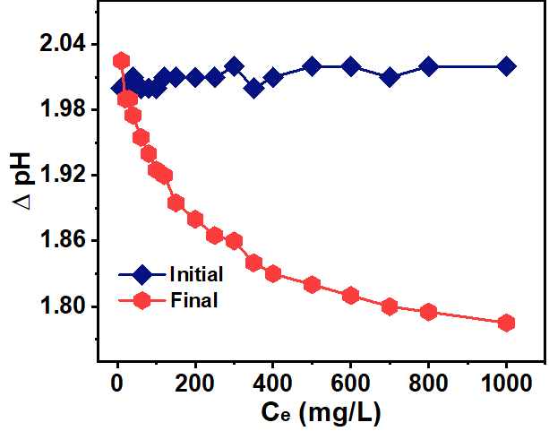
Figure S19 The variation of pH value at different adsorption concentrations.
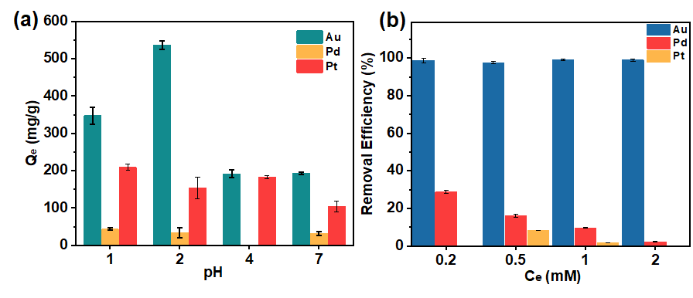
Figure S20 The selectivity test of T-CD to Au³⁺ capture in the solution containing precious metals at different pH values (a) and different concentration (b).
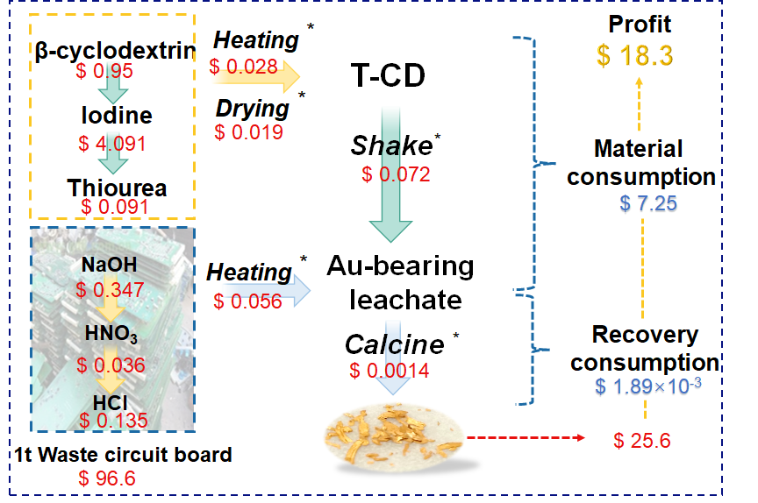
Figure S21 The detailed cost consumption and benefits for the extraction of gold from one ton e-waste.

Table S1 The variation of the percentage of four valence states of gold in Au-loaded-T-CD after adsorption of different concentrations of Au.
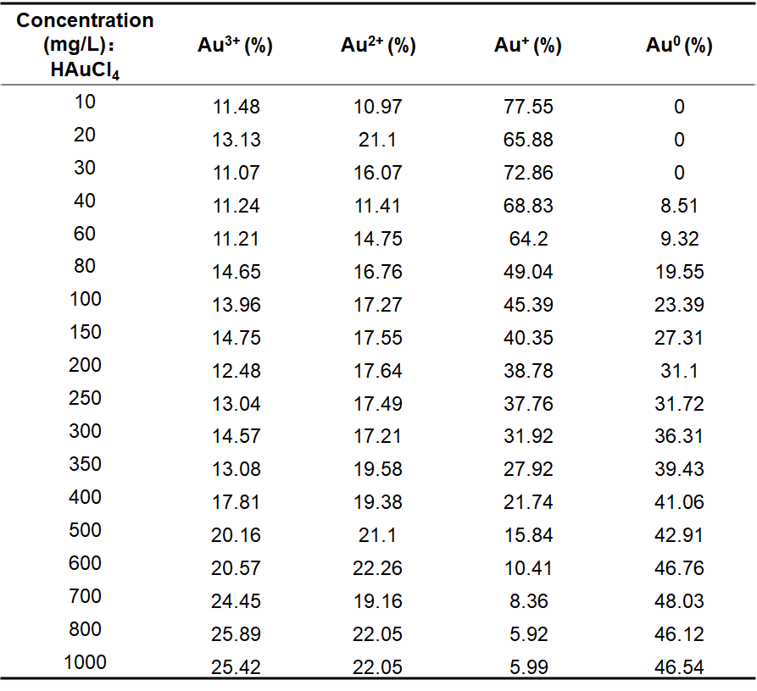
Table S2 The variation of the percentage of four valence states of gold in Au-loaded-T-CD at different adsorption times.
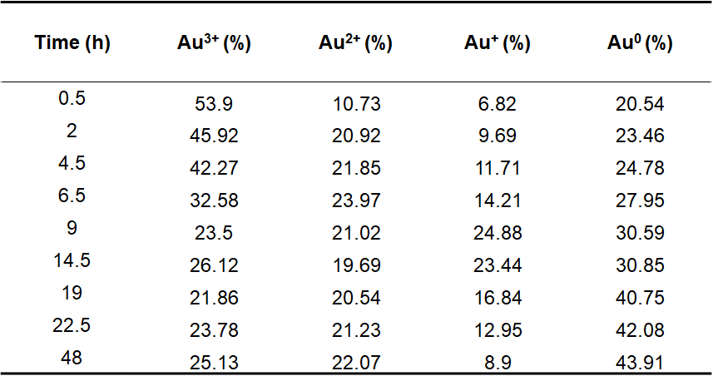

Table S3 The variation of the percentage of different C structures in Au-loaded-T-CD after adsorption of different concentrations of Au.
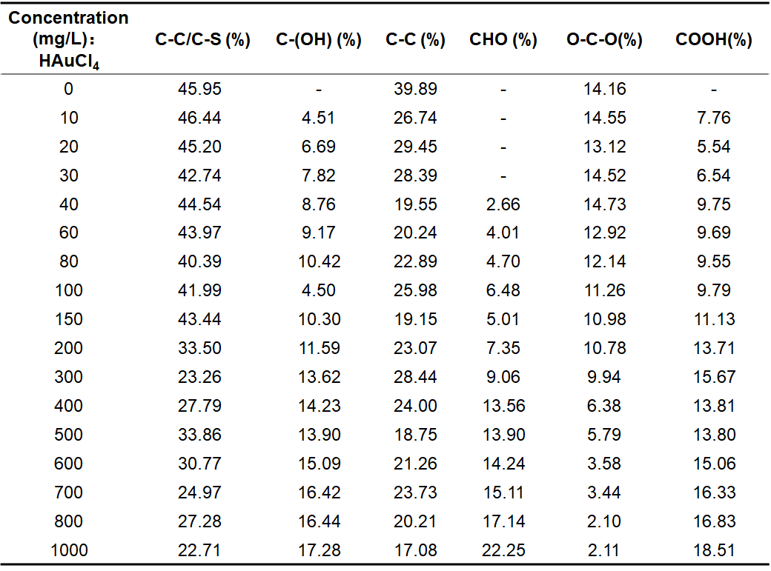
Table S4 The variation of the percentage of different carbon structures in Au-loaded-T-CD at different adsorption times.
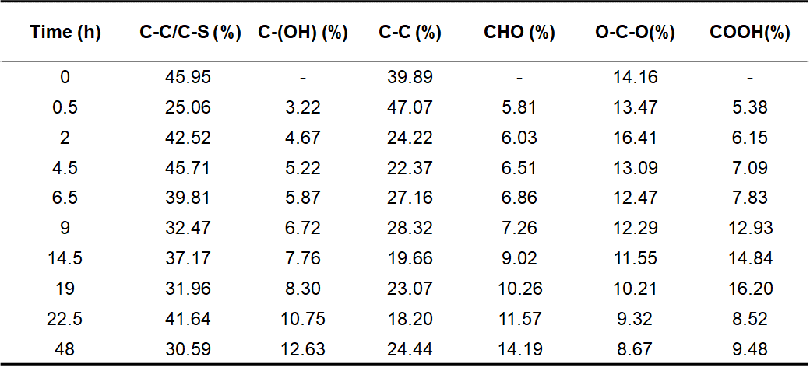

Table S5 The variation of the percentage of different O structures in Au-loaded-T-CD after adsorption of different concentrations of Au.
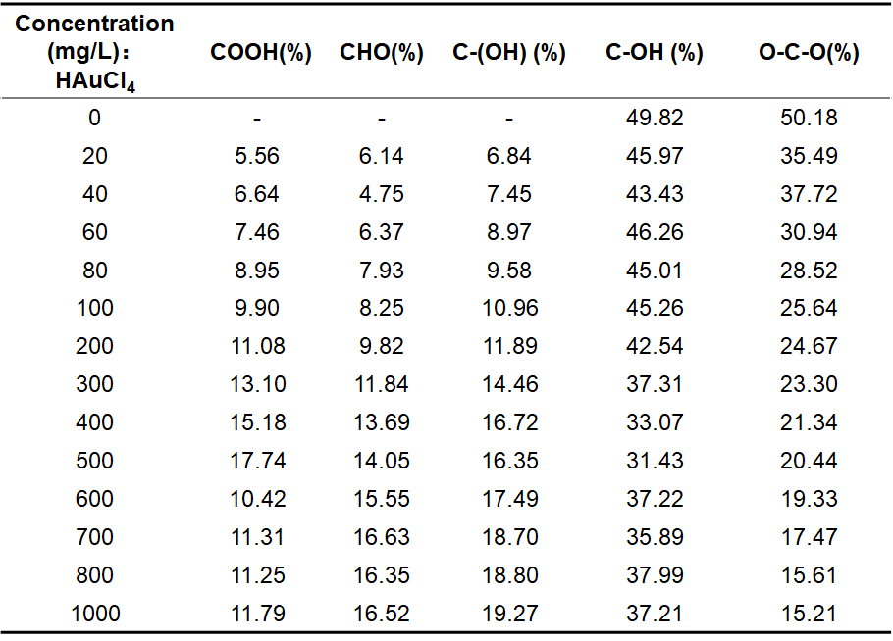
Table S6 The variation of the percentage of different O structures in Au-loaded-T-CD at different adsorption times.
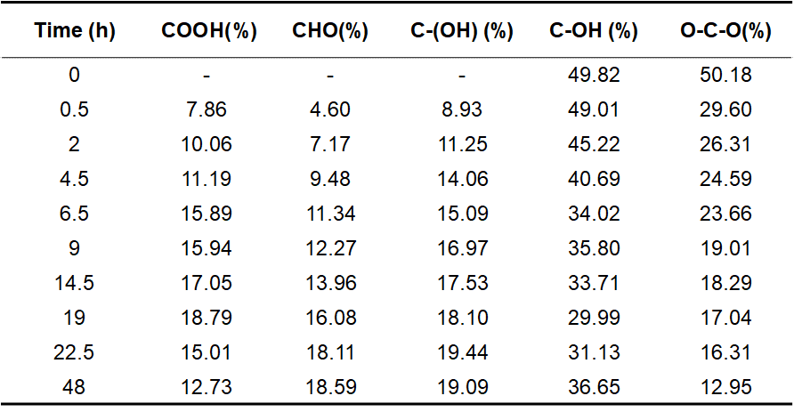

Table S7 Selective adsorption parameters of T-CD toward twenty simulated metals in e-waste leaching solution.
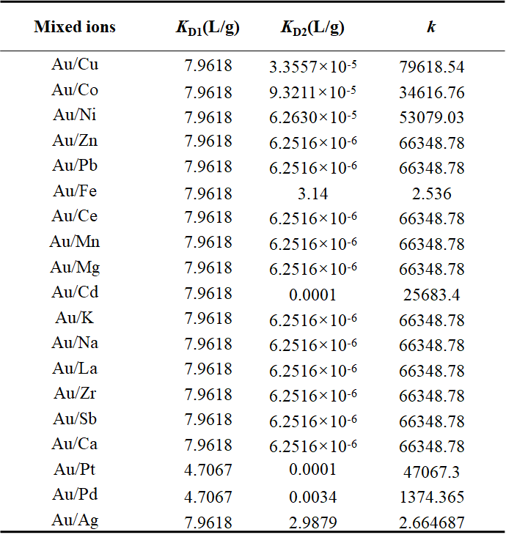
Table S8 Selective adsorption parameters of T-CD toward copper and gold under different ratios of copper and gold.
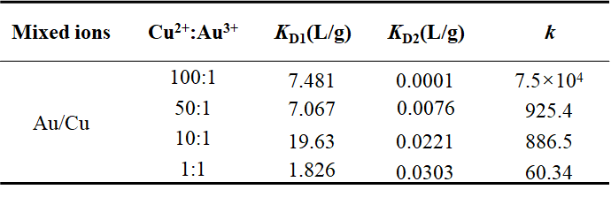
Table S9 Selective adsorption parameters of T-CD toward gold, palladium and platinum under different pH.
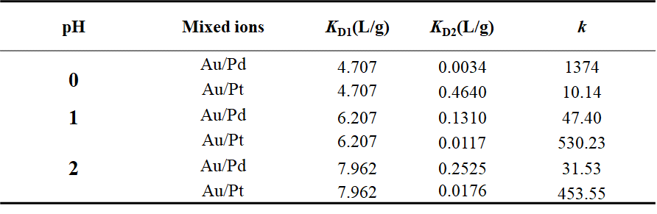
Table S10 Selective adsorption parameters of T-CD toward gold, palladium and platinum under different initial concentration.
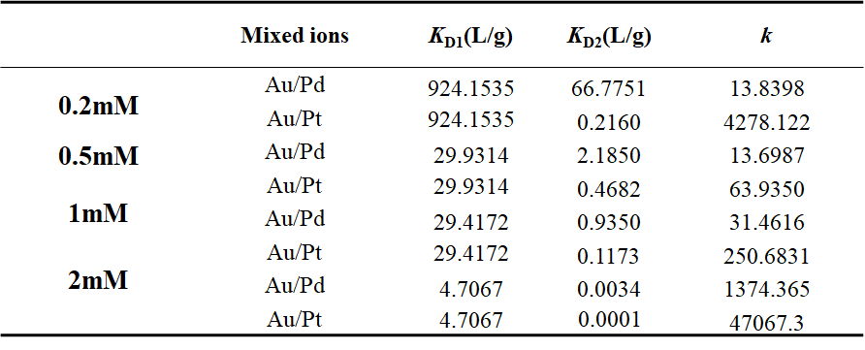
Table S11 The mass of each metal in per waste circuit board.
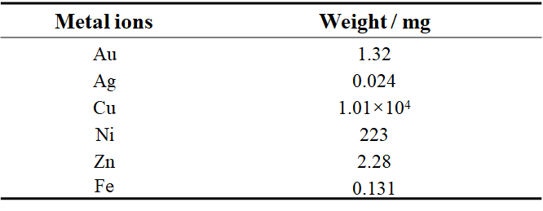
Table S12 The concentration of six metals in the first acid leach solution of five-piece waste circuit boards.
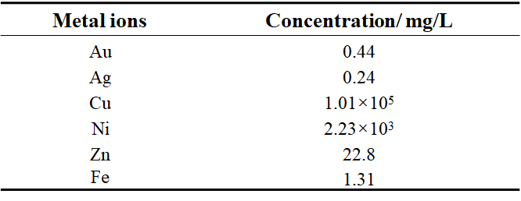
Table S13 The concentration of six metals in the second acid leach solution of five-piece waste circuit boards.
