Title: Increasing Large Wildfires over the Western United States Linked to Diminishing Sea Ice in the Arctic
Authors: Yufei Zou^{1*}, Philip J. Rasch¹, Hailong Wang^{1*}, Zuowei Xie² & Rudong Zhang¹
Affiliations:
¹Atmospheric Sciences and Global Change Division, Pacific Northwest National Laboratory, Richland, WA 99354, USA.
²International Center for Climate and Environment Sciences, Institute of Atmospheric Physics, Chinese Academy of Sciences, Beijing, 100029, China.
*Correspondence to: Y. Zou (yufei.zou@pnnl.gov) and H. Wang (hailong.wang@pnnl.gov).

Supplementary information:
Supplementary figures 1-14
Supplementary tables 1-3
References (65-83)

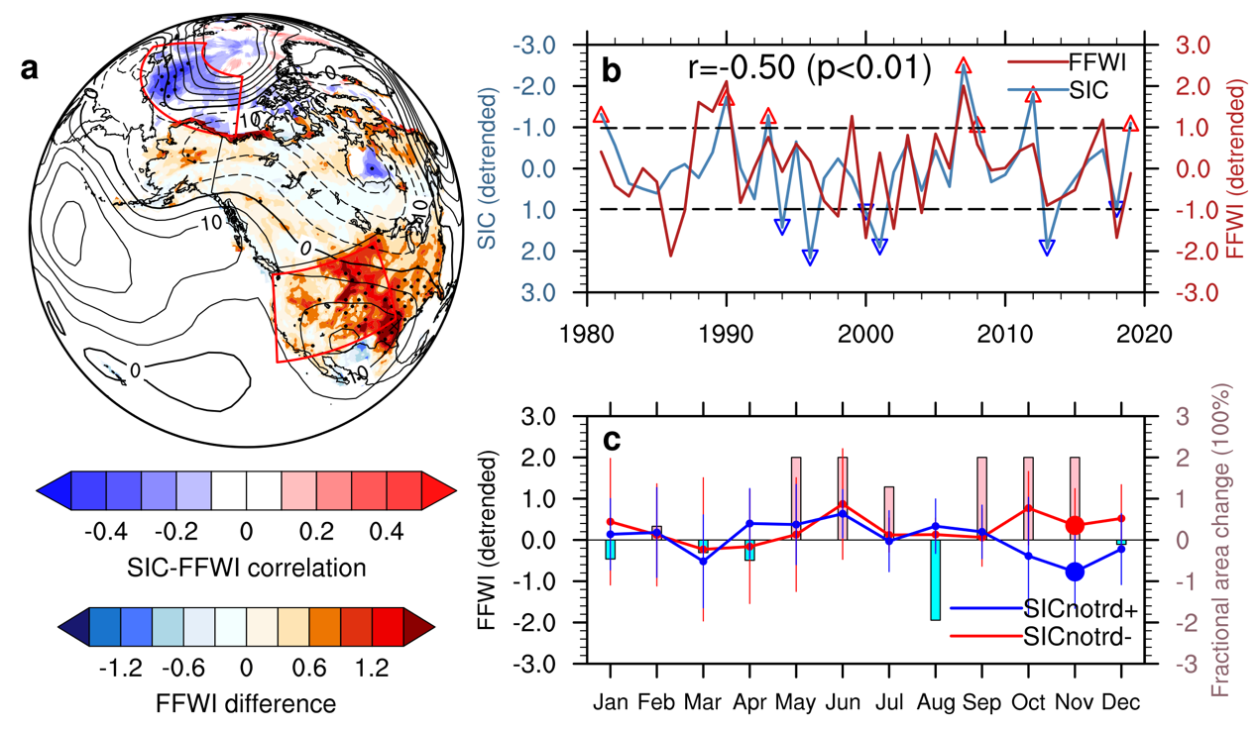
Supplementary Fig. 1. Observation- and ERA5 reanalysis-based Arctic sea ice and regional fire teleconnection after removing the long-term trends. a, spatial distributions of the correlation (shading in the Arctic) between seasonal average detrended Arctic sea-ice concentrations in summer and autumn (July to October) and seasonal and regional average detrended FFWI over the western U.S. in the following autumn and early winter (September to December), and the difference of seasonal average detrended FFWI (shading in the U.S.) between years with minimum (SICnotrd-: red up-pointing triangles in b) and maximum (SICnotrd+: blue down-pointing triangles in b) detrended Arctic SIC. The difference of seasonal (September to December) average detrended geopotential height at 500 hPa between the SICnotrd- and SICnotrd+ years is also shown (contours with negative values in dashed lines; unit: m). b, time series of seasonal and regional average detrended SIC (seasonal mean from July to October; first normalized by its 1981-2010 climatological mean and standard deviation and then detrended), detrended FFWI (seasonal mean from September to December), and their correlation. The region definitions for the Pacific sector of the Arctic and the western U.S. are outlined by red boxes in a. The horizontal dashed lines denote the ±1 standard deviations of normalized and detrended SIC as thresholds for selecting the SICnotrd+/- years. c, the composite of monthly detrended FFWI (solid lines with dots and error bars) and fractional detrended burned area change of large wildfires (vertical bars) over the western U.S. Error bars in c denote ±1 standard deviations of monthly detrended FFWI in each group. Stipples in a mark regions that are significantly different from 0 at the 0.05 significance level of two-sided t-test. The larger dot for monthly FFWI in c denotes the 0.05 significance level of two-sided t-test.

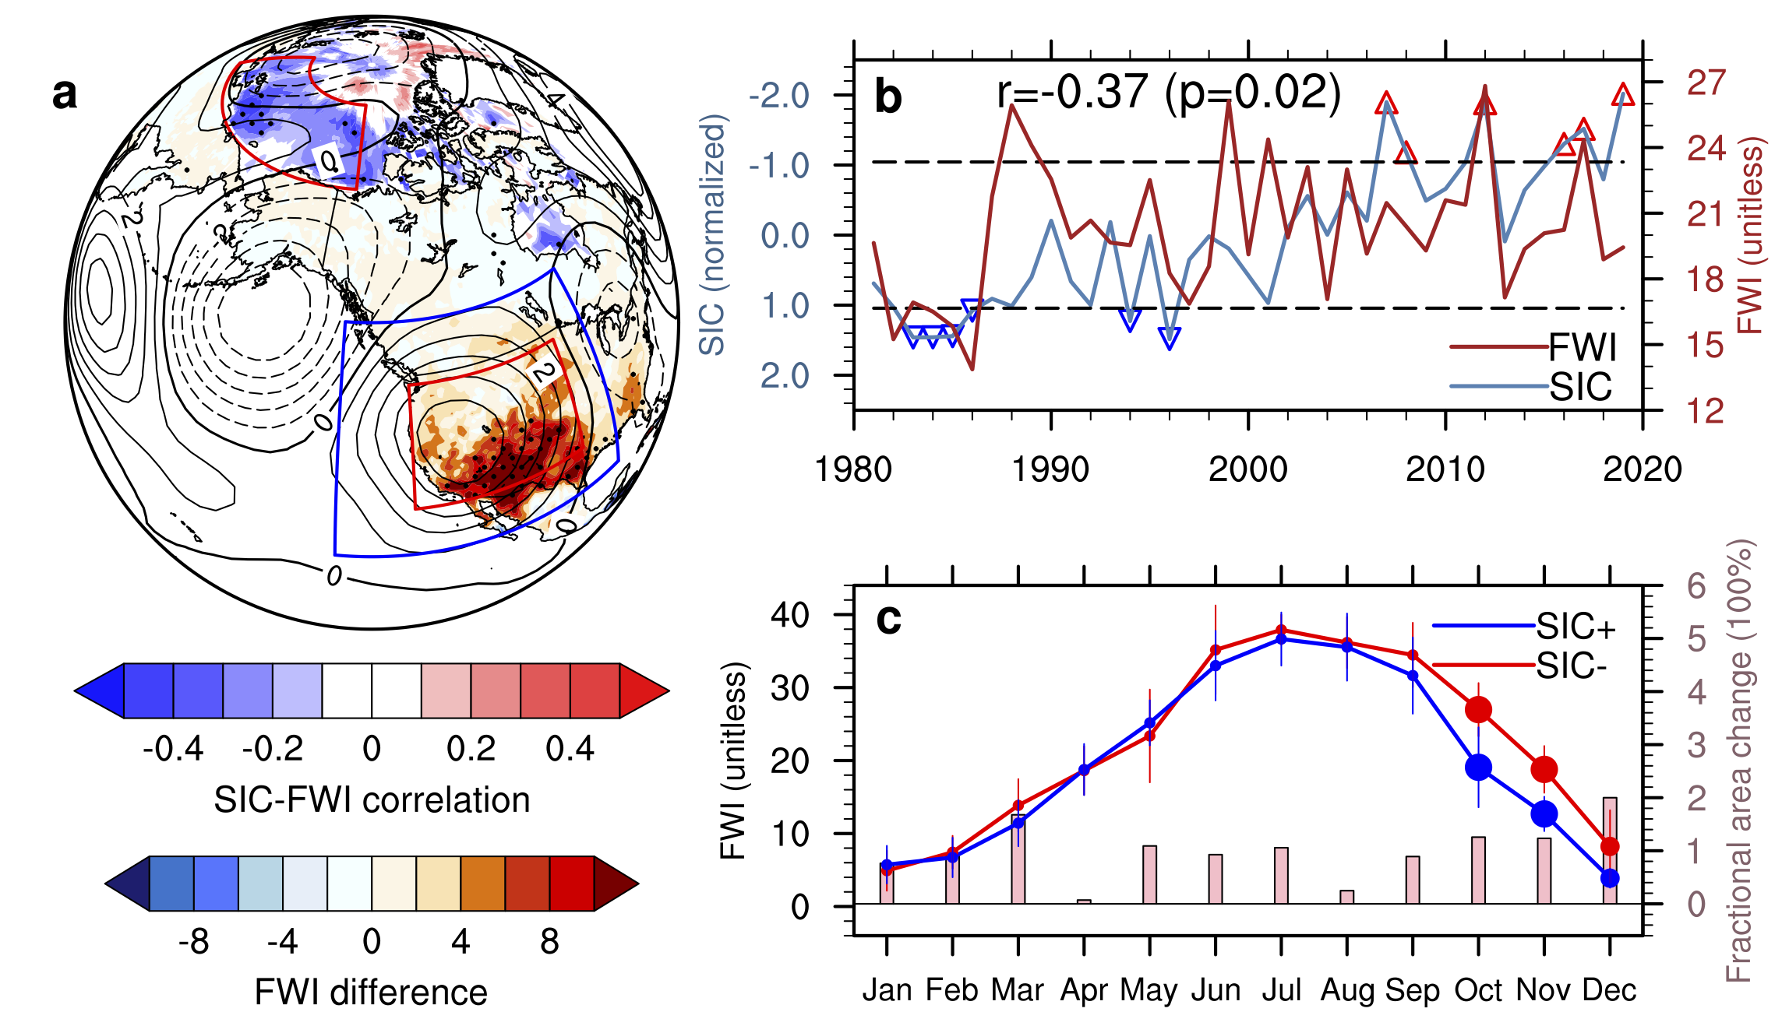
Supplementary Fig. 2. Observation- and MERRA-2 reanalysis-based Arctic sea ice and regional fire teleconnection. a, spatial distributions of the correlation (shading in the Arctic) between seasonal average Arctic sea-ice concentrations in summer and autumn (July to October) and seasonal and regional average FWI over the western U.S. in the following autumn and early winter (September to December), and the difference of seasonal average FWI (shading in the U.S.) between years with minimum (red up-pointing triangles in b) and maximum (blue down-pointing triangles in b) Arctic SIC. The regression of geopotential height anomalies at 500 hPa onto the seasonal and regional average FFWI is also shown (contours with negative values in dashed lines; unit: m). b, time series of seasonal and regional average SIC (seasonal mean from July to October; normalized by its 1981-2010 climatological mean and standard deviation) and FWI (seasonal mean from September to December) and their correlation. The region definitions for the Pacific sector of the Arctic (red box over the Arctic), the western U.S. (red box over the western U.S.), and the Z500i projection region (blue box over the western U.S.) are outlined by red and blue boxes, respectively, in a. c, the composite of monthly FWI (solid lines with dots and error bars) and fractional burned area change of large wildfires (vertical bars) over the western U.S. Error bars in c denote ±1 standard deviations of monthly FWI in each group. Stipples in a mark regions that are significantly different from 0 at the 0.05 significance level of two-sided t-test, and dot sizes for monthly FWI in c denote the 0.05 (large) and 0.1 (medium) significance levels, respectively.

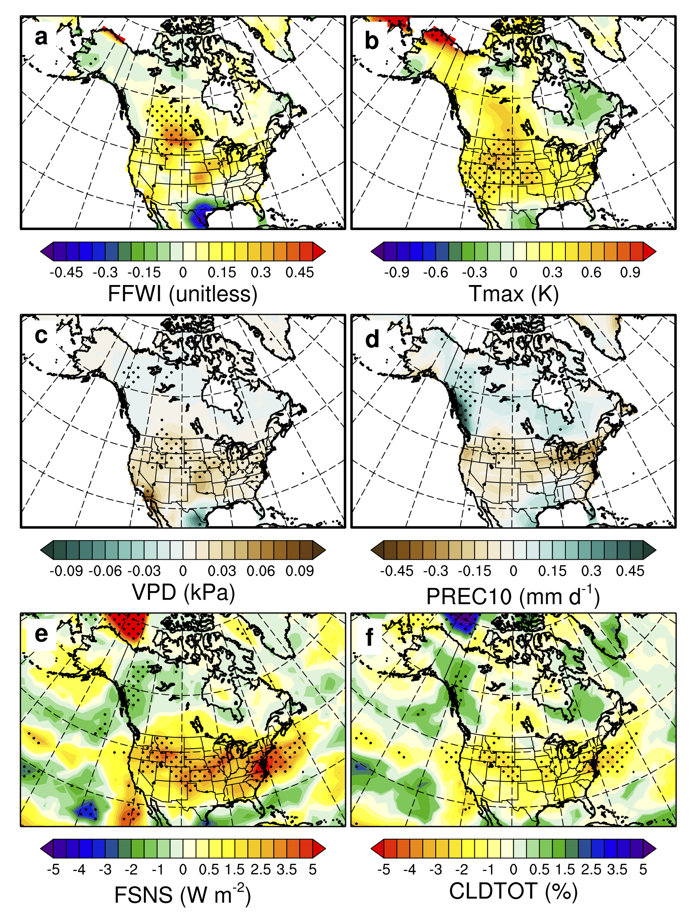
Supplementary Fig. 3. Fire-related weather responses in the CESM-RESFire experiments. a, the difference of seasonal average (September to December) FFWI between the SICexp- and SICexp+ sensitivity experiments. b, As in a, but for the difference of seasonal average daily maximum of 2-m temperature (Tmax). c, As in a, but for the difference of seasonal average surface vapor pressure deficit (VPD). d, As in a, but for the difference of seasonal average 10-day running mean of total precipitation (PREC10). e, As in a, but for the difference of seasonal average net solar flux at surface (FSNS; positive for the downward direction). f, As in a, but for the difference of seasonal average vertically integrated total cloud fraction (CLDTOT). Stipples in a-f show regions that are significantly different from 0 at the 0.1 significance level of two-sided t-test.

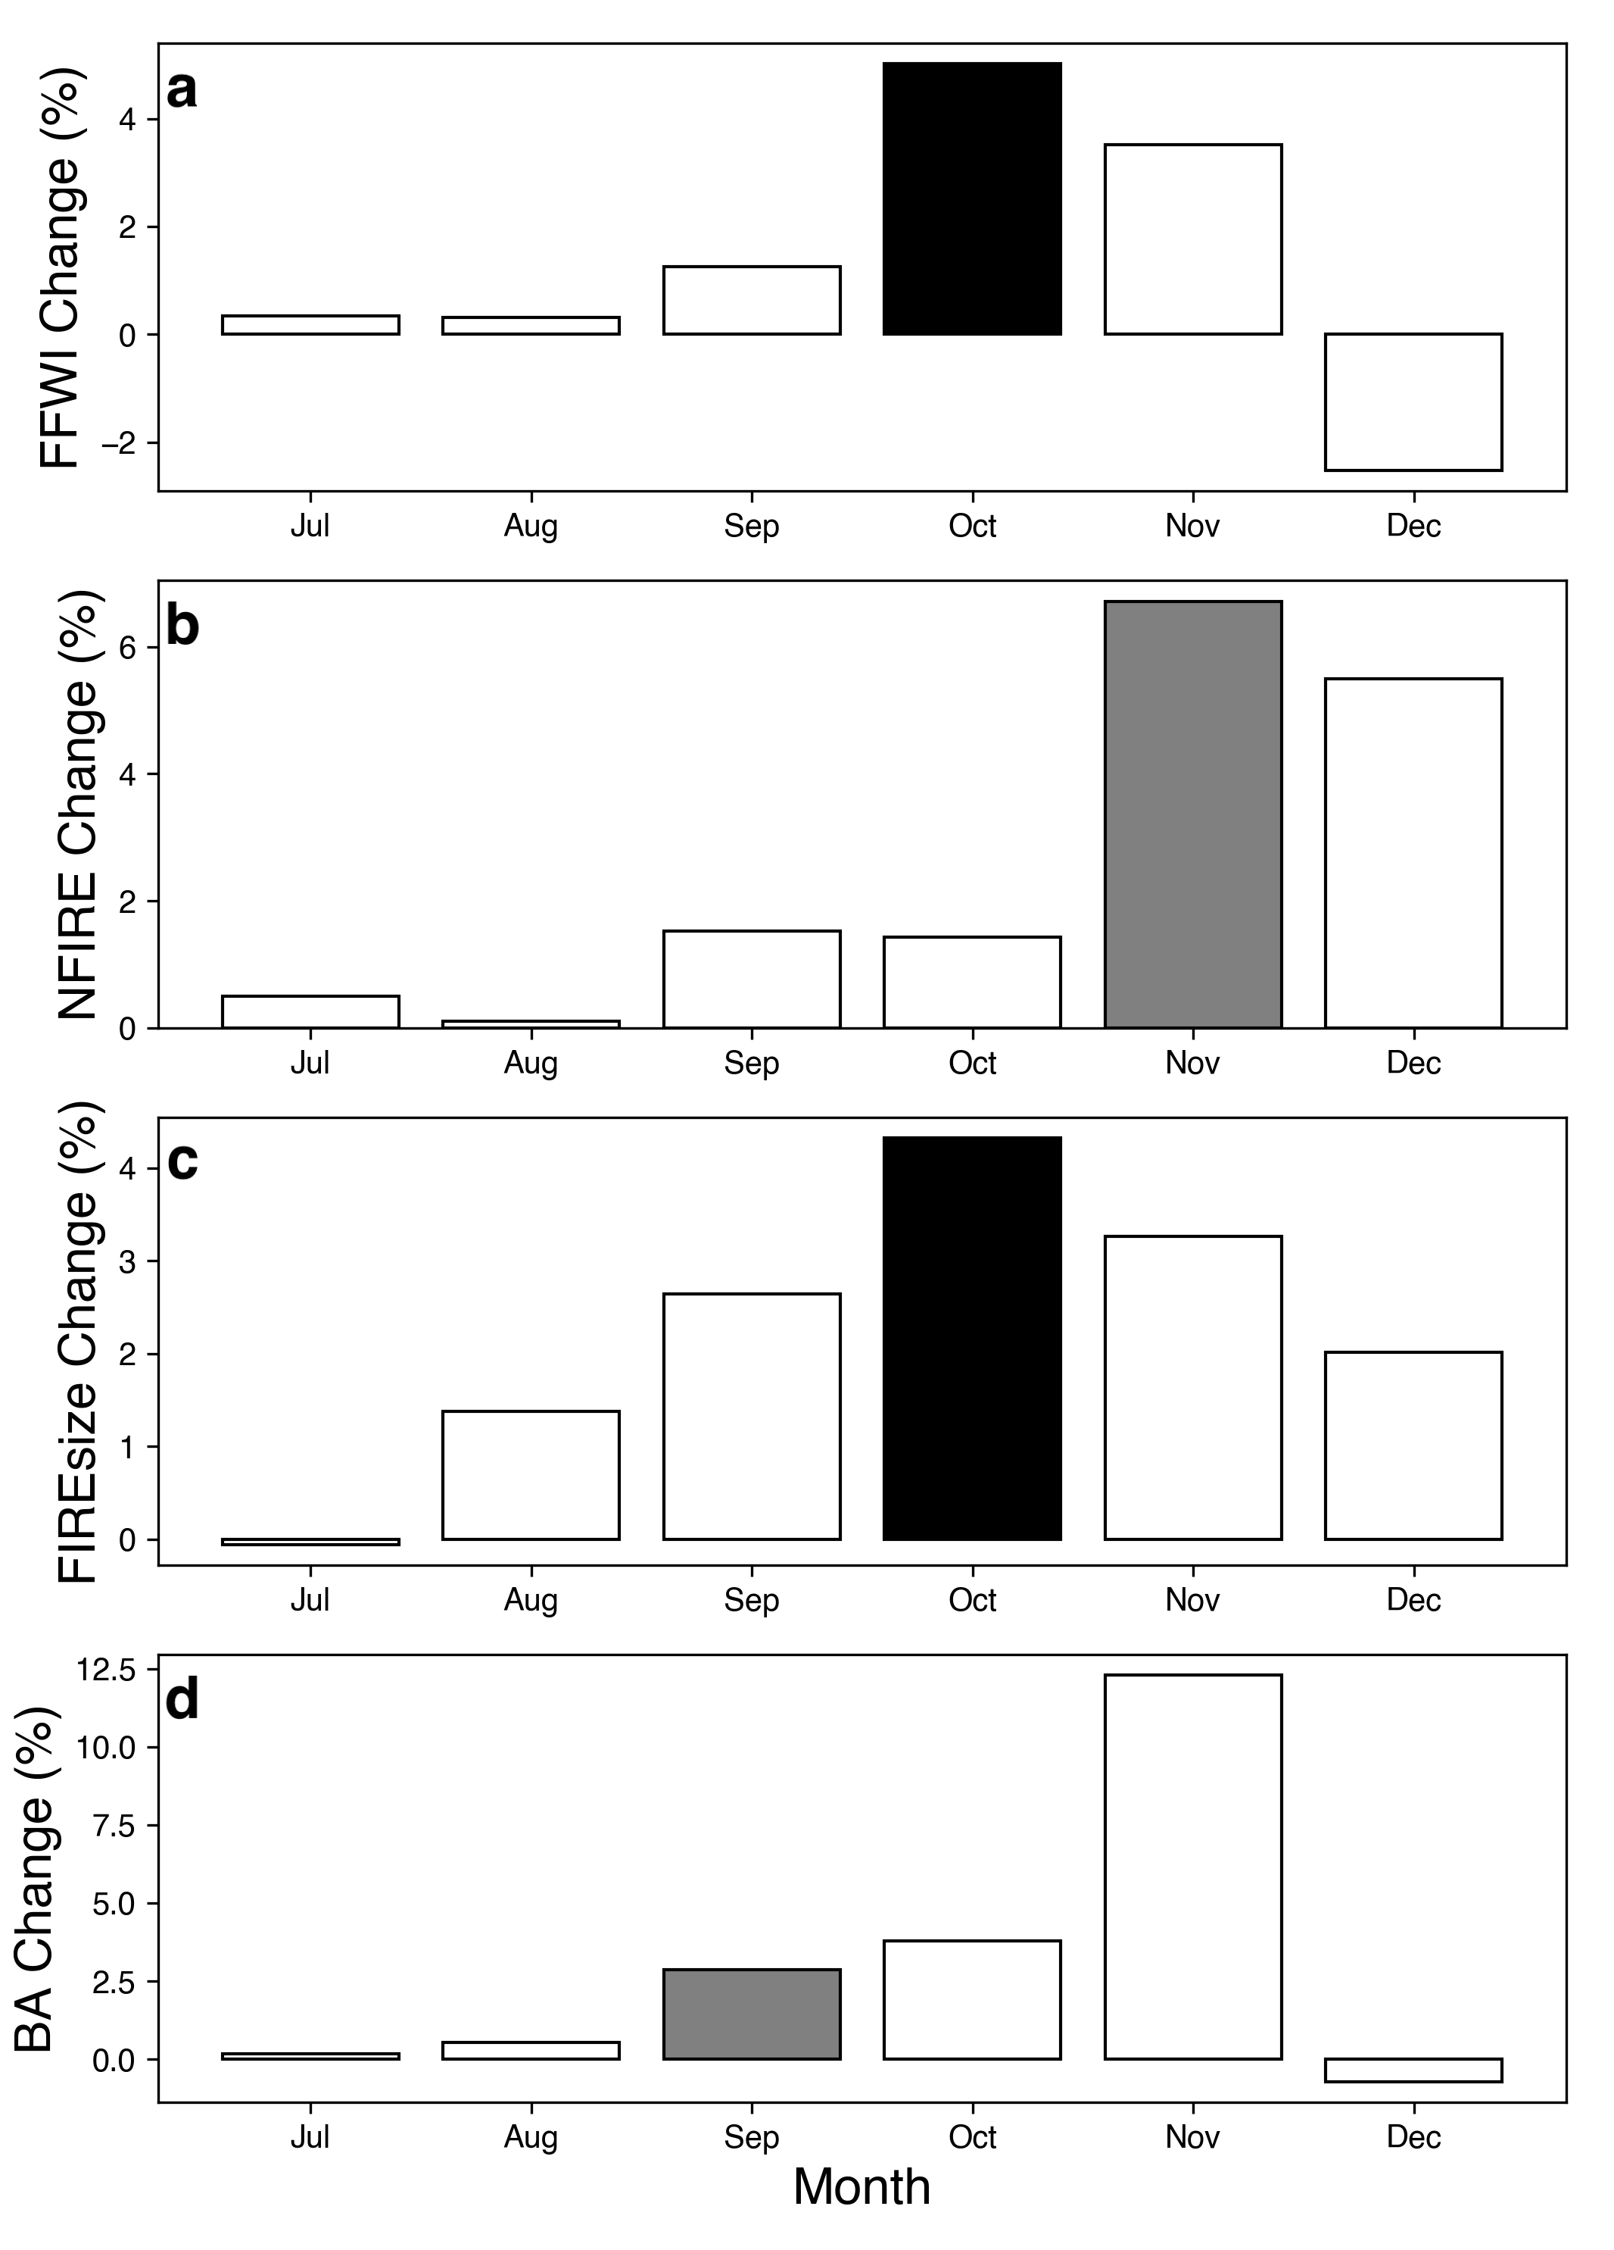
Supplementary Fig. 4. Fractional changes of monthly fire weather and fire variables in the CESM-RESFire experiments. a, fractional Changes of regional average FFWI over the western U.S. between the SICexp- and SICexp+ sensitivity experiments. b, As in a, but for fractional changes of regional total fire counts. c, As in a, but for fractional changes of regional average fire sizes. d, As in a, but for fractional changes of regional total burned area. Shadings in a-d show fractional changes that are significantly different from 0 at the 0.05 (dark) and 0.1 (grey) significance levels of two-sided t-test.

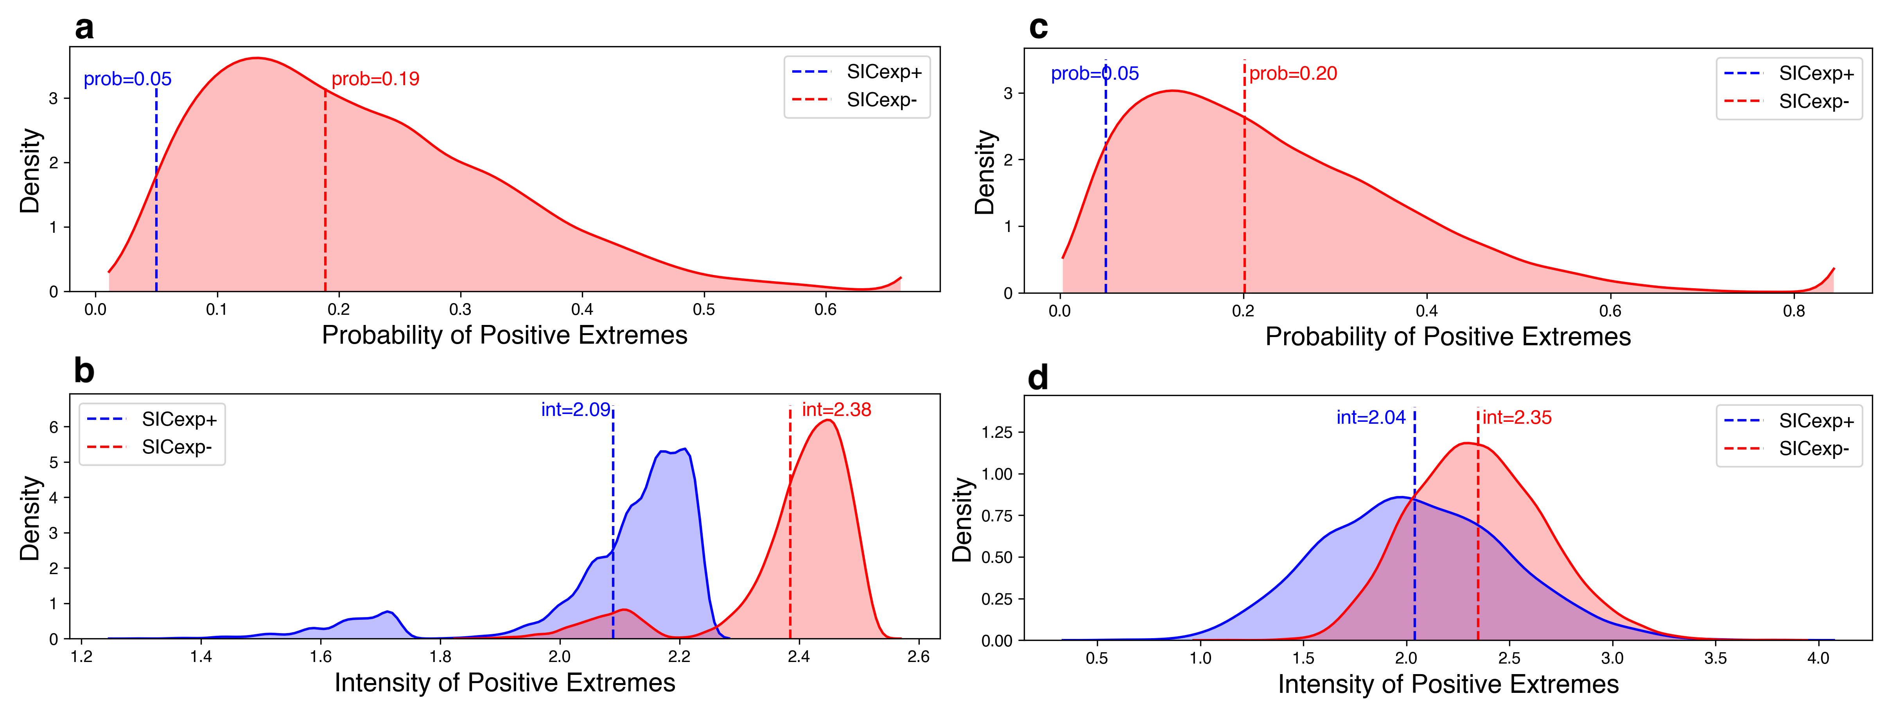
Supplementary Fig. 5. Probability and intensity changes of extreme burning years in the CESM-RESFire experiments. a, the statistical distribution for occurrence probability estimates of extreme burning years in the SICexp- and SICexp+ climate sensitivity experiments based on the bootstrap resampling method without replacement (see Methods). The vertical dashed lines denote ensemble mean probabilities for the SICexp- (red) and SICexp+ (blue) experiments. b, As in a, but for intensity estimates of extreme burning years without replacement in the bootstrap estimation. The vertical dashed lines denote ensemble mean intensity for the SICexp- (red) and SICexp+ (blue) experiments. c-d, As in a-b, but for the probability and intensity estimates of extreme burning years with replacement in the bootstrap estimation.

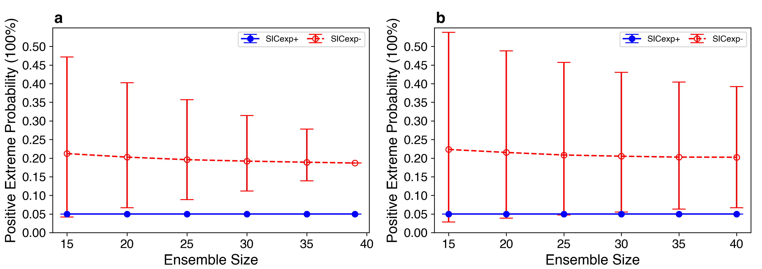
Supplementary Fig. 6. The relationship between the occurrence probability estimates of extreme burning years and ensemble sizes of the CESM-RESFire experiments. a, the probability estimates of extreme burning years based on different sizes of ensemble members in the SICexp- and SICexp+ experiments without replacement in the bootstrap method (see Methods). Note the probabilities of extreme burning years in SICexp+ are always 5% by definition. b, As in a, but for the probability estimates of extreme burning years with replacement in the bootstrap method. The circles in a-b denote the ensemble means of the probability estimates, and the lower and upper whiskers denote the 95% (from 2.5% to 97.5%) inter-percentile ranges of the probability estimates.

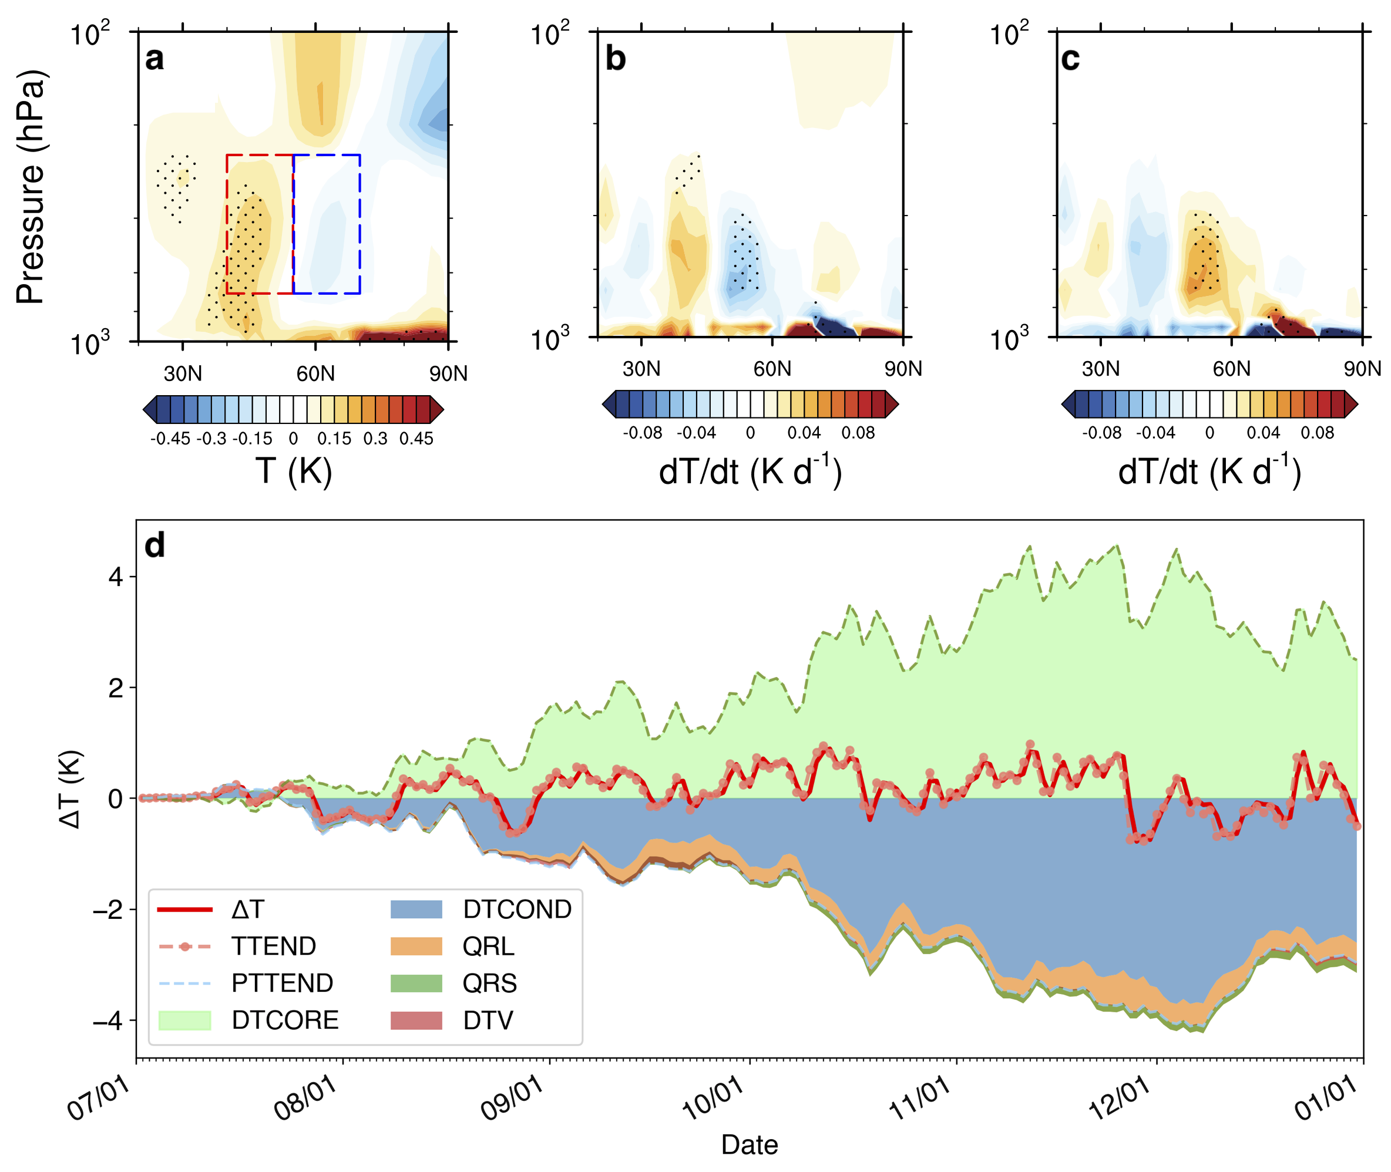
Supplementary Fig. 7. Air temperature and its tendency responses in the CESM-RESFire experiments. a, zonally-averaged temperature difference between the SICexp- and SICexp+ sensitivity experiments as shown in Fig. 3c. The red (blue) box outlines a warm (cool) region in response to the sea-ice perturbation in the SICexp- and SICexp+ experiments, which is averaged for the meridional temperature gradient ($∆T=\left|T_{warm}\right|-\left|T_{cool}\right|$) decomposition in d. b, As in a, but for the difference between the SIC- and SIC+ experiments in zonally-averaged temperature tendency due to dynamic processes (DTCORE). c, As in a, but for the temperature tendency difference due to total physical processes (PTTEND). d, time series of the meridional gradient in temperature anomaly ($∆T$) and its decomposition into each contributing component, including TTEND as the time integral of the total temperature tendency, PTTEND as the time integral of the temperature tendency due to total physical processes, DTCORE as the time integral of the temperature tendency due to dynamic processes, DTCOND as the time integral of the temperature tendency due to moisture processes, QRL as the time integral of longwave heating rate, QRS as the time integral of shortwave heating rate, and DTV as the time integral of the temperature tendency due to vertical diffusion ($TTEND=DTCORE+PTTEND=DTCORE+DTCOND+QRL+QRS+DTV$)). All these terms are calculated as the differences between the SIC- and SIC+ experiments. Stipples in a-c show regions that are significantly different from 0 at the 0.1 significance level of two-sided t-test.

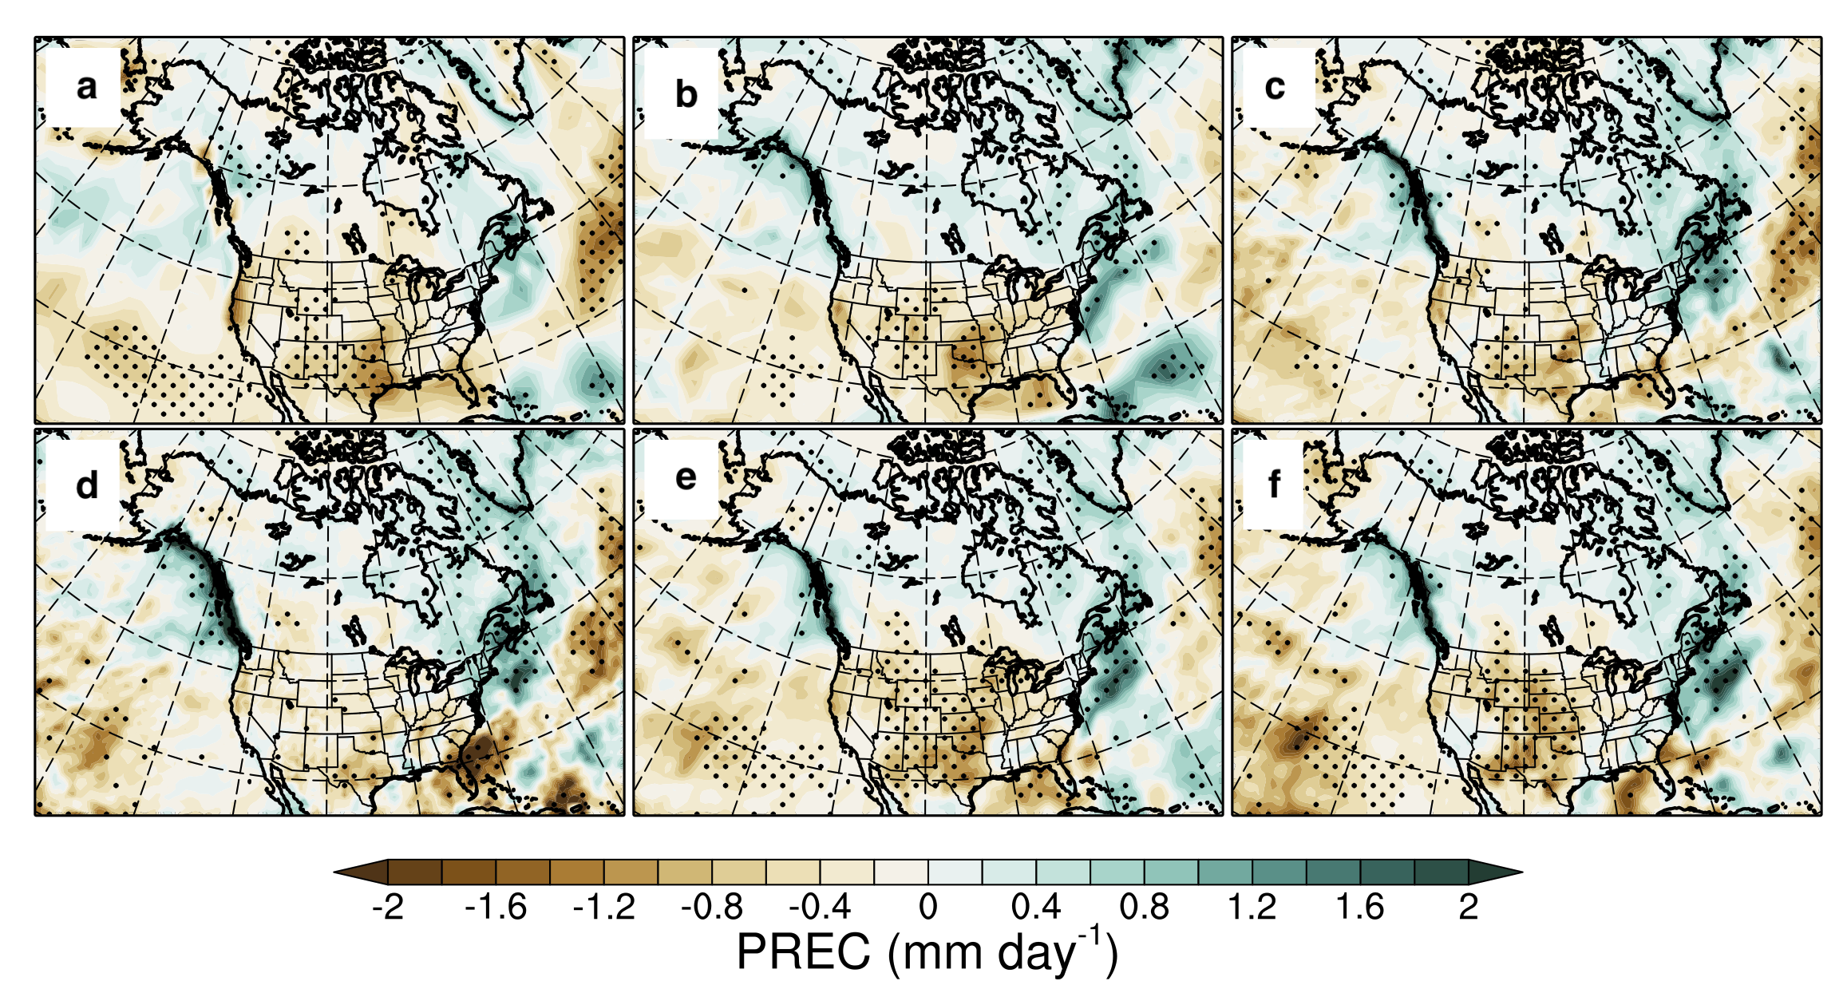
Supplementary Fig. 8. The composite difference of the seasonal average (September to December) total precipitation rates between the SIC- and SIC+ years based on different observational and reanalysis data. a, the precipitation difference based on the GPCP observational data. b, As in a, but based on the ERA5 reanalysis data. c, As in a, but based on the ERA5 reanalysis data. b, As in a, but based on the MERRA-2 reanalysis data. d, As in a, but based on the CFSR reanalysis data. e, As in a, but based on the ERA-interim reanalysis data. f, As in a, but based on the JRA-55 reanalysis data. Stipples in a-f show regions that are significantly different from 0 at the 0.1 significance level of two-sided t-test.

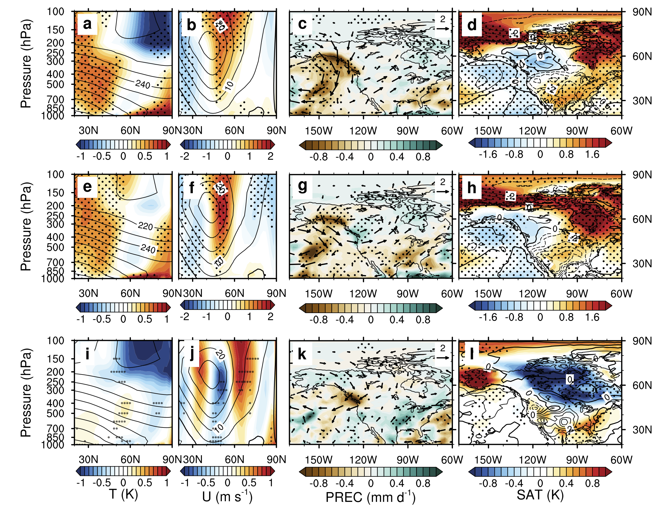
Supplementary Fig. 9. Climate and fire weather changes between the SIC- and SIC+ years based on the CMIP6 amip and amip-piForcing experiments (4-model ensemble). a, zonally-averaged (170 °W to 60 °W; as shown in c) temperature composite difference (shading) in autumn and early winter (September to December) between the SIC- and SIC+ years (as shown in Fig. 4a) in the amip experiment. The climatology of zonally-averaged temperature in the SIC+ years is also shown (contours; unit: K). b, As in a, but for zonally-averaged zonal wind in the amip experiment. c, As in b, but for wind circulation at 500 hPa (arrows; unit: m) and total precipitation rate (shading) differences in the amip experiment. d, As in c, but for 2-m relative humidity (contours with negative values in dashed lines; unit: %) and 2-m surface temperature (shading) differences in the amip experiment. e-h, As in a-d, but for the corresponding variables in the amip-piForcing experiment. i-l, As in a-d, but for the differences of the corresponding variables between the amip and amip-piForcing experiments. Stipples in a-l show regions with all 4 CMIP6 models agreeing on the signs.

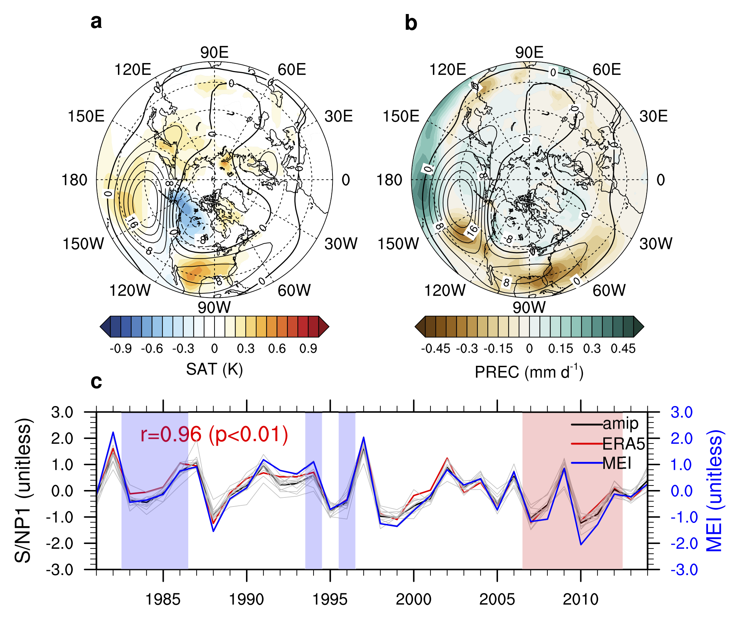
Supplementary Fig. 10. The first group of forced responses (S/NP1) in seasonal mean multi-field weather variables based on the ERA5 and CMIP6 amip experiment ensemble. a, the composite difference of S/NP1 forced responses in surface air temperature (shading) and Z500 (contours with negative values in dashed lines; unit: m) in autumn and early winter between the SIC- and SIC+ years. b, As in a, but for total precipitation rates (shading) and Z500 (contours with negative values in dashed lines; unit: m). c, timeseries of S/NP1 in the multi-variable meteorological fields based on the ERA5 (red thick line) and amip 12-model ensemble. The black thick line denotes the 12-model ensemble mean and the grey lines denote results from each model. The MEI (blue thick line) and its correlation coefficient with the ERA5 result (red thick line) are also shown for comparison and interpretation. The vertical bar shading in c denotes the SIC- (pink) and SIC+ (blue) years for the composite differences in a and b.
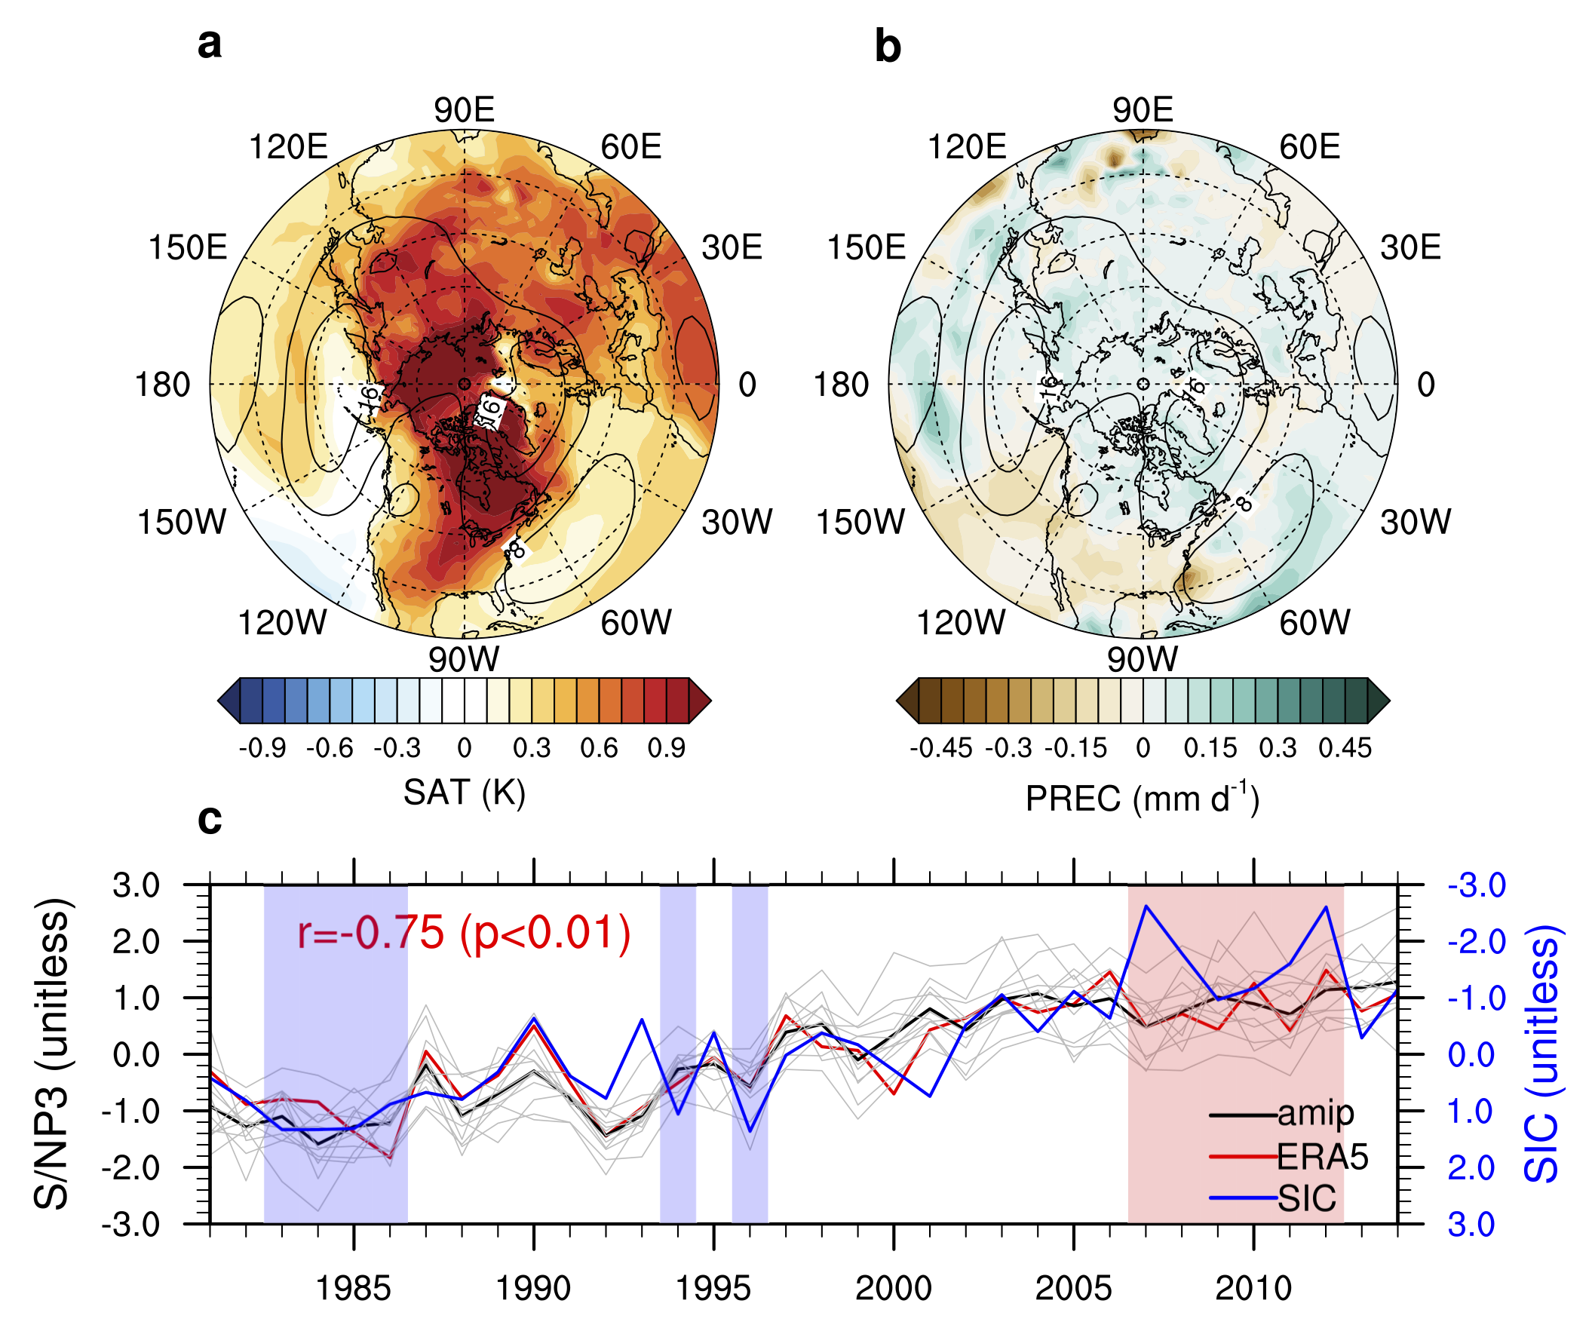
Supplementary Fig. 11. The third group of forced responses (S/NP3) in seasonal mean multi-field weather variables based on the ERA5 and CMIP6 amip experiment ensemble. a, the composite difference of S/NP3 forced responses in surface air temperature (shading) and Z500 (contours with negative values in dashed lines; unit: m) in autumn and early winter between the SIC- and SIC+ years. b, As in a, but for total precipitation rates (shading) and Z500 (contours with negative values in dashed lines; unit: m). c, timeseries of S/NP3 in the multi-variable meteorological fields based on the ERA5 (red thick line) and amip 12-model ensemble. The black thick line denotes the 12-model ensemble mean and the grey lines denote results from each model. The normalized SIC (blue thick line) and its correlation coefficient with the ERA5 result (red thick line) are also shown for comparison and interpretation. The vertical bar shading in c denotes the SIC- (pink) and SIC+ (blue) years for the composites differences in a and b.

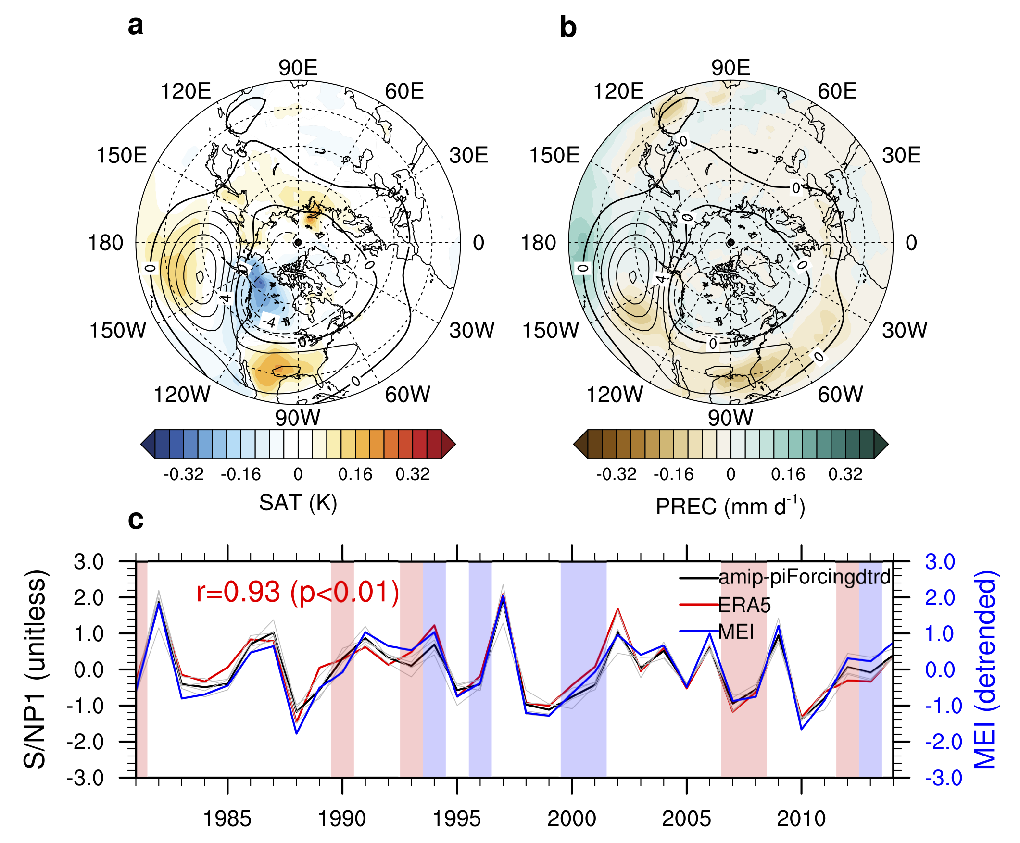
Supplementary Fig. 12. The first group of forced responses (S/NP1) in seasonal mean multi-field weather variables based on the detrended ERA5 and detrended CMIP6 amip-piForcing experiment ensemble. a, the composite difference of S/NP1 forced responses in detrended surface air temperature (shading) and detrended Z500 (contours with negative values in dashed lines; unit: m) in autumn and early winter between the SICnotrd- and SICnotrd+ years. b, As in a, but for detrended total precipitation rates (shading) and detrended Z500 (contours with negative values in dashed lines; unit: m). c, timeseries of S/NP1 in the multi-variable meteorological fields based on the detrended ERA5 (red thick line) and detrended amip-piForcing 4-model ensemble. The black thick line denotes the 4-model ensemble mean and the grey lines denote results from each model. The detrended MEI (blue thick line) and its correlation coefficient with the ERA5 result (red thick line) are also shown for comparison and interpretation. The vertical bar shading in c denotes the SICnotrd- (pink) and SICnotrd+ (blue) years for the composite differences in a and b.

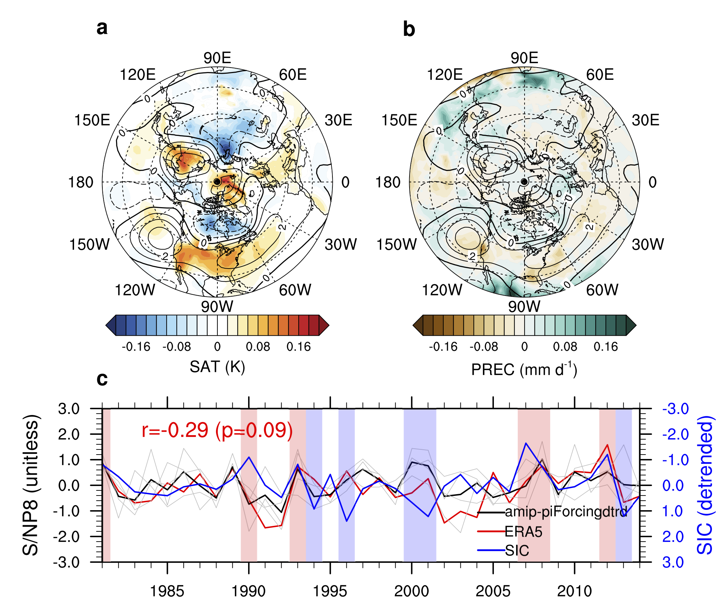
Supplementary Fig. 13. The eighth group of forced responses (S/NP8) in seasonal mean multi-field weather variables based on the detrended ERA5 and detrended CMIP6 amip-piForcing experiment ensemble. a, the composite difference of S/NP8 forced responses in detrended surface air temperature (shading) and detrended Z500 (contours with negative values in dashed lines; unit: m) in autumn and early winter between the SICnotrd- and SICnotrd+ years. b, As in a, but for detrended total precipitation rates (shading) and detrended Z500 (contours with negative values in dashed lines; unit: m). c, timeseries of S/NP8 in the multi-variable meteorological fields based on the detrended ERA5 (red thick line) and detrended amip-piForcing 4-model ensemble. The black thick line denotes the 4-model ensemble mean and the grey lines denote results from each model. The detrended SIC (blue thick line) and its correlation coefficient with the ERA5 result (red thick line) are also shown for comparison and interpretation. The vertical bar shading in c denotes the SICnotrd- (pink) and SICnotrd+ (blue) years for the composites differences in a and b.

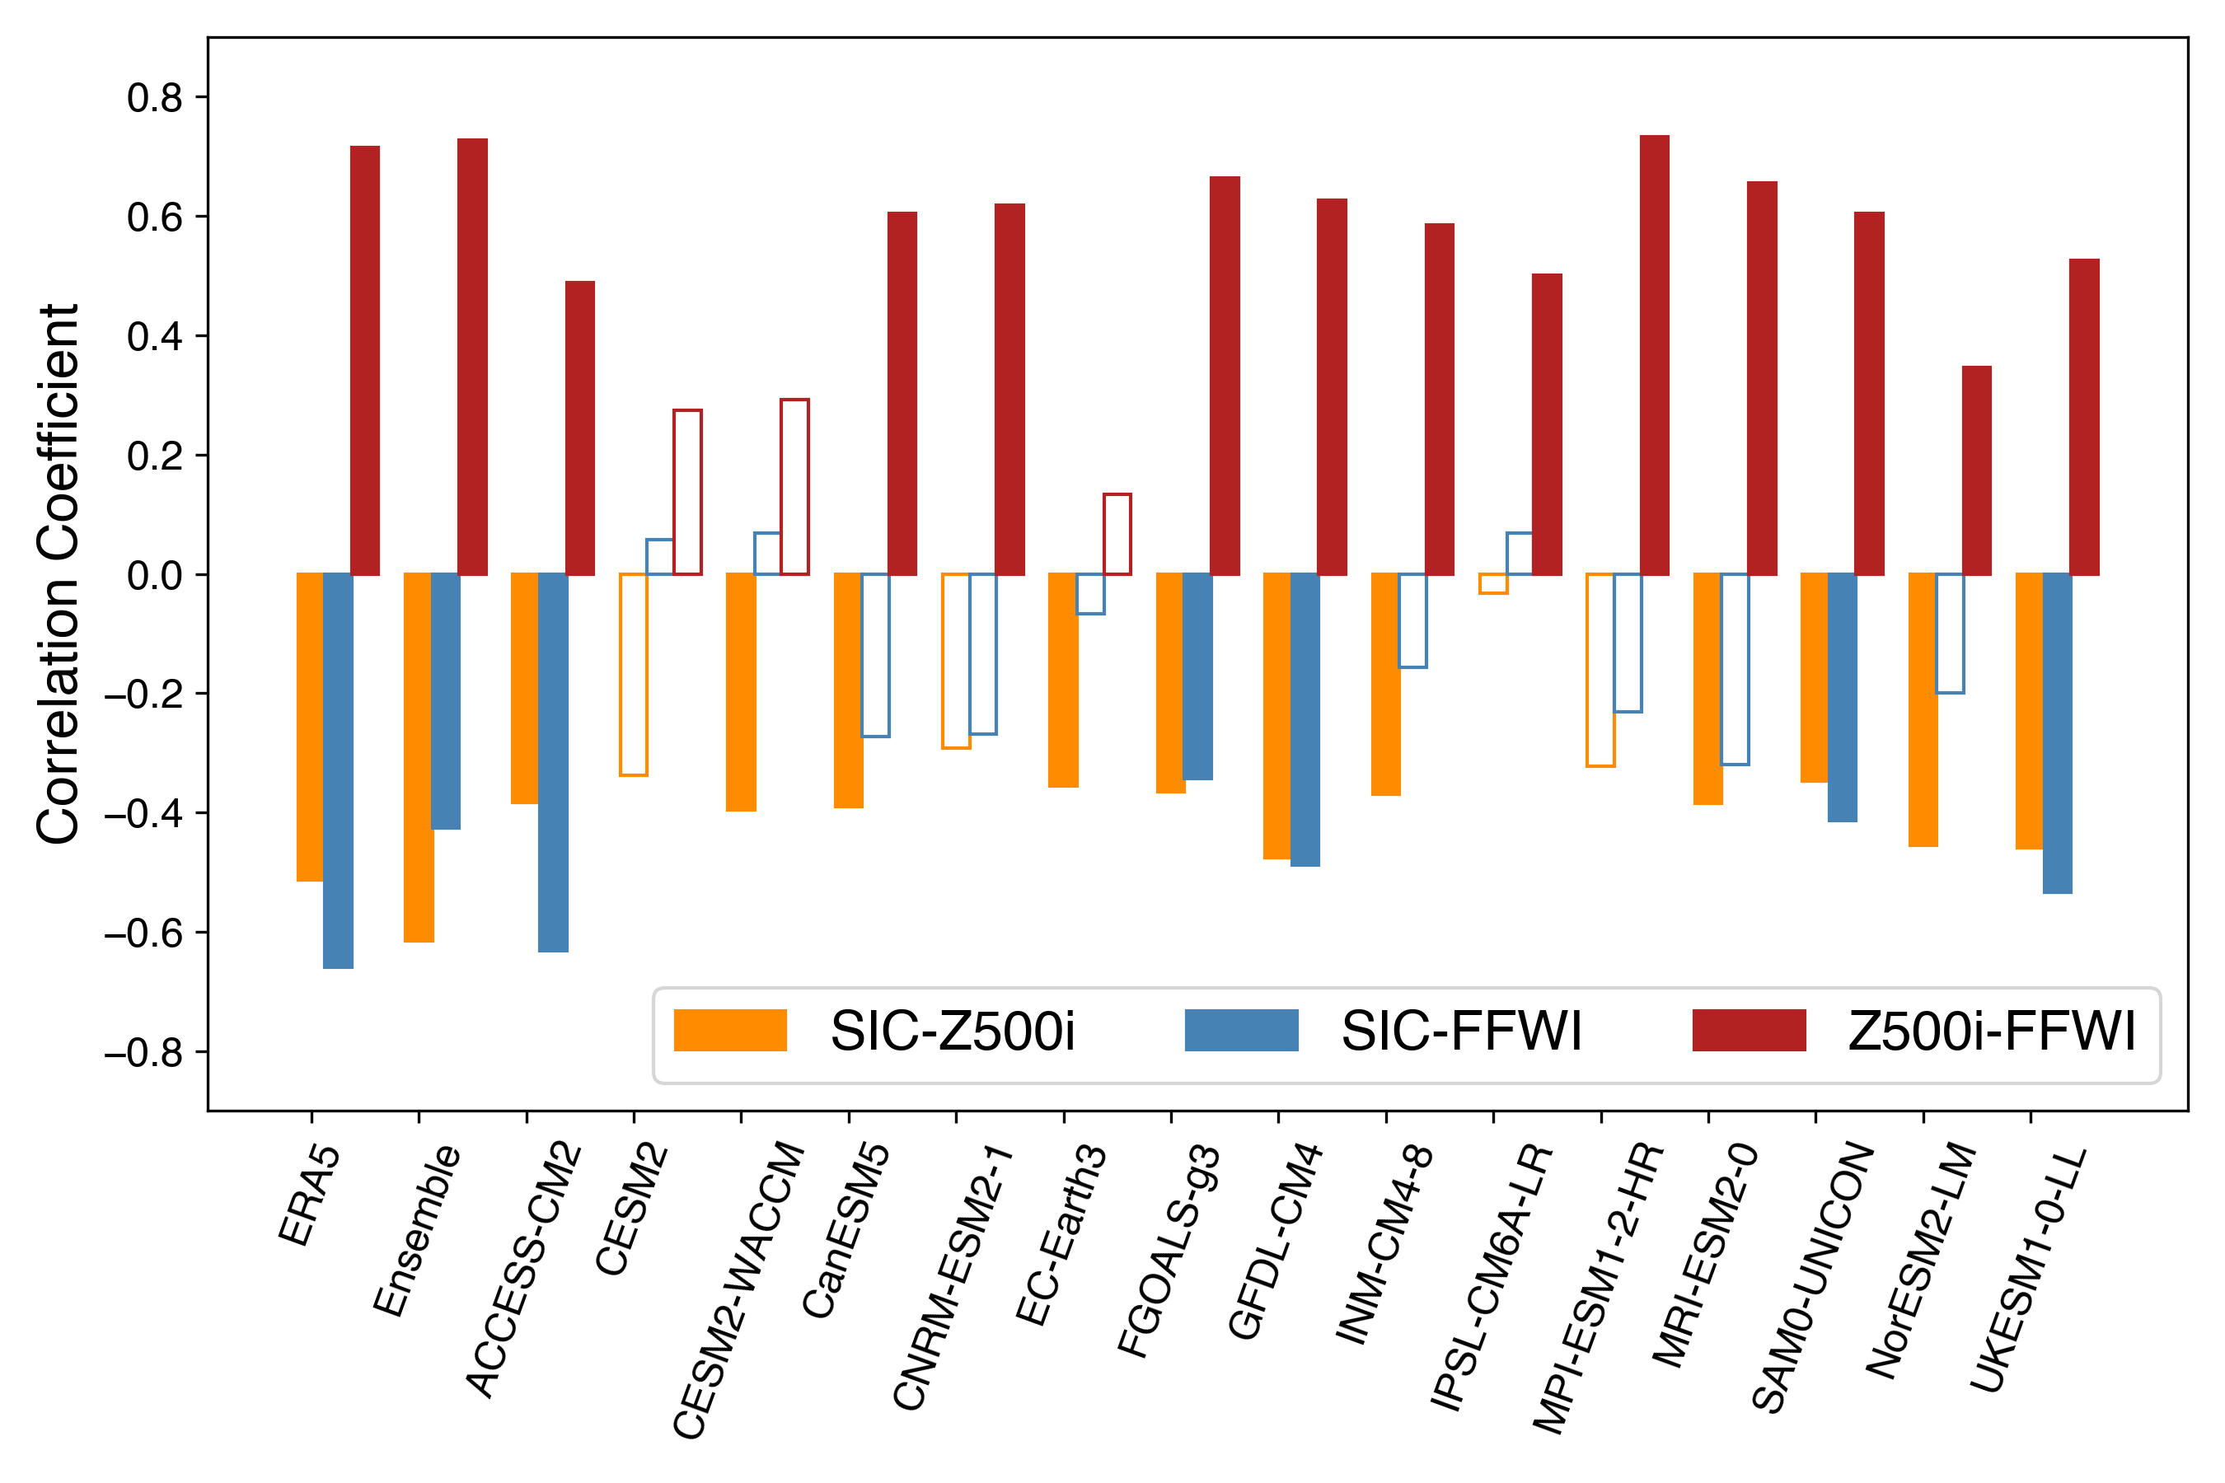
Supplementary Fig. 14. Correlation coefficients among SIC, Z500i, and FFWI in the ERA5 reanalysis data and the amip experiment (1981-2014) based on 15 CMIP6 models and their ensemble mean. The solid-colored bars show correlation coefficients at the 0.05 significance level of two-sided t-test.

Supplementary Table 1. The modeling settings of the CESM-RESFire sensitivity experiments
Experiment | CTRL | ICE+ | ICE-
Time period | 40 years | 40 years | 40 years
Horizontal resolution | 1.9°×2.5° | 1.9°×2.5° | 1.9°×2.5°
Vertical level | 70 | 70 | 70
Atmosphere | WACCM^{(a)} | WACCM | WACCM
Land | CLM4.5 with RESFire | CLM4.5 with RESFire | CLM4.5 with RESFire
Ocean | Climatology^{(b)} | ICE+ year-average regional SST for the Pacific sector of the Arctic^{(c)} | ICE- year-average regional SST for the Pacific sector of the Arctic^{(c)}
Sea ice | Climatology^{(b)} | ICE+ year-average regional SIC^{(c)} | ICE- year-average regional SIC^{(c)}
^{(a)}: using CAM5 physics package and WACCM_MOZART_MAM3 chemistry package;
^{(b)}: 1981-2010 average based on the HadISST SST and SIC data⁴⁵;
^{(c)}: see the main text and Fig. 2a for the region definition;

Supplementary Table 2. The CMIP6 models in the amip experiment used in this study
Model Name | Institute ID | Experiment ID | Ensemble Member
ACCESS-CM2⁶⁵ | CSIRO-ARCCSS | amip | r1i1p1f1
CanESM5⁶⁶ | CCCma | amip | r1i1p1f1
CESM2⁶⁷ | NCAR | amip | r1i1p1f1
CESM2-WACCM⁶⁸ | NCAR | amip | r1i1p1f1
CNRM-ESM2-1⁶⁹ | CNRM-CERFACS | amip | r1i1p1f2
EC-Earth3⁷⁰ | EC-Earth-Consortium | amip | r1i1p1f1
FGOALS-g3⁷¹ | CAS | amip | r1i1p1f1
GFDL-CM4⁷² | NOAA-GFDL | amip | r1i1p1f1
INM-CM4-8⁷³ | INM | amip | r1i1p1f1
IPSL-CM6A-LR⁷⁴ | IPSL | amip | r1i1p1f1
MPI-ESM1-2-HR⁷⁵ | MPI-M | amip | r1i1p1f1
MRI-ESM2-0⁷⁶ | MRI | amip | r1i1p1f1
NorESM2-LM⁷⁷ | NCC | amip | r1i1p1f1
SAM0-UNICON⁷⁸ | SNU | amip | r1i1p1f1
UKESM1-0-LL⁷⁹ | MOHC | amip | r1i1p1f2

Supplementary Table 3. The CMIP6 models in the amip-piForcing experiment used in this study
Model Name | Institute ID | Experiment ID | Ensemble Member
CanESM5⁸⁰ | CCCma | amip-piForcing | r1i1p2f1
HadGEM3-GC31-LL⁸¹ | MOHC | amip-piForcing | r1i1p1f3
IPSL-CM6A-LR⁸² | IPSL | amip-piForcing | r1i1p1f1
MRI-ESM2-0⁸³ | MRI | amip-piForcing | r1i1p1f1

References:
65 Dix, M. et al. (Earth System Grid Federation, 2019).
66 Swart, N. C. et al. (Earth System Grid Federation, 2019).
67 Danabasoglu, G. (Earth System Grid Federation, 2019).
68 Danabasoglu, G. (Earth System Grid Federation, 2019).
69 Seferian, R. (Earth System Grid Federation, 2018).
70 Consortium, E. C.-E. (Earth System Grid Federation, 2019).
71 Li, L. (Earth System Grid Federation, 2019).
72 Guo, H. et al. (Earth System Grid Federation, 2018).
73 Volodin, E. et al. (Earth System Grid Federation, 2019).
74 Boucher, O., Denvil, S., Caubel, A. & Foujols, M. A. (Earth System Grid Federation, 2018).
75 Jungclaus, J. et al. (Earth System Grid Federation, 2019).
76 Yukimoto, S. et al. (Earth System Grid Federation, 2019).
77 Seland, Ø. et al. (Earth System Grid Federation, 2019).
78 Park, S. & Shin, J. (Earth System Grid Federation, 2019).
79 Tang, Y. et al. (Earth System Grid Federation, 2019).
80 Cole, J. N. S. et al. (Earth System Grid Federation, 2019).
81 Webb, M. (Earth System Grid Federation, 2019).
82 Boucher, O., Denvil, S., Caubel, A. & Foujols, M. A. (Earth System Grid Federation, 2019).
83 Yukimoto, S. et al. (Earth System Grid Federation, 2019).

