Supporting Informations
for
Multistep synthesis, reactivity and X-ray structure of the anisole-terminated iron(II) polyhalogenoclathrochelates and their monoribbed-functionalized macrobicyclic derivatives
Ilya P. Limarev,^{a,b} Genrikh E. Zelinskii,^{a,b} Danila O. Mosov,ª
Anna V. Vologzhaninaª, Pavel V. Dorovatovskii,^{c} Vladimir A. Lazarenko,^{c} Ekaterina G. Lebed ^{a,b} and Yan Z. Voloshin*^{,a,b}
ªNesmeyanov Institute of Organoelement Compounds of the Russian Academy of Sciences, 28–1 Vavilova st., 119334 Moscow, Russia
^{b}Kurnakov Institute of General and Inorganic Chemistry of the Russian Academy of Sciences, 31 Leninsky pr., 119991 Moscow, Russia
^{c}National Research Center “Kurchatov Institute”, 1 Kurchatova pl., 123098, Moscow, Russia
*Corresponding author E-mail: voloshin@ineos.ac.ru, voloshin@igic.ras.ru

Figure S1. Solution UV-vis spectrum of the clathrochelate Fe(Сl₂Gm)₃(B4-C₆H₄OCH₃)₂ in CH₂Cl₂ (shown in black line) and its deconvolution into the Gaussian components (shown in color lines).
Figure S2. Solution UV-vis spectrum of the clathrochelate Fe(Сl₂Gm)₂(PrchGm)(B4-C₆H₄OCH₃)₂ in CH₂Cl₂ (shown in black line) and its deconvolution into the Gaussian components (shown in color lines).
Figure S3. Solution UV-vis spectrum of the clathrochelate Fe(Сl₂Gm)₂(S₂-Nx)(B4-C₆H₄OCH₃)₂
in CH₂Cl₂ (shown in black line) and its deconvolution into the Gaussian components (shown in color lines).
Figure S4. Solution UV-vis spectrum of the clathrochelate Fe(Сl₂Gm)(S₂-Nx)₂(B4-C₆H₄OCH₃)₂
in CH₂Cl₂ (shown in black line) and its deconvolution into the Gaussian components (shown in color lines).
Figure S5. Solution UV-vis spectrum of the clathrochelate Fe((S₂-Nx)₂(S-n-C₄H₉)₂Gm)(B4-C₆H₄OCH₃)₂ in CH₂Cl₂ (shown in black line) and its deconvolution into the Gaussian components (shown in color lines).
Figure S6. Solution UV-vis spectrum of the 4-methoxyphenylboronic acid in CH₃OH (shown in black line) and its deconvolution into the Gaussian components (shown in color lines).

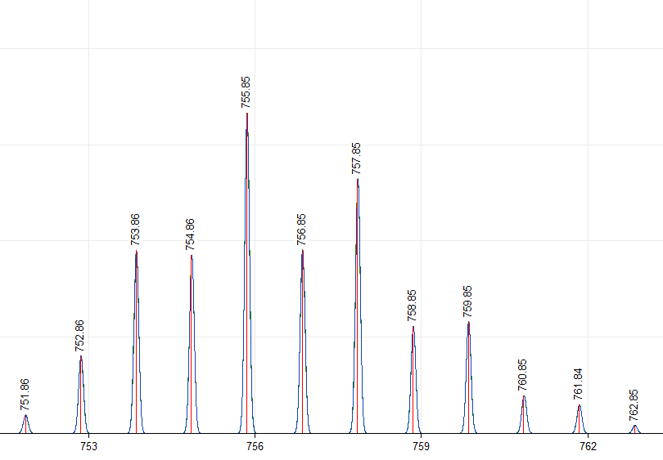
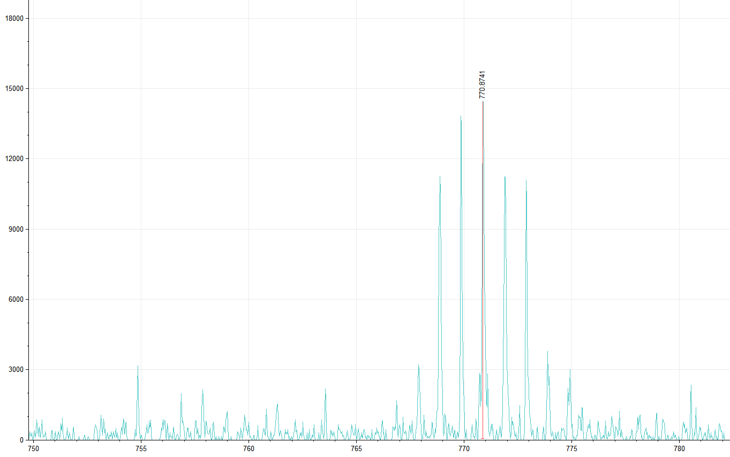
Figure S7. Fragment of the MALDI-TOF mass spectrum of Fe(Cl₂Gm)₃(B4-C₆H₄OCH₃)₂ in its positive range.
Insert: the theoretically calculated isotopic distribution in its molecular ion.

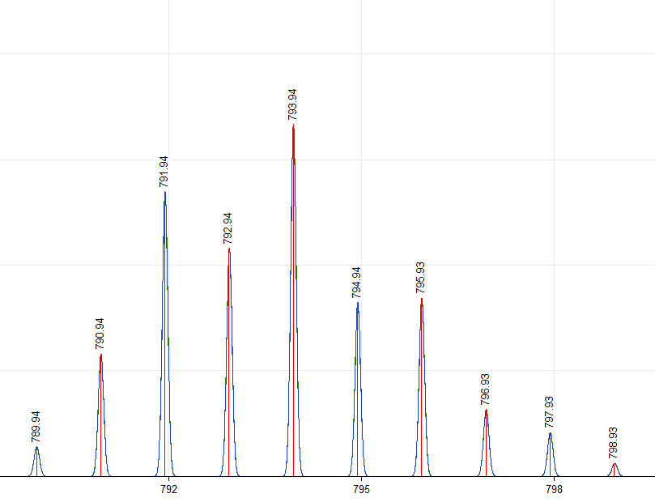
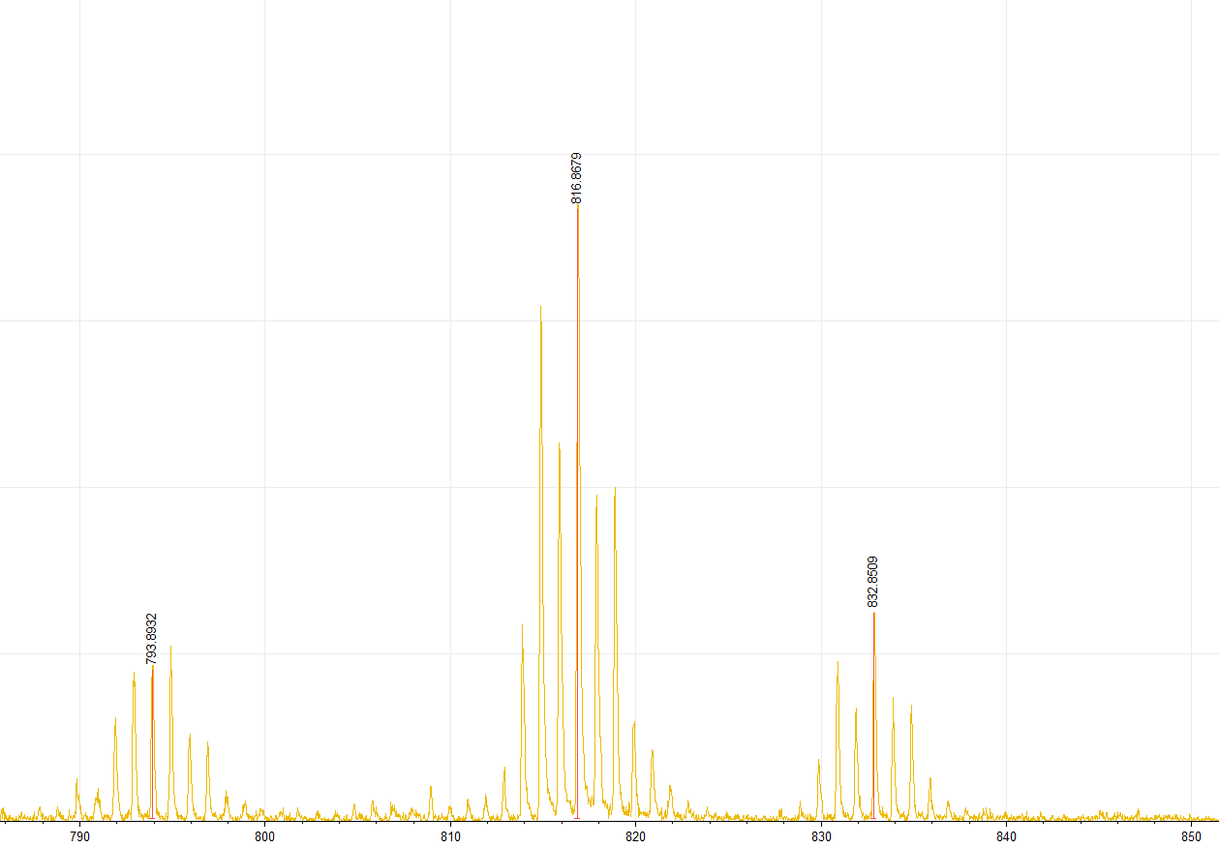
Figure S8. Fragment of the MALDI-TOF mass spectrum of Fe(Cl₂Gm)₂(PrchGm)(B4-C₆H₄OCH₃)₂ in its positive range.
Insert: the theoretically calculated isotopic distribution in its molecular ion.
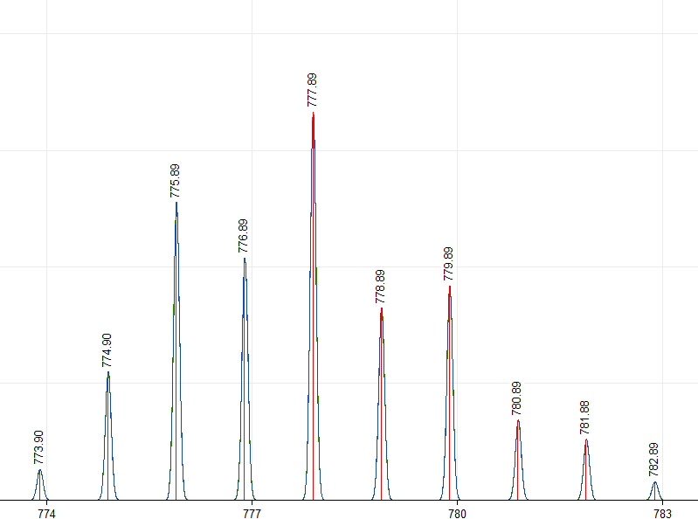
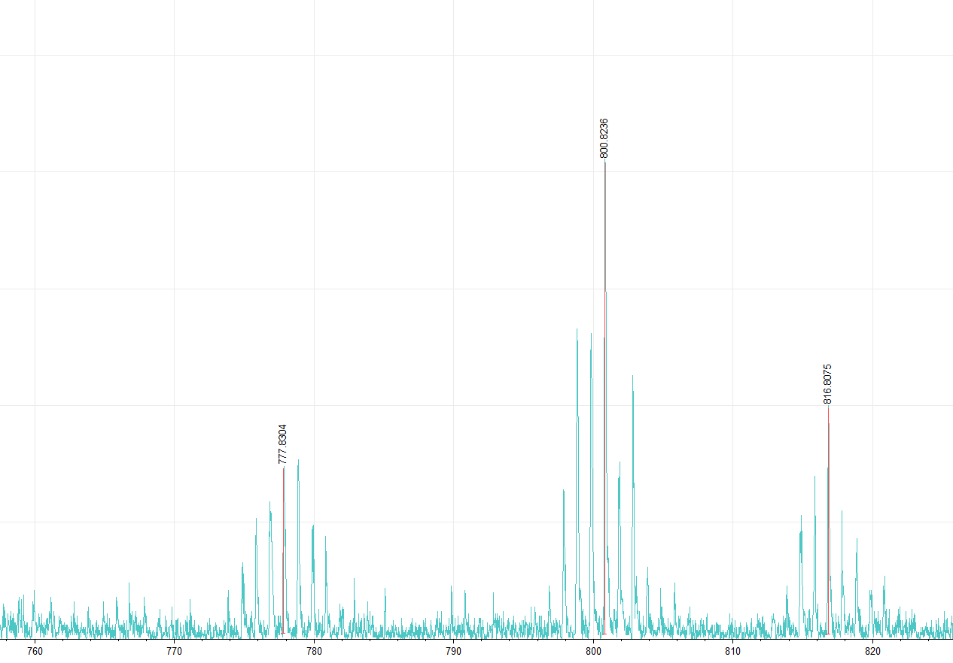
Figure S9. Fragment of the MALDI-TOF mass spectrum of Fe(Cl₂Gm)₂(S₂-Nx)(B4-C₆H₄OCH₃)₂ in its positive range.
Insert: the theoretically calculated isotopic distribution in its molecular ion.

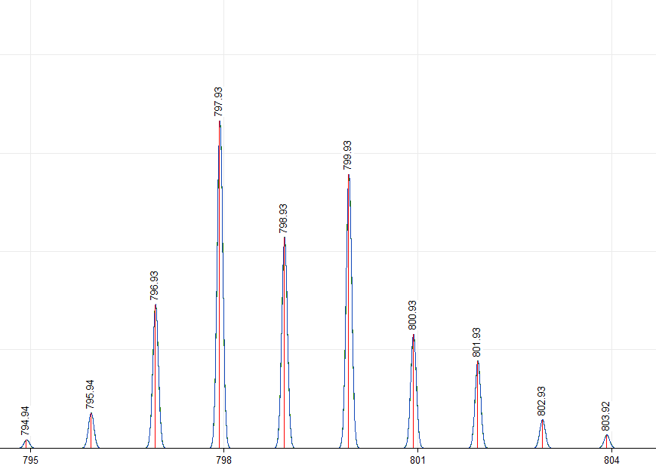
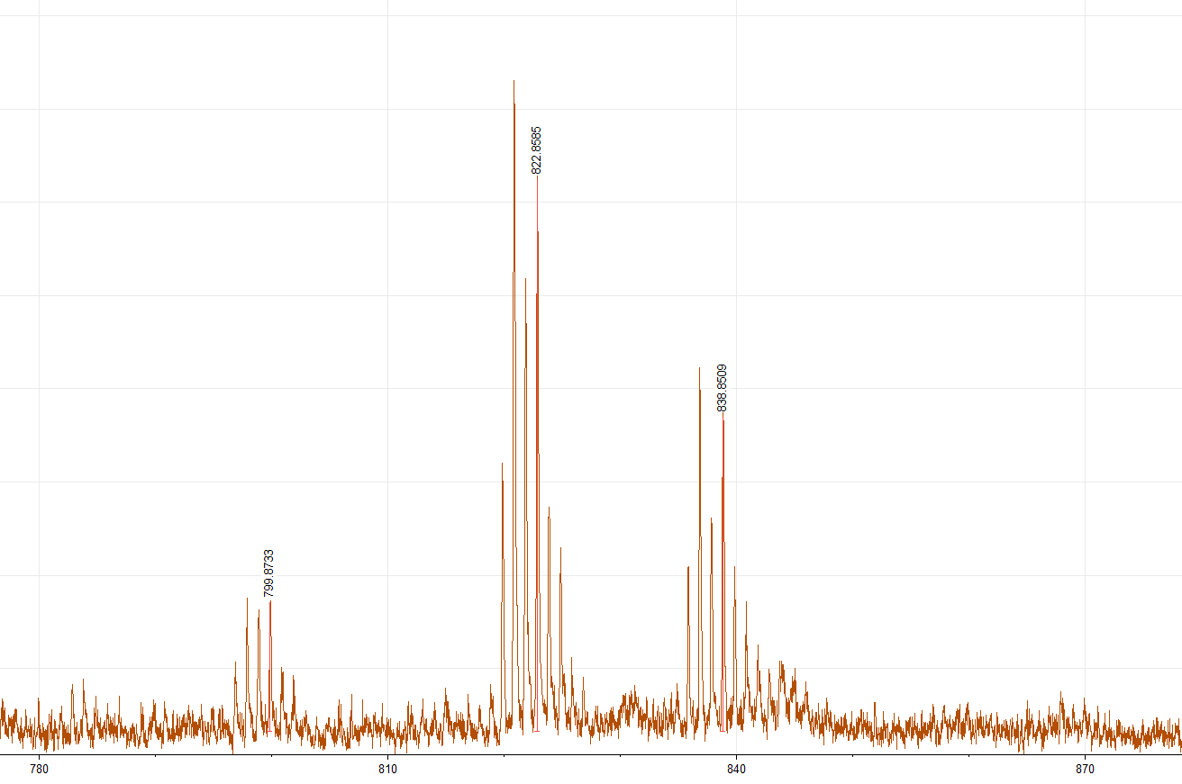
Figure S10. Fragment of the MALDI-TOF mass spectrum of Fe(Cl₂Gm)(S₂-Nx)₂(B4-C₆H₄OCH₃)₂ in its positive range.
Insert: the theoretically calculated isotopic distribution in its molecular ion.
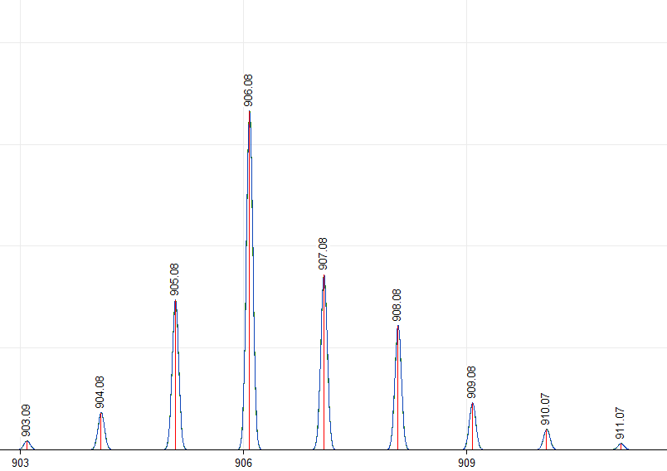
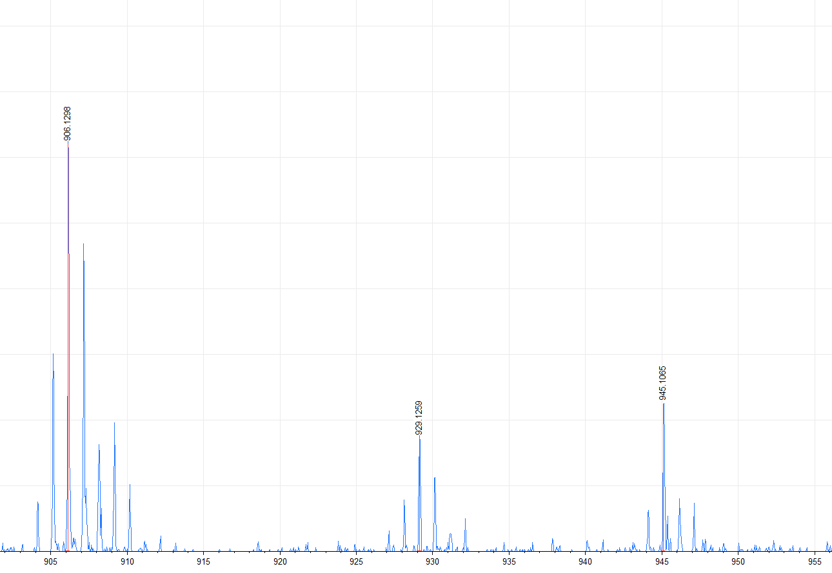
Figure S11. Fragment of the MALDI-TOF mass spectrum of Fe((S₂-Nx)₂(S-n-C₄H₉)₂Gm)(B4-C₆H₄OCH₃)₂ in its positive range. Insert: the theoretically calculated isotopic distribution in its molecular ion.
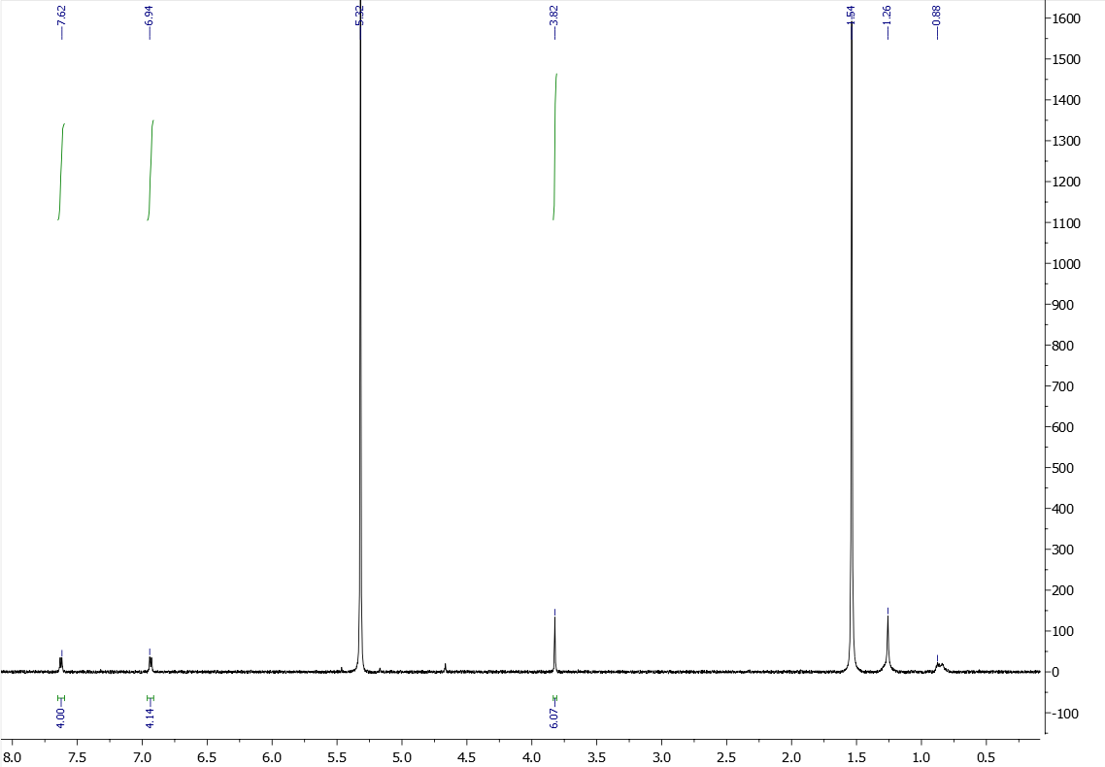
δ¹_{H} (ppm)

Figure S12. ¹H NMR spectrum of the clathrochelate Fe(Cl₂Gm)₃(B4-C₆H₄OCH₃)₂ in CD₂Cl₂

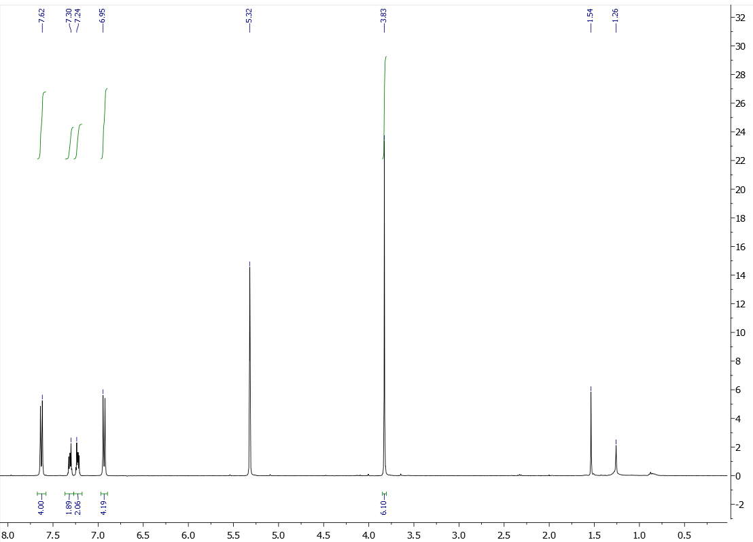
δ¹_{H} (ppm)

Figure S13. ¹H NMR spectrum of the clathrochelate Fe(Cl₂Gm)₂(PrchGm)(B4-C₆H₄OCH₃)₂ in CD₂Cl₂

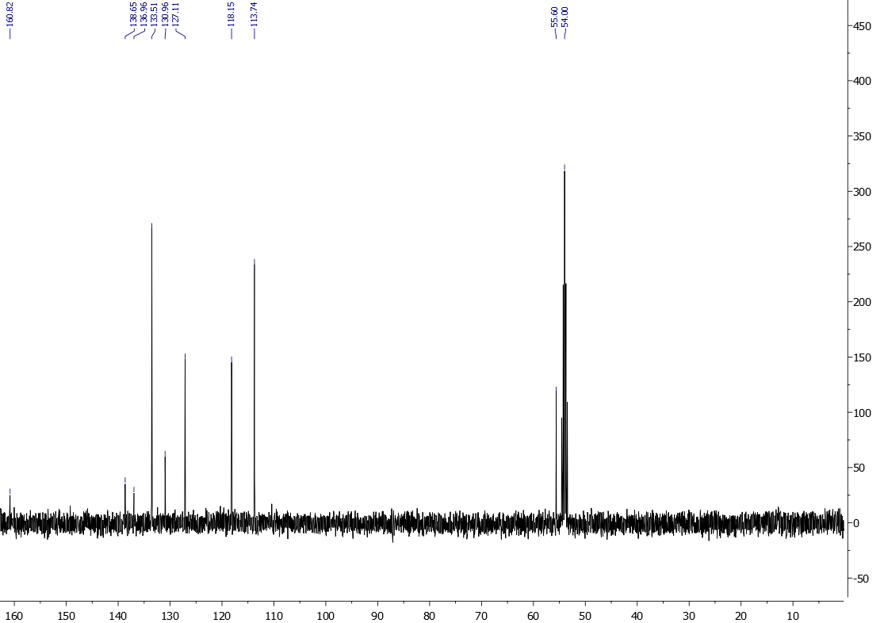
δ¹³C (ppm)

Figure S14. ¹³C{¹H} NMR spectrum of the clathrochelate Fe(Cl₂Gm)₂(PrchGm)(B4-C₆H₄OCH₃)₂ in CD₂Cl₂

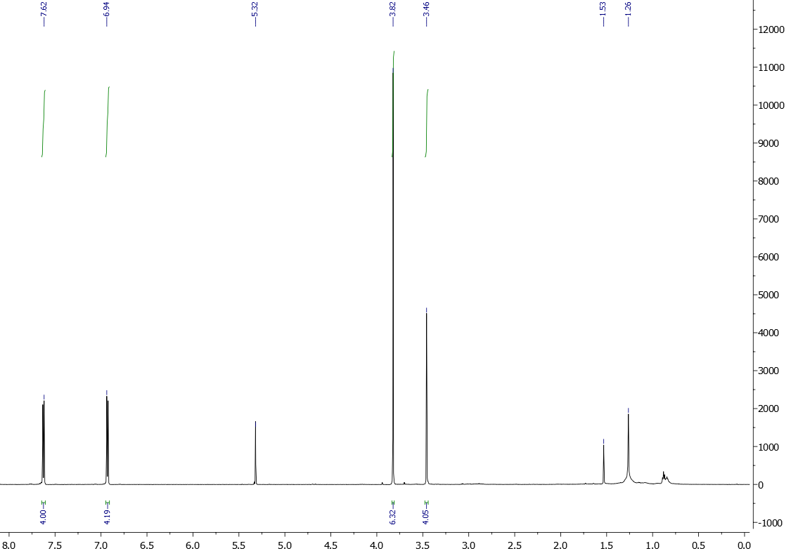
δ¹_{H} (ppm)

Figure S15. ¹H NMR spectrum of the clathrochelate Fe(Cl₂Gm)₂(S₂-Nx)(B4-C₆H₄OCH₃)₂ in CD₂Cl₂
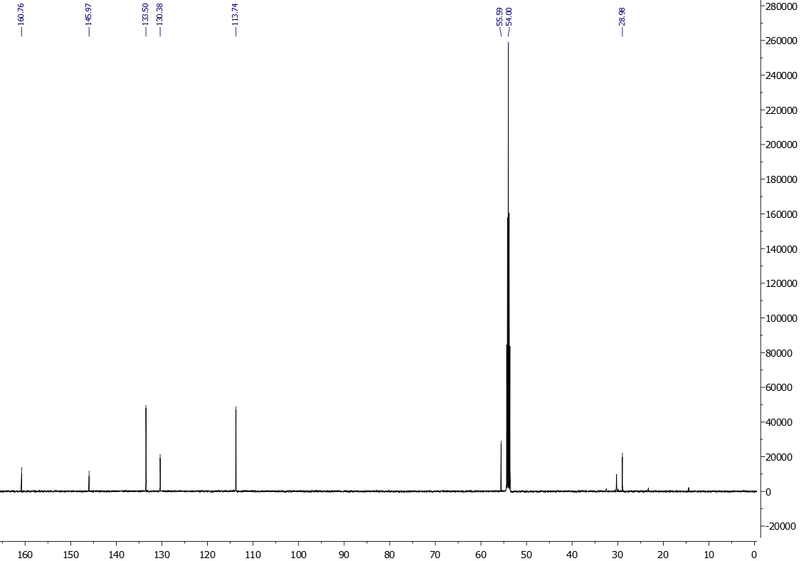δ¹³_{C} (ppm)

Figure S16. ¹³C{¹H} NMR spectrum of the clathrochelate Fe(Cl₂Gm)₂(S₂-Nx)(B4-C₆H₄OCH₃)₂ in CD₂Cl₂
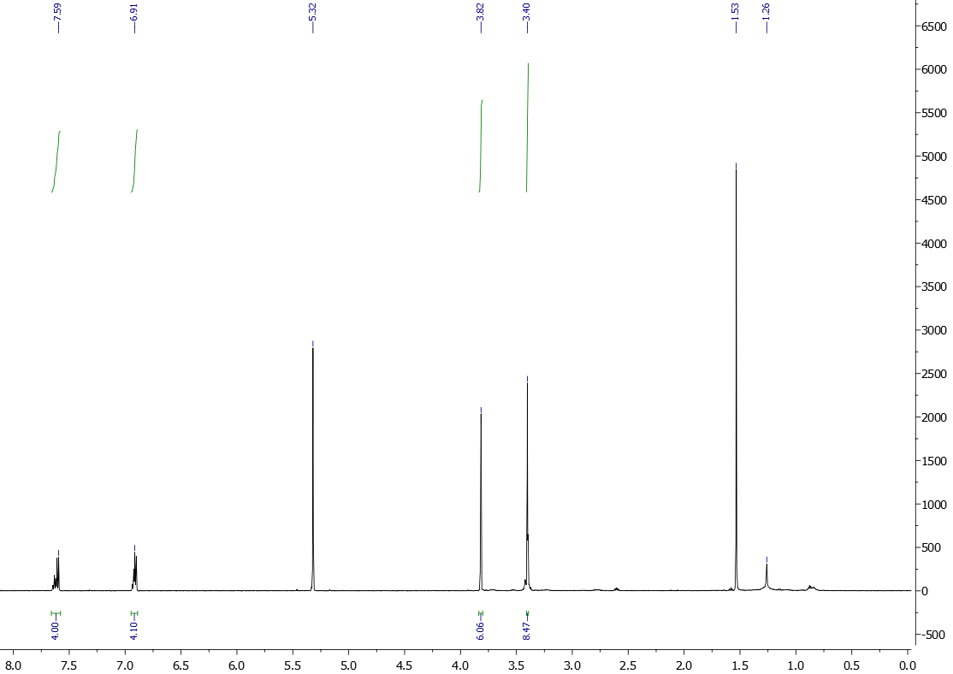
δ¹_{H} (ppm)

Figure S17. ¹H NMR spectrum of the clathrochelate Fe(Cl₂Gm)(S₂-Nx)₂(B4-C₆H₄OCH₃)₂ in CD₂Cl₂
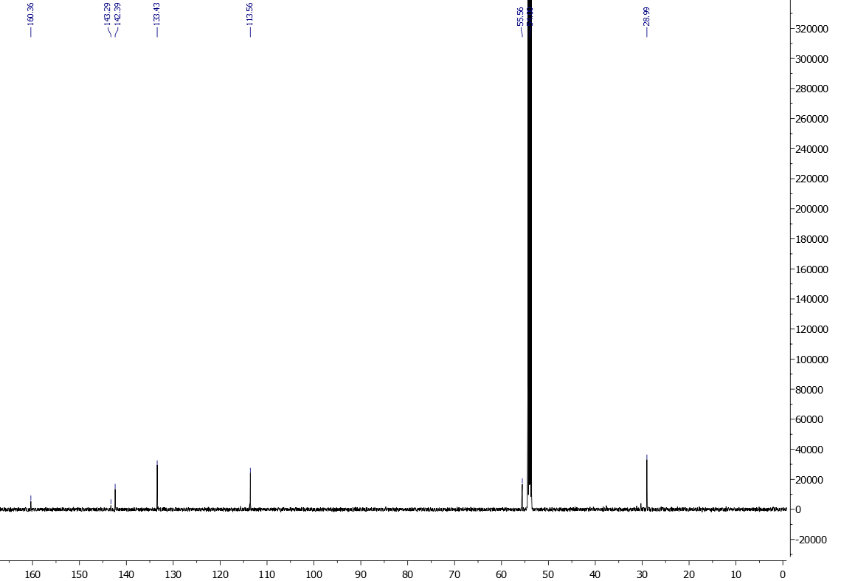
δ¹³_{C} (ppm)

Figure S18. ¹³C{¹H} NMR spectrum of the clathrochelate Fe(Cl₂Gm)(S₂-Nx)₂(B4-C₆H₄OCH₃)₂ in CD₂Cl₂
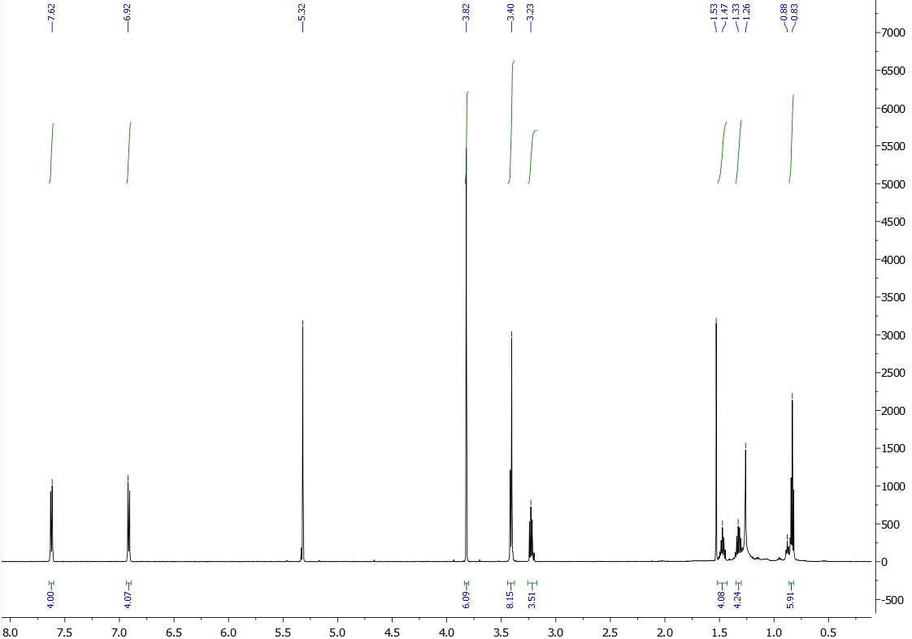
δ¹_{H} (ppm)

Figure S19. ¹H NMR spectrum of the clathrochelate Fe((S₂-Nx)₂(S-n-C₄H₉)₂Gm)(B4-C₆H₄OCH₃)₂ in CD₂Cl₂
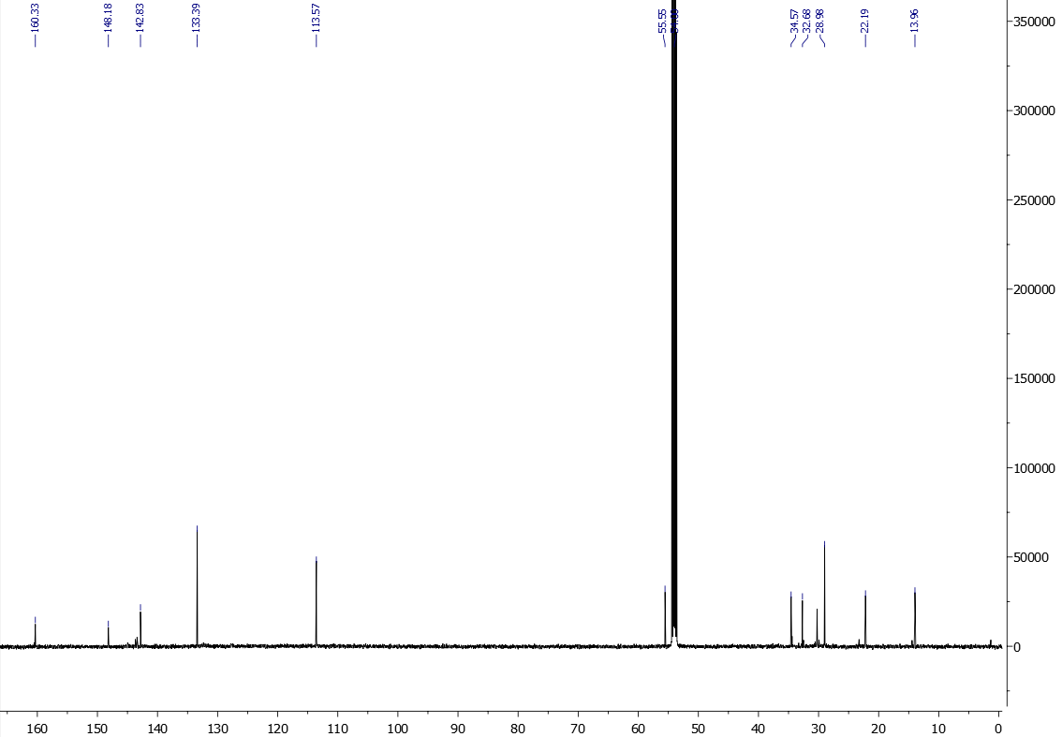
δ¹³_{C} (ppm)

Figure S20. ¹³C{¹H} NMR spectrum of the clathrochelate Fe((S₂-Nx)₂(S-n-C₄H₉)₂Gm)(B4-C₆H₄OCH₃)₂ in CD₂Cl₂
Table S1. Deconvoluted solution UV-vis spectra (ν, cm^{–1}, ε×10^{–3}, mol^{–1}·l·cm^{–1}) of the anisoleboron-capped iron(II) clathrochelates in dichloromethane and that of 4-methoxyphenylboronic acid in methanol
Compound | ν₁ | ν₂ | ν₃ | ν₄ | ν₅ | ν₆ | ν₇ | ν₈ | ν₉ | ν₁₀
Fe(Сl₂Gm)₃(B4-C₆H₄OCH₃)₂ | 43329  (42) | 40500  (2.4) | 39570  (3.3) | 37628  (12) | 32622  (7.0) | 28352  (1.3) | 23755  (2.1) | 23179  (6.4) | 22062  (7.8)
Fe(Сl₂Gm)₂(PrchGm)(B4-C₆H₄OCH₃)₂ | 43434  (48) | 40596  (4.5) | 39454  (11) | 36767  (8.6) | 33924  (11) | 28971  (3.6) | 26099  (1.7) |  | 22437  (13)
Fe(Сl₂Gm)₂(S₂-Nx)(B4-C₆H₄OCH₃)₂ | 43316  (40) | 40582  (5.4) | 39092  (9.4) | 36410  (1.0) | 34415  (10) |  | 23698  (3.4) |  | 21526  (11)
Fe(Сl₂Gm)(S₂-Nx)₂(B4-C₆H₄OCH₃)₂ | 43394  (44) | 40534  (7.5) | 38795  (16) | 36154  (2.2) | 33360  (12) | 24011  (3.8) |  |  | 21019  (15)
Fe((S₂-Nx)₂(S-n-C₄H₉)₂Gm)(B4-C₆H₄OCH₃)₂ | 43477  (23) | 40697  (5.4) | 38692  (7.9) | 36093  (1.4) | 33274  (6.0) | 26094  (1.4) | 23835  (0.9) |  | 20801  (8.4)
4-CH₃OC₆H₄B(OH)₂ | 49652  (31) | 48173  (4.7) | 45130  (3.5) | 42769  (10) | 41365  (5.5) | 38235  (0.7) | 36646  (1.0) | 35605  (0.7)

Table S2. Crystallographic data and refinement parameters for the anisoleboron-capped iron(II) clathrochelates
Parameter | Fe(Cl₂Gm)₃(B4-C₆H₄OCH₃)₂ | Fe(S₂-Nx)₂(Cl₂Gm)(B4-C₆H₄OCH₃)₂·2C₆H₆ | Fe(S₂-Nx)₂((S-n-C₄H₉)₂Gm)(B4-C₆H₄OCH₃)₂
Empirical formula | C₂₀H₁₄B₂Cl₆FeN₆O₈ | C₃₆H₃₄B₂Cl₂FeN₆O₈S₄ | C₃₂H₄₀B₂FeN₆O₈S₆
Fw | 750.64 | 955.30 | 906.53
Crystal system, space group | Monoclinic, C2/c | Triclinic, P -1 | Orthorhombic, P2₁2₁2₁
a (Å) | 25.4978(13) | 8.1820(16) | 8.2360(16)
b (Å) | 7.9006(4) | 20.556(4) | 14.891(3)
c (Å) | 16.6673(8) | 25.168(5) | 31.673(6)
α (°) | 90 | 103.81(3) | 90
β (°) | 124.805(2) | 91.53(3) | 90
γ (°) | 90 | 100.61(3) | 90
V (Å³) | 2756.9(2) | 4029.2(15) | 3884.4(13)
Z | 4 | 4 | 4
μ (cm^{–1}) | 1.188 | 0.878 | 0.870
No. of measured, independent and observed [I > 2σ(I)] reflections | 17639, 4232, 2791 | 40360, 14324, 11664 | 20897, 6560, 5248
R_{int} | 0.064 | 0.050 | 0.057
R[F² > 2σ(F²)], wR(F²), S | 0.050, 0.127, 1.07 | 0.108, 0.260, 1.06 | 0.043, 0.105, 1.02
Δρ_{max}, Δρ_{min} (e Å⁻³) | 0.468, -0.463 | 2.312, -0.916 | 0.373, -0.309

