Enhance energy supply of largemouth bass (Micropterus salmoides) in gills during acute hypoxia exposure
Qiao Liu*, Hong Wang*, Jiayu Ge, Jie Luo, Kuo He, Haoxiao Yan, Xin Zhang, Rabia Tahir, Wei Luo, Zhiqiong Li, Song Yang#, Liulan Zhao#
*These authors have contributed equally to this work
#Corresponding author
E-mail addresses:
Qiao Liu (liuqiaosau@163.com); Hong Wang (939757417@qq.com);
Jiayu Ge (1975435458@qq.com); Jie Luo (335890494@qq.com);
Kuo He (897285204@qq.com); Haoxiao Yan (yhx07272022@hotmail.com);
Xin Zhang (737312802@qq.com); Rabia Tahir (rabiatahir7012@gmail.com);
Wei Luo (514270367@qq.com); Zhiqiong Li (10986@sicau.edu.cn);
Song Yang (ysys210@hotmail.com); Liulan Zhao (119065966@qq.com).

Supplementary
Supplementary table-1
Summary of the transcriptome of the gill of largemouth bass (Micropterus salmoides)
SampleID | Total Reads | mapped Reads(%) | Clean reads | Clean bases | %≥Q30
C0h-1 | 46012008 | 94.03% | 23006004 | 6900251948 | 94.08%
C0h-2 | 48943328 | 93.06% | 24471664 | 7331632162 | 93.38%
C0h-3 | 45142134 | 93.45% | 22571067 | 6762617946 | 93.90%
C4h-1 | 52844656 | 93.55% | 26422328 | 7919697458 | 93.05%
C4h-2 | 42208500 | 93.58% | 21104250 | 6324401748 | 93.70%
C4h-3 | 56358858 | 92.28% | 28179429 | 8445121504 | 92.80%
C8h-1 | 46125198 | 93.79% | 23062599 | 6912757882 | 93.52%
C8h-2 | 39782924 | 93.75% | 19891462 | 5966700696 | 92.84%
C8h-3 | 45936590 | 93.09% | 22968295 | 6884189354 | 93.09%
C12h-1 | 44668028 | 93.63% | 22334014 | 6691232932 | 93.10%
C12h-2 | 43313208 | 93.86% | 21656604 | 6491738762 | 93.56%
C12h-3 | 42647356 | 93.79% | 21323678 | 6395385250 | 93.51%
C24h-1 | 41635208 | 93.51% | 20817604 | 6239043014 | 93.17%
C24h-2 | 44041136 | 93.36% | 22020568 | 6598933392 | 92.36%
C24h-3 | 40437398 | 93.38% | 20218699 | 6059580740 | 93.62%
H0h-1 | 40803084 | 93.79% | 20401542 | 6115794998 | 93.47%
H0h-2 | 43229662 | 93.08% | 21614831 | 6478958336 | 92.90%
H0h-3 | 50959290 | 93.32% | 25479645 | 7636357734 | 92.89%
H4h-1 | 42505908 | 93.54% | 21252954 | 6367846798 | 94.01%
H4h-2 | 47907456 | 93.11% | 23953728 | 7179626650 | 92.27%
H4h-3 | 45754274 | 93.61% | 22877137 | 6857922906 | 93.44%
H8h-1 | 50194310 | 93.71% | 25097155 | 7524000122 | 93.63%
H8h-2 | 42817286 | 93.50% | 21408643 | 6416832210 | 93.91%
H8h-3 | 43439754 | 93.98% | 21719877 | 6509283114 | 94.16%
H12h-1 | 45364410 | 93.79% | 22682205 | 6802748840 | 93.94%
H12h-2 | 44166722 | 93.20% | 22083361 | 6616904918 | 93.49%
H12h-3 | 44104640 | 93.03% | 22052320 | 6612908414 | 92.56%
H24h1 | 44981062 | 90.45% | 22490531 | 6738708842 | 93.05%
H24h-2 | 44321418 | 93.31% | 22160709 | 6642008900 | 93.37%
H24h-3 | 46774702 | 93.61% | 23387351 | 7014212476 | 94.03%
R12h-1 | 44596216 | 93.86% | 22298108 | 6682060090 | 93.73%
R12h-2 | 45573826 | 93.93% | 22786913 | 6834476484 | 93.45%
R12h-3 | 45842586 | 93.49% | 22921293 | 6874929420 | 93.93%

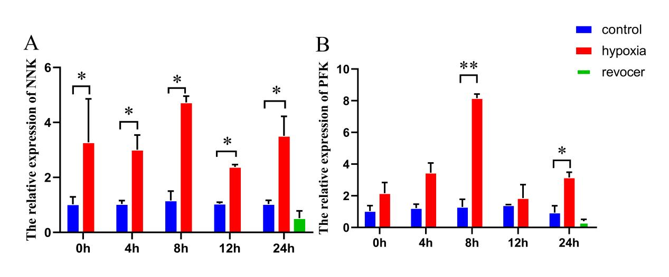
Supplementary fig.1. Expression data of mRNA in gills of largemouth bass under hypoxia stress. The “*” and “**” indicate significant differences (p＜0.05) and an extremely significant difference (p＜0.01) compared with control in each time.
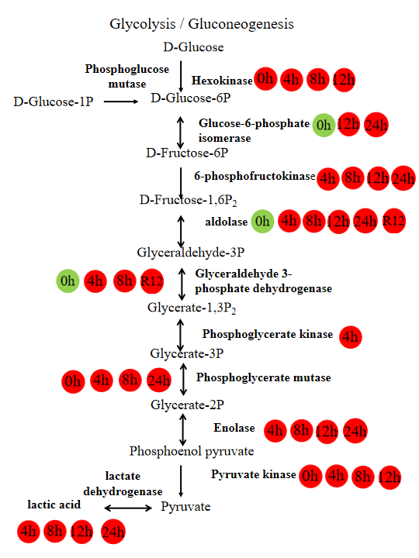

: down
: up
Supplementary fig.2. Gene expression in the glycolysis/gluconeogenesis pathway at different time points. Note:The red box means up, and the green box means down.

