Supporting information for
Neural network multi-component gas mixture analysis with broadband dual-frequency comb absorption spectroscopy
Linbo Tian^{1, 2, †}, Jinbao Xia^{3, 4, †}, Alexandre A. Kolomenskii⁵, Hans A. Schuessler⁵, Feng Zhu⁶, Yanfeng Li³, Jingliang He³, Qian Dong^{7,} *, Sasa Zhang^{8, 1, 2,} *
¹ Key Laboratory of Education Ministry for Laser and Infrared System Integration Technology, Shandong University, 72 Binhai Road, Qingdao 266237, China
² Shandong Provincial Key Laboratory of Laser Technology and Application, Shandong University, 72 Binhai Road, Qingdao 266237, China
³ State Key Laboratory of Crystal Materials, Institute of Novel Semiconductors, Shandong University, Jinan,250100, China
⁴ The State Key Laboratory of Applied Optics, Changchun,130000, China
⁵ Department of Physics and Astronomy, Texas A&M University, College Station, Texas 77843-4242, USA
⁶ School of Physics and Astronomy, Sun Yat-sen University, Zhuhai, Guangdong 519082, China
⁷ Department of Computer Science, Jinan University, Guangzhou 510632, China
⁸ School of Information Science and Engineering, Shandong University, 72 Binhai Road, Qingdao 266237, China

1. Characterization results of the DFG frequency combs:
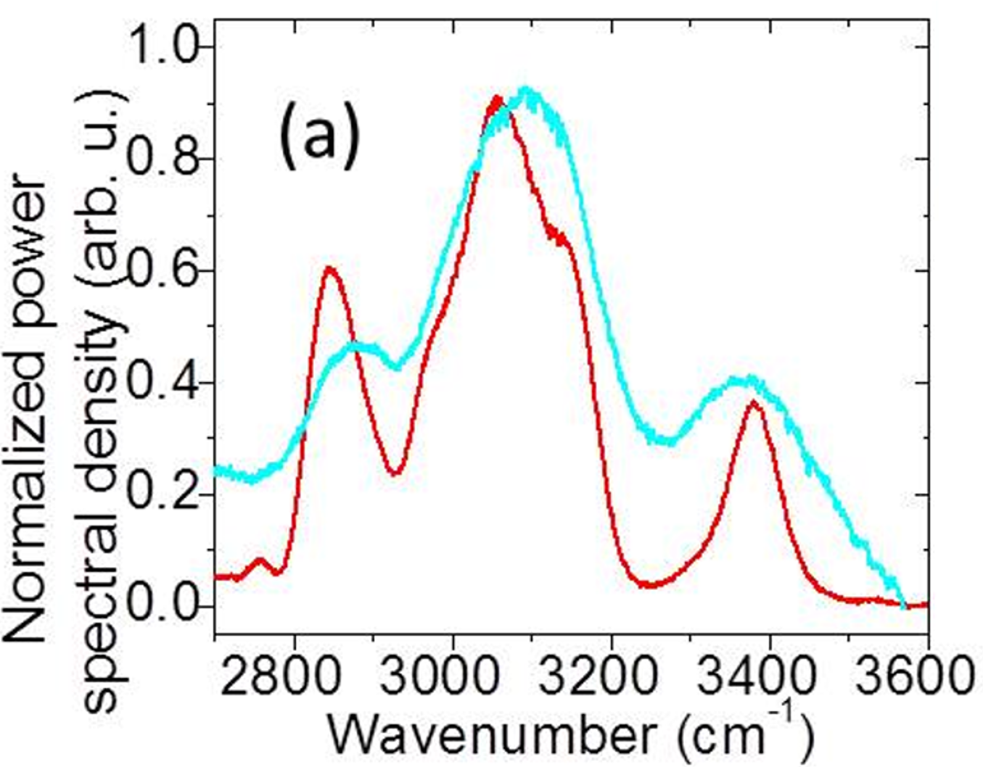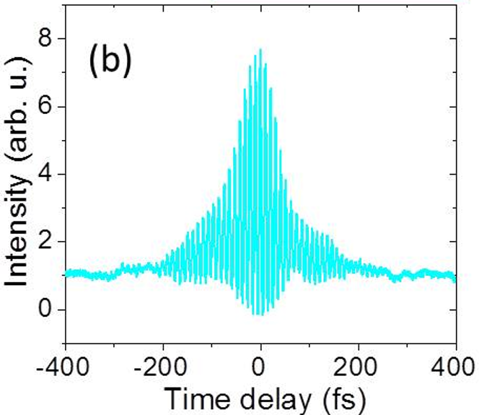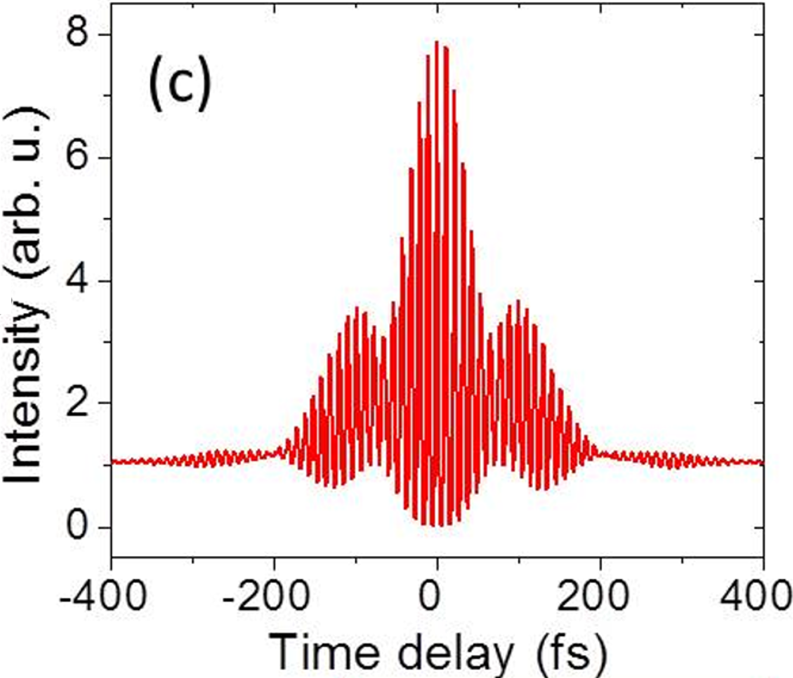
Figure. S1. (a) The spectra measured with a scanning monochromator for MIR comb1 (cyan) and MIR comb2 (red). (b) Interferometric autocorrelation traces for MIR comb1 (cyan) and (c) for MIR comb2 (red).
The DFG sources have a passive carrier-envelope offset (CEO) frequency stabilization. Indeed, since the pump and signal fields originate from the same source, the generated idler field is carrier-envelope phase slip free. The MIR frequency combs are stabilized by stabilizing the source repetition rates.
2. Detailed introduction of the multi-pass cell:
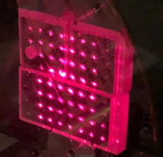
Figure. S2. The aligned spot distributions on the mirrors of the multipass cell.
The multipass cell has a confocal design, the radii of curvatures of the two 50×50 mm² mirrors are 1 m and equal to the distance between these two mirrors. Both mirrors are divided into 3 parts, two 25×25 mm² squares, and one 25×50 mm² rectangle. In one of the square parts, a hole of 5 mm diameter serves as the entrance and exit for the laser beam. The subsequent spots are aligned using the corresponding mirror mounts according to the design. After all six mirror parts are aligned, the spot patterns are formed on the mirrors (Fig. S2), such that the laser beam exits the multipass cell after bouncing between the mirrors with 579 reflections, thus the effective path length is ~580 m. The mirror coating has two high reflection regions, one is in the MIR range (>99.85%, 3100~3600 nm) and the other is in the red visible range (>99.9%, 670~680nm) (Layertec GmbH). For the alignment purpose, we use a visible red diode laser (as shown in Fig. 1(a)) to adjust the multipass mirrors and to achieve the simulated spot patterns. Then the MIR beam replaces the red laser beam by moving up the flip mirror and is aligned through two pinholes to enter the multipass cell. The output of the multipass cell is around 1.0~2.0 mW, depending on the humidity because of the water vapor absorption.

3. Simulated absorption spectra datasets:

Table S1 Compositions of different classes of gases and numbers of spectra used in training, validation and evaluation sets.
 | Components | Total number of simulated spectra | Number of spectra used for training & validation | Number of spectra in evaluation set
Class 1 | CH₄,CH₃COCH₃,H₂O | 2500 | 2253 | 247
Class 2 | CH₄,CH₃COCH | 2500 | 2254 | 246
Class 3 | CH₄, H₂O | 2500 | 2237 | 263
Class 4 | CH₃COCH₃,H₂O | 2500 | 2254 | 246
Class 5 | CH₄ | 2500 | 2254 | 246
Class 6 | CH₃COCH₃ | 2500 | 2257 | 243
Class 7 | H₂O | 2500 | 2260 | 240

4. 6-digits multi-labels:
Table S2. 6-digit labels. The first three digits are gas component identifier, while the last three digits are concentration regressor. The check marks for particular components show that some concentrations of them are present in the mixture and then the corresponding CI is 1, while if they are not present the CI is 0 and the corresponding position in the regressor has (-).
Class | Component Identifier |  |  | Concentration Regressor
Class | Methane | Acetone | Water | Methane | Acetone | Water
Class1 | 1 | 1 | 1 | √ | √ | √
Class2 | 1 | 1 | 0 | √ | √ | -
Class3 | 1 | 0 | 1 | √ | - | √
Class4 | 0 | 1 | 1 | - | √ | √
Class5 | 1 | 0 | 0 | √ | - | -
Class6 | 0 | 1 | 0 | - | √ | -
Class7 | 0 | 0 | 1 | - | - | √
5. Multi-layer perceptron (MLP) concept
MLP was used to model the predictive function for finding gas composition and concentrations. MLP is a type of neural network with strong nonlinear mapping ability using feedforward network topology which is composed of stacked layers. The neurons inside each layer are closely connected to form the main structure of the neural network. To go from one layer to the next, a set of neurons in each layer computes a weighted sum of their inputs from the previous layer and passes the results through a non-linear activation function as expressed by the following equations:
$$z^{(l)}=W^{(l)}∙a^{\left(l-1\right)}+b^{(l)}$$
$$a^{(l)}=g(z^{(l)})$$
where $z^{(l)}$ represents the training parameter matrix $W^{(l)}$and bias vectors $b^{(l)}$ of the hidden $l$-th layer and the hidden vectors $a^{\left(l-1\right)}$ of the linear output of the activation function from the previous layer. $g(∙)$ represents the nonlinear activation function. We use the Rectified Linear Unit (ReLU) to replace the sigmoid function to introduce the nonlinear mapping capability for the neural network and thus $a^{(l)}=max⁡(0, z^{(l)})$. The information is passed layer by layer in MLP and the whole network can be seen as a composite function that maps the input vector to the final output.

5. Code implementation:
All codes of the models, including SAM, 2L-ARNN and 1D-CNN are provided in the repository: Popsama/Neural-network-multi-component-gas-mixture-analysis-with-broadband-dual-frequency-comb: Code repository for paper "Neural network multi-component gas mixture analysis with broadband dual-frequency comb absorption spectroscopy" (github.com)
6. GAMs for 2L-ARNN and 1D-CNN:
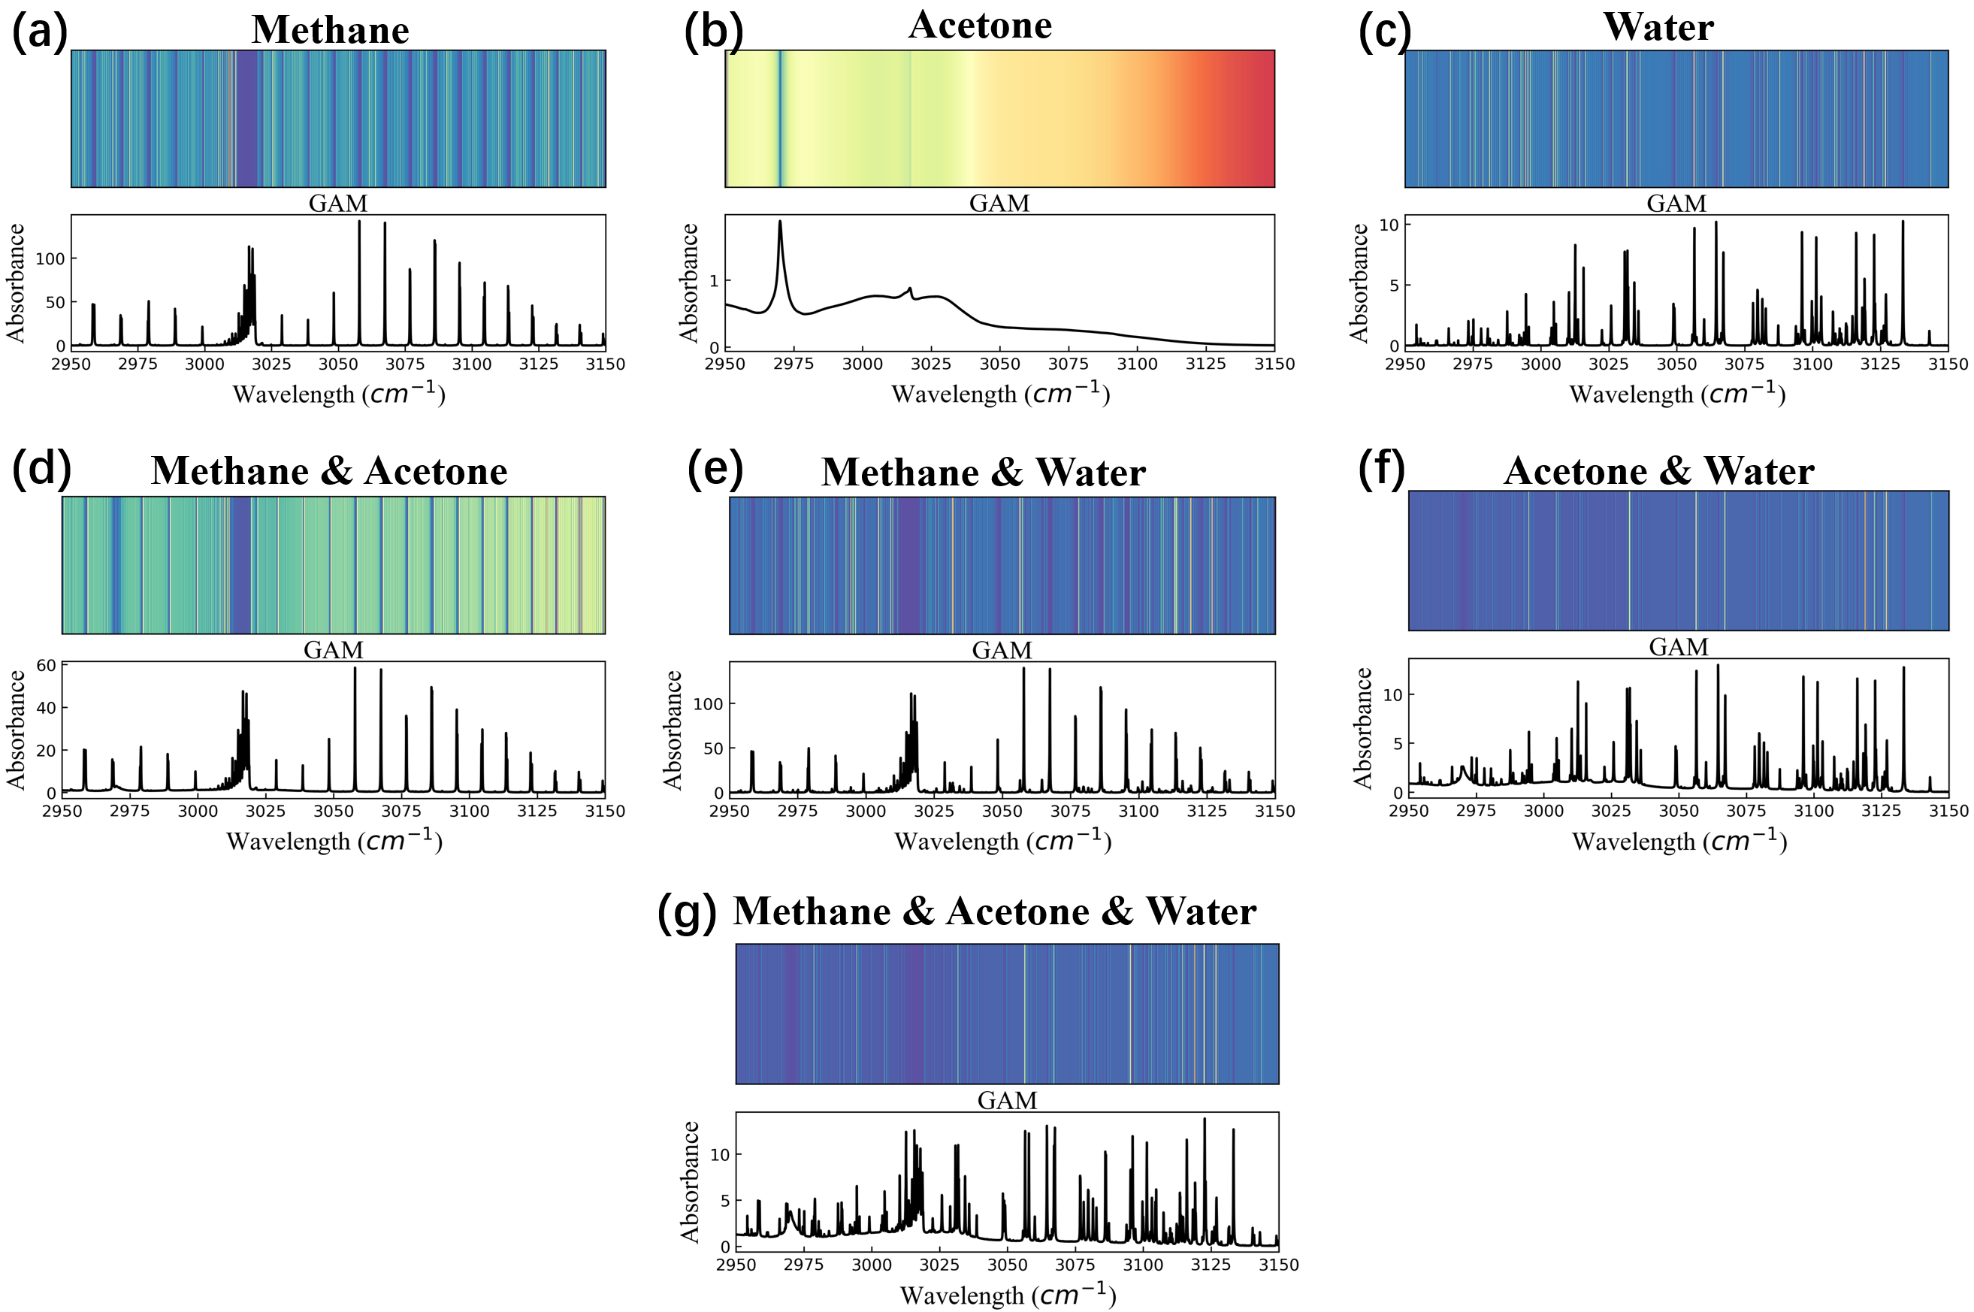
Figure S3. 2L-ARNN GAMs of single component of (a)~(c), and of dual-components of (d)~(f), and of multi-components of (g).
The GAMs drawn by the attention layer of 2L-ARNN to the attention weight of the input spectrum allocation help us understand how 2L-ARNN treats the absorption spectrum and makes the final prediction. As shown in the Figure S3, the response of 2L-ARNN’s attention mechanism to the fine-grained information flow between the input spectra and the prediction is similar to that of our model. The GAM of single component shows that 2L-ARNN can also well capture the absorption feature peaks of different gases. When the overlapped absorption features occur due to the increase of gas concentration, 2L-ARNN also realizes the detection of multicomponent gases by putting more attention weights into the blended absorption area. Therefore, 2L-ARNN has a good ability to identify multicomponent gases. The difference is that the attention weights are normalized by the attention layer through the softmax function before outputting, so the sum of the attention weight assigned to each position of the spectrum is 1. Such operation leads to the slight fluctuation of each position of the spectrum, which will greatly affect the overall understanding of the model for the spectrum. Therefore, we can see that when detecting the methane and water mixture, although the effective component identification can be carried out through the learned spectral features, the accuracy of 2L-ARNN for water concentration inversion decreases sharply due to the cross interference of methane absorption and water. Moreover, 2L-ARNN takes the dot product of the attention weights and the temporal hidden states outputted by the GRU layer as the context vector to realize the fusion of information and passes it to the subsequent network structure. However, the spectral spatial information extracted by the attention mechanism (i.e., the different responses of the model to different unknown spectra) is consequently discarded, which is also the reason for the poor concentration inversion accuracy of 2L-ARNN compared with our model.
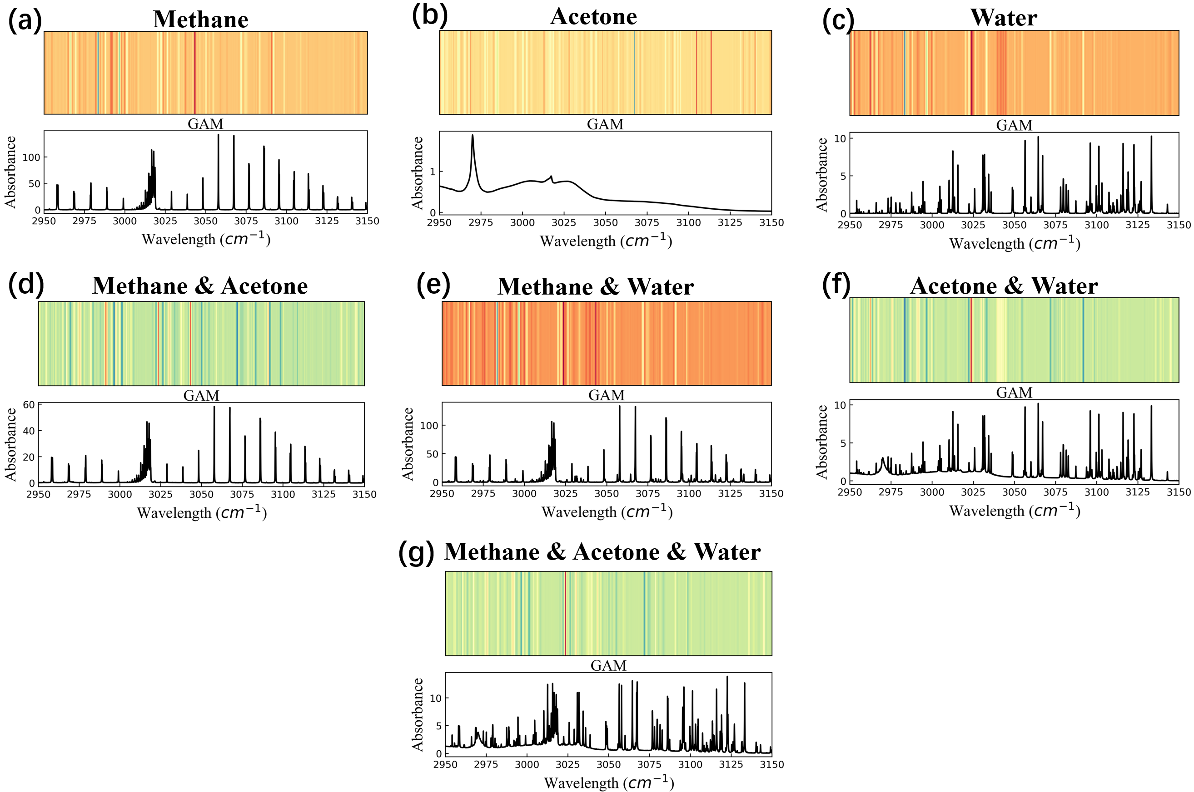
Figure S4. 1D-CNN GAMs of single component of (a)~(c), and of dual-components of (d)~(f), and of multi-components of (g).
For 1D-CNN, as shown in the Figure S4, the GAMS of the 1D-CNN model do not follow the expected rules. Unlike our model and 2L-ARNN, it seems to pay more attention to the non-absorption region, but does not show obvious response to the absorption characteristic peak. We assume that, on the one hand, due to the performance of 1D-CNN architecture itself, it is difficult for 1D-CNN to learn spectral patterns similar to our model and 2L-ARNN from complex spectral features. Thus this model needs to concentrate more on gas component identification and component concentration inversion, instead of focusing on non-absorption positions to determine gas components. This drawback leads also to large deviations in the gas concentrations inversion Generally, absorbance provides the bulk of information for calculating gas concentrations, and the first two models also focus on characteristic absorption peaks or aliasing absorption to realize gas concentration inversion. On the other hand, the original 1D-CNN model was not proposed for the gas concentration inversion task, and our modification may have not quite optimal design for this purpose.

