SCHEMES:
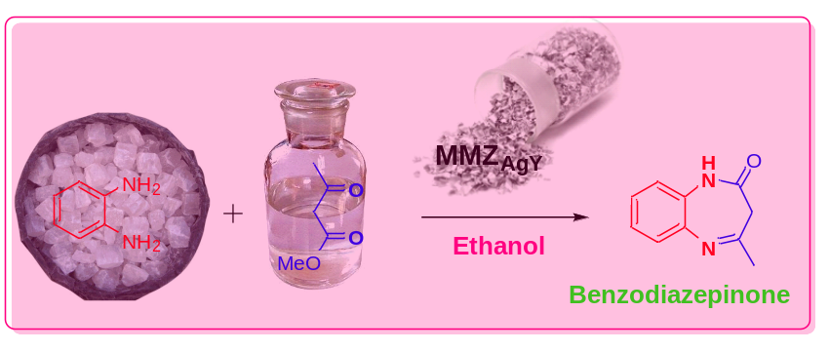
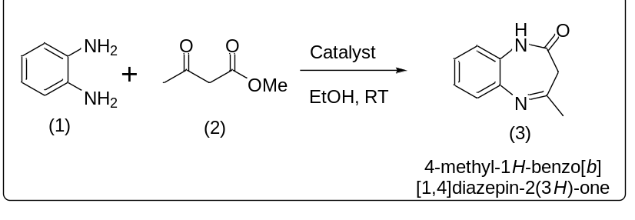
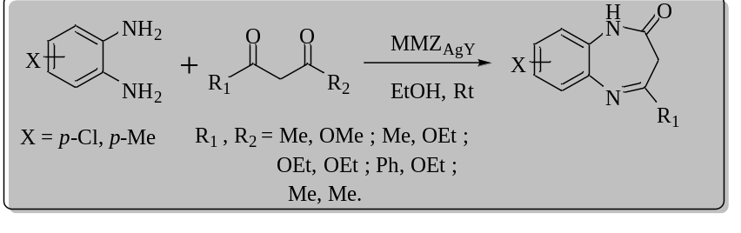
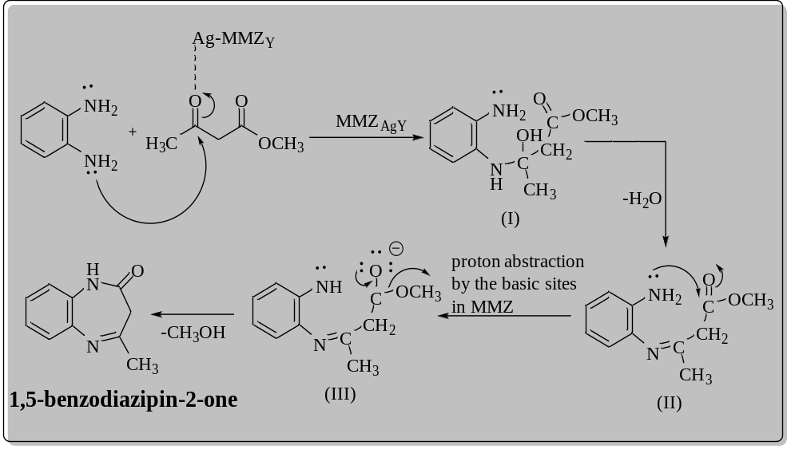
Table 1: Screening of catalysts for the synthesis of benzodiazepinoneª
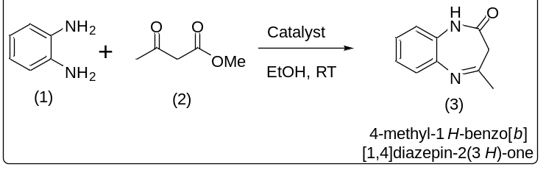
Entry | Catalyst | Time(hrs) | Yield^{b} % (3)
1. | NaY | 24 | --
2. | CuY | 24 | 20
3. | CoY | 24 | 22
4. | NiY | 24 | 60^{c}
5. | AgY | 10 | 81^{c}
6. | MMZ_{Ag(I)Y} | 10 | 96

ªReaction conditions: stirred the mixture of ortho phenylenediamine (1mmol), methyl acetoacetate (1 mmol), catalyst (100 mg), ethanol (3mL) at room temperature for the specified time as mentioned in the table 1 .
^{b}Isolated Yields.
^{c}Minor amount of benzimidazole was also obtained (confirmed by NMR)

Table 2: Synthesis of benzodiazepinone derivativesª

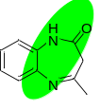 | 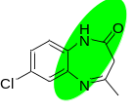 | 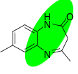
3A (96%) | 3B (89%) | 3C (83%)
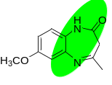 | 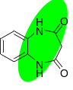 | 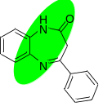
3D (80%) | 3E (76%) | 3F (79%)
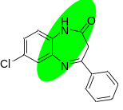 | 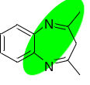 | 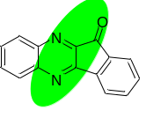
3G (78%) | 3H (74%) | 3I (89%)
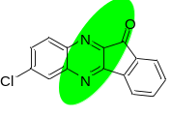
3J (82%)

ªReaction conditions: stirred the slurry containing 1,2-diamine compounds(1mmol), β-ketoester / diketone compounds (1 mmol), MMZ_{AgY}(100 mg), Ethanol (3mL), at room temperature for 10hrs.

