Silver-MMZ catalysed greener synthesis of 1,5-benzodiazepin-2-one derivatives using phenylenediamine and β-ketoesters
Cheirmakani Thangapriya, Simsonrubarathinam Ilaamirthamani & Mayilvasagam Kumarraja⃰
Centre for Research and Post-graduate Studies in Chemistry,
Ayya Nadar Janaki Ammal College (Autonomous), Sivakasi – 626 124, Tamil Nadu, India.

Table of Contents for Supporting Information

- General procedure………………………………………………………. 2
- Characterization of the isolated products ……………………………... 3
- References………………………………………………………………... 7
- ¹H and ¹³C NMR spectra of the products……………………………… 8

1. Experimental Section
Synthesis and Characterization of Hierarchical Nanoporous Zeolite (MMZ_{AgY}):
The nanoporous MMZ_{Y} zeolite was synthesized from the commercially available NaY powder according to the reported procedure.¹ The as prepared MMZ_{Y} was stirred with silver nitrate (100 ml, 10%) solution at 70 °C for 12 h. The exchange was repeated for three times. Each time after exchange, the MMZ powder was washed repeatedly with distilled water and then dried, activated at 450 °C before use. The structural aspects of as prepared MMZ_{AgY} catalyst was characterized by Scanning Electron Microscope EVO18 (CARL ZEISS) and Energy Dispersive X-ray-Spectrometer Quantax 200 with X Flash which are shown in the figures. EDAX analysis was carried out using Bruker Nano GmbH, X50 flash Detector, model 5010.

General procedure for the synthesis of benzodiazepinone derivatives using MMZ_{AgY}.
100mg of MMZ_{AgY} was taken in a reaction tube containing ethanol (3 mL) as a solvent. A mixture of equimolar (1 mmol) o-phenylenediamine (1a) and β-ketoesters (2a) were added simultaneously to the reaction tube. The reaction mixture was allowed to stir for 10 hours at room temperature and the proceedings of the reaction was constantly monitored by TLC (silica gel : pet ether, 8:2). After 10 hours, products were extracted from MMZ using excess amount of solvent. The organic layer was separated, dried and concentrated in vacuo and the isolated products were characterized by ¹H- and ¹³C-NMR spectra on Bruker Instrument (300MHz and 75MHz, respectively) in CDCl₃. GC-MS spectrum was recorded in Agilent GC 7820A and MS 5977E Model using DB-5 Column.

2. Characterization of the isolated products
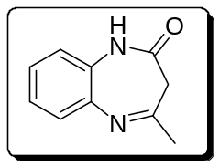 | (Z)-4-methyl-1H-benzo[b][1,4]diazepin-(3H)one²(3a)  ¹H NMR: (300 MHz, CDCl₃): δ 7.48-7.52 (m,4H), 5.58 (s,1H), 4.12 (s, 2H), 2.51(s, 3H)  ¹³C NMR (75 MHz, CDCl₃): δ 167.80, 135.95, 133.60, 128.86, 46.03, 26.93.
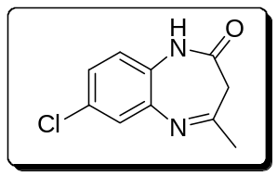 | (Z)-7-chloro-4-methyl-1H-benzo[b][1,4]diazepin-2(3H)one(3b)  ¹H NMR: (300 MHz, CDCl₃): δ 8.73 (s, NH), 7.54-7.58 (m, 1H), 7.107.13 (m, 2H), 2.37 (s, 2H), 2.08 (s, 3H)  ¹³C NMR (75 MHz, CDCl₃): δ 167.83, 145.60, 139.51, 124.56, 123.56, 38.81, 22.87
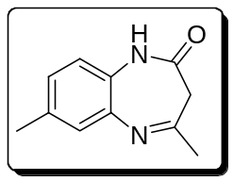 | (Z)-4,7-dimethyl-1H-benzo[b][1,4]diazepin-2(3H)-one(3c)  ¹H NMR: (300 MHz, CDCl₃): δ 10.07 (s, NH), 7.29-7.38,(m, 1H), 6.77-6.81 (m, 2H), 3.71 (s, 3H), 2.29 (s, 3H), 2.05 (s, 2H)  ¹³C NMR (75 MHz, CDCl₃): δ 165.29, 156.10, 145.57, 139.48, 128.58, 124.54, 123.55,120.02, 29.64, 22.58
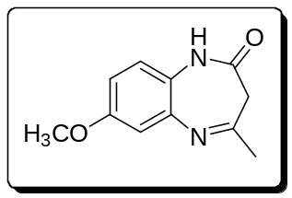 | (Z)-7-methoxy-4-methyl-1H-benzo[b][1,4]diazepin-2(3H)-one (3d)  ¹H NMR: (300 MHz, CDCl₃): δ 10.00 (s, NH), 7.47-7.49 (m, 1H), 7.19 (s, 1H), 4.24 (s, 3H), 2.27 (m, 2H), 1.38 (s, 3H)  ¹³C NMR (75 MHz, CDCl₃): δ 155.37, 147.31, 139.61, 124.48, 59.79, 40.99, 33.91
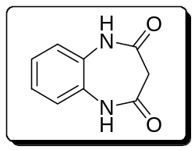 | (1H-benzo[b][1,4]diazepine-2,4-93H,5H)-dione(3e)  ¹H NMR: (300 MHz, CDCl₃): δ 9.80 (s, NH), 7.74-7.76 (m, 2H), 7.41-7.39 (m, 2H), 4.25 (s, 2H)  ¹³C NMR (75 MHz, CDCl₃): δ 162.68, 139.27, 128.49, 123.32, 56.90
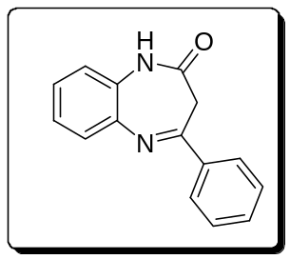 | (E)-4-phenyl-1H-benzo[b][1,4]diazepin-2-(3H)-one)³ (3f)  ¹H NMR: (300 MHz, CDCl₃): δ 9.34 (s, NH), 7.46-7.58 (m, 9H), 4.00 (s, 2H)  ¹³C NMR (75 MHz, CDCl₃): δ 162.06, 158.76, 145.34, 139.24, 132.92, 130.90, 128.88, 124.50, 120.52, 46.33
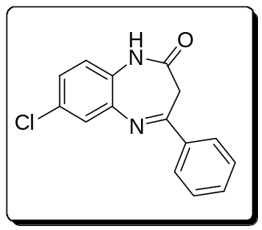 | (E)-7-chloro-4-phenyl-1H-benzo[b][1,4]diazepin-2(3H)-one(3g)  ¹H NMR: (300 MHz, CDCl₃): δ 12.58 (s, NH), 7.82-7.95 (m,2H), 7.71-7.78 (m,1H), 7.63 (s, 2H), 7.41-7.59 (m, 3H), 2.04 (s, 2H)  ¹³C NMR (75 MHz, CDCl₃): δ 167.48, 145.65, 139.26, 135.93, 133.90, 130.90, 128.84, 126.22, 124.53, 123.48, 46.36
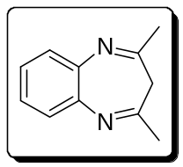 | (1Z,4Z)-2,4-dimethyl-3H-benzo[b][1,4]diazepine⁴ (3h)  ¹H NMR: (300 MHz, CDCl₃): δ 7.75-7.79(m,2H), 7.68-7.71 (m, 2H), 2.91 (s, 2H), 2.78 (s, 6H)  ¹³C NMR (75 MHz, CDCl₃): δ 162.99,146.21, 141.60, 138.76, 130.99, 128.83, 128.56, 127.44, 38.99,28.91
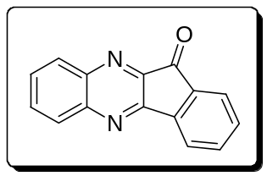 | 11H-Indeno[1,2-b]quinoxalin-11-one)⁵(3i)  ¹H NMR: (300 MHz, CDCl₃): δ 812-8.14 (d, 1H), 7.97-8.00 (m, 2H), 7.80-7.82 (d, 1H), 7.72-7.73 (d, 1H), 7.63-7.66 (m, 3H), 7.50-7.52 (d, 1H)  ¹³C NMR (75 MHz, CDCl₃): δ 189.83, 156.55, 149.22, 143.01, 142.49, 136.67, 132.40, 131.63, 129.61, 124.77, 122.65
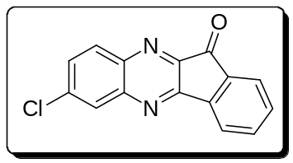 | 7-chloro-11H-indeno[1,2-b]quinoxalin-11-one (3j)  ¹H NMR: (300 MHz, CDCl₃): δ 8.22 (s, 2H), 8.17-8.19 (d, 1H), 7.62-7.66 (m, 4H)  ¹³C NMR (75 MHz, CDCl₃): δ 189.22, 157.03, 156.75, 139.79, 136.94, 132.52, 130.93, 128.64, 124.84

3. References:
- H. J. Park, J. K. Jeon, J. M. Kim, H. Lee, J. H. Yim, J. Park, Y. K. Park, J. Nanosci and Nanotechnol. 8, 5439–5444 (2008).
- C. Ameta, A. K. Pathak, K. Bhanat, P. B. Punjabi, S. C. Ameta, Int. J. Curr. Res. Chem. Pharma. Sci. 2, 8–18 (2015).
- T. N. Ongone, R. Achour, M. El Ghoul, L. El Ousaif, K. Taghzouti, M. El Jemli, Y. Cherrah, K. Alaoui, A. Zellou, Adv. Pharmacol. Sci. 1-8 (2018).
- G. P. Yang, S. X. Shang, B. Yu, C. W. Hu, Inorg. Chem. Front. 5, 2472- 2477 (2018).
- M. S. Khan, M. Ali Munawar, M. Ashraf, U. Alam, A. Ata, A. Mohamed Asiri, S. Kousar, M. Ain Khan, Bioorg. Med. Chem. 22, 1195–1200 (2014).

- ¹H-NMR and ¹³C-NMR data
