Supplementary Information

Table S1 Association between obesity indicators and prediabetes (per 1-SD increase) stratified by age and sex
 |  | Age, years |  |  |  |  |  | Sex
 |  | <55 (n=2118) |  | ≥55 (n=2258) |  |  |  | Male (n=1411) |  | Female (n=2965)
BMI | 1.19 (1.07 - 1.32) |  | 1.16 (1.06 - 1.27) |  |  |  | 1.09 (0.95 - 1.24) |  | 1.21 (1.11 - 1.31)
WC | 1.27 (1.13 - 1.43) |  | 1.20 (1.08 - 1.32) |  |  |  | 1.12 (0.97 - 1.29) |  | 1.27 (1.16 - 1.39)
HC | 1.15 (1.03 - 1.28) |  | 1.08 (0.99 - 1.19) |  |  |  | 1.02 (0.90 - 1.17) |  | 1.15 (1.06 - 1.25)
WHR | 1.24 (1.09 - 1.42) |  | 1.21 (1.08 - 1.35) |  |  |  | 1.15 (1.00 - 1.32) |  | 1.25 (1.13 - 1.38)
WHtR | 1.27 (1.14 - 1.42) |  | 1.20 (1.10 - 1.32) |  |  |  | 1.20 (1.04 - 1.38) |  | 1.24 (1.14 - 1.35)
VAI | 1.23 (1.12 - 1.35) |  | 1.20 (1.08 - 1.32) |  |  |  | 1.08 (0.97 - 1.19) |  | 1.32 (1.20 - 1.45)
METS-VF | 1.32 (1.17 - 1.50) |  | 1.24 (1.11 - 1.39) |  |  |  | 1.17 (1.01 - 1.38) |  | 1.35 (1.23 - 1.49)
The model was adjusted for age, sex, smoking, drinking, education level, family history of diabetes and the history of hypertension, hyperlipidemia, cardiovascular disease and stroke.
BMI: body mass index; WC: waist circumference; HC: hip circumference; WHR: waist-hip ratio; WHtR: waist height ratio; VAI: visceral adipose index; METS-VF: metabolic score for visceral fat.

Table S2 Association between METS-VF cutoff and the risk of prediabetes
METS-VF | Incident prediabetes |  | aORª | 95% CI
METS-VF | No | Yes | aORª | 95% CI
<6.51 | 1748 (78.25) | 486 (21.75) | 1.28 | 1.10-1.50
≥6.51 | 1509 (70.45) | 633 (29.55)
ªThe model was adjusted for age, sex, smoking, drinking, education level, family history of diabetes, the history of hypertension, hyperlipidemia, cardiovascular disease and stroke, fasting glucose and 2-hour postprandial plasma glucose.
METS-VF: metabolic score for visceral fat. OR: odds ratio; CI: confidence interval.

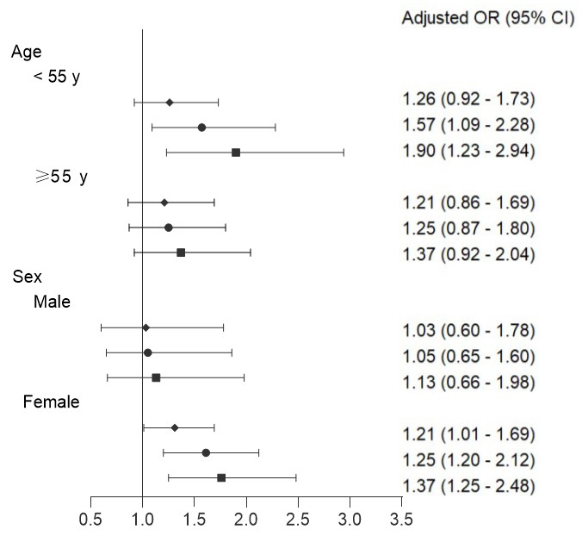
Figure S1 Subgroup analysis of the association between METS-VF level and incident of prediabetes
The model was adjusted for age, sex, smoking, drinking, physical exercise, education level, body mass index, history of hypertension, hyperlipidemia, cardiovascular disease and stroke, fasting glucose and 2-hour postprandial plasma glucose.
The solid diamond, circle and square were the odds ratios (95%CI) for incident of prediabetes by METS-VF quartile 2 versus quartile 1, quartile 3 versus quartile 1, quartile 3 versus quartile 1, respectively.

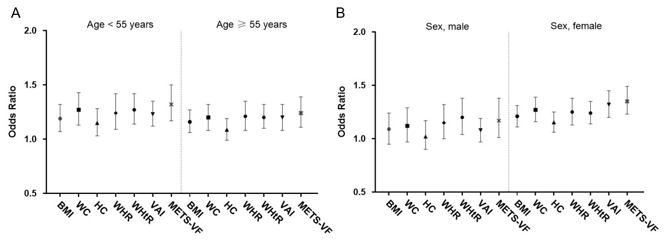
Figure S2 Subgroup analysis for odds ratio and 95%CI of obesity index (per 1-SD increasing) associated with prediabetes stratified by age (A) and sex (B).
The model was adjusted for age, sex, smoking, drinking, education level, family history of diabetes and hypertension.
BMI: body mass index; WC: waist circumference; HC: hip circumference; WHR: waist-hip ratio; WHtR: waist height ratio; VAI: visceral adipose index; METS-VF: metabolic score for visceral fat.

