Supporting Information

Possible high-T_{c} superconductivity exceeding 100 K in Ir-substituted perovskite-type manganese oxides

Structural analyses
The reciprocal space mappings presented in Fig. S1 show that increasing the Ir substitution resulted in an expansion of the lattice volume: the compressive epitaxial strain thereby increased, leading to further elongation of the c-axis with a gradual increase of c/a from 1.011 (Sample A) to 1.030 (Sample S), as summarized in Table S1. As has been similarly concluded for Ru-doped LSMO films,^{S1} the lattice volume expansion by Ir substitution at the B-site in LSMO is reasonable, considering that the 6-coordinated ionic radii of Ir³⁺ (0.68 Å) and Ir⁴⁺ (0.625 Å) are larger than those of Mn³⁺ (0.645 Å, high spin) and Mn⁴⁺ (0.53 Å).^{S2} Even for the sample with the highest Ir % of 19% (Sample S), the full width at half maximum (FWHM) of the LSMO 002 peak in the rocking curve was at most 0.032 deg. (not shown), indicating that high crystallinity was maintained in all the samples even with Ir substitution.

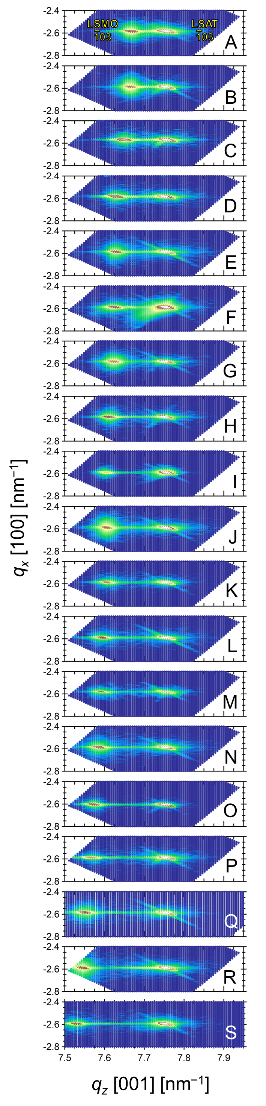
Fig. S1 | Structural analyses of nonsubstituted and Ir-substituted lanthanum strontium manganite (LSMO) thin films.
Reciprocal space maps of nonsubstituted (Sample A) and Ir-substituted (Samples B - S) LSMO thin films on (LaAlO₃)_{0.3}-(SrAl_{0.5}Ta_{0.5}O₃)_{0.7} (LSAT) (001) substrates around the 103 LSAT diffraction peak. All the maps indicate that the thin films are fully strained and are in an epitaxial relationship with the LSAT substrate: LSMIO [001] || LSAT [001] and LSMIO [100] || LSAT [100].
Table S1 | The structural and magnetic parameters of nonsubstituted (Sample A) and Ir-substituted (Samples B-S) LSMO thin films.
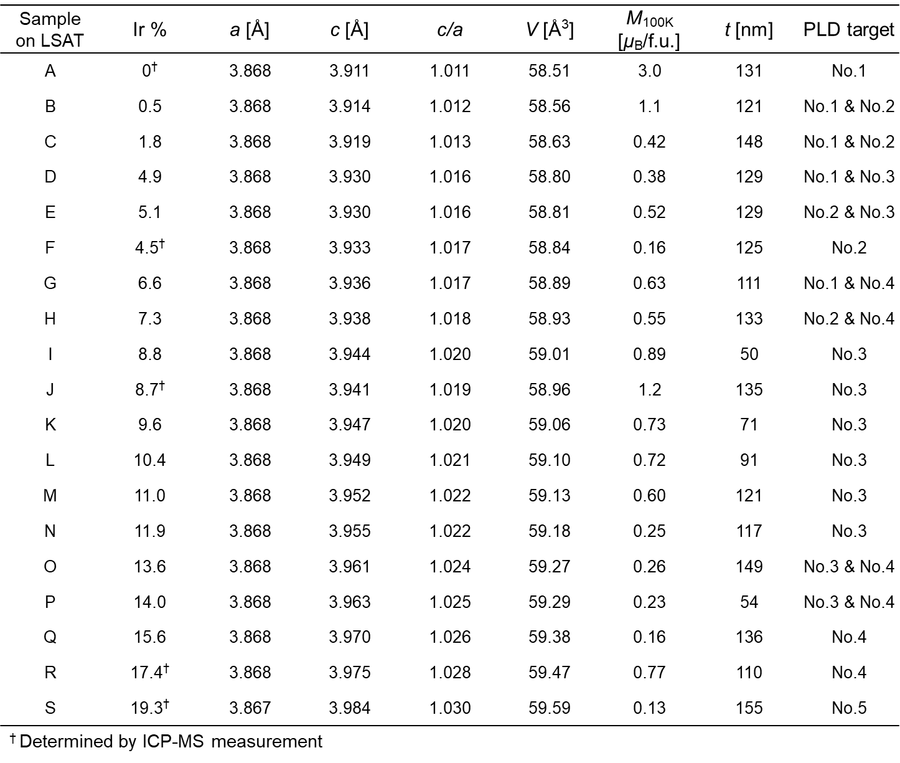
a, c: lattice constants; V: unit cell volume; M_{100K}: out-of-plane saturation magnetization per formula unit at 100 K; and t: film thickness

The cross-sectional HAADF-STEM image of an LSMIO thin film (here, Sample H with Ir 7%) (Fig. S2a) exhibits homogeneous contrast at the atomic scale. The distance between the atomic positions in the scanning direction in the HAADF-STEM image is ∼0.39 nm, which is roughly in agreement with that for tetragonal distortion, as inferred from the XRD pattern (Fig. 1a and Table S1). Fig. S2b is a TEM image of the LSMIO film, and the corresponding EDX mappings for the constituent elements are presented in Fig. 2c−g. The contrast in the elemental mapping results was observed in relation to the lattice contrast of all atoms, except oxygen. Mn or Ir atoms were found to occupy the B-site positions, whereas the A-site positions are occupied by La or Sr atoms.

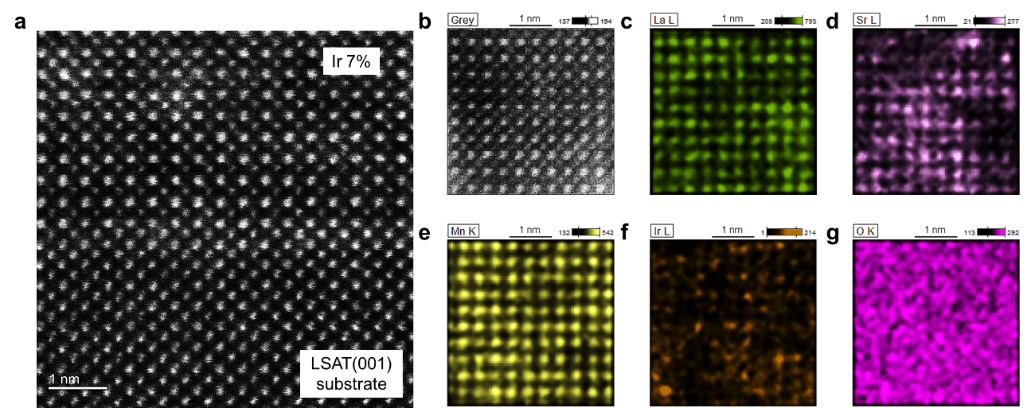
Fig. S2 | Atomic characterization of a typical Ir-substituted LSMO thin film.
a, High-angle annular dark-field (HAADF) STEM image of an LSMIO thin film (Ir 7%, Sample H). b, Cross-sectional TEM image and (c−g) the corresponding EDX mappings for all the elements.

Composition analysis
Considering the evaporative nature of IrOx during vacuum deposition, inductively coupled plasma‒mass spectrometry (ICP‒MS) was used to precisely determine the atomic concentration of Ir substituted at the B site of LSMO (Ir %, [Ir]/([Mn]+[Ir])). Table S2 shows the results for the PLD targets (No. 1 – No. 5) and the thin films fabricated from these targets (Samples A, F, J, R, and S). All the Sr concentrations were determined to be almost 30% at the A sites (Sr %, [Sr]/([La]+ [Sr])) in the PLD targets but could not be determined for the thin films due to the inclusion of La and Sr in the LSAT that was used as a substrate. As the relative area intensities of the Sr3d peaks in the XPS spectra are nearly equal for the Ir 0% (nonsubstituted), 4%, and 9% LSMIO samples (Fig. S3b), it is reasonable to assume, henceforth, the same Sr % in all the samples as in the targets. The Ir % of the samples was 1-4% lower than expected from the Ir % of the PLD targets due to the re-evaporation of IrOx during deposition, as mentioned above. As shown in Fig. 1c, the Ir % determined from the ICP‒MS spectra increased linearly with the lattice volume (V [Å³]) calculated from the RSM data: V = 0.0542*(Ir %) +58.53[Å³]. This linear relationship was used as a calibration curve to estimate the Ir % of the other film samples from the corresponding lattice volume, and the results are shown in Table S1. This estimation is reliable because these calculated Ir % values are in good agreement with those calculated from the laser pulse numbers and deposition rates of LSMO and LSMIO targets used in alternating deposition (see the Methods section for more details).
Table S2 | The results of an ICP‒MS analysis of the PLD targets and the corresponding fabricated thin films (Samples A, F, J, R, and S).

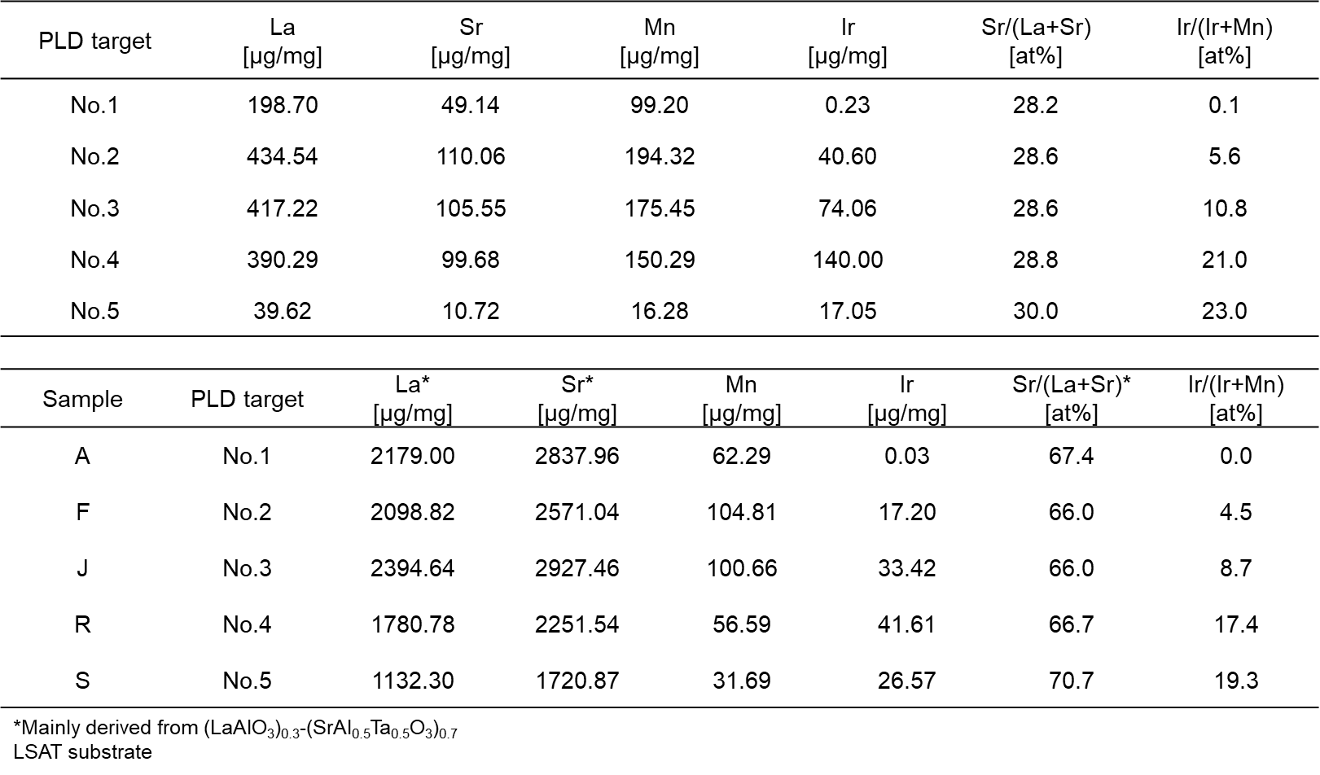

For the XPS measurements, nonsubstituted and Ir-substituted LSMO epitaxial thin films were simultaneously deposited on 0.5 wt% Nb:SrTiO₃ (Nb:STO) (001) substrates and LSAT (001) substrates for the Nos. 1-3 PLD targets. Fig. S3a shows the XPS survey scans for the Ir 0%, Ir 4% and Ir 9% samples. No peaks of impurity elements were detectable in the spectra for the films. Except for the Ir peaks, there was no significant difference in the intensity of the peaks for each element among the samples. High-resolution XPS scans of the Ir 4f peaks for the samples are shown in Fig. S3c. The peak area ratio of Ir 4f between the Ir 4% and Ir 9% samples was close to 1:2, indicating that the composition of each PLD target used for deposition was transferred to the films with little re-evaporation during deposition and/or postannealing. Unfortunately, as the XPS spectra were obtained after Ar⁺ sputtering of the samples under charge neutralization with an electron flood gun, the exact valence state of Ir could not be determined. High-resolution XPS scans of the Mn 2p peaks for all the samples are shown in Fig. S3d. The shoulder structure on the lower-binding-energy side of the Mn 2p_{3/2} core-level spectra (black arrow), originating from a Mn³⁺ well-screened final state,^{S3} monotonically disappeared with increasing Ir %.
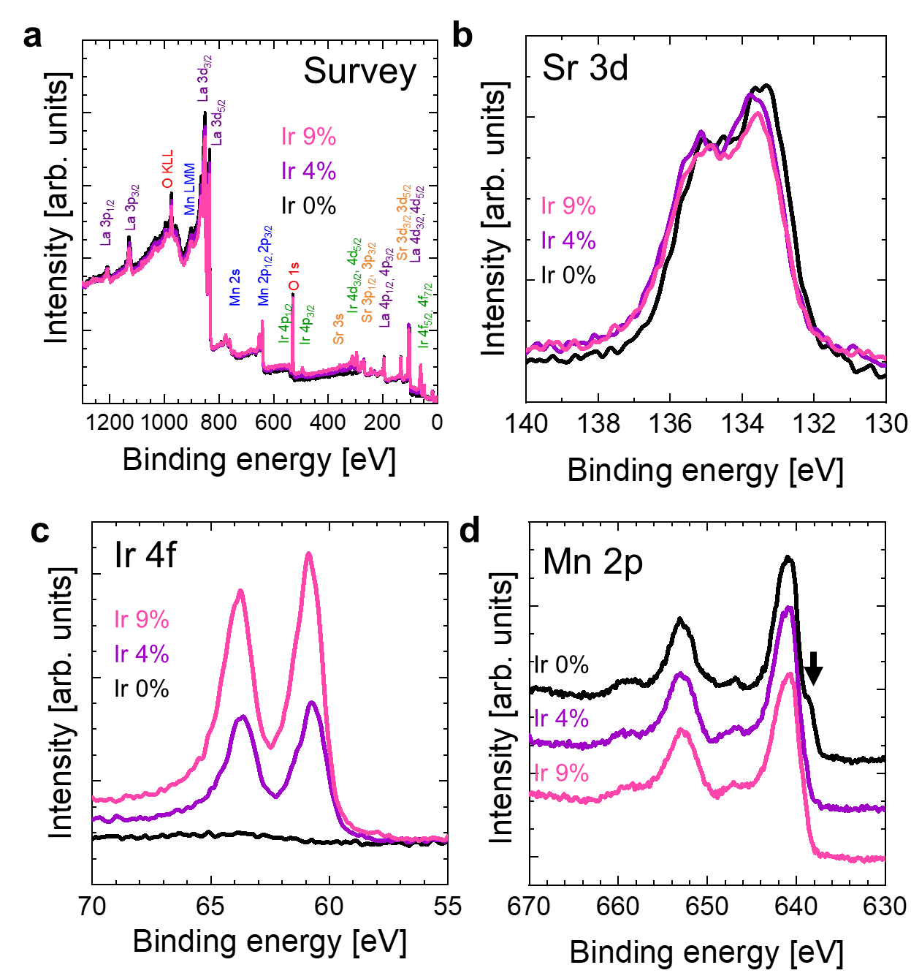
Fig. S3| Spectroscopic characterization of nonsubstituted and Ir-substituted LSMO thin films.
a, Survey XPS spectra, b, high-resolution Sr 3d XPS spectra, c, high-resolution Ir 4f XPS spectra, d, high-resolution Mn 2p XPS spectra, and e, high-resolution XPS spectra near the Fermi level (E_{F}) for the Ir 0% (black), Ir 4% (purple), and Ir 9% (pink) LSMIO films grown on 0.5 wt% Nb:STO (001) substrates. The black arrow indicates the shoulder structure found on the lower-binding-energy side of the Mn 2p_{3/2} core-level spectra. The XPS spectra were obtained after performing Ar⁺ sputtering under charge neutralization with an electron flood gun on samples with different Ir compositions, which were prepared by simultaneous deposition on 0.5 wt% Nb:STO (001) and LSAT (001) substrates.

Electrical transport properties
Fig. S4 shows the ρ-T curves for all the films on LSAT (Samples A-S) listed in Table S1 in logarithmic scale. The colour coding in Fig. 4 is based on the electrical transport properties. The applied magnetic field response for the transitions of Samples C (Ir 2%), H (Ir 7%), M (Ir 11%), and S (Ir 19%) is shown in Fig. S5a-d. The magnetic field strength affects the transition behaviour of the samples with different Ir % quite differently, in addition to the isotropic nature of the lowering of T_{c}^{on}. For Sample C (Ir 2%), resistive broadening was suppressed around T_{c}^{on} with increasing applied magnetic field; even after this sample was cooled to 2 K (the lower limit of the PPMS), the superconducting behaviour completely disappeared beyond an applied magnetic field of 5 T. Conversely, for Sample H (Ir 7%), resistive broadening gradually became prominent with increasing applied magnetic field strength. Sample H also exhibited the largest magnetic field response of T_{c}^{on} among the samples (ΔT ~ 30 K). By contrast, the ρ-T curve for Sample M (Ir 11%) shows that the resistivity was dropped drastically without such prominent broadening, even under an applied magnetic field. The ρ-T curve of Sample S (Ir 19%) exhibited a characteristic hump in the vicinity of T_{c}^{on} that was gradually suppressed with increasing applied magnetic field strength.
Table S3 shows the estimated superconducting parameters for the superconducting samples. Table S4 is a list of all the superconducting compounds containing La, Sr, Mn, Ir, and/or O known to date, none of which have a T_{c} as high as the SC transition temperature of LSMIO.
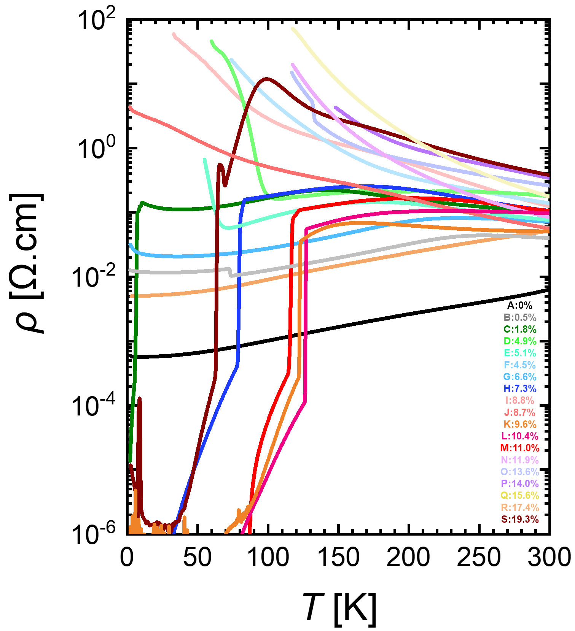
Fig. S4 | Electrical transport properties of Ir-substituted LSMO thin films.
The ρ-T curves for all the films on LSAT (Samples A-S) listed in Table S1 in logarithmic scale.

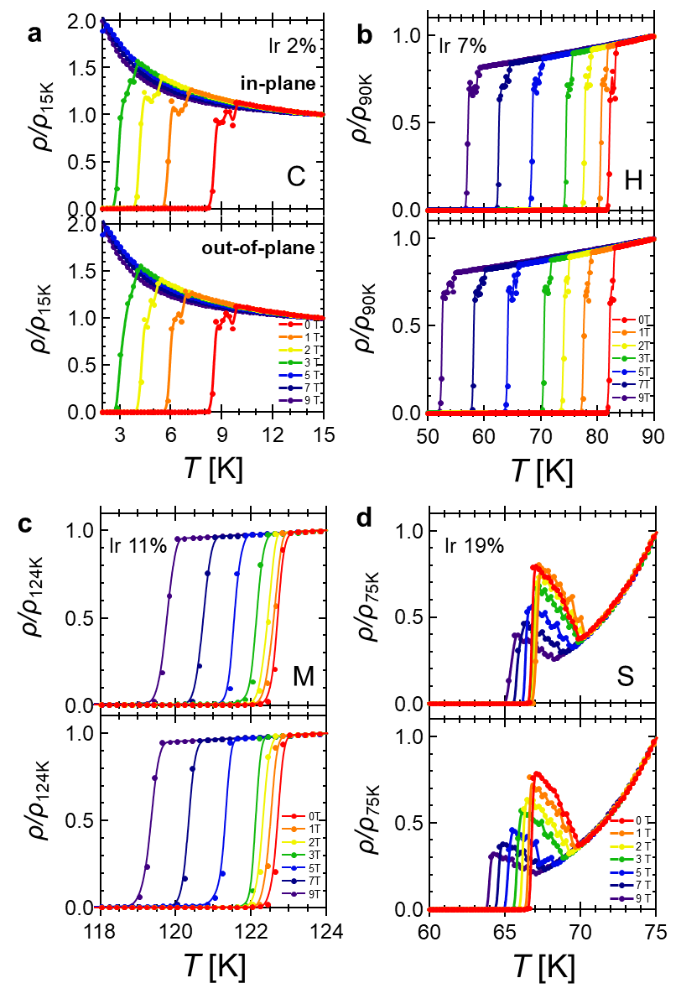
Fig. S5 | Magnetic-field response of the superconducting Ir-substituted LSMO thin films.
a-d, Temperature dependence of the normalized resistivity under in-plane (upper panel) and out-of-plane (bottom panel) magnetic fields: a, ρ/ρ_{15K} for Sample C (Ir 2%), b, ρ/ρ_{90K} for Sample H (Ir 7%), c, ρ/ρ_{124K} for Sample M (Ir 11%), and d, ρ/ρ_{75K} for Sample S (Ir 19%).

Table S3 | Structural and superconducting parameters of the superconducting Ir-substituted LSMO thin films.

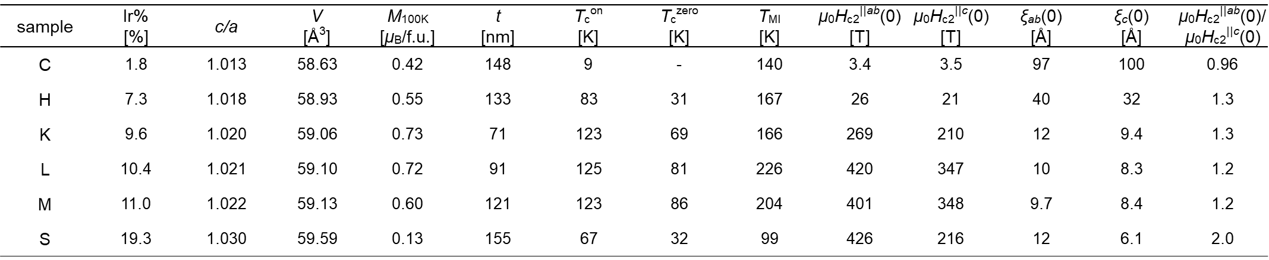

c/a: ratio of lattice constants; V: unit cell volume; M_{100K}: out-of-plane saturation magnetization per formula unit at 100 K; T_{c}^{on}: onset superconducting transition temperature; T_{c}^{zero}: superconducting transition temperature below ρ < 1 μΩ.cm; T_{MI}: metal-insulator transition temperature; H_{c2}^{||ab} and H_{c2}^{||c}: in-plane (H || ab) and out-of-plane (H || c) upper critical fields; ξ_{ab}(0) and ξ_{c}(0): in-plane and out-of-plane zero temperature Ginzburg–Landau coherence lengths.

Table S4 | List of superconducting compounds containing elements La, Sr, Mn, Ir or O known to date.

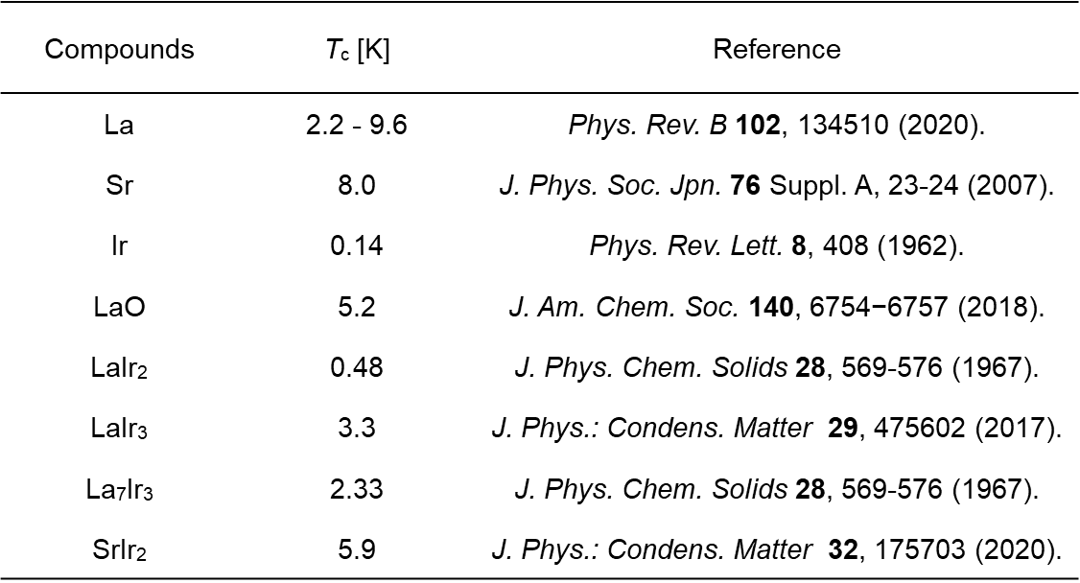

Magnetic properties of LSMIO thin films
As shown in Table S1 and Fig. 4a, Ir substitution (even Ir 0.5%) significantly reduces the saturation magnetization at 100 K, M_{100K}, to less than one-third that of nonsubstituted LSMO. Similar to Ru-substituted LSMO,^{S1} perpendicular magnetic anisotropy is observed in all the Ir-substituted samples, whereas LSMO originally exhibits in-plane magnetic anisotropy (Fig. S7a-e). This change in the magnetic anisotropy may be attributed to the restored orbital angular momentum of the heavy element Ir, which occurs cooperatively with the imposition of a compressive biaxial epitaxial strain by the LSAT substrate. The M-T curve measured under a magnetic field applied along the out-of-plane direction showed that all the samples, irrespective of the Ir %, remained ferromagnetic with Curie temperatures of approximately 350 K, which were close to that of nonsubstituted LSMO (Fig. S6f). This ferromagnetism probably originates from the so-called double exchange interaction between the Mn sites along the Mn-O-Mn bond via conduction carriers.^{S4} However, the curve for M_{100K} versus the Ir % exhibits two local maximal peaks at approximately Ir 9% and 17%, in addition to the peak at Ir 0% that occurs for nonsubstituted LSMO.

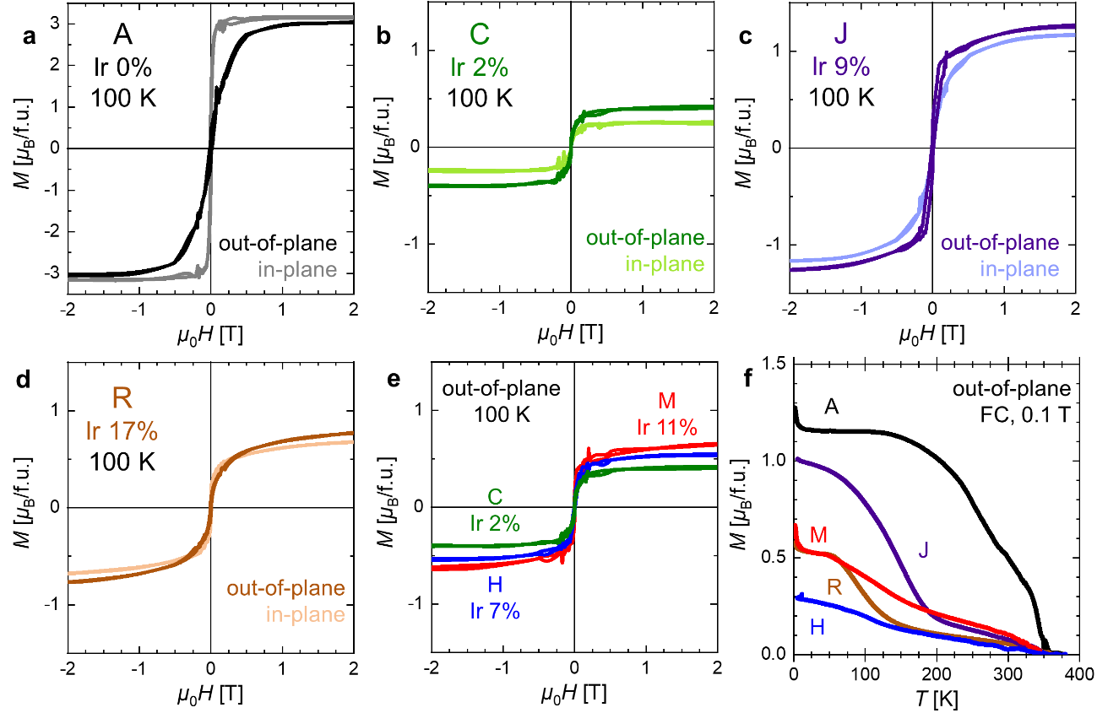
Fig. S6 | Magnetic properties of nonsubstituted and Ir-substituted LSMO thin films on LSAT substrates.
a-d, In-plane and out-of-plane magnetic hysteresis loops measured at 100 K for Samples A (a, Ir 0%), C (b, Ir 2%), J (c, Ir 9%), and R (d, Ir 17%). e, Out-of-plane magnetic hysteresis loops measured at 100 K for samples exhibiting presumed superconductivity, Samples C (green, Ir 2%), H (blue, Ir 7%), and M (red, Ir 11%). f, Temperature dependence of the out-of-plane magnetization under a magnetic field of 0.1 T during the field cooling (FC) process for Samples A (Ir 0%, black), H (Ir 7%, blue), J (Ir 9%, dark blue), M (Ir 11%, red), and R (Ir 17%, brown).

References for Supporting Information
[S1] Nakamura, M. et al., Emergence of topological Hall effect in half-metallic manganite thin films by tuning perpendicular magnetic anisotropy. J. Phys. Soc. Jpn., 87, 074704 (2018).
[S2] Shannon, R. T. et al., Revised values of effective ionic radii. Acta Crystallogr., Sect. B: Struct. Sci., Cryst. Eng. Mater., 26, 1046-1048 (1970).
[S3] Hishida, T. et al., Empirical relationship between X-ray photoemission spectra and electrical conductivity in a colossal magnetoresistive manganite La_{1-x}Sr_{x}MnO₃. J. Appl. Phys. 113, 233702 (2013).
[S4] Motome, Y. et al., Critical Temperature of Ferromagnetic Transition in Three-Dimensional Double-Exchange Models. J. Phys. Soc. Jpn. 69, 3785 (2000).

