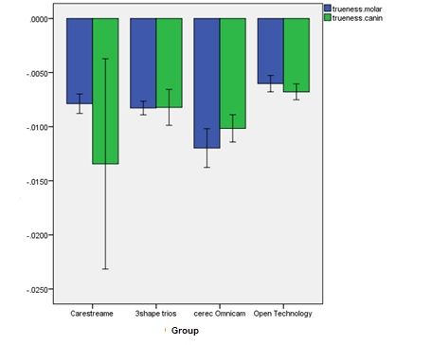
Diagram 1. Mean and 95% confidence interval for trueness in the studied scanners by tooth type

