Supplementary Data to

Peripheral metabolites of the kynurenine pathway are decreased in serious mental illness and show phase-specific differences in bipolar disorder patients
Murielle Brum, Matthias Nieberler, Christopher Kehrwald, Katrin Knopf, Nathalie Brunkhorst-Kanaan, Semra Etyemez, Kelly A Allers, Robert A. Bittner, David A. Slattery, Rhiannon V. McNeill, Andreas Reif, Sarah Kittel-Schneider

Scale | MDD |  | BD |  | SCZ
Scale | Remitters  N (%) | Responders  N (%) | Remitters  N (%) | Responders  N (%) | Responders  N (%)
MADRS | 19 (48.7 %) | 30 (76,9 %) | 29 (61.7 %) | 30 (55.,6 %) | /
YMRS | / | / | 24 (96.0 %) | 31 (79.5 %) | /
PANSS_G | / | / | / | / | 4 (10.3 %)
PANSS_P | / | / | / | / | 21 (53.8 %)
PANSS_N | / | / | / | / | 9 (23.1 %)

Supplementary Table 1. Numbers and percentages of patients whose symptoms remitted and responded to treatment between T1 and T2, based on the respective scales used. Patients were classified as responders if symptom severity scores were decreased at least 50 % at discharge. MDD and BD patients were further classified as remitters if the respective scores were ≤10 (MADRS) or ≤12 (YMRS) at T2. MDD: major depressive disorder; BD: bipolar disorder; SCZ: schizophrenia; MADRS: Montgomery-Ǻsberg Depression Scale; YMRS: Young Mania Rating Scale; PANSS: Positive and Negative Syndrome Scale, subscales G: General Psychopathology, P: Positive Scale, N: Negative Scale.

Diagnosis | Administered medication during inpatient treatment
Diagnosis | / | AD | Li | AP | AD+  Li | AD+  AC | AD+  AP | Li+  AC | Li+  AP | AC+  AP | AD+  Li+  AP | AD+  AC+  AP | Li+  AC+  AP | Li+ AC+ AP+ AC
HC | 40 | 0 | 0 | 0 | 0 | 0 | 0 | 0 | 0 | 0 | 0 | 0 | 0 | 0
MDD | 0 | 13 | 0 | 0 | 1 | 1 | 22 | 0 | 0 | 0 | 2 | 1 | 0 | 0
BD | 1 | 1 | 2 | 8 | 6 | 2 | 3 | 1 | 9 | 5 | 9 | 3 | 4 | 2
SCZ | 0 | 0 | 0 | 28 | 0 | 0 | 8 | 0 | 0 | 2 | 0 | 1 | 0 | 0

Supplementary Table 2. Medication during inpatient treatment was assigned to four substance groups (antidepressants, lithium carbonate, antipsychotics, anticonvulsants), which were assessed with respect to patient diagnosis. The majority of patients was prescribed a combination of substances from at least two different groups with BD patients taking medication from different substance groups most frequently. AD: antidepressants; Li: lithium carbonate; AP: antipsychotics; AC: anticonvulsants; HC: healthy controls; MDD: major depressive disorder; BD: bipolar disorder; SCZ: schizophrenia.

Diagnosis | N | Number of administered substance groups |  |  |  |  | Mean (SD)
Diagnosis | N | 0 | 1 | 2 | 3 | 4 | Mean (SD)
MDD | 40 | 0 | 13 | 24 | 3 | 0 | 1.75 (0.59)
BD | 56 | 1 | 11 | 26 | 16 | 2 | 2.14 (0.82)
SCZ | 39 | 0 | 28 | 10 | 1 | 0 | 1.31 (0.52)

Supplementary Table 3. Patient medication was assigned to four substance groups (antidepressants, lithium carbonate, antipsychotics, anticonvulsants) and number of administered substance groups was assessed with respect to patient diagnosis. BD patients were most frequently prescribed a combination therapy with medication from 2.14 different substance groups. SD: standard deviation; HC: healthy controls; MDD: major depressive disorder; BD: bipolar disorder; SCZ: schizophrenia.

Medication | N | Mean (SD) | 95% Confidence intervall |  | Minimum | Maximum
Medication | N | Mean (SD) | Minimum | Maximum | Minimum | Maximum
none | 1 | 2.17 (/) | / | / | 2.17 | 2.17
AD | 14 | 1.85 (0.60) | 1.50 | 2.20 | 1.20 | 3.03
Li | 2 | 1.91 (0.32) | -0.98 | 4.81 | 1.68 | 2.14
AP | 36 | 1.90 (0.59) | 1.69 | 2.10 | 0.91 | 3.76
AD + Li | 7 | 2.31 (0.92) | 1.46 | 3.16 | 1.22 | 3.69
AD + AC | 3 | 1.66 (0.96) | -0.73 | 4.06 | 0.69 | 2.62
AD + AP | 33 | 2.05 (0.37) | 1.91 | 2.18 | 1.41 | 3.00
Li + AC | 1 | 1.41 (/) | / | / | 1.41 | 1.41
Li + AP | 9 | 1.92 (0.48) | 1.54 | 2.29 | 1.23 | 2.57
AC + AP | 7 | 1.10 (0.20) | 0.92 | 1.29 | 0.81 | 1.38
AD + Li + AP | 11 | 1.89 (0.60) | 1.48 | 2.30 | 1.19 | 3.03
AD + AC + AP | 5 | 1.66 (0.21) | 1.40 | 1.93 | 1.28 | 1.78
Li + AC + AP | 4 | 2.11 (0.38) | 1.50 | 2.73 | 1.85 | 2.69
Li + AC + AP + AC | 2 | 2.17 (0.67) | -3.87 | 8.22 | 1.69 | 2.65
Total | 135 | 1.91 (0.56) | 1.81 | 2.00 | 0.69 | 3.76

Supplementary Table 4. In the whole patient sample, Kruskal-Wallis test revealed a non-corrected significant difference between the 15 different medication subgroups for kynurenine levels in µmol/l (p=0.013). SD: standard deviation; AD: antidepressants; Li: lithium carbonate; AP: antipsychotics; AC: anticonvulsants.

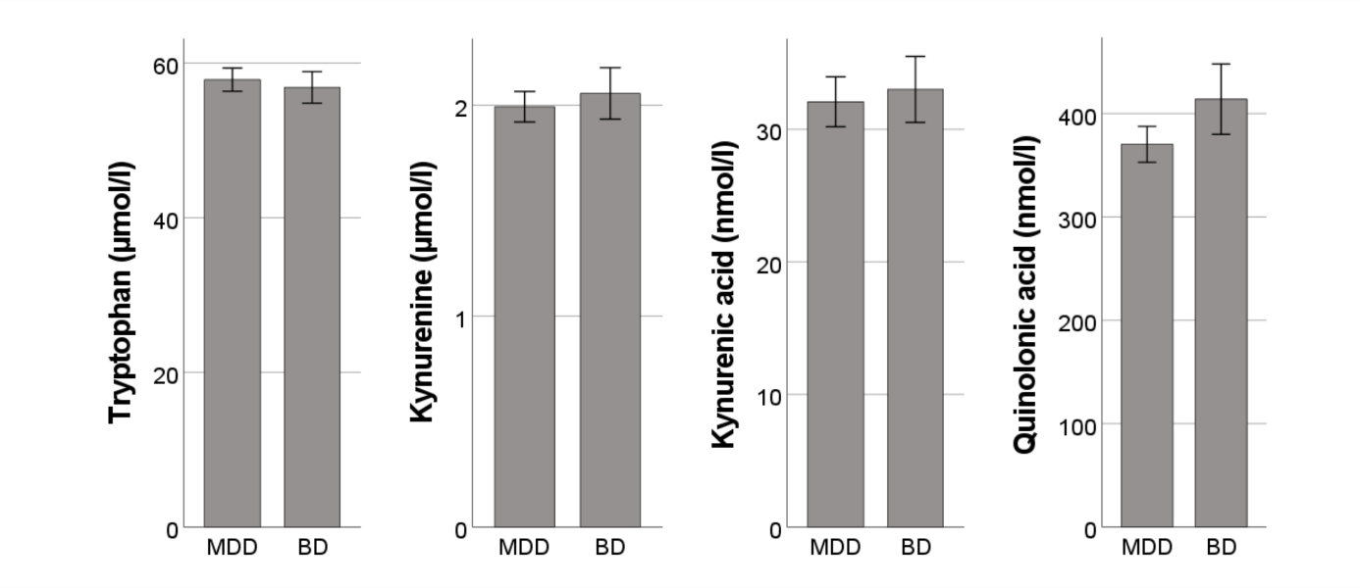
Supplementary Figure 1. No significant differences in TRYCAT levels could be found to distinguish acutely ill unipolar from bipolar depressed patients. Concentrations are displayed as mean with standard deviation. TRYCAT: tryptophan catabolite; MDD: major depressive disorder; BD: bipolar disorder.

