Supplementary Figures

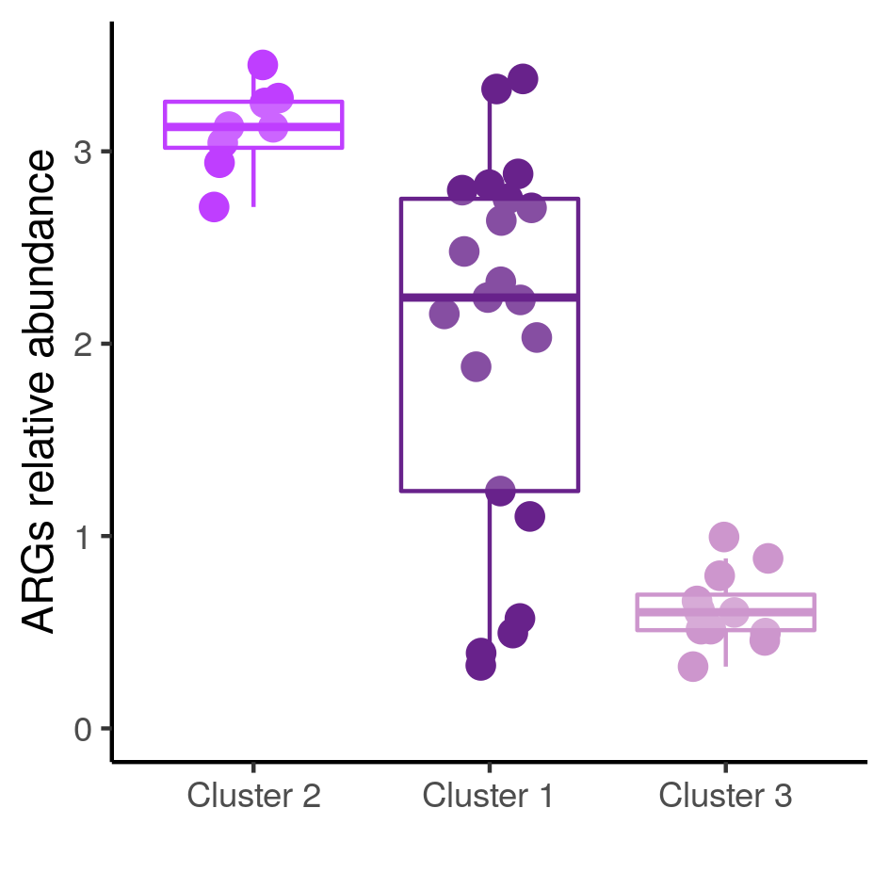

Supplementary Figure S1. Relative abundance of ARGs. Boxplots showing the relative abundance of ARGs in the three metagenomic clusters.

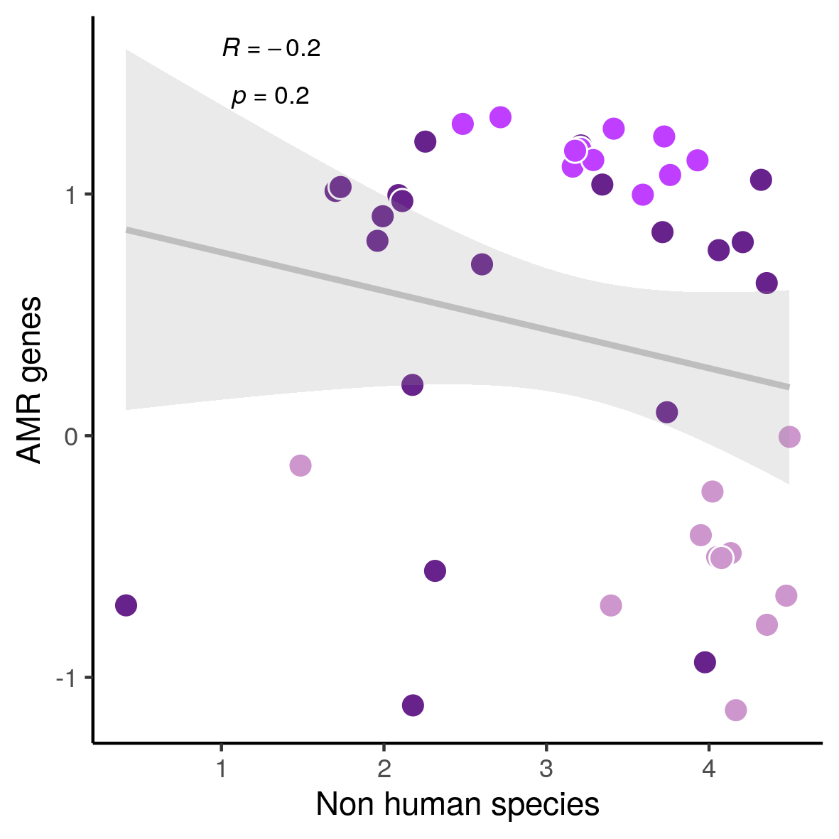

Supplementary Figure S2. Analysis of ARGs and non-human species. Lack of significant linear correlation between the relative abundance of ARGs and non-human species. Dots are colored according to the three metagenomic clusters.

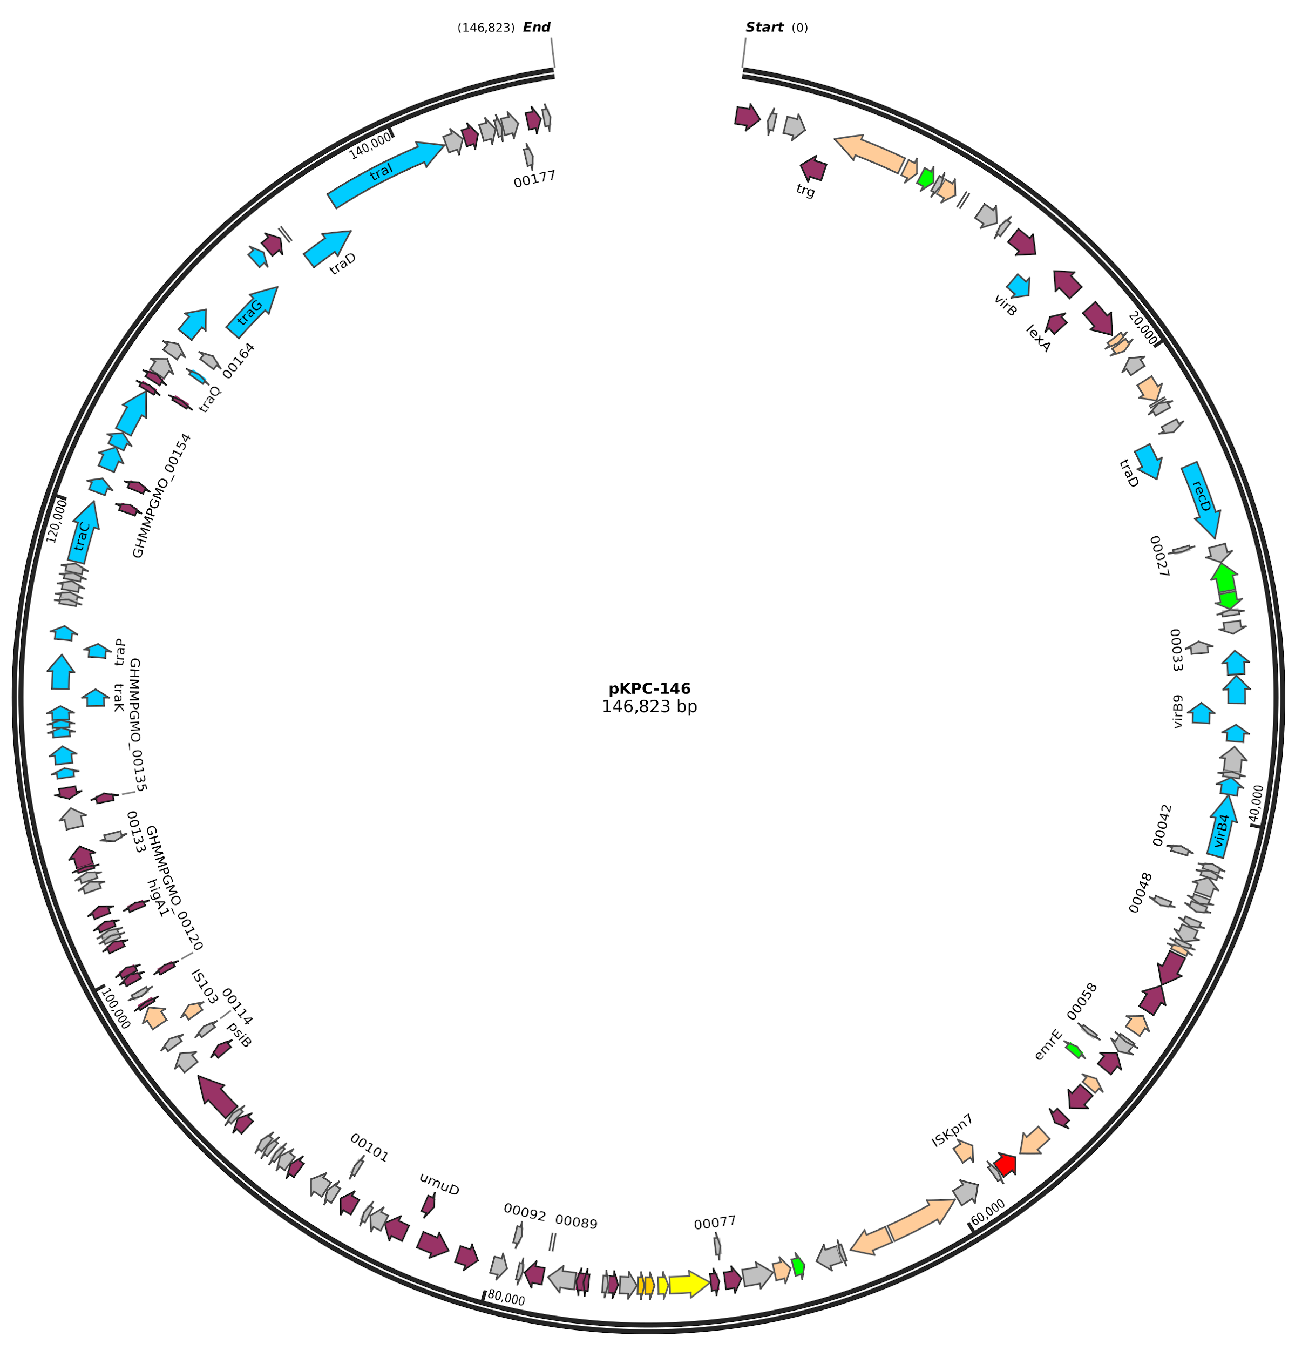

Supplementary Figure S3. Schematic representation of the pKPC-146 plasmid. Circular representation of the pKPC-146 plasmid with annotated genes. Genes are colored according to their functions: plasmid conjugation (skyblue), hypothetical (gray), antibiotic resistance (green), mercuric resistance (yellow), other functions (purple), transposons (pink). The KPC carbapenemase gene is highlighted in red.

