Phylosymbiosis between Microbial Communities and Fish; Spatial and Host Species Shape Bacterial Community Composition
Javad Sadeghi¹, Subba Rao Chaganti², Timothy B. Johnson³, Daniel D Heath¹,^{4*}
1 Great Lakes Institute for Environmental Research, University of Windsor, Windsor, Canada
2 Cooperative Institute for Great Lakes Research, University of Michigan, Ann Arbor, MI, USA
3 Ontario Ministry of Natural Resources and Forestry, Glenora Fisheries Station, Picton, Ontario, Canada
4 Department of Integrative Biology, University of Windsor, Windsor, ON, Canada

Corresponding author: D. D. Heath, Great Lakes Institute for Environmental Research, University of
Windsor, Ontario N9B 3P4, Canada
e-mail: dheath@uwindsor.ca

Table S1: Summary of Great Lakes fish species sampled for gut and skin microbiome. We provide a description of the sample locations and total sample size.

Species | Locations |  |  | Number of samples
Species | Detroit River | Lake Erie | Lake Ontario | Number of samples
Alewife (Alosa pseudoharengus) | 0 | 0 | 22 | 22
Blacknose shiner (Notropis heterolepis) | 11 | 0 | 0 | 11
Brook silver (Labidesthes sicculus) | 7 | 0 | 0 | 7
Brown trout (Salmo trutta) | 0 | 0 | 16 | 16
Emerald shiner (Notropis atherinoides) | 15 | 0 | 0 | 15
Freshwater Drum (Aplodinotus grunniens) | 5 | 17 | 10 | 32
Gizzard Shad (Dorosoma cepedianum) | 10 | 0 | 2 | 12
Lake trout (Salvelinus namaycush) | 0 | 0 | 24 | 24
Pumpkinseed (Lepomis gibbosus) | 11 | 0 | 5 | 16
Rock Bass (Ambloplites rupestris) | 7 | 0 | 3 | 10
Round goby (Neogobius melanostomus) | 0 | 8 | 16 | 24
Spotfin shiner (Cyprinella spiloptera) | 12 | 0 | 0 | 12
Walleye (Sander vitreus) | 0 | 19 | 7 | 26
White Bass (Morone chrysops) | 0 | 10 | 11 | 21
White perch (Morone americana) | 0 | 21 | 12 | 33
White sucker (Catostomus commersonii) | 10 | 0 | 2 | 12
Yellow perch (Perca flavescens) | 10 | 15 | 16 | 41
Total | 98 | 90 | 146 | 334

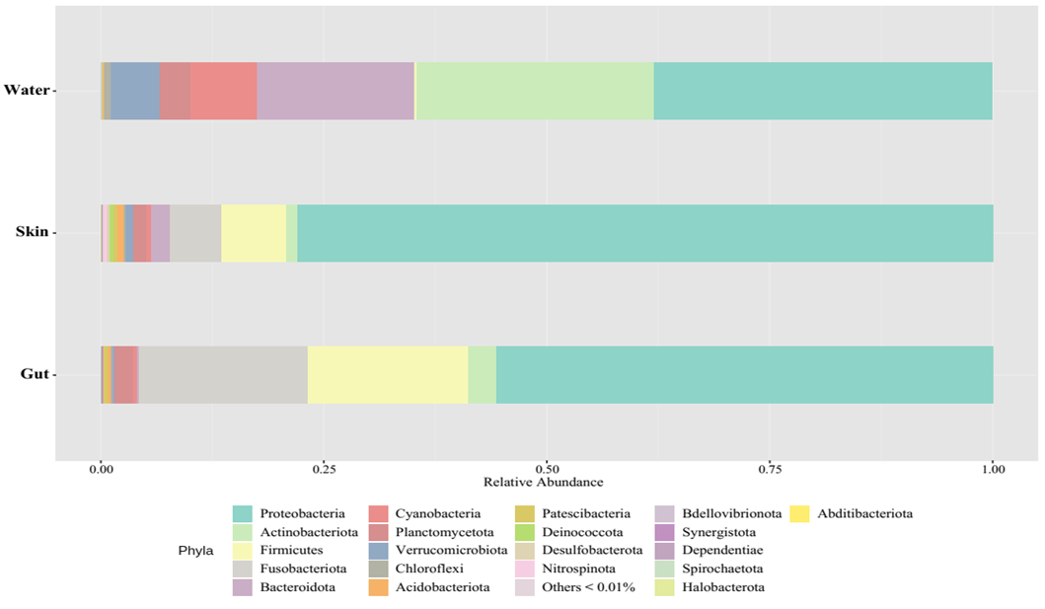
Figure S1: Relative abundance of bacterial community composition presented at the phylum level for gut, skin, and water microbiomes (samples are combined across sample types). Phyla with less than 0.01% of relative abundance are combined and presented as “others”)

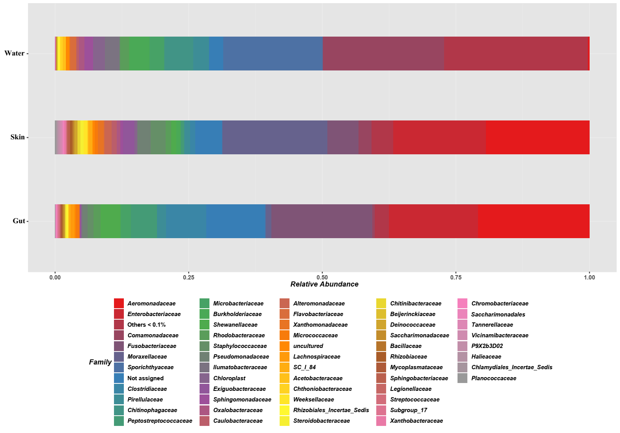
Figure S2: Bacterial community composition (relative abundance at the family level) for gut, skin, and water microbiomes across all fish species collected at three sites in the Great Lakes (Lake Erie, Lake Ontario and Detroit River). Bacterial families with less than 0.1% relative abundance are combined and presented as “others”.

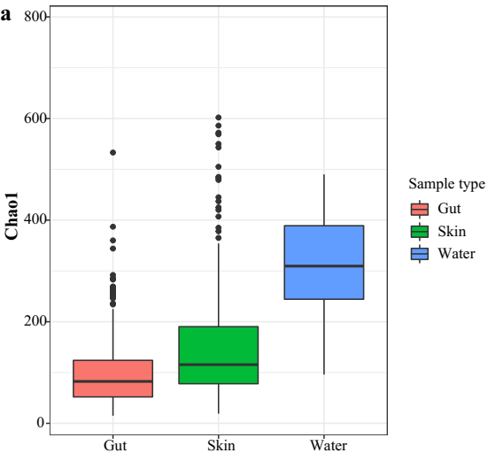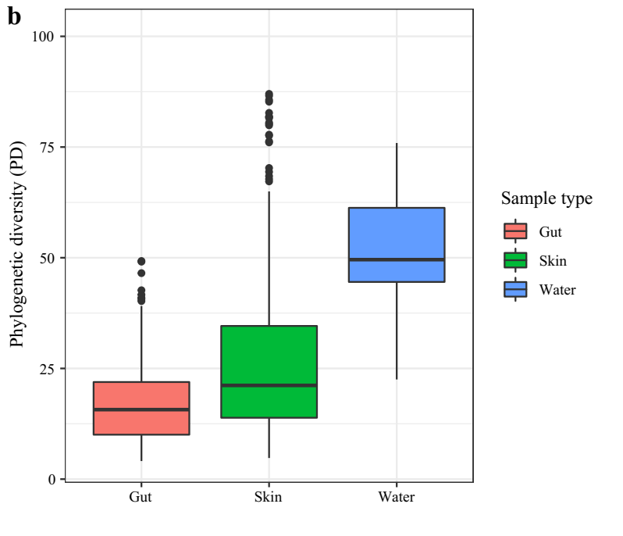
Figure S3: Box and whisker plots of alpha diversity indices (Cho1 (a) and Faith’s phylogenetic diversity (b)) for gut, skin and water microbiomes. The colours reflect sample type and the black dots are outliers. The black line in each box plot is median.

Table S2: Comparison of differentially abundant bacterial taxa at the family level for gut and skin microbiomes across all fish species and sample locations using DESeq2 method (Benjamini-Hochberg false-discovery rate [BH FDR] 0.05, |log₂fold change| > 2). Positive log₂ FC indicate higher abundance in skin samples and negative log₂ FC specify higher abundance in gut samples.
Family | log₂ FC | padj
Deinococcaceae | 5.7 | 2.00E-169
Exiguobacteraceae | 5.6 | 4.00E-144
Alteromonadaceae | 5 | 2.00E-98
Moraxellaceae | 4.9 | 2.00E-86
Oxalobacteraceae | 4.6 | 1.00E-135
Caulobacteraceae | 4 | 2.00E-84
Weeksellaceae | 3.3 | 2.00E-50
Sphingobacteriaceae | 3.2 | 3.00E-68
Xanthomonadaceae | 2.7 | 4.00E-49
Rickettsiaceae | 2.7 | 1.00E-44
Flavobacteriaceae | 2.5 | 1.00E-30
Alcaligenaceae | 2.4 | 1.00E-40
Devosiaceae | 2.3 | 6.00E-41
Pseudomonadaceae | 2.1 | 9.00E-28
Xanthobacteraceae | 2.1 | 7.00E-25
Comamonadaceae | 2 | 3.00E-36
P9X2b3D02 (Nitrospinota) | 2 | 8.00E-35
Microbacteriaceae | -5.7 | 9.00E-139
Lachnospiraceae | -4.3 | 1.00E-72
PeM15 (Actinobacteria) | -4.3 | 7.00E-118
Rhizobiales | -4.1 | 1.00E-106
Cyanobiaceae | -3.4 | 2.00E-69
Clostridiaceae | -3.3 | 2.00E-40
Peptostreptococcaceae | -3.3 | 2.00E-36
Subgroup_17 (Vicinamibacteria) | -3.1 | 9.00E-65
Pirellulaceae | -3.1 | 6.00E-50
Caldilineaceae | -3 | 9.00E-68
Microcystaceae | -3 | 4.00E-53
Saccharimonadales | -2.9 | 6.00E-56
Mycoplasmataceae | -2.8 | 1.00E-38
Isosphaeraceae | -2.6 | 1.00E-46
IMCC26256 (Acidimicrobiia) | -2.6 | 7.00E-58
Saccharimonadaceae | -2.6 | 5.00E-42
1_20 (Anaerolineae) | -2.4 | 1.00E-40
Gemmataceae | -2.3 | 3.00E-39
Holosporaceae | -2 | 5.00E-33
Fusobacteriaceae | -2 | 6.00E-15

