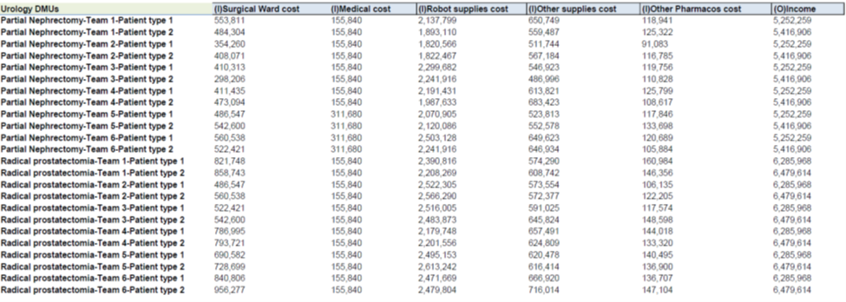
Table 1. Sample Input and output data for Robotic Urology without CPU

