Supplementary information

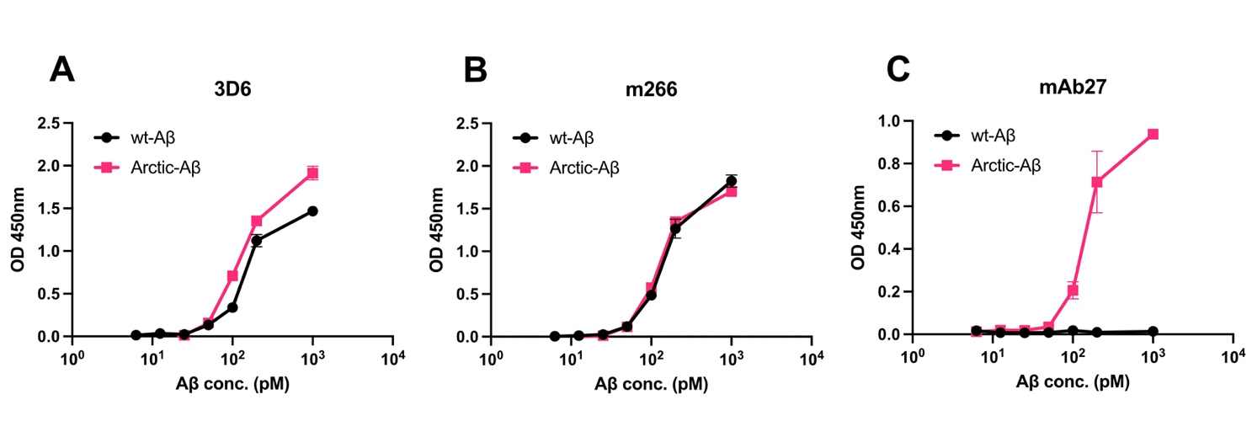
Supplementary Figure 1 Binding selectivity of anti-Aβ antibodies used in this study. ELISA plates coated with an anti-Aβ42 capture antibody. Serial dilution of either wild-type Aβ1-42 (wt-Aβ) or arctic-Aβ1-42 added to the plates. A: when using 3D6 as the detection antibody, both wt-Aβ and arctic-Aβ could be detected. B: when using m266 as the detection antibody, both wt-Aβ and arctic-Aβ could be detected. C: when using mAb27 as the detection antibody, only arctic-Aβ could be detected.

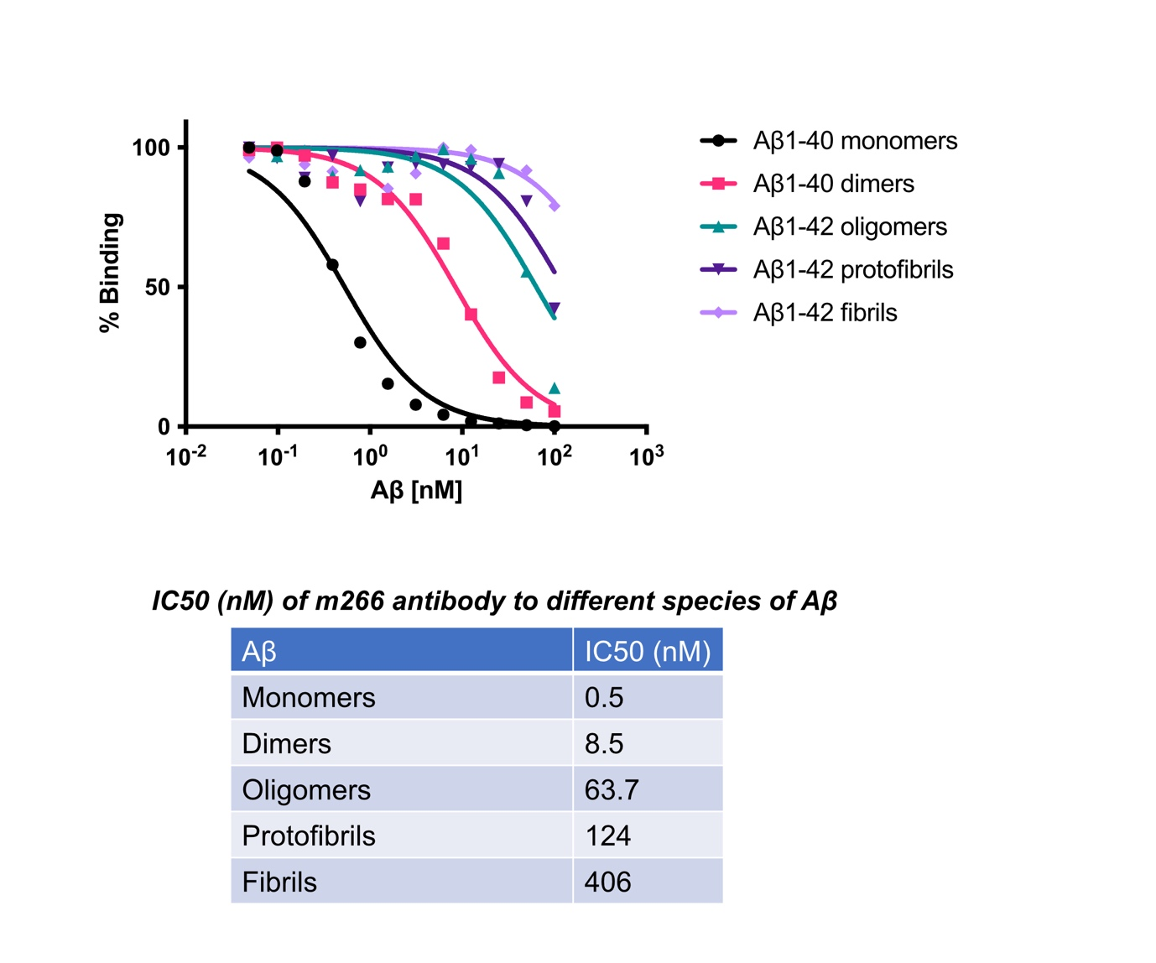
Supplementary Figure 2 Inhibition ELISA demonstrating the binding strength of m266 antibody to different species of Aβ. Five different Aβ species were used: Aβ1-40 monomers, Aβ1-40 dimers, Aβ1-42 oligomers, Aβ1-42 protofibrils and Aβ1-42 fibrils, prepared as described previously [40]. The assay was performed as described previously [40]. Inhibitory concentration-50 (IC50) of m266 binding to the different Aβ species is present in the table. m266 bound stronger to Aβ monomers compared to other Aβ species. Binding strength of m266 antibody decreased as the size of Aβ species increased.

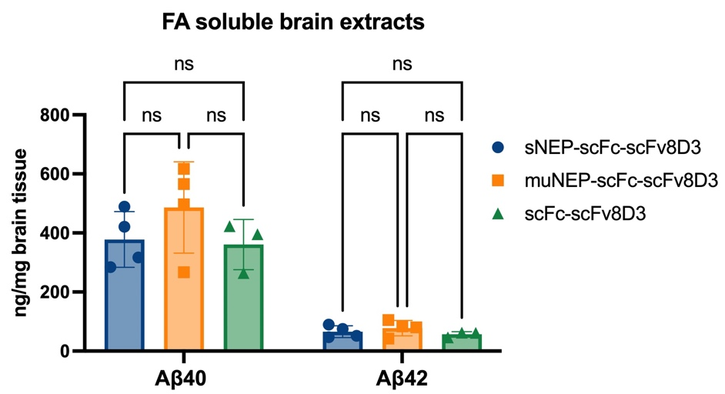
Supplementary Figure 3 Total concentration of Aβ40 and Aβ42 in FA soluble brain extracts of tg-ArcSwe mice following treatment with therapeutic doses of 30 nmol/kg of sNEP-scFc-scFv8D3 or muNEP-scFc-scFv8D3, using scFc-scFv8D3 as the negative control. No significant differences detected among the three groups. Results presented as mean ± SD. One-way ANOVA with Bonferroni’s multiple comparison test was applied (n=4/sNEP-scFc-scFv8D3 and muNEP-scFc-scFv8D3; n=3/scFc-scFv8D3). (p>0.05=ns; p≤0.05= *; p≤0.01= **; p≤0.001= ***).

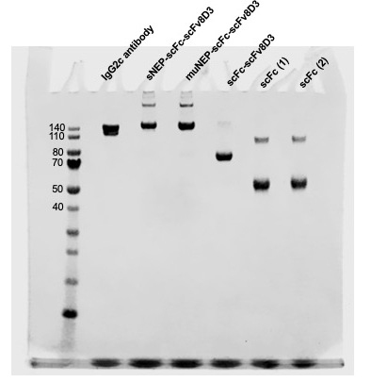

Supplementary Figure 4 Ful picture of the SDS-PAGE gel presented in Figure 2A.

