Supplementary Materials for

Earthworm-inspired MASH (Multi-material, Adaptive Strain-limiting, Hybrid) Actuators for Soft Robots

Quan Xiong, Benjamin W.K. Ang, Tao Jin, Jonathan W. Ambrose, Raye C.H. Yeow*

*Corresponding author. Email: rayeow@nus.edu.sg

This PDF file includes:

Figs. S1 to S10
Table S1
Legends for movies S1 to S10

Other Supplementary Materials for this manuscript include the following:
Movies S1 to S10

Fig. S1. The EA braking force after the AC voltage is turned off. The EA braking force decreases sharply to 0, after the applied AC voltage is turned off from 800 V to 0 V. The EA braking force is measured by the setup in Fig. 3A, and an Arduino controls the applied AC voltage through a H-bridge converter in real-time.

Fig. S2. Detailed design parameters of the 3D printed soft pneumatic actuator and the 3D printed rigid base. (A) The detailed parameters of the 3D printed soft pneumatic actuator, including a longitudinal section view and a cross section view. (B) Detailed parameters of the 3D printed rigid base, including a top view and a side view.

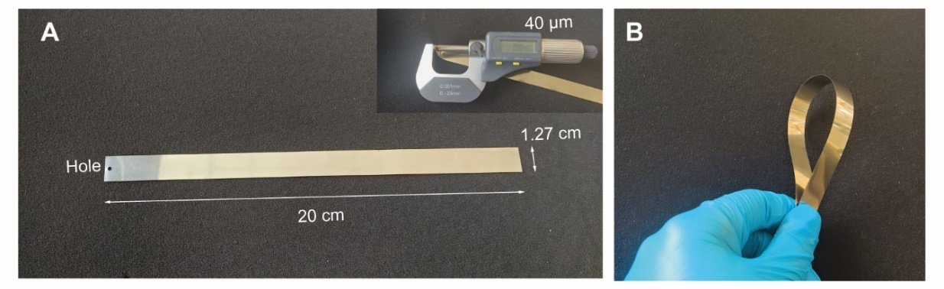

Fig. S3. A stainless steel sheet is used as Electrode A. (A) The steel strip with 20 cm length, 1.27 cm width, and 40 μm thickness as measured by an electronic thickness gauge. (B) Demonstration of the flexibility of Electrode A.

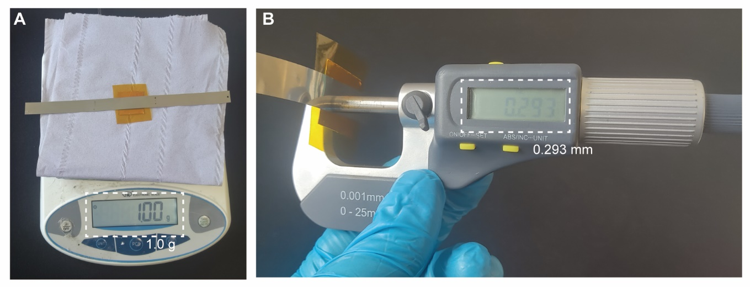

Fig. S4. The weight and thickness of the EA brake. (A) The weight of the EA brake, including Electrode A, Electrode B and a polyimide layer measured by an electronic weight gauge. (B) The total thickness of the EA brake is measured to be 0.293 mm.

Fig. S5. AC high voltage power supplies. (A) The schematic diagram of the H-bridge converter, converting from a DC high voltage to AC high voltage, where PWM 1 and PWM 2 are outputted by a microcontroller, and Port A and Port B are AC high voltage output ports. (B) The DC high voltage power supply with two screens display real-time voltage and current. (C) The H-bridge converter prototype. (D) The portable AC high voltage power supply, integrating a portable DC high voltage power supply and the H-bridge circuit. The input voltage is 24 V and the magnitude of AC high voltage can be tuned manually by a regulator. The whole system weighs only 0.9 kg.

Fig. S6. Crawling from a steep slope to a horizontal plane. (A) The procedures for crawling from a steep slope to a horizontal plane. (B) Snapshots of the earthworm-inspired crawling robot crawling from 45°, 60°, and 90° slopes (a vertical wall) to a horizontal plane respectively.

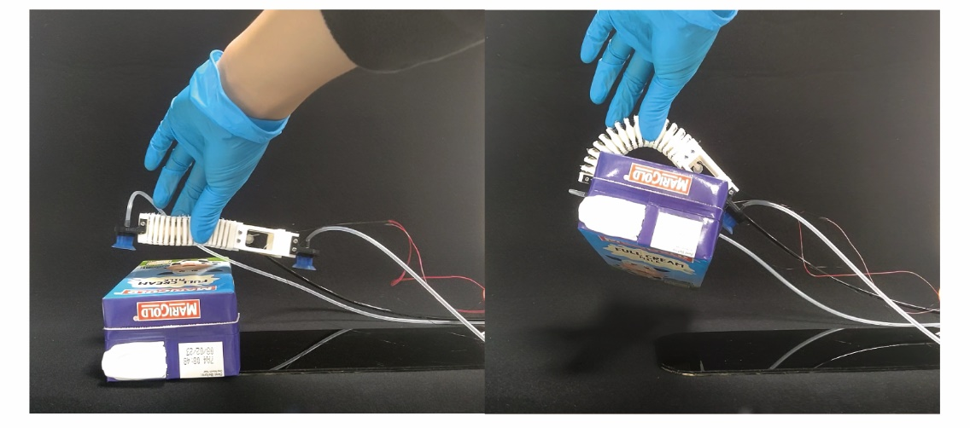

Fig. S7. Transition from a locomotion robot to a manipulation robot. The crawling robot can also pinch a box by bending its body.

Fig. S8. The electronic design and three basic motion patterns of the versatile soft robotic gripper. (A) Front view of the prototype, where the internal chambers of the three actuators are interconnected and share the same pneumatic inlet. (B) The schematic diagram in the top view, where all the Electrode A are interconnected to Port B (black wires), all the Electrode B of inner EA brakes are interconnected to Port A (green wires) and all the Electrode B of outer EA brakes are interconnected to Port C (magenta wires). (C) Three basic motion patterns of the gripper. When solely increasing pneumatic pressure, the gripper achieves extension. When increasing pneumatic pressure and activating inner EA brakes by applying AC voltage between Port A and Port B, the gripper grasps inward. When increasing pneumatic pressure and activating outer EA brakes by applying AC voltage between Port B and Port C, the gripper grasps outward.

Fig. S9. The load capacity of a finger with different lengths of the strain-limiting layer. (A) The experimental setup used to test the maximum holding force of the finger, where a tensile machine pulls a force gauge and a rod handle up at a constant speed to uncurl the bending finger, while the force gauge simultaneously measures the maximum force. (B) The maximum forces during uncurling the bending finger with 70 mm, 100 mm, and 130 mm lengths of the strain-limiting layer.

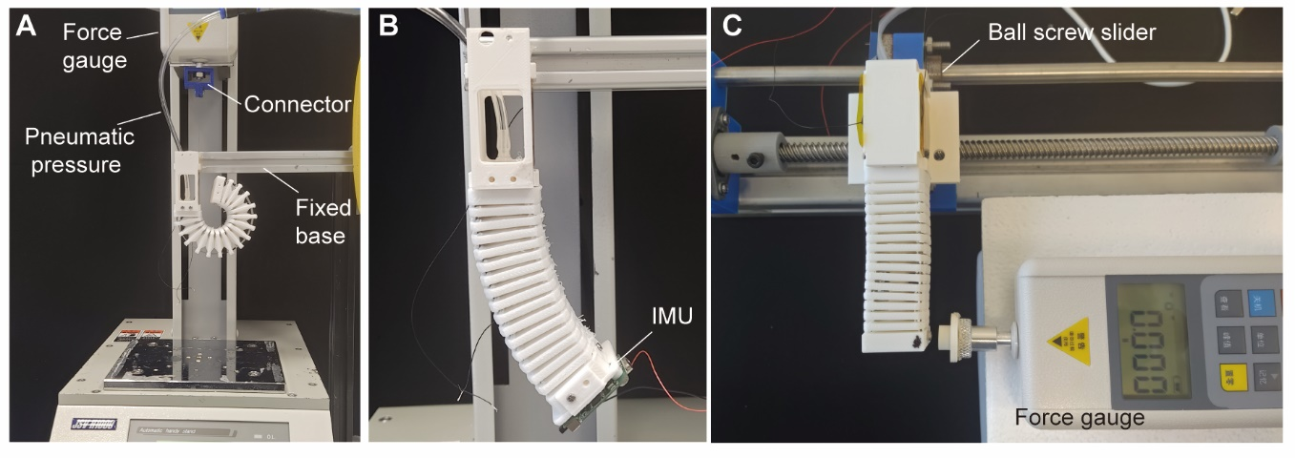

Fig. S10. Experimental setups for characterizing adaptive strain-limiting layer. (A) The setup to test the needed constraining force. Electrode A is connected to a force gauge through a connector and the soft pneumatic actuator is mounted on a fixed base. (B) The setup to test the bending angle by a Bluetooth IMU mounted on the tip of the actuator. (C) The setup to test the stiffness of the actuator. The actuator is mounted on a ball screw slider, while the force gauge is fixed on a base.

Table S1. Comparison between the MASH actuator with other soft pneumatic actuators reviewed.
Ref |  | [26] | [27] | [47] | [48] | [28] | [49] | This work
Motion patterns | Linear motion | No | No | No | No | Yes | No | Yes
Motion patterns | Bending direction | Uni | Uni | Bi | Uni | Bi | Tri | Bi
Length variation  (Percent of OAL*) |  | 0 | 0 | 0 | 150 | 52 | 0 | 86
Stiffness variation  (Percent of OAS**) |  | 486 | 250 | - | - | - | 250 | 605
Pneumatic source number |  | 1 | 2 | 2 | 1 | 1 | 3 | 1
Maximum bending angle (degree) |  | 210 | 56.4 | 55 | 180 | 90 | 128 | 257
*Original actuator length
**Original actuator stiffness

Movie S1. The multiple motion patterns.

Movie S2. The variable length of EA-based strain-limiting layer.

Movie S3. The variable stiffness of the actuator.

Movie S4. The earthworm-inspired crawling robot crawls on different slopes.

Movie S5. The earthworm-inspired crawling robot climbs from a horizontal plane to a steep slope.

Movie S6. The earthworm-inspired crawling robot crawls from a steep slope down to a horizontal plane.

Movie S7. The earthworm-inspired crawling robot pinches a box.

Movie S8. The versatile soft robotic gripper grasps items of different sizes.

Movie S9. The versatile soft robotic gripper grasps inside of items.

Movie S10. The versatile soft robotic gripper extends its grasping space.

