Periodical propagation of torsion in polymer gels

Yuhei Yamada¹, Yuji Otsuka², Zebing Mao^{*1}, Shingo Maeda^{*1}

¹Department of Mechanical engineering, Tokyo Institute of Technology, 2-12-1 Ookayama Meguro-ku Tokyo, 152-8550, Japan.
²Department of Engineering Science and Mechanics, Shibaura Institute of Technology, 3-7-5 Toyosu, Koto-ku, Tokyo 135-8548, Japan.
*Corresponding author: mao.z.aa@m.titech.ac.jp, maeda.s.ao@m.titech.ac.jp

Fig. S1 shows the tortional motion of the BZ gel fluctuates with a pre-twisted angle of 8π. Three angles of $θ\left(s_{1}, t\right)$, $θ\left(s_{2},t\right)$ and $Δθ\left(s_{1},s_{2},t\right)$ fluctuates over the experimental time. The fluctuation of $θ\left(s_{2},t\right)$ lags behind $θ\left(s_{1}, t\right)$ because the BZ wave propagates from the upper rotator to the bottom rotator and meanwhile, the wavelength of BZ gel is smaller than the distance between two rotators. Here, $Δθ\left(s_{1},s_{2},t\right)$ starts with the angle $Δθ_{0}=16.16°$.

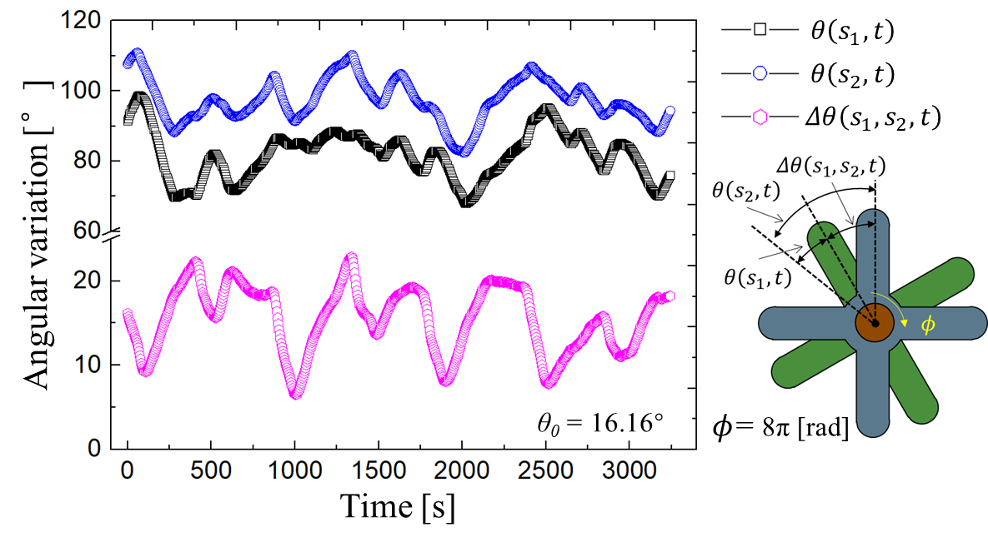
Fig. S1 Angular variation $θ\left(s_{1}, t\right), θ\left(s_{2},t\right), Δθ\left(s_{1},s_{2},t\right)$ of PDMS rotators driven by the BZ reaction when the pre-twist angle $ϕ$ and the mounting angel are 8π and 16.16°, respectively.
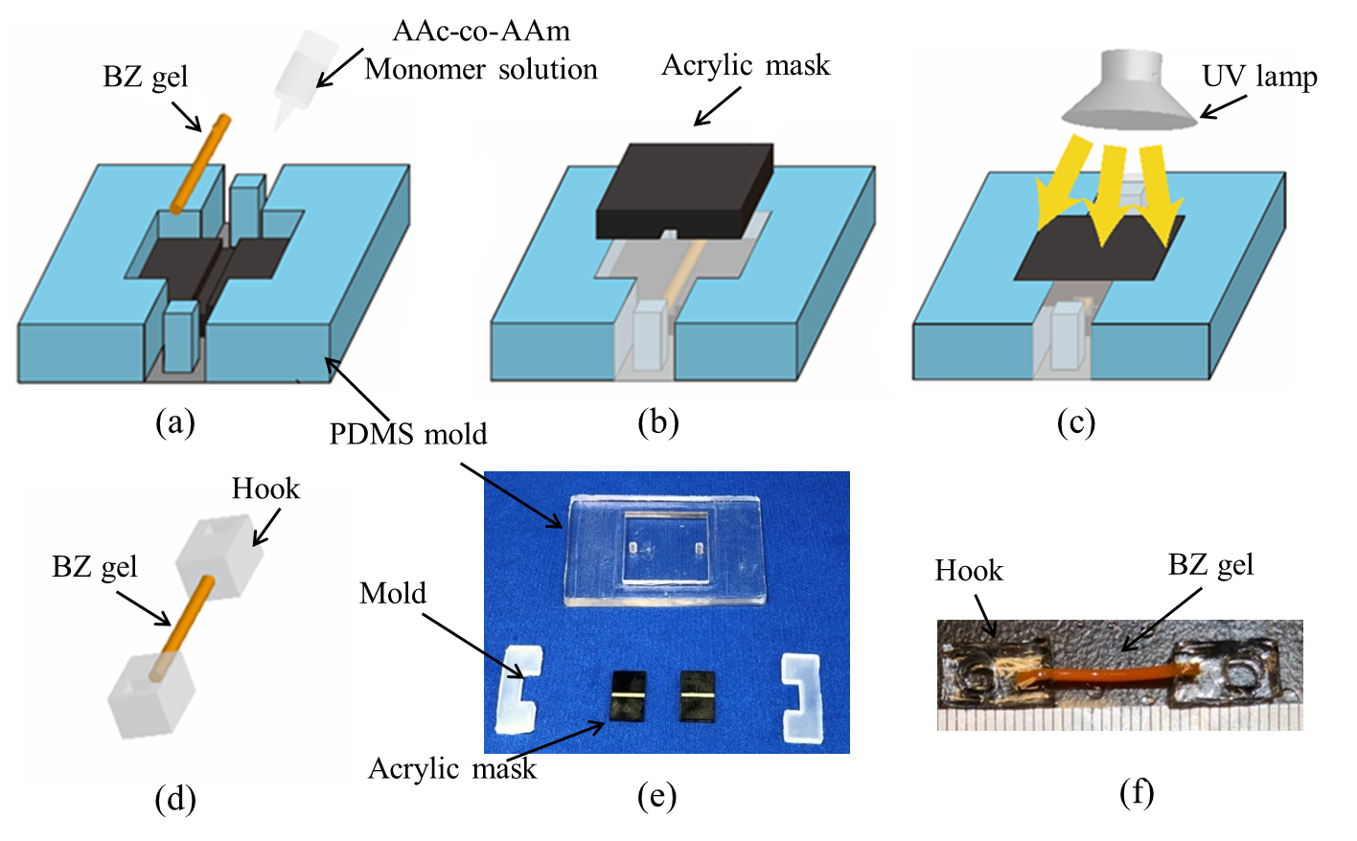
Fig. S2 Synthesis of BZ gel and AAc-co-AAm gel (hook). (a) Preparation of BZ gel, AAc-co-AAm (hook), Acrylic mask, and PDMS mold. (b) Placement of upper acrylic mask. (c) UV exposure. (d) Removal. (e) Optical image of the prepared molds. (f) BZ gel and its hook.
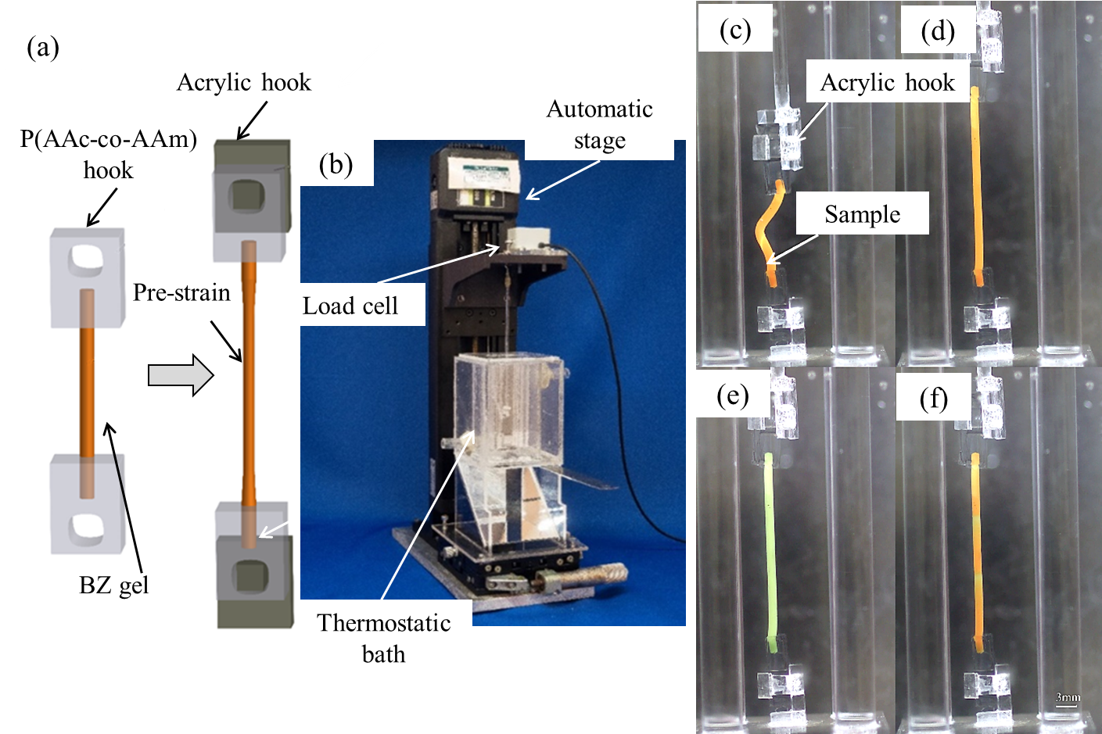
Fig. S3 Experimental setup. (a) Schematic. (b) Tensile test rig. (c) BZ gel hung in the acrylic hook. (d) Pre-stretch process. (e) Addition of BZ reaction solution. (f) BZ waves generation along the axis of the BZ gel.

