Behavioral coping phenotypes associated with risk and resilience to adverse outcomes in a national U.S. sample of pregnant and postpartum women during the COVID-19 pandemic: Supplementary Information
Latent profile analysis: BIPOC women only
Four models, testing the fit of 2-5 possible profiles, were generated and compared for both pregnant and postpartum BIPOC women using the composite coping strategy variables as indicators. The 4-profile model was the best fitting model for both pregnant and postpartum women (Supplementary Table 1). The latent structures of the profiles are presented in Supplementary Figure 1, which illustrate mean values for the continuous and categorical variables for each profile. The latent profiles followed the same pattern as those identified in the full sample.
Supplementary Table 1. LPA model fits for pregnant and postpartum BIPOC women.

 | BIC |  | Entropy |  | Smallest profile (%) |  | LMR p value
 | Pregnant | Postpartum | Pregnant | Postpartum | Pregnant | Postpartum | Pregnant | Postpartum
2-profile | 1226.12 | 801.50 | .91 | .85 | 44% | 20% | < .001 | < .001
3-profile | 1193.14 | 799.14 | .85 | .78 | 6% | 17% | .19 | .18
4-profile | 1149.13 | 780.73 | .81 | .87 | 10% | 7% | < .001 | .04
5-profile | 1163.02 | 803.04 | .82 | .87 | 1% | 5% | .40 | .30
Note. BIC = Bayesian Information Criteria; LMR = Lo-Mendell-Rubin.
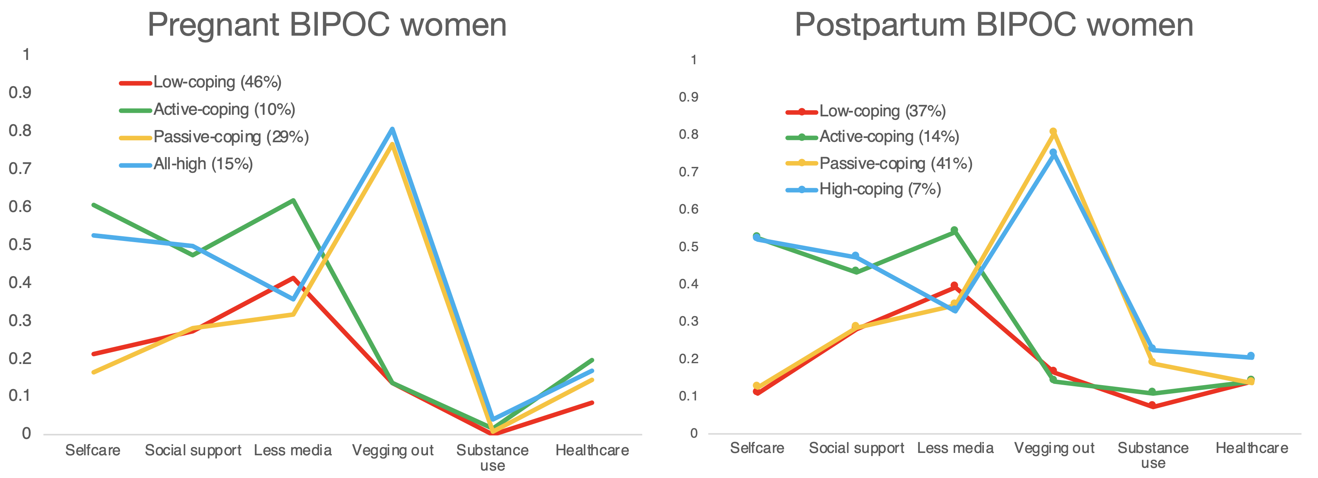
Supplementary Figure 1. Estimated means for the 6 coping strategies across all profiles for both pregnant BIPOC women (n = 750) and postpartum BIPOC women (n = 364).

Relation to demographic and socioeconomic variables: BIPOC women only
Multinomial logistic regression analysis was used to examine predictors of latent profile membership based on demographic and socioeconomic variables. The multinomial logistic model parameters with the low-coping profile as the reference category are presented for pregnant and postpartum women in Supplementary Table 2 and Supplementary Table 3, respectively. In pregnant women, the passive-coping profile was more likely to be younger (OR = .95, 95% CI = .92-.99), and women in the active-coping profile were more likely to have fewer children in the home (OR = .49, 95% CI = .29-.82). In postpartum BIPOC women, the active-coping profile was more likely to be younger (OR = .88, 95% CI = .81-.95) and were more likely to report higher levels of educational attainment (OR = 1.37, 95% CI = 1.00-1.87).
Supplementary Table 2. Multinomial logistic regression of demographic predictors of latent profile membership for pregnant BIPOC women.
 | High-coping (vs. low) |  |  | Passive-coping (vs. low) |  |  | Active-coping (vs. low)
 | B | SE | Odds ratio | B | SE | Odds ratio | B | SE | Odds ratio
Maternal age | -0.03 | 0.04 | 0.98 | -0.05⁺ | 0.02 | 0.95 | 0.00 | 0.05 | 1.00
Children | -0.69 | 0.46 | 0.50 | -0.14 | 0.11 | 0.87 | -0.71* | 0.31 | 0.49
Education | 0.11 | 0.16 | 1.12 | 0.02 | 0.07 | 1.03 | 0.14 | 0.19 | 1.15
Income | 0.07 | 0.05 | 1.07 | 0.04 | 0.03 | 1.04 | 0.02 | 0.05 | 1.02
⁺ p < .10
* p < .05

Supplementary Table 3. Multinomial logistic regression of demographic predictors of latent profile membership for postpartum BIPOC women.
 | All high (vs. all low) |  |  | Passive coping (vs. all low) |  |  | Active coping (vs. all low)
 | B | SE | Odds ratio | B | SE | Odds ratio | B | SE | Odds ratio
Maternal age | -0.02 | 0.08 | 0.99 | -0.06 | 0.04 | 0.95 | -0.13* | 0.05 | 0.88
Children | -0.06 | 0.44 | 0.94 | 0.06 | 0.13 | 1.06 | 0.12 | 0.14 | 1.13
Education | 0.14 | 0.19 | 1.15 | 0.14 | 0.10 | 1.15 | 0.31⁺ | 0.19 | 1.37
Income | 0.08 | 0.06 | 1.09 | 0.05 | 0.04 | 1.05 | -0.03 | 0.07 | 0.97
⁺ p < .10
* p < .05

Relation to mental and physical health outcomes: BIPOC women only
Finally, we examined whether latent profile membership was a significant predictor of mental and physical health outcome variables. In pregnant women, latent profile was a significant predictor of all mental and physical health outcomes, as indicated in Supplementary Table 4. Of note, coping profiles characterized by high levels of vegging out (high-coping and passive-coping) were associated with increased anxiety and depression, worsening stress levels, worsening energy levels, and overall greater COVID-related distress relative to the active-coping and low-coping profiles. Additionally, profiles characterized by high self-care and social support (active-coping and high-coping) also reported fewer negative changes in sleep quality relative to the passive-coping profile. As indicated in Supplementary Table 5, latent profile was a significant predictor of depression and anxiety symptoms for postpartum BIPOC women. Of note, the active-coping profile was associated with lower levels of depression and anxiety symptoms relative to all other profiles.
Supplementary Table 4. Comparisons of mental and physical outcomes for pregnant BIPOC women.
 | Active-coping | High-coping | Passive-coping | Low-coping | Omnibus χ2 test
 | M (SE) | M (SE) | M (SE) | M (SE)
BSI anxiety | .50 (.07) ª | .65 (.08) ^{a, b} | .80 (.06) ^{b} | .60 (.05) ª | χ2(3) = 11.98, p = .007
BSI depression | .58 (.08) ª | .76 (.08) ª | 1.00 (.07) ^{b} | .71 (.05) ª | χ2(3) = 18.75, p < .001
Change in energy | 2.54 (.10) ª | 2.17 (.08) ^{b} | 2.13 (.06) ^{b} | 2.35 (.05) ª | χ2(3) = 20.84, p < .001
Change in sleep | 2.75 (.10) ª | 2.60 (.10) ª | 2.34 (.06) ^{b} | 2.52 (.05) ª | χ2(3) = 14.40, p = .002
Change in stress | 2.30 (.09) ª | 2.05 (.08) ^{b, c} | 1.95 (.05) ^{b} | 2.22 (.05) ^{a, c} | χ2(3) = 25.34, p < .001
COVID-related distress | 4.13 (.23) ª | 4.56 (.16) ^{a, b} | 4.73 (.11) ^{b} | 4.35 (.11) ª | χ2(3) = 10.82, p = .013
Superscripts indicate which groups differ based on significant (p < .05) Wald tests.

Supplementary Table 5. Comparisons of mental and physical outcomes for postpartum BIPOC women.
 | Active-coping | High-coping | Passive-coping | Low-coping | Omnibus χ2 test
 | M (SE) | M (SE) | M (SE) | M (SE)
BSI anxiety | .44 (.10) ª | .79 (.18) ^{a, b} | .73 (.07) ^{b} | .67 (.07) ^{a, b} | χ2(3) = 6.43, p = .009
BSI depression | .36 (.08) ª | .82 (.20) ^{b} | .90 (.08) ^{b} | .82 (.09) ^{b} | χ2(3) = 28.67, p < .001
Change in energy | 2.55 (.12) ª | 2.41 (.15) ª | 2.29 (.07) ª | 2.30 (.08) ª | χ2(3) = 4.15, p = .246
Change in sleep | 2.80 (.13) ª | 2.61 (.08) ª | 2.61 (.06) ª | 2.50 (.08) ª | χ2(3) = 3.90, p = .273
Change in stress | 2.38 (.11) ª | 2.43 (.20) ª | 2.13 (.07) ª | 2.17 (.07) ª | χ2(3) = 4.67, p = .198
COVID-related distress | 4.15 (.27) ª | 4.54 (.30) ª | 4.54 (.14) ª | 4.41 (.18) ª | χ2(3) = 1.79, p = .618
Superscripts indicate which groups differ based on significant (p < .05) Wald tests.

