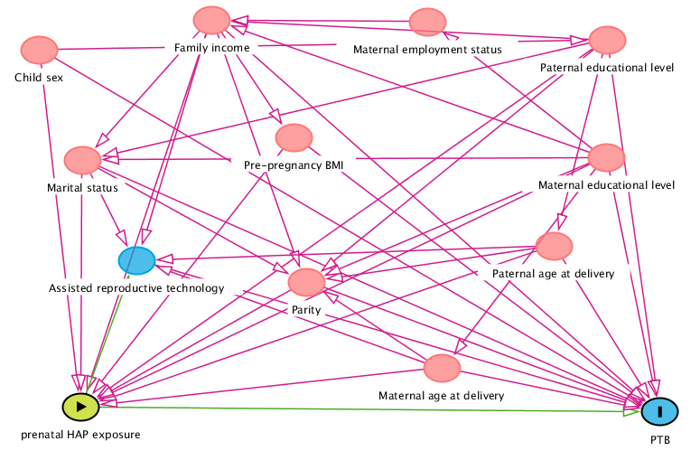
Figure S1. Directed acyclic graph (DAG) for the association between prenatal HAP exposure and PTB, showing all potential confounders. Pink lines indicate potential confounders.
HAP: household air pollution; PTB: preterm birth; BMI: body mass index

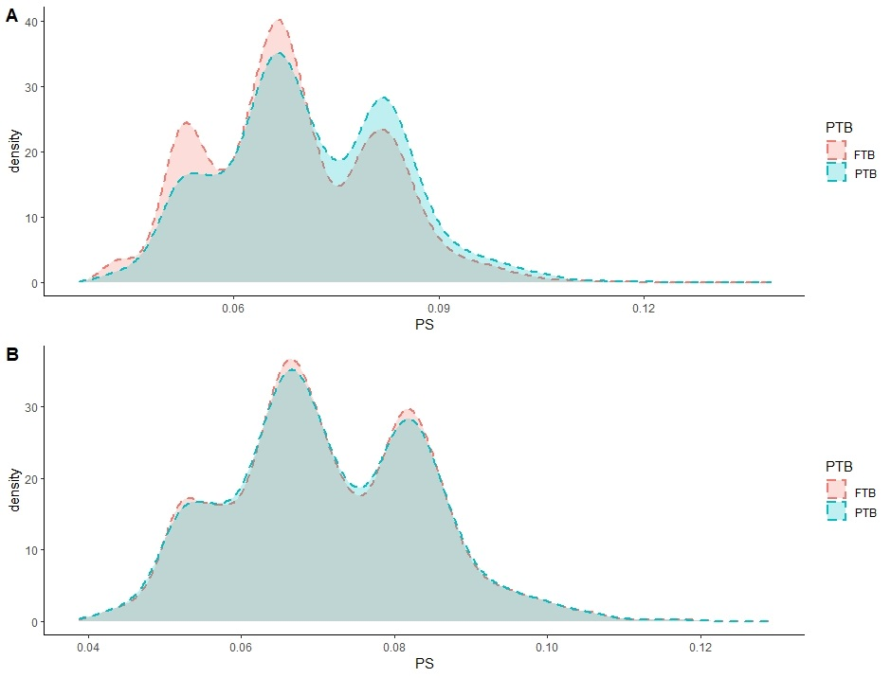
Figure S2. Matching quality and balancing tests. (A) Distribution of propensity scores (PS) in PTB and FTB before PSM (B) Distribution of propensity scores (PS) in PTB and FTB after PSM.
FTB: full-term birth; PTB: preterm birth; PS: propensity score
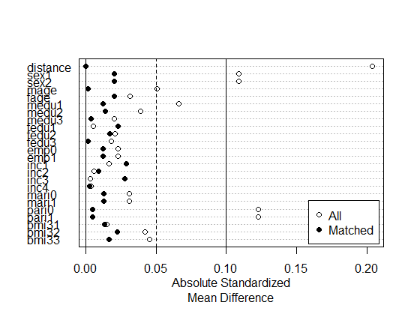
Figure S3. Absolute standardized mean difference across covariates before and after PSM. Y axis was the selected potential covariates. X axis represented the absolute standardized mean difference of each covariate.
sex: child’s sex; mage: maternal age at delivery; fage: paternal age at delivery; medu: maternal educational level; fedu: paternal educational level; emp: maternal employment status; inc: family income; mari: marital status; pari: parity; bmi: maternal pre-pregnancy BMI.

