Supplementary Material for

Tunable sliding ferroelectricity and magnetoelectric coupling in two-dimensional multiferroic MnSe materials

Kehan Liu, Xikui Ma, Shuoke Xu, Yuanyuan Qu, Yangyang Li, Mingwen Zhao*
School of Physics, Shandong University, Jinan 250100, China

E-mail: zmw@sdu.edu.cn

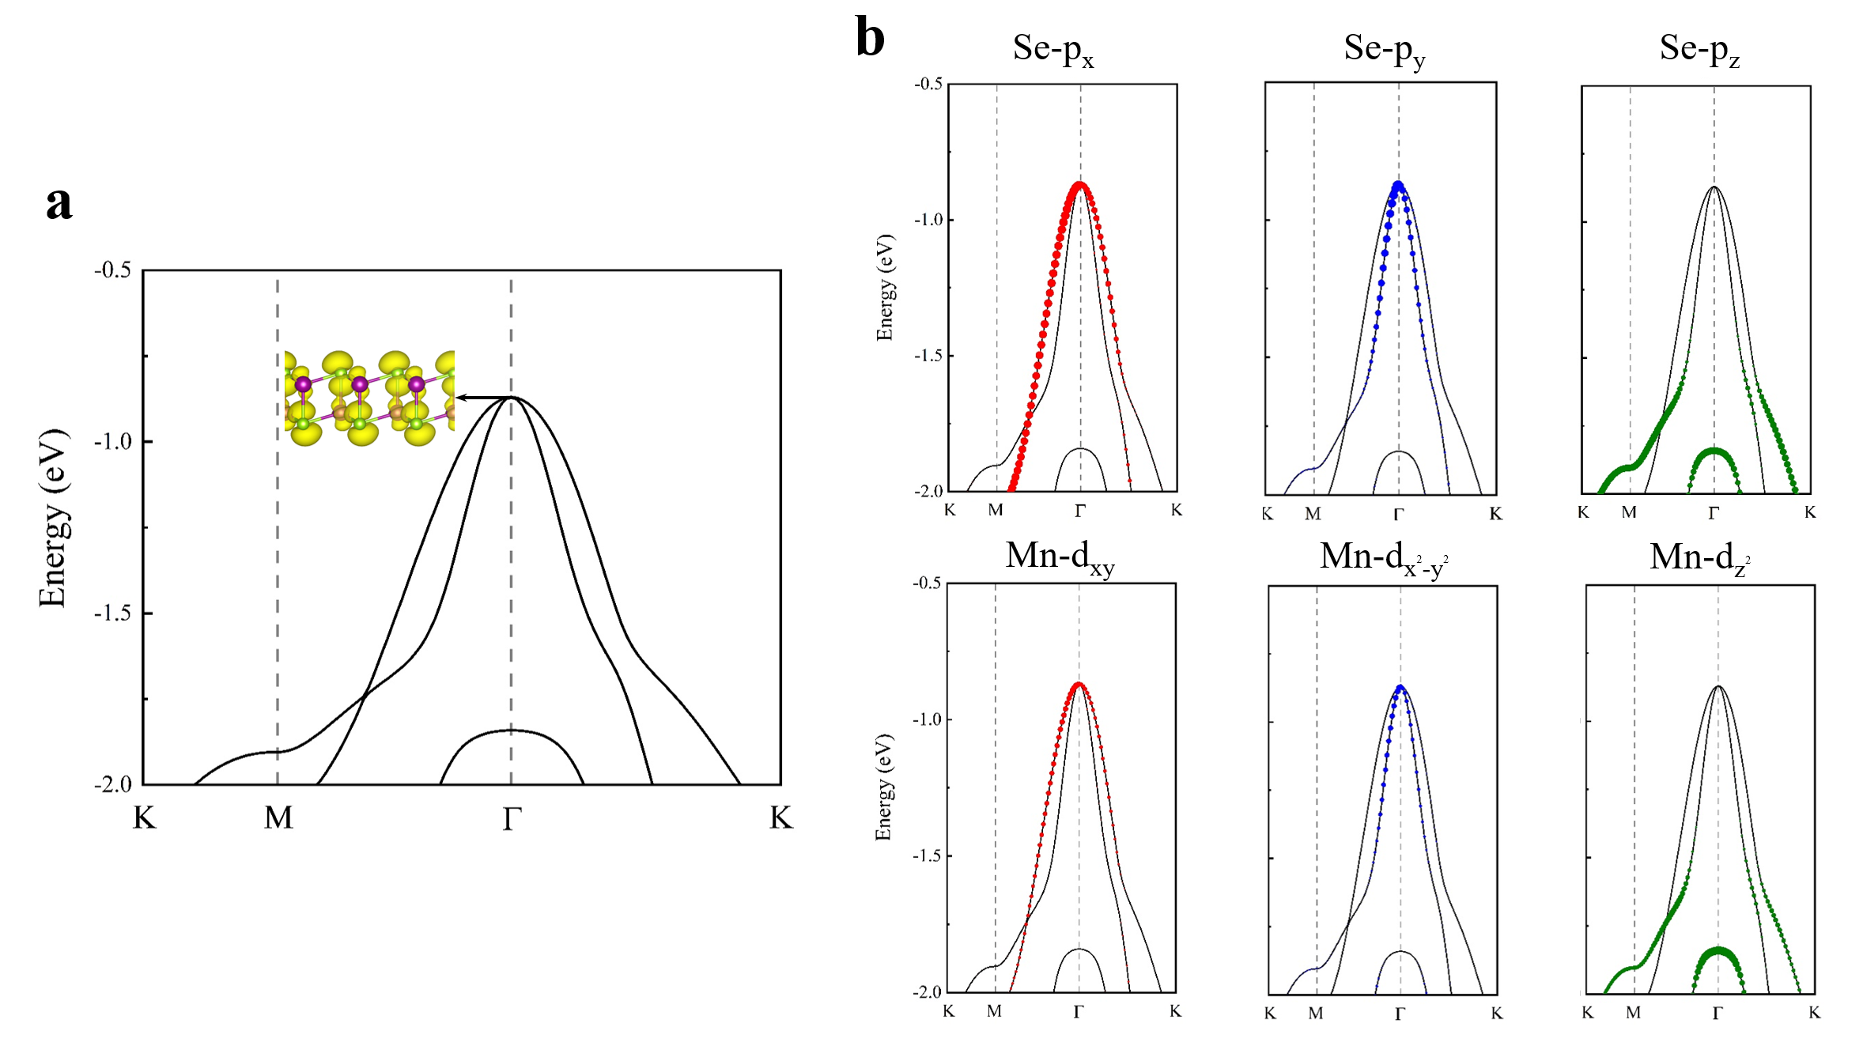

Figure S1. a Band structure of MnSe monolayer. Inset is the partial charge density of highest occupied state in Г. b Projected band structure of different atomic orbitals in MnSe monolayer.

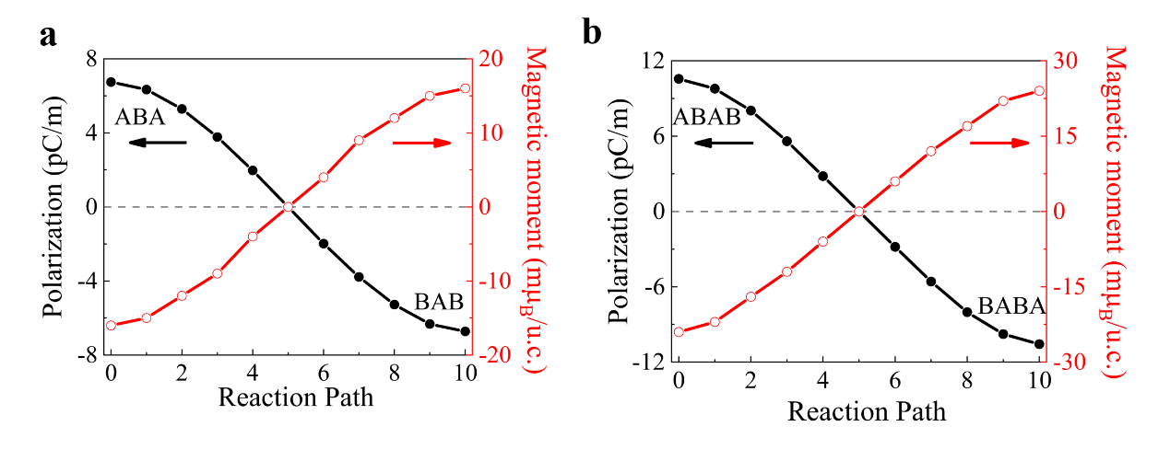

Figure S2. a and b are electric polarization and net magnetic moment for MnSe trilayer and tetralayer as a function of the interlayer sliding.

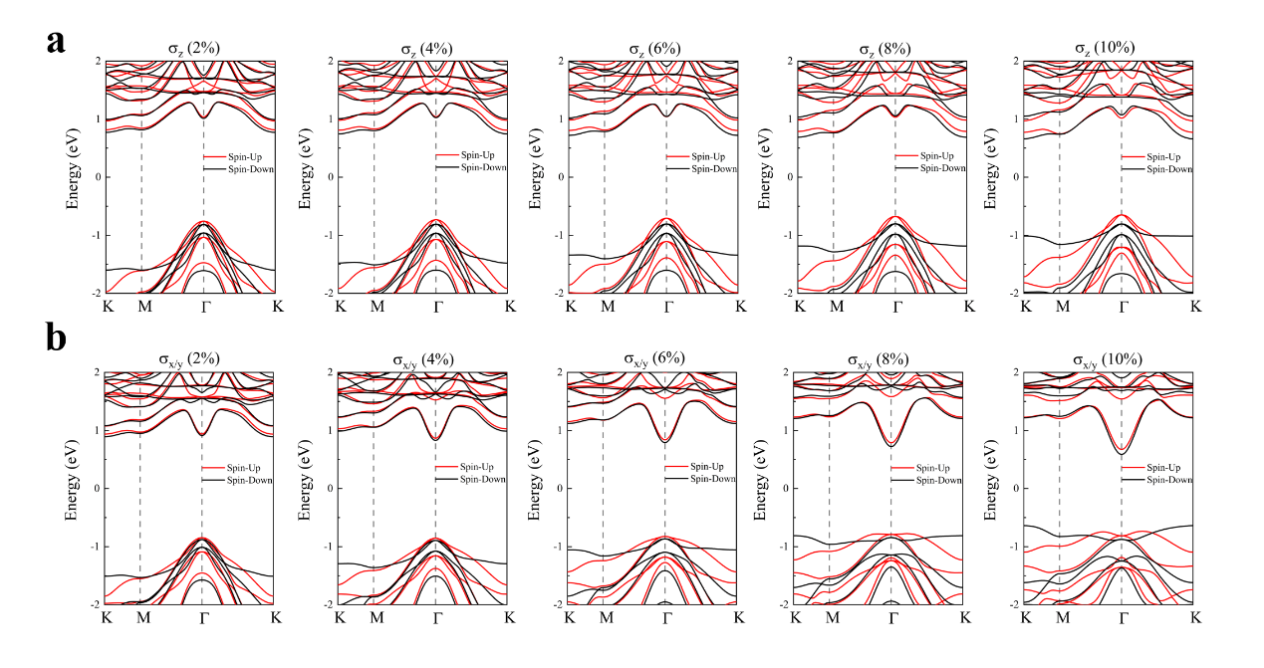

Figure S3. Evolution of spin polarized band structure of AB stacking for MnSe bilayer with the increase of a out-of-plane pressure and b biaxial tensile in-plane strain.

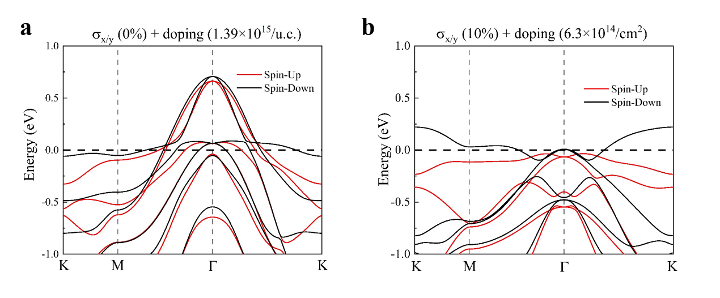

Figure S4. Spin polarized band structure for AB stacking in MnSe bilayer under a hole doping density of 1.39×10¹⁵/cm² without strain and b hole doping density of 1.39×10¹⁵/cm² with 10% biaxial tensile in-plane strain.

