Appendix S1
Figure. Segmental abdominal body fat and muscle analysis at the L3 vertebra on abdominopelvic computed tomography. HU: Hounsfield units; SFA: subcutaneous fat area; VFA: visceral fat area; IMFA: intermuscular fat area; LAMA: low-attenuation abdominal muscle area; NAMA: normal-attenuation muscle area; TAMA: total abdominal muscle area

Appendix S2
Figure. Distribution of (a) testosterone and (b) loge-transformed testosterone in the cohort.

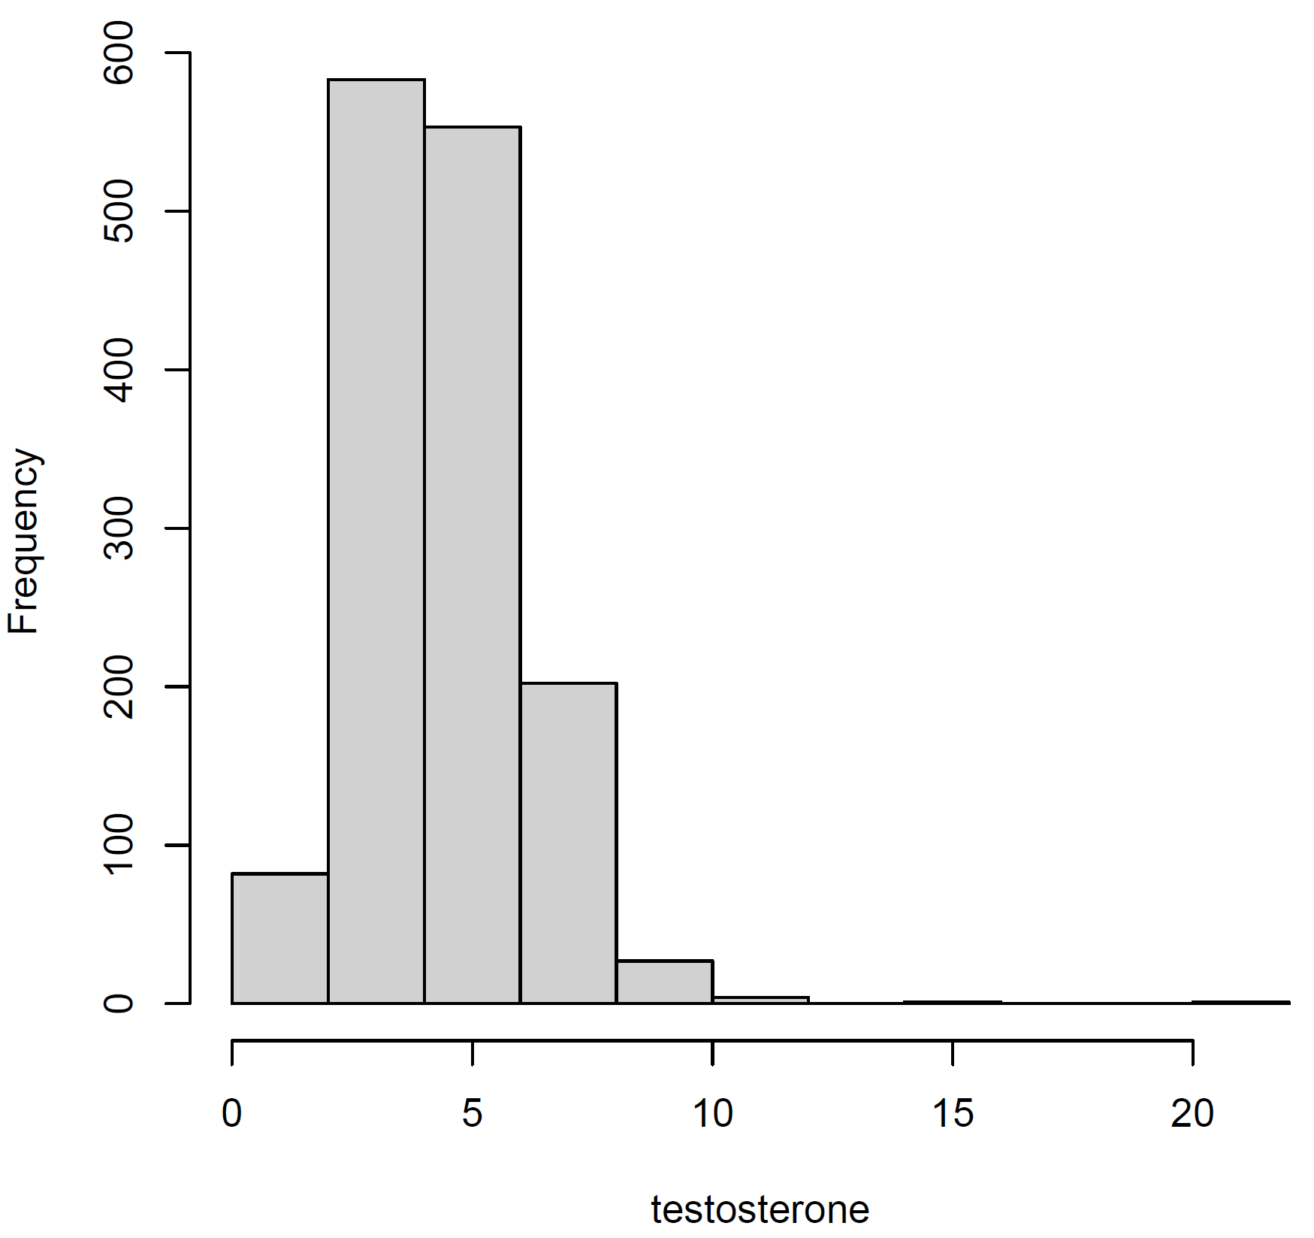

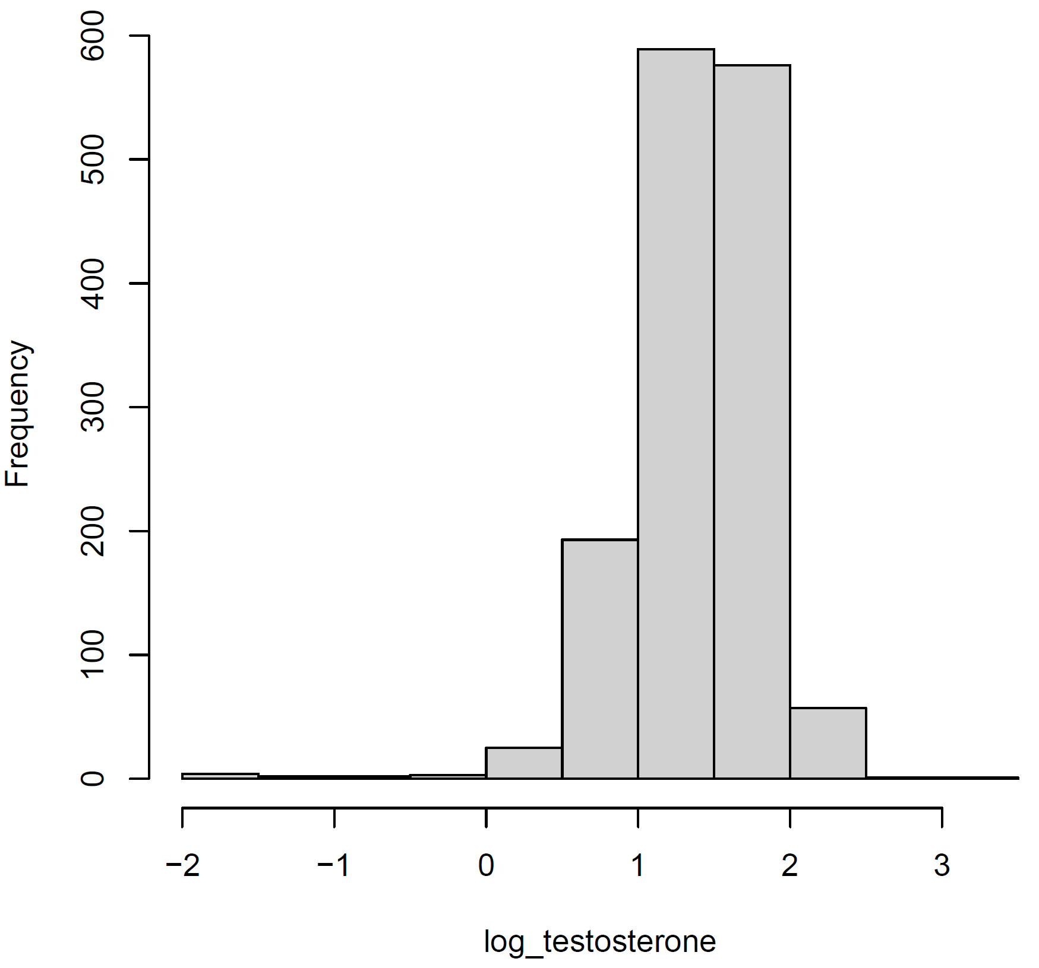

Appendix S3
Multivariable analysis (each factors)
- Subcutaneous fat area index
Variables | Coefficient  (β) | 95% CI |  | P-value
Variables | Coefficient  (β) | LB | UB | P-value
Age, year | -0.001 | -0.004 | 0.003 | 0.727
CRP (≥2.0 vs. <2.0) | -0.417 | -0.605 | -0.229 | <0.001
Albumin, g/dL | -0.114 | -0.193 | -0.035 | 0.005
Hemoglobin A1c, % | -0.049 | -0.082 | -0.016 | 0.004
Waist circumference ≥90 cm (yes vs. no) | -0.029 | -0.087 | 0.029 | 0.328
Triglyceride ≥150 mg/dL (yes vs. no) | 0.017 | -0.042 | 0.076 | 0.570
High-density lipoprotein <40 mg/dL or receiving drug treatment (yes vs. no) | -0.092 | -0.148 | -0.036 | 0.001
Systolic blood pressure ≥130/85 mmHg or receiving drug treatment (yes vs. no) | -0.058 | -0.111 | -0.005 | 0.032
Fasting blood glucose ≥100 mg/dL or receiving drug treatment (yes vs. no) | -0.033 | -0.096 | 0.031 | 0.310
Subcutaneous fat index, cm2/kg/m2 | -0.042 | -0.059 | -0.024 | <0.001
CI = confidence interval
LB = lower bound
UB = upper bound

- Visceral fat area index
Variables | Coefficient  (β) | 95% CI |  | P-value
Variables | Coefficient  (β) | LB | UB | P-value
Age, year | 0.001 | -0.002 | 0.005 | 0.374
CRP (≥2.0 vs. <2.0) | -0.415 | -0.604 | -0.226 | <0.001
Albumin, g/dL | -0.121 | -0.201 | -0.041 | 0.003
Hemoglobin A1c, % | -0.041 | -0.074 | -0.008 | 0.015
Waist circumference ≥90 cm (yes vs. no) | -0.073 | -0.133 | -0.013 | 0.017
Triglyceride ≥150 mg/dL (yes vs. no) | 0.025 | -0.035 | 0.085 | 0.416
High-density lipoprotein <40 mg/dL or receiving drug treatment (yes vs. no) | -0.093 | -0.150 | -0.036 | 0.001
Systolic blood pressure ≥130/85 mmHg or receiving drug treatment (yes vs. no) | -0.061 | -0.115 | -0.007 | 0.026
Fasting blood glucose ≥100 mg/dL or receiving drug treatment (yes vs. no) | -0.042 | -0.106 | 0.022 | 0.200
Visceral fat index, cm2/kg/m2 | -0.005 | -0.020 | 0.009 | 0.483
CI = confidence interval
LB = lower bound
UB = upper bound

- Log_{e} (Intramuscular fat index)
Variables | Coefficient  (β) | 95% CI |  | P-value
Variables | Coefficient  (β) | LB | UB | P-value
Age, year | 0.001 | -0.002 | 0.004 | 0.526
CRP (≥2.0 vs. <2.0) | -0.410 | -0.600 | -0.221 | <0.001
Albumin, g/dL | -0.124 | -0.203 | -0.044 | 0.002
Hemoglobin A1c, % | -0.043 | -0.073 | -0.010 | 0.012
Waist circumference ≥90 cm (yes vs. no) | -0.088 | -0.143 | -0.033 | 0.002
Triglyceride ≥150 mg/dL (yes vs. no) | 0.020 | -0.039 | 0.079 | 0.515
High-density lipoprotein <40 mg/dL or receiving drug treatment (yes vs. no) | -0.093 | -0.150 | -0.036 | 0.001
Systolic blood pressure ≥130/85 mmHg or receiving drug treatment (yes vs. no) | -0.064 | -0.118 | -0.011 | 0.019
Fasting blood glucose ≥100 mg/dL or receiving drug treatment (yes vs. no) | -0.042 | -0.106 | 0.022 | 0.200
Log_{e} (Intramuscular fat index), cm2/kg/m2 | 0.019 | -0.020 | 0.058 | 0.338
CI = confidence interval
LB = lower bound
UB = upper bound

- Total abdominal muscle index
Variables | Coefficient  (β) | 95% CI |  | P-value
Variables | Coefficient  (β) | LB | UB | P-value
Age, year | 0.004 | 0.001 | 0.007 | 0.014
CRP (≥2.0 vs. <2.0) | -0.392 | -0.579 | -0.205 | <0.001
Albumin, g/dL | -0.108 | -0.186 | -0.029 | 0.007
Hemoglobin A1c, % | -0.035 | -0.068 | -0.003 | 0.034
Waist circumference ≥90 cm (yes vs. no) | -0.061 | -0.114 | -0.007 | 0.028
Triglyceride ≥150 mg/dL (yes vs. no) | 0.021 | -0.038 | 0.079 | 0.488
High-density lipoprotein <40 mg/dL or receiving drug treatment (yes vs. no) | -0.087 | -0.144 | -0.031 | 0.002
Systolic blood pressure ≥130/85 mmHg or receiving drug treatment (yes vs. no) | -0.051 | -0.104 | 0.001 | 0.057
Fasting blood glucose ≥100 mg/dL or receiving drug treatment (yes vs. no) | -0.048 | -0.111 | 0.015 | 0.135
Total abdominal muscle index, cm2/kg/m2 | 0.115 | 0.076 | 0.153 | <0.001
CI = confidence interval
LB = lower bound
UB = upper bound
- Normal-attenuation muscle index
Variables | Coefficient  (β) | 95% CI |  | P-value
Variables | Coefficient  (β) | LB | UB | P-value
Age, year | 0.003 | 0.000 | 0.007 | 0.040
CRP (≥2.0 vs. <2.0) | -0.397 | -0.586 | -0.209 | <0.001
Albumin, g/dL | -0.127 | -0.206 | -0.047 | 0.002
Hemoglobin A1c, % | -0.037 | -0.070 | -0.004 | 0.030
Waist circumference ≥90 cm (yes vs. no) | -0.053 | -0.109 | 0.003 | 0.062
Triglyceride ≥150 mg/dL (yes vs. no) | 0.024 | -0.034 | 0.083 | 0.417
High-density lipoprotein <40 mg/dL or receiving drug treatment (yes vs. no) | -0.092 | -0.149 | -0.036 | 0.001
Systolic blood pressure ≥130/85 mmHg or receiving drug treatment (yes vs. no) | -0.053 | -0.106 | 0.000 | 0.052
Fasting blood glucose ≥100 mg/dL or receiving drug treatment (yes vs. no) | -0.047 | -0.110 | 0.017 | 0.150
Normal-attenuation muscle index, cm2/kg/m2 | 0.070 | 0.035 | 0.104 | <0.001
CI = confidence interval
LB = lower bound
UB = upper bound

- Log_{e} (Low-attenuation muscle index)
Variables | Coefficient  (β) | 95% CI |  | P-value
Variables | Coefficient  (β) | LB | UB | P-value
Age, year | 0.000 | -0.003 | 0.003 | 0.872
CRP (≥2.0 vs. <2.0) | -0.415 | -0.603 | -0.226 | <0.001
Albumin, g/dL | -0.104 | -0.185 | -0.024 | 0.011
Hemoglobin A1c, % | -0.045 | -0.078 | -0.012 | 0.007
Waist circumference ≥90 cm (yes vs. no) | -0.109 | -0.165 | -0.052 | <0.001
Triglyceride ≥150 mg/dL (yes vs. no) | 0.014 | -0.044 | 0.073 | 0.631
High-density lipoprotein <40 mg/dL or receiving drug treatment (yes vs. no) | -0.090 | -0.147 | -0.033 | 0.002
Systolic blood pressure ≥130/85 mmHg or receiving drug treatment (yes vs. no) | -0.068 | -0.121 | -0.014 | 0.013
Fasting blood glucose ≥100 mg/dL or receiving drug treatment (yes vs. no) | -0.041 | -0.105 | 0.022 | 0.204
Log_{e} (Low-attenuation muscle index), cm2/kg/m2 | 0.140 | 0.050 | 0.230 | 0.002
CI = confidence interval
LB = lower bound
UB = upper bound

