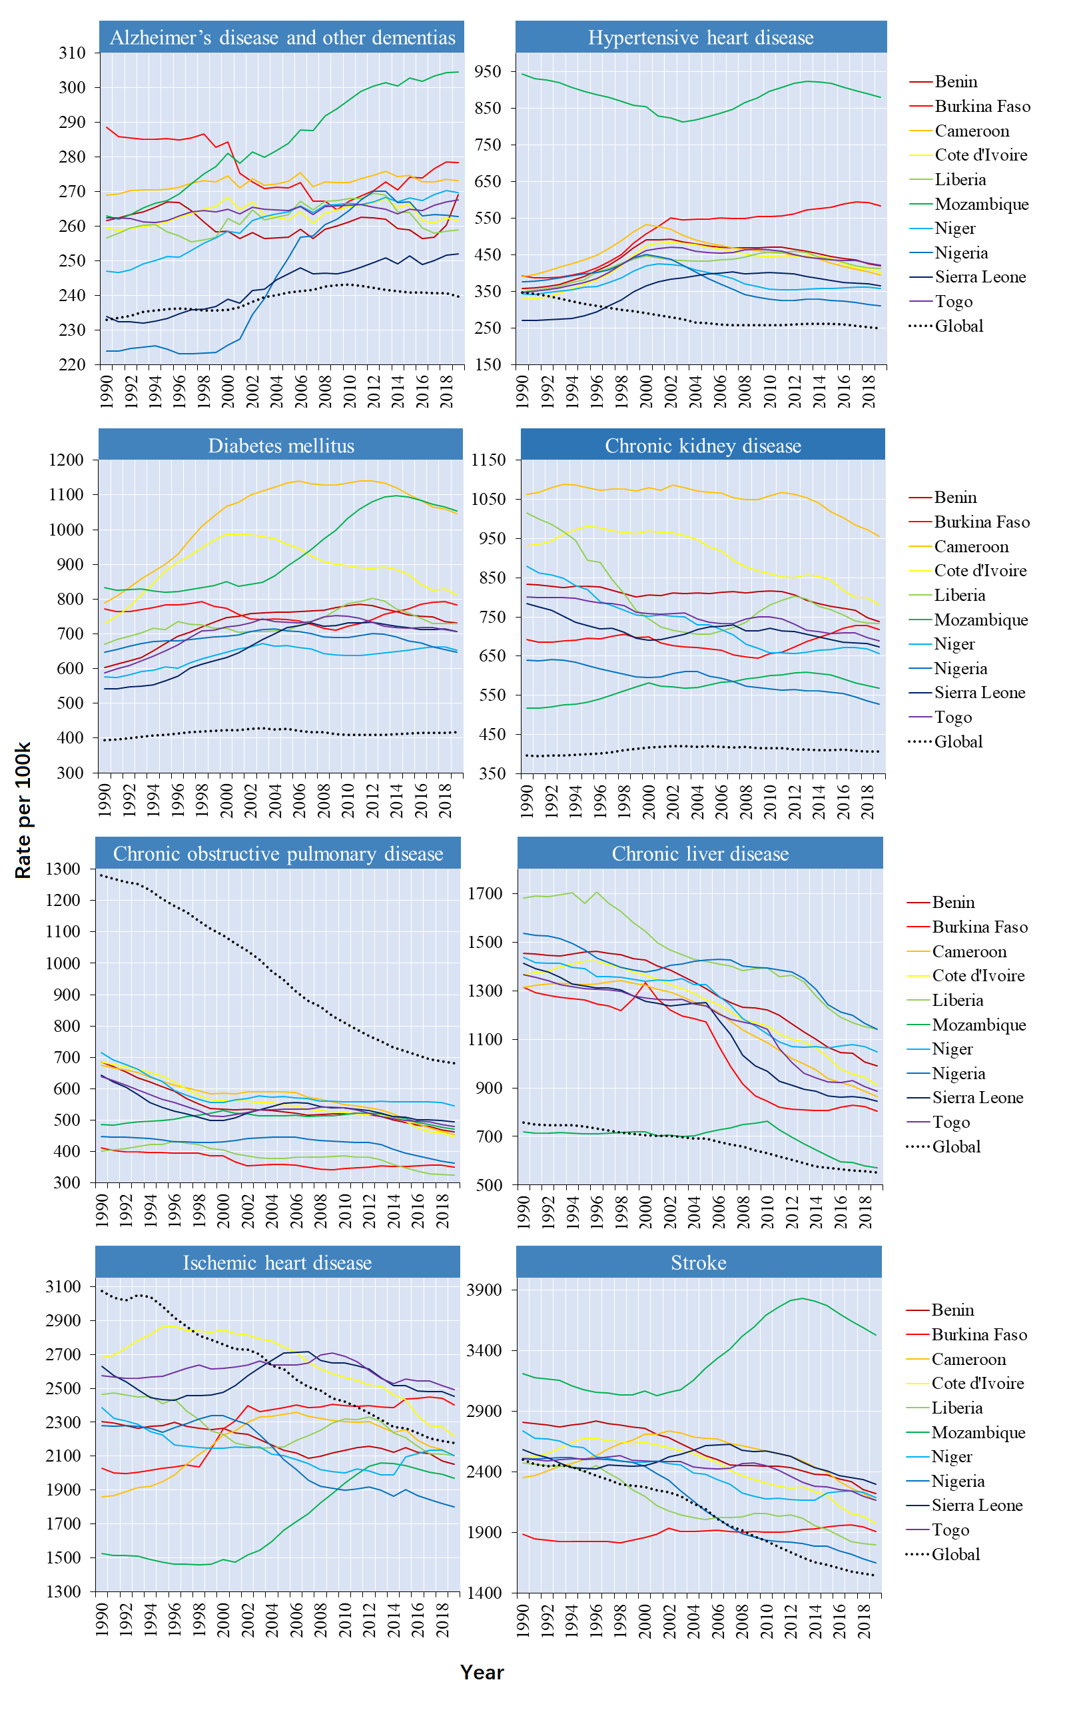Appendix 1. Trends of age-standardized rates for YLLs of the eight selected NCDs in the ten countries per 100 000 populations, 1990-2019
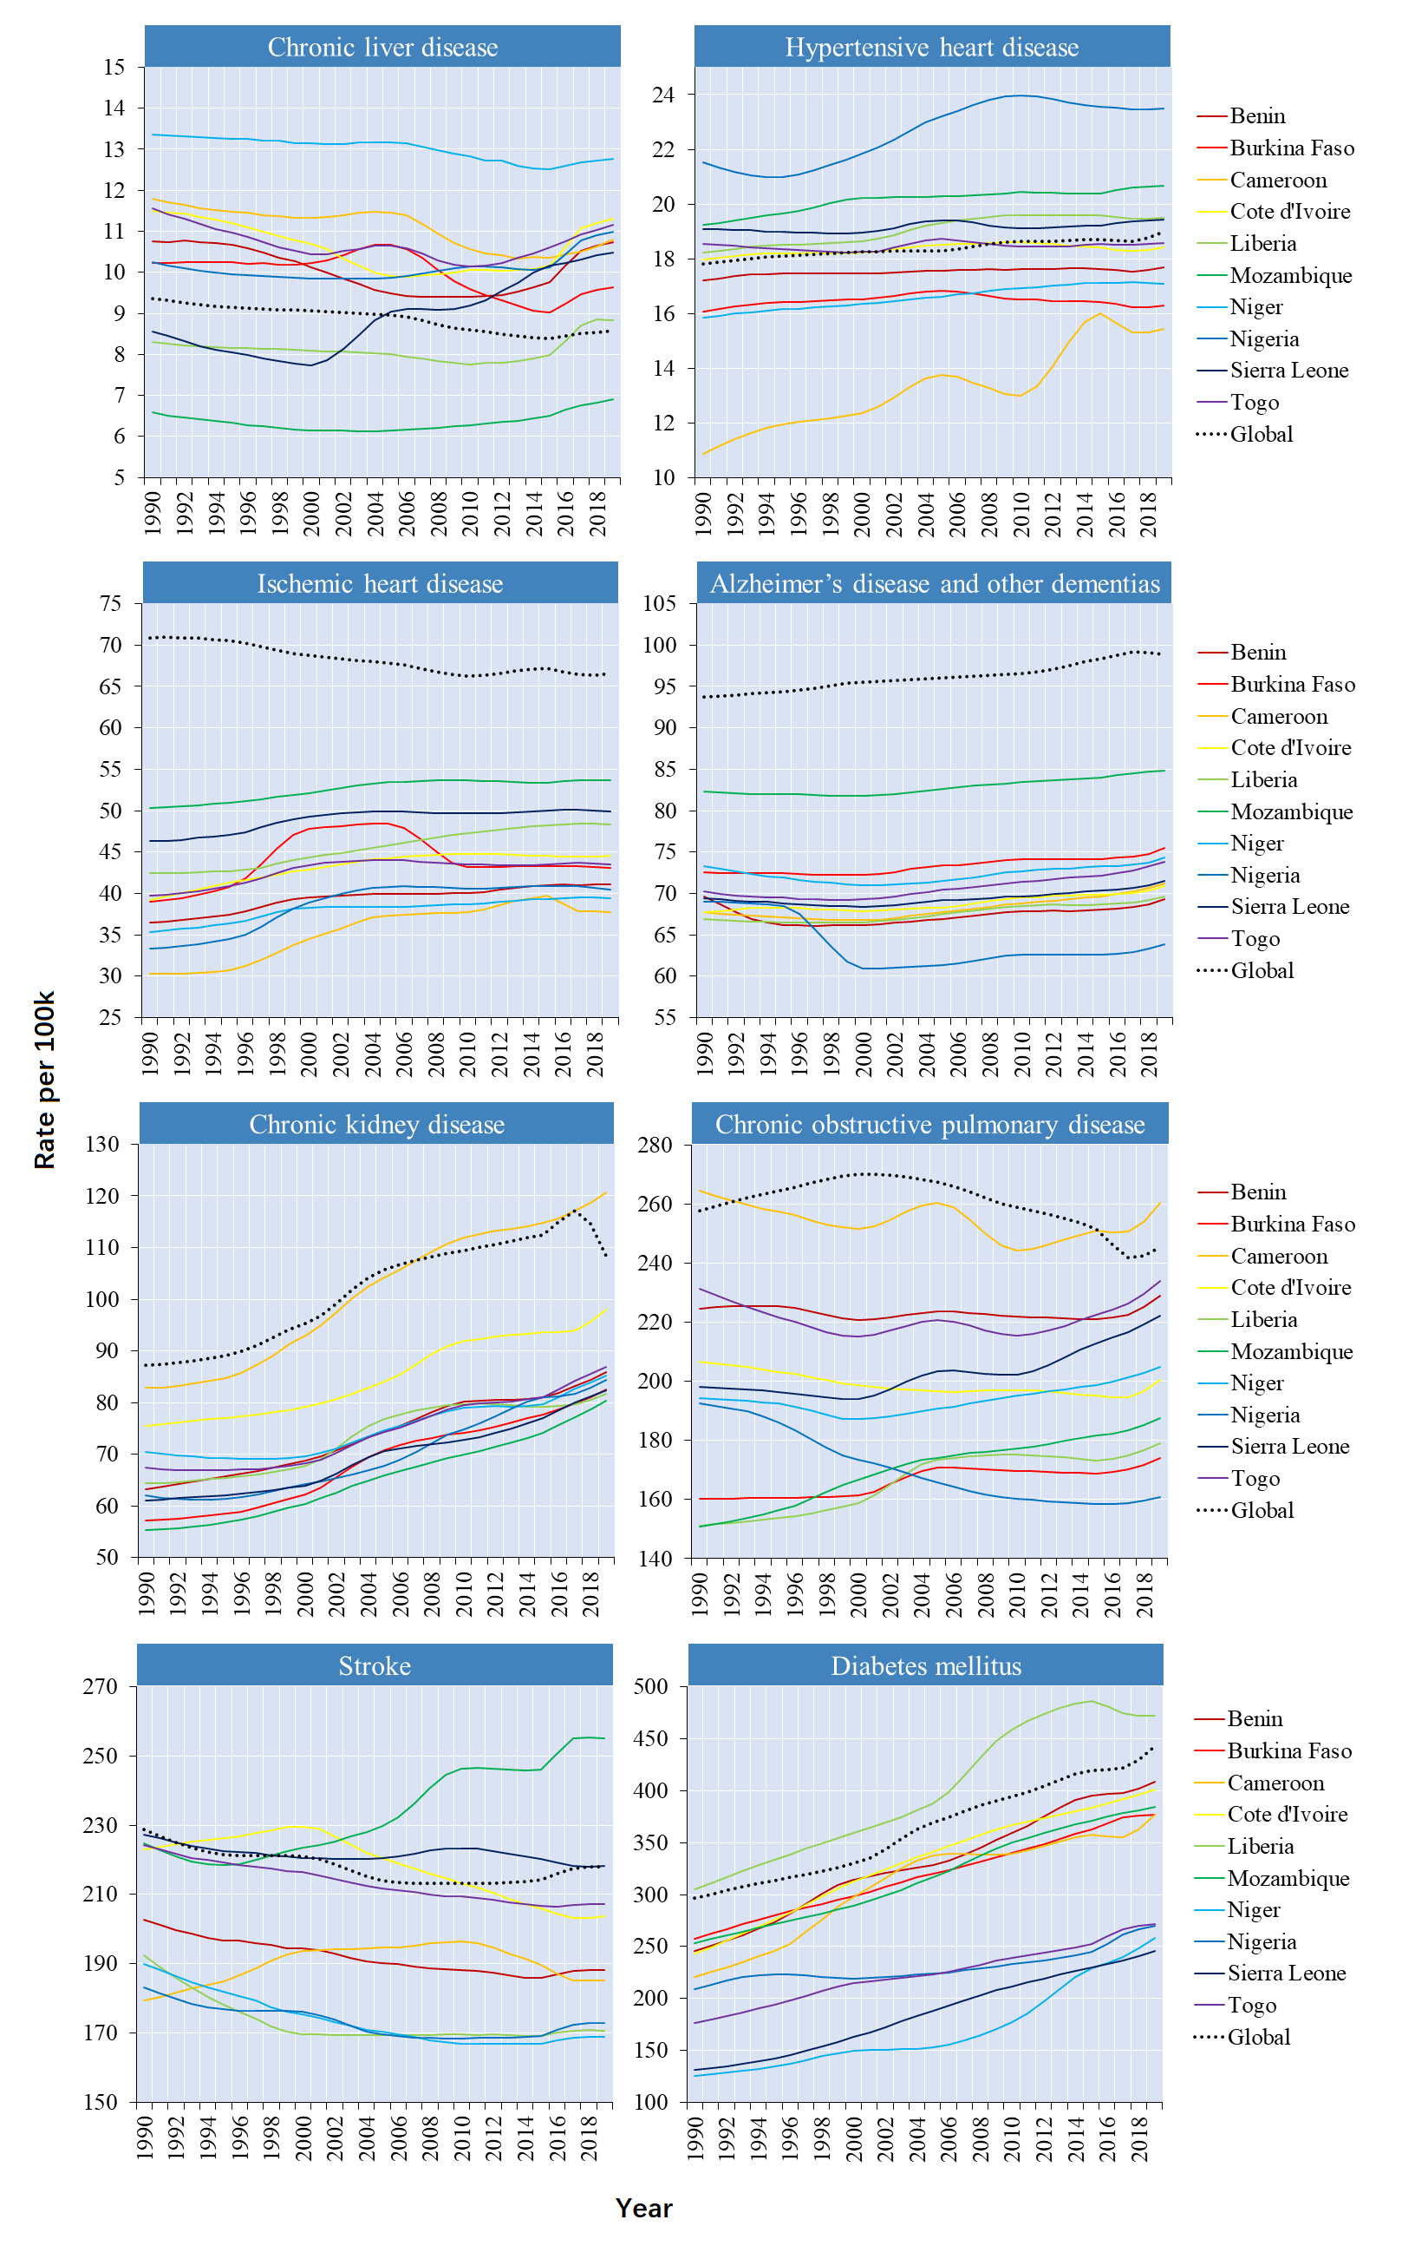Appendix 2. Trends of age-standardized rates for YLDs of the eight selected NCDs in the ten countries per 100 000 populations, 1990-2019

