TABLES
Table 1. Timeline of legume crop domestication.
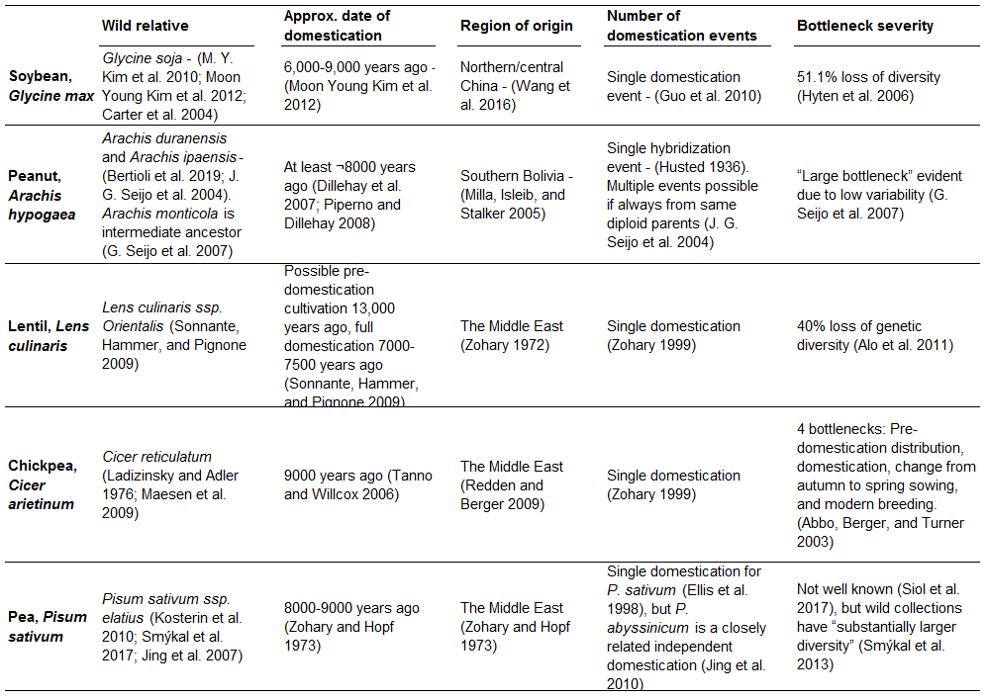
Approximate date of domestication for each crop, its region of origin, the number of independent domestication events for each, and the severity of the genetic bottleneck(s) each underwent. Also included is information on assigning wild progenitors for each crop.

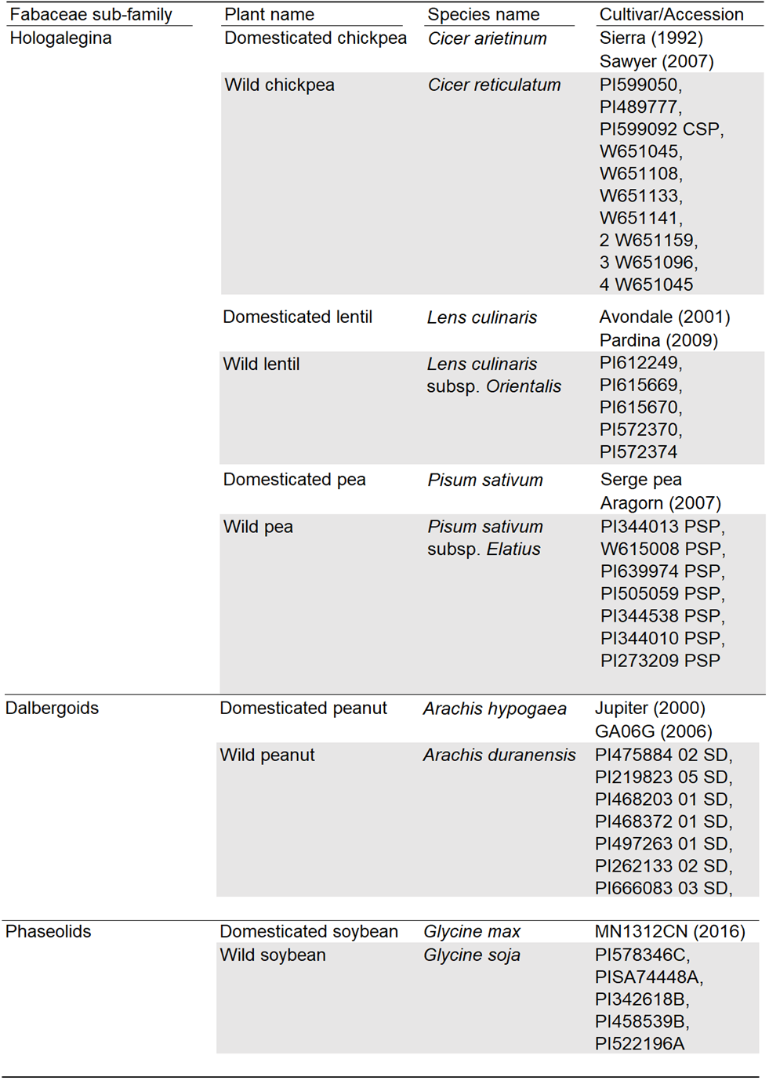
Table 2. Cultivars and accessions of legumes used in the experiment.

Dates of release of domesticated cultivars are shown in brackets next to their names.

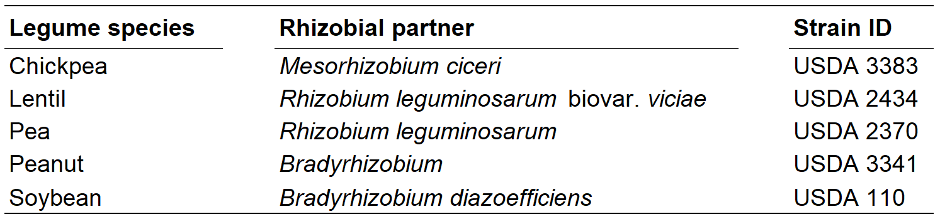
Table 3: Rhizobium strains in the experiment. Rhizobial partners were chosen to be beneficial for both wild and domesticated legumes.

Table 4: Nitrogen fertilization levels in the experiment. Total g N per pot, NH₄NO₃ content of fertiliser in g/L, N molarity of fertiliser. Fertiliser was applied in a series of eight 2ml applications.
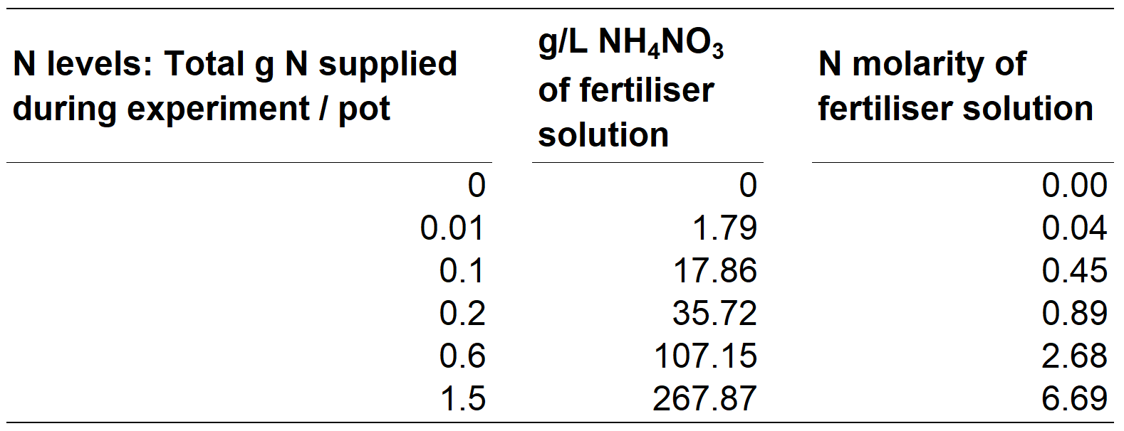

Table 5. Generalized mixed-effects models comparing outcomes of symbiosis between crops and wild relatives across levels of nitrogen fertilization. The models test whether shoot mass, nodule count/shoot mass, and CFU/nodule were affected by rhizobial inoculation (Rhiz), domestication (Dom), fertilisation (N), and the two- or three-way interactions between these terms. The table presents the likelihood ratio test, degrees of freedom (D.f.), χ² values, and p-values. Significant P-values are shown in bold.
