Supplementary Materials
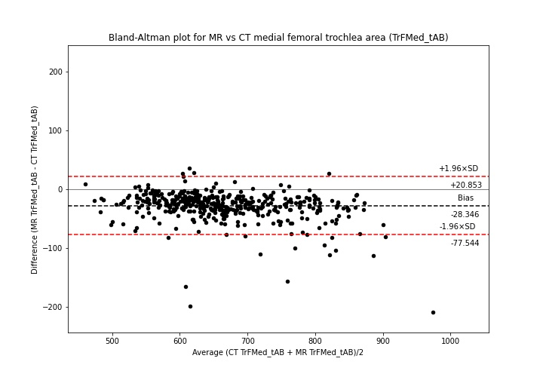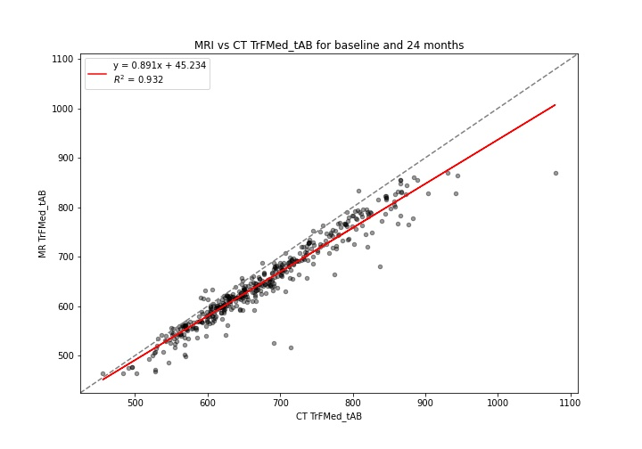

Figure S1: CT vs MRI bone area TrFMed.tAB. Top: Bland-Altman plot; Bottom: linear regression

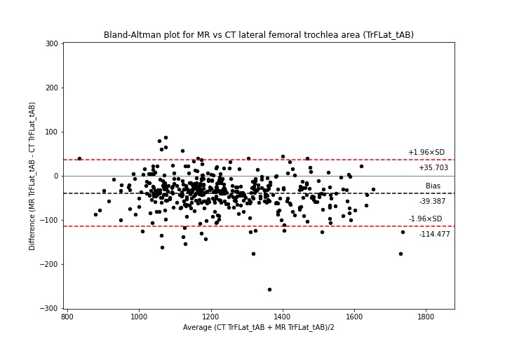
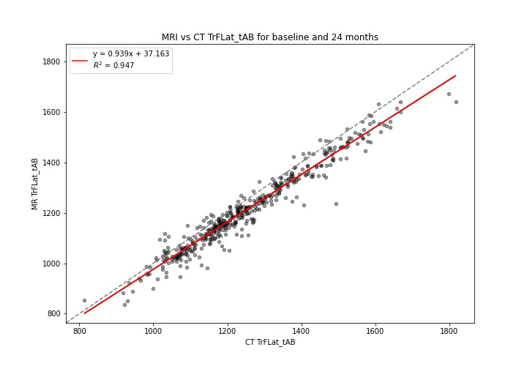

Figure S2: CT vs MRI bone area TrFLat.tAB. Top: Bland-Altman plot; Bottom: linear regression

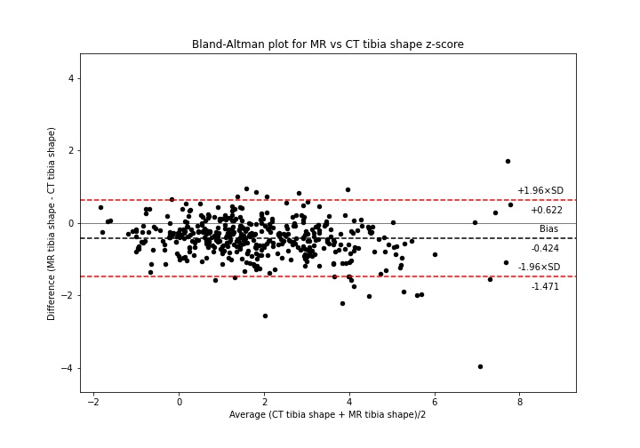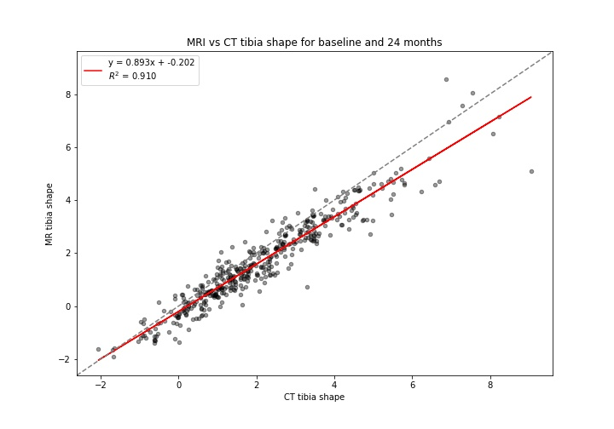

Figure S3: CT vs MRI tibia shape z-score. Top: Bland-Altman plot; Bottom: linear regression
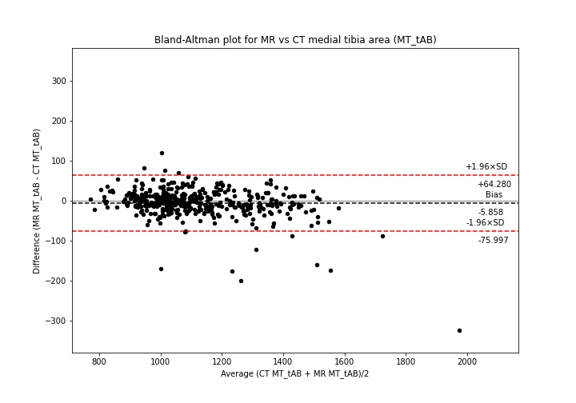
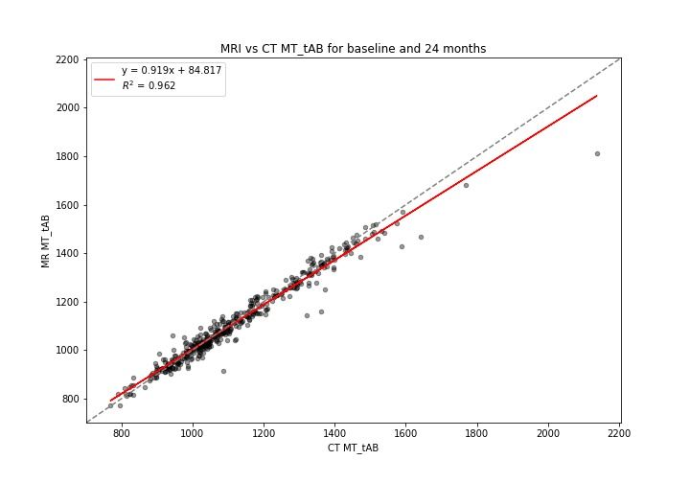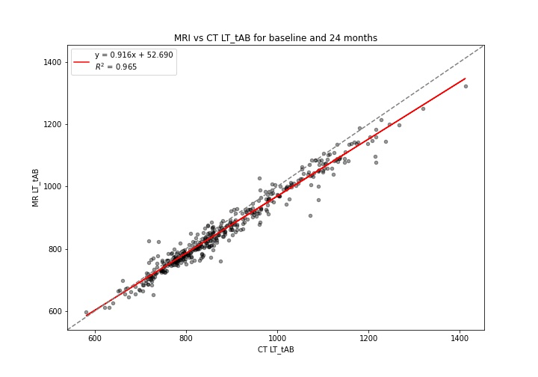

Figure S4: CT vs MRI bone area MT.tAB. Top: Bland-Altman plot; Bottom: linear regression
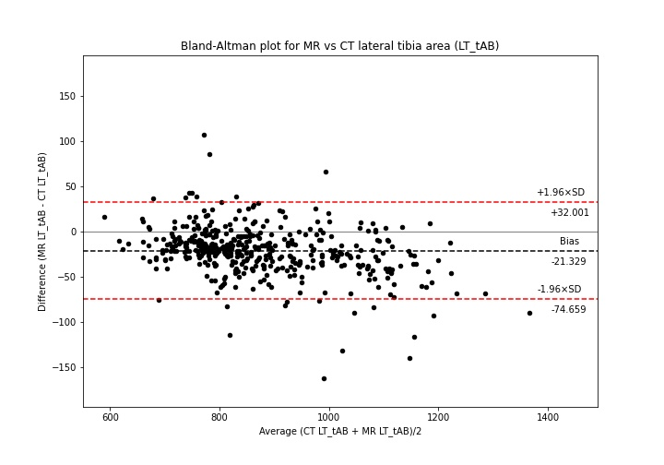

Figure S5: CT vs MRI bone area LT.tAB. Top: Bland-Altman plot; Bottom: linear regression

