Supplemental Materials

Title
Probing the distinct chemosensitivity of Plasmodium vivax liver stage parasites and demonstration of 8-aminoquinoline radical cure activity in vitro

Steven P. Maher^{1†}*, Amélie Vantaux^{2†}, Victor Chaumeau^{3,4}, Adeline C. Y. Chua^{5,6,7}, Caitlin A. Cooper¹, Chiara Andolina^{3,4}, Julie Péneau², Mélanie Rouillier⁸, Zaira Rizopoulos⁸, Sivchheng Phal², Eakpor Piv², Chantrea Vong², Sreyvouch Phen², Chansophea Chhin², Baura Tat², Sivkeng Ouk², Bros Doeurk², Saorin Kim², Sangrawee Suriyakan³, Praphan Kittiphanakun³, Nana Akua Awuku¹, Amy J. Conway⁹, Rays H.Y. Jiang⁹, Bruce Russell⁷, Pablo Bifani^{5,6,10,11}, Brice Campo⁸, François Nosten^{3, 4}, Benoît Witkowski²*, Dennis Kyle¹*

Contents

Supplementary Figure 1
Supplementary Figure 2
Supplementary Figure 3
Supplementary Figure 4
Supplementary Figure 5
Supplementary Figure 6
Supplementary Figure 7
Supplemental Table 1 (Excel file): All Prophylactic Actives
Supplemental Table 2 (Excel file): Al Radical Cure Actives

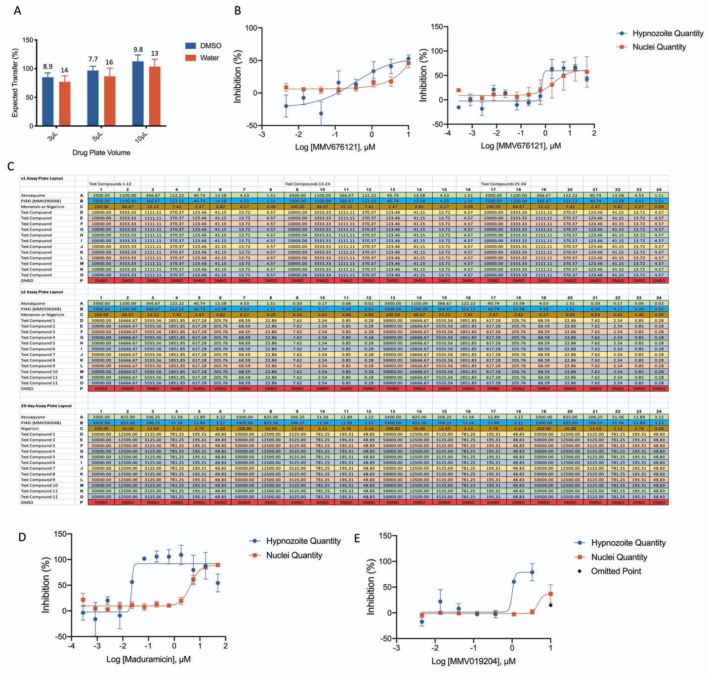Figure S1. Methods and Assay Refinement. A) Fluorescein dye was diluted in water or DMSO and plated at 3, 5, or 10 μL per well prior to transfer by a 40 nL, hand-actuated pin tool into a 384-well assay plate with 40 μL culture media. Fluorescence intensity was measured to assess actual transfer versus expected transfer. Bars represent SD of 10 wells per condition, data are representative of two independent experiments. The CV (%) across wells for each condition is listed above respective bars. B) Left: Putative hit MMV676121, with Radical Cure activity against hypnozoites (EC₅₀ 347 nM) was first identified from the original (v1) assay dose response format, which included singleton wells of each concentration rom 10 μM to 46 nM. A curve could not be fit to hepatic nuclei inhibition values but was estimated to be > 2 μM. Bars represent SEM of 6 independent experiments. Right: MMV676121 retested in the refined (v2) assay dose response format, which included duplicate wells of each concentration from 50 μM to 280 pM. The v2 assay demonstrates little selectivity (~3) between activity against hypnozoites (EC₅₀ 707 nM), and host hepatocytes (EC₅₀ 2.17 nM). Bars represent SEM of 2 independent experiments, each the average of two wells at each concentration. C) Plate maps for v1, v2, and 20-day formats, values represent μM in 1000x source plate and nM in assay plate. D) Radical Cure activity from a v2 assay of maduramicin against hypnozoites. Maduramicin is potently active against hypnozoites (EC₅₀ 22 nM) and toxic against host hepatocytes (EC₅₀ 4.28 μM), leading to a calculated selectivity of > 190. Bars represent SEM of 2 independent experiments, each the average of two wells at each concentration. E) Radical Cure activity from a v2 assay of P. falciparum stage V gametocyte hit MMV019204, with activity against hypnozoites (EC₅₀ 1.00 μM) and toxic against host hepatocytes (EC₅₀ 4.71 μM), leading to a calculated selectivity of 4.7. Black marker indicates hypnozoite inhibition data marked as an outlier. Bars represent SEM of 2 independent experiments, each experiment including two wells at each concentration.

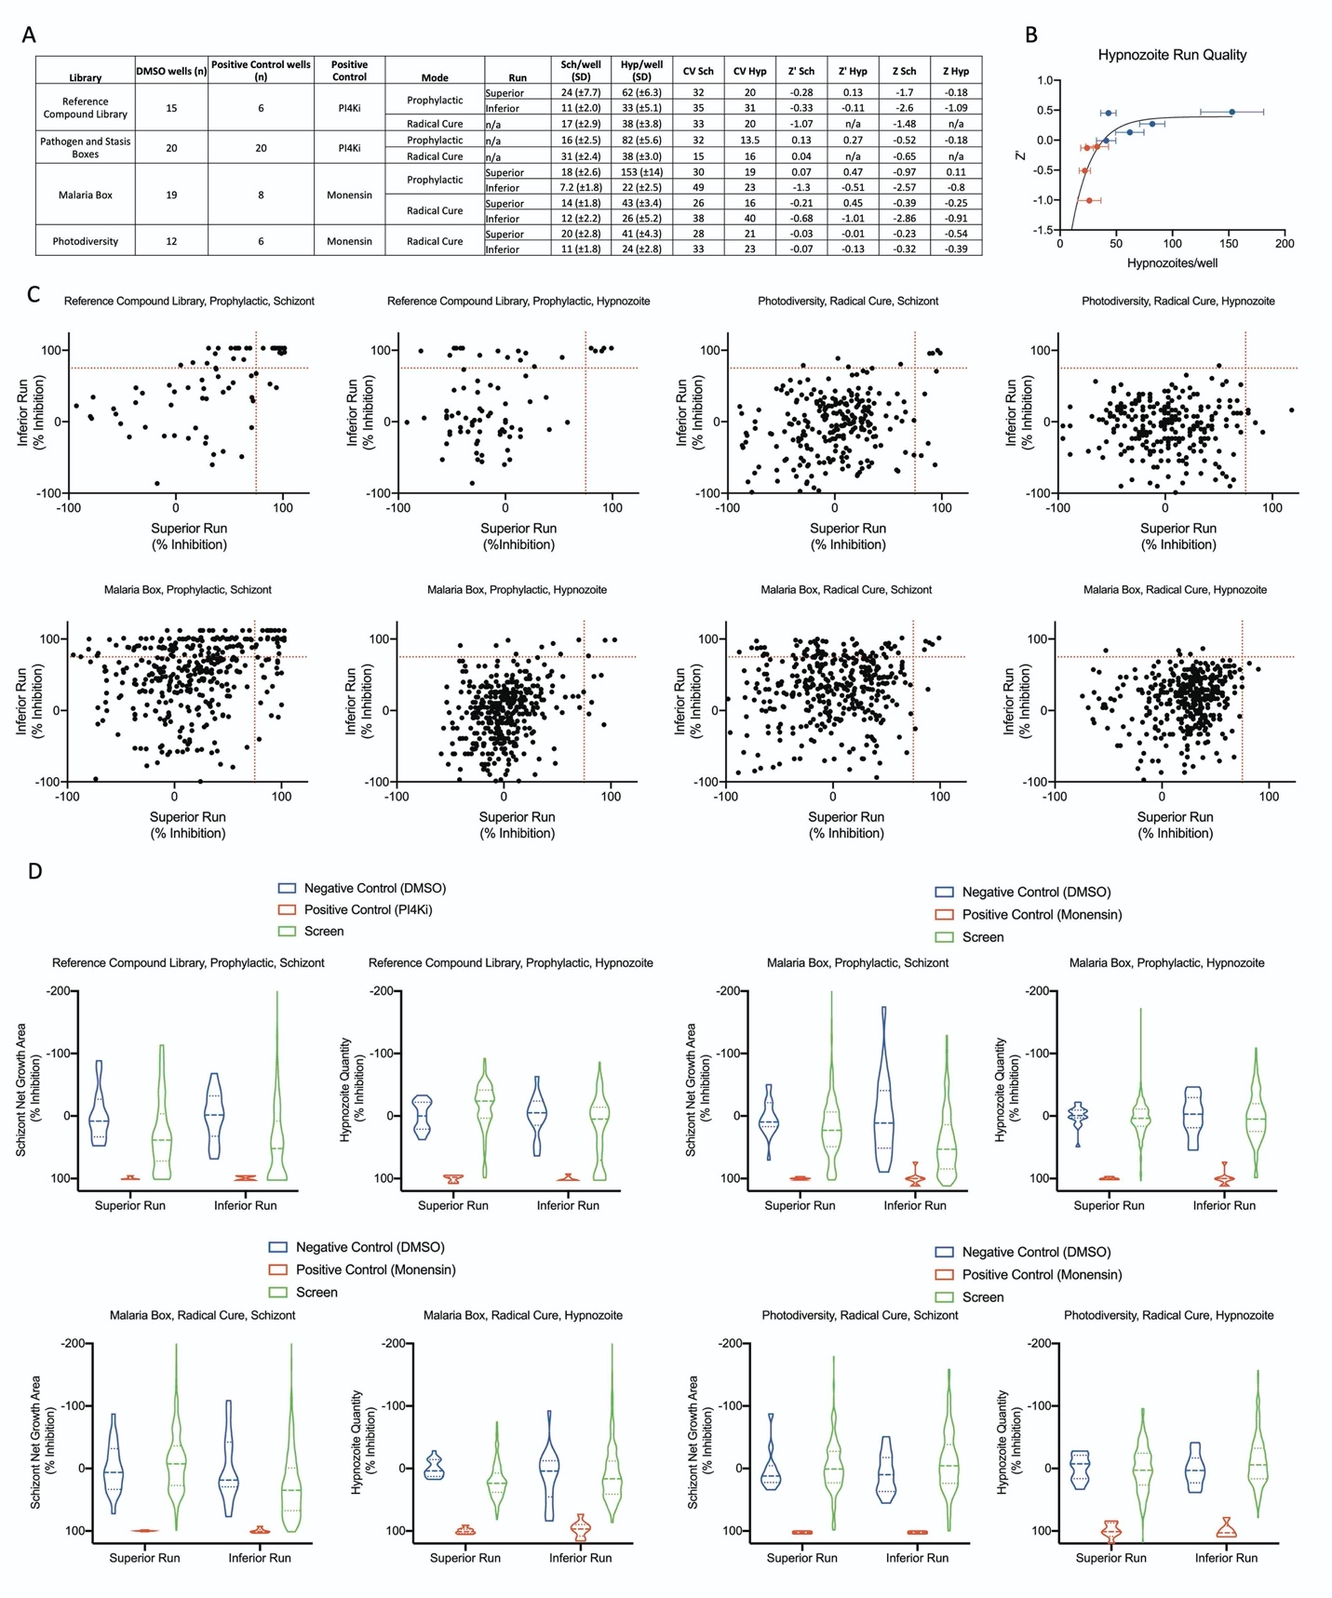

Figure S2. Multi-run analyses and putative hit consistency. A) Infection rate and statistical metrics from every Single Point run. Sch, Schizont; Hyp, Hypnozoite; SD, standard deviation; CV, coefficient of variance; Z’, Z’ factor between positive and negative controls; Z, Z score between the inhibition of screen wells and the positive control. B) Nonlinear regression of Z’ factor as a function of infection rate. A minimum of about 40 hypnozoites per well is needed to obtain a positive Z’ factor. Bars represent SD. C) The Reference Compound Library, Photodiversity Library, and Malaria Box were ran twice; the higher-quality run (as measured by Z’ factor as well as absence of confounding results such as edge effects or plate gradients) was designated as the “Superior Run” while the other was designated as the “Inferior Run.” Red dotted lines indicate 75% inhibition for reference. Paired data for each compound from both runs were plotted together to show which compounds were consistently putative hits (top right area), versus compounds which were likely false positive due to poor run quality (top left area and bottom right area). D) Violin plots from the negative control wells (blue) positive control wells (red), and screen wells (green) from each set of Superior and Inferior runs. The positive controls perform the same regardless of run quality, resulting in a consistent average at and narrow deviation around 100% inhibition. Conversely, the negative control and screen well average and deviation, as well as the separate between positive and negative control means, are dependent on run quality. Solid line, average; dotted lines, 25% and 75% quartiles.

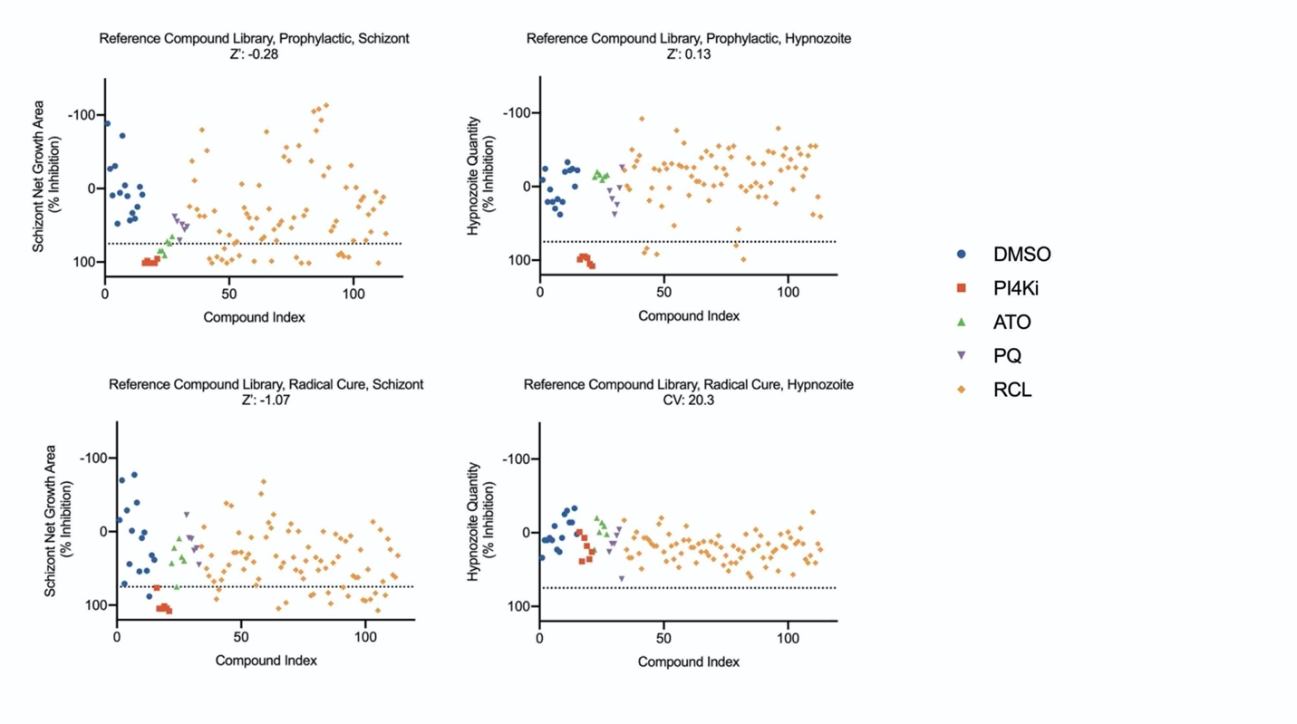Figure S3. Single point activity from the Reference Compound Library. The net schizont growth area per well for both the Prophylactic and Radical Cure runs, as well as the hypnozoite quantity per well from the Prophylactic run, were normalized to the PI4Ki controls; Z’ factor is shown for each run. Hypnozoite quantity per well from the Radical Cure run was normalized to DMSO controls and percent inhibition was calculated as 100%-(% remaining hypnozoites); the CV (%) for hypnozoite quantity in DMSO wells is shown. Dotted line represents 75% inhibition for reference. Legend: DMSO, negative control; PI4Ki, MMV390048 positive control; ATO, atovaquone reference compound; PQ, primaquine reference compound; RCL, Reference Compound Library.

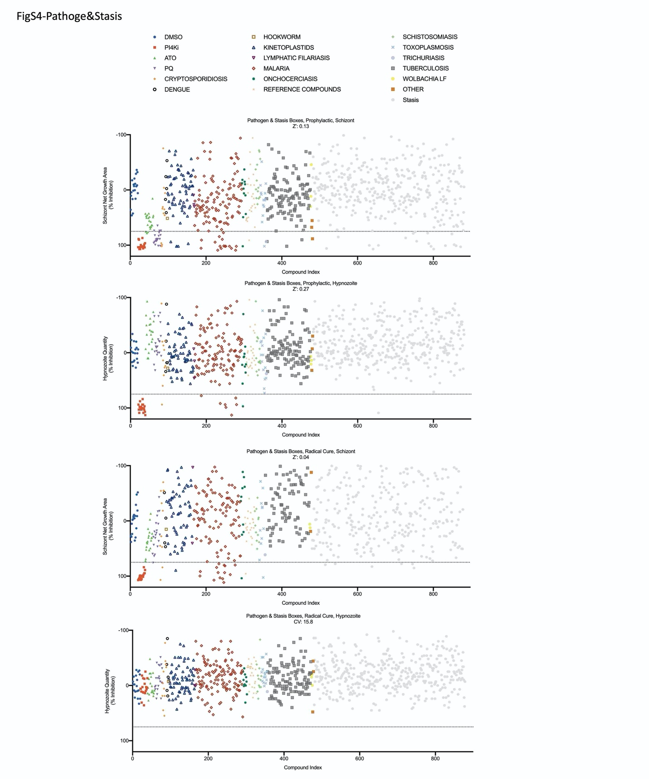Figure S4. Single point activity from the Pathogen and Stasis Boxes. The Pathogen Box and Stasis Box were merged and ran together. The net schizont growth area per well for both the Prophylactic and Radical Cure runs, as well as the hypnozoite quantity per well from the Prophylactic run, were normalized to the PI4Ki controls; Z’ factor is shown for each run. Hypnozoite quantity per well from the Radical Cure run was normalized to DMSO controls and percent inhibition was calculated as 100%-(% remaining hypnozoites); the CV (%) for hypnozoite quantity in DMSO wells is shown. Dotted line represents 75% inhibition for reference. Legend: DMSO negative control; PI4Ki, MMV390048 positive control; ATO, atovaquone reference compound; PQ, primaquine reference compound; PB compounds were characterized by disease set and are represented with different points as indicated; Stasis, SB compounds.

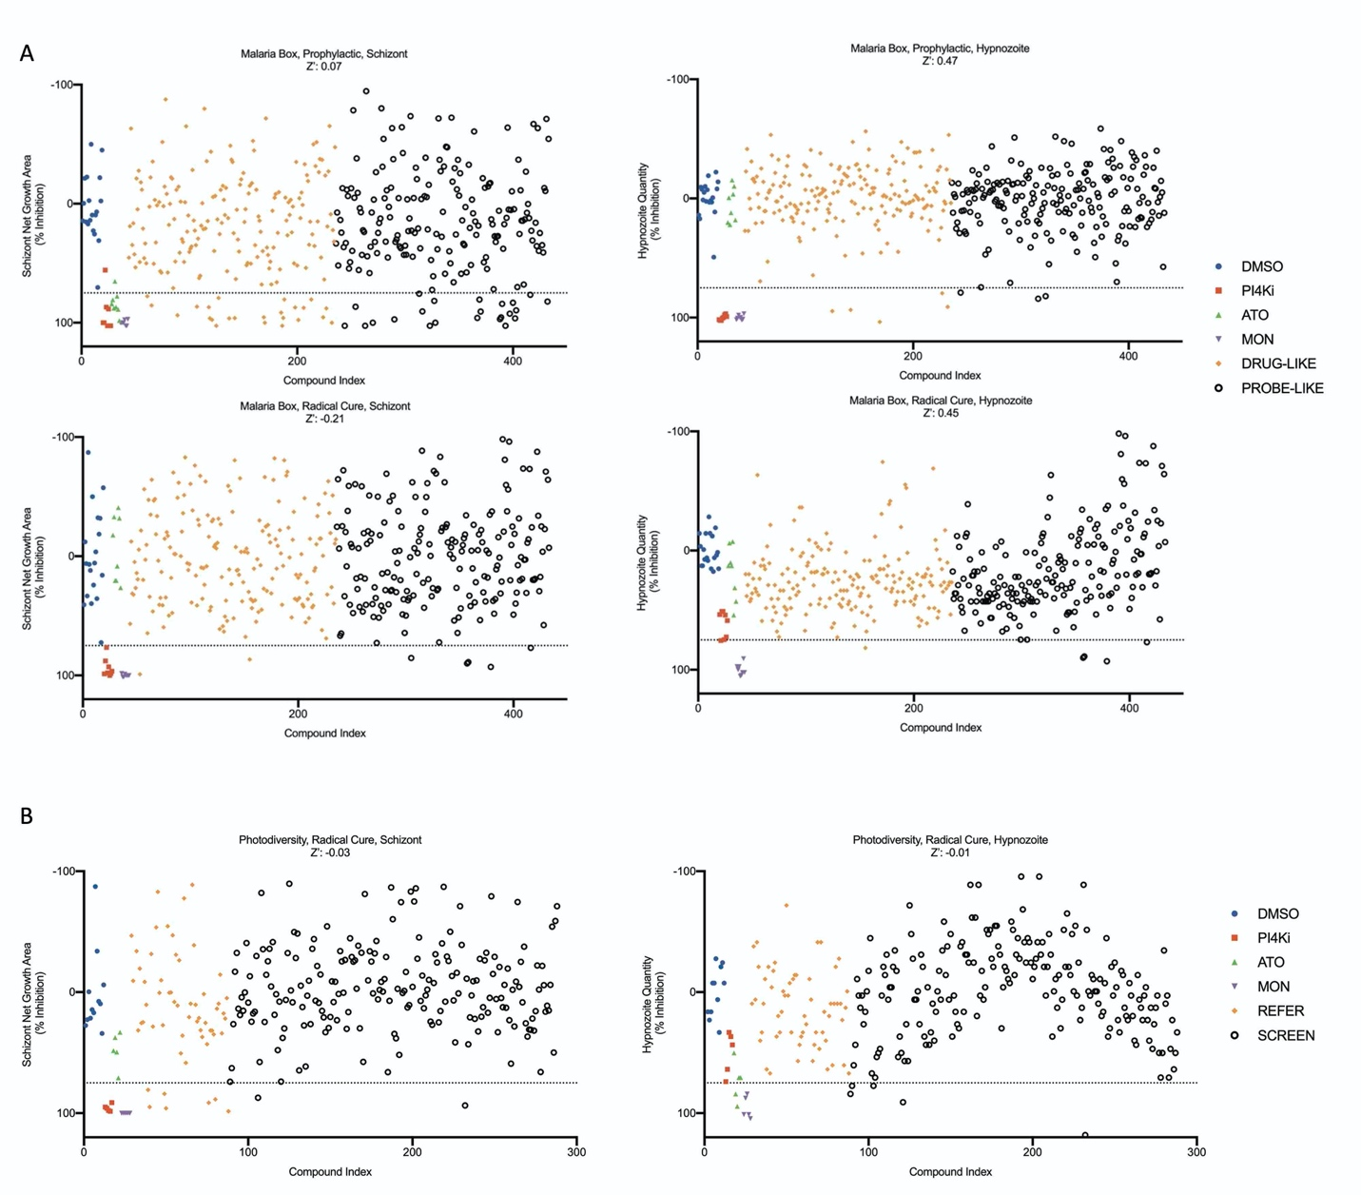
Figure S5. Single point activity from the Malaria Box and Photodiversity Library. The net schizont growth area per well for both the Prophylactic and Radical Cure runs, as well as the hypnozoite quantity per well from for both the Prophylactic and Radical Cure runs, were normalized to the monensin controls; Z’ factor is shown for each run. Dotted line represents 75% inhibition for reference. Legend: DMSO negative control; PI4Ki, MMV390048 reference compound; ATO, atovaquone reference compound; MON, monensin positive control; Malaria Box compounds were characterized as either Probe-like or Drug-like and are represented with different points as indicated; REFER, the Photodiversity Library contained 60 reference compounds which are represented with different points as indicated.

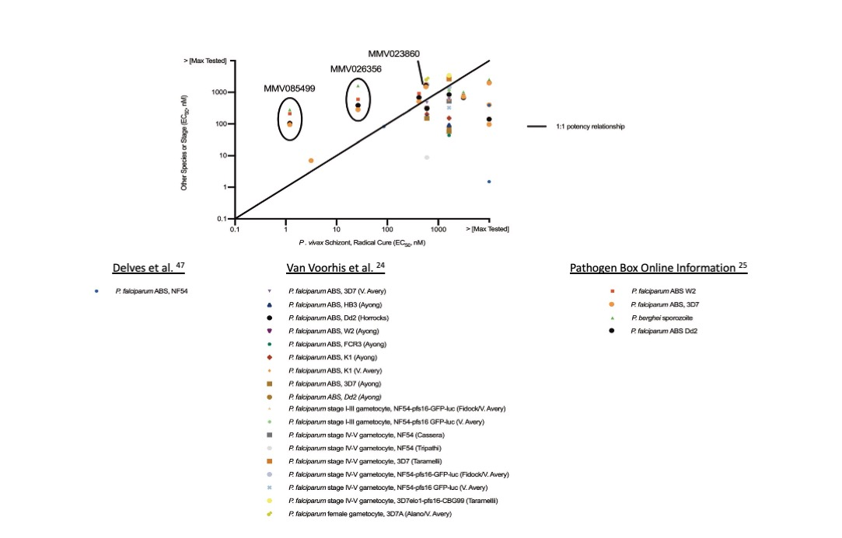

Figure S6. Cross-comparison of potency against P. vivax late schizonts and other Plasmodium species and lifecycle stages. Data were derived from previously-published data or information available with the Pathogen Box. Markers above black line indicate more potency against P. vivax late schizonts, markers below black line indicate less potency against P. vivax late schizonts. ABS: asexual blood stage.

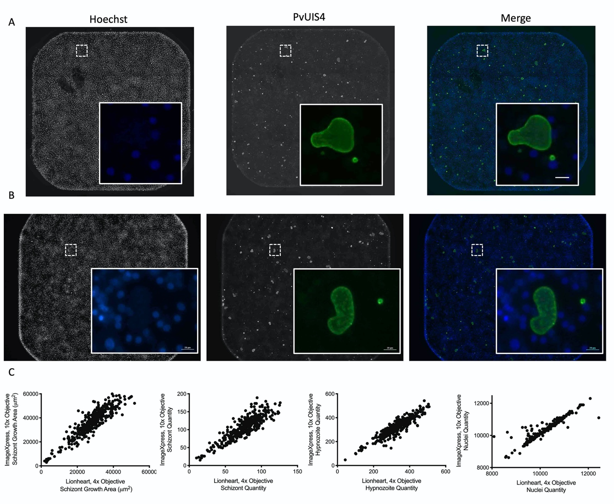
Figure S7. High Content Imaging methodology and validation. High Content Imaging (HCI) was first performed on an ImageXpress (IMX) Micro Confocal with a 10x objective and then with a Lionheart with a 4x objective. A) Representative image from a single well of a 384-well plate, stitched from 9 fields of view imaged with a 10x objective on an IMX. Inset: digitally zoomed image from area marked by dotted white line. B) Representative image from a single well of a 384-well plate, stitched from 4 fields of view imaged with a 4x objective on a Lionheart. Inset: digitally zoomed image from area marked by dotted white line. Bar represents 20 μm. C) HCI data obtained from an IMX and Lionheart was compared for several assay plates, including one with a very high infection rate of over 500 parasites per well (shown). Each point represents the PvLS parasite growth metrics or nuclei count for a single well.

