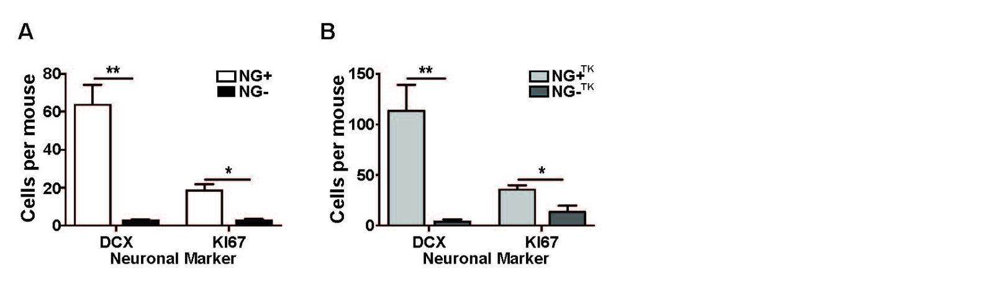
Figure S1. X-irradiation leads to a prolonged reduction in neurogenesis and VGCV suppresses neurogenesis in GFAP-Tk+/- mice. A) Neuronal markers for doublecortin (immature neuron; t(4)=5.727, p= 0.0046) and Ki67 (cell division; t(4)=4.438, p= 0.0114) were reduced in NG- mice 5 months after X-irradiation compared to NG+ mice (n=3 per group). B) Doublecortin; (t(6)=4.327, p= 0.0049) and Ki67 (t(6)=2.907, p= 0.0271) were reduced in NG-^{TK} mice after 5 months of VGCV treatment compared to NG+^{TK} mice (n=4 per group). Bars represent mean ± SEM.

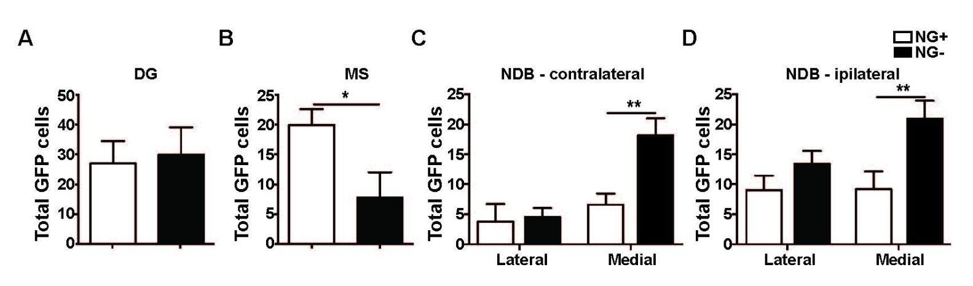
Figure S2. Absolute numbers of cells labeled by CAV2-GFP in DG and MS-NDB in NG+ and NG- mice.

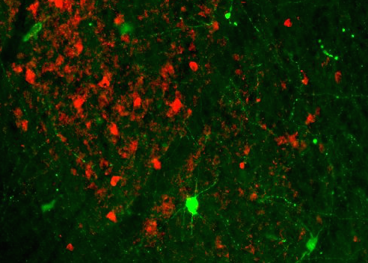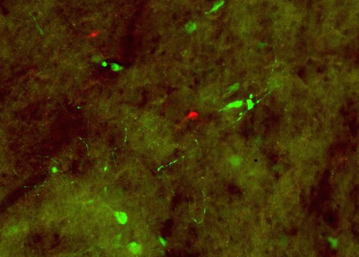
CAV-GFP SOM
CAV-GFP PV

Figure S3. GFP cells in the MS-NDB do not co-label with parvalbumin or somatostatin. GFP cells that project to the dorsal hilus (green) in the MS-NDB did not show co-labeling with parvalbumin (PV; red) or somatostatin (SOM; red) in NG+, NG-, NG+^{TK} and NG-^{TK} mice. Images are of a NG+ mouse and are representative of all groups.

A) B)

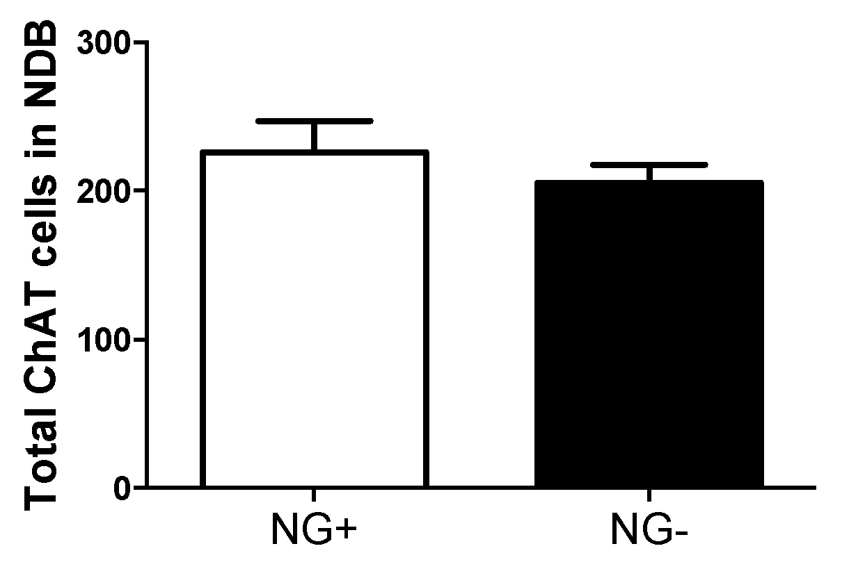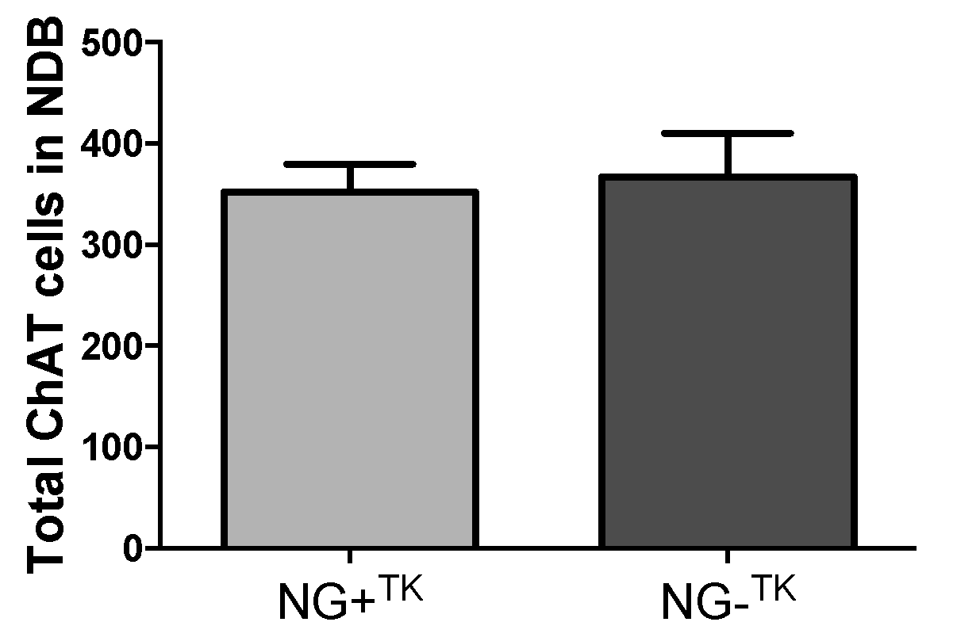

Figure S4. The total number of cholinergic cells in MS-NDB is unchanged by reduction of neurogenesis. A) NG- mice without neurogenesis for 5 months show similar total number of cholinergic cells, labeled by choline acetyltransferase, as NG+ mice. B) NG-^{TK} mice without neurogenesis for 5 months show a similar total number of cholinergic cells, labeled by choline acetyltransferase, as NG+^{TK} mice. Bars represent mean ± SEM.

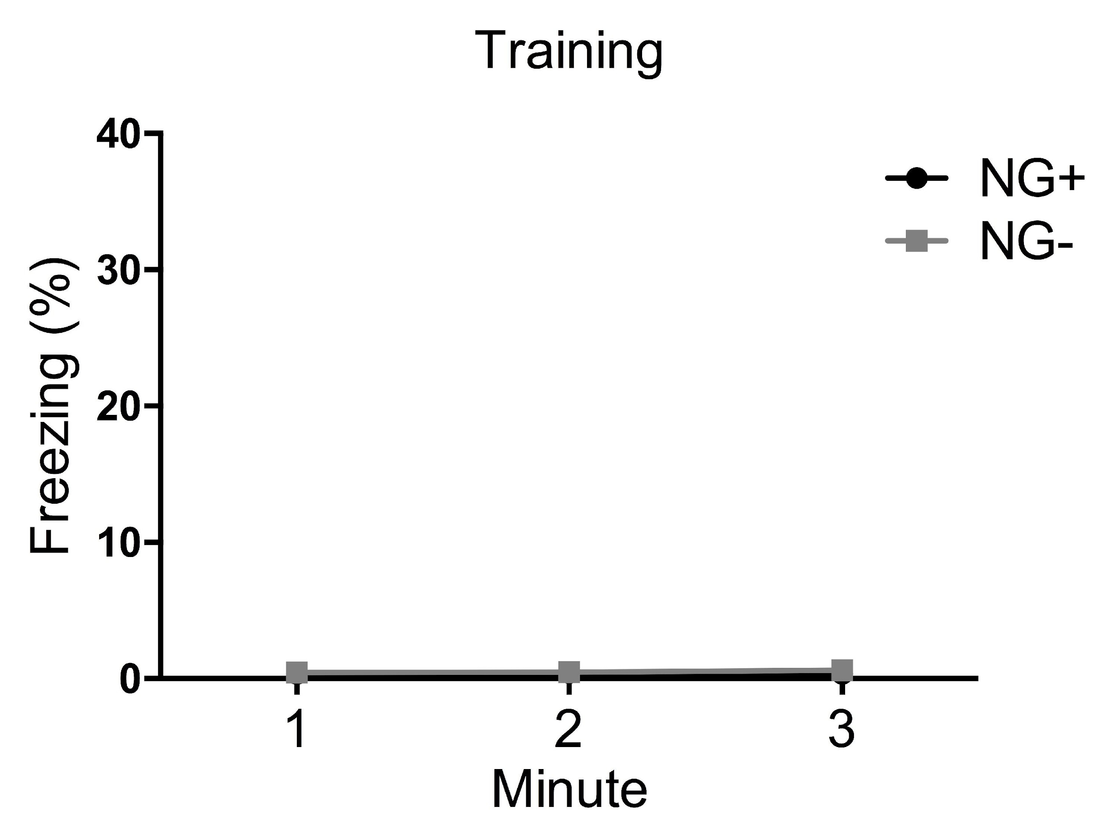
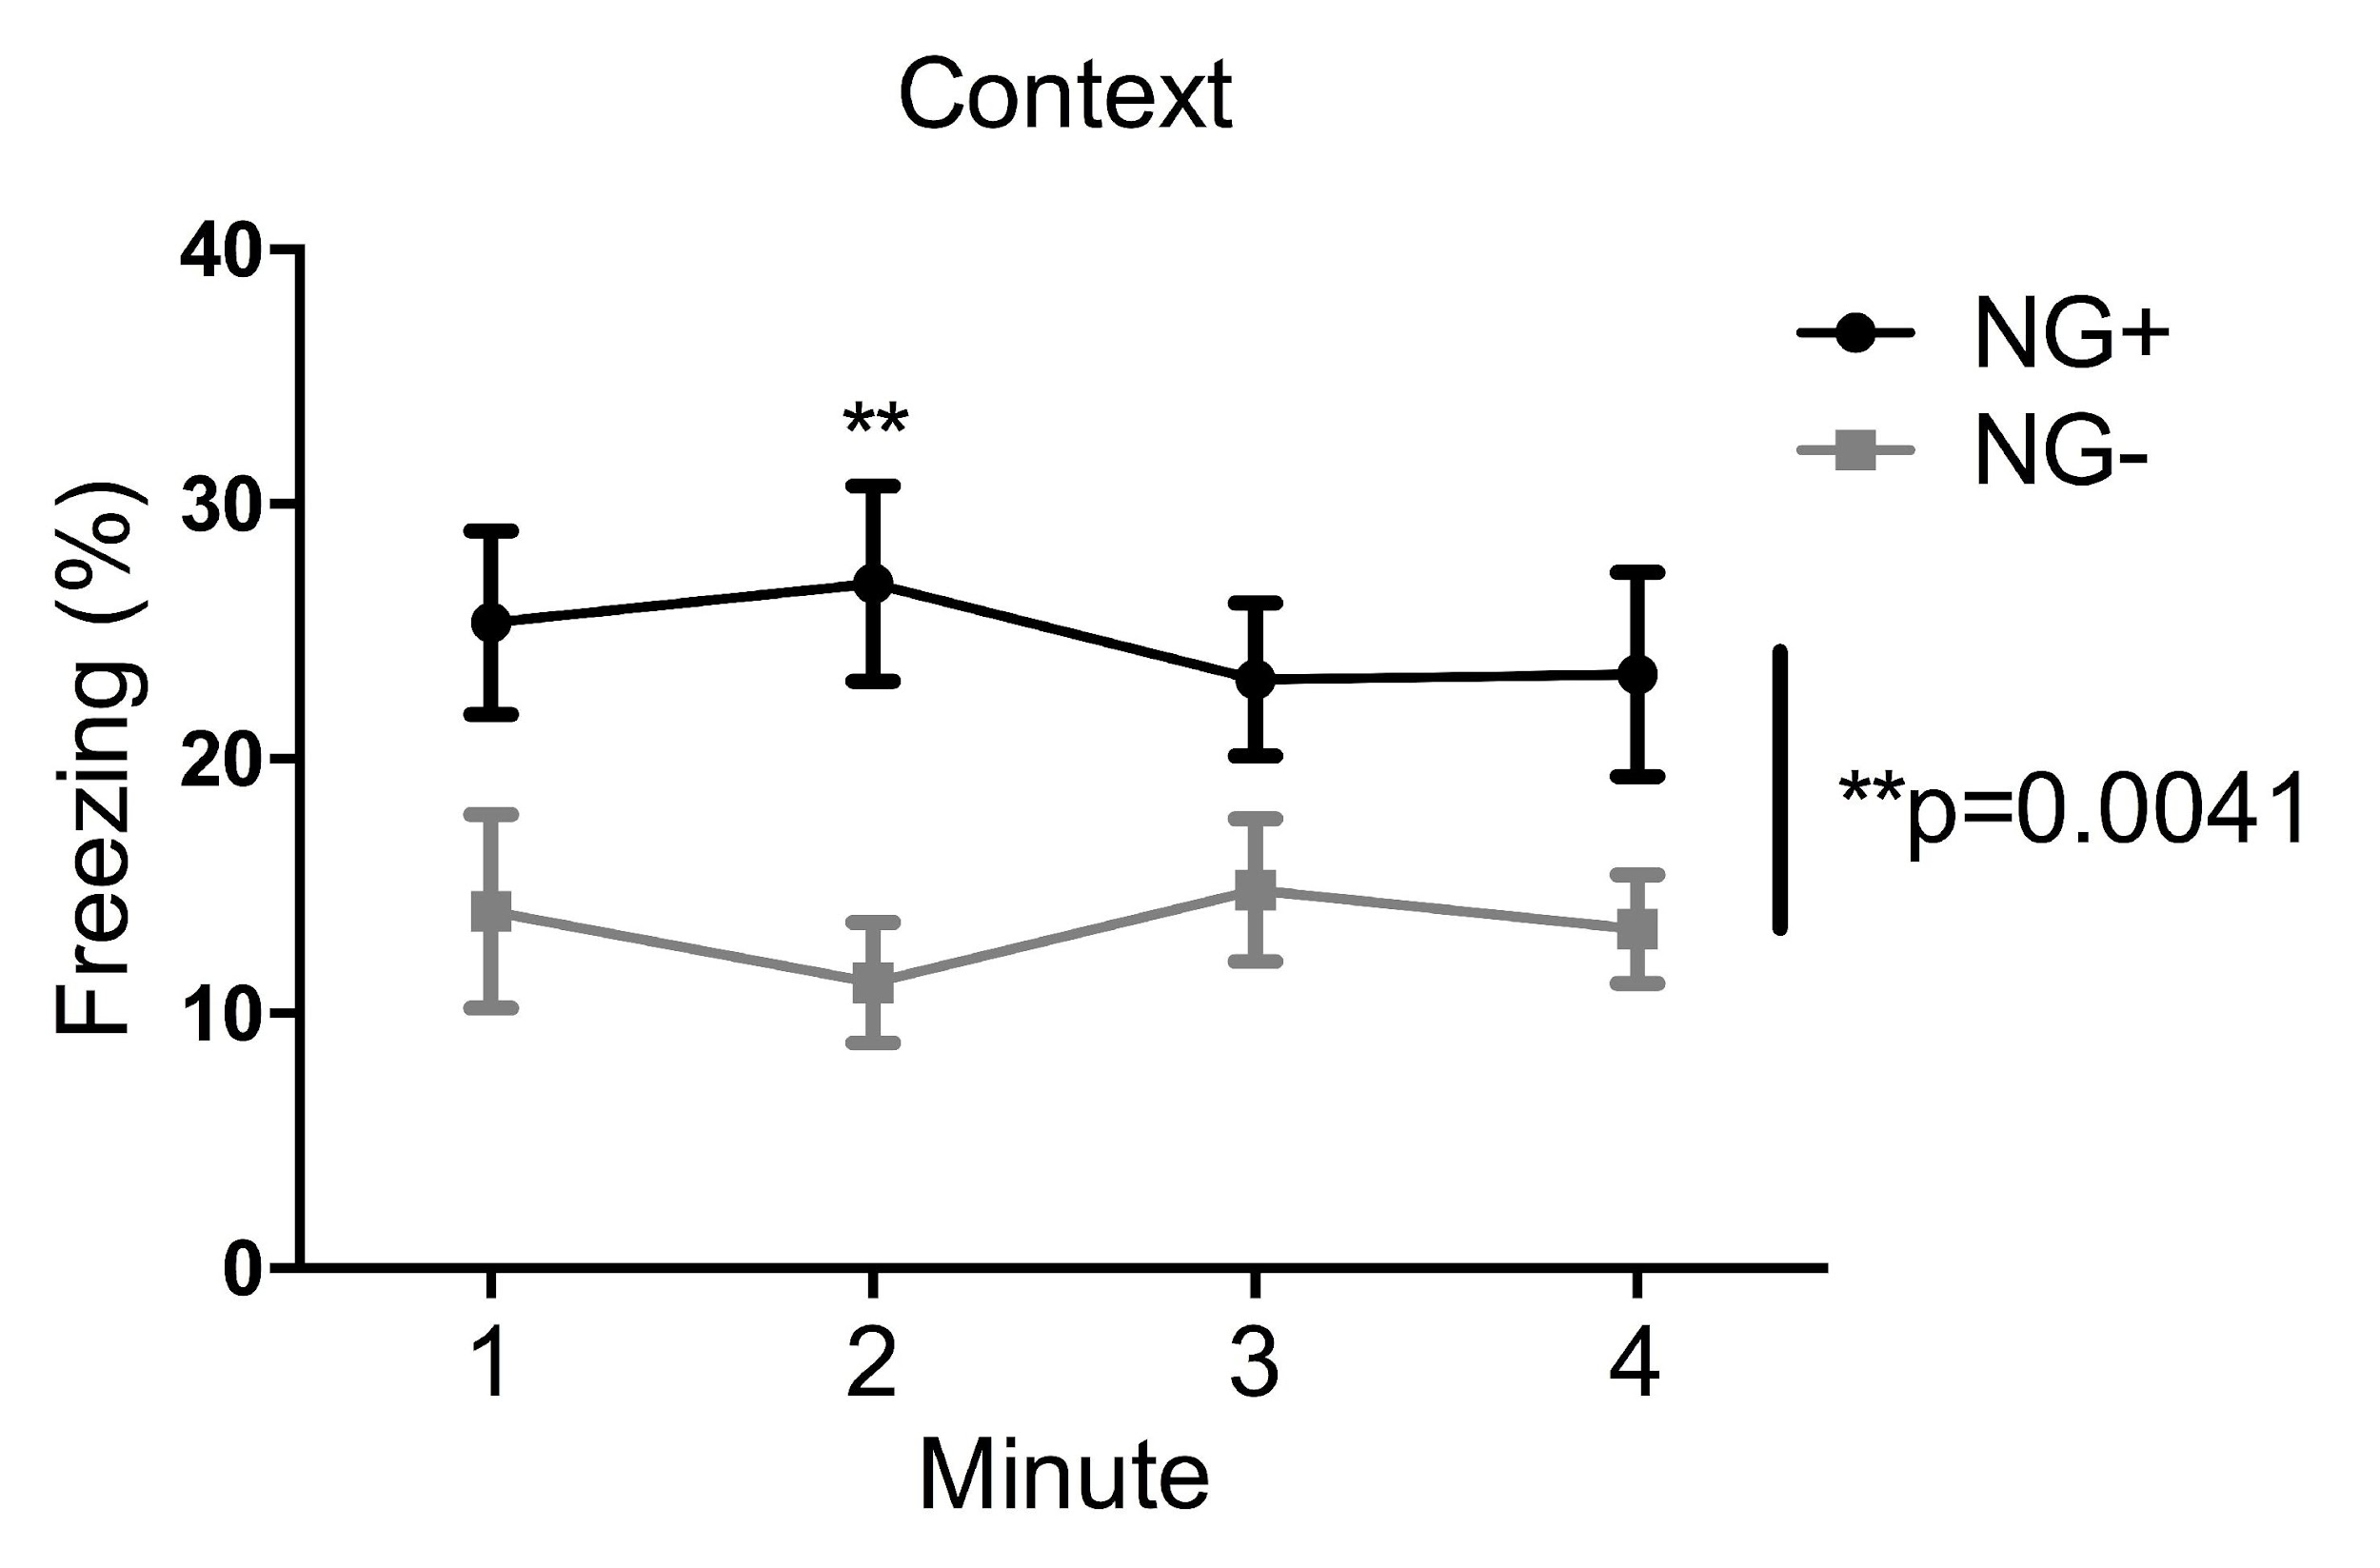
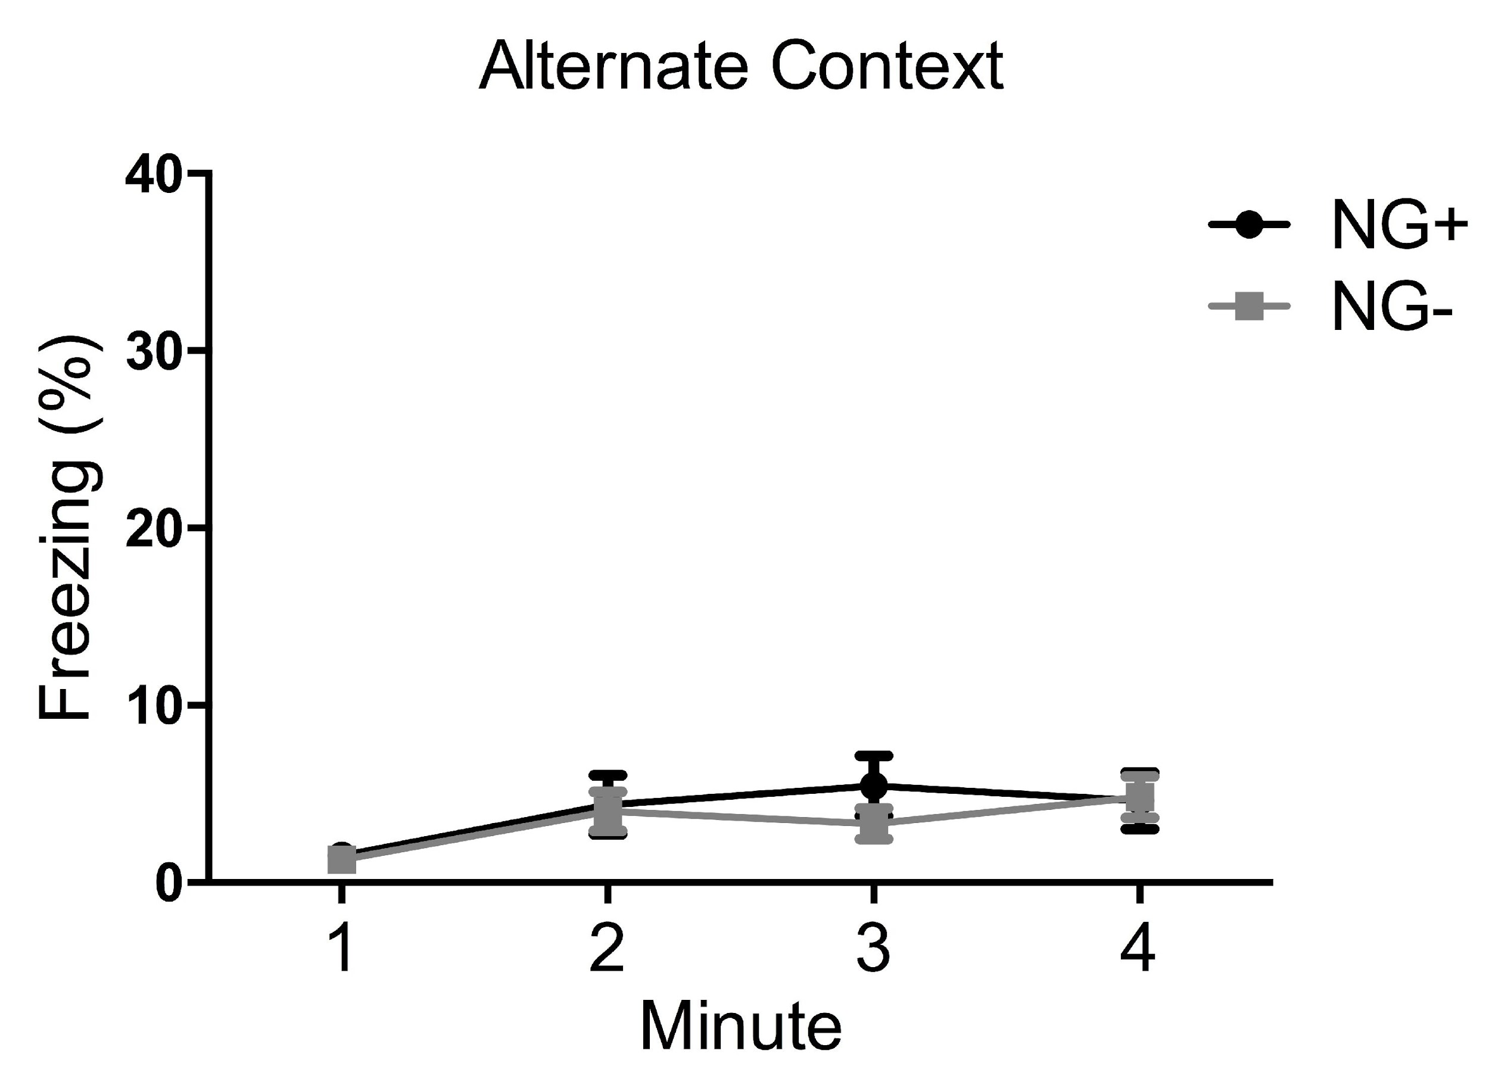
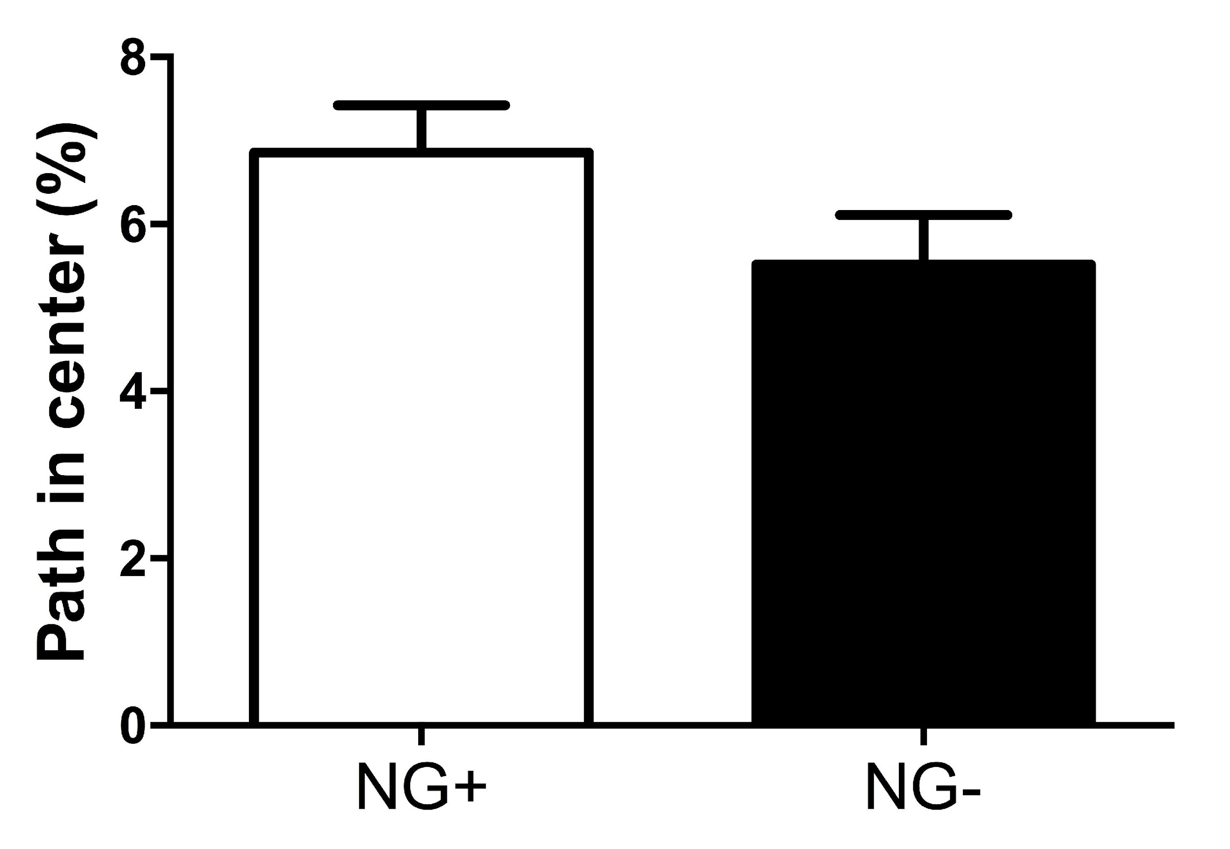
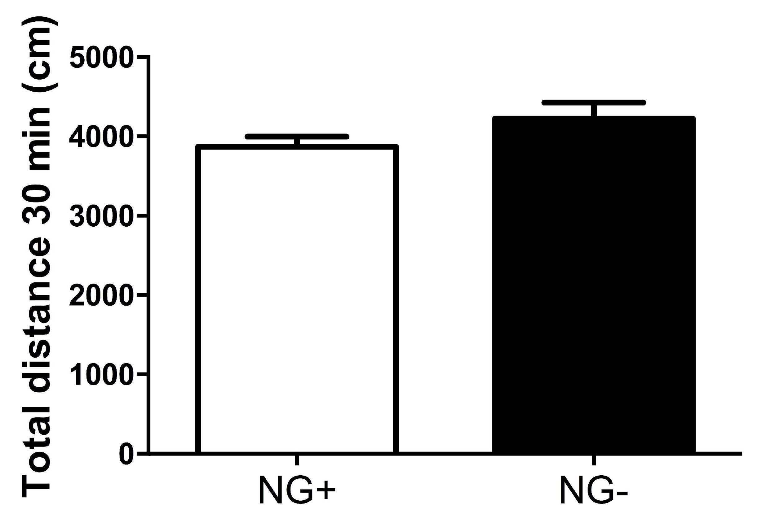

A) 2 month Fear Conditioning
B) 2 month Open Field

Figure S5. Behavior in NG- mice without neurogenesis for 2 months and NG+ littermates. A) During fear conditioning training NG+ and NG- mice did not show freezing behavior at baseline. When exposed to the context where one shock was delivered 24h prior, NG- mice showed reduced freezing compared to NG+ mice (n=15 per group; main effect of group F_{1,84} = 17.35, p= 0.0041). When exposed to an alternate context 26h after receiving a shock NG+ and NG- mice froze at similarly low levels. B) In an open field NG+ and NG- mice showed similar measures of total distance traveled in 30 min (cm) and in the percent path in the center. Bars or points represent mean ± SEM.

0 6 12 18 24 30 36 42 48 54 60 66 72

Figure S6. Intraperitoneal administration of physostigmine increases DG acetylcholine. Dialysate was collected from dentate gyrus of animals in their home cage every 6 minutes. Physostigmine (20 μg/kg ip) was administered after 15 minutes (dashed line). Note that dentate gyrus acetylcholine begins to increase around 9 minutes after administration, peaks 15-20 minutes after administration, and declines back to baseline after 45 minutes post administration of physostigmine (n=6).

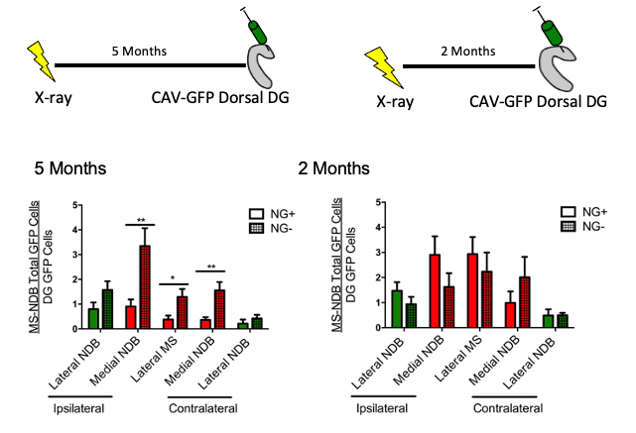

Figure S7 Increased innervation of the dorsal hilus is by ventrally projecting
neurons. Mice were treated with X-irradiation or Sham treatment and CAV-GFP was injected into the dorsal hilus after 5 or 2 months. After 5 months without neurogenesis, the dorsal hilus of NG- mice shows an increase in innervation by GFP+ cell bodies that are expected to primarily innervate the ventral hilus (Ohara et al., 2013) compared to NG+ mice (n=12 per group). NG+ mice show an increase in projections to the dorsal hilus from the medial NDB, contralateral (t(22)=3.171, p= 0.0044) and ipsilateral (t(22)=3.346, p= 0.0029) to the injection site, as well as the lateral MS (t(22)=2.554, p= 0.0181). This change has not emerged in NG- mice without neurogenesis for 2 months.

CAV2–GFP Dorsal
Lateral
CAV2–mCherry Ventral
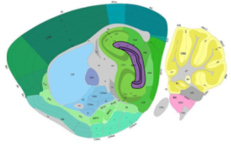
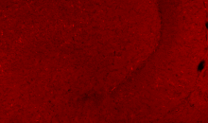
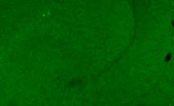
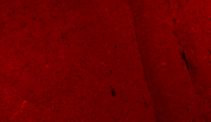
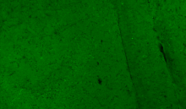
GFP
mCherry
2.80

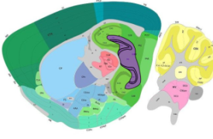
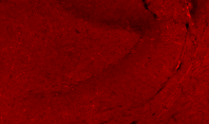
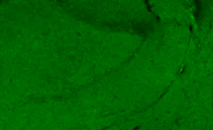
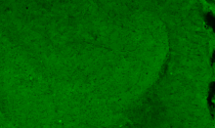
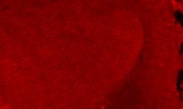
2.60

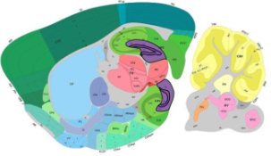
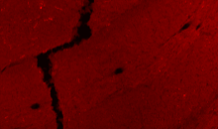
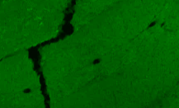
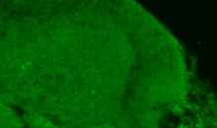
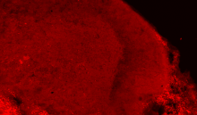
2.40

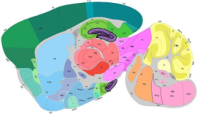
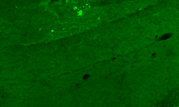
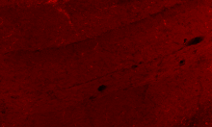
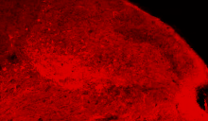
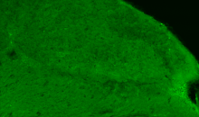

2.20

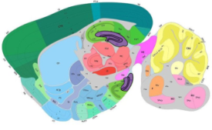
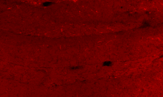
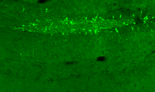
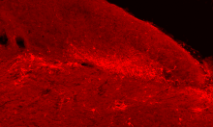
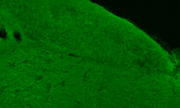
2.05

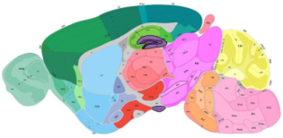
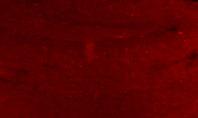
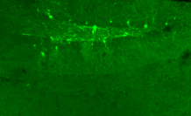
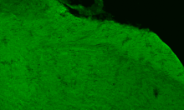
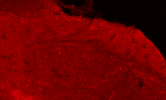
1.95

Medial

Figure S8 Extent of viral spread from dorsal and ventral hilar injections. CAV2-GFP was injected into the dorsal hilus and CAV2-mCherry was injected into the ventral hilus. Note the absence of GFP+ cells in the ventral DG and the absence of mCherry cells in the dorsal DG indicating that GFP+mCherry+ cells in the MS-NDB complex are not the result of overlapping injection areas.

Supplemental Video 1
3D reconstruction and animation of confocal stack images presented in Fig 4G-K. mCherry is restricted to cholinergic axons and is presented in red. GFAP staining is in blue and s100b is in green. Note the proximity of cholinergic axons with abundant varicosities to GFAP+ astrocyte processes.

Supplemental Video 2
Complete 3D reconstruction and animation of axonal tracing presented in Fig S9C. NG-animals were injected with CAV2-mCherry in the ventral hilus and CAV2-GFP in the dorsal hilus. Septohippocampal circuit was microdissected, immunolabeled for GFP and mCherry, and cleared using iDISCO. A GFP+mCherry+ axon was traced from the diagonal band-medial septum cell body to the ventral dentate gyrus. Note extensive arborization to both the dorsal and ventral dentate gyri.

Supplemental Video 3
3D reconstruction and animation of a unilateral septohippocampal circuit from an NG- animal injected with CAV2-mCherry into the ventral hilus and CAV2-GFP into the dorsal hilus. The circuit was microdissected, immunolabeled for mCherry and GFP, and cleared using iDISCO. Note extensive labeling of cells around injection sites. Individual axons traversing the circuit were analyzed in detail in Fig S9C-K.

