SUPPLEMENTARY MATERIAL

Characterization of a new potent and long-lasting single chain peptide agonist of RXFP1 in human cells and in vivo translational models
Stephane Illiano,†*, Bruno Poirier†, Claire Minoletti§, Olivier Pasquier #, Laurence Riva†, Xavier Chenede†, Isabelle Menguy§, Michel Guillotel†, Philippe Prigent†, Stéphane Le Claire †, Florence Gillot†, Gilbert Thill$, François Lo Presti†, Alain Corbier†, Jean-Christophe Le Bail †, Patrick Grailhe †, Edith Monteagudo‡, Raffaele Ingenito‡, Elisabetta Bianchi‡, Christophe Philippo†, Olivier Duclos§, Sergio Mallart§, Ross Bathgate¥, Philip Janiak †.
† Cardio-Vascular and metabolism, Sanofi R&D, 1 avenue Pierre Brossolette 91385 Chilly Mazarin, France.
§ Integrated Drug Discovery, Sanofi R&D, 1 avenue Pierre Brossolette 91385 Chilly Mazarin, France
# DMPK France, Sanofi R&D, 1 avenue Pierre Brossolette 91385 Chilly Mazarin, France
$ Translational Science, Sanofi R&D, 1 avenue Pierre Brossolette 91385 Chilly Mazarin, France
‡ Peptides and Small Molecules R&D Department, ≠DMPK, and Structural Biology IRBM Spa, Via Pontina Km 30 600, 00 071 Pomezia (ROME), Italy
¥ Florey Institute of Neuroscience and Mental Health and Department of Biochemistry and Pharmacology, The University of Melbourne, Parkville, VIC 3052, Australia

Correspondence and reprints request to:
Stephane Illiano, PhD, Sanofi 1 Avenue Pierre Brossolette, 91385 Chilly Mazarin, France;
Email: stephane.illiano@sanofi.com, Tel: +33-1-60497826

Supplementary Table S1
Individual and Mean plasma PK parameters of SA10SC_RLX following IV administration at 1 mg/kg to male Sprague-Dawley Rats

Animal ID | Co  (µM) | AUC  (µM*h) | AUXext  (%) | CL  (mL/min/kg) | Vss  (L/kg) | T1/2  (h) | number of PK points used for t1/2 calculation
1 | 3.02 | 8.48 | 1.01 | 0.48 | 0.14 | 4.16 | 5
2 | 3.36 | 9.32 | 1.01 | 0.44 | 0.11 | 3.49 | 5
3 | 3.28 | 10.9 | 1.02 | 0.38 | 0.12 | 4.11 | 5
Mean | 3.2 | 9.57 | 1.01 | 0.43 | 0.12 | 3.9
S.D. | 0.2 | 1 |  | 0.05 | 0.01 | 0.4

Supplementary Table S2
Individual and Mean plasma PK parameters of SA10SC_RLX following SC administration at 3 mg/kg to male Sprague-Dawley Rats

Animal ID | Cmax  (µM) | Tmax  (h) | AUC  (µM*h) | AUC_{ext}  (%) | F  (%)
4 | 1.59 | 8 | 20.7 | 1.07 | 72
5 | 1.88 | 8 | 25.4 | 1.10 | 89
6 | 1.11 | 8 | 17.6 | 1.11 | 61
Mean | 1.5 | 8 | 21.2 | 1.09 | 74
S.D. | 0.4 | 0 | 4 |  | 14

Supplementary Table S3
Individual plasma PK parameters of SA10SC_RLX following IV administration at 1 mg/kg to female Göttingen minipig

Animal  ID. | C₀  (µM) | AUC  (µM*h) | AUC_{ext}  (%) | CL  (mL/min/kg) | V_{ss}  (L/kg) | t_{1/2}  (h) | number of PK points used for t1/2 calculation
1 | 9.36 | 31.9 | 0.462 | 0.130 | 0.0439 | 7.06 | 5
2 | 8.57 | 27.1 | 0.479 | 0.151 | 0.0497 | 6.92 | 5

Supplementary Table S4
Individual plasma PK parameters of SA10SC_RLX following SC administration at 1 mg/kg to female Göttingen minipig

Animal  ID. | C_{max}  (µM) | t_{max}  (h) | AUC  (µM*h) | AUC_{ext}  (%) | F  (%)
3 | 1.42 | 6 | 23.8 | 3.16 | 81
4 | 1.45 | 4 | 16.6 | 1.83 | 56

Supplementary Figure S1

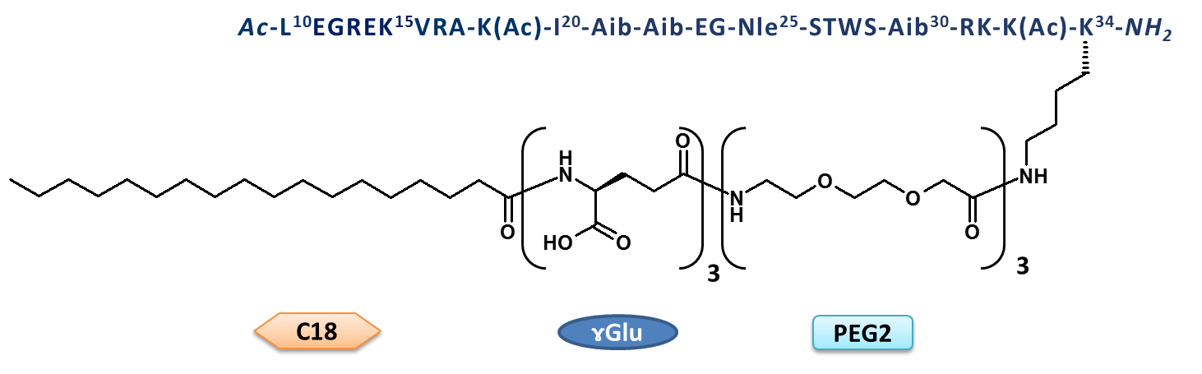

Supplementary Figure S1: Structure of SA10SC-RLX.
H2 relaxin B chain numbering has been chosen based on the first description of this series of peptides by Mallart et al. (2021). The PEG2 were used as spacers, the γGlu as linkers to the lipid moiety (C18, CH₃-(CH₂)₁₆-CO-) used to promote albumin binding and increase peptide half-life.

Supplementary Figure S2

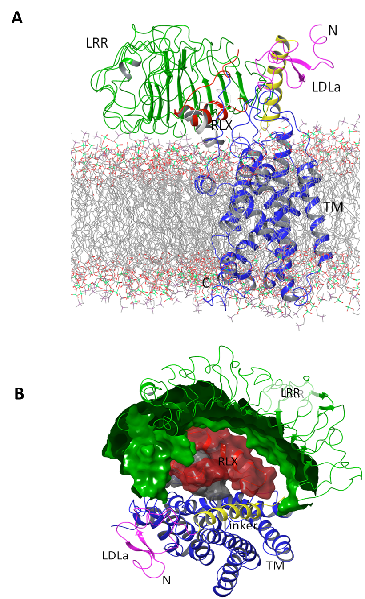

Supplementary Figure S2: Model of RXFP1 in complex with relaxin
Each domain is identified by a unique color: relaxin, A chain in grey and B chain in red. For RXFP1, LDLa is in magenta, the linker with LDLa in yellow, LRR in green and Transmembrane (TM) domains in blue. Supplementary Figure 2A is a side view of the model and in Supplementary Figure 2B the contact surface view from extracellular side of relaxin and the LRR are shown, respectively in red and green to visualize the binding cassette.
Supplementary Figure S3
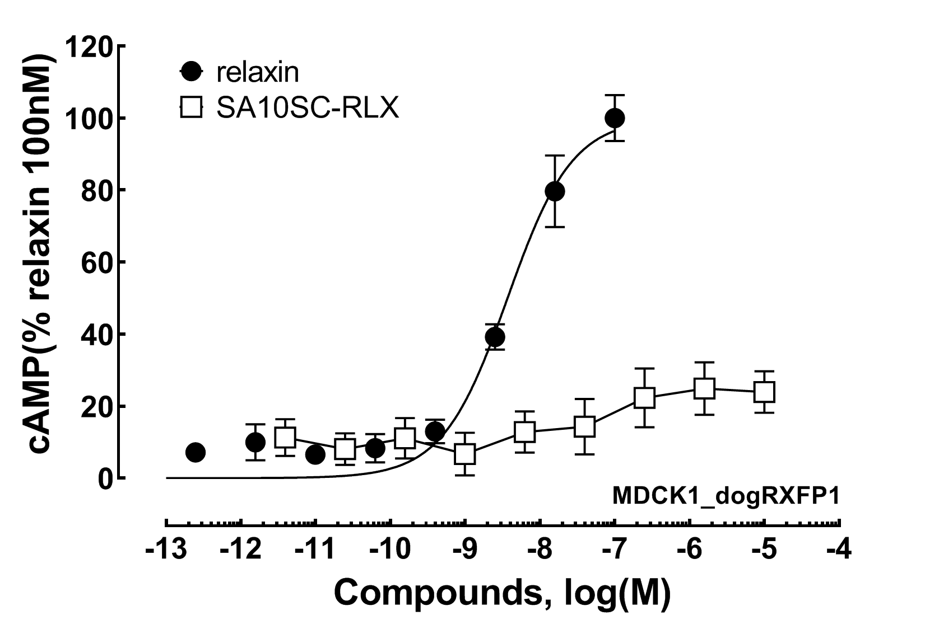

Supplementary Figure S3: Decreased response of SA10SC-RLX compared to relaxin on cAMP production in dog MDCK.1 cells with stable expression of recombinant dog RXFP1 (sequence id. MW713050) (mean +/- sem n=6 different experiments performed in duplicate).

Supplementary Figure S4

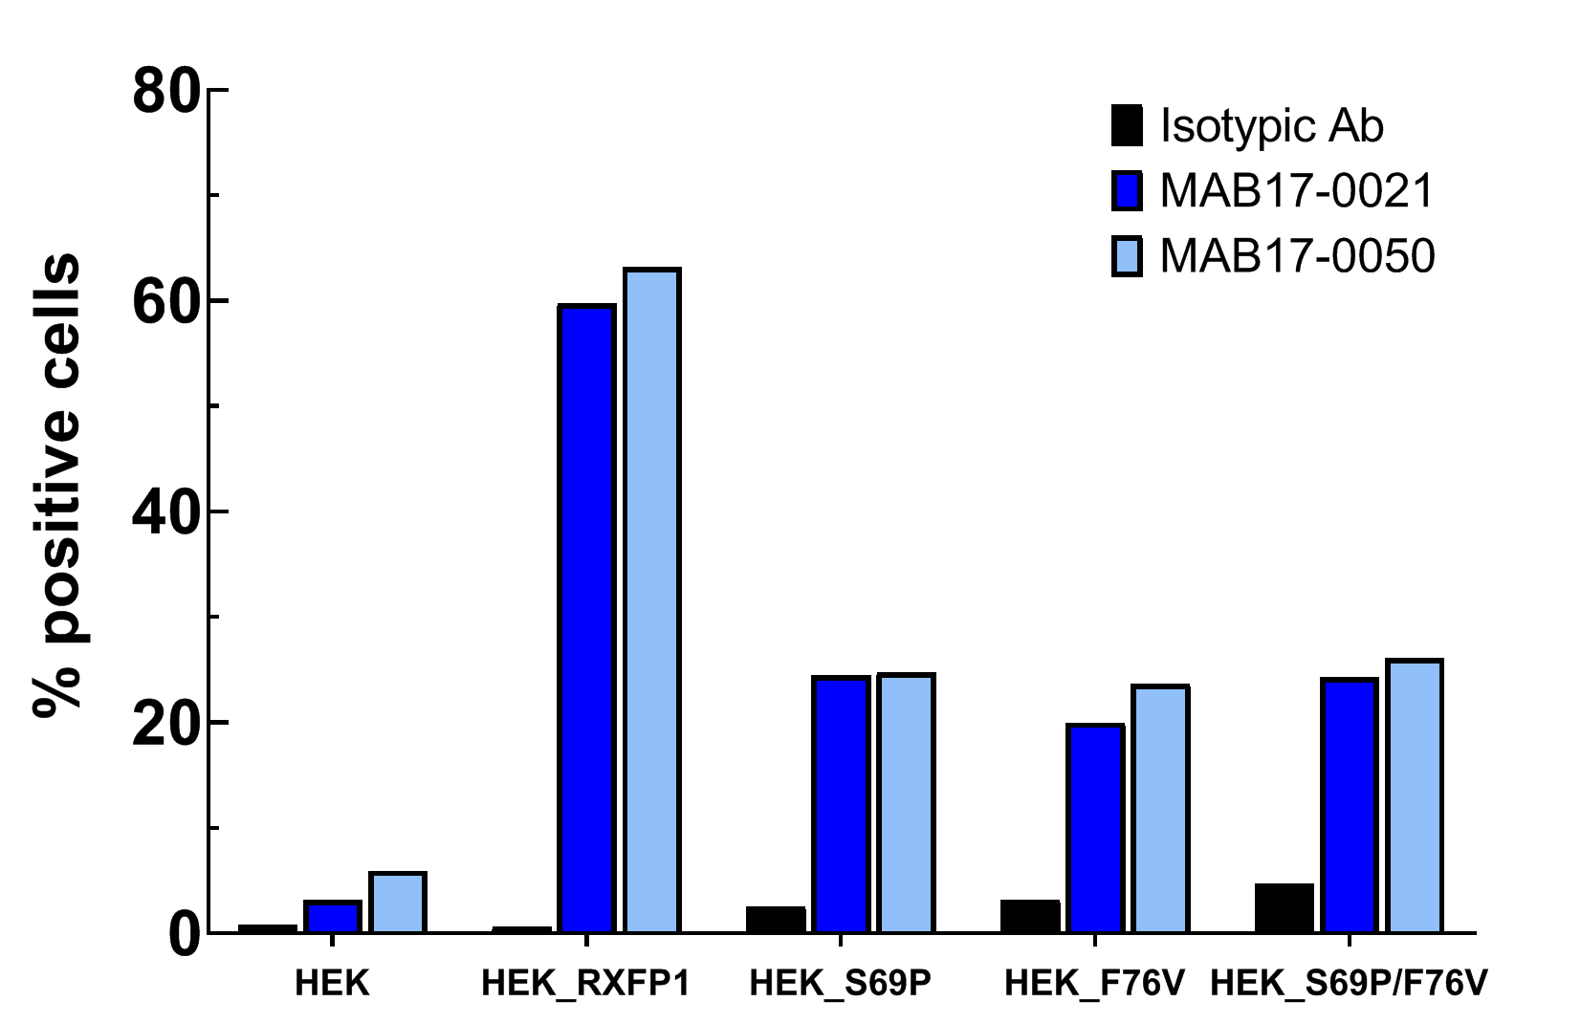
Supplementary Figure S4: Two different monoclonal anti-RXFP1 antibodies were obtained internally after immunization of rabbits with HEK cells expressing recombinant human RXFP1. They were used to detect by FACS, RXFP1 and mutated RXFP1 at the surface of stable cell lines (HEK_RXFP1 / HEK_S69P /HEK_F76V or HEK_S69P/F76V) as described in Methods. An isotypic antibody and wild type HEK cells (HEK) were used as negative controls.

Supplementary Figure S5
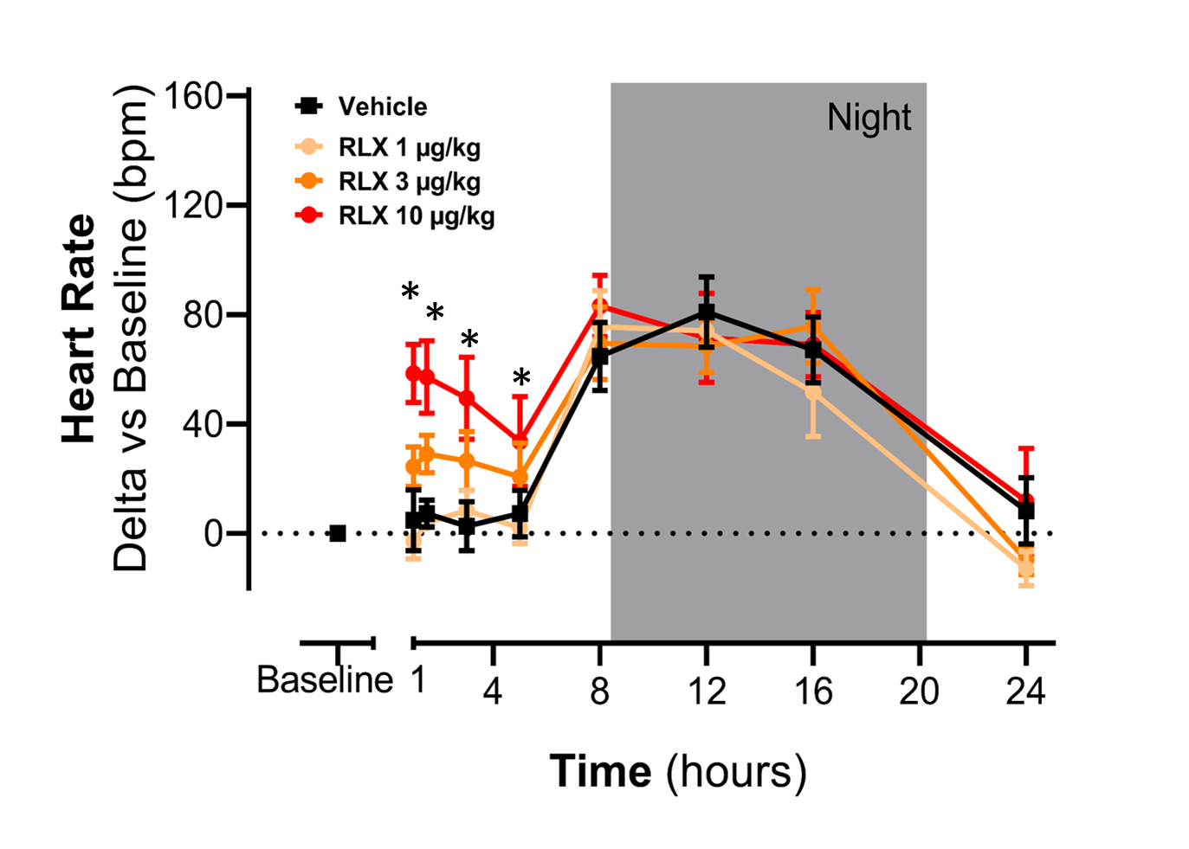
Supplementary Figure S5: Effects of a single iv administration of relaxin at 3 doses (1, 3 and 10 µg/kg) on HR in conscious healthy telemetered SD rats. Results are expressed as mean ± sem of changes from baseline for each animal (n=5/group). A significant difference (* P<0.05) between relaxin and vehicle was observed for the early time points (1-4h) at the doses of 3 and 10 µg/kg of relaxin.

