A 2D Fragment-Assisted Protein Mimetic Approach to Rescue α-Synuclein Aggregation Mediated Early and Post-Disease Parkinson’s Phenotypes

Nicholas H. Stillman^{1,2,4}, Johnson A. Joseph^{1,2,4}, Jemil Ahmed^{2,3,4}, Ryan A. Dohoney^{1,2}, Tyler D. Ball^{1,2}, Alexandra G. Thomas^{1,2}, Tessa C. Fitch², Courtney M. Donnelly^{1,2}, Sunil Kumar^{1,2,5}

¹ Department of Chemistry and Biochemistry, ²The Knoebel Institute for Healthy Aging, ³Molecular and Cellular Biophysics Program, University of Denver, Denver, CO 80210

⁴Authors contributed equally.
⁵Correspondence: sunil.kumar97@du.edu

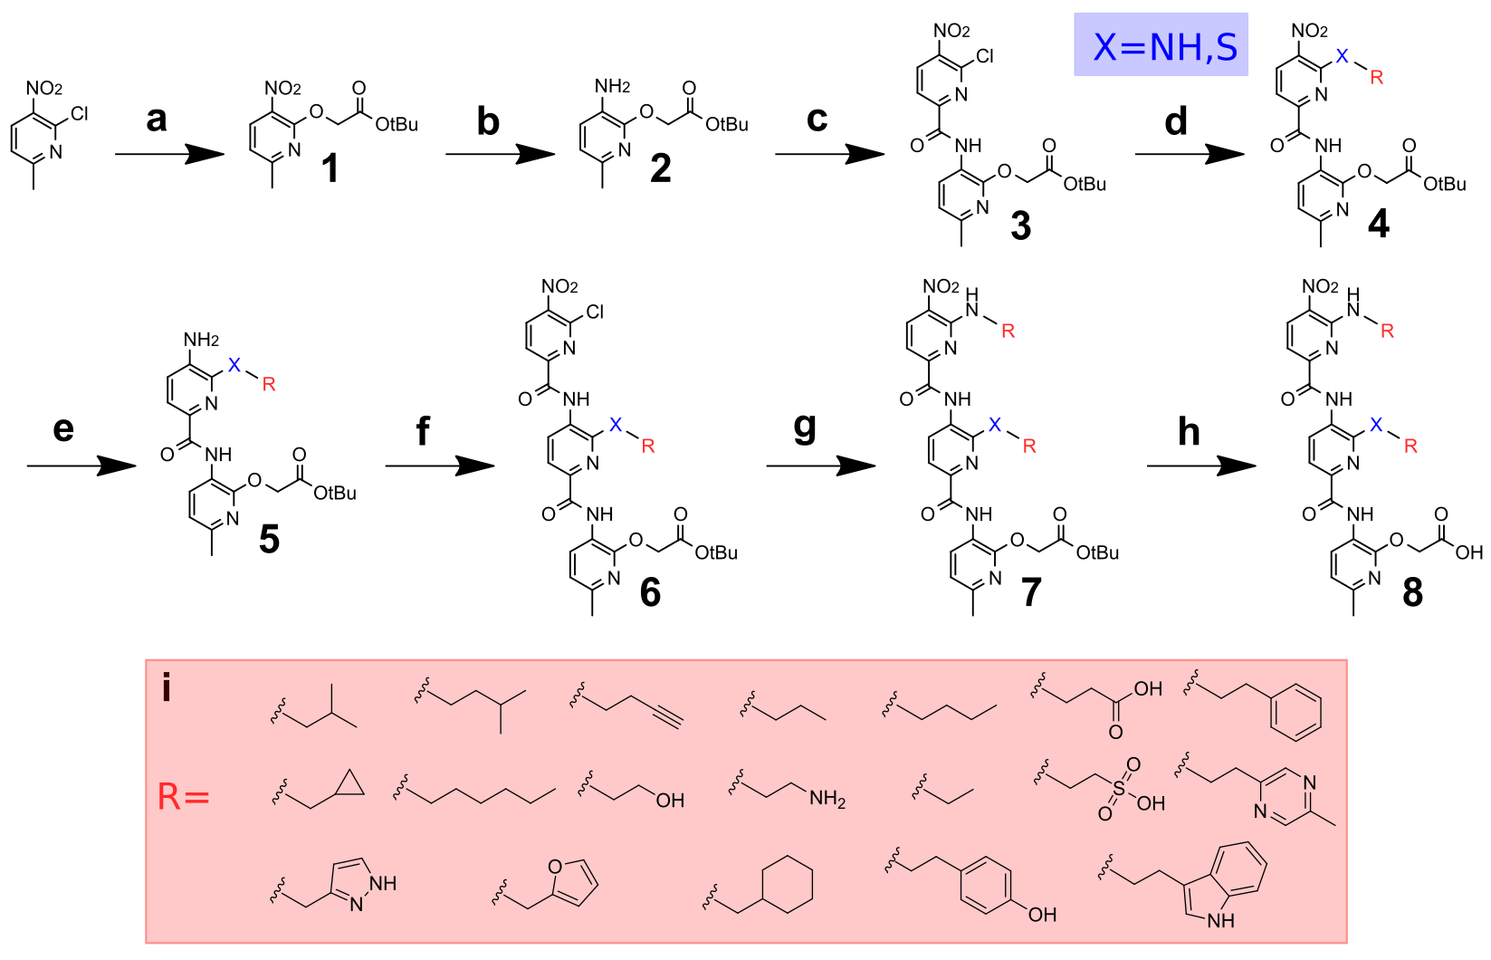

Supplementary Fig. 1. General Synthesis of Ops using 2D-FAST. a, tert-Butyl 2-hydroxyacetate, NaH (60% dispersion in mineral oil), toluene, 50 min at 0 °C, then 5 h at room temperature (r.t.) b,e, Palladium on activated carbon (Pd/C), H₂ (g), ethyl acetate (EtOAc), 3 h at r.t. c, 6-chloro-5-nitropicolinic acid, dichloromethane (DCM, anhydrous), triethylamine (TEA), thionyl chloride 0 °C to r.t., 45 min. d,g, Primary amine/thiol, N,N-Diisopropylethylamine (DIPEA), DCM 3 h at r.t. f, TEA, 6-chloro-5-nitropicolinoyl chloride, THF (anhydrous) 0 °C to r.t., 40 min h, Triethylsilane (TES):trifluoroacetic acid (TFA) (1:1), DCM, 3-6 h at r.t. i, Chemical structures of various side chains appended on the dipyridyls and tripyridyls.

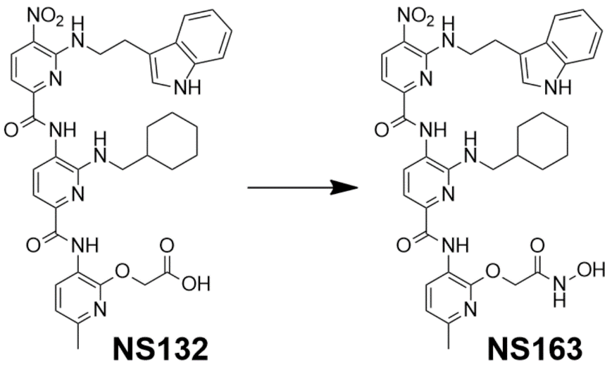

Supplementary Fig. 2. Synthesis of NS163. Reagents and conditions: Carbonyldiimidazole (CDI), tetrahydrofuran (THF, anhydrous), stir 1 h at r.t., hydroxylamine hydrochloride, 20 h, r.t.

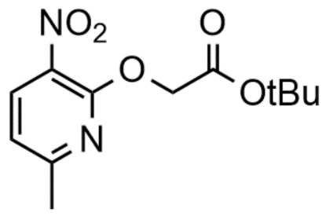
Synthesis of Starting Monomer (1)
A solution of 6-chloro-5-nitro-2-picoline (2.00 g, 11.6 mmol) in toluene (30 mL) under argon (g) was stirred at 0 °C for 15 min before adding tert-Butyl 2-hydroxyacetate (2.45 g, 18.5 mmol, 1.6 eq.). After stirring the solution for an additional 15 min at 0 °C, NaH (60% dispersion in mineral oil, 0.445 g, 18.5 mmol, 1.6 eq.) was added incrementally over 20 min. The reaction was then stirred at 0 °C for 30 min and then at r.t. for 5 h. After the disappearance of the starting material was observed via TLC, the reaction mixture was partitioned between EtOAc and brine. The organic layers were combined, dried over anhydrous Na₂SO₄, and concentrated under vacuum (yellow solid, 3.02 g, 97.2%).
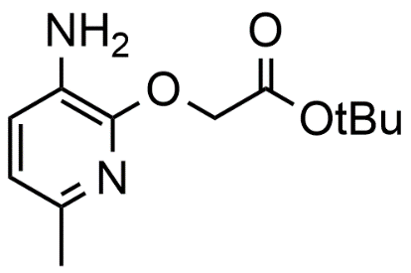
General method to reduce arylamides (2,5)
Pd/C (20% by wt., 0.298 g) was added to a solution of nitro arylamide (1.49 g, 5.55 mmol) in EtOAc (15 mL) and continuously stirred while bubbling H₂ (g) for 3 h at r.t. After confirming the disappearance of the starting material via TLC, the reaction was filtered and concentrated. The use of a rotary evaporator in this reaction is ill-advised due to the risk of product degradation. The product of this reaction was used in the next step without being further characterized (red/brown oil, 95.6%).
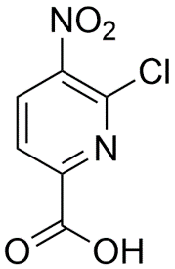
Synthesis of 6-chloro-5-nitropicolinic acid
To a stirring solution of 6-chloro-5-nitro-2-picoline (5 g, 29.0 mmol) in conc. H₂SO₄ (45 mL), potassium dichromate (11.4 g, 38.6 mmol, 1.3 eq.) was added portionwise over 20 min and refluxed at 60 °C overnight. After confirming the absence of starting material via TLC, the reaction was placed on ice and quenched with water (25 mL). The reaction was then extracted with EtOAc (6×125 mL), dried over Na₂SO₄, and concentrated under vacuum to yield the pure product (pale yellow solid, 5.63 g, 96.0%).
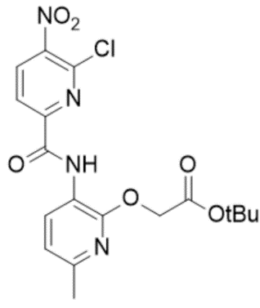
One-pot Amide Coupling (3)
A solution of 6-chloro-5-nitropicolinic acid (0.335 g, 1.65 mmol, 1 eq.) and compound (2) (0.394 g, 1.7 mmol) in DCM (anhydrous, 10mL) was equilibrated for 15 min at 0 °C under argon (g). To the stirring solution was added TEA (0.690 mL, 4.96 mmol, 3 eq.) and equilibrated for an additional 60 sec at 0 °C, followed by the addition of thionyl chloride (0.360 mL, 4.96 mmol, 3 eq.). The reaction mixture was stirred for 45 min at r.t. and the disappearance of starting material was confirmed by TLC. The volatiles were removed on a rotovap, and the resulting product was partitioned between EtOAc and 1M HCl (1×15 mL). The organic layer was then washed with 1M NaOH (3×15 mL), followed by brine (1×15 mL), dried over anhydrous Na₂SO₄, and concentrated under vacuum (yellow solid, 0.699 g, 94.3%).
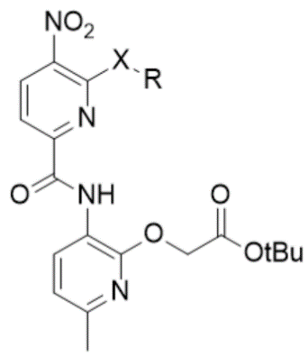
General Method for Aromatic Substitution (4,7)
To a solution of compound (3) or (6) (0.015 g, 0.036 mmol) in DCM (3 mL), a primary amine or thiol (0.355 mmol, 10 eq.) and N,N-Diisopropylethylamine (DIPEA) (0.071 mmol, 20 eq.) were added and stirred at r.t. for 3 h. For reactions involving reagents that exhibit low solubility in DCM, e.g., tryptamine and C-(1-H_Pyrazol-3-yl)-methylamine, DMF was substituted as the solvent. The reaction mixture was dried following confirmation that the starting material had disappeared via TLC. For the removal of non-volatile reagents, flash chromatography is required (10 to 80% EtOAc in hexanes, v/v, over 8 min). The products appear as yellow solids with a yield ranging from 48.0% to 94.3%.
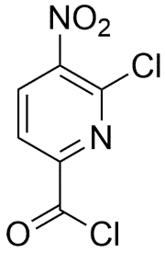
Synthesis of 6-chloro-5-nitropicolinoyl chloride
A solution of 6-chloro-5-nitropicolinic acid (0.500 g, 2.47 mmol) in SOCl₂ (10 mL) was refluxed overnight at 70 °C. After confirming the reaction was complete via ¹H NMR, the volatiles were removed under vacuum and the final product was preserved under argon (g) at -20 °C (pale brown solid, 0.516 g, 94.8%).
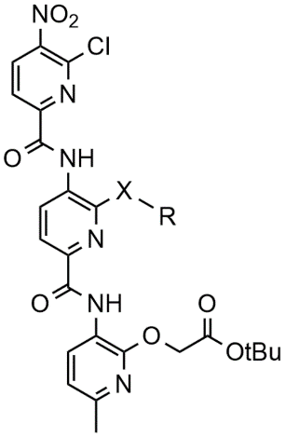
General method for amide coupling (6)
A solution of compound (5) (0.033 g, 0.070 mmol) in THF (anhydrous, 4 mL) with TEA (0.028 g, 0.280 mmol, 4 eq.) was stirred at 0 °C for 5 min under argon (g). After equilibration, 6-chloro-5-nitropicolinoyl chloride (0.062 g, 0.280 mmol, 4 eq) in THF (anhydrous, 2 mL) was added dropwise over 60 sec. The solution was stirred at 0 °C for 10 min, then allowed to come to room temperature. TLC confirmed the disappearance of the starting material after 30 min and the resulting solution was partitioned between EtOAc and saturated NaOH. The combined organic layers were washed with brine, dried over Na₂SO₄, and concentrated under vacuum (orange solid, 0.042 g, 90.8 %).
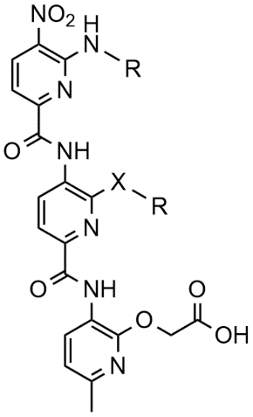
General Method for Deprotection (8)
Compound (7) (0.004 - 0.010 g) was dissolved in 3 mL of DCM followed by the addition of 1:1 TES:TFA (0.5 mL each), stirring 60 sec prior to the addition of TFA. The solution was allowed to stir at r.t. for 3 h, confirming the disappearance of starting material by TLC. Upon completion of the reaction, volatiles were removed under vacuum and the resulting product was washed with diethyl ether (3×2 mL, 0 °C) to yield the pure product; Yellow-Orange solids with a yield ranging from 50.8 to 97.1%.
Due to the sensitivity of indoles to acidic conditions, alternative methods of deprotection were required for molecules containing this functional group^{1,2}. To a stirring solution of NS72 (0.012 g, 0.022 mmol) in acetonitrile (6 mL), water (40 μL) and elemental iodine (0.002g, 30% mol) were added, and the solution refluxed at 75 °C for 5.5 h. After equilibrium was reached, the solution was extracted with Na₂S₂O₃ (aq., 4 mL) and DCM (2×10 mL), and the combined organic layers were dried over Na₂SO₄. Flash chromatography was used to recover the starting material (0 to 40% EtOAc in hexanes, v/v, over 6 min, 0.002 g, 16.4%) and to isolate the pure product (0 to 20% methanol in DCM, v/v over 6 min, 0.005g 42.9%).
To a stirring solution of NS132 (0.023g, 0.030 mmol) in DCM (6 mL), zinc bromide (ZnBr₂, 0.033 g, 0.147 mmol, 5 eq) was added and stirred 72 h at r.t. Additional solvent was added as needed to replace evaporated solvent. Subsequently, deionized water (30 mL) was added, and the solution stirred vigorously for an additional 2 h. The solution was then extracted with DCM (3×10 mL) and the combined organic layers were washed with brine, dried over Na₂SO₄, and concentrated under vacuum (orange solid, 0.014 g, 65.2%).
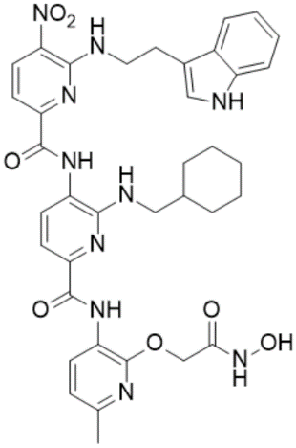
Synthesis of NS163
A solution of NS132 (0.009g, 0.011 mmol) and CDI (0.003g, 0.016 mmol, 1.5 eq.) in 2 mL of THF (anhydrous) was stirred at r.t. for 1 h. After adding hydroxylamine hydrochloride (0.002g, 0.022 mmol, 2 eq.), the reaction was stirred at r.t. for 20 hours. The volatiles were removed on a rotovap, and the resulting product was redissolved in EtOAc and washed with brine (3×5 mL). The organic layer was dried over Na₂SO₄ and concentrated under vacuum. Flash chromatography (0 to 15 % EtOAc in Hexanes, v/v, over 15 min) yielded the final product (yellow solid, 0.002g, 23.7%).

Protein Expression and Purification
The plasmid construct pET11-αS (Addgene, Watertown, MA) was chemically transformed into competent BL21(DE3) cells and plated on ampicillin selection plate. A single colony was used to inoculate a 5 mL starter culture which was kept overnight at 37 °C while shaking at 200 rpm. The following day, the starter culture was used to inoculate 4 L of autoclaved Luria Broth (LB). The culture was incubated at 37 °C and shaken at 200 rpm until the optical density (OD_{600nm}) reached 0.8. Then, protein expression was induced for 5 h by adding isopropyl β-D-thiogalactoside (IPTG) at a final 1 mM concentration. Cells were then harvested by centrifugation at 7,000 rpm and 4 °C for 15 min. αS purification was carried out using a previously described Osmotic Shock protocol³. Briefly, harvested cells were resuspended in Osmotic Shock Buffer (30 mM Tris pH 7.2, 30% sucrose, 2 mM EDTA) and stirred for 15 min at 4 °C. The cells were centrifuged again at 12,000 rpm for 10 min at 4 °C and resuspended in cold Milli-Q H₂O. The cell suspension was spiked with MgCl₂ at a final 5 mM concentration. The suspension was stirred for an additional 5 min and centrifuged at 6,000 rpm for 10 min to remove cells. The supernatant was boiled at 95 °C for 15 min to precipitate proteins other than αS. The resulting precipitate was removed by centrifugation at 6000xg for 20 min and the solution was loaded on Bio-Scale Macro-Prep High Q ion-exchange column (Bio-Rad, Hercules, CA) equilibrated with 20 mM Tris pH 8.0, 25 mM NaCl, 1 mM EDTA, and αS was eluted using 20 mM Tris pH 8.0, 1 M NaCl, 1 mM EDTA. Pure fractions were collected, buffer exchanged to Milli-Q water using Amicon ultra 3K filters (MilliPoreSigma, Burlington, MA), before lyophilizing and storing the dried protein at -80 °C.
Aggregation Kinetics Measurement
Aggregation Kinetics were measured according to a previously described protocol⁴. Briefly, 100 μM αS solutions (250 μL, with or without ligands) were prepared in phosphate buffer saline (PBS, 137 mM NaCl, 2.7 mM KCl, 8 mM Na₂HPO_{4,} 2 mM KH₂PO₄, pH 7.3). The solutions were placed in a ThermoMixer (Eppendorf, Hamberg, Germany) at 37 °C with constant shaking at 1300 rpm (rpm). At different time points, 5 μL aliquots of each αS solution were added to 95 μL PBS containing 50 μM Thioflavin T (ThT) dye in a Costar black 96 well plate (Corning Inc., Kennebunk, ME). ThT fluorescence intensity was measured (λ_{ex} = 450 nm and λ_{em} = 490 nm) on an Infinite M200PRO plate reader (Tecan, Männedorf, Switzerland), and plotted against time to give a sigmoidal curve typical of amyloid aggregation. For the single point ThT aggregation, 100 μM αS, in the absence and presence of ligands, was aggerated under the described conditions and the ThT fluorescence was reported at 96 h. The reported ThT intensity values are the average of each experiment conducted in triplicate, with the error bars representing the standard deviations or standard error of the mean (sem) as described in the main manuscript.
Spin-down assay
An αS solution (100 µM) was prepared in PBS with or without ligands and shaken (13,000 rpm, 37 °C) until the fluorescence plateaued, as observed using the ThT aggregation assay, indicative of the aggregation of αS as a control. The solutions were separated into soluble and insoluble fractions by centrifugation at 22,000×g for 20 min. The fractions were diluted in 2×Laemmli protein sample loading buffer (Bio-rad, Hercules, CA), boiled at 95 °C for 5 min, and ran on a 12% Mini-PROTEAN precast protein gel (Bio-rad, Hercules, CA). The gel was visualized using ChemiDoc MP Imaging System (Bio-rad, Hercules, CA) and band intensity was quantified using Image Lab image acquisition and analysis software (Bio-rad, Hercules, CA). Densitometry values were averaged from three technical replicates and reported with the error bars representing their standard deviations.
Transmission Electron Microscopy (TEM)
Transmission Electron Microscopy was used to visualize protein assemblies after aggregation experiments as previously described⁴. Briefly, aliquots (5 μL) of αS solutions (with or without ligands) were applied on glow-discharged carbon-coated 300-mesh copper grids for 2 min and dried using Kimwipes (Kimberly-Clark, Irving, TX). The copper grids were negatively stained for 1 min with uranyl acetate (0.75%, w/v). The micrographs were taken on an FEI Tecnai G2 Biotwin TEM at 80 kV accelerating voltages.
Isothermal Titration Calorimetry (ITC)
The ITC experiments were performed in a NANO-ITC (TA Instruments, New Castle, DE). For each ITC experiment, a solution of 250 μM NS132 in PBS was serially titrated (2 μL injections every 10 sec via rotary syringe, stirring speed at 300 rpm) into a sample cell containing 350 μL of 15 μM αS in the same buffer conditions at 300 sec intervals. The heat associated with each injection was calculated by integrating each heat burst curve using NanoAnalyze software (TA Instruments, New Castle, DE). The associated heat for each injection of NS132 in αS solution was corrected by subtracting heat resulted from the titration of NS132 into buffer (in 1 × PBS) under identical conditions. The corrected heat values were plotted as a function of the molar ratio of NS132 to αS and the plot was fitted using a one binding site independent model available in NanoAnalyze software. The fitting was carried out using 10,000 iterations in the software without any data constraints during the fitting. The ITC titrations were conducted in triplicate and the reported thermodynamic parameters were calculated as an average of three independent experiments.
Protein Misfolding Cyclic Amplification Assay (PMCA)
The PMCA assay was performed according to a previously described protocol⁴. Briefly, an αS solution (100 µM) was prepared in PBS and 60 µL of the solution was placed in a 200 µL Polymerase Chain Reaction (PCR) tube and the mixture was subjected to five 24 h cycles of 1 min shaking (1200 rpm) and 29 min incubation at 37 °C. Every 24 h, 1 µL of αS solution was passaged to seed 60 µL of fresh soluble monomeric αS solution. The seeding cycle was repeated for five days, after which the ThT signal was measured for all five passages. For the preparation of PMCA samples of αS in the presence of NS132, a molar ratio of 1:1 (αS:NS132) was maintained. All experiments were performed in triplicate. The reported ThT intensity values are the average of three separate experiments with the error bars representing the standard deviations.
Proteinase K Digestion of PMCA Samples
A Protease K (PK) solution at 50 μg/mL (IBI Scientific, Dubuque, IA) in digestion buffer (10 mM Tris, pH 8.0, 2 mM CaCl₂) was diluted (0.1 eq.) into 30 μL of PMCA solution (with or without NS132) and incubated for 30 min at 37 °C. Subsequently, the samples were diluted (1:1, v/v) in SDS Protein Gel Loading Dye 2× (Quality Biological, Gaithersburg, MD) and loaded on Mini-PROTEAN TGX Stain-Free Protein Gel (BioRad, Hercules, CA). The gel was stained using the Fairbanks staining method and imaged using ChemiDoc MP (BioRad, Hercules, CA).
Parallel Artificial Membrane Permeability Assay (PAMPA)
The permeability of various ligands was assessed with a PAMPA kit (BioAssay Systems, Hayward, CA) according to a previously described protocol². Briefly, 4% lecithin solution (LS) was prepared in dodecane and 5 µL was applied to the donor plate membrane. Then, 300 μL PBS was added to the acceptor plate. Subsequently, 200 µL of ligand solutions (500 μM) and various permeability standards (high, medium, and low, 500 μM) were added to the donor plate membrane. The donor plate was placed in the acceptor plate and incubated at r.t. for 18 h. The solutions were then moved from the acceptor plate into a clear-bottom 96-well plate (Corning Inc., Corning, NY) and absorbance was recorded at 360 nm for various ligands and 275 nm for permeability standards. The permeability was calculated using Eq. 1 below, where the permeability rate, C, equals 7.72 × 10⁻⁶, OD_{A} is the absorbance of the acceptor solution, and OD_{E} is the absorbance of the equilibrium standard.
(Eq. 1)
$$P_{e}=C × -\ln\left(1- \frac{{OD}_{A}}{{OD}_{E}}\right) cm/s$$
Heteronuclear Single Quantum Coherence (HSQC) NMR Spectroscopy
A solution of ¹⁵N αS was prepared by resuspending 1 mg of uniformly labelled ¹⁵N αS (rpeptide, Bogart, GA) in 1 mL Milli-Q water to yield a 70 μM αS solution in 20 mM Tris-HCl pH 7.4, 100 mM NaCl. The protein was buffer exchanged to Milli-Q water, lyophilized, and stored at -80 °C. For the preparation of NMR experiments, the lyophilized ¹⁵N αS powder was dissolved in the NMR buffer (300μL, 20 mM NaPO pH 6.4, 5% D₂O, v/v) to make a final concentration of 70 μM. The protein concentration was confirmed with a NanoDrop One (Thermo Scientific, Waltham, MA) at 280 nm using an extinction coefficient of 5960 M⁻¹cm⁻¹. The solutions were transferred into Shigemi BMS-005 NMR tube (Shigemi, Tokyo, Japan) and the two-dimensional ¹H-¹⁵N HSQC NMR experiments were performed on a 600 MHz Bruker Avance Neo (CU Anschutz, NMR core facility, CO) instrument equipped with a triple resonance HCN cryoprobe. Data was collected at 12 °C on Topspin 4.9.0 software (Bruker, Billerica, MA). The HSQC spectra were recorded using a data matrix consisting of 1024 (t₂, ¹H) × 160 (t₁, ¹⁵N) complex points. Resonance assignments were determined utilizing a previous publication⁵ and the data analysis was performed using MestReNova software.
For the HSQC experiments titrating NS132 into ¹⁵N αS, the same experimental conditions were used as above. Incrementally, NS132 was added to a single ¹⁵N αS solution, mixed, kept at r.t. for 10 min and HSQC was recorded under the conditions stated above. For HSQC experiments containing pre-formed fibrils (PFF) of αS, 5.4 eq. of PFF solution (500 μM) was added to monomeric ¹⁵N αS solution, and the spectra was recorded as previously stated.

Preparation of Lipofectamine solution

The Lipofectamine solution was made fresh for each transfection to avoid possible denaturation of reagents in a stored stock solution. For each transfection protocol, the total volume of lipofectamine solution required is equivalent to 30% of the total volume of αS/lipofectamine solution needed. The solution was made by mixing OptiMEM media (Thermo Fisher Scientific, Waltham, MA), Lipofectamine, and P3000 reagents (Invitrogen, Carlsbad, CA) at a ratio of 50:1:1 (v/v/v), homogenized, and incubated at r.t. for 20 min. To prepare a 5 μM αS/Lipofectamine solution, 250 μL of an aggregated solution of αS (100 μM) was diluted with OptiMEM to a final volume of 3.5 mL and sonicated for 10 min. Subsequently, the Lipofectamine solution (1.5 mL) was combined with the αS protein solution for a total volume of 5 mL. The resulting solution (5 μM) was homogenized and added into their respective wells for transfection of cells.

MTT (3-(4,5-dimethylthiazol-2-yl)-2,5-diphenyltetrazolium bromide) reduction Assay

This assay was performed based on a previous protocol with slight modifications⁴. Unless stated otherwise, the density of Human Embryonic Kidney (HEK) cells (Generous gift by Prof. Mark Diamond’ lab) expressing αS_{A53T}-YFP was 150,000 cells/mL for each experiment. The HEK cells were plated (100 μL/ well) and incubated (24 h, 37 °C, 5% CO₂) in a Costar 96-well transparent plate (Corning, Kennebunk, ME) with complete DMEM (Thermo Fisher Scientific, Waltham, MA) supplemented with 10% FBS (Hyclone, Logan, UT) media containing 1% penicillin/streptomycin (Life Technologies Corporation, Grand Island, NY). The cell solution replaced with OptiMEM (Life Technologies Co., Grand Island, NY) containing αS aggregated solution in the absence and presence of NS132 at an equimolar ratio, containing the lipofectamine solution. A solution of MTT dye (10 μL, 5 mg/mL in PBS) was added to each well and the plate was covered with aluminum foil and incubated for 3 h. Afterward, the solution was carefully aspirated out without disturbing the formazan crystals, and replaced with DMSO (100 μL/well). The crystals were dissolved with gentle shaking of the plate, and subsequently, the absorbance was measured at 570 nm using an Infinite M200 Pro Plate Reader (Tecan, Grŏdig, Austria). For all MTT assays, four biological replicates were performed and each biological assay consisted of four technical replicates.

ProteoStat-Dye Assay

This assay was performed based on a previous protocol with slight modifications⁴. The HEK cells (αS_{A53T}-YFP) were plated in 35 mm dishes (Celltreat, Pepperell, MA) with a density of 300,000 cells/dish. The cells were then transfected with αS fibrils (aggregated in the absence and presence of NS132 at an equal molar ratio) using lipofectamine and incubated for 24 h. The Petri dishes were checked for puncta using an Axio Observer Microscope (Carl Zeiss Microscopy, Göttingen, Germany) before measuring intracellular aggregation using the PROTEOSTAT Protein Aggregation Assay Kit (Enzolifesciences, Farmingdale, NY). The media containing dead cells was then transferred into 15 mL Falcon tubes (Corning Science Mexico, Tamaulipas, Mexico). Subsequently, a solution of Detachin (Genlantis, San Diego, CA) was added to detach the live cells, which were then transferred into their respective 15 mL Falcon tubes. After the cells were transferred, the solution was centrifuged for 10 min, and the detachin was aspirated out and replaced with 500 μL PBS. The resulting cell pellets were then homogenized, transferred into an autoclaved 1.7 mL microcentrifuge tube, and counted to normalize the data. The microcentrifuge tubes were then centrifuged for 5 min at 4000 rpm and 4 °C (unless stated otherwise, centrifugation parameters remained the same throughout the assay). The process was repeated two more times with 500 μL PBS to properly wash the cell pellets and remove any excess of detachin or FBS media. The cells were treated with 4% paraformaldehyde (Electron Microscopy Sciences, Hatfield, PA), homogenized, and incubated on ice for 30 min. The tubes were then centrifuged for 5 min, the paraformaldehyde solution was replaced with 100 μL PBS, and centrifuged for another 5 min. The 100 μL PBS was replaced with 500 μL PBS containing 0.15% (v/v) Triton X-100 (Oakwood Chemical, Estill, SC), homogenized, and incubated on ice for 20 min. The tubes were then centrifuged again, and the supernatant was replaced with 100 μL PBS. Following another round of centrifugation, the supernatant was replaced with 375 μL PBS containing the ProteoStat buffer (10%, v/v) and ProteoStat Dye (1%, v/v), according to the manufacturer’s guidelines. The cell solutions were homogenized, protected from ambient light, and incubated at r.t. for 20 min. The tubes were centrifuged, and the dye solution was replaced with 400 μL PBS. The cell solution was homogenized and equally aliquoted into the desired number of wells in a Costar 96-well flat black plate and fluorescence was measured (λ_{ex} = 550 nm, λ_{em} = 600 nm) on an Infinite M200 Pro Plate Reader. For each condition, four biological replicates were performed, each consisting of three technical replicates.

Immunofluorescence staining and confocal imaging

The staining and confocal imaging of HEK cells (αS_{A53T-}YFP) was carried out using a previously reported protocol with slight modifications⁴. The HEK cells were plated (300 μL/well) in a μ-slide 8-well plate (Ibidi, Gräfelfing, Germany) and incubated (24 h at 37 °C and 5% CO₂). The cells were then transfected with αS fibrils aggregated in the absence and presence of NS132, using lipofectamine and incubated for 24 h as previously described. The transfection was confirmed by the appearance of puncta within the plated cells using an Axio Observer microscope. The cells were then fixed with 4% paraformaldehyde for 10 min and subsequently washed with PBS (3×). The paraformaldehyde was then replaced with PBS containing 0.15% Triton X-100 for 10 min and washed with PBS (3×). A PBS solution containing 1% (w/v) BSA (Thermo-Fischer Scientific, Rockford, IL) and 0.1% (v/v) Tween-20 (Sigma-Aldrich, St. Louis, MO) was added and incubated at r.t. for an additional 30 min then washed with PBS (3×). Next, the cells were stained with anti-α-Synuclein Phospho Ser129 (phosphorylated αS at serine residue 129) mouse antibody (BioLegend, San Diego, CA) for 1 h and washed with PBS (3×). The cells were then treated with Donkey anti-mouse tagged with Alexa Fluor Plus 647 secondary antibody (Invitrogen, Rockford, IL) for 1 h and washed with PBS (3×). Lastly, the cell nuclei were stained with DAPI (Cayman Chemical Company, Ann Arbor, MI) for 10 min and washed with PBS (2×). Confocal imaging was conducted on an Olympus Fluoview (FV3000 confocal/2-photon microscope). The images produced by the confocal microscope were analyzed on OlympusViewer in ImageJ processing software.
Culture methods for C. elegans strains
The N2 (wild-type C. elegans Bristol strain), NL5901 (C. elegans model of PD), and Escherichia coli OP50 (E. coli, a uracil requiring mutant) strains were obtained from Caenorhabditis Genomics Center (Minneapolis, MN). Dopaminergic neuron-specific RNAi UA196 strain was generously donated by the laboratory of Dr. Guy Caldwell (Department of Biological Science, The University of Alabama, Tuscaloosa, AL, United States)⁶. The worms were maintained at standard conditions on nematode growth media (NGM) agar in 60 mm plates (CytoOne, Ocala, FL) using E. coli OP50 as the food source following the previous protocols^{4,7,8}. NGM agar plates, M9 buffer (3 g KH₂PO₄, 6 g Na₂HPO₄, 5 g NaCl, 1 mL 1 M MgSO₄, milli-Q H₂O to 1 L), Chemotaxis (CTX) media plates (2% Agar, 5 mM KH₂PO₄, 1 mM CaCl₂, and 1 mM MgSO₄), CTX buffer (5 mM KH₂PO₄, 1 mM CaCl₂, and 1 mM MgSO₄) and OP50 solution at 0.5 OD_{600nm} were prepared using previous protocols^{4,8–10}.
Motility assay for C. elegans (N2, NL5901 and UA196)
The motility assay was conducted based on previously described protocols^{4,8,11,12} with slight modifications. On day one, N2 and NL5901 strains were synchronized using the bleaching process, involving egglay⁷ and incubation of the eggs (23 °C, 30 h) on a solution of NGM in 60 mm culture plates (CytoOne, Ocala, FL) with OP50 (350 µL, 0.5 OD_{600nm}) as a food source. On day two, the worms were transferred (using M9 buffer) to 35 mm NGM plates (CellTreat Scientific, Pepperell, MA) containing 75 µM Fluorodeoxyuridine (FUDR; to prevent worm reproduction and ensure that equal ages of worms were used for the experiment)^{4,8} and ligand (NS132 and NS163, 50 μM) and incubated at r.t. for 24 h (up to day four). On day three, fresh stock of OP50 was prepared by diluting 1 μL of OP50 in 5 mL of LB Miller media (Neogen, Lansing, MI) and incubated in a shaking incubator (Eppendorf, Hamburg, Germany) at 37 °C and 200 rpm for ~24 h. On day four, liquid media was prepared with 67.28% (v/v) of M9 buffer, 0.018% (75 μM) of FUDR solution (v/v), 0.1% of 1 M magnesium sulfate (v/v), 0.1% of 1 M calcium chloride (v/v), 2.5% of 1 M potassium phosphate solution (pH 6, v/v)⁸, and 30% of 0.5 OD_{600nm} OP50 (v/v). The experiment was carried out using a sterile 24 well plate (CellTreat Scientific, Pepperell, MA) containing liquid media (500 μL/well). The three conditions included: (1) N2 worms (positive control), (2) NL5901 worms (untreated, negative control) and (3) NL5901 worms treated with the ligands (50 μM NS132 and NS163). A total of 50 worms per well were manually transferred into a 24 well plate and incubated at r.t. for 24 h. On day four, before conducting each motility assay, the 24 well plate was mechanically tapped for about 30 sec to make the worms more active in the liquid media. The assay was started on day four where 20 activity scores per well were collected using the WMicroTracker ARENA plate reader (Phylumtech, Santa Fe, Argentina) at 23 °C for 1 h per day over a 14-day period. For each condition, four biological replicates were performed and each biological replicate consisted of two technical replicates. For each condition, the data were expressed as mean and the error bars report the s.e.m. (n = 4 independent experiments and each n consisted of a minimum of two technical replicates). The motility rate experiment was repeated for the UA196 strain (in the absence and presence of NS132 and NS163 at 50 μM) following the same conditions and protocol as used for the NL5901 strain.
Motility assay for C. elegans (N2 and UA196) in the presence of dopamine and ligands
The motility assay was conducted for UA196 and N2 worms in the absence and presence of Dopamine (2 mM, treated on day two) and ligand (50 µM NS163, treated on day two) using the previous protocols^{4,8,11,12}. The six worm conditions for this experiment included: (1,2) N2 in the absence and presence of Dopamine (2 mM), (3) UA196 (negative untreated control), (4) UA196 treated with 2 mM Dopamine, (5) UA196 treated with ligand (50 µM NS163), and (6) UA196 treated with both Dopamine (2 mM) and ligand (50 µM NS163). The worms were treated with NS163 and/or dopamine on day two and the motility assay was conducted as described in the previous section.
Confocal microscopy of early stage treated C. elegans (NL5901 and UA196) with ligands
This experiment was performed based on previously described protocols^{4,11,13} with slight modifications. The NL5901 worms in the absence and presence of ligands (50 μM NS132 or NS163 treated on day two) were used for this experiment under conditions identical to the motility assay. At least 10 worms per condition were transferred to a cover slide containing an anesthetic (40 mM sodium azide), and mounted on glass microscope slide containing 2% agarose pads for imaging¹³. The images of the worms were collected using an Olympus Fluoview FV3000 confocal/2-photon microscope (40 x Plan-Apo/1.3 NA objective with DIC capability) from day five through day nine (for NL5901 strain) and processed using the OlympusViewer in ImageJ software⁴. The inclusions of aggregated αS (in the muscle cells of NL5901 strain) were manually counted (10 worms per condition) for the five-day imaging period. For UA196 strain, the confocal imaging of the worms was conducted on day 3, day 5, day 10, and day 15. For each condition, three biological replicates were performed and at least 10 technical replicates were used for each biological replicate. The data were expressed as mean and the error bars report the s.e.m. (n = 3 or 4 independent experiments and each n consisted of a minimum of ten technical replicates).
Confocal imaging of a post-disease onset PD model of UA196 worms in the presence of ligands
The UA196 worms were synchronized by bleaching and transferred into FUDR plates as described in the previous section. For this experiment, the UA196 worms were treated with 50 µM ligands (NS132 or NS163) on day five and then incubated at r.t. Confocal imaging was performed with worms immediately prior to treatment with the ligand on day five. The confocal imaging of UA196 worms was then performed on day 10 and day 15 in the absence and presence of ligands. For each condition, three biological replicates were performed and at least 10 technical replicates were used for each biological replicate. The data were expressed as mean and the error bars report the s.e.m. (n = 3 or 4 independent experiments and each n consisted of a minimum of ten technical replicates).
Chemotaxis Assay for C. elegans (N2 and UA196) in the presence of ligands
The previous protocols^{9,10} with slight modifications were used to perform this assay in CTX solid media 35 mm plates (CellTreat Scientific, Pepperell, MA). The UA196 (treated and untreated with 50 µM ligands on day two) and N2 worms were prepared similar to the motility assay conditions as described above. Three CTX 35 mm plates (for the N2, treated and untreated UA196 strains) were divided into four equal quadrants designated A and C (the left diagonal quadrant), B and D (the right diagonal quadrant). A solution of E coli (attractant) was placed at ~ 0.4 cm from the edge of quadrants B and D and ethanol (10 μL, repellant) was placed at ~ 0.4 cm from the edge of quadrants A and C. The solutions in the quadrants were allowed to dry for about 1 h at r.t. to develop the gradient. CTX buffer (1 mL) was used to transfer adult worms from the 35 mm plates (in the absence and presence of ligands) for each condition in sterile 1.7 mL microcentrifuge tubes (Eppendorf, Hamburg, Germany). The worm solution was centrifuged for 10 sec using a mini-Vortex mixer (VWR, China) to allow the worm pellets to settle at the bottom of the microcentrifuge tubes. The supernatant solution was aspirated out and replaced with CTX buffer. This buffer exchange step was conducted three times to ensure that the worms are re-suspended in only 100 µL of CTX buffer. After homogenizing the worm solution, 10 µL of the worm solution was transferred into a blank solid media 35 mm plate and the number of worms were counted under an Olympus microscope (SZ-6145, Waltham, MA) in triplicate. A worm suspension was then prepared with the CTX buffer containing 50 worms/10 µL. Approximately 50 worms were transferred to the center of the CTX plate, and the lids were covered with parafilm (Bemis Company, Inc., Neenah, WI). Subsequently, the worm activity was monitored using a WMicroTracker ARENA plate reader (Phylumtech, Santa Fe, Argentina) at ~23 °C for 2 h. The report was generated using MapPlot option on the plate reader. Three biological replicates of this experiment were performed. The experiment was conducted for the UA196 worms (in the absence and presence of ligands) and N2 worms on day three and day 10 of the aging process. For each condition, three biological replicates were performed and at least two technical replicates were used for each biological replicate. The data were expressed as mean and the error bars report the s.e.m. (n = 3 independent experiments and each n consisted of two technical replicates).
Measurement of the ROS level in UA196 worms in the presence of ligands (Quantification of ROS and confocal imaging)
A fluorescent probe 2’,7’-dichlorofluorescein diacetate (H₂DCFDA) was used to measure the intracellular ROS based on previously established protocols^{11,14,15} with slight modifications. The UA196 worms were synchronized and treated with ligands (NS163 and NS132, 50 µM) on day two as described in the previous sections. On day eight, the worms were transferred into 1.7 mL microcentrifuge tubes using M9 buffer (1 mL). The samples were centrifuged for 2 min at 2,500 rpm and 20 °C. Subsequently, 0.8 mL of the supernatant was discarded. After, homogenizing the worm pellet in the remaining solution, 10 μL of the suspension was placed onto a glass slide for counting using an Olympus microscope (SZ-6145, Waltham, MA) in triplicate. The worm solution was then diluted with M9 buffer to approximately 50 worms/10 μL. Each well of a Costar 96-well black plate (Corning, Kennebunk, ME) contained M9 buffer (40 μL), worm solution (10 μL), and H₂DCFDA (50 μL, 50 μM in DMSO). For the vehicle, 50 μL of M9 buffer and 50 μL of H₂DCFDA reaction solution were placed in the wells (as a control). Subsequently, the Costar 96-well plate was gently shaken for 30 sec at r.t. and the fluorescence intensity was quantified (λ_{ex} = 485 nm and λ_{em} = 530 nm) at multiple time points (0 to 120 min) using the Infinite M200 Pro Plate Reader.
For confocal imaging, the same UA196 worms used for running the ROS quantification, were transferred into different 35 mm NGM plates, air-dried using the fume hood, and transferred to a cover slide containing an anesthetic (40 mM sodium azide), and mounted on a glass microscope slide containing 2% agarose pads for imaging as described previously.¹³ This experiment consisted of three biological replicates and each biological replicate consisted of three technical replicates. The data were expressed as mean and the error bars report the sd’s (n = 3 independent experiments and each n consisted of three technical replicates).
Measurement of intracellular ROS level in a post-disease onset PD model of UA196 worms in the presence of ligands
The UA196 worms were synchronized by bleaching and transferred into FUDR treated plates as described in the previous sections. On day five, the quantification of ROS level was conducted as described in the previous section. Subsequently, the UA196 worms were treated with ligands (NS132 and NS163, 50 µM) on day five and then incubated at r.t. for three days. On day eight, the quantification of ROS level was carried out for UA196 worms in the absence and presence of ligands. This experiment consisted of one biological replicate and four technical replicates. This experiment consisted of three biological replicates and each biological replicate consisted of three technical replicates. The data were expressed as mean and the error bars report the sd’s (n = 3 independent experiments and each n consisted of three technical replicates).

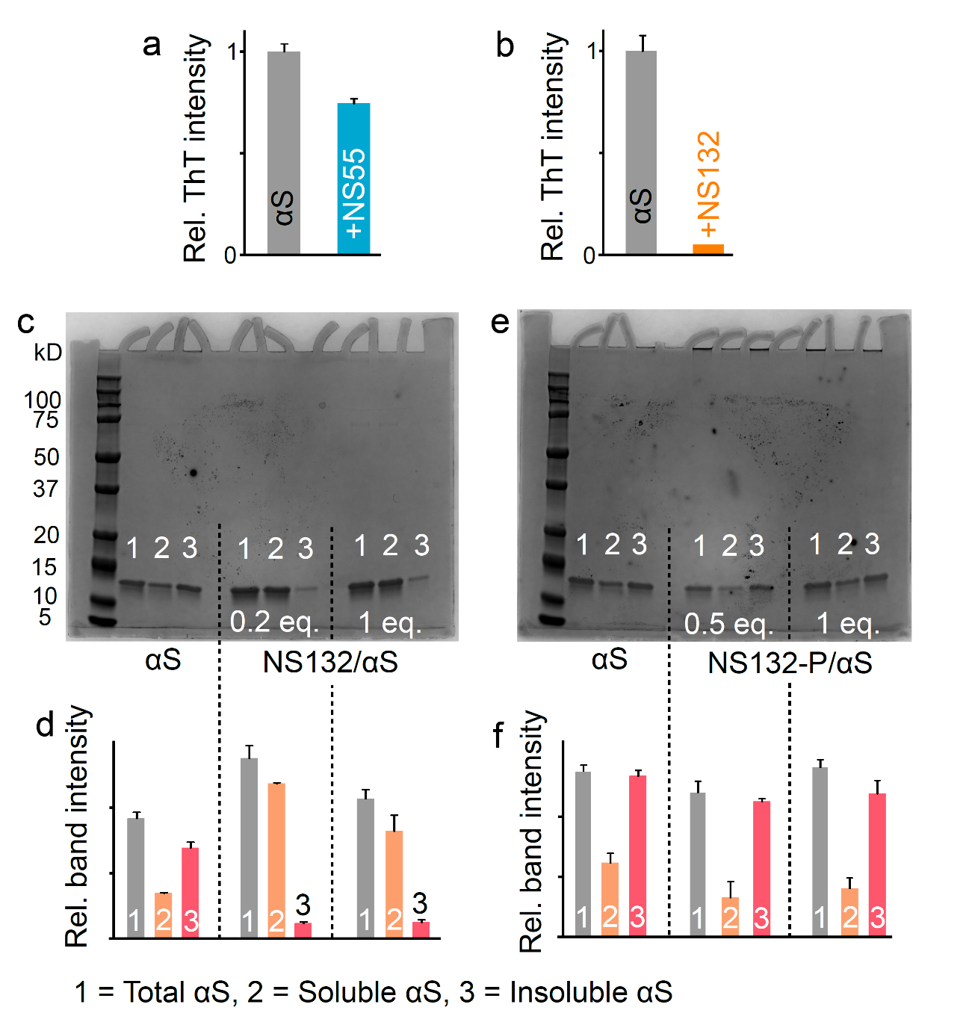

Supplementary Fig. 3. a, The graphical representation of the ThT intensity of 100 µM αS aggregation for four days in the absence and presence of NS55 (a) and NS132 (b) in 1 × PBS at substoichiometric ratio (for NS55, αS:ligand, 1:0.5, and for NS132, αS:ligand, 1:0.1, ). c, Representative SDS-PAGE gel images and band intensities of 100 µM αS aggregation for four days in the absence and presence of NS132 (c,d) and NS132-P (e,f) at the indicated molar ratios. The ThT experiments were conducted three times and the reported change in the ThT intensity was an average of three separate experiments. The gel shift assay experiments were conducted three times and the reported intensity changes were an average of three separate experiments. The data were expressed as mean and the error bars report the standard deviation (s.d.) (n = 3 independent experiments and each n consisted of three technical replicates).

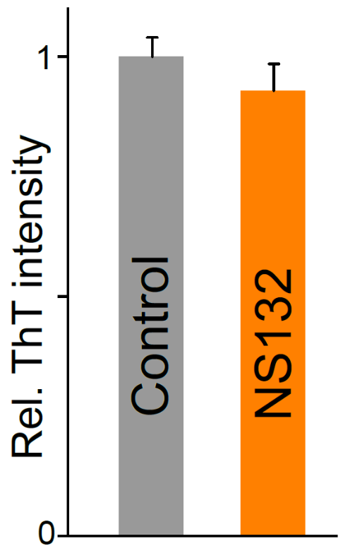

Supplementary Fig. 4. The comparison of the fluorescence intensity of the ThT dye (50 μM) in the absence and presence of NS132 (100 μM) in 1 × PBS. The ThT experiments were conducted three times and the reported change in the ThT intensity was an average of three separate experiments. The data were expressed as mean and the error bars report the s.d. (n = 3 independent experiments and each n consisted of three technical replicates).

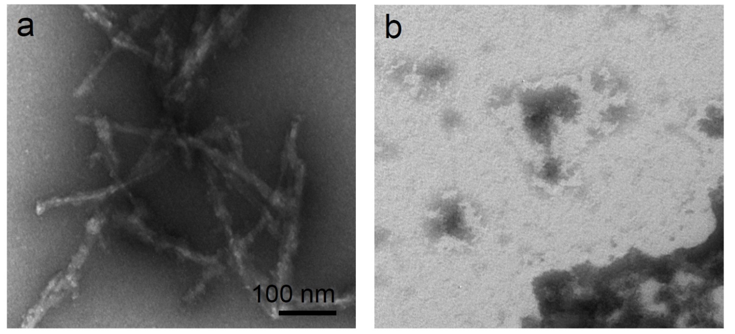

Supplementary Fig. 5. The TEM images of 100 μM αS solution aggregated for four days under aggregation conditions (1 × PBS buffer) in the absence (a) and presence (b) of NS163 at an equimolar ratio.

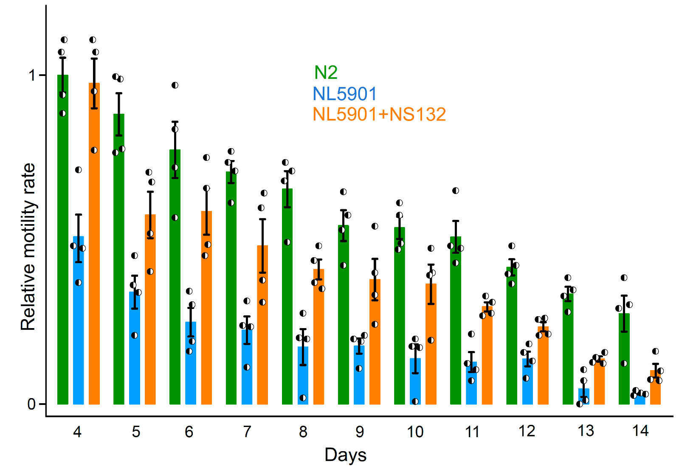
Supplementary Fig. 6. The intracellular inhibition of αS aggregation by NS132 in an in vivo PD model. The comparison of the motility rate of N2 and NL5901 and statistics in the absence and presence of 50 µM NS132 (treatment on day two). For motility rate experiment, a total of 50 worms were used in duplicate for each experiment and each condition consisted of at least four independent experiments. The data were expressed as mean and the error bars report the s.e.m. (n = 4 independent experiments and each n consisted of two technical replicates). The statistical analysis was performed using ANOVA with Tukey’s multiple comparison test. *p < 0.05, **p < 0.01, ***p < 0.001.

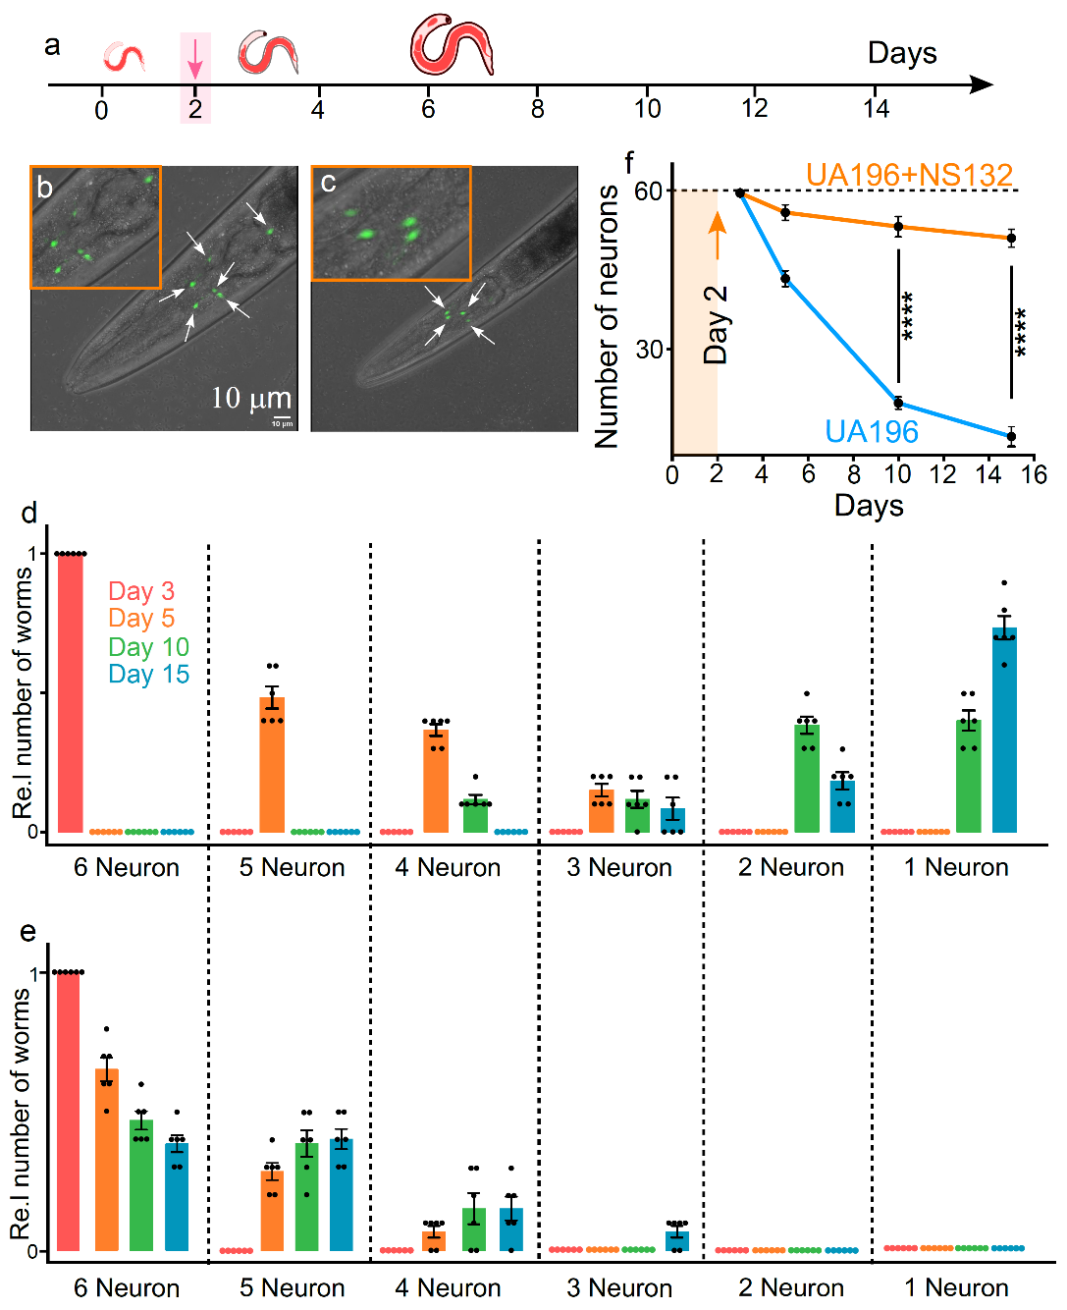

Supplementary Fig. 7. Neuroprotective effect of NS132 on the degeneration of DA neurons. a, Schematic of the aging process of UA196 worms and their treatment with the ligands. Representative confocal images of UA196 worms in the presence of 50 µM NS132 on day 5 (b) and day 15 (c). The healthy DA neurons (white arrow) in UA196 worms on day 5. The relative number of neurons in UA196 worms during the aging process in the absence (d) and presence of 50 µM NS132 (e). f, Statistics for the total number of neurons in UA196 worms during the aging process in the absence (blue) and presence (orange) of 50 µM NS132. For each confocal imaging experiment (b,c), at least 10 worms were used, and the healthy neurons were counted manually, and each condition (day) consisted of six independent experiments with freshly bleached worms. For motility rate experiment, a total of 50 worms were used in duplicate for each experiment and each condition consisted of four independent experiments with freshly bleached worms. The data were expressed as mean and the error bars report the s.e.m. (n = at least 4 independent experiments and each n consisted of at least two technical replicates). The statistical analysis was performed using ANOVA with Tukey’s multiple comparison test. *p < 0.05, **p < 0.01, ***p < 0.001, ****p < 0.0001.

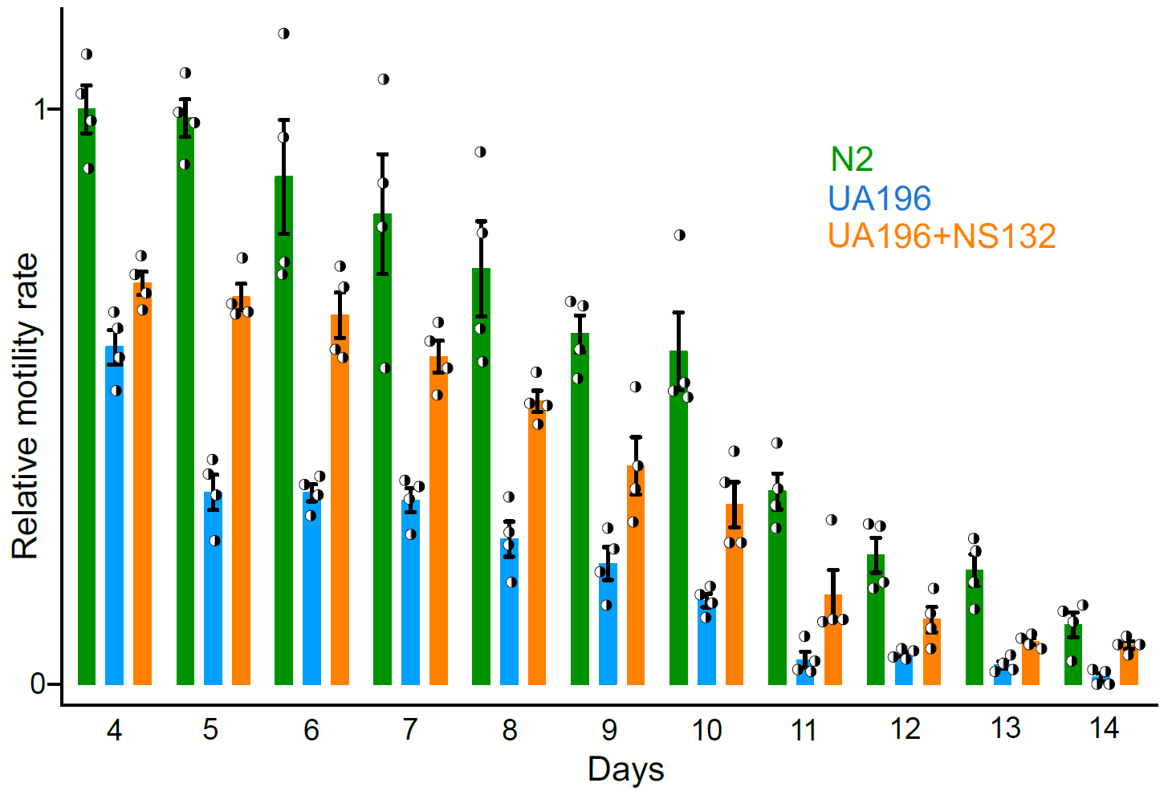

Supplementary Fig. 8. The rescue of motility rate in UA196 worms by NS132. The comparison of the motility rate of N2 and UA196 in the absence and presence of 50 µM NS132 (treatment on day two). For motility rate experiment, a total of 50 worms were used in duplicate for each experiment and each condition consisted of four independent experiments. The data were expressed as mean and the error bars report the s.e.m. (n = 4 independent experiments and each n consisted of two technical replicates). The statistical analysis was performed using ANOVA with Tukey’s multiple comparison test. *p < 0.05, **p < 0.01, ***p < 0.001.

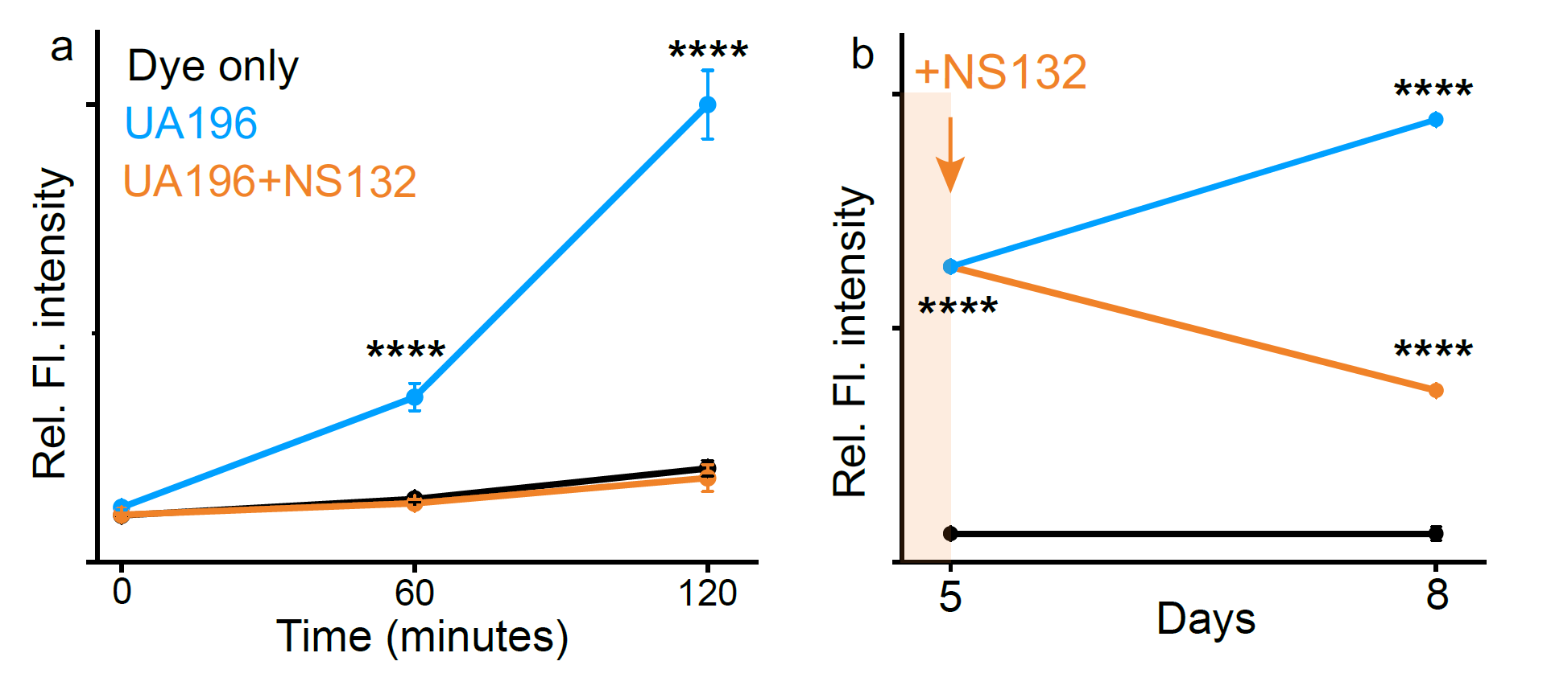

Supplementary Fig. 9. The effect of NS132 on the ROS level in UA196 worms. a, The comparison of the ROS level in UA196 worms in the absence and presence of 50 µM NS132 at the indicated time points. The UA196 worms were treated with NS132 on day 2 and the ROS level was measured on day 10. b, The comparison of the ROS level in UA196 worms (blue) on day 5 and day 8 when treated (orange) with 50 µM NS132 on day 5. For ROS level quantification, at least 50 worms were used and each condition consisted of three independent experiments with freshly bleached worms. The data were expressed as mean and the error bars report the s.d. (n = 3 independent experiments and each n consisted of three technical replicates). The statistical analysis was performed using ANOVA with Tukey’s multiple comparison test. *p < 0.05, **p < 0.01, ***p < 0.001, ****p < 0.0001.

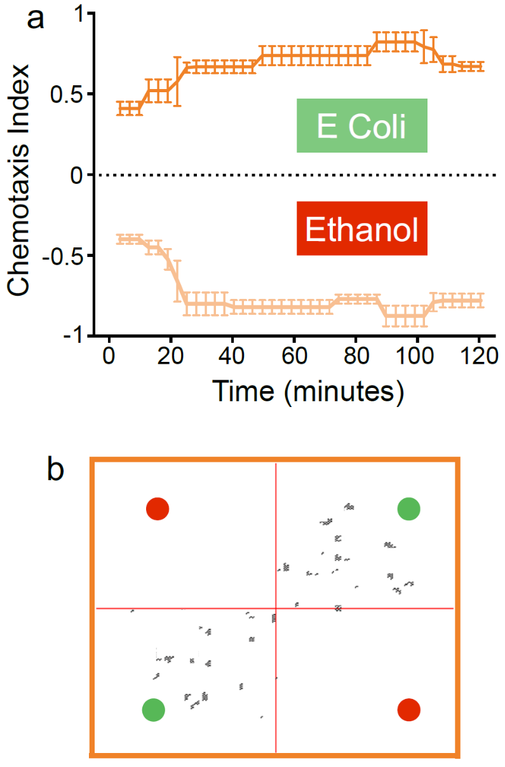

Supplementary Fig. 10. The effect of NS132 on the behavioral deficits mediated by αS aggregation in DA neurons in UA196 worms. a, The CI graph for UA196 worms treated with 50 µM NS132 (treatment on day two) under the indicated conditions on day 10. b, The snapshots at 60 min. of the animated videos (Movie S8) collected for the CI for UA196+NS132 under the indicated conditions. For chemotaxis assays, a total of 50 worms were used in duplicate for each experiment and each condition consisted of three independent experiments with freshly bleached worms. The data were expressed as mean and the error bars report the s.e.m. (n = 3 independent experiments and each n consisted of two technical replicates).

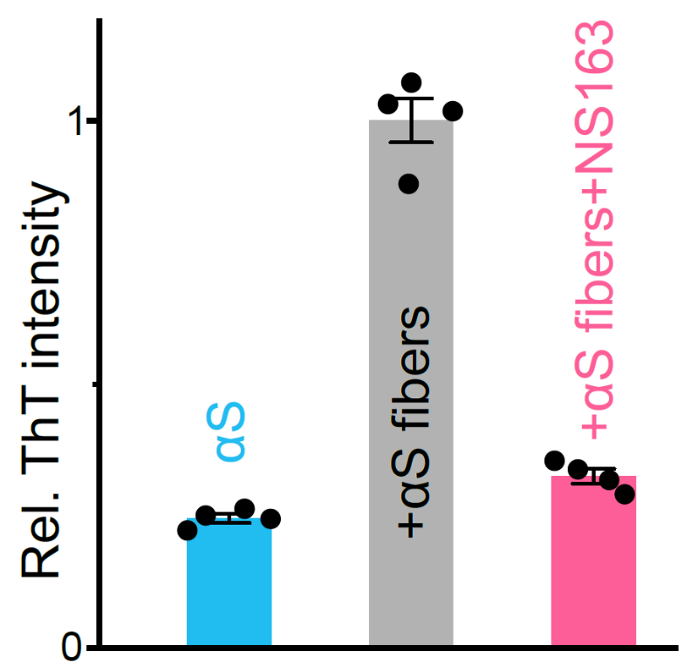

Supplementary Fig. 11. Effect of NS132 on the seed catalyzed aggregation of αS. The relative ThT intensity of the aggregation of αS monomer (100 µM), αS monomer (100 µM) + αS fibers (20% monomer), and αS monomer (100 µM) + αS fibers (20% monomer) + NS163 (100 µM) after 20 h in the aggregation buffer conditions.

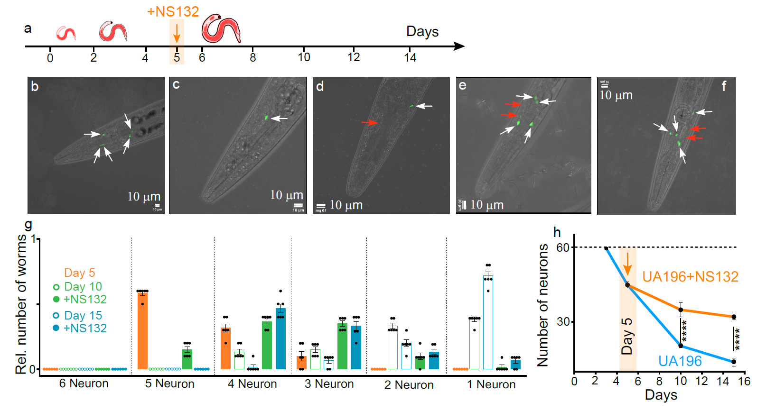

Supplementary Fig. 12. Neuroprotective effect of NS132 on the preexiting PD C. elegans model. a, Schematic of the aging process of UA196 worms and their treatment with NS-132 at the mid-stage pathology (day 5). Representative confocal images of UA196 worms on day 5 (b), day 10 (c), and day 15 (d). Representative confocal images of UA196 worms on day 10 (e) and day 15 (f) when treated with 50 µM NS132 on day 5. The healthy (white) and degenerated (red) DA neurons in UA196 worms. g, The relative number of healthy DA neurons in UA196 worms during the aging process when treated with 50 µM NS132 on day 5. h, Statistics for the total number of neurons in UA196 worms during the aging process in the absence and presence of 50 µM NS132. For each confocal imaging experiment at least 10 worms were used, and the healthy neurons were counted manually, and each condition (day) consisted of six independent experiments. The data were expressed as mean and the error bars report the s.e.m. (n = 6 independent experiments and each n consisted of 10 technical replicates). The statistical analysis was performed using ANOVA with Tukey’s multiple comparison test. *p < 0.05, **p < 0.01, ***p < 0.001, ****p < 0.0001.

Supplementary Fig. 13. ¹H-NMR of 6-chloro-5-nitro-2-picoline

¹H NMR (500 MHz, CDCl₃) δ 2.63 – 2.66 (s, 3H), 7.26 – 7.29 (d, J = 8.0 Hz, 1H), 8.13 – 8.18 (d, J = 8.1 Hz, 1H). HRMS (m/z): [M]+ calcd. for C₆H₅ClN₂O₂, 173.0112; found, 173.0114.

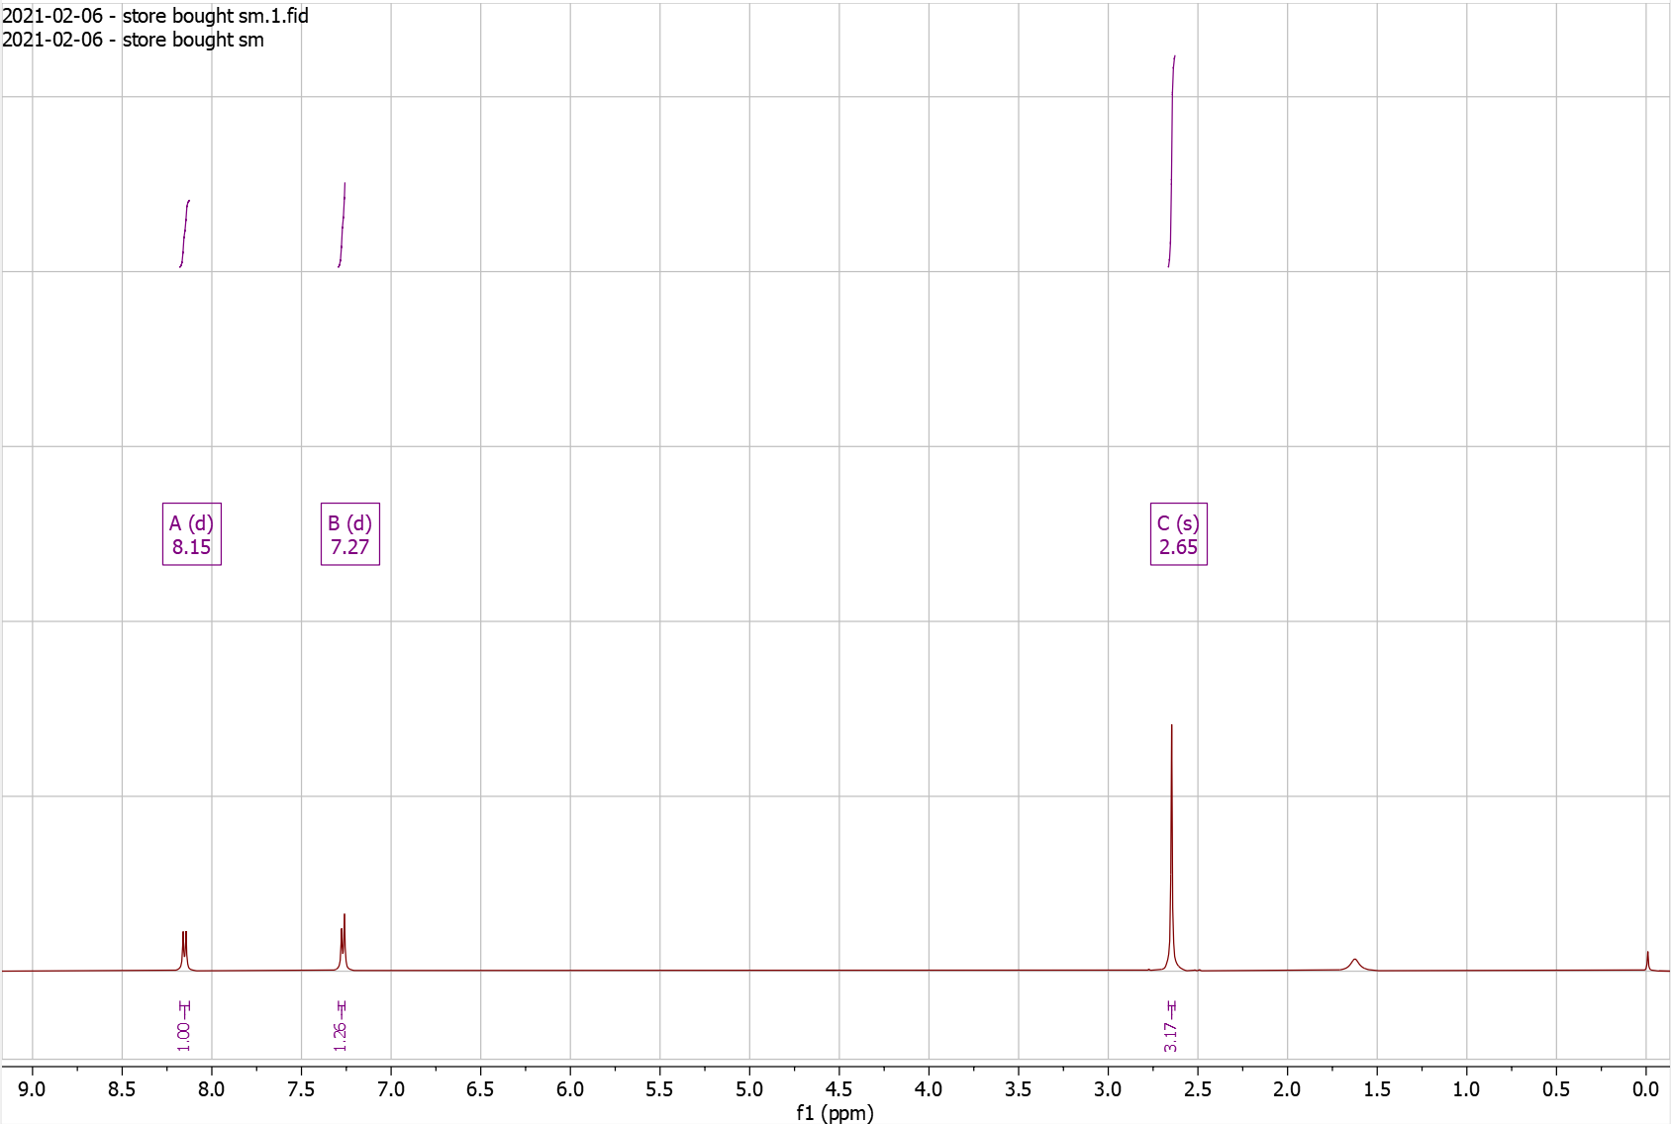
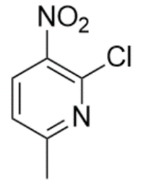
Supplementary Fig. 14. ¹H-NMR of NS41 Pro

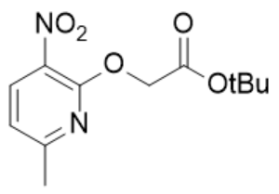
¹H NMR (500 MHz, CDCl₃) δ 1.42 – 1.45 (s, 9H), 2.46 – 2.48 (s, 3H), 4.88 – 4.92 (s, 2H), 6.87 – 6.91 (d, J = 8.1 Hz, 1H), 8.22 – 8.25 (d, J = 8.1 Hz, 1H).

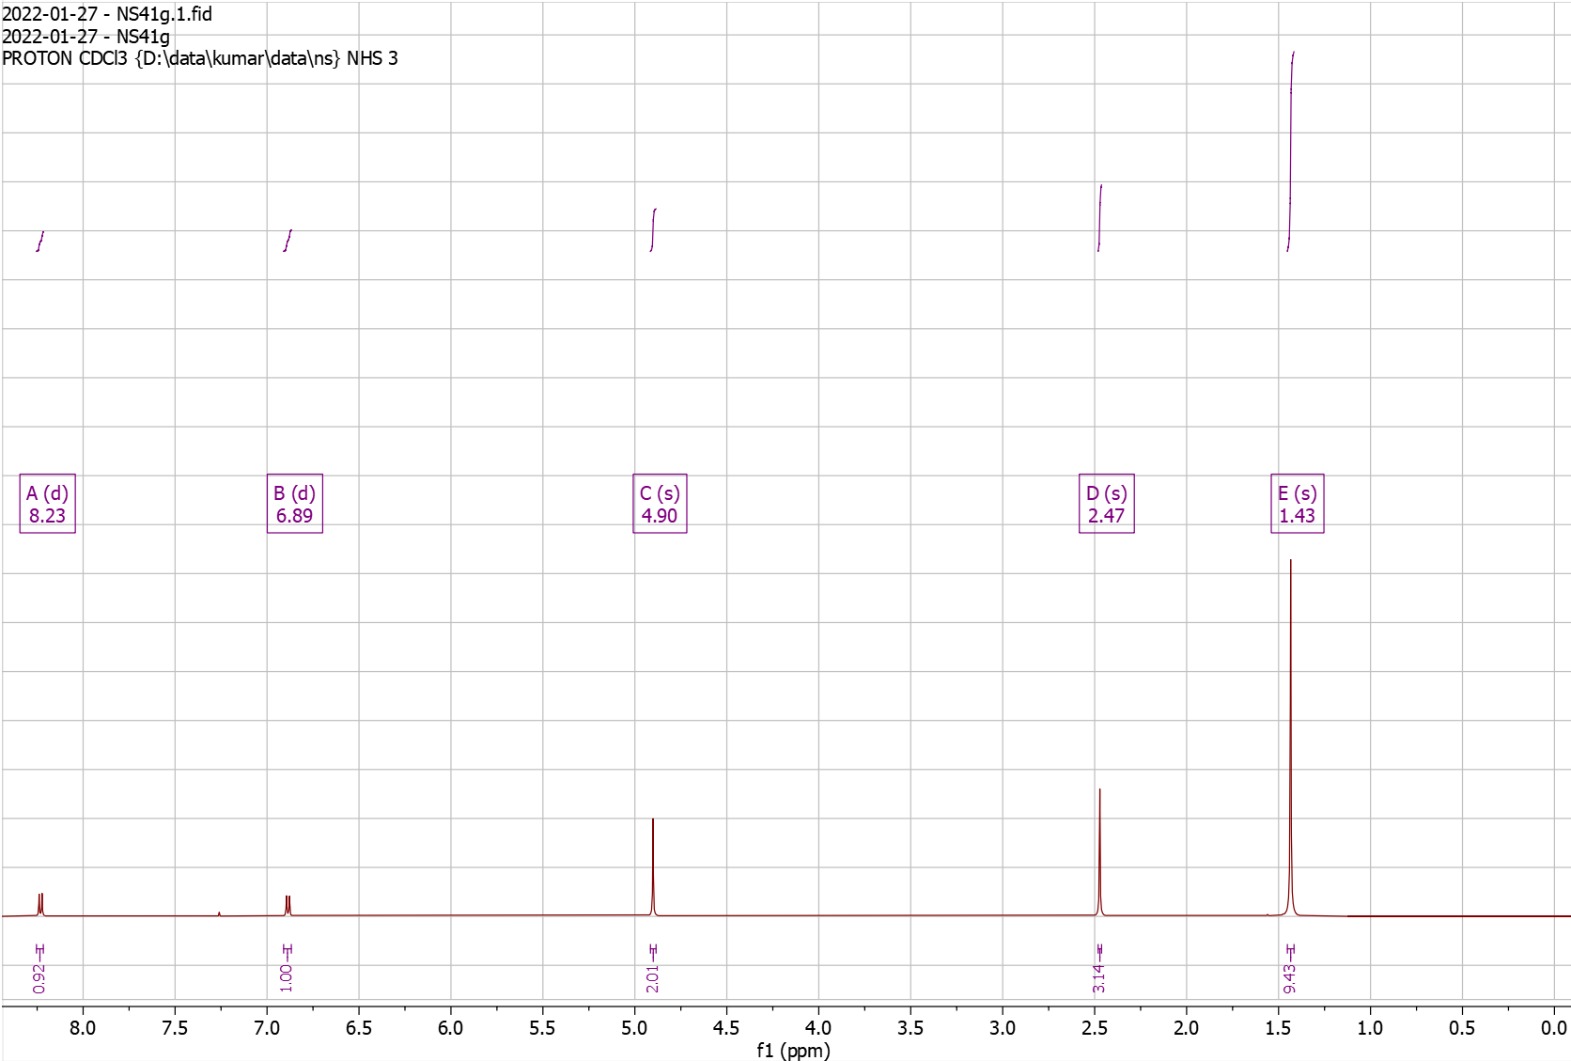
Supplementary Fig. 15. ¹H-NMR of NS101

¹H NMR (500 MHz, DMSO) δ 8.19 – 8.29 (d, J = 8.2 Hz, 1H), 8.65 – 8.73 (d, J = 8.2 Hz, 1H). HRMS (m/z): [M]+ calcd. for C₆H₃ClN₂O₄, 202.9854; found, 202.9859.

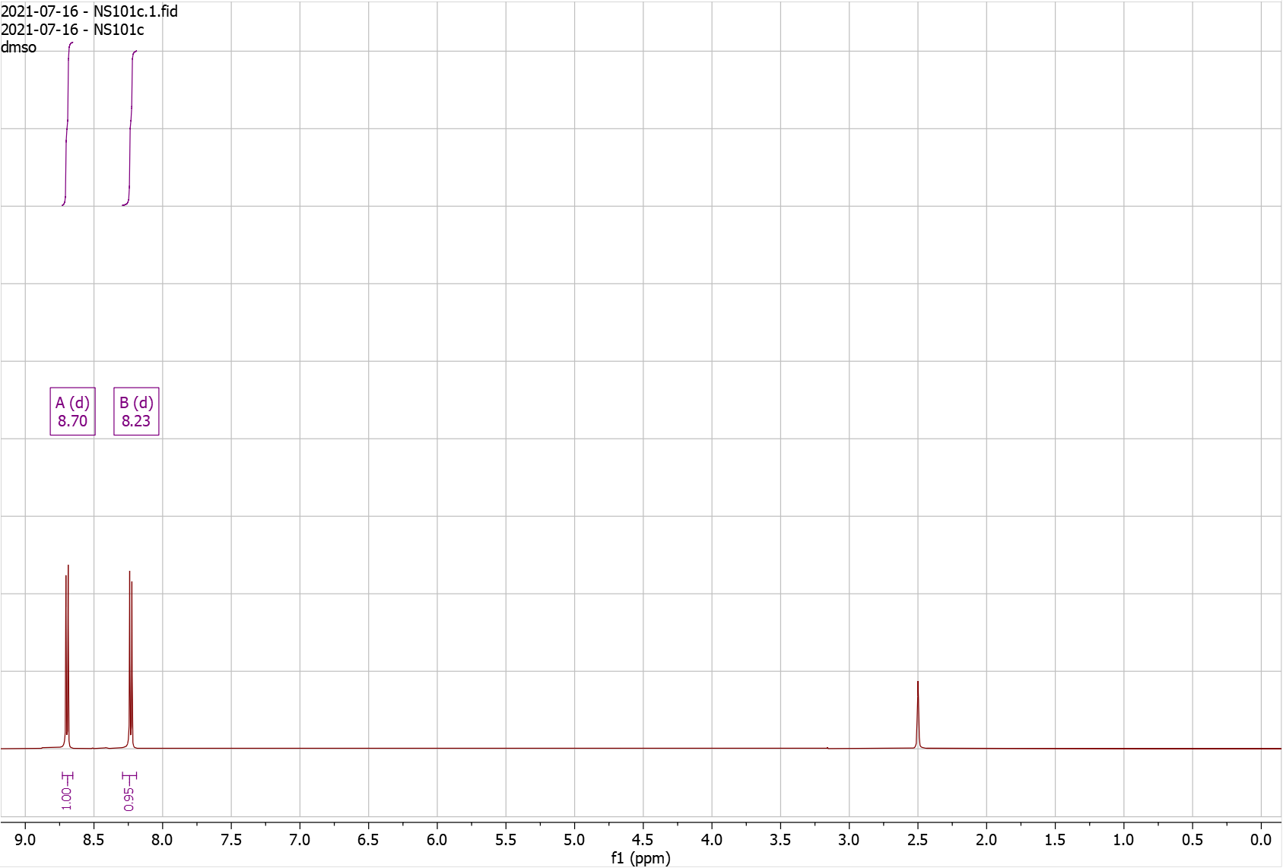
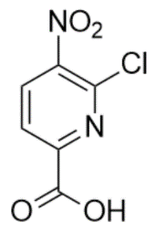

Supplementary Fig. 16. ¹H-NMR of RD121

¹H NMR (500 MHz, CDCl₃) δ 8.15 – 8.25 (d, J = 8.1 Hz, 1H), 8.33 – 8.38 (d, J = 8.2 Hz, 1H). HRMS (m/z): [M]+ calcd. for C₆H₂Cl₂N₂O₃, 220.9515; found, 220.9516.

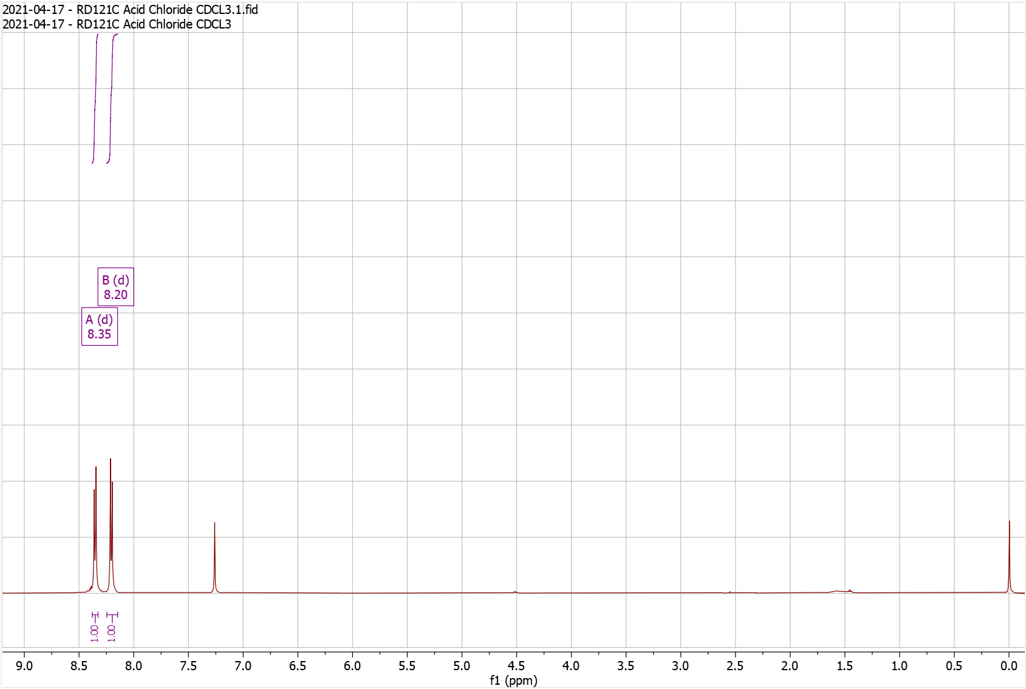
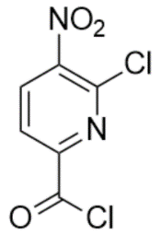

Supplementary Fig. 17. ¹H-NMR of RD127 Pro

¹H NMR (500 MHz, CDCl₃) δ 1.47 – 1.50 (s, 9H), 2.38 – 2.42 (s, 3H), 4.87 – 4.91 (s, 2H), 6.80 – 6.86 (d, J = 7.9 Hz, 1H), 8.34 – 8.42 (m, 2H), 8.60 – 8.66 (d, J = 7.9 Hz, 1H), 10.02 – 10.06 (s, 1H); HRMS (m/z): [M]+ calcd. for C₁₈H₁₉ClN₄O₆, 423.1066; found, 423.1055.

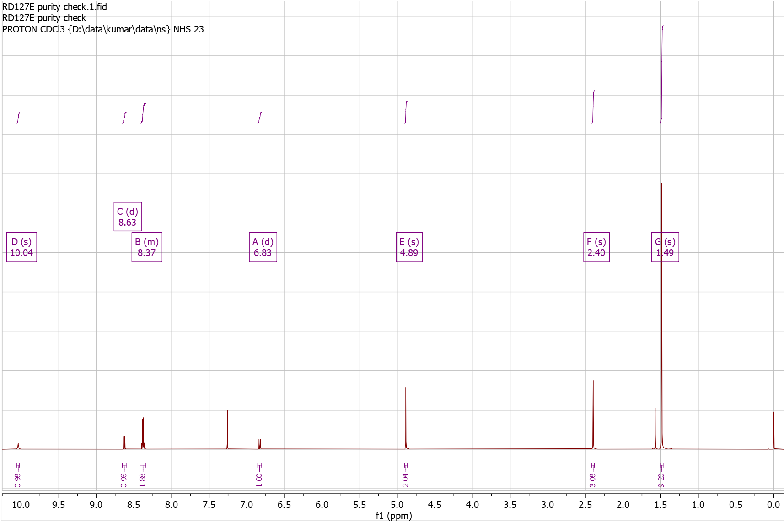

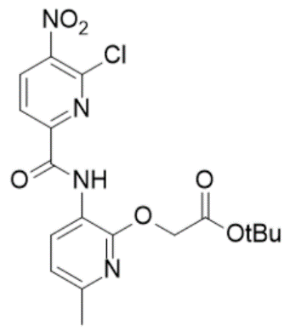
Supplementary Fig. 18. ¹H-NMR of RD127 Dep

¹H NMR (500 MHz, DMSO) δ 2.31 – 2.40 (s, 3H), 4.92 – 5.00 (s, 2H), 6.93 – 7.00 (d, J = 7.9 Hz, 1H), 8.33 – 8.42 (d, J = 8.3 Hz, 1H), 8.42 – 8.53 (d, J = 7.9 Hz, 1H), 8.74 – 8.86 (d, J = 8.3 Hz, 1H), 9.96 – 10.01 (s, 1H), 12.84 – 13.06 (s, 1H); HRMS (m/z): [M]+ calcd. for C₁₄H₁₁ClN₄O₆, 367.0440; found, 367.0423.

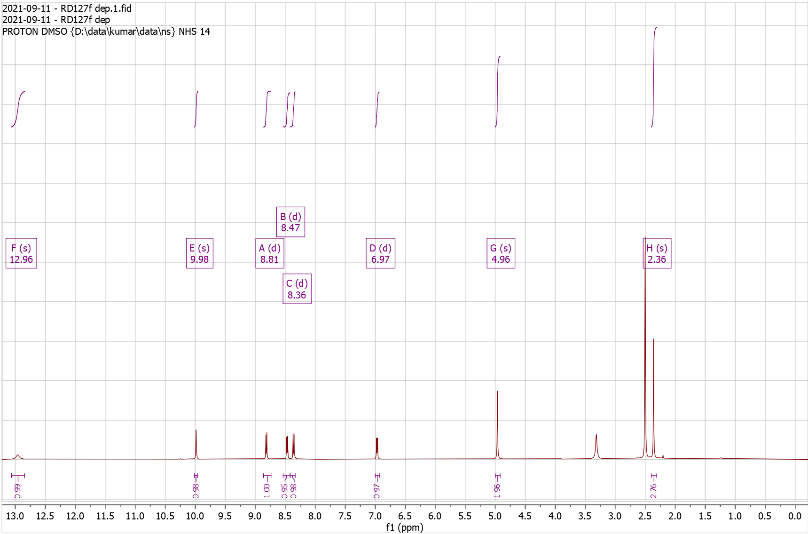

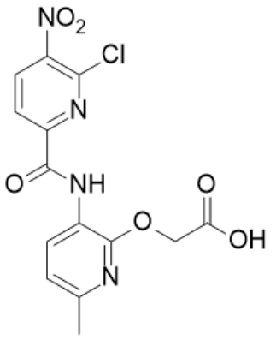
Supplementary Fig. 19. ¹H-NMR of NS48 Pro

¹H NMR (500 MHz, CDCl₃) δ 0.96 – 1.03 (d, J = 6.6 Hz, 6H), 1.42 – 1.48 (s, 9H), 1.63 – 1.69 (q, J = 7.0 Hz, 2H), 1.71 – 1.83 (dh, J = 13.3, 6.6 Hz, 1H), 2.36 – 2.44 (s, 3H), 3.72 – 3.83 (td, J = 7.3, 5.4 Hz, 2H), 4.80 – 4.88 (s, 2H), 6.77 – 6.88 (d, J = 8.0 Hz, 1H), 7.51 – 7.59 (d, J = 8.5 Hz, 1H), 8.15 – 8.27 (t, J = 5.4 Hz, 1H), 8.56 – 8.63 (d, J = 8.4 Hz, 1H), 8.65 – 8.71 (d, J = 7.9 Hz, 1H), 10.16 – 10.28 (s, 1H); HRMS (m/z): [M]+ calcd. for C₂₃H₃₁N₅O₆, 474.2347; found, 474.2349.

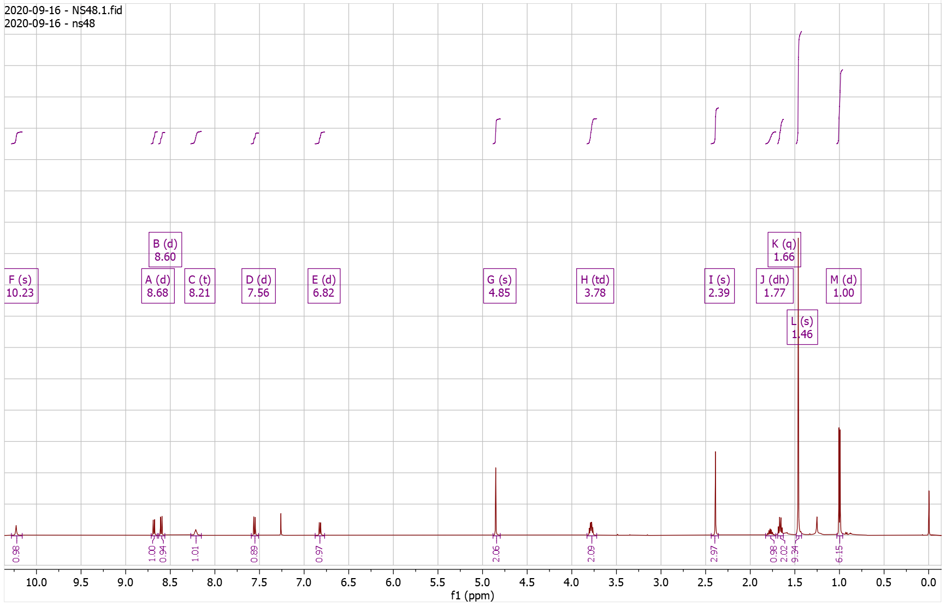

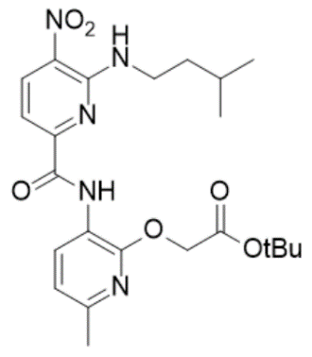
Supplementary Fig. 20. ¹H-NMR of NS48 Dep

¹H NMR (500 MHz, DMSO) δ 0.90 – 0.93 (d, J = 6.5 Hz, 6H), 1.54 – 1.60 (q, J = 7.1 Hz, 2H), 1.62 – 1.74 (hept, J = 6.6 Hz, 1H), 2.31 – 2.35 (s, 3H), 3.56 – 3.73 (q, J = 6.6 Hz, 2H), 4.91 – 4.95 (s, 2H), 6.87 – 6.97 (d, J = 8.0 Hz, 1H), 7.33 – 7.44 (d, J = 8.4 Hz, 1H), 8.47 – 8.52 (t, J = 5.7 Hz, 1H), 8.52 – 8.56 (d, J = 7.9 Hz, 1H), 8.56 – 8.64 (d, J = 8.4 Hz, 1H), 10.09 – 10.13 (s, 1H), 12.66 – 13.23 (s, 1H); HRMS (m/z): [M]+ calcd. for C₁₉H₂₃N₅O₆, 418.1721; found, 418.1704.

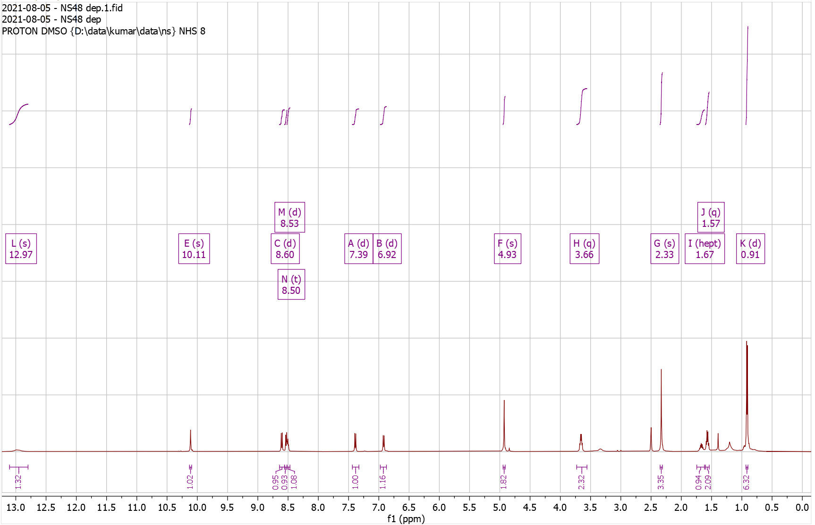
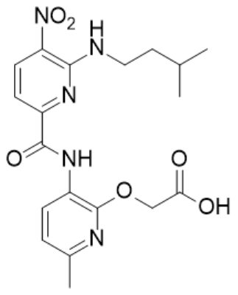
Supplementary Fig. 21. ¹H-NMR of NS50 Pro

¹H NMR (500 MHz, CDCl₃) δ 1.47 – 1.48 (s, 9H), 2.06 – 2.11 (t, J = 2.7 Hz, 1H), 2.38 – 2.41 (s, 3H), 2.65 – 2.72 (td, J = 6.8, 2.7 Hz, 2H), 3.93 – 4.00 (q, J = 6.6 Hz, 2H), 4.90 – 4.94 (s, 2H), 6.80 – 6.85 (d, J = 7.9 Hz, 1H), 7.58 – 7.63 (d, J = 8.4 Hz, 1H), 8.45 – 8.51 (t, J = 6.0 Hz, 1H), 8.60 – 8.65 (d, J = 8.4 Hz, 1H), 8.65 – 8.70 (d, J = 7.9 Hz, 1H), 10.22 – 10.26 (s, 1H); HRMS (m/z): [M]+ calcd. for C₂₂H₂₅N₅O₆, 456.1878; found, 456.1867.

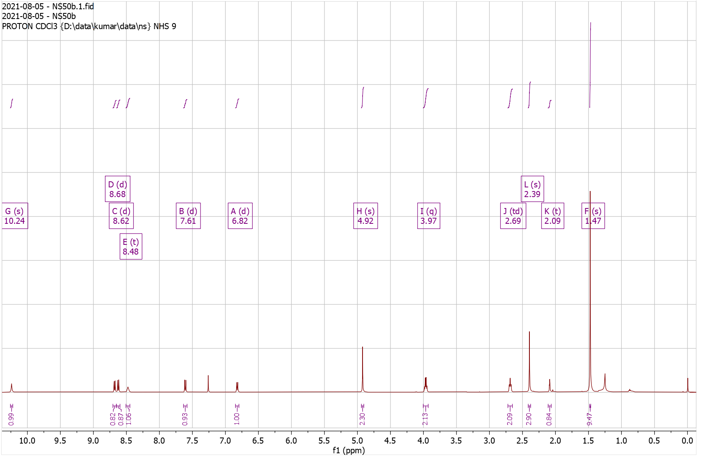

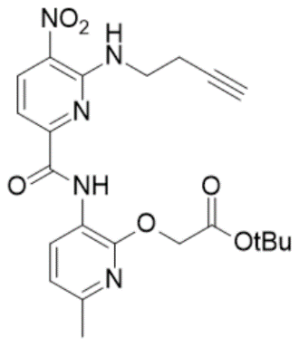
Supplementary Fig. 22. ¹H-NMR of NS50 Dep

¹H NMR (500 MHz, DMSO) δ 2.32 – 2.36 (s, 3H), 2.55 – 2.67 (td, J = 7.2, 2.7 Hz, 2H), 2.85 – 2.90 (d, J = 2.7 Hz, 1H), 3.75 – 3.87 (q, J = 6.8 Hz, 2H), 4.95 – 5.03 (s, 2H), 6.89 – 6.98 (d, J = 7.8 Hz, 1H), 7.40 – 7.50 (d, J = 8.1 Hz, 1H), 8.49 – 8.57 (d, J = 7.8 Hz, 1H), 8.59 – 8.68 (d, J = 8.1 Hz, 1H), 8.68 – 8.78 (t, J = 6.0 Hz, 1H), 10.16 – 10.23 (s, 1H); HRMS (m/z): [M]+ calcd. for C₁₈H₁₇N₅O₆, 400.1252; found, 400.1251.

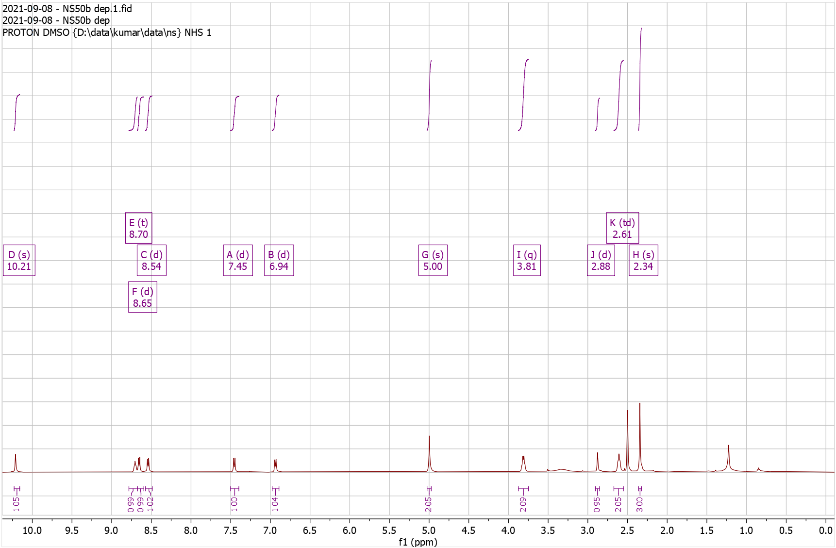

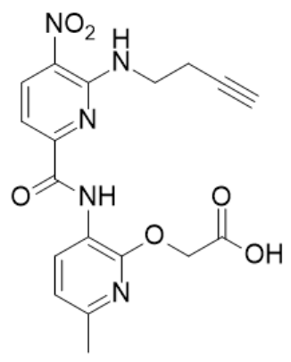
Supplementary Fig. 23. ¹H-NMR of NS52 Pro

¹H NMR (500 MHz, CDCl₃) δ 1.03 – 1.12 (t, J = 7.4 Hz, 3H), 1.44 – 1.49 (s, 9H), 1.73 – 1.87 (h, J = 7.3 Hz, 2H), 2.37 – 2.41 (s, 3H), 3.68 – 3.79 (td, J = 7.0, 5.6 Hz, 2H), 4.84 – 4.93 (s, 2H), 6.78 – 6.89 (d, J = 7.9 Hz, 1H), 7.50 – 7.59 (d, J = 8.4 Hz, 1H), 8.23 – 8.32 (t, 1H), 8.57 – 8.64 (d, J = 8.4 Hz, 1H), 8.65 – 8.72 (d, J = 7.9 Hz, 1H), 10.18 – 10.36 (s, 1H); HRMS (m/z): [M]+ calcd. for C₂₁H₂₇N₅O₆, 446.2034; found, 446.2037.

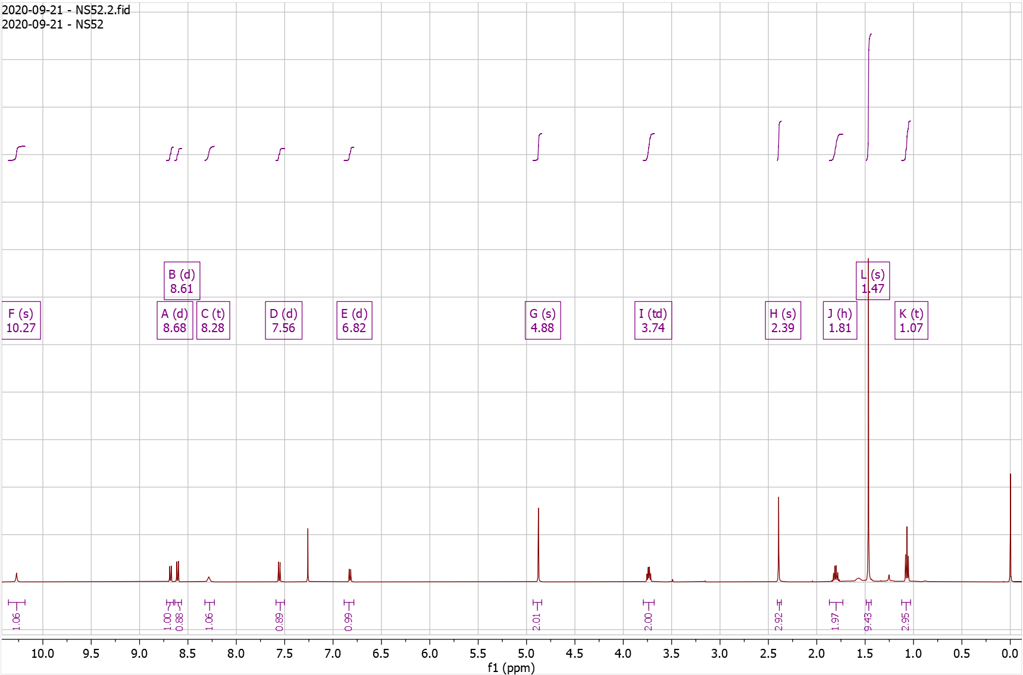

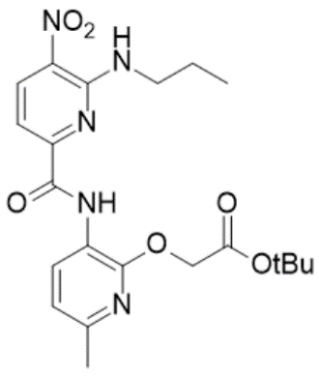
Supplementary Fig. 24. ¹H-NMR of NS52 Dep

¹H NMR (500 MHz, DMSO) δ 0.89 – 0.98 (t, J = 7.4 Hz, 3H), 1.63 – 1.77 (h, J = 7.4 Hz, 2H), 2.28 – 2.40 (s, 3H), 3.55 – 3.68 (q, J = 6.6 Hz, 2H), 4.89 – 5.05 (s, 2H), 6.90 – 7.04 (d, J = 7.9 Hz, 1H), 7.35 – 7.50 (d, J = 8.2 Hz, 1H), 8.52 – 8.59 (d, J = 7.9 Hz, 1H), 8.59 – 8.64 (t, 1H), 8.64 – 8.69 (d, J = 8.3 Hz, 1H), 10.12 – 10.29 (s, 1H), 12.74 – 13.08 (s, 1H); HRMS (m/z): [M]+ calcd. for C₁₇H₁₉N₅O₆, 390.1408; found, 390.1403.

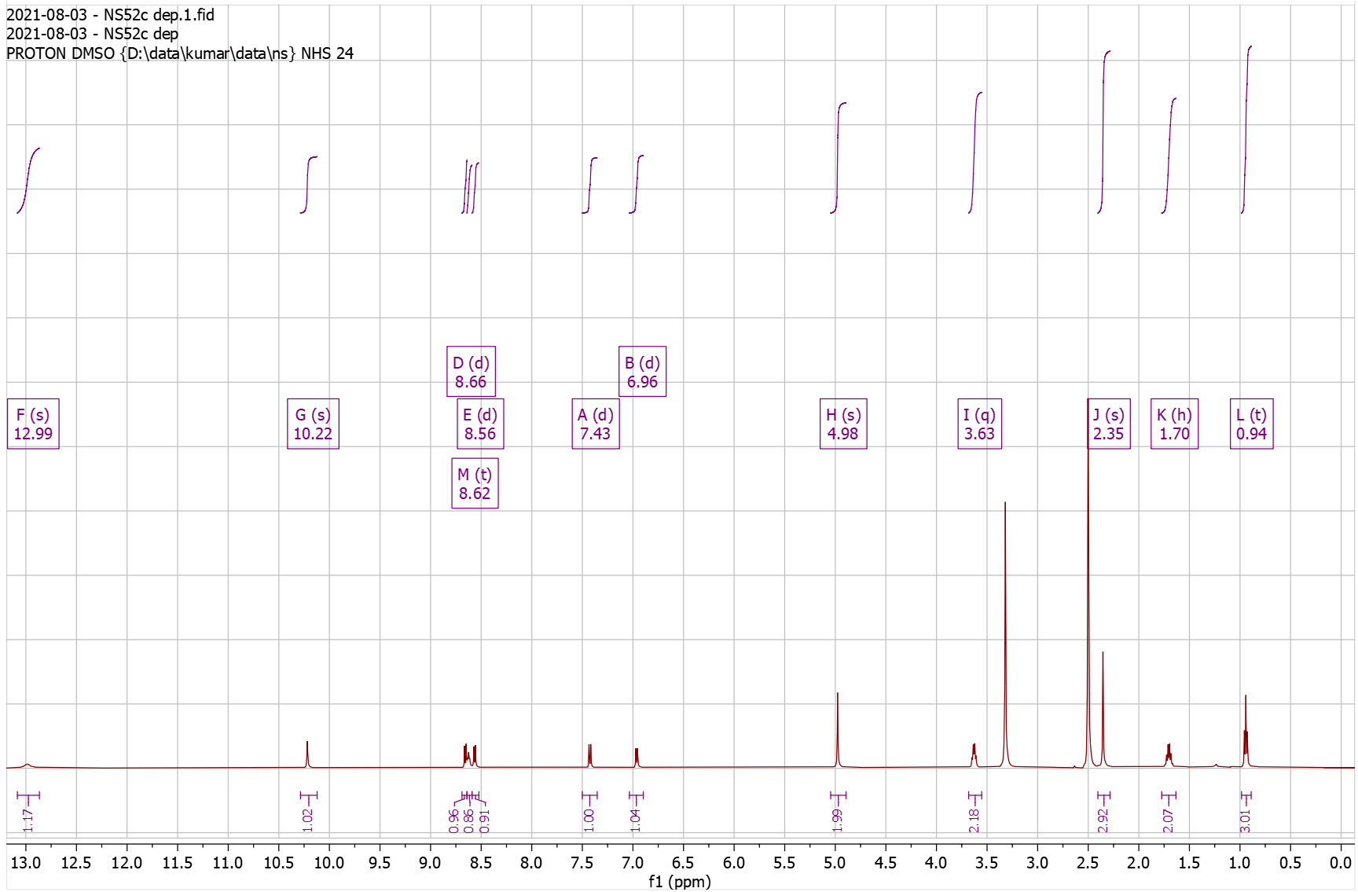

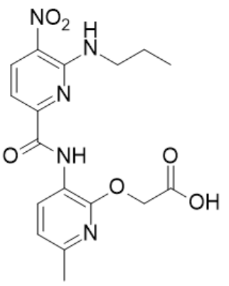
Supplementary Fig. 25. ¹H-NMR of NS53 Pro

¹H NMR (500 MHz, CDCl₃) δ 1.46 – 1.50 (s, 9H), 2.38 – 2.42 (s, 3H), 4.81 – 4.85 (s, 2H), 4.93 – 4.98 (d, J = 5.5 Hz, 2H), 6.30 – 6.34 (d, J = 2.2 Hz, 1H), 6.80 – 6.85 (d, J = 7.9 Hz, 1H), 7.47 – 7.51 (d, J = 2.2 Hz, 1H), 7.56 – 7.61 (d, J = 8.4 Hz, 1H), 8.47 – 8.52 (d, J = 7.9 Hz, 1H), 8.57 – 8.62 (d, J = 8.5 Hz, 1H), 8.62 – 8.67 (t, J = 5.4 Hz, 1H), 10.31 – 10.35 (s, 1H); HRMS (m/z): [M]+ calcd. for C₂₂H₂₅N₇O₆, 484.1939; found, 484.1934.

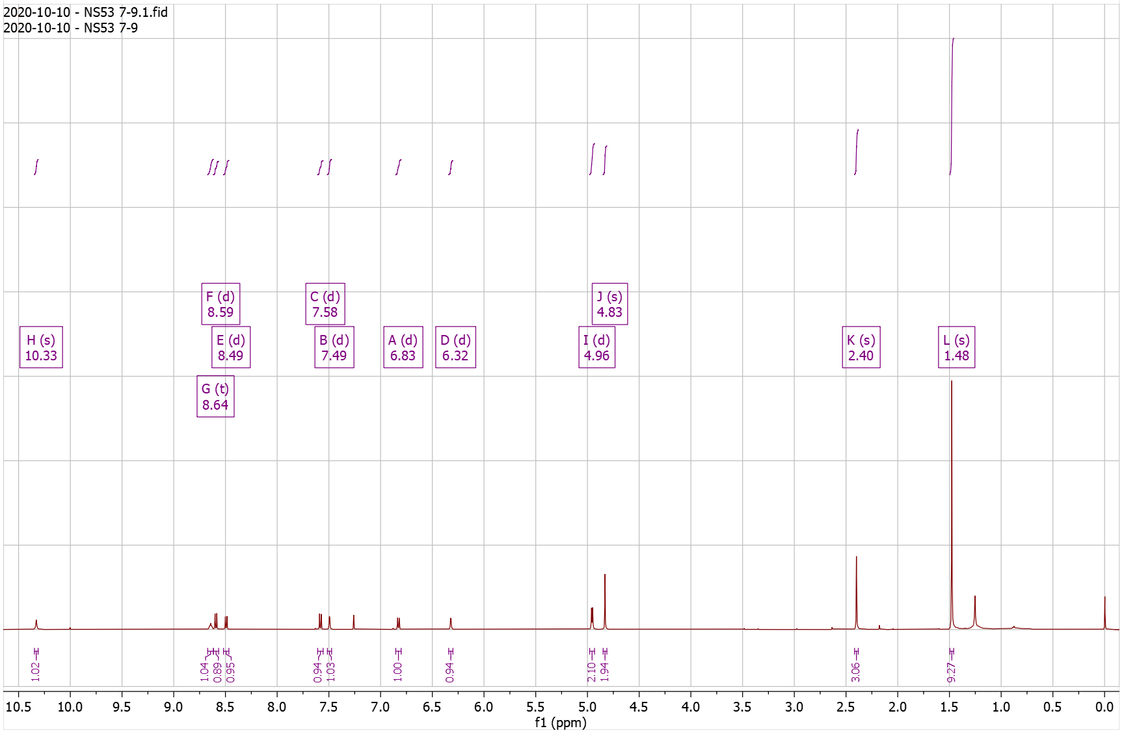

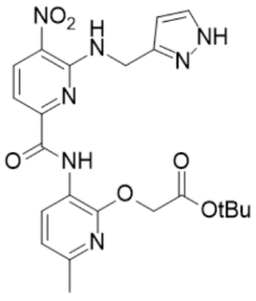
Supplementary Fig. 26. ¹H-NMR of NS53 Dep

¹H NMR (500 MHz, DMSO) δ 2.34 – 2.37 (s, 3H), 4.87 – 4.90 (s, 3H), 6.22 – 6.31 (s, 1H), 6.89 – 7.00 (d, J = 7.9 Hz, 1H), 7.42 – 7.51 (d, J = 8.4 Hz, 1H), 7.54 – 7.63 (s, 1H), 8.41 – 8.54 (d, J = 7.9 Hz, 1H), 8.64 – 8.73 (d, J = 8.4 Hz, 1H), 8.88 – 9.06 (t, J = 5.8 Hz, 1H), 10.15 – 10.39 (s, 1H); HRMS (m/z): [M]+ calcd. for C₁₈H₁₇N₇O₆, 428.1313; found, 428.1313.

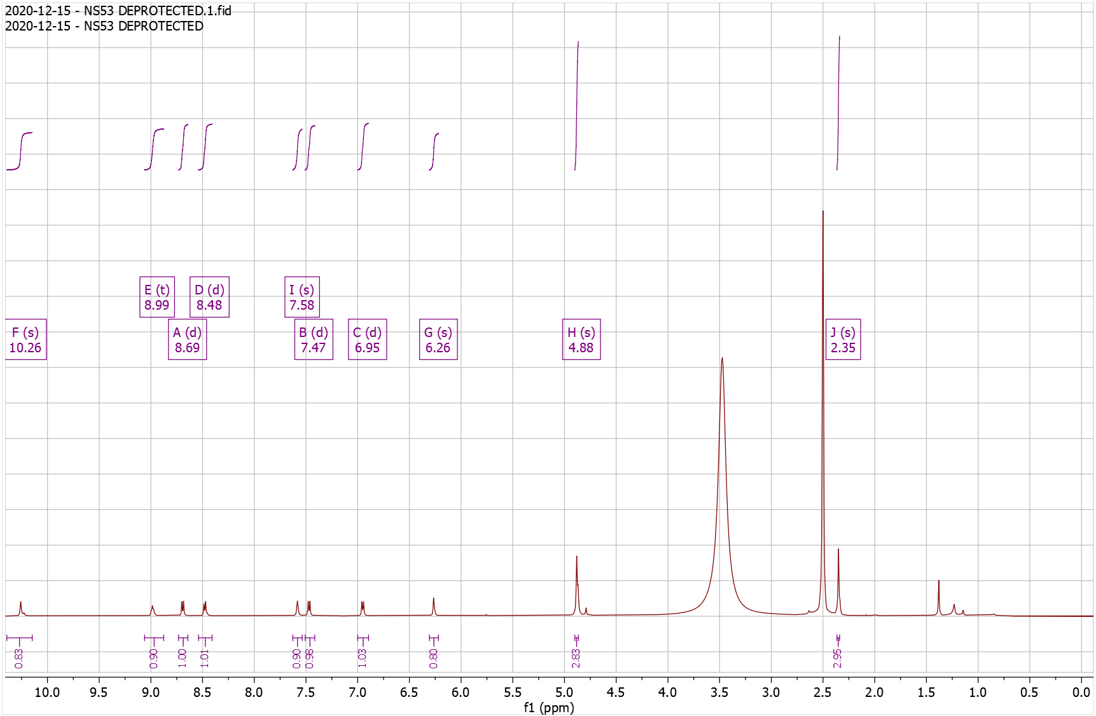
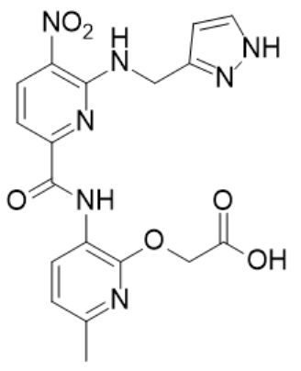
Supplementary Fig. 27. ¹H-NMR of NS54 Pro

¹H NMR (500 MHz, CDCl₃) δ 0.35 – 0.40 (m, 2H), 0.60 – 0.66 (m, 2H), 1.26 – 1.32 (tdd, J = 8.0, 5.2, 1.9 Hz, 1H), 1.45 – 1.49 (s, 9H), 2.37 – 2.42 (s, 3H), 3.58 – 3.65 (dd, J = 7.2, 5.2 Hz, 2H), 4.87 – 4.91 (s, 2H), 6.80 – 6.85 (d, J = 7.9 Hz, 1H), 7.54 – 7.60 (d, J = 8.4 Hz, 1H), 8.29 – 8.38 (t, 1H), 8.58 – 8.64 (d, J = 8.4 Hz, 1H), 8.64 – 8.70 (d, J = 7.9 Hz, 1H), 10.25 – 10.34 (s, 1H); HRMS (m/z): [M]+ calcd. for C₂₂H₂₇N₅O₆, 458.2034; found, 458.2034.

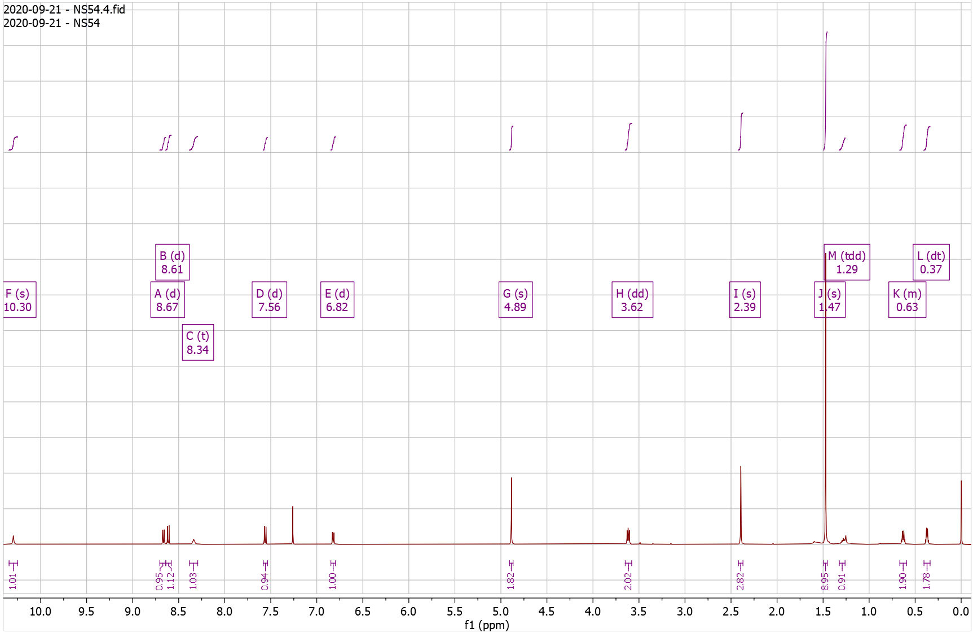
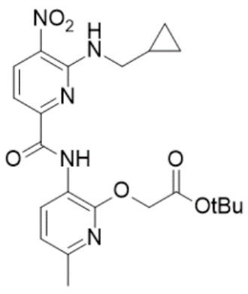
Supplementary Fig. 28. ¹H-NMR of NS54 Dep

¹H NMR (500 MHz, DMSO) δ 0.32 – 0.38 (q, J = 4.8 Hz, 2H), 0.42 – 0.50 (d, J = 7.6 Hz, 2H), 1.26 – 1.34 (m, 1H), 2.33 – 2.38 (s, 3H), 3.48 – 3.56 (t, J = 6.1 Hz, 2H), 4.96 – 5.01 (s, 2H), 6.91 – 7.01 (d, J = 7.9 Hz, 1H), 7.38 – 7.49 (d, J = 8.3 Hz, 1H), 8.50 – 8.59 (d, J = 7.8 Hz, 1H), 8.63 – 8.69 (d, J = 8.4 Hz, 1H), 8.69 – 8.77 (t, J = 6.0 Hz, 1H), 10.29 – 10.34 (s, 1H); HRMS (m/z): [M]+ calcd. for C₁₈H₁₉N₅O₆, 402.1408; found, 402.1402.

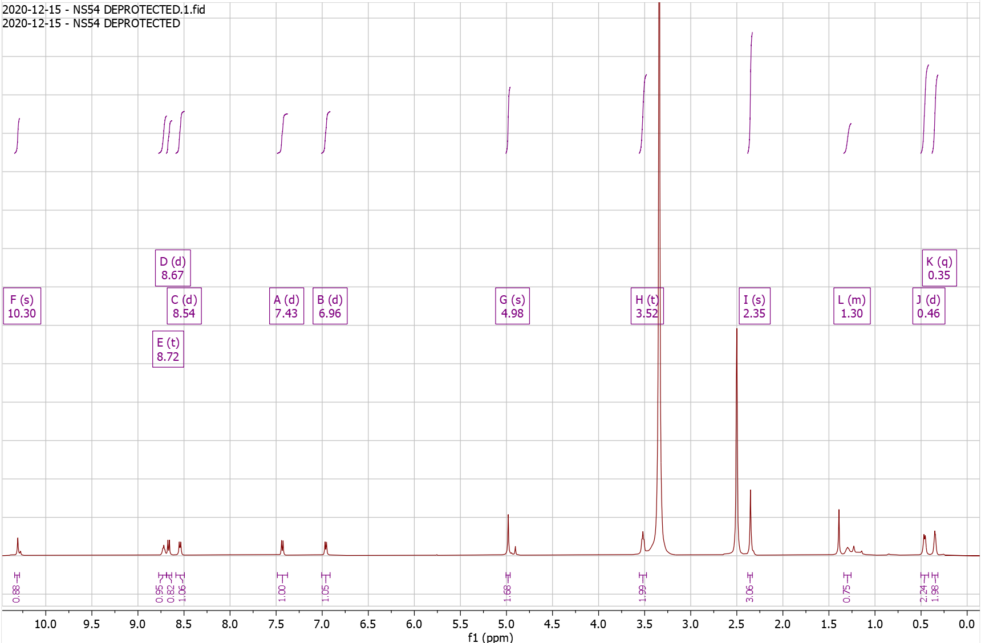
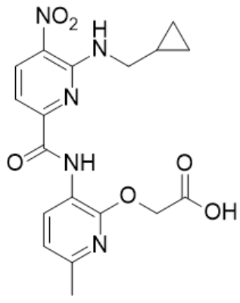
Supplementary Fig. 29. ¹H-NMR of NS55 Pro

¹H NMR (500 MHz, CDCl₃) δ 1.01 – 1.34 (m, 5H), 1.46 – 1.46 (s, 9H), 1.66 – 1.91 (m, 6H), 2.37 – 2.41 (s, 3H), 3.59 – 3.65 (t, J = 6.3 Hz, 2H), 4.84 – 4.89 (s, 2H), 6.79 – 6.85 (d, J = 7.9 Hz, 1H), 7.50 – 7.57 (d, J = 8.4 Hz, 1H), 8.31 – 8.37 (t, J = 5.8 Hz, 1H), 8.57 – 8.62 (d, J = 8.4 Hz, 1H), 8.66 – 8.71 (d, J = 8.0 Hz, 1H), 10.21 – 10.24 (s, 1H); HRMS (m/z): [M]+ calcd. for C₂₅H₃₃N₅O₆, 500.2504; found, 500.2500.

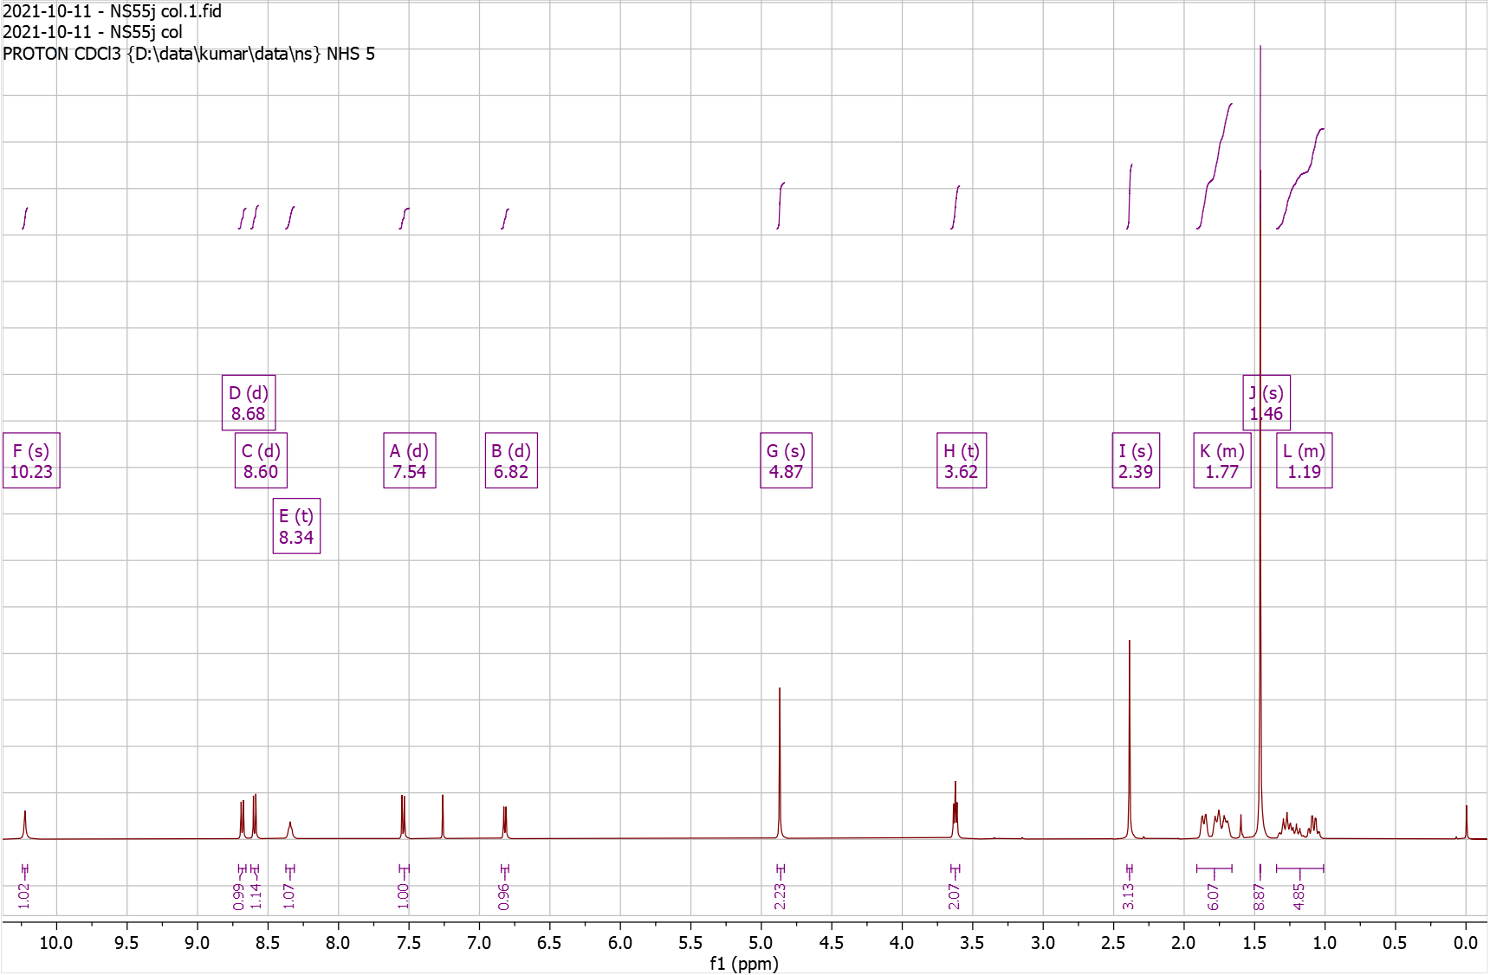
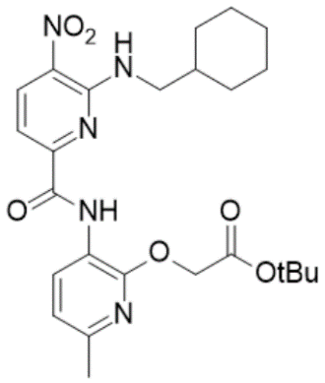
Supplementary Fig. 30. ¹H-NMR of NS55 Dep

¹H NMR (500 MHz, DMSO) δ 10.19 – 10.10 (s, 1H), 8.67 – 8.62 (d, J = 8.4 Hz, 1H), 8.60 – 8.50 (m, 2H), 7.48 – 7.39 (d, J = 8.4 Hz, 1H), 6.99 – 6.93 (d, J = 8.0 Hz, 1H), 4.99 – 4.95 (s, 2H), 3.59 – 3.53 (t, J = 6.4 Hz, 2H), 2.37 – 2.33 (s, 3H), 1.81 – 1.63 (m, 6H), 1.24 – 0.94 (m, 5H); HRMS (m/z): [M]+ calcd. for C₂₁H₂₅N₅O₆ , 444.1878; found, 444.1878.

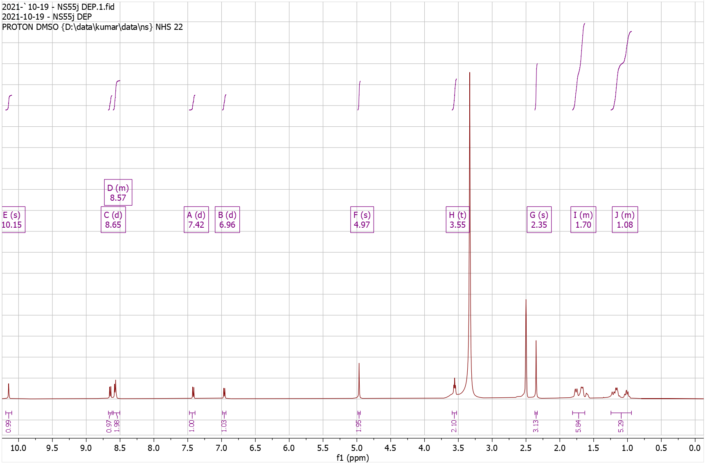
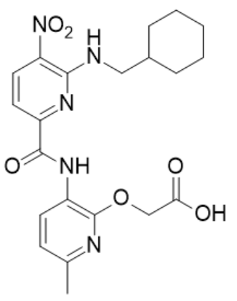
Supplementary Fig. 31. ¹³C-NMR of NS55 Dep

¹³C NMR (126 MHz, DMSO) δ 23.27, 25.47, 25.94, 30.45, 37.46, 46.79, 62.14, 109.03, 116.85, 118.94, 127.13, 129.82, 138.05, 149.60, 150.92, 151.09, 152.25, 160.39, 169.73.
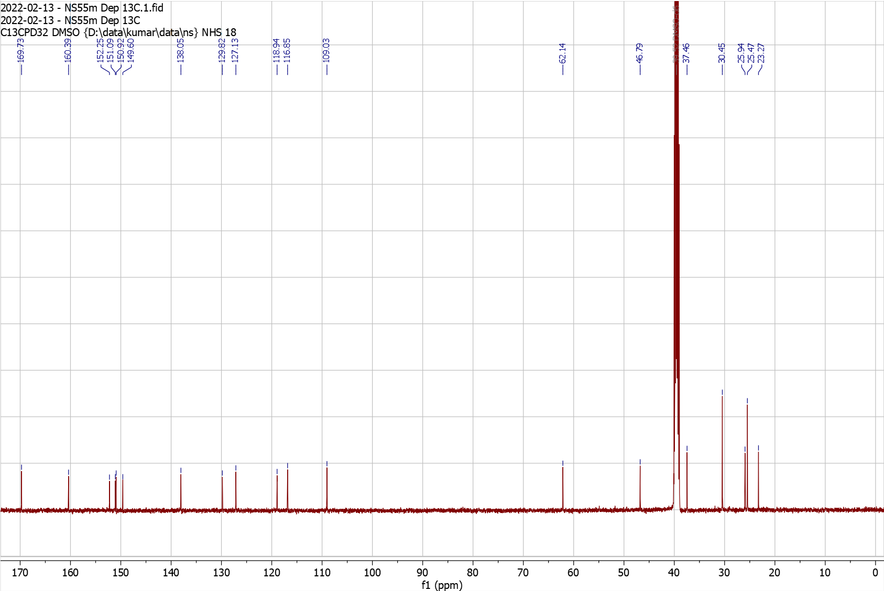
Supplementary Fig. 32. ¹H-NMR of NS56 Pro

¹H NMR (500 MHz, CDCl₃) δ 1.46 – 1.46 (s, 9H), 2.34 – 2.44 (s, 3H), 3.02 – 3.12 (t, J = 7.1 Hz, 2H), 3.97 – 4.12 (td, J = 7.1, 5.4 Hz, 2H), 4.62 – 4.69 (s, 2H), 6.77 – 6.86 (d, J = 7.9 Hz, 1H), 7.20 – 7.36 (m, 5H), 7.53 – 7.59 (d, J = 8.5 Hz, 1H), 8.21 – 8.30 (t, J = 5.3 Hz, 1H), 8.54 – 8.63 (d, J = 8.3 Hz, 1H), 8.64 – 8.73 (d, J = 7.9 Hz, 1H), 10.20 – 10.32 (s, 1H); HRMS (m/z): [M]+ calcd. for C₂₆H₂₉N₅O₆, 508.2191 ; found, 508.2190.

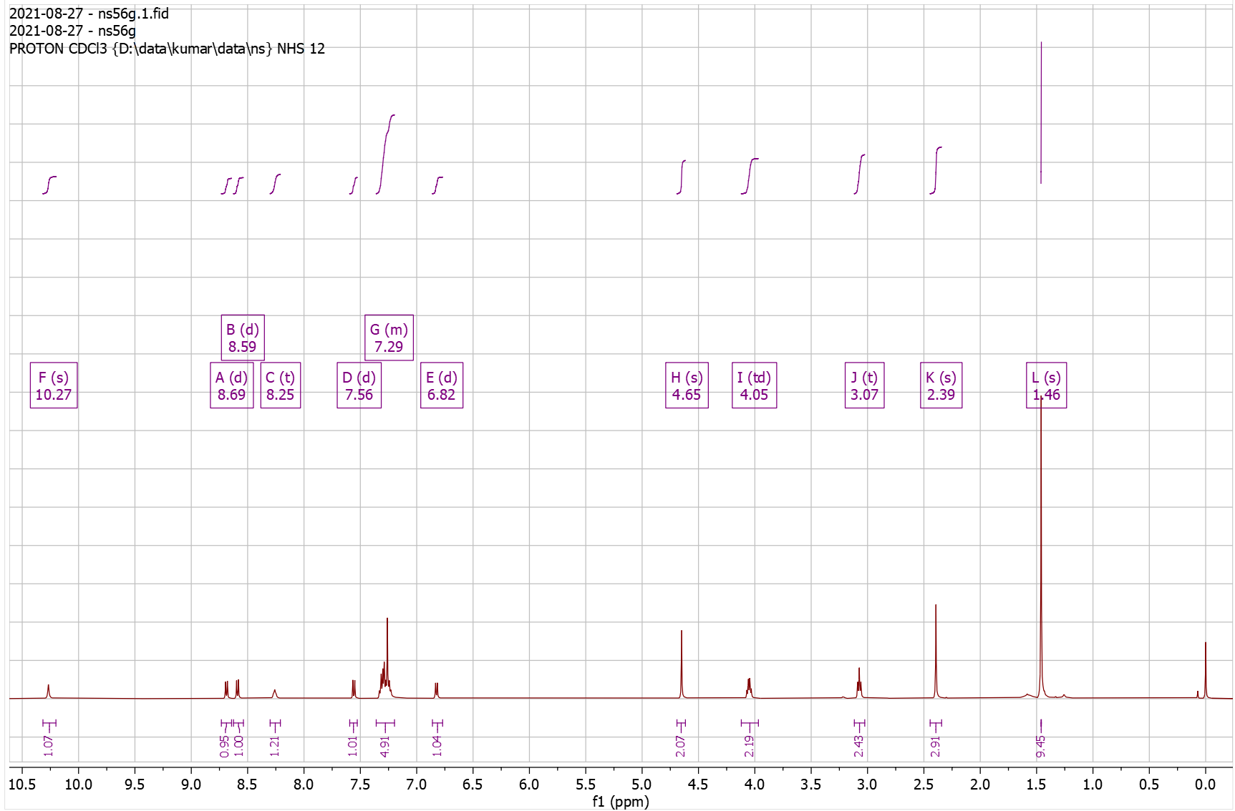
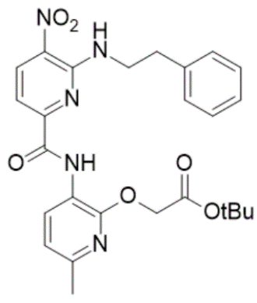
Supplementary Fig. 33. ¹H-NMR of NS56 Dep

¹H NMR (500 MHz, DMSO) δ 2.31 – 2.38 (s, 3H), 2.95 – 3.07 (t, J = 7.1 Hz, 2H), 3.88 – 4.00 (q, J = 6.7 Hz, 2H), 4.69 – 4.77 (s, 2H), 6.90 – 6.99 (d, J = 8.0 Hz, 1H), 7.12 – 7.29 (m, 5H), 7.36 – 7.44 (d, J = 8.4 Hz, 1H), 8.48 – 8.57 (d, J = 7.9 Hz, 1H), 8.57 – 8.61 (t, J = 5.8 Hz, 1H), 8.61 – 8.67 (d, J = 8.4 Hz, 1H), 10.10 – 10.17 (s, 1H); HRMS (m/z): [M]+ calcd. for C₂₂H₂₁N₅O₆, 452.1565; found, 452.1565.

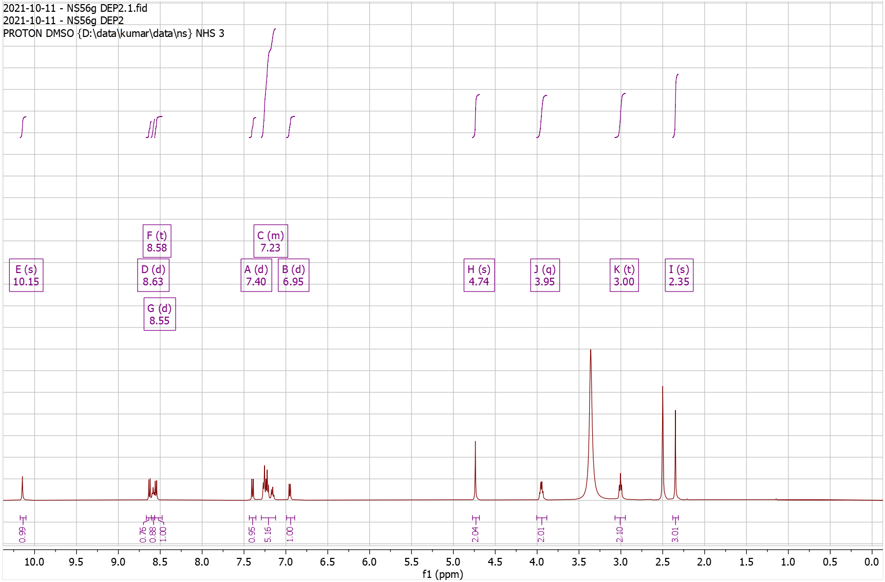

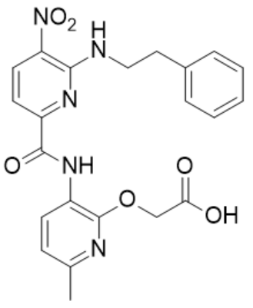
Supplementary Fig. 34. ¹H-NMR of NS57 Pro

¹H NMR (500 MHz, CDCl₃) δ 1.44 – 1.47 (s, 9H), 1.47 – 1.51 (t, J = 7.4 Hz, 3H), 2.26 – 2.50 (s, 3H), 3.27 – 3.47 (q, J = 7.4 Hz, 2H), 4.80 – 4.97 (s, 2H), 6.75 – 6.94 (d, J = 7.9 Hz, 1H), 8.05 – 8.13 (d, 1H), 8.56 – 8.79 (dd, J = 8.2, 5.9 Hz, 2H), 10.21 – 10.35 (s, 1H); HRMS (m/z): [M]+ calcd. for C₂₀H₂₄N₄O₆S, 449.1489; found, 449.1488.

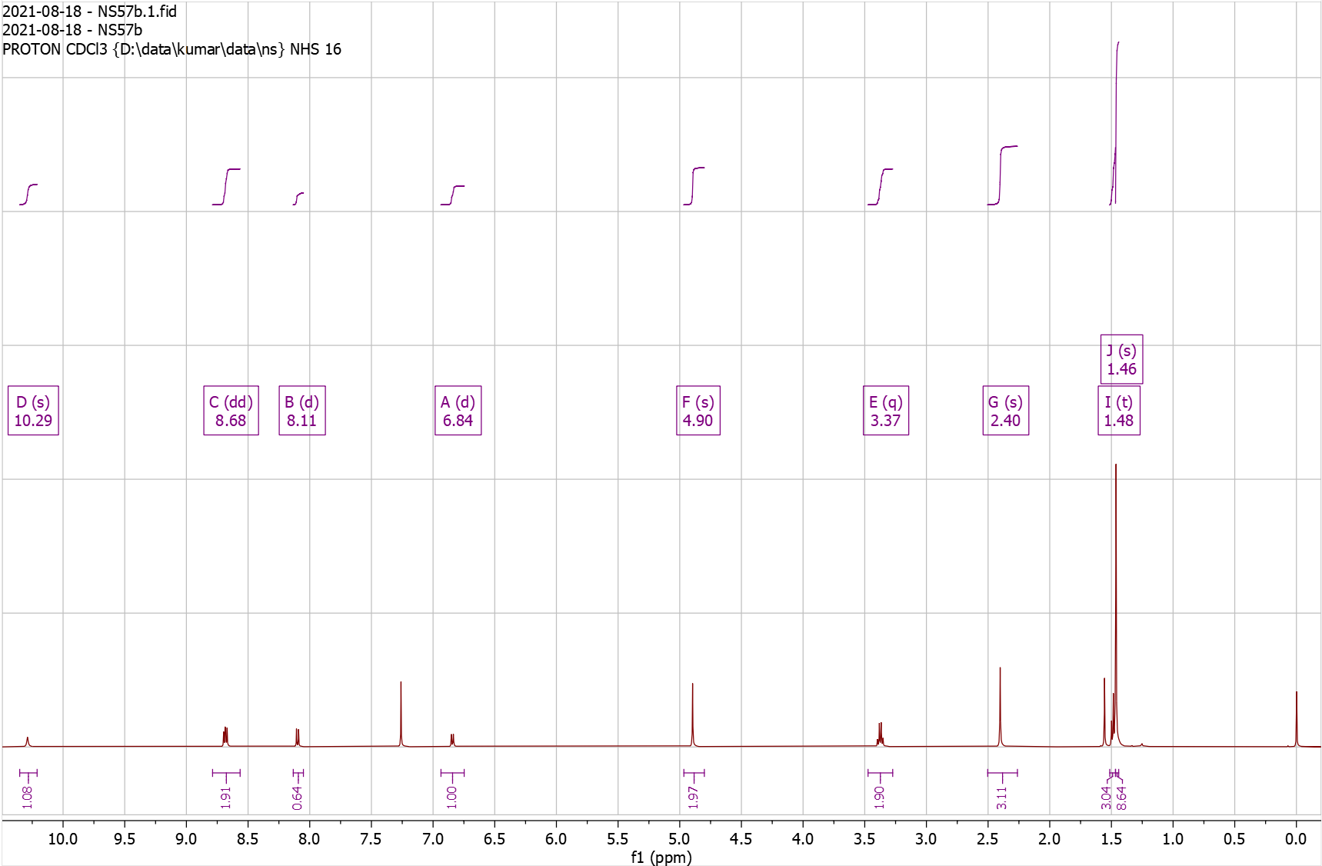
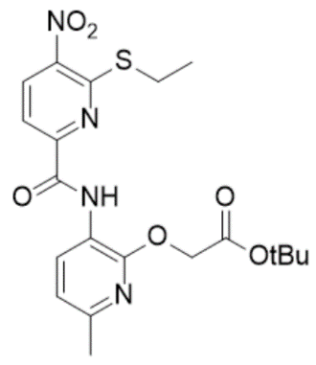
Supplementary Fig. 35. ¹H-NMR of NS57 Dep

¹H NMR (500 MHz, DMSO) δ 1.32 – 1.36 (t, J = 7.3 Hz, 3H), 2.31 – 2.37 (s, 3H), 3.09 – 3.20 (q, J = 7.3 Hz, 2H), 4.92 – 4.97 (s, 2H), 6.88 – 6.99 (d, J = 7.9 Hz, 1H), 7.99 – 8.06 (d, J = 8.4 Hz, 1H), 8.06 – 8.14 (d, J = 8.1 Hz, 1H), 8.46 – 8.54 (d, J = 7.9 Hz, 1H), 9.81 – 9.88 (s, 1H); HRMS (m/z): [M]+ calcd. for C₁₆H₁₆N₄O₆S, 393.0863; found, 393.0862.

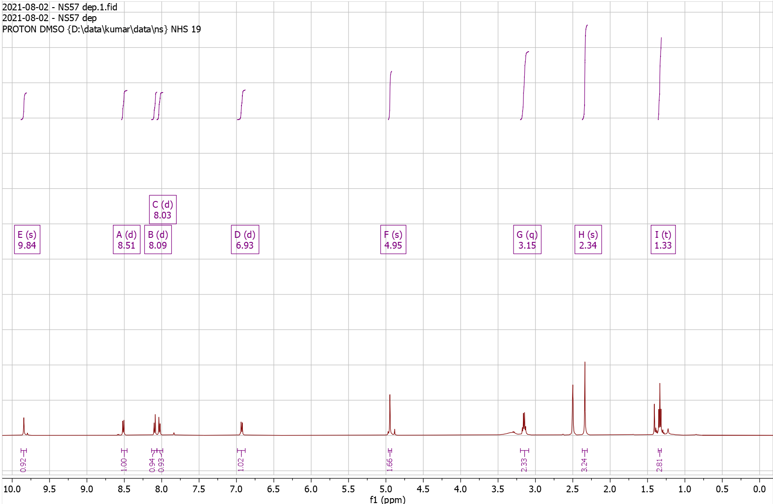

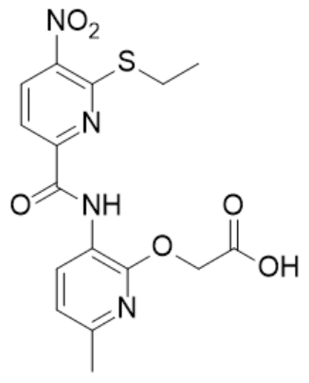
Supplementary Fig. 36. ¹H-NMR of NS59 Pro

¹H NMR (500 MHz, CDCl₃) δ 1.10 – 1.15 (d, J = 6.6 Hz, 6H), 1.44 – 1.47 (s, 9H), 1.99 – 2.11 (hept, J = 6.7 Hz, 1H), 2.38 – 2.42 (s, 3H), 3.25 – 3.30 (d, J = 6.7 Hz, 2H), 4.86 – 4.90 (s, 2H), 6.78 – 6.89 (d, J = 8.0 Hz, 1H), 8.03 – 8.13 (d, J = 8.4 Hz, 1H), 8.62 – 8.67 (d, J = 8.3 Hz, 1H), 8.67 – 8.72 (d, J = 7.9 Hz, 1H), 10.12 – 10.15 (s, 1H); HRMS (m/z): [M]+ calcd. for C₂₂H₂₈N₄O₆S, 477.1802; found, 477.1803.

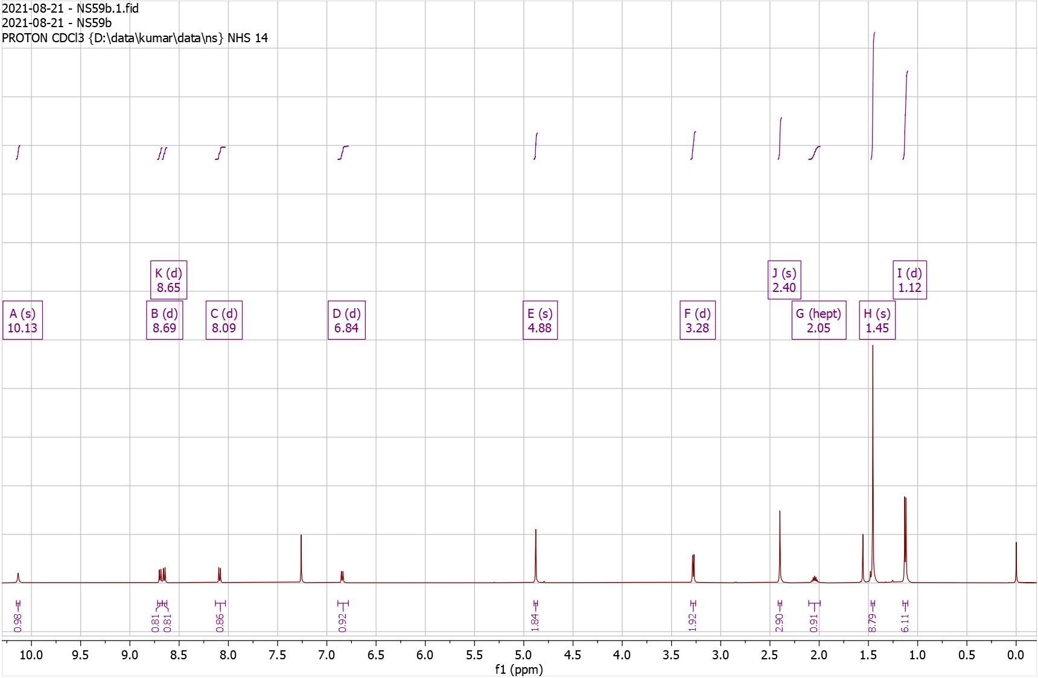

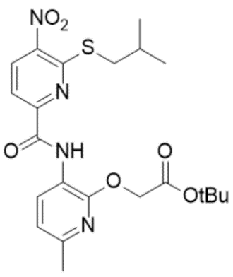
Supplementary Fig. 37. ¹H-NMR of NS59 Dep

¹H NMR (500 MHz, DMSO) δ 1.03 – 1.09 (d, J = 6.6 Hz, 6H), 1.89 – 1.99 (hept, J = 6.7 Hz, 1H), 2.31 – 2.36 (s, 3H), 3.01 – 3.05 (d, J = 6.7 Hz, 2H), 4.88 – 4.93 (s, 2H), 6.88 – 6.93 (d, J = 8.0 Hz, 1H), 8.01 – 8.06 (d, J = 8.2 Hz, 1H), 8.06 – 8.12 (d, J = 8.1 Hz, 1H), 8.47 – 8.55 (d, J = 7.9 Hz, 1H), 9.84 – 9.93 (s, 1H); HRMS (m/z): [M]+ calcd. for C₁₈H₂₀N₄O₆S, 421.1176; found, 421.1171.

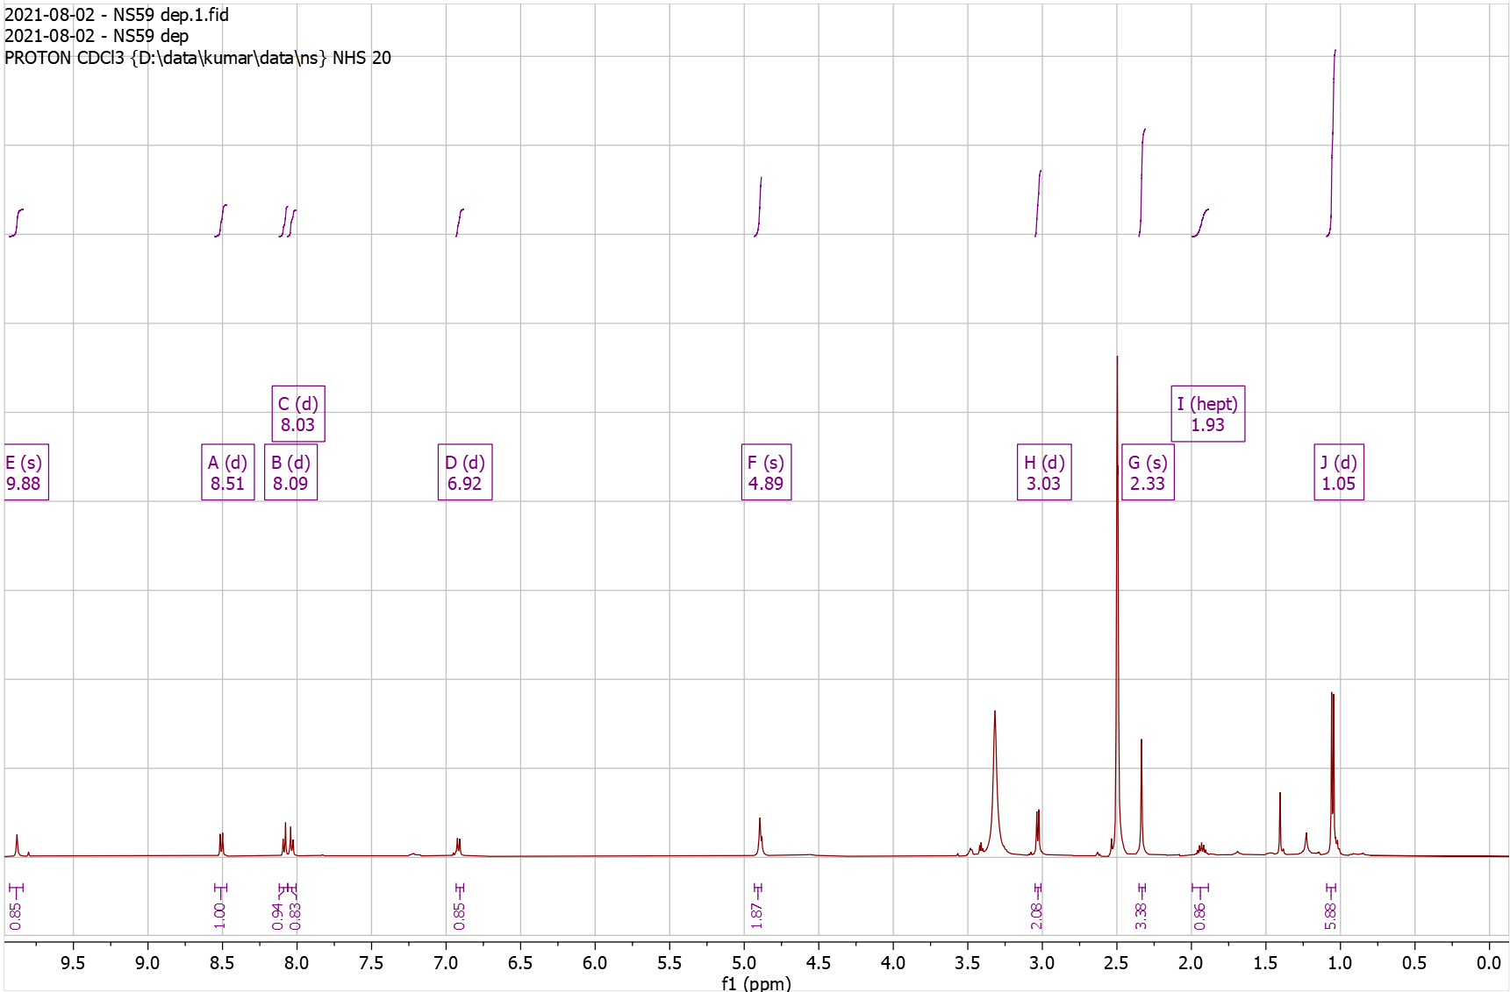

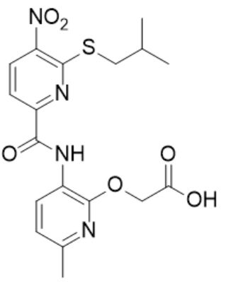
Supplementary Fig. 38. ¹H-NMR of NS60 Pro

¹H NMR (500 MHz, CDCl₃) δ 0.95 – 1.03 (t, J = 7.4 Hz, 3H), 1.46 – 1.49 (s, 9H), 1.49 – 1.61 (h, J = 7.3 Hz, 2H), 1.70 – 1.80 (ddd, J = 15.1, 8.6, 6.3 Hz, 2H), 2.35 – 2.39 (s, 3H), 2.95 – 3.01 (t, J = 7.4 Hz, 2H), 4.86 – 4.89 (s, 2H), 6.76 – 6.85 (d, J = 7.9 Hz, 1H), 7.58 – 7.66 (d, J = 8.1 Hz, 1H), 8.07 – 8.14 (d, J = 8.1 Hz, 1H), 8.61 – 8.67 (d, J = 7.8 Hz, 1H), 9.96 – 10.05 (s, 1H); HRMS (m/z): [M]+ calcd. for C₂₂H₂₈N₄O₆S, 477.1802; found, 477.1805.

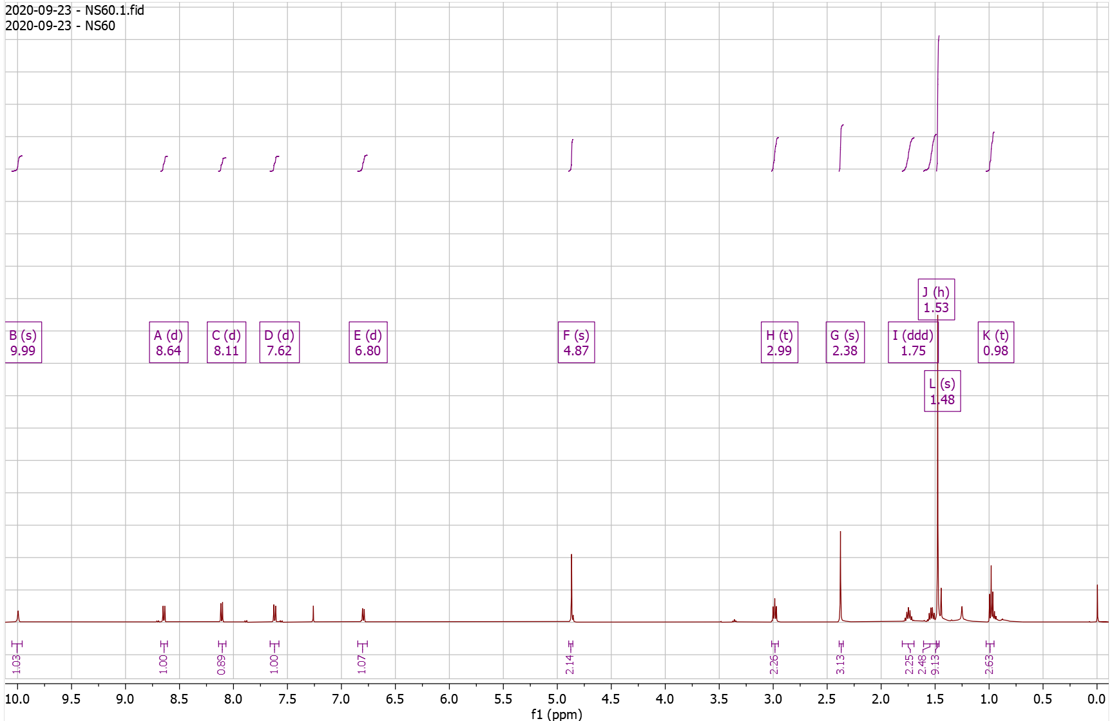
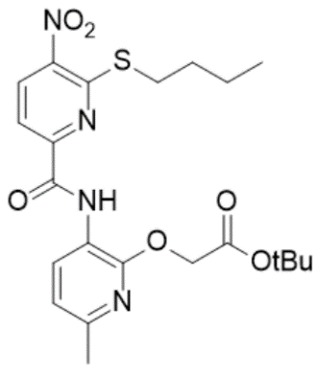
Supplementary Fig. 39. ¹H-NMR of NS60 Dep

¹H NMR (500 MHz, DMSO) δ 0.86 – 0.96 (t, J = 7.4 Hz, 3H), 1.41 – 1.50 (q, J = 7.4 Hz, 2H), 1.54 – 1.72 (p, J = 7.4 Hz, 2H), 2.26 – 2.39 (s, 3H), 3.03 – 3.16 (t, J = 7.3 Hz, 2H), 4.91 – 5.03 (s, 2H), 6.85 – 6.96 (d, J = 7.9 Hz, 1H), 7.95 – 8.03 (d, J = 8.3 Hz, 1H), 8.03 – 8.11 (d, J = 8.1 Hz, 1H), 8.44 – 8.55 (d, J = 7.9 Hz, 1H), 9.78 – 9.83 (s, 1H); HRMS (m/z): [M]+ calcd. for C₁₈H₂₀N₄O₆S, 421.1176; found, 421.1176.

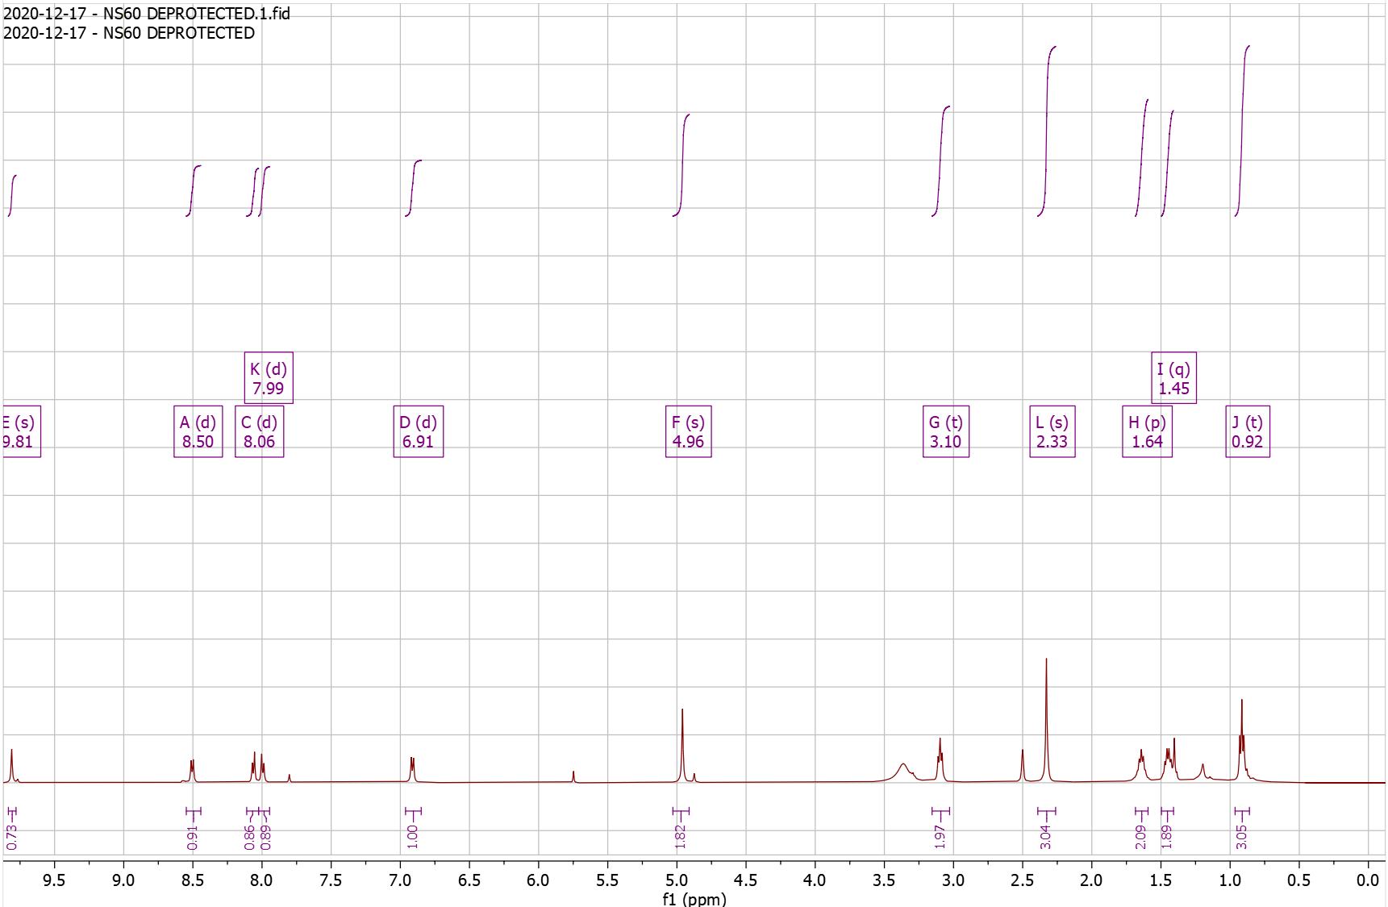

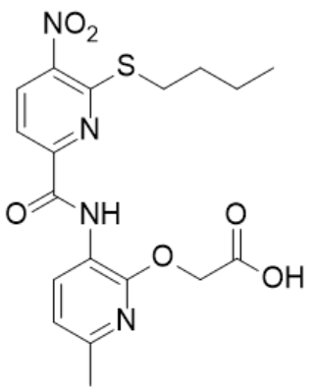
Supplementary Fig. 40. ¹H-NMR of NS61 Pro

¹H NMR (500 MHz, CDCl₃) δ 1.46 – 1.50 (s, 9H), 2.36 – 2.40 (s, 3H), 4.22 – 4.26 (s, 2H), 4.85 – 4.89 (s, 2H), 6.25 – 6.29 (d, J = 3.3 Hz, 1H), 6.29 – 6.35 (dd, J = 3.3, 1.9 Hz, 1H), 6.77 – 6.82 (d, J = 7.9 Hz, 1H), 7.35 – 7.41 (d, J = 1.9 Hz, 1H), 7.73 – 7.78 (d, J = 8.1 Hz, 1H), 8.07 – 8.12 (d, J = 8.0 Hz, 1H), 8.61 – 8.66 (d, J = 8.0 Hz, 1H), 9.98 – 10.01 (s, 1H); HRMS (m/z): [M]+ calcd. for C₂₃H₂₄N₄O₇S, 501.1439; found, 501.1434.

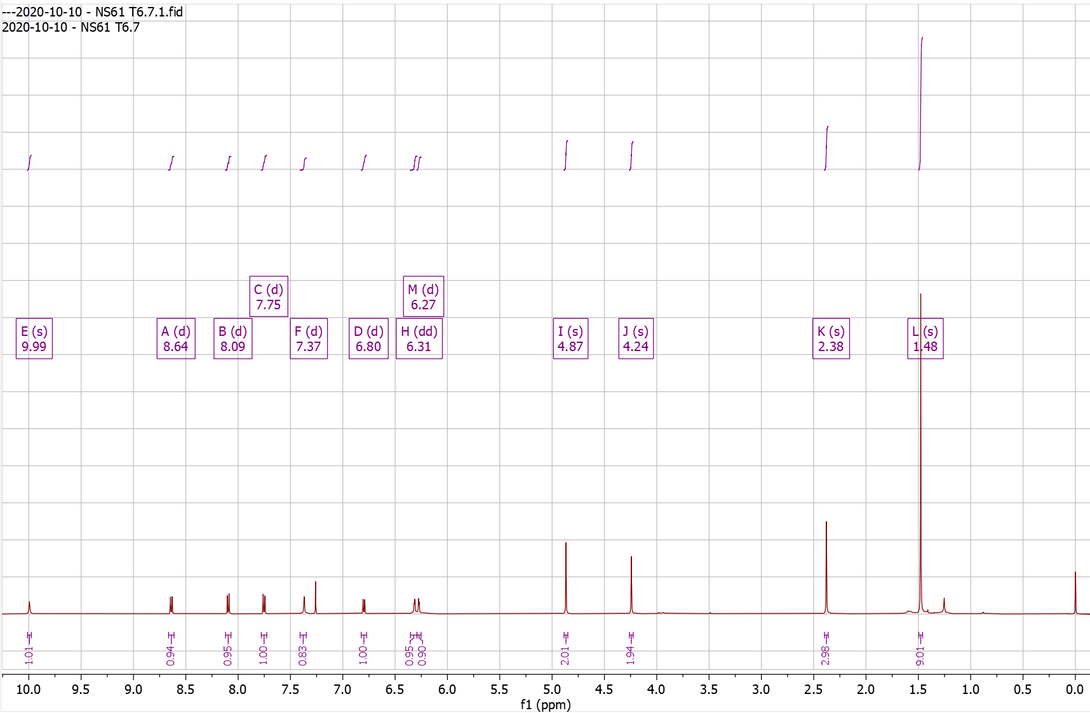
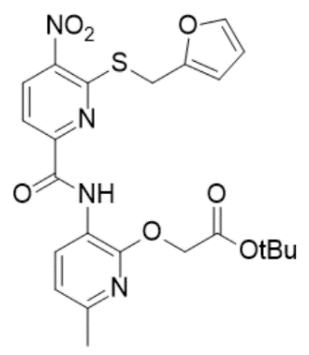
Supplementary Fig. 41. ¹H-NMR of NS61 Dep

¹H NMR (500 MHz, DMSO) δ 2.31 – 2.37 (s, 3H), 4.54 – 4.58 (s, 2H), 4.93 – 4.98 (s, 2H), 6.38 – 6.44 (dd, J = 3.2, 1.9 Hz, 1H), 6.44 – 6.50 (d, J = 3.3 Hz, 1H), 6.88 – 7.00 (d, J = 8.0 Hz, 1H), 7.58 – 7.65 (d, J = 1.9 Hz, 1H), 8.08 – 8.15 (d, J = 8.1 Hz, 1H), 8.17 – 8.27 (d, J = 8.2 Hz, 1H), 8.46 – 8.54 (d, J = 7.9 Hz, 1H), 9.80 – 9.89 (s, 1H), 12.77 – 12.97 (s, 1H); HRMS (m/z): [M]+ calcd. for C₁₉H₁₆N₄O₇S, 445.0813; found, 445.0821.

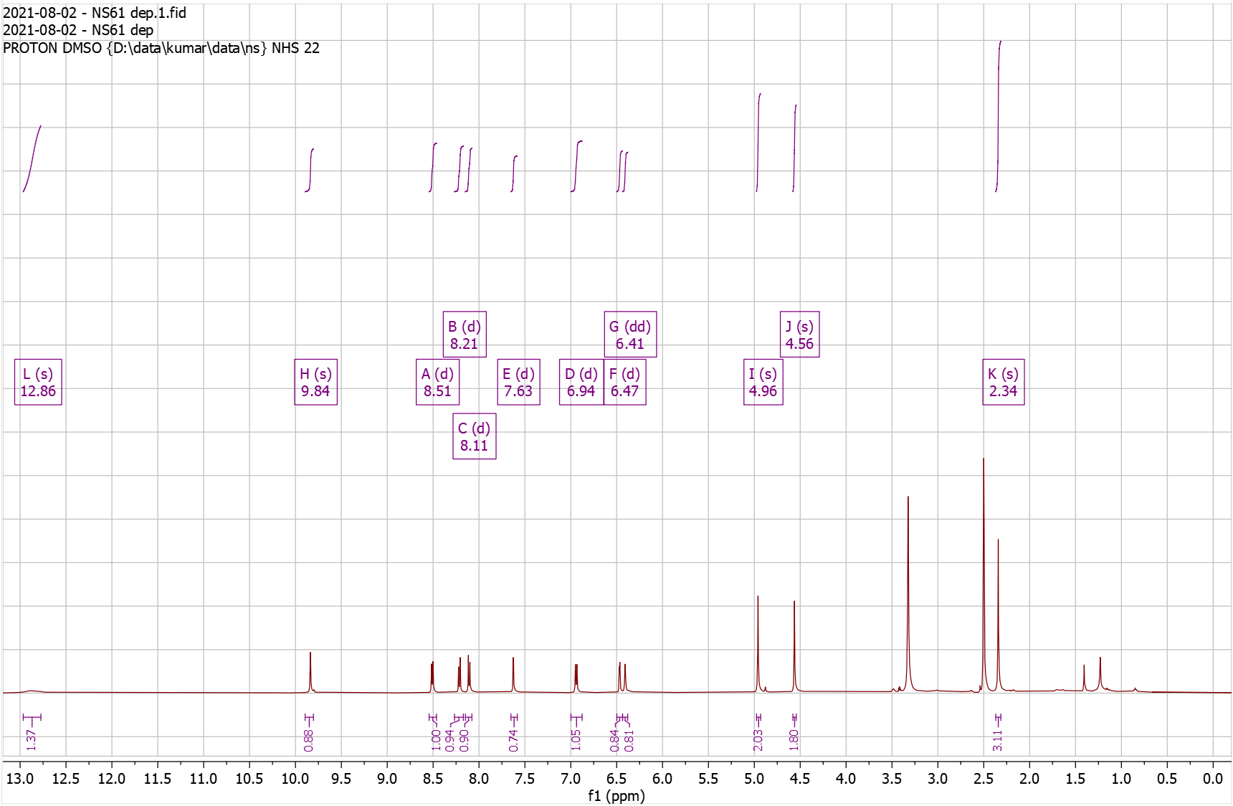
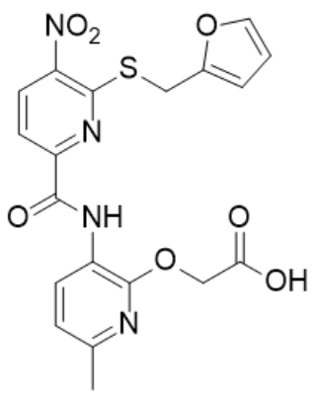
Supplementary Fig. 42. ¹H-NMR of NS62 Pro

¹H NMR (500 MHz, CDCl₃) δ 1.46 – 1.49 (s, 18H), 2.36 – 2.41 (s, 3H), 2.67 – 2.74 (t, J = 6.1 Hz, 2H), 4.00 – 4.07 (q, J = 6.0 Hz, 2H), 4.86 – 4.93 (s, 2H), 6.79 – 6.85 (d, J = 7.9 Hz, 1H), 7.55 – 7.61 (d, J = 8.4 Hz, 1H), 8.50 – 8.56 (t, J = 5.9 Hz, 1H), 8.57 – 8.64 (d, J = 8.4 Hz, 1H), 8.64 – 8.71 (d, J = 7.9 Hz, 1H), 10.21 – 10.32 (s, 1H); HRMS (m/z): [M]+ calcd. for C₂₅H₃₃N₅O₈, 532.2402; found, 532.2402.

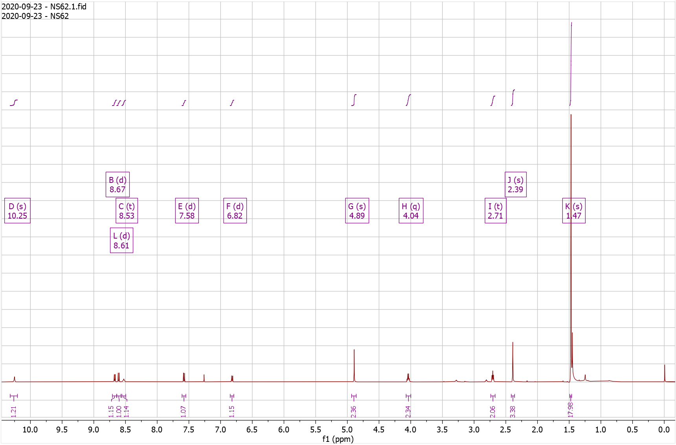
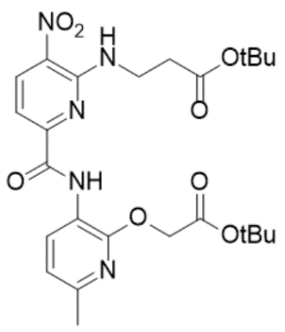
Supplementary Fig. 43. ¹H-NMR of NS62 Dep

¹H NMR (500 MHz, DMSO) δ 2.31 – 2.38 (s, 3H), 2.64 – 2.74 (t, J = 6.8 Hz, 2H), 3.83 – 3.94 (q, J = 6.5 Hz, 2H), 4.86 – 5.00 (s, 2H), 6.91 – 6.96 (d, J = 7.9 Hz, 1H), 7.41 – 7.48 (d, J = 8.7 Hz, 1H), 8.50 – 8.55 (d, J = 7.9 Hz, 1H), 8.59 – 8.72 (dd, 2H), 10.14 – 10.36 (s, 1H); HRMS (m/z): [M]+ calcd. for C₁₇H₁₇N₅O₈, 420.1150; found, 420.1143.

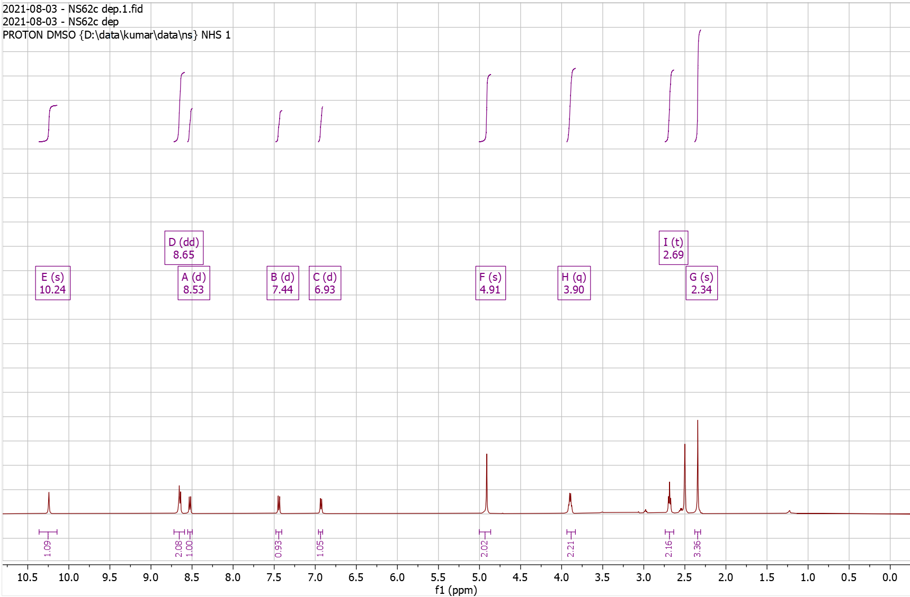
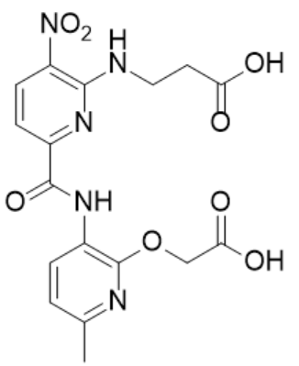
Supplementary Fig. 44. ¹H-NMR of NS71 Pro

¹H NMR (500 MHz, DMSO) δ 1.35 – 1.46 (s, 9H), 2.32 – 2.36 (s, 3H), 2.81 – 2.92 (t, J = 6.4 Hz, 2H), 3.88 – 3.97 (q, J = 6.0 Hz, 2H), 4.94 – 4.98 (s, 2H), 6.86 – 7.02 (d, J = 7.9 Hz, 1H), 7.37 – 7.50 (d, J = 8.3 Hz, 1H), 8.47 – 8.53 (d, J = 8.0 Hz, 1H), 8.61 – 8.71 (d, J = 8.3 Hz, 1H), 9.06 – 9.19 (t, J = 4.9 Hz, 1H), 10.19 – 10.30 (s, 1H); HRMS (m/z): [M]+ calcd. for C₂₀H₂₅N₅O₉S, 512.1446; found, 512.1439.

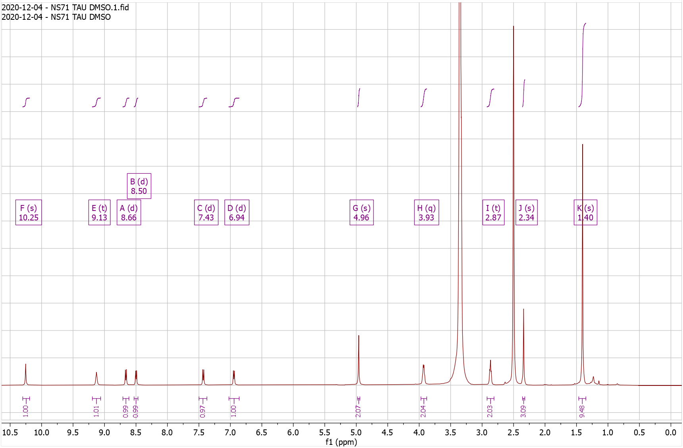
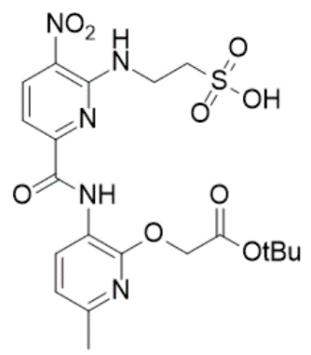
Supplementary Fig. 45. ¹H-NMR of NS71 Dep

¹H NMR (500 MHz, DMSO) δ 2.26 – 2.41 (s, 3H), 2.82 – 2.91 (t, J = 6.2 Hz, 2H), 3.90 – 4.02 (q, J = 5.8 Hz, 2H), 4.88 – 5.02 (s, 2H), 6.87 – 6.97 (d, J = 7.9 Hz, 1H), 7.37 – 7.48 (d, J = 8.4 Hz, 1H), 8.41 – 8.54 (d, J = 7.9 Hz, 1H), 8.59 – 8.70 (d, J = 8.4 Hz, 1H), 9.07 – 9.20 (t, J = 5.1 Hz, 1H), 10.23 – 10.42 (s, 1H); HRMS (m/z): [M]+ calcd. for C₁₆H₁₇N₅O₉S, 456.0820; found, 456.0820.

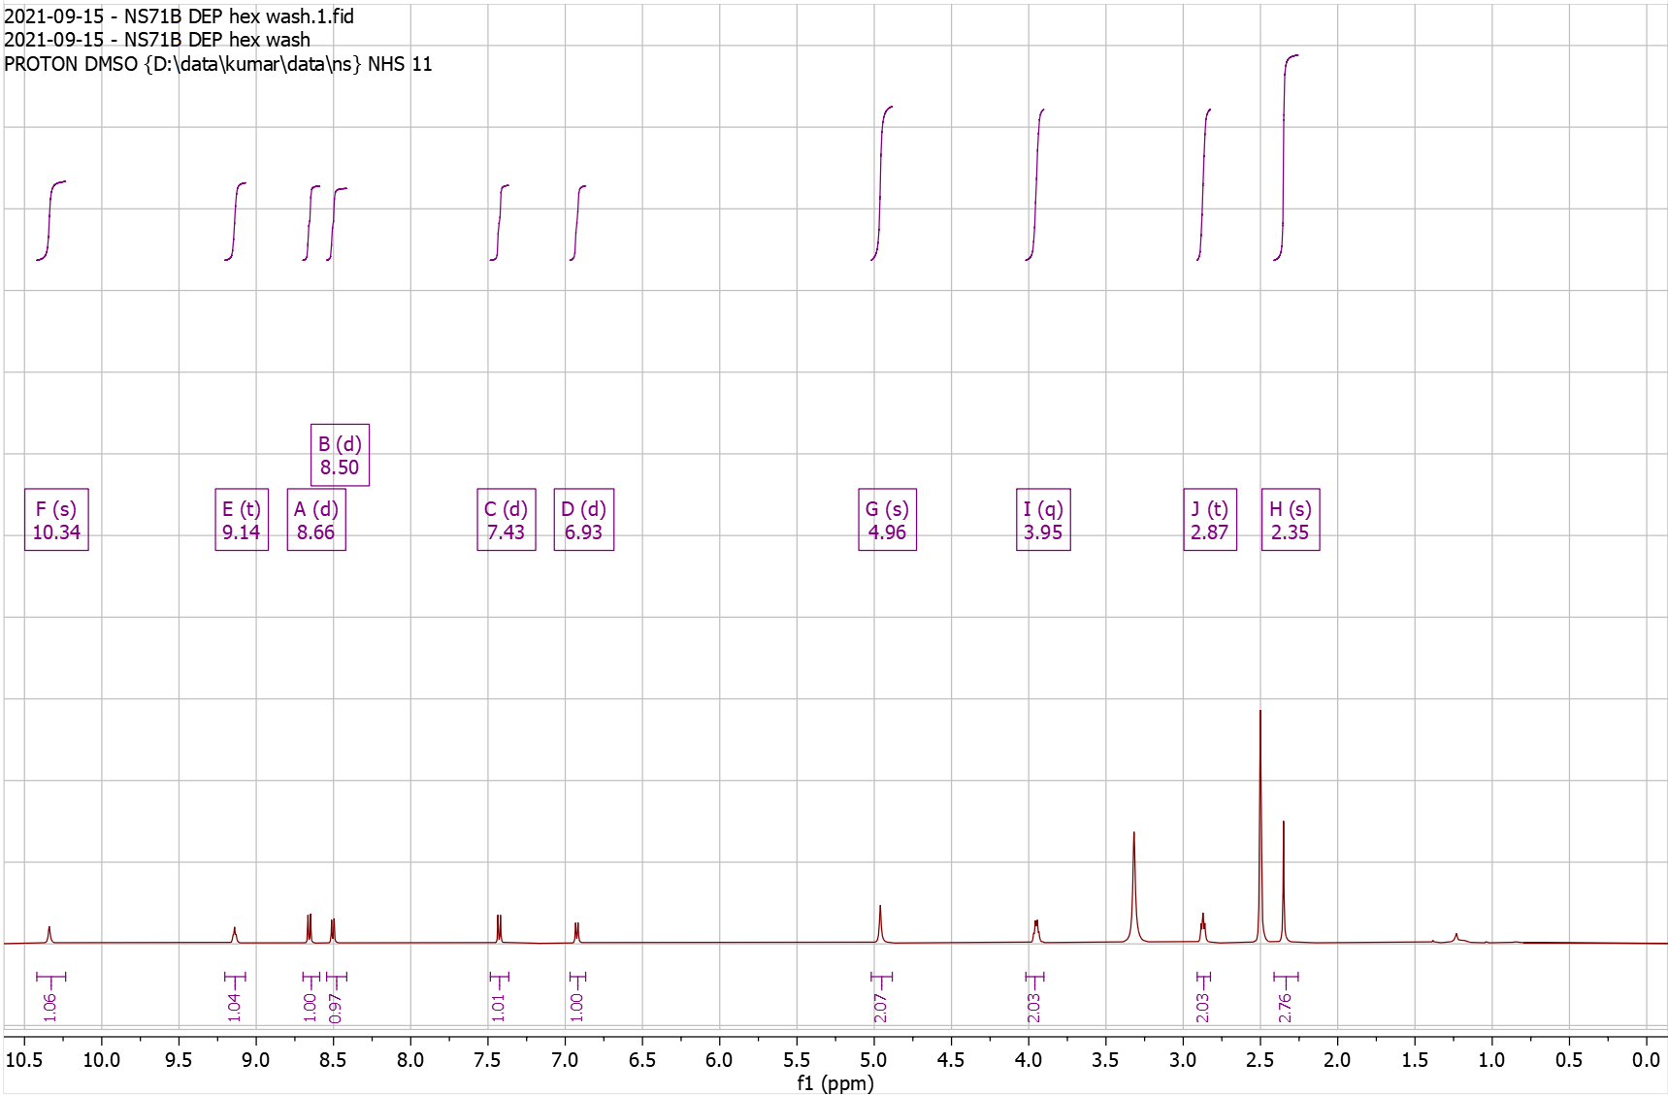
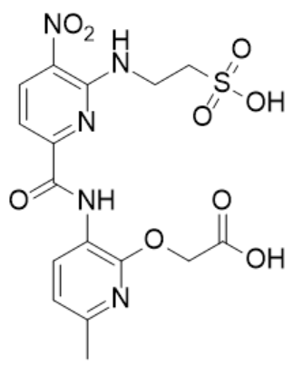
Supplementary Fig. 46. ¹H-NMR of NS72 Pro

¹H NMR (500 MHz, CDCl₃) δ 1.45 – 1.50 (s, 9H), 2.36 – 2.43 (s, 3H), 3.18 – 3.29 (t, J = 6.8 Hz, 2H), 4.07 – 4.17 (q, J = 6.5 Hz, 2H), 4.63 – 4.67 (s, 2H), 6.80 – 6.86 (d, J = 7.9 Hz, 1H), 7.04 – 7.10 (t, J = 7.5 Hz, 1H), 7.14 – 7.22 (m, 2H), 7.34 – 7.39 (d, J = 8.2 Hz, 1H), 7.49 – 7.55 (d, J = 8.4 Hz, 1H), 7.61 – 7.66 (d, J = 8.0 Hz, 1H), 8.05 – 8.08 (s, 1H), 8.29 – 8.33 (t, 1H), 8.53 – 8.58 (d, J = 8.4 Hz, 1H), 8.65 – 8.70 (d, J = 7.9 Hz, 1H), 10.17 – 10.28 (s, 1H); HRMS (m/z): [M]+ calcd. for C₂₈H₃₀N₆O₆, 547.2300; found, 547.2299.

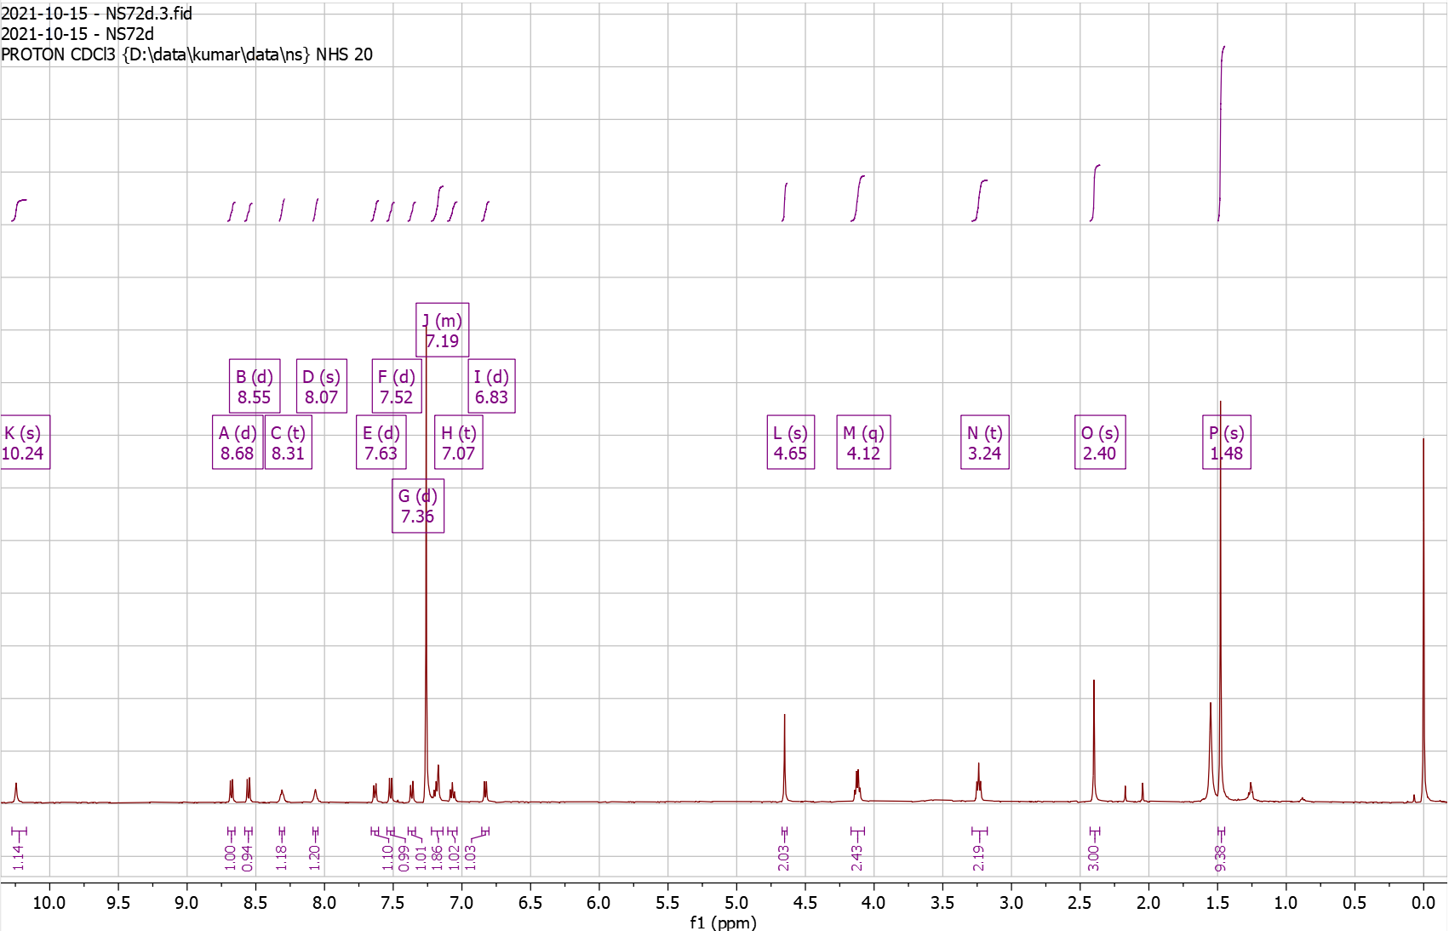
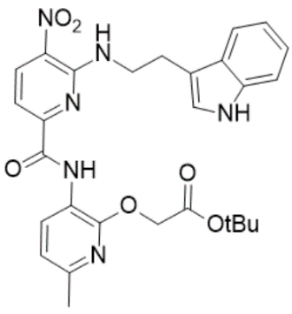
Supplementary Fig. 47. ¹H-NMR of NS72 Dep

¹H NMR (500 MHz, DMSO) δ 2.32 – 2.35 (s, 3H), 3.05 – 3.12 (t, J = 6.8 Hz, 2H), 3.93 – 4.04 (q, J = 6.5 Hz, 2H), 4.61 – 4.65 (s, 2H), 6.81 – 6.86 (t, J = 7.4 Hz, 1H), 6.86 – 6.92 (d, J = 7.9 Hz, 1H), 6.94 – 7.02 (t, J = 7.5 Hz, 1H), 7.22 – 7.25 (d, J = 2.3 Hz, 1H), 7.24 – 7.30 (d, J = 8.1 Hz, 1H), 7.31 – 7.38 (d, J = 8.4 Hz, 1H), 7.50 – 7.56 (d, J = 7.9 Hz, 1H), 8.48 – 8.53 (d, J = 7.8 Hz, 1H), 8.53 – 8.65 (dd, J = 9.6, 6.9 Hz, 2H), 10.33 – 10.41 (s, 1H), 10.79 – 10.87 (m, 1H). HRMS (m/z): [M]+ calcd. for C₂₄H₂₂N₆O₆, 491.1674; found, 491.1678.

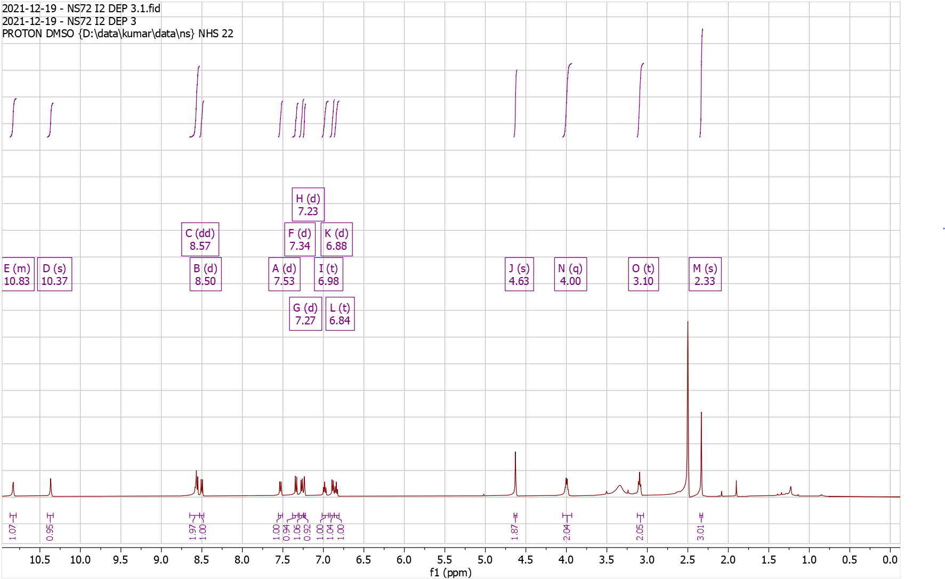
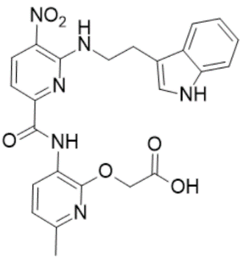
Supplementary Fig. 48. ¹H-NMR of NS119 Pro

¹H NMR (500 MHz, CDCl₃) δ 1.39 – 1.41 (s, 9H), 1.48 – 1.51 (s, 9H), 2.36 – 2.44 (s, 3H), 3.47 – 3.60 (q, J = 6.0 Hz, 2H), 3.84 – 3.99 (q, J = 5.9 Hz, 2H), 4.84 – 4.95 (s, 2H), 4.99 – 5.09 (s, 1H), 6.80 – 6.86 (d, J = 7.9 Hz, 1H), 7.56 – 7.62 (d, J = 8.4 Hz, 1H), 8.35 – 8.47 (s, 1H), 8.59 – 8.64 (d, J = 8.4 Hz, 1H), 8.65 – 8.70 (d, J = 7.9 Hz, 1H), 10.13 – 10.25 (s, 1H); HRMS (m/z): [M]+ calcd. for C₂₅H₃₄N₆O₈, 547.2511; found, 547.2510.
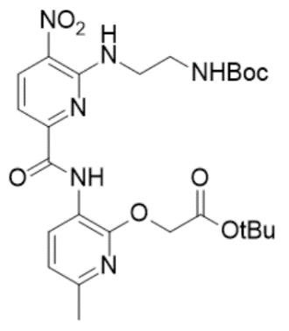
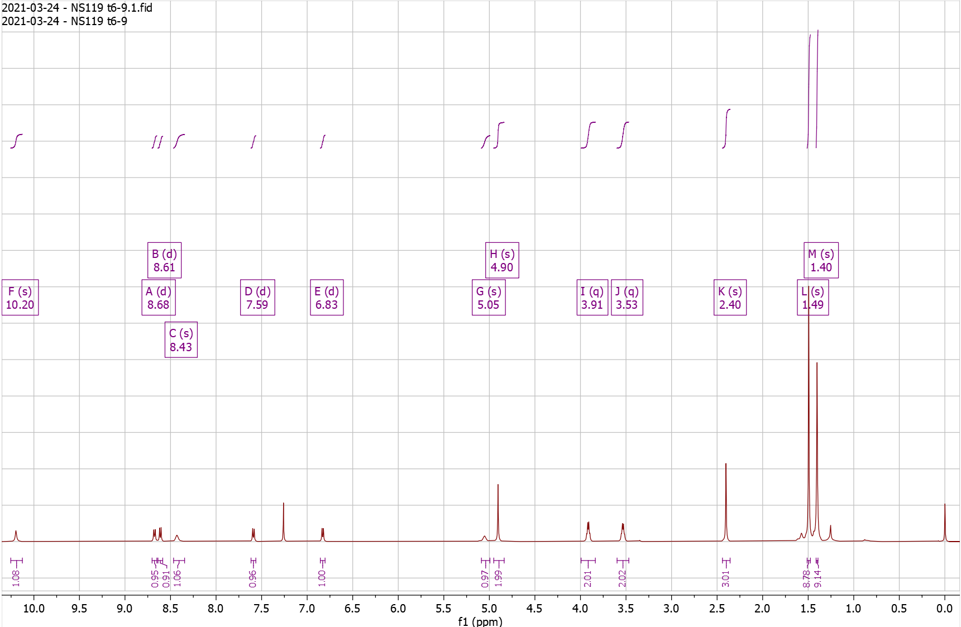
Supplementary Fig. 49. ¹H-NMR of NS119 Dep

¹H NMR (500 MHz, DMSO) δ 2.32 – 2.38 (s, 3H), 3.13 – 3.21 (t, J = 5.5 Hz, 2H), 3.89 – 3.98 (q, J = 5.6 Hz, 2H), 4.96 – 4.99 (s, 2H), 6.94 – 6.99 (d, J = 7.9 Hz, 1H), 7.48 – 7.53 (d, J = 8.4 Hz, 1H), 7.72 – 7.89 (s, 4H), 8.44 – 8.49 (d, J = 7.8 Hz, 1H), 8.58 – 8.66 (t, J = 5.9 Hz, 1H), 8.66 – 8.74 (d, J = 8.4 Hz, 1H), 10.07 – 10.21 (s, 1H); HRMS (m/z): [M]+ calcd. for C₁₆H₁₈N₆O₆, 391.1361; found, 391.1365.

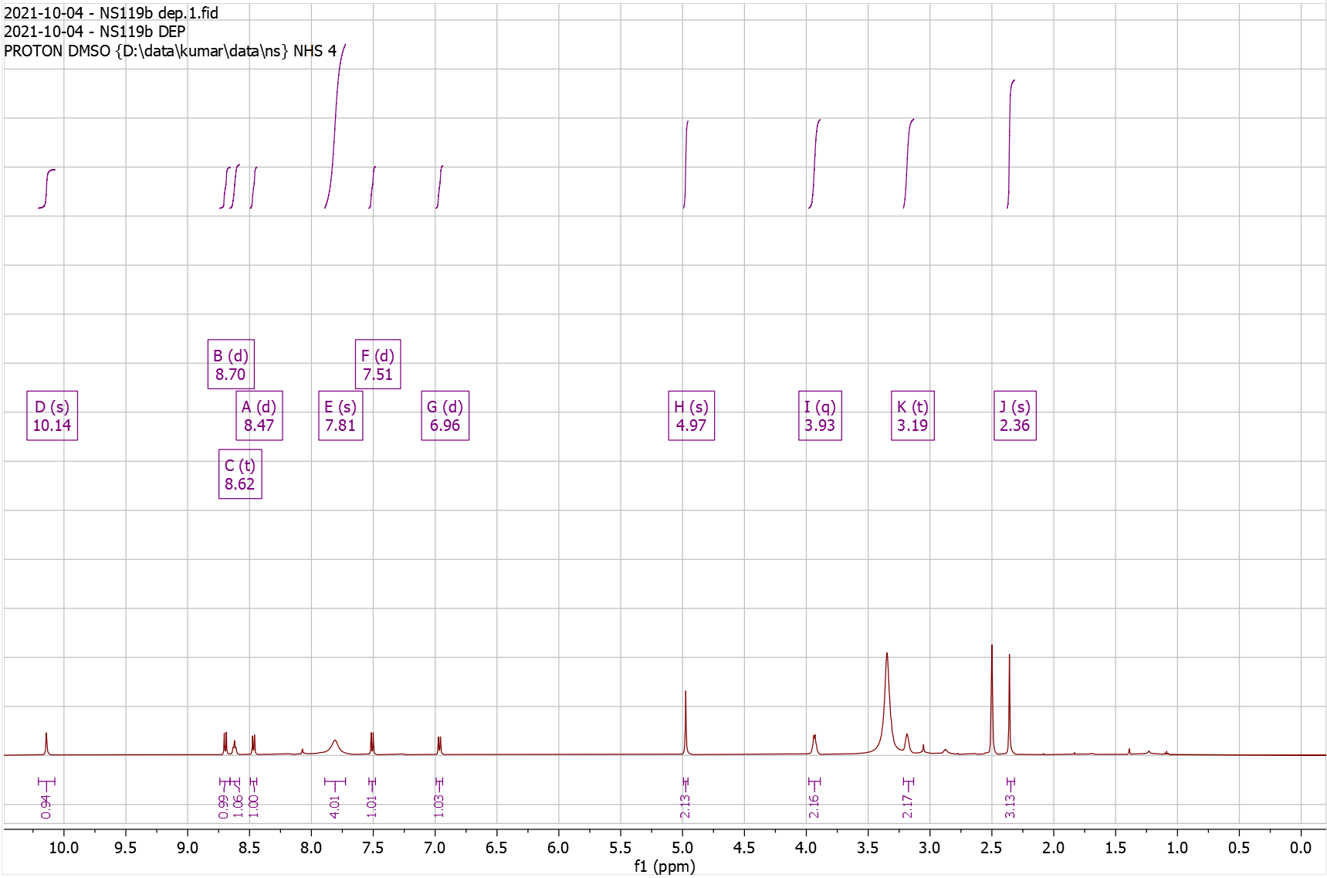
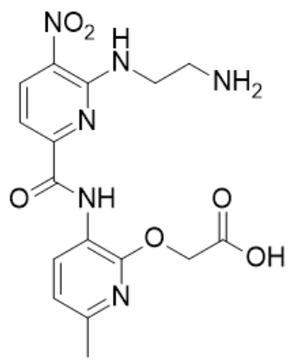
Supplementary Fig. 50. ¹H-NMR of NS137 Pro

¹H NMR (500 MHz, CDCl₃) δ 1.02 – 1.10 (d, J = 6.7 Hz, 6H), 1.41 – 1.49 (s, 9H), 1.97 – 2.14 (dp, J = 13.6, 6.9 Hz, 1H), 2.35 – 2.41 (s, 3H), 3.52 – 3.67 (t, J = 6.4 Hz, 2H), 4.79 – 4.94 (s, 2H), 6.72 – 6.88 (d, J = 7.8 Hz, 1H), 7.48 – 7.57 (d, J = 8.4 Hz, 1H), 8.25 – 8.42 (t, J = 6.0 Hz, 1H), 8.53 – 8.62 (d, J = 8.4 Hz, 1H), 8.62 – 8.69 (d, J = 7.9 Hz, 1H), 10.09 – 10.31 (s, 1H); HRMS (m/z): [M]+ calcd. for C₂₂H₂₉N₅O₆, 460.2191; found, 460.2188.

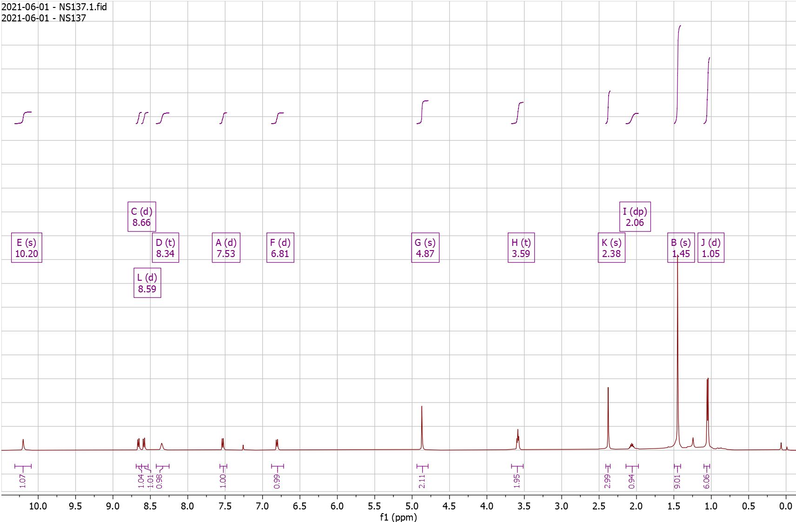
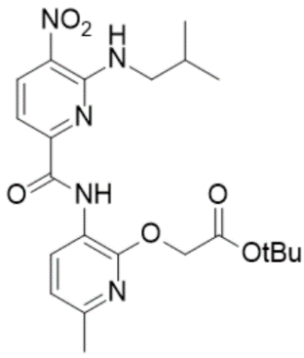
Supplementary Fig. 51. ¹H-NMR of NS137 Dep

¹H NMR (500 MHz, DMSO) δ 0.94 – 0.96 (d, J = 6.7 Hz, 6H), 1.99 – 2.10 (tt, J = 13.3, 6.4 Hz, 1H), 2.33 – 2.37 (s, 3H), 3.48 – 3.54 (t, J = 6.4 Hz, 2H), 4.96 – 4.99 (s, 2H), 6.93 – 6.99 (d, J = 7.9 Hz, 1H), 7.40 – 7.45 (d, J = 8.3 Hz, 1H), 8.51 – 8.58 (d, J = 8.0 Hz, 1H), 8.58 – 8.63 (t, J = 6.0 Hz, 1H), 8.62 – 8.70 (d, J = 8.4 Hz, 1H), 10.10 – 10.17 (s, 1H); HRMS (m/z): [M]+ calcd. for C₁₈H₂₁N₅O₆, 404.1565; found, 404.1565.

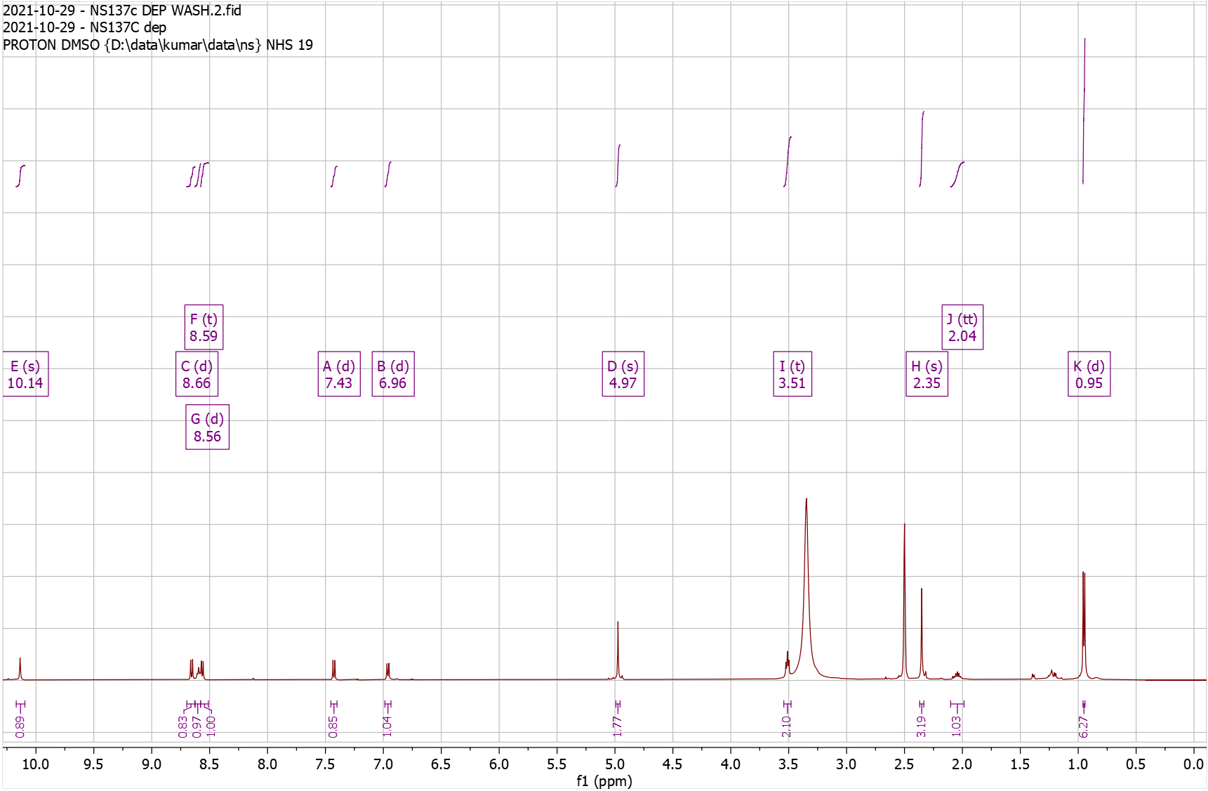
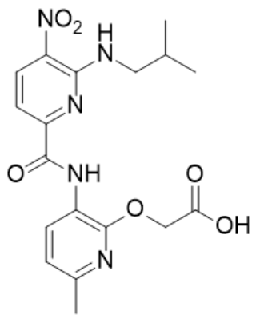
Supplementary Fig. 52. ¹H-NMR of NS157 Pro

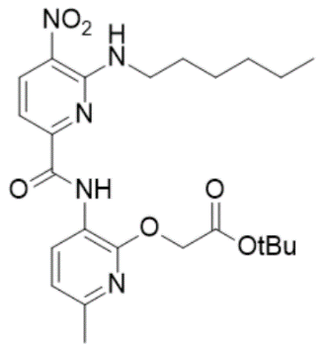
¹H NMR (500 MHz, CDCl₃) δ 0.80 – 0.95 (m, 5H), 1.30 – 1.39 (m, 4H), 1.46 – 1.47 (s, 9H), 1.71 – 1.82 (p, J = 7.1 Hz, 2H), 2.36 – 2.41 (s, 3H), 3.71 – 3.81 (q, J = 6.5 Hz, 2H), 4.84 – 4.88 (s, 2H), 6.80 – 6.85 (d, J = 7.9 Hz, 1H), 7.53 – 7.58 (d, J = 8.3 Hz, 1H), 8.22 – 8.28 (t, J = 5.8 Hz, 1H), 8.58 – 8.63 (d, 1H), 8.65 – 8.71 (d, J = 7.9 Hz, 1H), 10.25 – 10.29 (s, 1H); HRMS (m/z): [M]+ calcd. for C₂₄H₃₃N₅O₆, 488.2504; found, 488.2503.

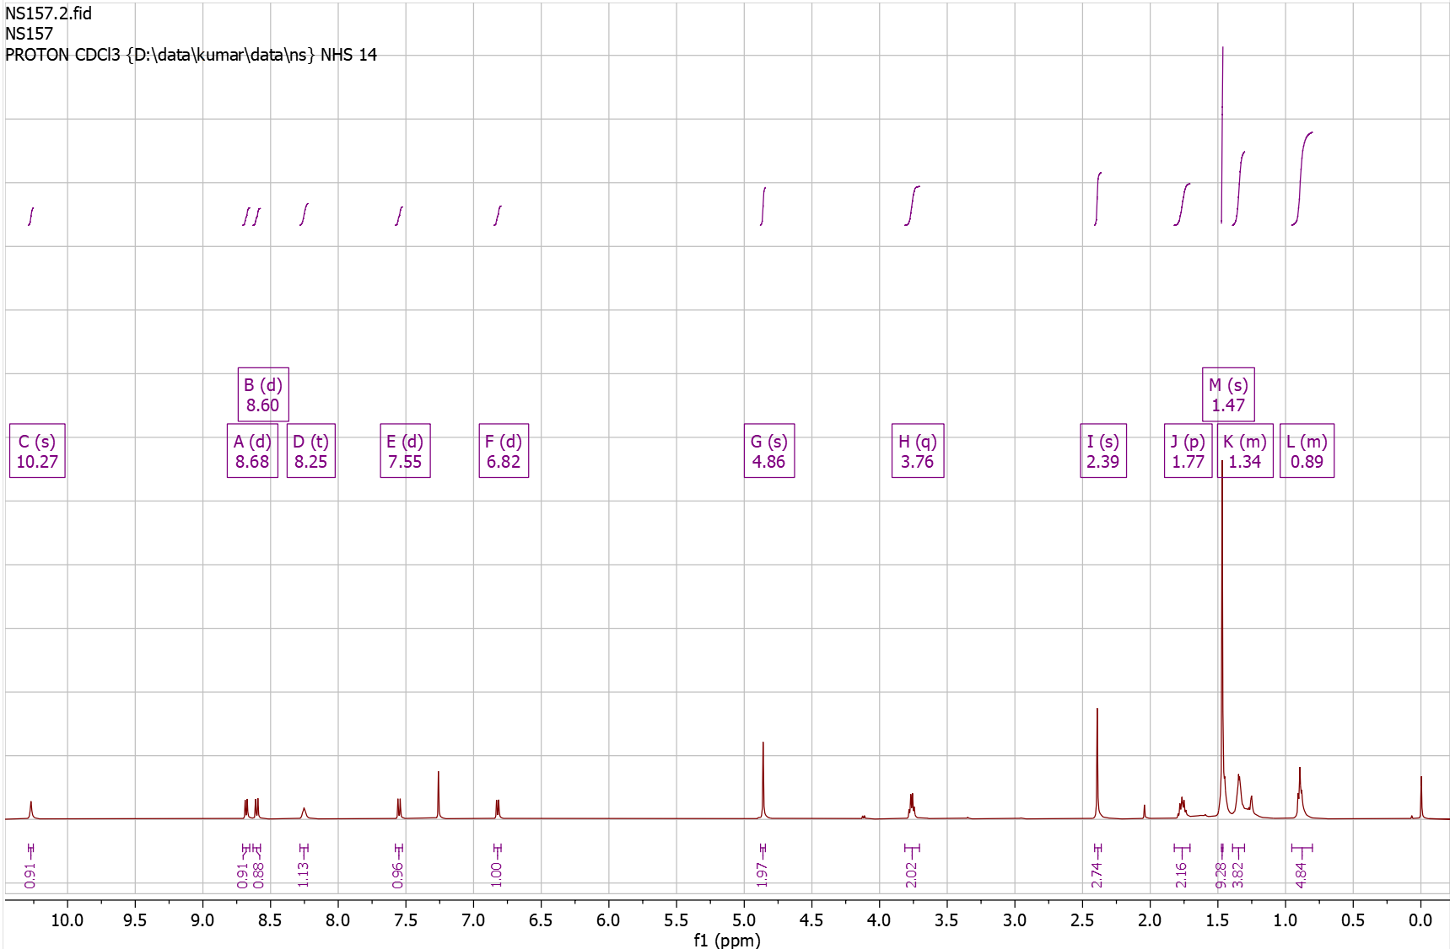
Supplementary Fig. 53. ¹H-NMR of NS157 Dep

¹H NMR (500 MHz, DMSO) δ 0.74 – 0.89 (m, 3H), 1.24 – 1.33 (m, 4H), 1.32 – 1.42 (p, J = 6.9 Hz, 2H), 1.60 – 1.72 (p, J = 7.2 Hz, 2H), 2.29 – 2.34 (s, 3H), 3.61 – 3.76 (q, J = 6.7 Hz, 2H), 4.64 – 4.77 (s, 2H), 6.80 – 6.91 (d, J = 7.9 Hz, 1H), 7.39 – 7.44 (d, J = 8.4 Hz, 1H), 8.45 – 8.53 (d, J = 7.9 Hz, 1H), 8.53 – 8.59 (t, J = 5.8 Hz, 1H), 8.59 – 8.67 (d, J = 8.4 Hz, 1H), 10.35 – 10.50 (s, 1H); HRMS (m/z): [M]+ calcd. for C₂₀H₂₅N₅O₆, 432.1878; found, 432.1882.

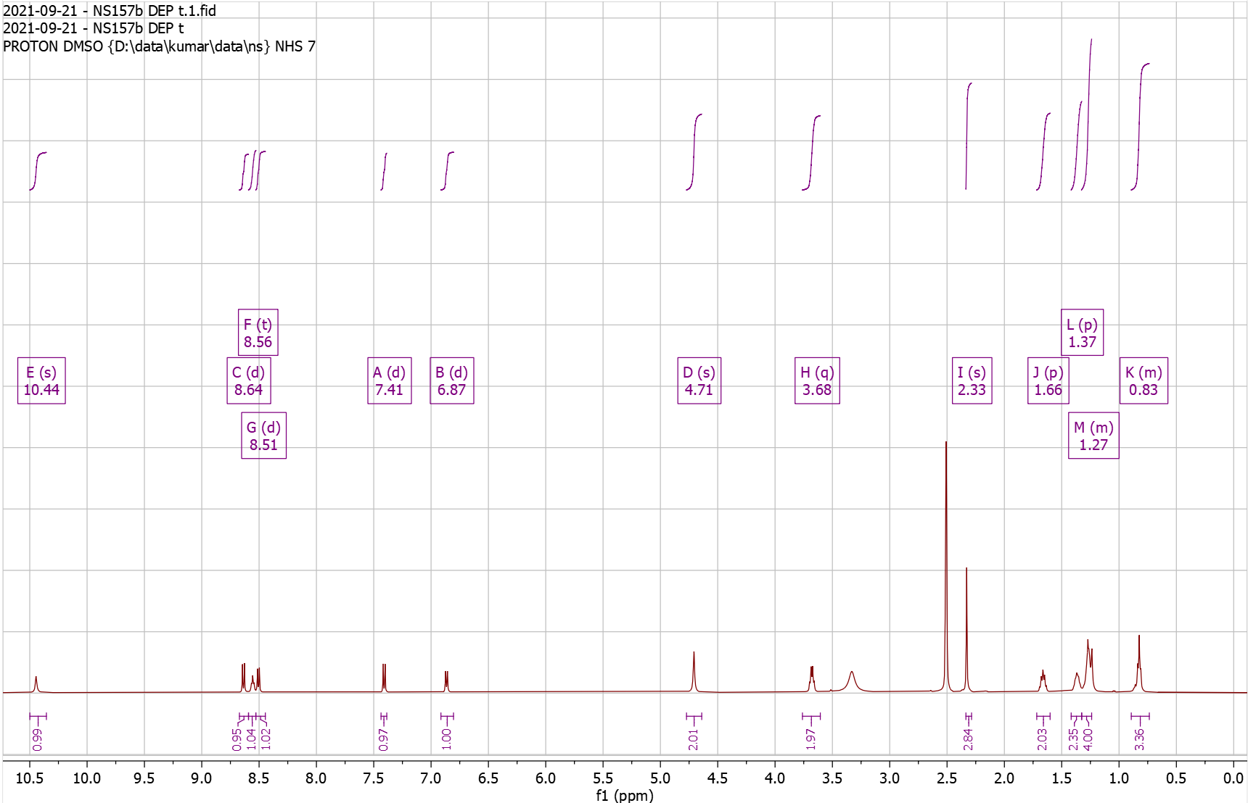
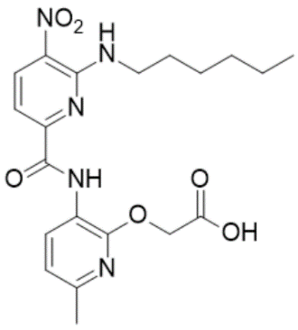
Supplementary Fig. 54. ¹H-NMR of NS158 Pro

¹H NMR (500 MHz, CDCl₃) δ 1.49 – 1.51 (s, 9H), 2.38 – 2.41 (s, 3H), 3.93 – 4.02 (d, J = 3.3 Hz, 4H), 4.88 – 4.92 (s, 2H), 6.79 – 6.84 (d, J = 7.9 Hz, 1H), 7.54 – 7.59 (d, J = 8.4 Hz, 1H), 8.41 – 8.45 (t, 1H), 8.57 – 8.62 (d, J = 8.4 Hz, 1H), 8.63 – 8.68 (d, J = 7.9 Hz, 1H), 10.19 – 10.23 (s, 1H); HRMS (m/z): [M]+ calcd. for C₂₀H₂₅N₅O₇, 448.1827; found, 448.1827.

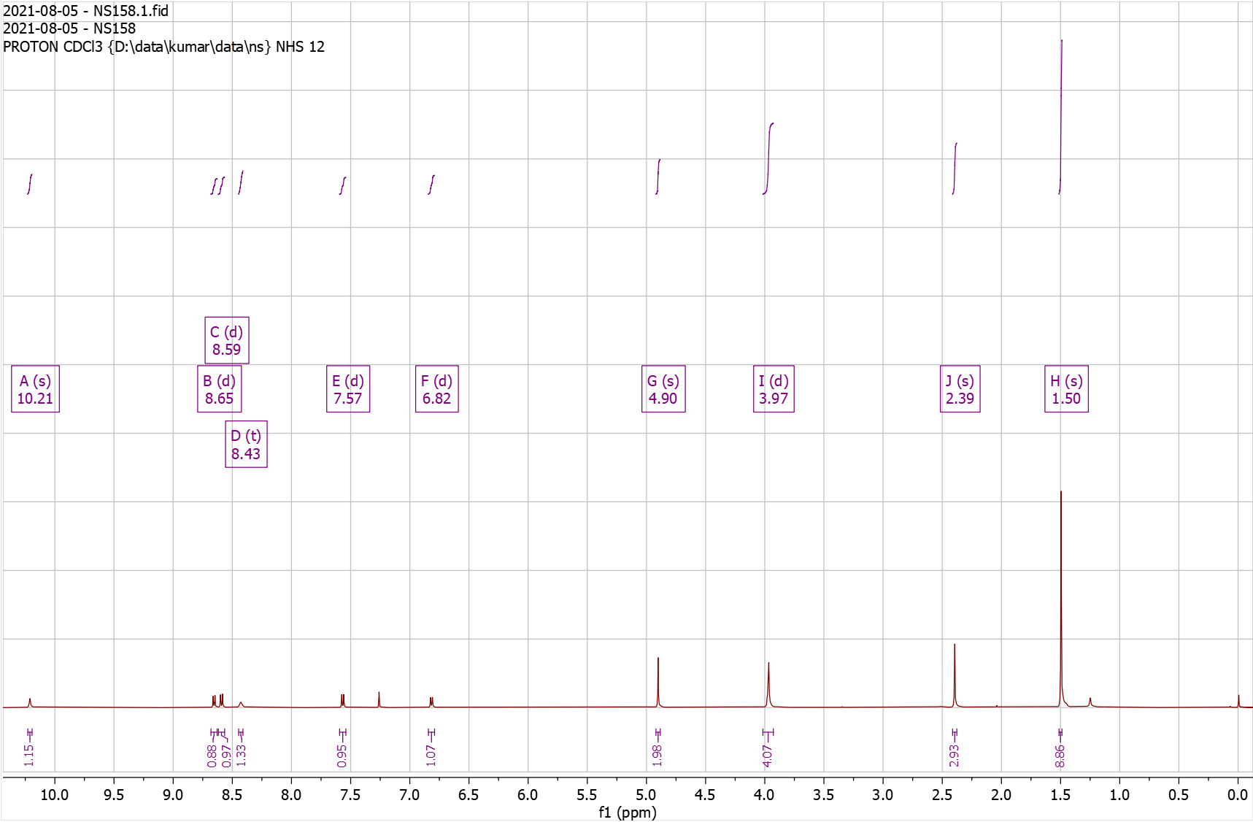
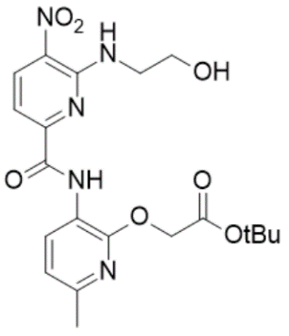
Supplementary Fig. 55. ¹H-NMR of NS158 Dep

¹H NMR (500 MHz, DMSO) δ 2.34 – 2.36 (s, 3H), 3.68 – 3.72 (t, J = 5.7 Hz, 2H), 3.72 – 3.78 (t, J = 5.5 Hz, 2H), 4.93 – 4.98 (s, 2H), 6.92 – 6.97 (d, J = 7.9 Hz, 1H), 7.38 – 7.49 (d, J = 8.4 Hz, 1H), 8.47 – 8.53 (d, J = 7.9 Hz, 1H), 8.53 – 8.59 (t, J = 5.6 Hz, 1H), 8.63 – 8.69 (d, J = 8.3 Hz, 1H), 10.31 – 10.33 (s, 1H); HRMS (m/z): [M]+ calcd. for C₁₆H₁₇N₅O₇, 392.1201; found, 392.1205.

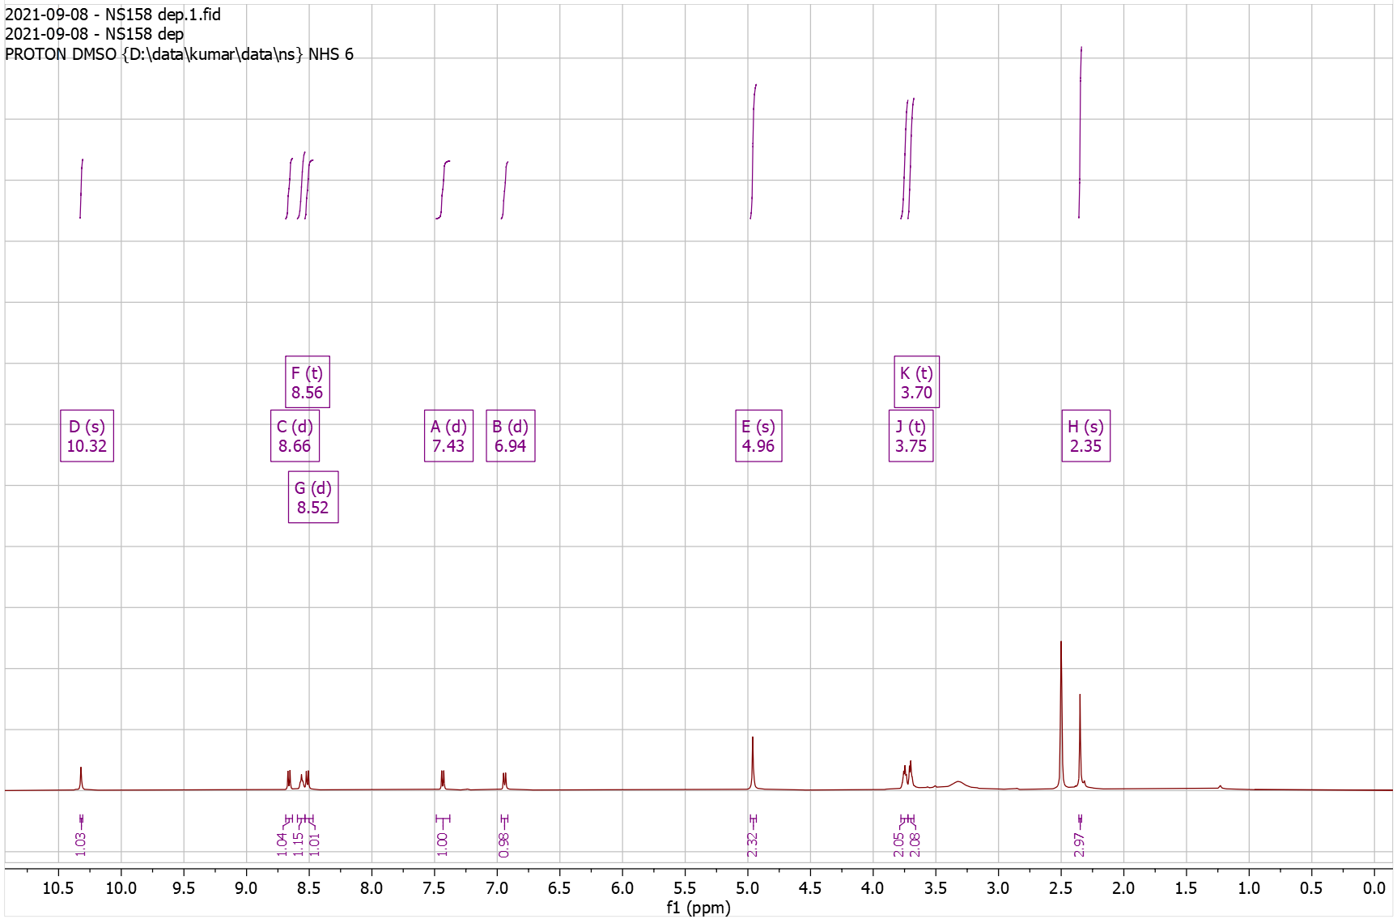
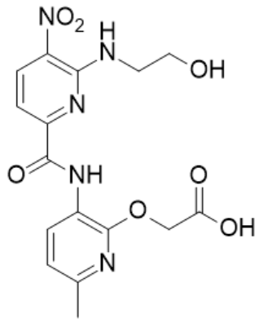
Supplementary Fig. 56. ¹H-NMR of NS160 Pro

¹H NMR (500 MHz, CDCl₃) δ 1.43 – 1.48 (s, 9H), 2.38 – 2.41 (s, 3H), 2.96 – 3.03 (t, J = 7.1 Hz, 2H), 3.97 – 4.04 (td, J = 7.1, 5.4 Hz, 2H), 4.67 – 4.71 (s, 2H), 4.80 – 4.94 (s, 1H), 6.74 – 6.80 (d, 2H), 6.80 – 6.85 (d, J = 8.0 Hz, 1H), 7.11 – 7.17 (d, 2H), 7.52 – 7.58 (d, J = 8.5 Hz, 1H), 8.18 – 8.29 (t, 1H), 8.52 – 8.63 (d, J = 8.5 Hz, 1H), 8.65 – 8.70 (d, J = 7.8 Hz, 1H), 10.24 – 10.28 (s, 1H); HRMS (m/z): [M]+ calcd. for C₂₆H₂₉N₅O₇, 524.2140; found, 524.2120.

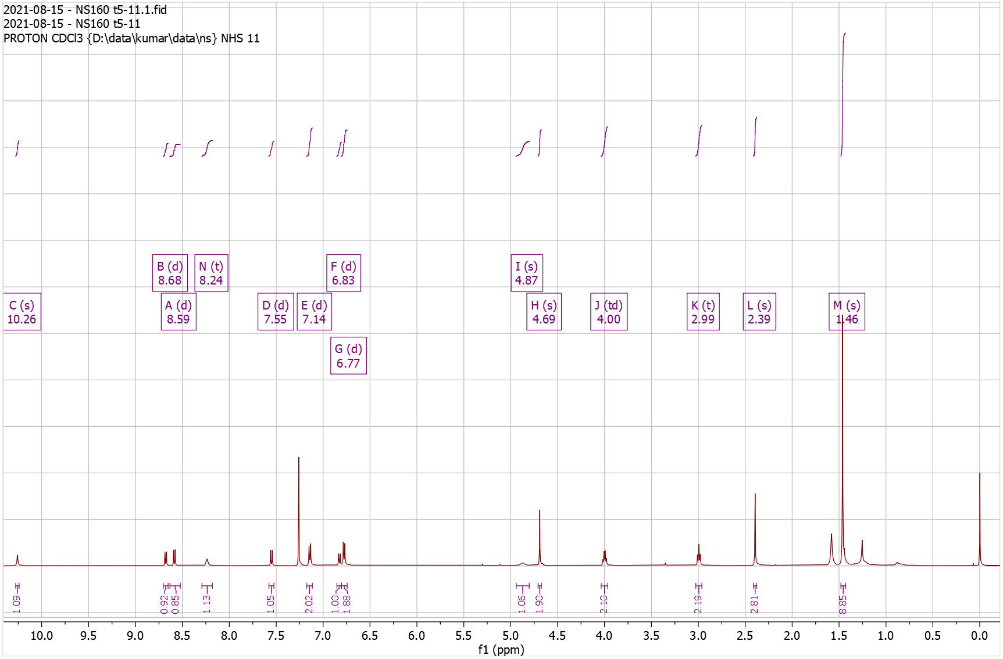
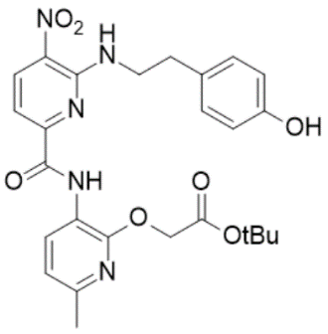

Supplementary Fig. 57. ¹H-NMR of NS160 Dep

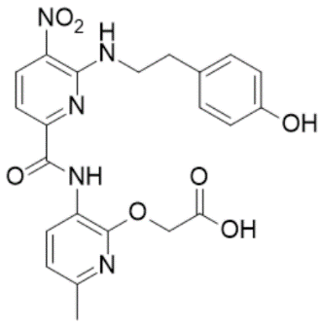
¹H NMR (500 MHz, DMSO) δ 2.32 – 2.38 (s, 3H), 2.83 – 2.92 (t, J = 7.0 Hz, 2H), 3.83 – 3.95 (q, J = 6.7 Hz, 2H), 4.72 – 4.81 (s, 2H), 6.60 – 6.65 (d, J = 8.1 Hz, 2H), 6.93 – 6.99 (d, J = 7.9 Hz, 1H), 7.02 – 7.08 (d, J = 8.0 Hz, 2H), 7.35 – 7.46 (d, J = 8.4 Hz, 1H), 8.47 – 8.55 (t, J = 5.6 Hz, 1H), 8.55 – 8.59 (d, J = 7.9 Hz, 1H), 8.61 – 8.67 (d, J = 8.4 Hz, 1H), 9.08 – 9.21 (m, 1H), 10.15 – 10.27 (s, 1H); HRMS (m/z): [M]+ calcd. for C₂₂H₂₁N₅O₇, 468.1514; found, 468.1512.

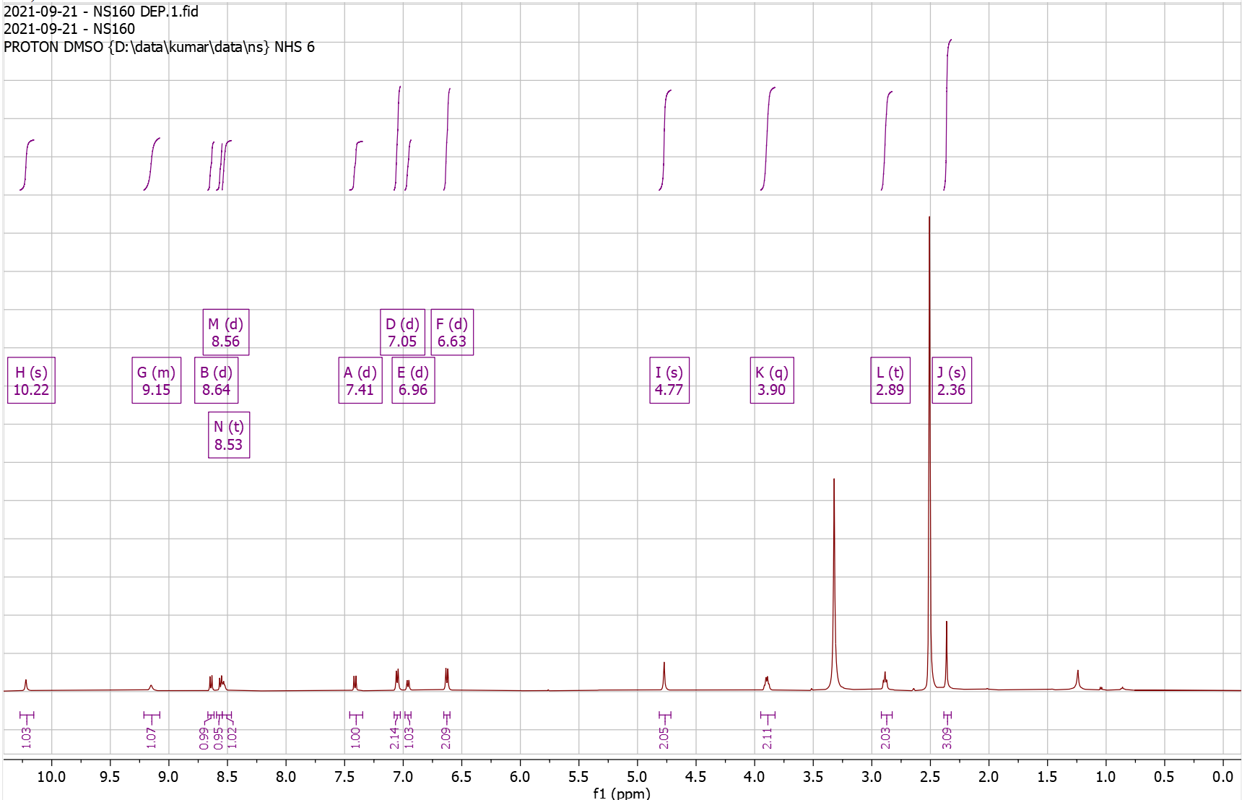
Supplementary Fig. 58. ¹H-NMR of NS161Pro

¹H NMR (500 MHz, CDCl₃) δ 1.44 – 1.44 (s, 9H), 2.39 – 2.42 (s, 3H), 2.54 – 2.58 (s, 3H), 4.88 – 4.92 (s, 2H), 5.05 – 5.18 (d, J = 5.3 Hz, 2H), 6.80 – 6.85 (d, J = 7.9 Hz, 1H), 7.61 – 7.66 (d, J = 8.4 Hz, 1H), 8.44 – 8.48 (s, 1H), 8.61 – 8.71 (m, 3H), 9.03 – 9.08 (t, J = 5.4 Hz, 1H), 10.20 – 10.24 (s, 1H); HRMS (m/z): [M]+ calcd. for C₂₄H₂₇N₇O₆, 510.2096; found, 510.2095.

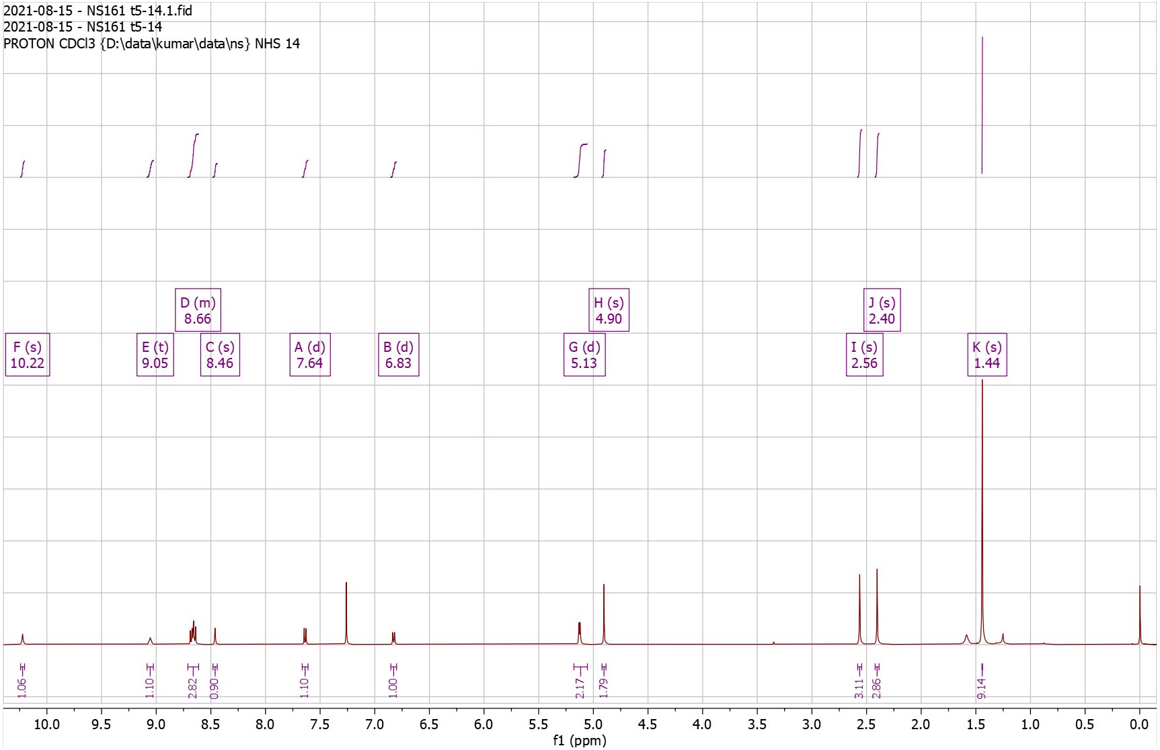

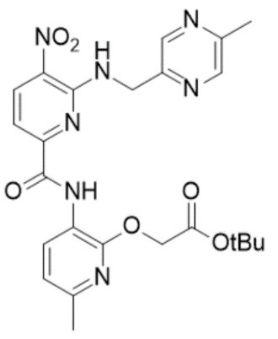
Supplementary Fig. 59. ¹H-NMR of NS161 Dep

¹H NMR (500 MHz, DMSO) δ 2.32 – 2.36 (s, 3H), 2.42 – 2.45 (s, 3H), 4.91 – 4.94 (s, 2H), 4.99 – 5.03 (d, J = 5.7 Hz, 2H), 6.90 – 6.95 (d, J = 7.9 Hz, 1H), 7.46 – 7.51 (d, J = 8.4 Hz, 1H), 8.44 – 8.49 (d, J = 7.8 Hz, 2H), 8.57 – 8.60 (s, 1H), 8.68 – 8.73 (d, J = 8.3 Hz, 1H), 9.21 – 9.27 (t, J = 5.7 Hz, 1H), 10.05 – 10.09 (s, 1H); HRMS (m/z): [M]+ calcd. for C₂₀H₁₉N₇O₆, 454.1470; found, 454.1470.

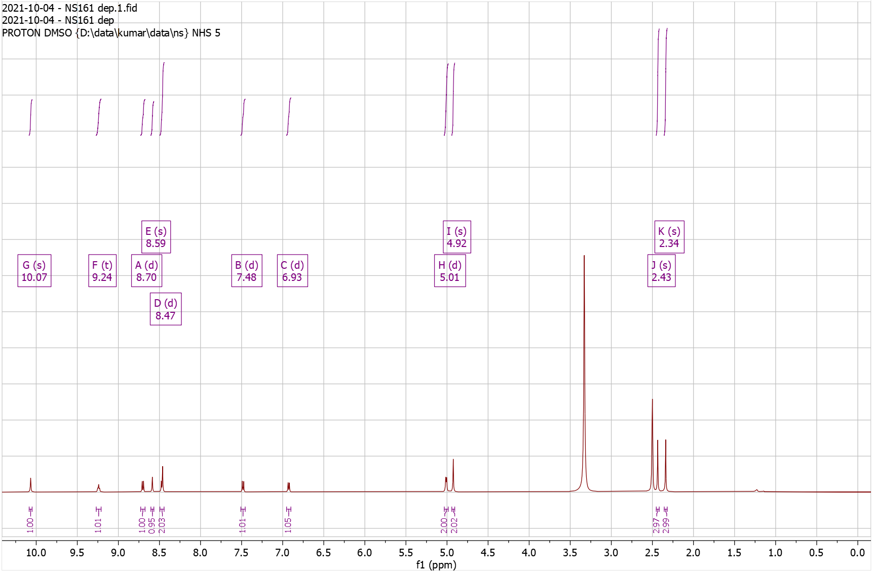

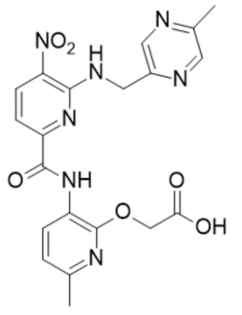
Supplementary Fig. 60. ¹H-NMR of NS122 Pro

¹H NMR (500 MHz, CDCl₃) δ 0.99 – 1.33 (m, 5H), 1.40 – 1.49 (s, 9H), 1.63 – 1.91 (m, 6H), 2.34 – 2.39 (s, 3H), 3.41 – 3.49 (t, J = 6.2 Hz, 2H), 4.85 – 4.87 (s, 2H), 4.95 – 5.01 (t, J = 5.7 Hz, 1H), 6.76 – 6.79 (d, J = 7.9 Hz, 1H), 7.57 – 7.62 (d, J = 7.8 Hz, 1H), 7.84 – 7.89 (d, J = 7.9 Hz, 1H), 8.32 – 8.39 (d, J = 8.1 Hz, 1H), 8.39 – 8.44 (d, J = 8.2 Hz, 1H), 8.65 – 8.71 (d, J = 7.9 Hz, 1H), 9.32 – 9.35 (s, 1H), 10.33 – 10.37 (s, 1H). HRMS (m/z): [M]+ calcd. for C₃₁H₃₆ClN₇O₇, 654.2438; found, 654.2424.
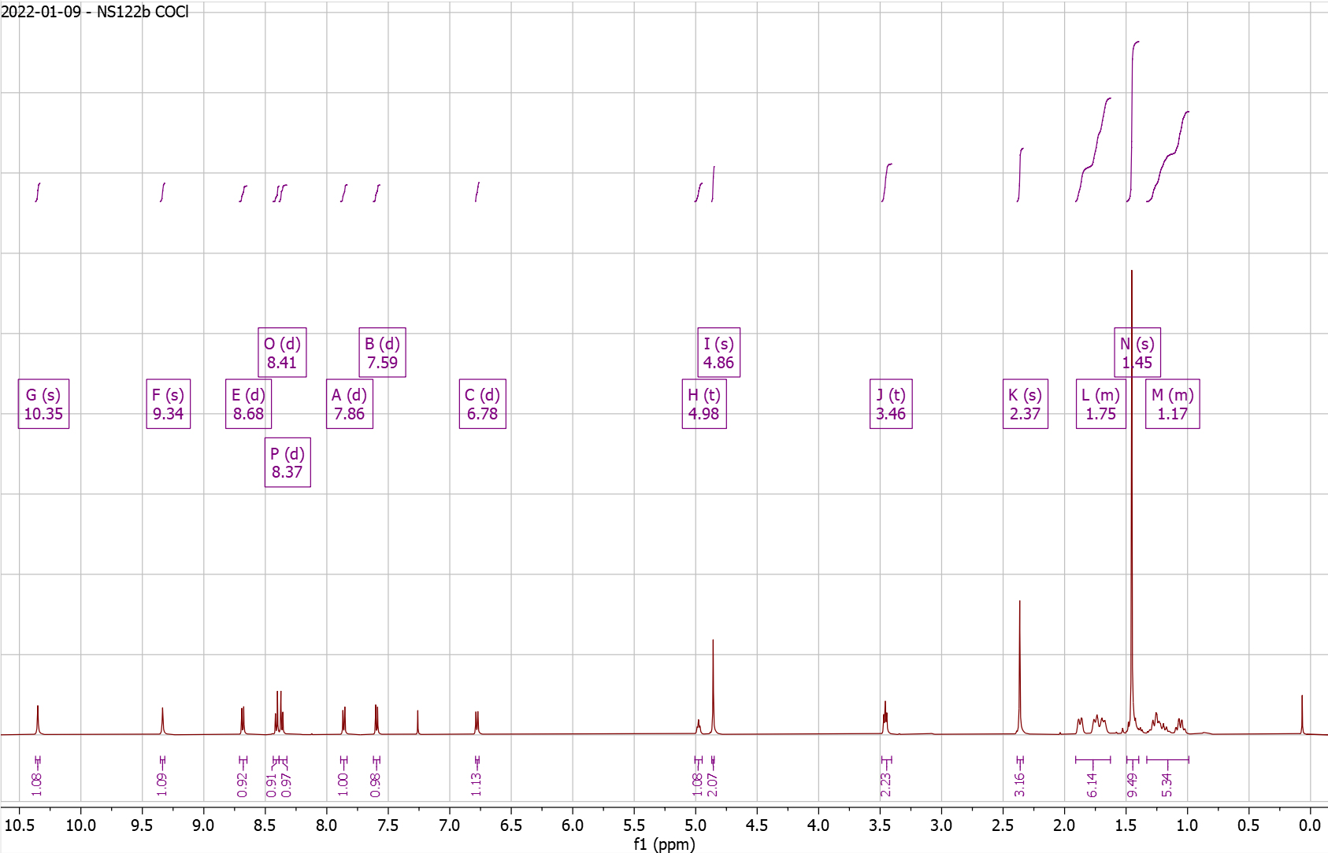

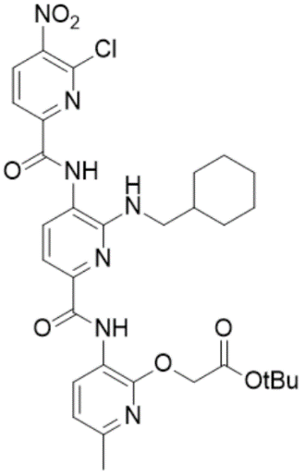
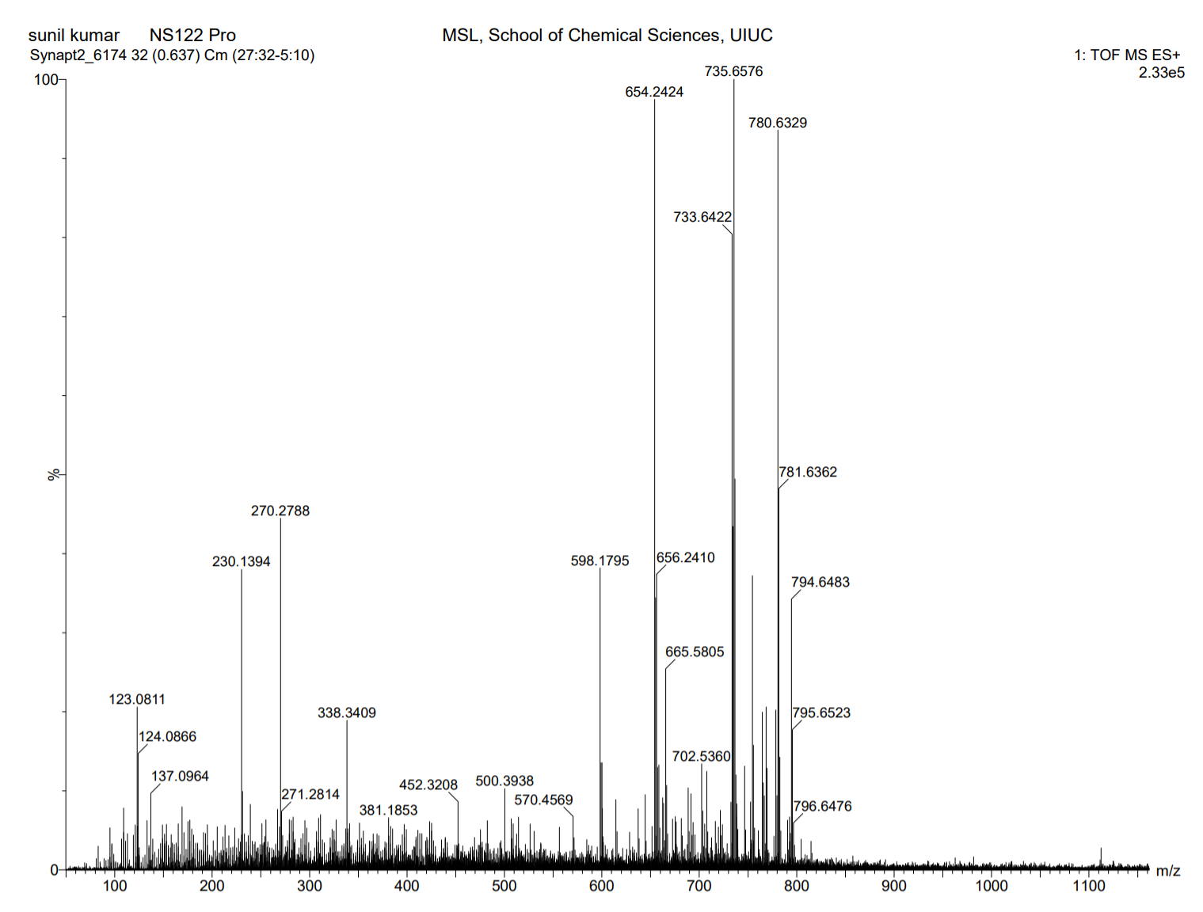
Supplementary Fig. 61. High Resolution Mass Spectrum for NS122 Pro

Supplementary Fig. 62. ¹H-NMR of NS122 Dep

¹H NMR (500 MHz, DMSO) δ 0.88 – 1.28 (m, 5H), 1.55 – 1.85 (dd, J = 85.2, 19.6 Hz, 6H), 2.33 – 2.36 (s, 3H), 4.94 – 4.98 (s, 2H), 6.67 – 6.78 (s, 1H), 6.92 – 6.97 (d, J = 7.9 Hz, 1H), 7.34 – 7.39 (d, J = 7.6 Hz, 1H), 7.66 – 7.72 (d, J = 7.6 Hz, 1H), 8.28 – 8.33 (d, J = 8.2 Hz, 1H), 8.60 – 8.68 (d, J = 7.8 Hz, 1H), 8.75 – 8.81 (d, J = 8.2 Hz, 1H), 10.24 – 10.33 (s, 1H), 10.33 – 10.43 (s, 1H). HRMS (m/z): [M]+ calcd. for C₂₇H₂₈ClN₇O₇, 598.1812; found, 598.1802.

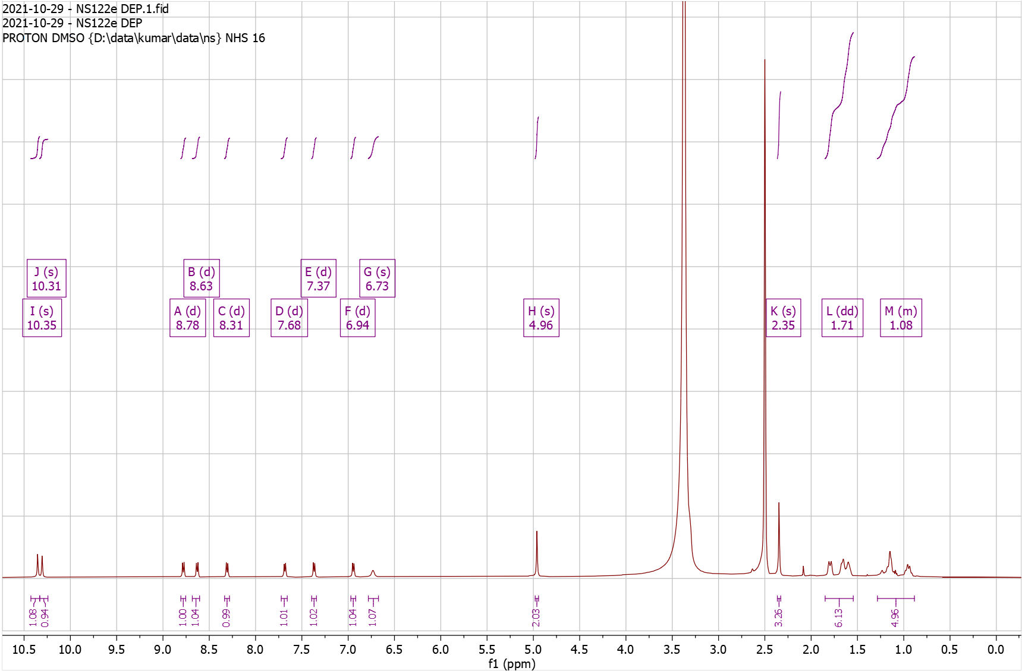
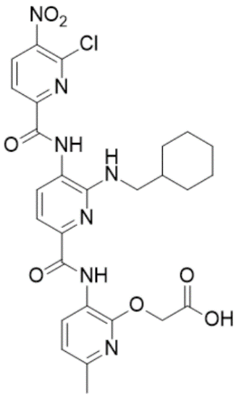
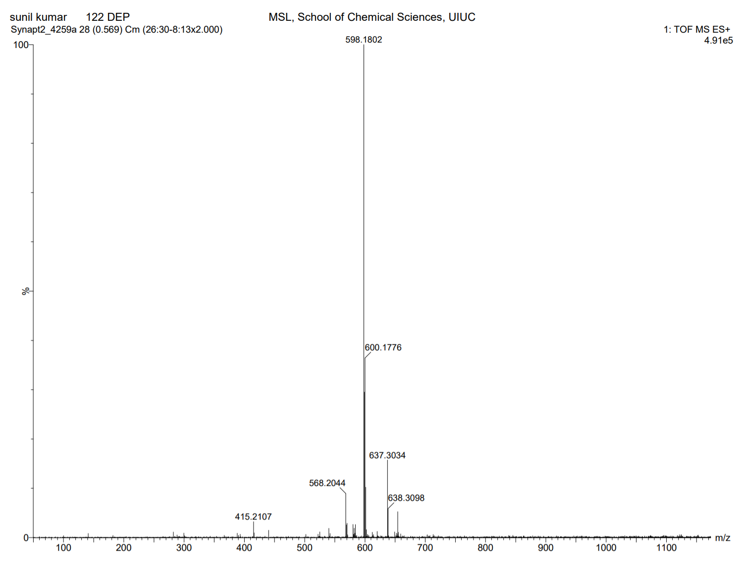
Supplementary Fig. 63. High Resolution Mass Spectrum for NS122 Dep
Supplementary Fig. 64. ¹H-NMR of NS123 Pro

¹H NMR (500 MHz, CDCl3) δ 1.08 – 1.12 (t, J = 7.5 Hz, 3H), 1.16 – 1.31 (m, 8H), 1.43 – 1.47 (s, 9H), 1.64 – 1.93 (m, 5H), 2.36 – 2.40 (s, 3H), 3.44 – 3.50 (t, J = 6.2 Hz, 2H), 3.62 – 3.69 (m, 2H), 4.81 – 4.85 (t, 1H), 4.85 – 4.88 (s, 2H), 6.78 – 6.83 (d, J = 8.0 Hz, 1H), 7.59 – 7.64 (d, J = 8.4 Hz, 1H), 7.65 – 7.70 (d, J = 7.8 Hz, 1H), 7.92 – 7.98 (d, J = 7.8 Hz, 1H), 8.28 – 8.32 (t, 1H), 8.63 – 8.68 (d, J = 8.3 Hz, 1H), 8.70 – 8.76 (d, J = 7.9 Hz, 1H), 9.38 – 9.41 (s, 1H), 10.36 – 10.40 (s, 1H). HRMS (m/z): [M]+ calcd. for C₃₄H₄₄N₈O₇, 677.3406; found, 677.3385.

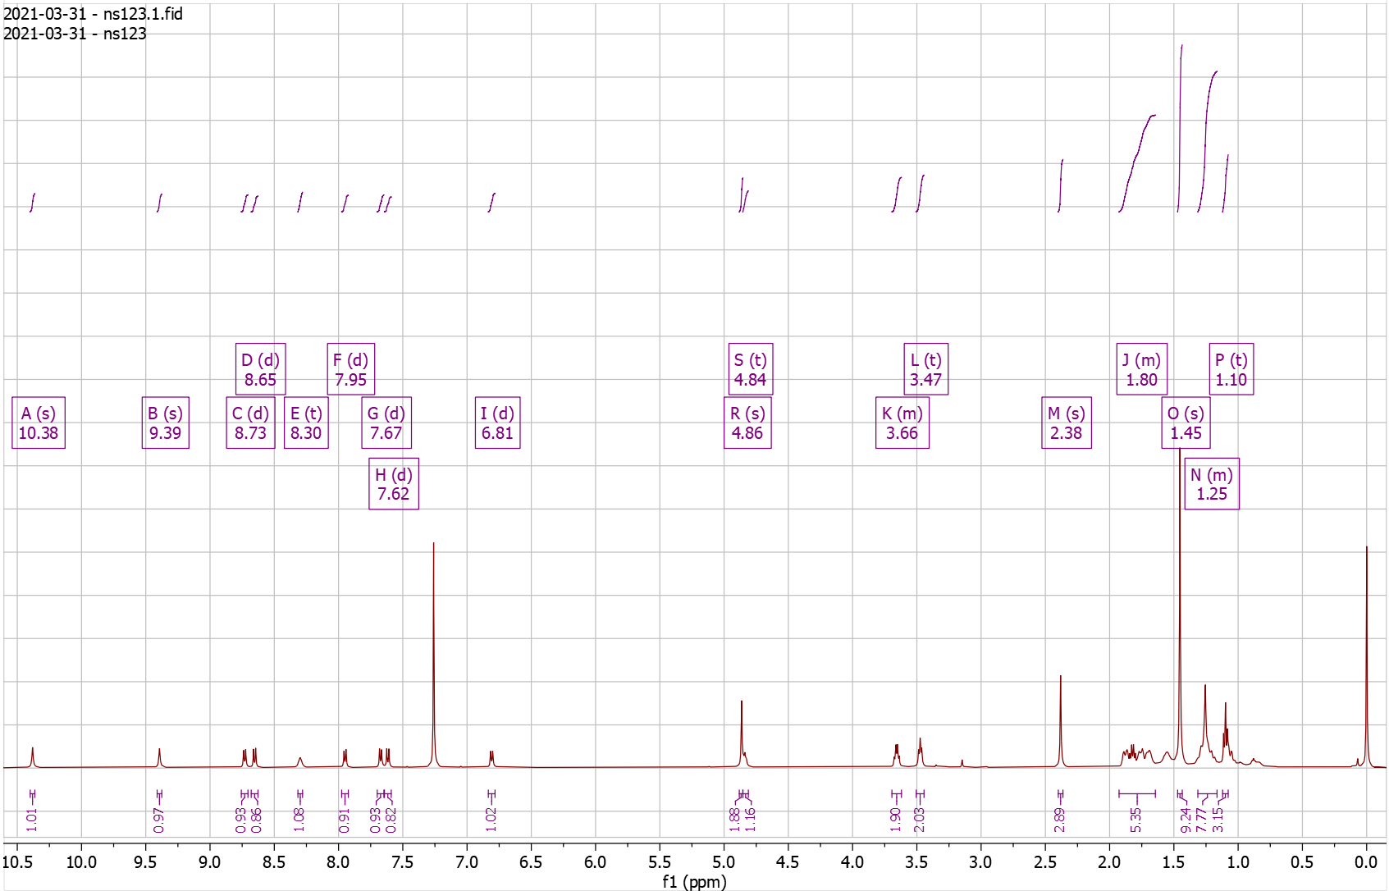
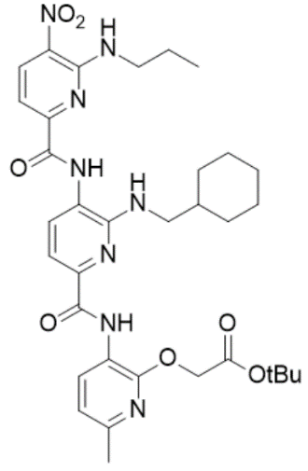
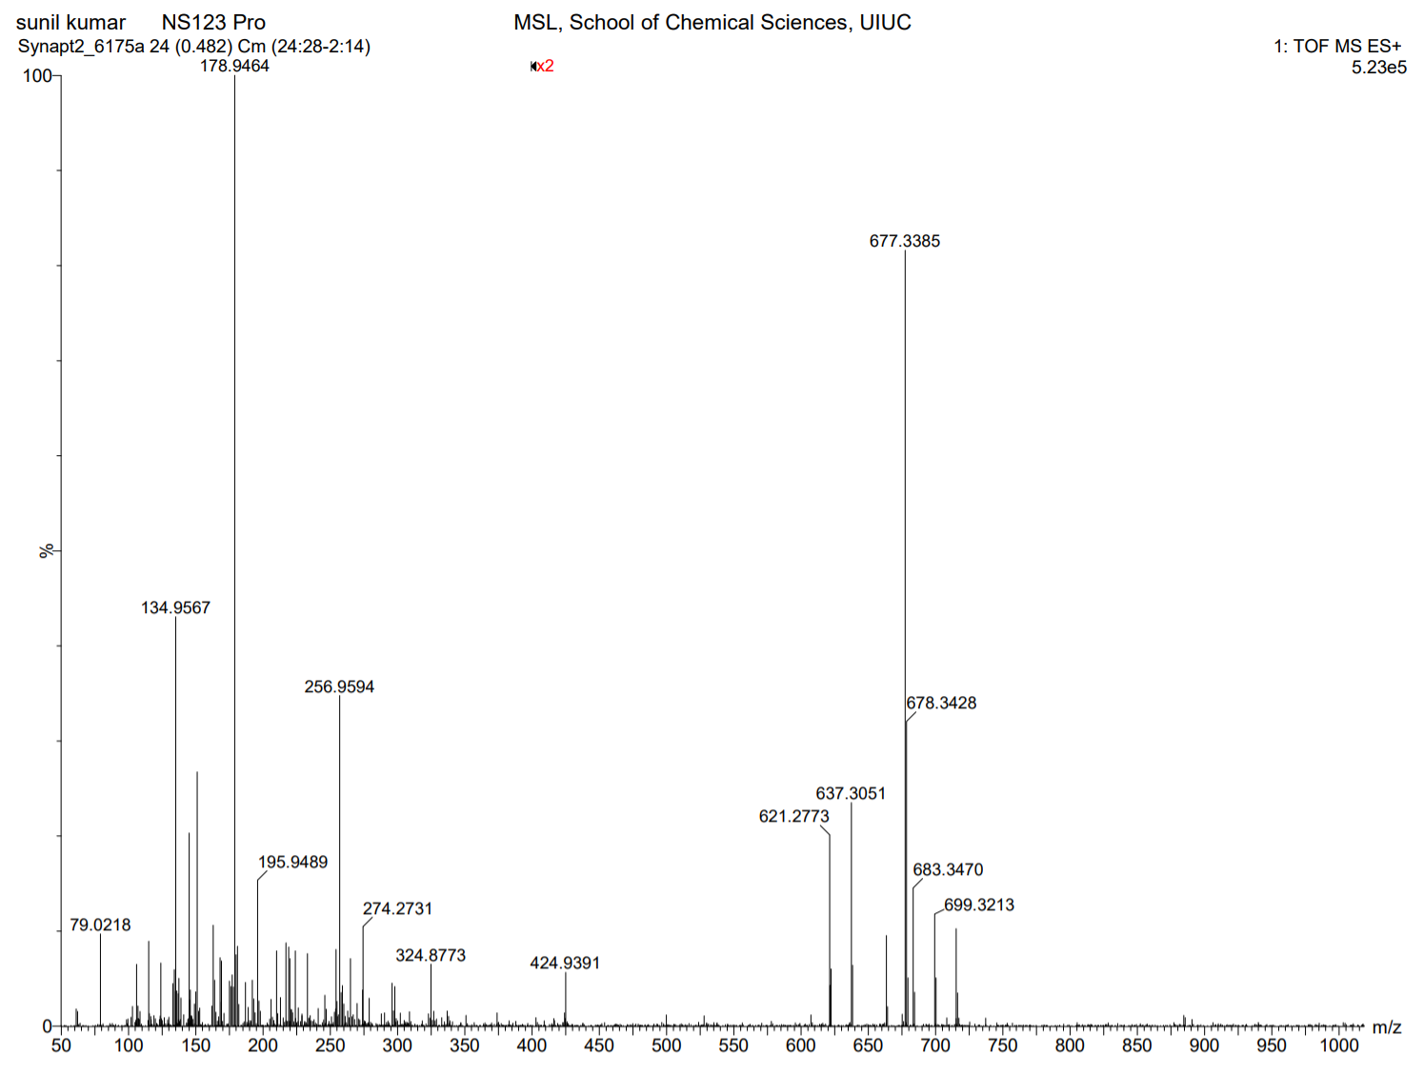
Supplementary Fig. 65. High Resolution Mass Spectrum for NS123 Pro

Supplementary Fig. 66. ¹H-NMR of NS123 Dep

¹H NMR (500 MHz, DMSO) δ 0.93 – 0.98 (t, J = 7.4 Hz, 3H), 1.10 – 1.31 (m, 7H), 1.64 – 1.88 (m, 7H), 2.33 – 2.34 (s, 3H), 3.68 – 3.80 (q, J = 6.6 Hz, 2H), 4.88 – 4.95 (s, 2H), 6.67 – 6.77 (t, J = 5.5 Hz, 1H), 6.87 – 6.94 (d, J = 8.0 Hz, 1H), 7.34 – 7.40 (d, J = 8.5 Hz, 1H), 7.40 – 7.46 (d, J = 7.7 Hz, 1H), 7.90 – 7.99 (t, J = 8.1 Hz, 1H), 8.49 – 8.56 (t, J = 5.8 Hz, 1H), 8.58 – 8.68 (dd, J = 9.8, 8.1 Hz, 2H), 9.76 – 9.86 (s, 1H), 10.35 – 10.41 (s, 1H). HRMS (m/z): [M]+ calcd. for C₃₀H₃₆N₈O₇, 621.2780; found, 621.2772.
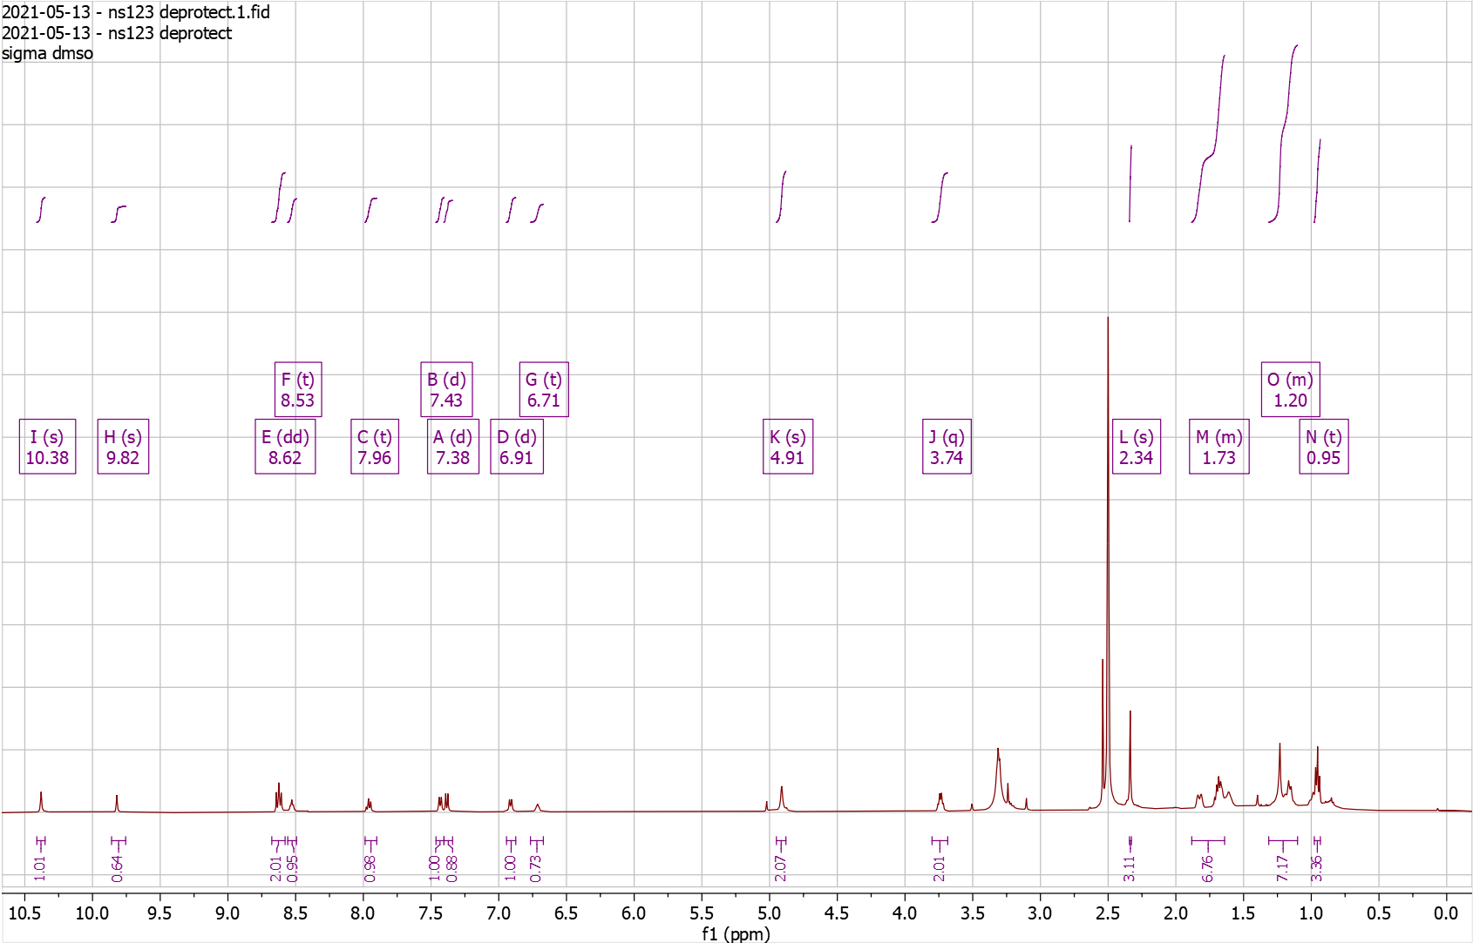
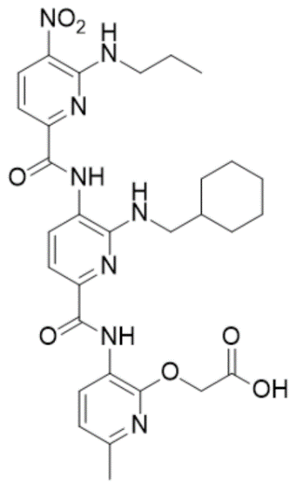
Supplementary Fig. 67. High Resolution Mass Spectrum for NS123 Dep
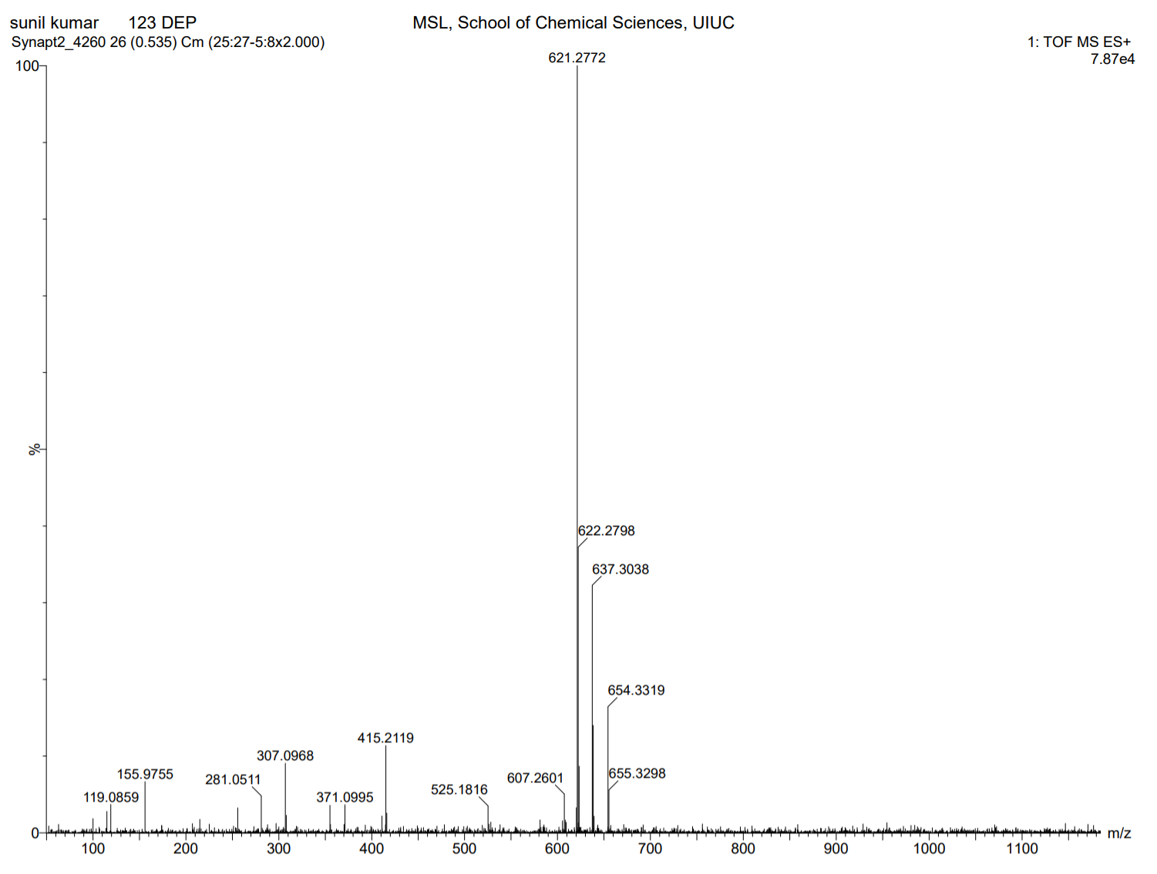

Supplementary Fig. 68. ¹H-NMR of NS125 Pro

¹H NMR (500 MHz, CDCl₃) δ 0.84 – 1.20 (m, 5H), 1.20 – 1.22 (s, 9H), 1.43 – 1.46 (s, 9H), 1.64 – 1.92 (m, 6H), 2.37 – 2.40 (s, 3H), 3.38 – 3.43 (q, J = 7.6 Hz, 2H), 3.43 – 3.45 (d, J = 6.8 Hz, 2H), 3.77 – 3.88 (q, J = 6.8 Hz, 2H), 4.81 – 4.86 (t, 1H), 4.86 – 4.90 (s, 2H), 6.78 – 6.83 (d, J = 7.9 Hz, 1H), 7.56 – 7.61 (d, J = 7.8 Hz, 1H), 7.65 – 7.70 (d, J = 8.4 Hz, 1H), 7.80 – 7.86 (d, J = 7.8 Hz, 1H), 8.34 – 8.38 (t, J = 7.8 Hz, 1H), 8.61 – 8.66 (d, J = 8.5 Hz, 1H), 8.72 – 8.77 (d, J = 7.9 Hz, 1H), 10.25 – 10.29 (s, 1H), 10.44 – 10.48 (s, 1H). HRMS (m/z): [M]+ calcd. for C₃₈H₅₁N₉O₉, 778.3883; found, 778.3856.

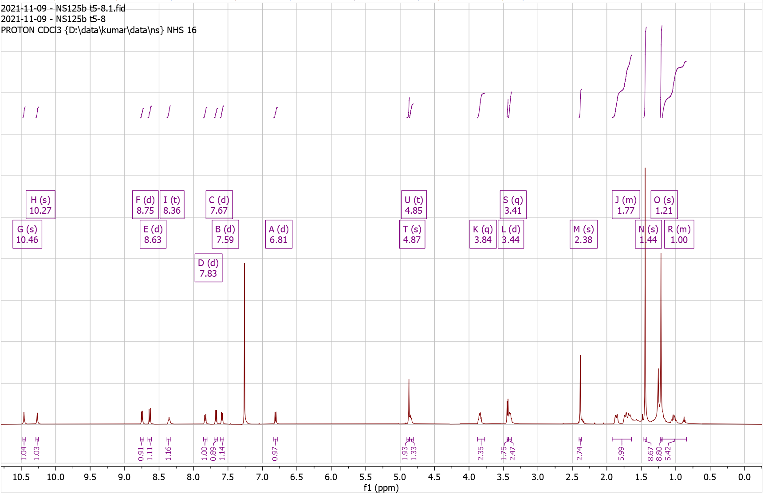
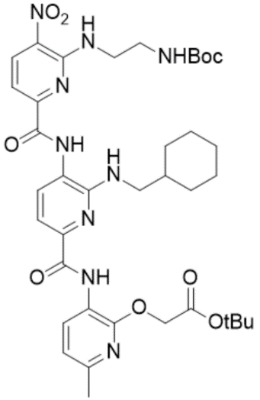
Supplementary Fig. 69. High Resolution Mass Spectrum for NS125 Pro
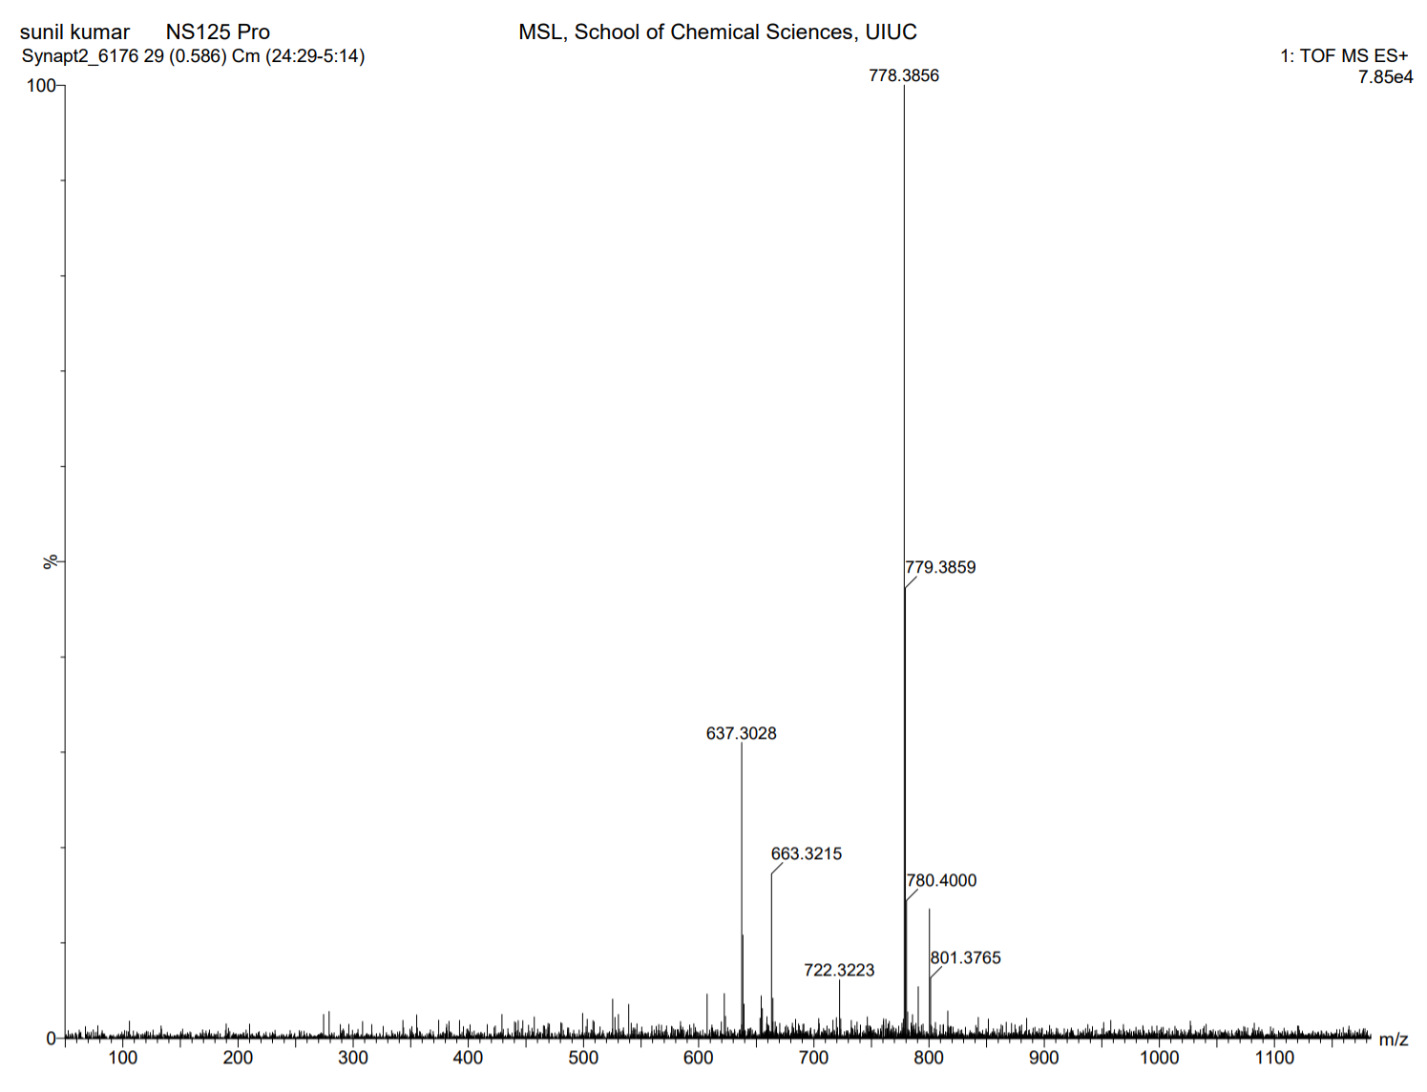
Supplementary Fig. 70. ¹H-NMR of NS125 Dep

¹H NMR (500 MHz, DMSO) δ 0.89 – 1.27 (dq, J = 98.6, 11.9 Hz, 6H), 1.56 – 1.87 (m, 7H), 2.32 – 2.35 (s, 3H), 3.07 – 3.13 (t, J = 5.7 Hz, 2H), 3.98 – 4.09 (q, J = 5.9 Hz, 2H), 4.92 – 4.96 (s, 2H), 6.79 – 6.83 (t, 1H), 6.91 – 6.96 (d, J = 7.9 Hz, 1H), 7.38 – 7.43 (d, J = 7.7 Hz, 1H), 7.44 – 7.49 (d, J = 8.4 Hz, 1H), 7.74 – 7.79 (d, J = 7.7 Hz, 1H), 8.59 – 8.73 (m, 3H), 10.33 – 10.36 (s, 1H). HRMS (m/z): [M]+ calcd. for C₂₉H₃₅N₉O₇, 622.2732; found, 622.2714.
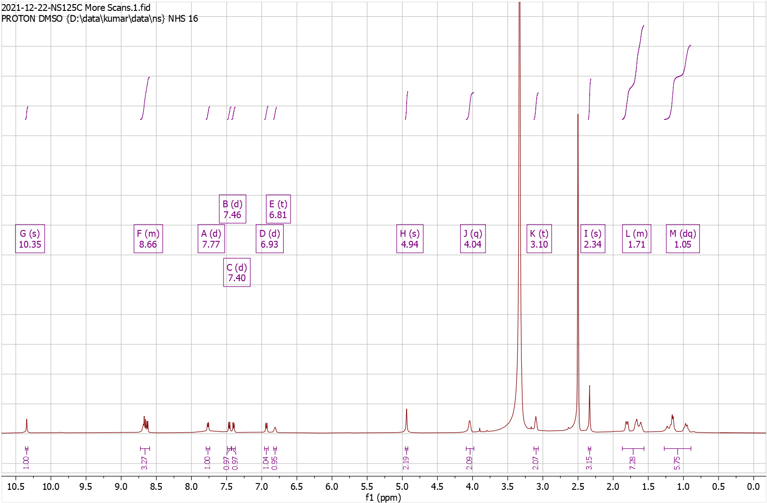
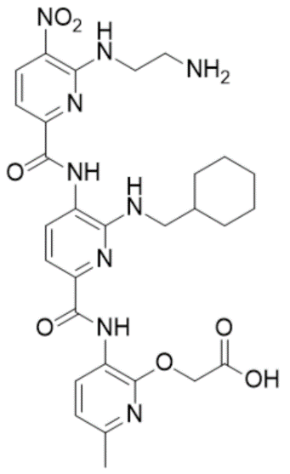
Supplementary Fig. 71. High Resolution Mass Spectrum for NS125 Dep
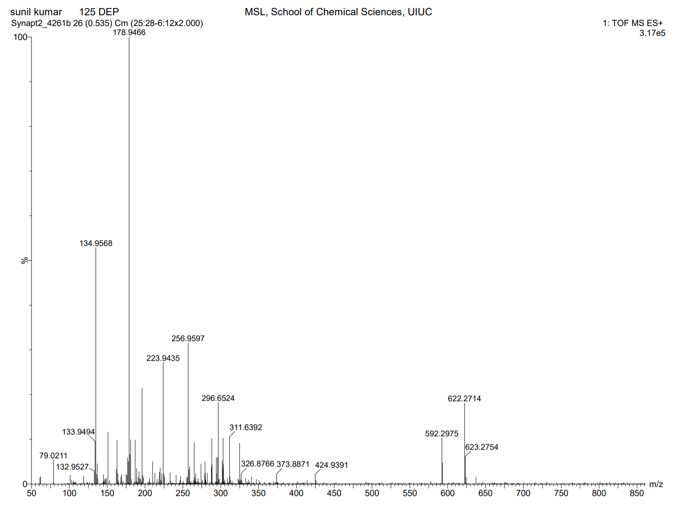
Supplementary Fig. 72. ¹H-NMR of NS126 Pro

¹H NMR (500 MHz, CDCl₃) δ 1.00 – 1.39 (m, 10H), 1.43 – 1.47 (s, 9H), 1.65 – 1.94 (m, 12H), 2.36 – 2.42 (s, 3H), 3.42 – 3.50 (t, J = 6.2 Hz, 2H), 3.50 – 3.59 (t, J = 6.1 Hz, 2H), 4.81 – 4.88 (s, 2H), 4.88 – 4.94 (t, J = 6.0 Hz, 1H), 6.76 – 6.85 (d, J = 8.0 Hz, 1H), 7.54 – 7.63 (d, J = 8.4 Hz, 1H), 7.63 – 7.71 (d, J = 7.8 Hz, 1H), 7.85 – 7.96 (d, J = 7.9 Hz, 1H), 8.30 – 8.41 (t, J = 5.7 Hz, 1H), 8.58 – 8.69 (d, J = 8.4 Hz, 1H), 8.69 – 8.78 (d, J = 7.9 Hz, 1H), 9.28 – 9.43 (s, 1H), 10.29 – 10.47 (s, 1H). HRMS (m/z): [M]+ calcd. for C₃₈H₅₀N₈O₇, 731.3875; found, 731.3856.

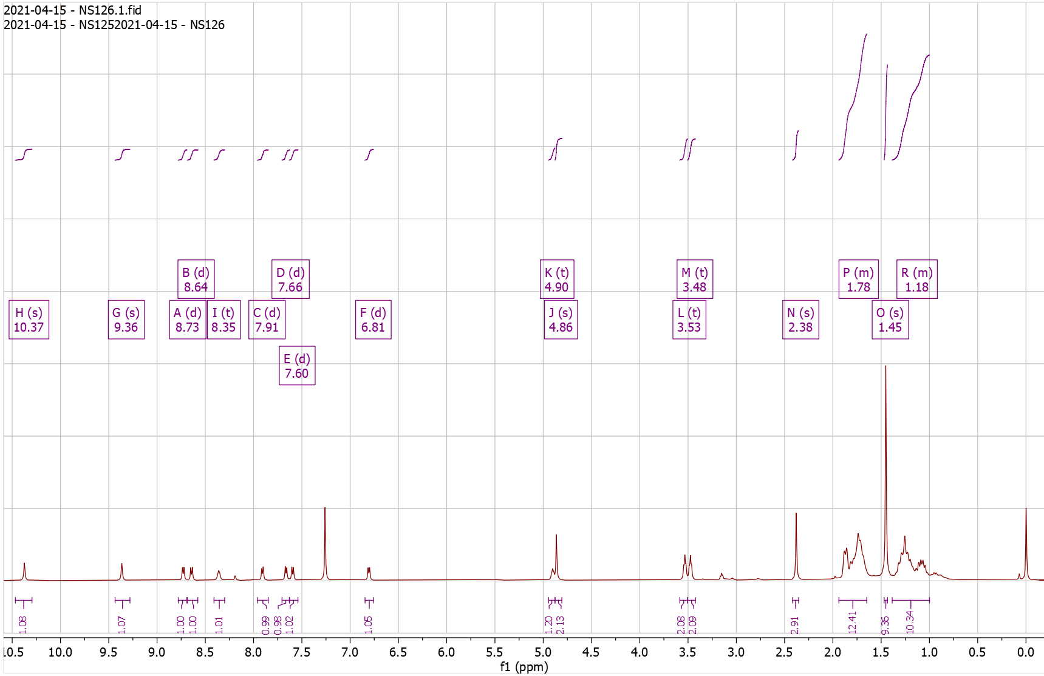
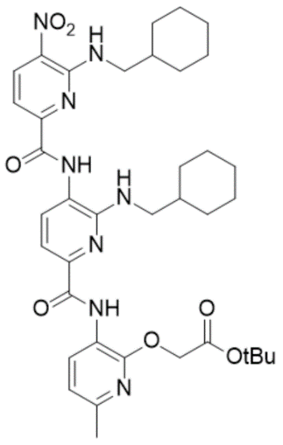
Supplementary Fig. 73. High Resolution Mass Spectrum for NS126 Pro
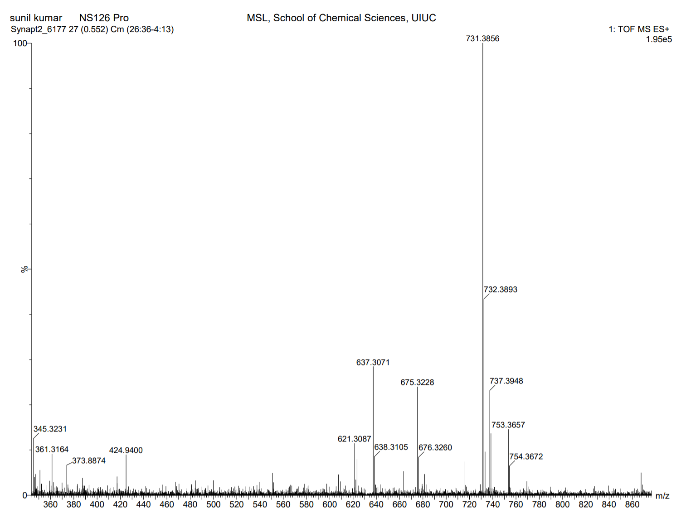
Supplementary Fig. 74. ¹H-NMR of NS126 Dep

¹H NMR (500 MHz, DMSO) δ 0.86 – 1.27 (m, 10H), 1.56 – 1.90 (m, 12H), 2.31 – 2.37 (s, 3H), 3.63 – 3.69 (t, J = 6.4 Hz, 2H), 4.92 – 4.96 (s, 2H), 6.72 – 6.80 (t, J = 5.8 Hz, 1H), 6.91 – 6.96 (d, J = 8.0 Hz, 1H), 7.36 – 7.48 (dd, J = 26.2, 8.1 Hz, 2H), 7.92 – 7.97 (d, J = 7.8 Hz, 1H), 8.46 – 8.53 (d, J = 6.2 Hz, 1H), 8.60 – 8.66 (dd, J = 8.2, 4.7 Hz, 2H), 9.78 – 9.81 (s, 1H), 10.35 – 10.38 (s, 1H). HRMS (m/z): [M]+ calcd. for C₃₄H₄₂N₈O₇, 675.3249; found, 675.3245.

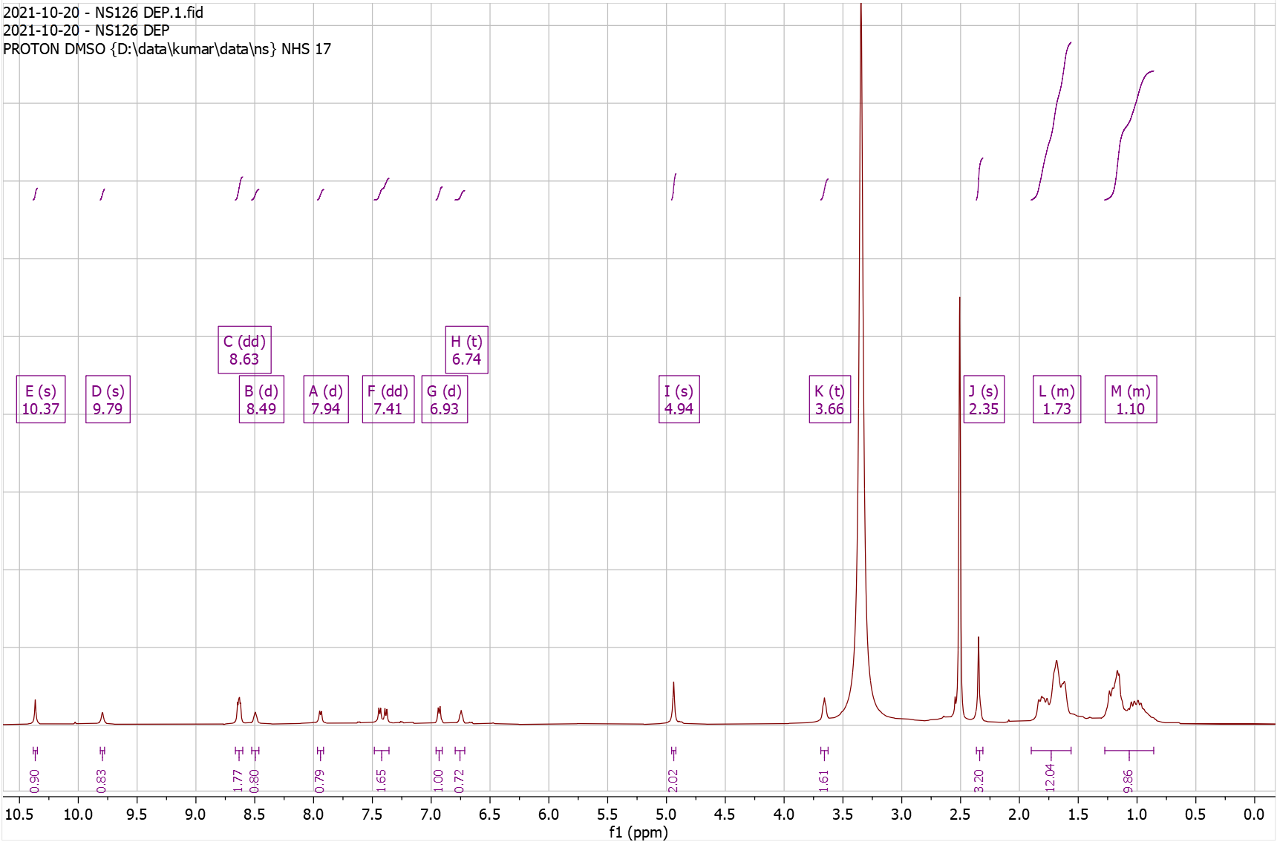
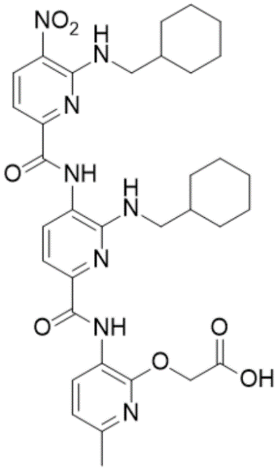
Supplementary Fig. 75. High Resolution Mass Spectrum for NS126 Dep
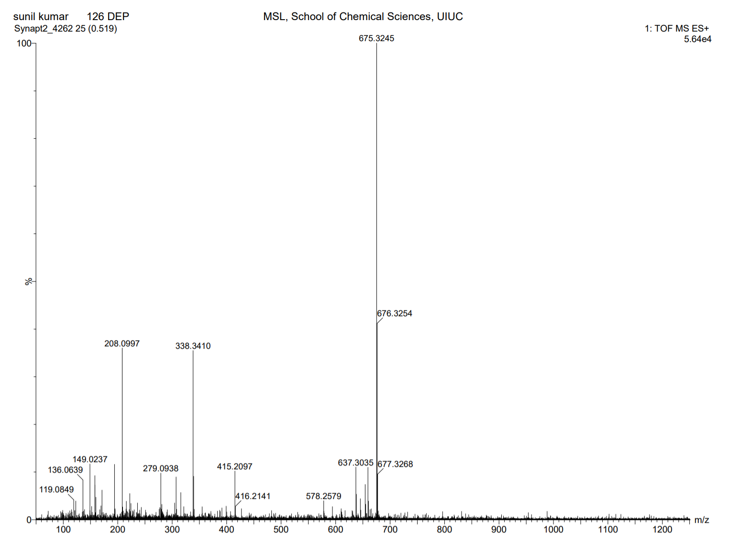
Supplementary Fig. 76. ¹H-NMR of NS127 Pro

¹H NMR (500 MHz, DMSO) δ 0.80 – 1.17 (m, 5H), 1.38 – 1.42 (s, 9H), 1.55 – 1.82 (m, 6H), 2.31 – 2.36 (s, 3H), 2.94 – 3.04 (t, J = 7.2 Hz, 2H), 3.30 – 3.31 (t, 3H), 3.99 – 4.07 (q, J = 6.8 Hz, 2H), 4.86 – 4.89 (s, 2H), 6.73 – 6.78 (t, J = 6.2 Hz, 1H), 6.92 – 6.97 (d, J = 7.9 Hz, 1H), 7.13 – 7.33 (m, 5H), 7.35 – 7.42 (d, J = 8.4 Hz, 1H), 7.42 – 7.47 (d, J = 7.7 Hz, 1H), 7.90 – 7.97 (d, J = 7.8 Hz, 1H), 8.52 – 8.58 (t, J = 5.8 Hz, 1H), 8.60 – 8.66 (dd, J = 8.1, 3.4 Hz, 2H), 9.82 – 9.87 (s, 1H), 10.33 – 10.37 (s, 1H). HRMS (m/z): [M]+ calcd. for C₃₉H₄₆N₈O₇, 739.3562; found, 739.3551.

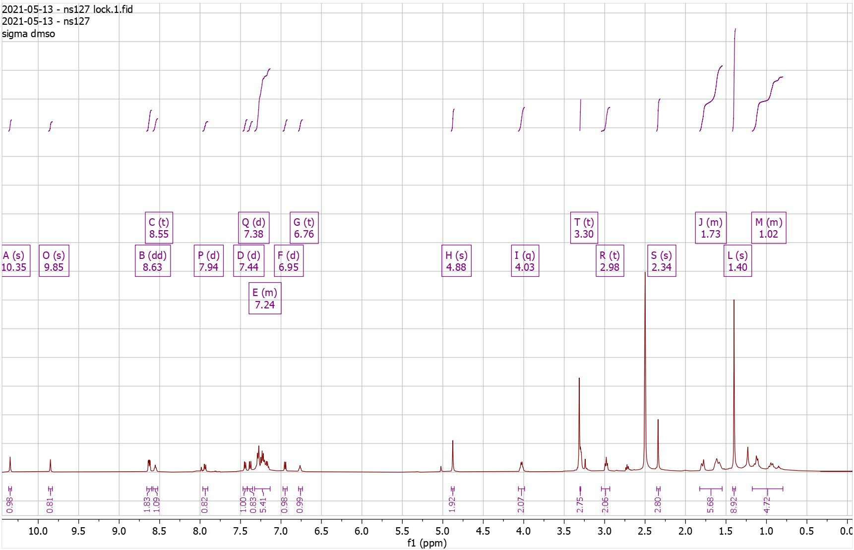
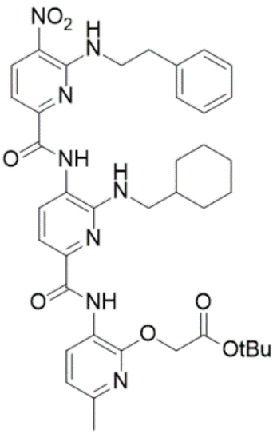
Supplementary Fig. 77. High Resolution Mass Spectrum for NS127 Pro
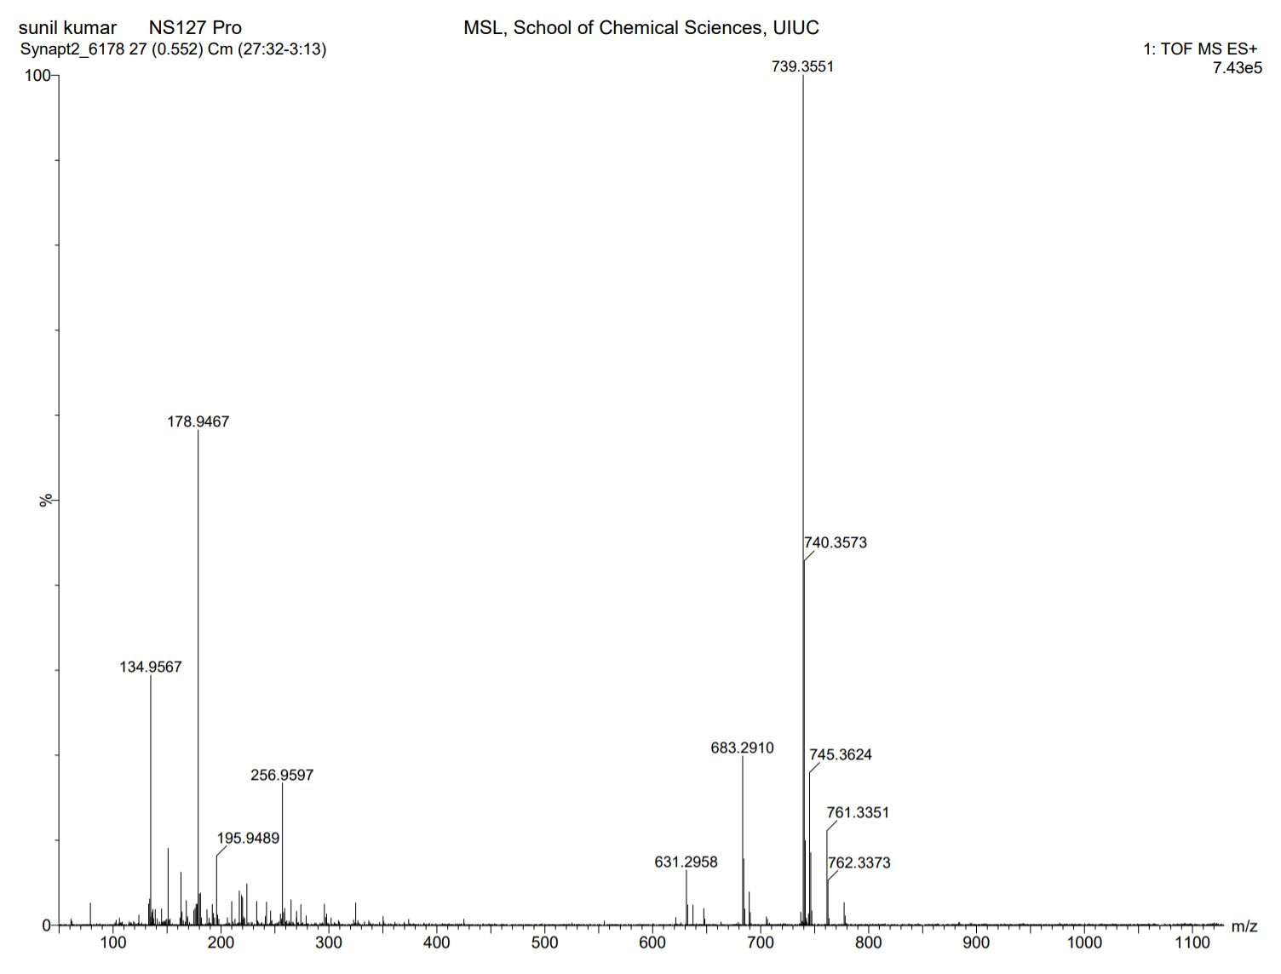
Supplementary Fig. 78. ¹H-NMR of NS127 Dep

¹H NMR (500 MHz, DMSO) δ 0.89 – 1.16 (m, 5H), 1.52 – 1.86 (m, 6H), 2.31 – 2.40 (s, 3H), 2.92 – 3.04 (t, J = 7.2 Hz, 2H), 3.23 – 3.33 (t, 2H), 3.99 – 4.07 (q, J = 6.7 Hz, 2H), 4.91 – 5.00 (s, 2H), 6.69 – 6.79 (t, J = 5.7 Hz, 1H), 6.88 – 6.98 (d, J = 7.9 Hz, 1H), 7.12 – 7.31 (m, 5H), 7.35 – 7.41 (d, J = 8.4 Hz, 1H), 7.41 – 7.48 (d, J = 7.7 Hz, 1H), 7.86 – 7.99 (d, J = 7.7 Hz, 1H), 8.48 – 8.58 (t, J = 5.8 Hz, 1H), 8.59 – 8.66 (dd, J = 8.2, 4.5 Hz, 2H), 9.80 – 9.88 (s, 1H), 10.33 – 10.39 (s, 1H). HRMS (m/z): [M]+ calcd. for C₃₅H₃₈N₈O₇, 683.2936; found, 683.2925.

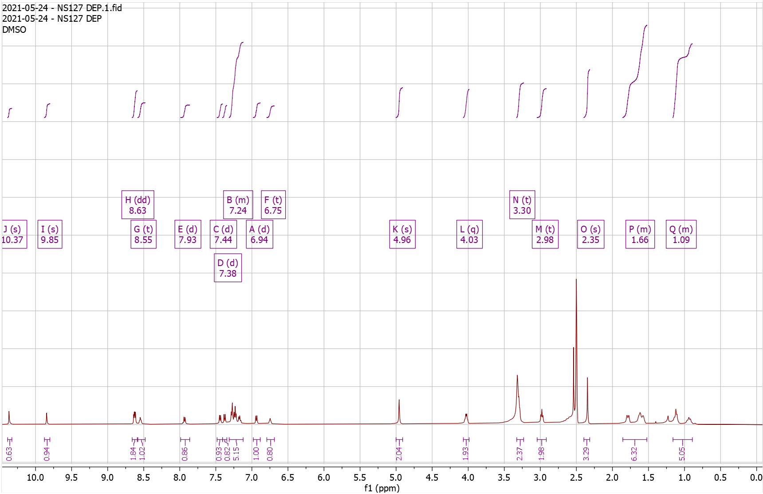
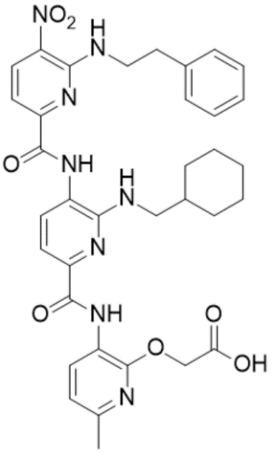
Supplementary Fig. 79. High Resolution Mass Spectrum for NS127 Dep

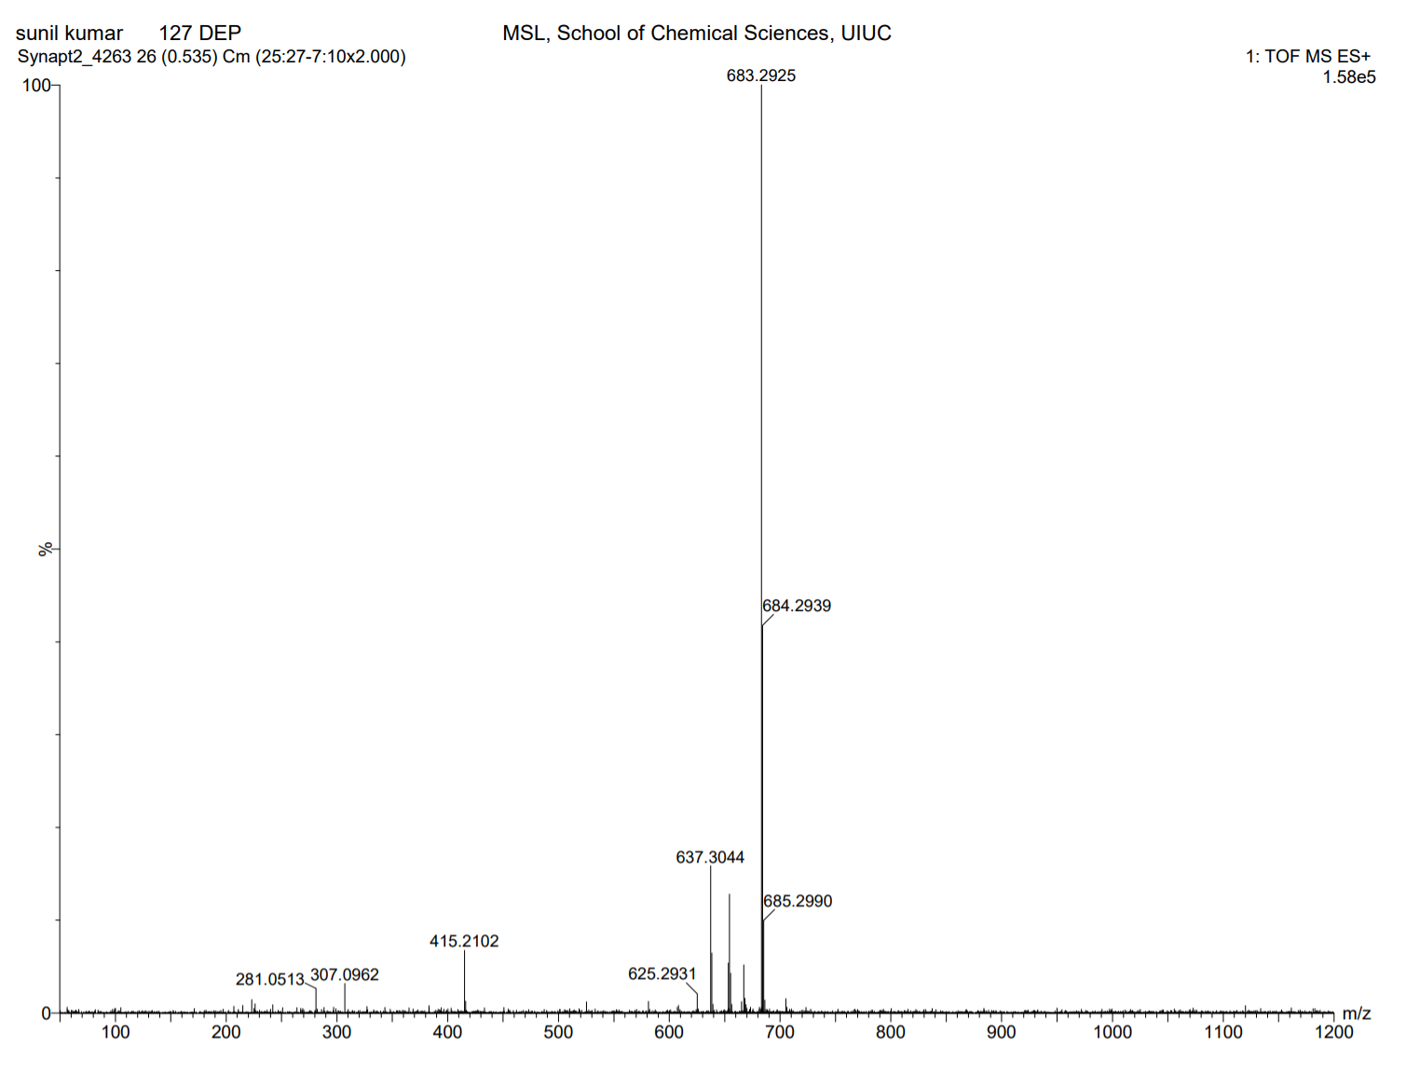
Supplementary Fig. 80. ¹H-NMR of NS129 Pro

¹H NMR (500 MHz, DMSO) δ 0.90 – 1.17 (dd, J = 81.8, 10.1 Hz, 5H), 1.29 – 1.49 (s, 9H), 1.50 – 1.87 (m, 6H), 2.30 – 2.37 (s, 3H), 3.27 – 3.40 (d, J = 6.7 Hz, 2H), 4.83 – 4.88 (s, 2H), 4.88 – 4.99 (s, 2H), 6.28 – 6.36 (s, 1H), 6.91 – 6.97 (d, J = 7.9 Hz, 1H), 7.38 – 7.49 (t, J = 7.5 Hz, 2H), 7.66 – 7.73 (s, 1H), 8.04 – 8.17 (d, J = 7.7 Hz, 1H), 8.59 – 8.68 (m, 2H), 8.96 – 9.04 (s, 1H), 10.17 – 10.29 (s, 1H), 10.31 – 10.45 (s, 1H). HRMS (m/z): [M]+ calcd. for C₃₅H₄₂N₁₀O₇, 715.3311; found, 715.3275.

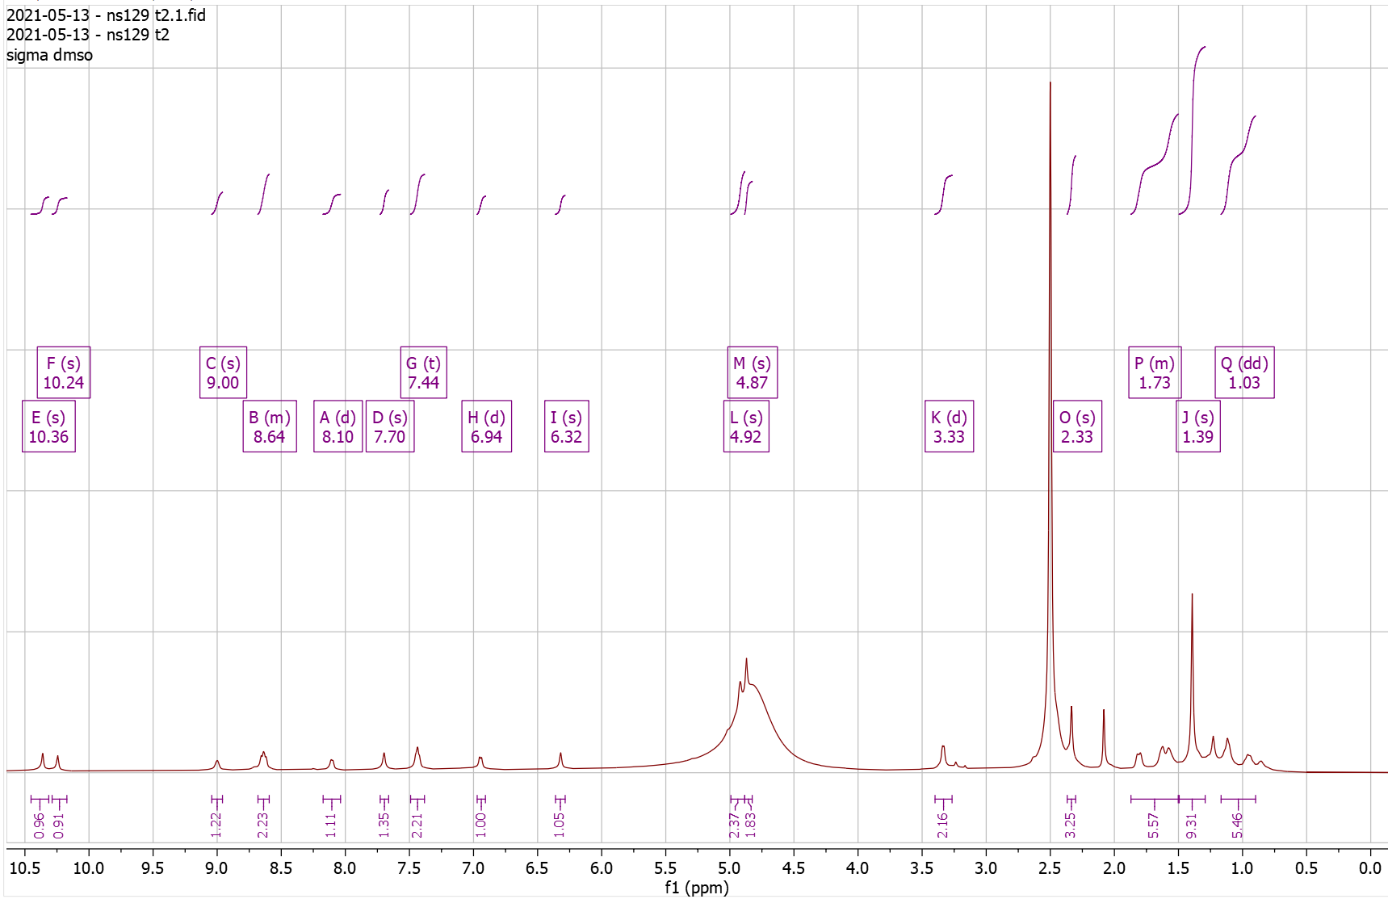
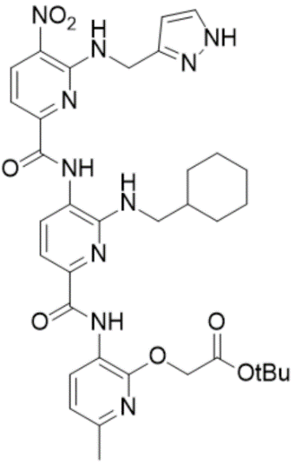
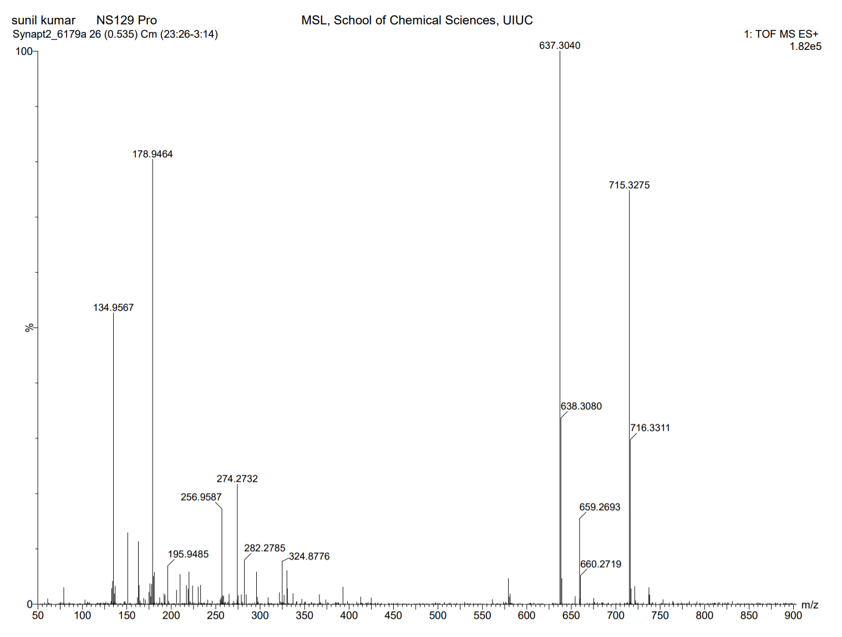
Supplementary Fig. 81. High Resolution Mass Spectrum for NS129 Pro

Supplementary Fig. 82. ¹H-NMR of NS129 Dep

¹H NMR (500 MHz, DMSO) δ 0.78 – 1.32 (m, 5H), 1.50 – 1.95 (m, 6H), 2.33 – 2.37 (s, 3H), 3.31 – 3.36 (d, J = 6.1 Hz, 2H), 4.87 – 4.92 (d, J = 5.1 Hz, 2H), 4.95 – 4.98 (s, 2H), 6.26 – 6.30 (s, 1H), 6.92 – 6.97 (d, J = 8.0 Hz, 1H), 7.10 – 7.14 (s, 1H), 7.16 – 7.22 (d, J = 10.3 Hz, 1H), 7.40 – 7.48 (dd, J = 13.0, 8.0 Hz, 2H), 7.62 – 7.66 (s, 1H), 8.13 – 8.18 (d, J = 8.0 Hz, 1H), 8.61 – 8.68 (t, J = 8.2 Hz, 2H), 8.97 – 9.03 (d, J = 5.8 Hz, 1H), 10.27 – 10.31 (s, 1H), 10.38 – 10.41 (s, 1H). HRMS (m/z): [M]+ calcd. for C₃₁H₃₄N₁₀O₇, 659.2685; found, 659.2673.

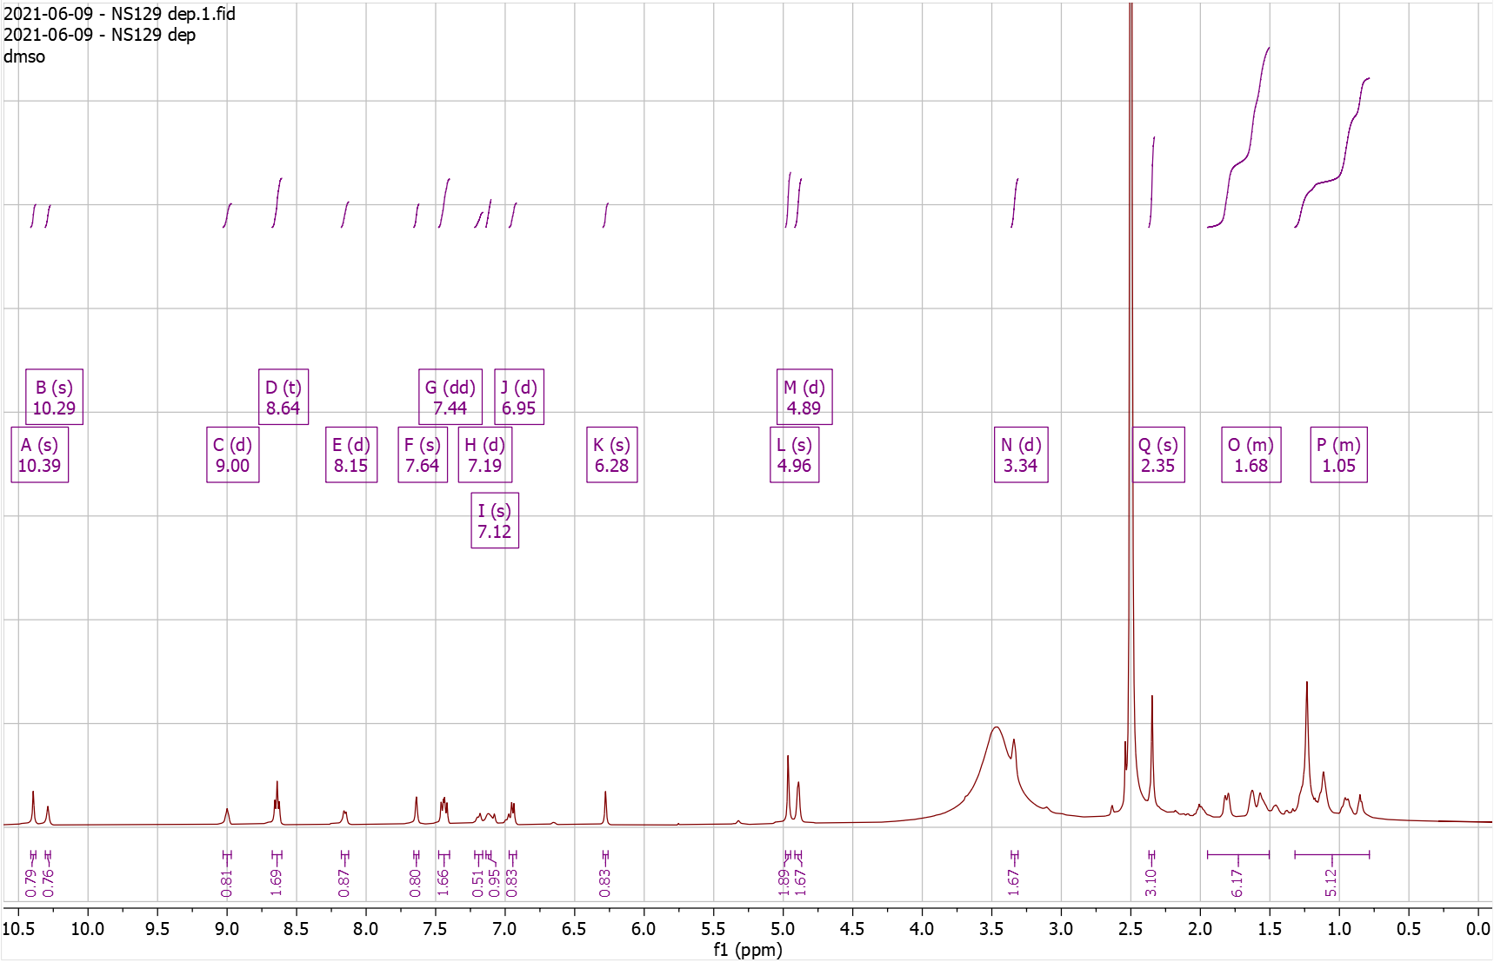
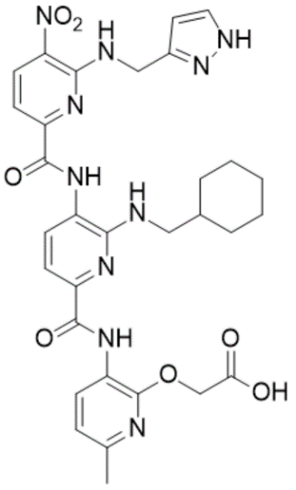
Supplementary Fig. 83. High Resolution Mass Spectrum for NS129 Dep
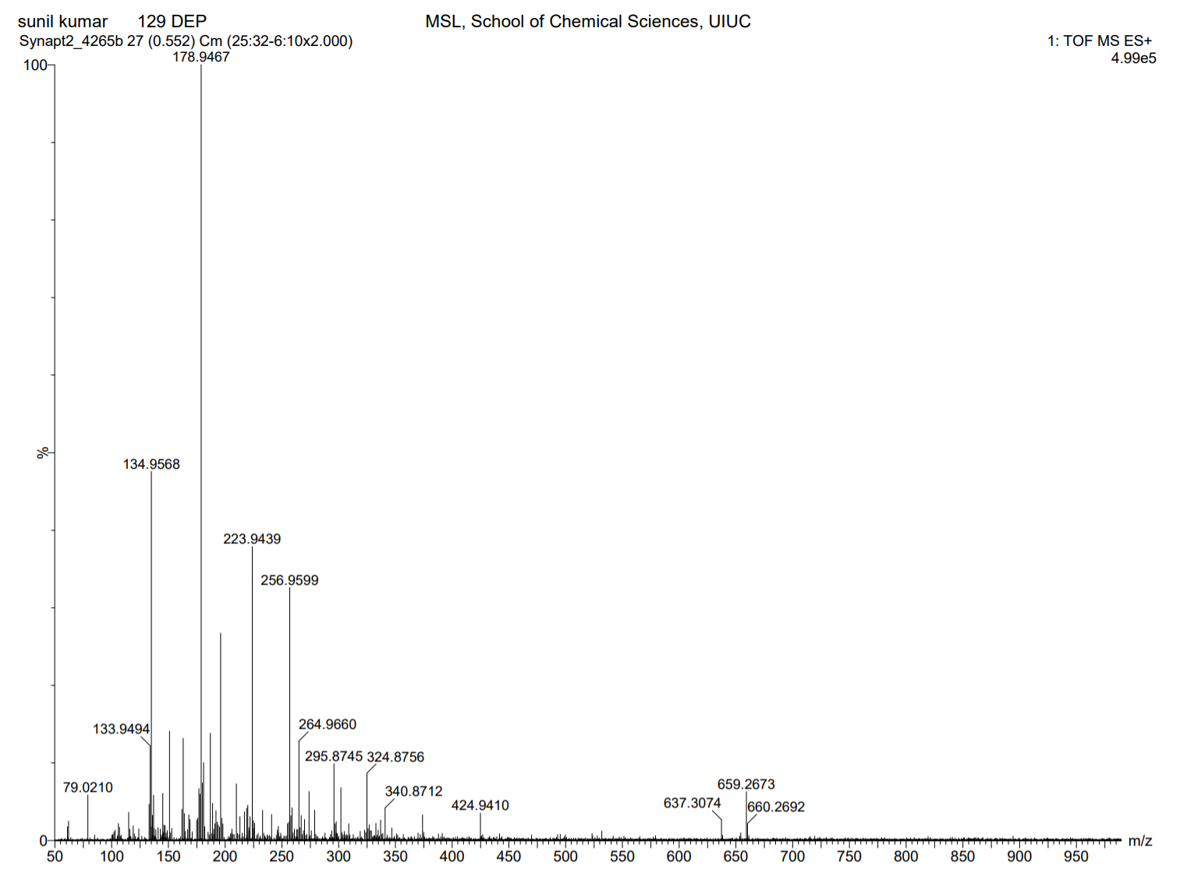
Supplementary Fig. 84. ¹H-NMR of NS130 Pro

¹H NMR (500 MHz, CDCl₃) δ 0.76 – 1.21 (m, 5H), 1.24 – 1.33 (s, 9H), 1.33 – 1.39 (s, 9H), 1.56 – 1.91 (m, 6H), 2.30 – 2.33 (s, 3H), 2.54 – 2.60 (t, J = 6.1 Hz, 2H), 3.38 – 3.43 (d, J = 6.8 Hz, 2H), 3.97 – 4.04 (q, J = 6.2 Hz, 2H), 4.77 – 4.82 (s, 2H), 6.72 – 6.77 (d, J = 8.0 Hz, 1H), 7.54 – 7.60 (dd, J = 8.1, 3.4 Hz, 2H), 7.98 – 8.04 (d, J = 7.9 Hz, 1H), 8.55 – 8.60 (d, J = 8.4 Hz, 1H), 8.65 – 8.70 (d, J = 7.9 Hz, 1H), 9.52 – 9.56 (s, 1H), 10.31 – 10.34 (s, 1H). HRMS (m/z): [M]+ calcd. for C₃₈H₅₀N₈O₉, 763.3774; found, 763.3752.

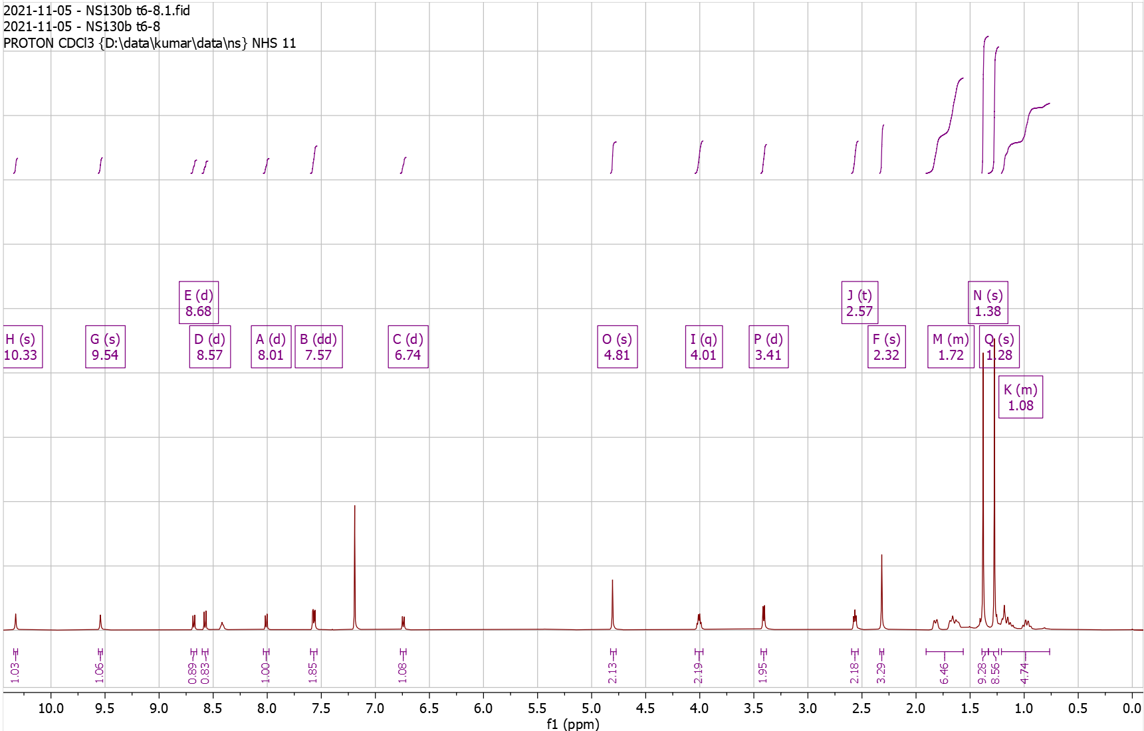
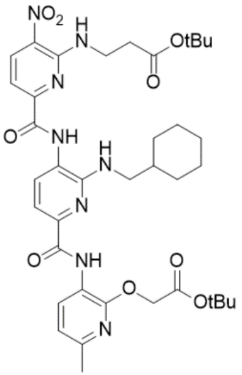
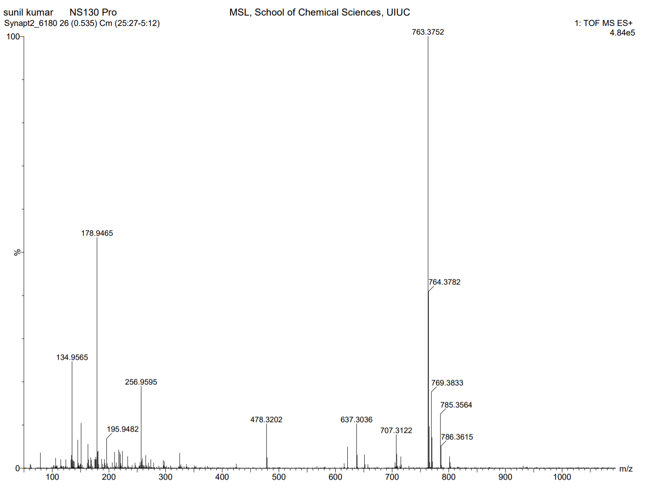
Supplementary Fig. 85. High Resolution Mass Spectrum for NS130 Pro

Supplementary Fig. 86. ¹H-NMR of NS130 Dep

¹H NMR (500 MHz, DMSO) δ 0.90 – 1.27 (dt, J = 96.8, 13.0 Hz, 5H), 1.56 – 1.86 (dd, J = 92.9, 19.4 Hz, 6H), 2.34 – 2.35 (s, 3H), 2.61 – 2.67 (t, J = 6.4 Hz, 2H), 3.98 – 4.06 (q, J = 6.3 Hz, 2H), 4.94 – 4.98 (s, 2H), 6.69 – 6.75 (t, J = 5.8 Hz, 1H), 6.92 – 6.97 (d, J = 8.0 Hz, 1H), 7.38 – 7.44 (d, J = 8.1 Hz, 2H), 7.84 – 7.89 (d, J = 7.7 Hz, 1H), 8.61 – 8.67 (dd, J = 8.2, 4.9 Hz, 2H), 8.68 – 8.74 (t, J = 5.9 Hz, 1H), 9.91 – 9.95 (s, 1H), 10.35 – 10.38 (s, 1H). HRMS (m/z): [M]+ calcd. for C₃₀H₃₄N₈O₉, 651.2522; found, 651.2520.

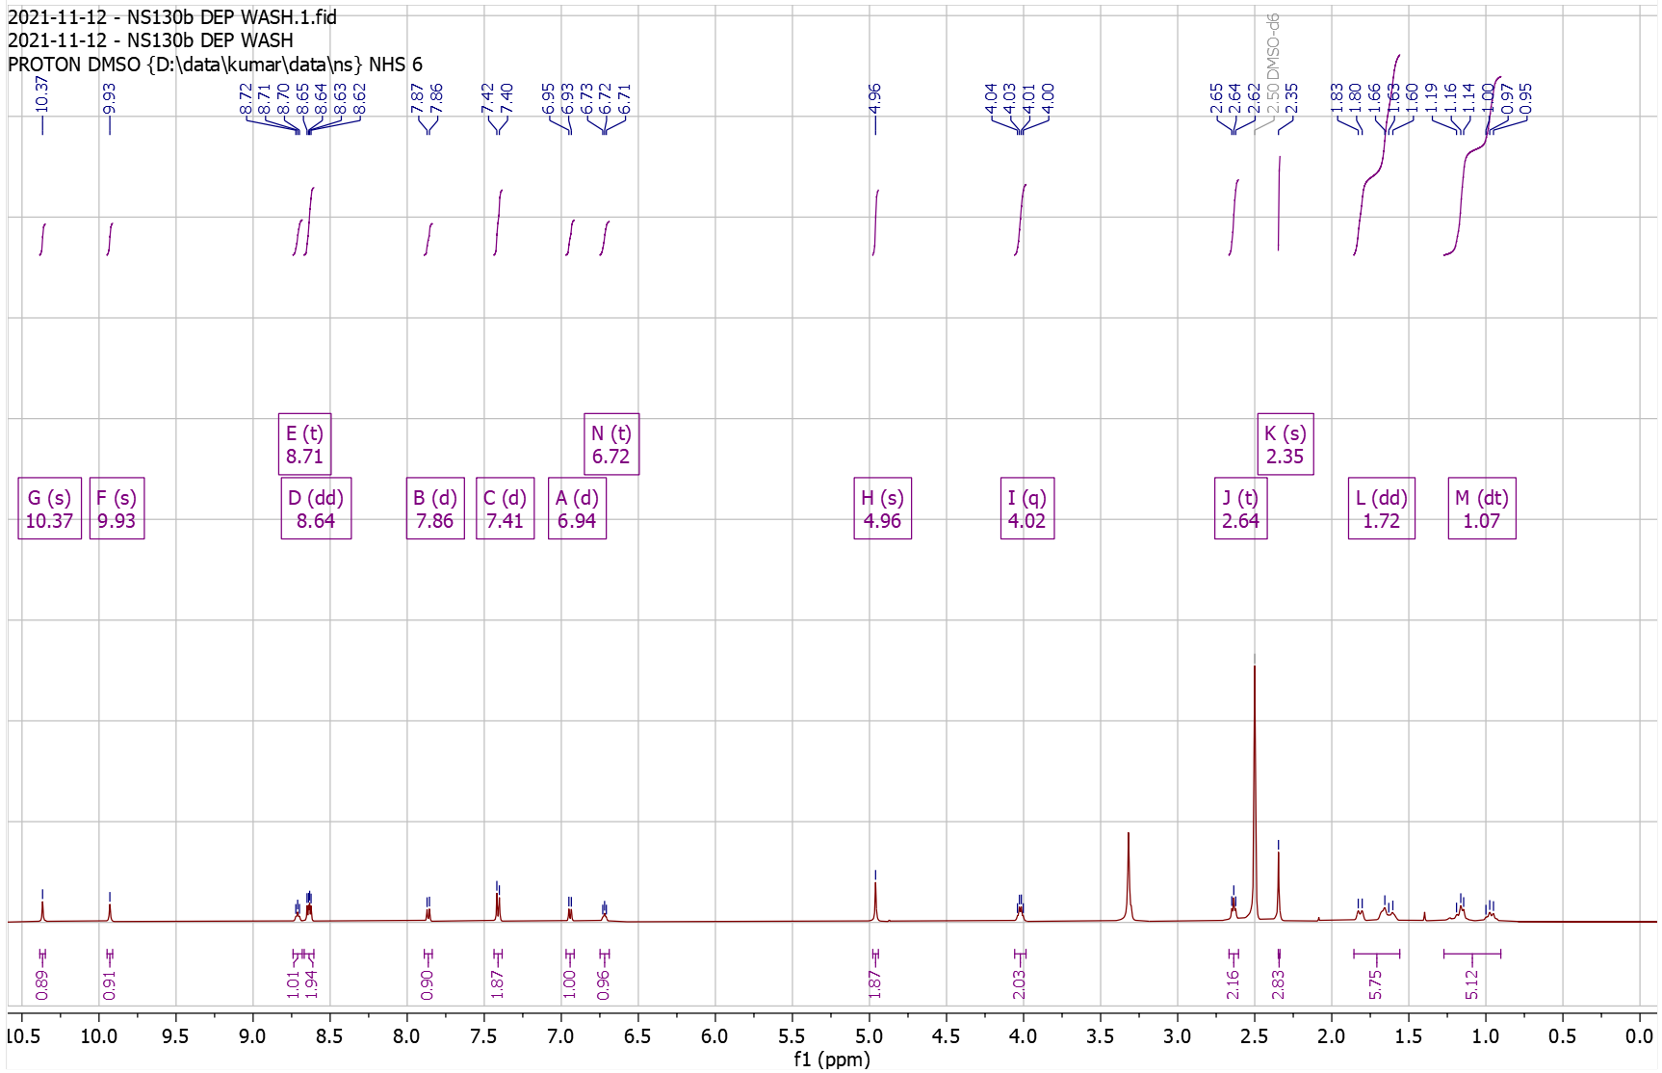
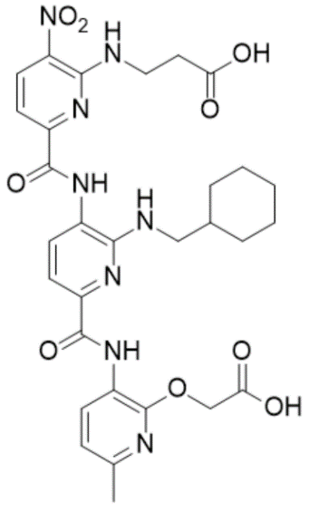
Supplementary Fig. 87. High Resolution Mass Spectrum for NS130 Dep
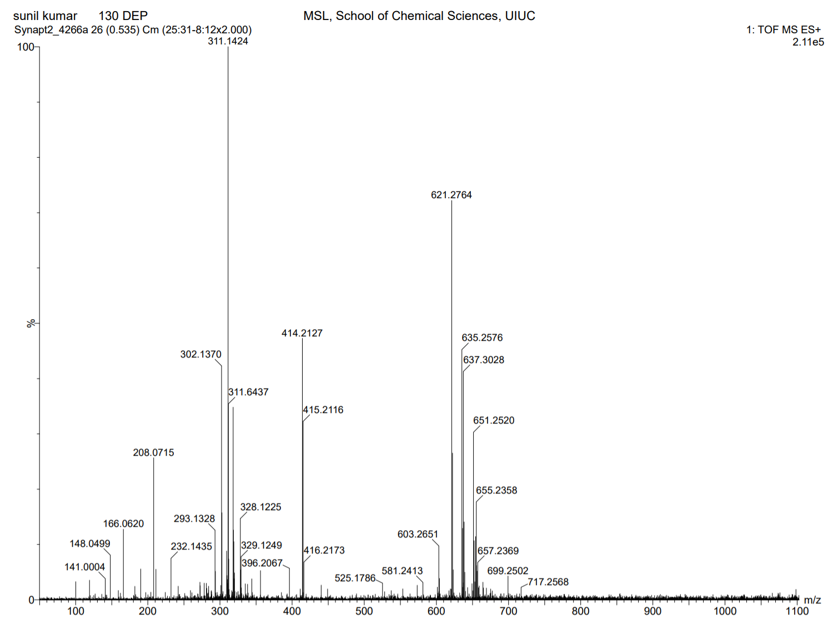
Supplementary Fig. 88. ¹H-NMR of NS131 Pro

¹H NMR (500 MHz, DMSO) δ 0.91 – 1.30 (m, 5H), 1.39 – 1.40 (s, 9H), 1.60 – 1.87 (m, 6H), 2.32 – 2.35 (s, 3H), 2.75 – 2.84 (t, J = 6.2 Hz, 2H), 3.97 – 4.13 (q, J = 6.1 Hz, 2H), 4.80 – 4.97 (s, 2H), 6.72 – 6.84 (t, J = 5.4 Hz, 1H), 6.91 – 6.98 (d, J = 7.9 Hz, 1H), 7.35 – 7.45 (dd, J = 8.1, 4.4 Hz, 2H), 7.85 – 7.94 (d, J = 7.6 Hz, 1H), 8.57 – 8.67 (dd, J = 8.2, 4.0 Hz, 2H), 9.05 – 9.14 (t, J = 5.5 Hz, 1H), 10.28 – 10.34 (s, 1H), 10.34 – 10.42 (s, 1H). HRMS (m/z): [M]+ calcd. for C₃₃H₄₂N₈O₁₀S, 743.2817; found, 743.2793.

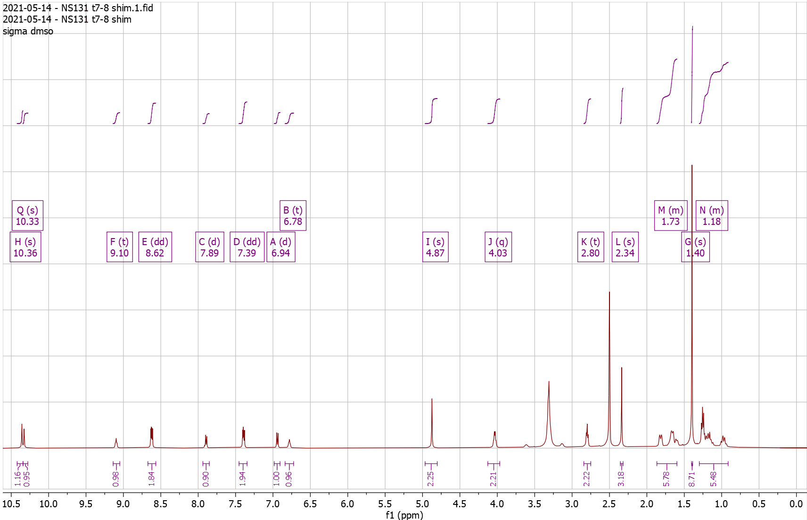
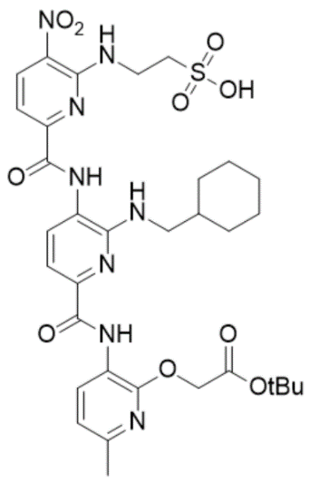
Supplementary Fig. 89. High Resolution Mass Spectrum for NS131 Pro
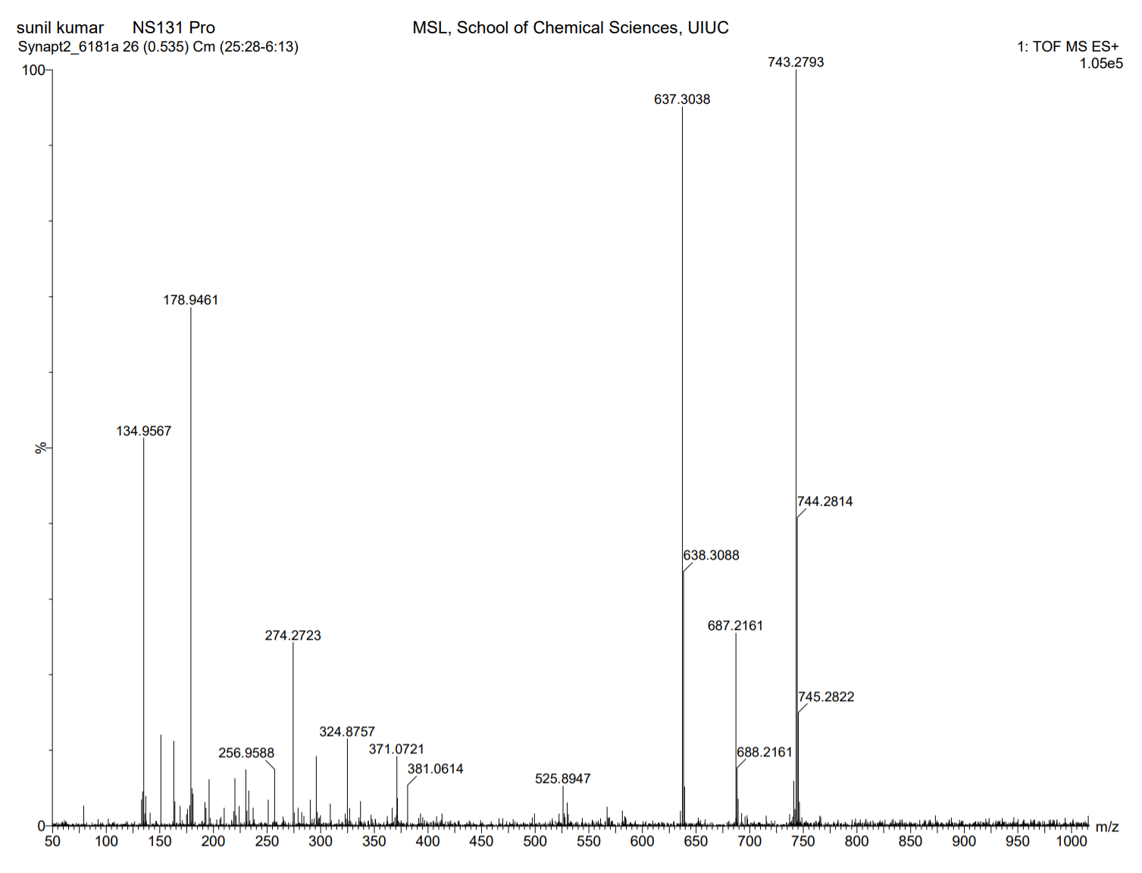
Supplementary Fig. 90. ¹H-NMR of NS131 Dep

¹H NMR (500 MHz, DMSO) δ 0.84 – 1.19 (m, 5H), 1.53 – 1.78 (m, 6H), 2.25 – 2.29 (s, 3H), 2.69 – 2.75 (t, J = 6.3 Hz, 2H), 3.92 – 4.00 (q, J = 6.1 Hz, 2H), 4.86 – 4.90 (s, 2H), 6.67 – 6.74 (t, J = 5.6 Hz, 1H), 6.84 – 6.90 (d, J = 7.9 Hz, 1H), 7.29 – 7.35 (dd, J = 8.1, 4.3 Hz, 2H), 7.80 – 7.85 (d, J = 7.7 Hz, 1H), 8.53 – 8.61 (dd, J = 8.1, 3.2 Hz, 2H), 9.00 – 9.06 (t, J = 5.6 Hz, 1H), 10.25 – 10.28 (s, 1H), 10.31 – 10.35 (s, 1H). HRMS (m/z): [M]+ calcd. for C₂₉H₃₄N₈O₁₀S, 687.2191; found, 687.2180.

Supplementary Fig. 91. High Resolution Mass Spectrum for NS131 Dep

Supplementary Fig. 92. ¹H-NMR of NS132 Pro

¹H NMR (500 MHz, DMSO) δ 0.81 – 1.18 (dt, J = 94.1, 11.7 Hz, 5H), 1.36 – 1.42 (s, 9H), 1.50 – 1.80 (m, 6H), 2.33 – 2.35 (s, 3H), 3.06 – 3.13 (t, J = 7.1 Hz, 2H), 3.23 – 3.29 (t, J = 6.1 Hz, 2H), 3.98 – 4.13 (q, J = 6.8 Hz, 2H), 4.83 – 4.90 (s, 2H), 6.71 – 6.76 (t, J = 5.6 Hz, 1H), 6.76 – 6.82 (t, J = 7.5 Hz, 1H), 6.91 – 6.97 (d, J = 7.9 Hz, 1H), 6.97 – 7.03 (t, J = 7.5 Hz, 1H), 7.19 – 7.23 (d, J = 2.3 Hz, 1H), 7.27 – 7.31 (d, J = 8.1 Hz, 1H), 7.34 – 7.39 (d, J = 8.4 Hz, 1H), 7.41 – 7.47 (d, J = 7.7 Hz, 1H), 7.51 – 7.58 (d, J = 7.9 Hz, 1H), 7.92 – 7.97 (d, J = 7.9 Hz, 1H), 8.55 – 8.68 (m, 3H), 9.81 – 9.87 (s, 1H), 10.31 – 10.38 (s, 1H), 10.79 – 10.85 (m, 1H). HRMS (m/z): [M]+ calcd. for C₄₁H₄₇N₉O₇, 778.3671; found, 778.3665.

Supplementary Fig. 93. High Resolution Mass Spectrum for NS132 Pro

Supplementary Fig. 94. ¹H-NMR of NS132 Dep

¹H NMR (500 MHz, DMSO) δ 0.84 – 1.13 (m, 5H), 1.49 – 1.83 (m, 6H), 2.33 – 2.36 (s, 3H), 3.06 – 3.16 (t, J = 7.1 Hz, 2H), 3.22 – 3.30 (t, J = 6.2 Hz, 2H), 3.99 – 4.14 (q, J = 6.7 Hz, 2H), 4.94 – 4.98 (s, 2H), 6.69 – 6.77 (t, J = 5.7 Hz, 1H), 6.77 – 6.83 (t, J = 7.4 Hz, 1H), 6.91 – 6.96 (d, J = 7.9 Hz, 1H), 6.97 – 7.03 (t, J = 7.6 Hz, 1H), 7.20 – 7.24 (d, J = 2.3 Hz, 1H), 7.28 – 7.33 (d, J = 8.1 Hz, 1H), 7.33 – 7.41 (d, J = 8.5 Hz, 1H), 7.41 – 7.47 (d, J = 7.7 Hz, 1H), 7.53 – 7.58 (d, J = 7.9 Hz, 1H), 7.93 – 7.98 (d, J = 7.7 Hz, 1H), 8.56 – 8.66 (td, J = 13.7, 12.0, 6.8 Hz, 3H), 9.83 – 9.87 (s, 1H), 10.33 – 10.38 (s, 1H), 10.83 – 10.87 (s, 1H), 12.88 – 13.07 (s, 1H). HRMS (m/z): [M]+ calcd. for C₃₇H₃₉N₉O₇, 722.3045; found, 722.3034.
Supplementary Fig. 95. ¹³C-NMR of NS132 Dep
13C NMR (126 MHz, DMSO) δ 23.25, 24.73, 25.52, 26.06, 30.69, 37.21, 41.66, 47.07, 54.90, 69.78, 109.64, 110.08, 111.38, 111.43, 116.49, 118.10, 118.16, 119.69, 120.91, 122.40, 123.03, 126.35, 127.18, 129.20, 132.17, 136.32, 137.37, 143.33, 148.53, 150.91, 151.67, 153.73, 162.21.
Supplementary Fig. 96. High Resolution Mass Spectrum for NS132 Dep

Supplementary Fig. 97. ¹H-NMR of NS138 Pro

¹H NMR (500 MHz, CDCl₃) δ 0.72 – 1.08 (m, 3H), 1.08 – 1.10 (d, J = 6.7 Hz, 6H), 1.10 – 1.33 (m, 3H), 1.45 – 1.46 (s, 9H), 1.64 – 1.91 (m, 5H), 2.02 – 2.13 (dt, J = 12.9, 6.5 Hz, 1H), 2.36 – 2.39 (s, 3H), 3.44 – 3.50 (t, J = 6.2 Hz, 2H), 3.50 – 3.55 (dd, J = 6.7, 5.4 Hz, 2H), 4.83 – 4.88 (s, 2H), 6.78 – 6.85 (d, J = 7.9 Hz, 1H), 7.58 – 7.65 (d, J = 8.4 Hz, 1H), 7.65 – 7.69 (d, J = 7.9 Hz, 1H), 7.90 – 7.94 (d, J = 7.9 Hz, 1H), 8.34 – 8.41 (s, 1H), 8.63 – 8.68 (d, J = 8.4 Hz, 1H), 8.71 – 8.75 (d, J = 7.9 Hz, 1H), 9.33 – 9.38 (s, 1H), 10.35 – 10.42 (s, 1H). HRMS (m/z): [M]+ calcd. for C₃₅H₄₆N₈O₇, 691.3562; found, 691.3537.

Supplementary Fig. 98. High Resolution Mass Spectrum for NS138 Pro

Supplementary Fig. 99. ¹H-NMR of NS138 Dep

¹H NMR (500 MHz, DMSO) δ 0.94 – 1.00 (d, J = 6.6 Hz, 5H), 1.58 – 1.86 (m, 6H), 1.10 – 1.29 (m, 5H), 1.99 – 2.07 (dq, J = 14.2, 7.7, 7.2 Hz, 1H), 2.25 – 2.40 (s, 3H), 3.59 – 3.65 (t, J = 6.3 Hz, 2H), 4.94 – 4.98 (s, 2H), 6.69 – 6.75 (t, J = 5.7 Hz, 1H), 6.91 – 6.96 (d, J = 7.9 Hz, 1H), 7.36 – 7.46 (dd, J = 22.4, 8.1 Hz, 2H), 7.90 – 7.94 (d, J = 7.8 Hz, 1H), 8.49 – 8.56 (t, J = 5.9 Hz, 1H), 8.60 – 8.63 (d, J = 5.0 Hz, 1H), 8.63 – 8.66 (d, J = 5.5 Hz, 1H), 9.77 – 9.80 (s, 1H), 10.32 – 10.37 (s, 1H). HRMS (m/z): [M]+ calcd. for C₃₁H₃₈N₈O₇, 635.2936; found, 635.2932.

Supplementary Fig. 100. High Resolution Mass Spectrum for NS138 Dep

Supplementary Fig. 101. ¹H-NMR of NS165 Pro

¹H NMR (500 MHz, CDCl3) δ 0.85 – 0.92 (m, 3H), 1.00 – 1.38 (m, 8H), 1.44 – 1.46 (s, 9H), 1.64 – 1.92 (m, 8H), 2.35 – 2.40 (s, 3H), 2.93 – 3.01 (t, J = 7.7 Hz, 3H), 3.38 – 3.51 (t, J = 6.2 Hz, 2H), 3.59 – 3.72 (td, J = 7.0, 5.2 Hz, 2H), 4.81 – 4.87 (s, 2H), 4.87 – 4.95 (t, J = 5.7 Hz, 1H), 6.72 – 6.83 (d, J = 7.9 Hz, 1H), 7.52 – 7.62 (d, J = 8.4 Hz, 1H), 7.62 – 7.69 (d, J = 7.8 Hz, 1H), 7.86 – 7.97 (d, J = 7.8 Hz, 1H), 8.20 – 8.32 (t, J = 5.3 Hz, 1H), 8.58 – 8.67 (d, J = 8.4 Hz, 1H), 8.67 – 8.74 (d, J = 7.9 Hz, 1H), 9.32 – 9.42 (s, 1H), 10.30 – 10.40 (s, 1H). HRMS (m/z): [M]+ calcd. for C₃₇H₅₀N₈O₇, 719.3875; found, 719.3874.
Supplementary Fig. 102. High Resolution Mass Spectrum for NS165 Pro

Supplementary Fig. 103. ¹H-NMR of NS165 Dep

¹H NMR (500 MHz, DMSO) δ 0.76 – 0.84 (t, J = 6.9 Hz, 3H), 0.92 – 1.41 (m, 11H), 1.57 – 1.87 (m, 8H), 2.29 – 2.39 (s, 3H), 3.29 – 3.33 (t, 2H), 3.70 – 3.81 (q, J = 6.6 Hz, 2H), 4.93 – 5.02 (s, 2H), 6.73 – 6.80 (t, J = 5.7 Hz, 1H), 6.91 – 6.96 (d, J = 7.9 Hz, 1H), 7.34 – 7.41 (d, J = 8.4 Hz, 1H), 7.41 – 7.46 (d, J = 7.8 Hz, 1H), 7.94 – 7.99 (d, J = 7.8 Hz, 1H), 8.45 – 8.57 (t, J = 5.7 Hz, 1H), 8.57 – 8.69 (dd, J = 8.2, 3.0 Hz, 2H), 9.75 – 9.82 (s, 1H), 10.29 – 10.43 (s, 1H). HRMS (m/z): [M]+ calcd. for C₃₃H₄₂N₈O₇, 663.3249; found, 663.3253.

Supplementary Fig. 104. High Resolution Mass Spectrum for NS165 Dep
Supplementary Fig. 105. ¹H-NMR of NS166 Pro

¹H NMR (500 MHz, CDCl₃) δ 0.87 – 1.35 (m, 5H), 1.44 – 1.48 (s, 9H), 1.65 – 1.92 (m, 6H), 2.33 – 2.41 (s, 3H), 3.38 – 3.47 (t, J = 6.2 Hz, 2H), 3.86 – 3.94 (q, J = 5.4 Hz, 2H), 3.97 – 4.04 (t, J = 4.9 Hz, 2H), 4.82 – 4.89 (s, 2H), 5.23 – 5.29 (t, J = 5.5 Hz, 1H), 6.72 – 6.80 (d, J = 7.9 Hz, 1H), 7.56 – 7.64 (d, J = 8.2 Hz, 2H), 8.06 – 8.16 (d, J = 7.8 Hz, 1H), 8.47 – 8.51 (t, J = 5.6 Hz, 1H), 8.54 – 8.62 (d, J = 8.4 Hz, 1H), 8.63 – 8.71 (d, J = 7.8 Hz, 1H), 9.45 – 9.53 (s, 1H), 10.26 – 10.33 (s, 1H). HRMS (m/z): [M]+ calcd. for C₃₃H₄₂N₈O₈, 679.3198; found, 679.3203.

Supplementary Fig. 106. High Resolution Mass Spectrum for NS166 Pro

Supplementary Fig. 107. ¹H-NMR of NS166 Dep

¹H NMR (500 MHz, DMSO) δ 0.90 – 1.25 (dt, J = 96.3, 12.3 Hz, 5H), 1.54 – 1.85 (m, 6H), 2.29 – 2.32 (s, 3H), 3.27 – 3.32 (t, J = 6.1 Hz, 2H), 3.64 – 3.70 (t, J = 5.5 Hz, 2H), 3.83 – 3.90 (q, J = 5.5 Hz, 2H), 4.75 – 4.79 (s, 2H), 6.65 – 6.75 (t, J = 5.6 Hz, 1H), 6.78 – 6.88 (d, J = 7.9 Hz, 1H), 7.33 – 7.47 (dd, J = 8.1, 5.5 Hz, 2H), 7.88 – 7.94 (d, J = 7.8 Hz, 1H), 8.52 – 8.60 (m, 2H), 8.60 – 8.70 (d, J = 8.4 Hz, 1H), 9.89 – 10.03 (s, 1H), 10.34 – 10.48 (s, 1H). HRMS (m/z): [M]+ calcd. for C₂₉H₃₄N₈O₈, 623.2572; found, 623.2581.
Supplementary Fig. 108. High Resolution Mass Spectrum for NS166 Dep
Supplementary Fig. 109. ¹H-NMR of NS168 Pro

¹H NMR (500 MHz, CDCl₃) δ 0.85 – 1.30 (m, 5H), 1.45 – 1.49 (s, 9H), 1.53 – 1.90 (m, 6H), 2.31 – 2.44 (s, 3H), 2.89 – 3.05 (t, J = 7.0 Hz, 2H), 3.36 – 3.47 (t, J = 6.2 Hz, 2H), 3.83 – 3.95 (q, J = 6.6 Hz, 2H), 4.80 – 4.94 (m, 3H), 5.32 – 5.45 (s, 1H), 6.66 – 6.76 (d, J = 8.3 Hz, 2H), 6.76 – 6.83 (d, J = 7.9 Hz, 1H), 7.04 – 7.10 (d, J = 8.1 Hz, 2H), 7.54 – 7.61 (d, J = 8.3 Hz, 1H), 7.60 – 7.68 (d, J = 7.8 Hz, 1H), 7.84 – 7.93 (d, J = 7.8 Hz, 1H), 8.25 – 8.36 (t, J = 5.4 Hz, 1H), 8.56 – 8.65 (d, J = 8.3 Hz, 1H), 8.68 – 8.74 (d, J = 7.9 Hz, 1H), 9.27 – 9.41 (s, 1H), 10.35 – 10.42 (s, 1H). HRMS (m/z): [M]+ calcd. for C₃₉H₄₆N₈O₈, 755.3511; found, 755.3497.

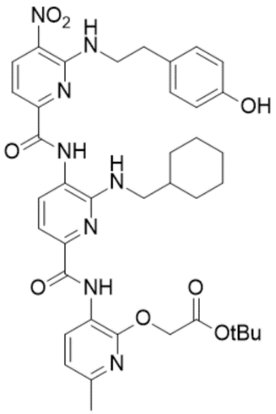
Supplementary Fig. 110. High Resolution Mass Spectrum for NS168 Pro
Supplementary Fig. 111. ¹H-NMR of NS168 Dep
¹H NMR (500 MHz, DMSO) δ 0.77 – 1.21 (m, 5H), 1.49 – 1.90 (m, 6H), 2.33 – 2.37 (s, 3H), 2.82 – 2.89 (t, J = 7.1 Hz, 2H), 3.27 – 3.31 (t, J = 6.4 Hz, 2H), 3.92 – 3.99 (q, J = 6.7 Hz, 2H), 4.96 – 4.98 (s, 2H), 6.60 – 6.65 (d, J = 8.3 Hz, 2H), 6.73 – 6.79 (t, J = 5.7 Hz, 1H), 6.92 – 6.97 (d, J = 7.9 Hz, 1H), 7.04 – 7.09 (d, J = 8.1 Hz, 2H), 7.35 – 7.40 (d, J = 8.4 Hz, 1H), 7.41 – 7.47 (d, J = 7.7 Hz, 1H), 7.90 – 7.95 (d, J = 7.8 Hz, 1H), 8.47 – 8.52 (t, J = 5.7 Hz, 1H), 8.60 – 8.67 (dd, J = 8.1, 6.3 Hz, 2H), 9.14 – 9.17 (s, 1H), 9.84 – 9.87 (s, 1H), 10.35 – 10.39 (s, 1H). HRMS (m/z): [M]+ calcd. for C₃₅H₃₈N₈O₈, 699.2885; found, 699.2873.

Supplementary Fig. 112. High Resolution Mass Spectrum for NS168 Dep
Supplementary Fig. 113. ¹H-NMR of NS169 Pro

¹H NMR (500 MHz, CDCl3) δ 0.71 – 1.38 (m, 5H), 1.44 – 1.47 (s, 9H), 1.55 – 1.96 (m, 6H), 2.37 – 2.40 (s, 3H), 2.50 – 2.55 (s, 3H), 3.49 – 3.54 (d, J = 6.8 Hz, 2H), 4.85 – 4.89 (s, 2H), 4.93 – 4.97 (d, J = 5.6 Hz, 2H), 6.79 – 6.84 (d, J = 7.9 Hz, 1H), 7.63 – 7.69 (dd, J = 8.1, 3.4 Hz, 2H), 8.21 – 8.29 (m, 2H), 8.61 – 8.67 (m, 2H), 8.73 – 8.78 (d, J = 7.9 Hz, 1H), 8.86 – 8.92 (t, J = 5.6 Hz, 1H), 9.93 – 9.96 (s, 1H), 10.40 – 10.43 (s, 1H). HRMS (m/z): [M]+ calcd. for C₃₇H₄₄N₁₀O₇, 741.3467; found, 741.3457.
Supplementary Fig. 114. High Resolution Mass Spectrum for NS169 Pro
Supplementary Fig. 115. ¹H-NMR of NS169 Dep

¹H NMR (500 MHz, DMSO) δ 0.90 – 1.19 (dd, J = 83.9, 10.2 Hz, 5H), 1.50 – 1.85 (m, 6H), 2.34 – 2.36 (s, 3H), 2.45 – 2.46 (s, 3H), 3.33 – 3.37 (d, J = 6.9 Hz, 2H), 4.92 – 4.99 (s, 2H), 5.05 – 5.16 (d, J = 5.6 Hz, 2H), 6.74 – 6.84 (t, J = 5.9 Hz, 1H), 6.91 – 6.97 (d, J = 8.0 Hz, 1H), 7.36 – 7.48 (dd, J = 8.1, 5.4 Hz, 2H), 7.87 – 7.94 (d, J = 7.8 Hz, 1H), 8.38 – 8.46 (s, 1H), 8.60 – 8.73 (m, 3H), 9.18 – 9.26 (t, J = 5.6 Hz, 1H), 9.96 – 10.05 (s, 1H), 10.31 – 10.42 (s, 1H). HRMS (m/z): [M]+ calcd. for C₃₃H₃₆N₁₀O₇, 685.2841; found, 685.2844.
Supplementary Fig. 116. High Resolution Mass Spectrum for NS169 Dep
Supplementary Fig. 117. ¹H-NMR of NS174 Pro

¹H NMR (500 MHz, CDCl3) δ 0.82 – 1.34 (m, 5H), 1.42 – 1.50 (s, 9H), 1.64 – 1.93 (m, 6H), 2.09 – 2.11 (t, J = 2.7 Hz, 1H), 2.36 – 2.39 (s, 3H), 2.64 – 2.69 (td, J = 6.6, 2.7 Hz, 2H), 3.43 – 3.52 (d, J = 5.7 Hz, 2H), 3.85 – 3.93 (q, J = 6.3 Hz, 2H), 4.84 – 4.88 (s, 2H), 4.93 – 5.00 (s, 1H), 6.77 – 6.82 (d, J = 7.9 Hz, 1H), 7.62 – 7.67 (dd, J = 8.1, 2.5 Hz, 2H), 7.91 – 7.97 (d, J = 7.9 Hz, 1H), 8.47 – 8.53 (t, J = 5.9 Hz, 1H), 8.63 – 8.68 (d, J = 8.4 Hz, 1H), 8.68 – 8.73 (d, J = 7.9 Hz, 1H), 9.36 – 9.40 (s, 1H), 10.34 – 10.38 (s, 1H). HRMS (m/z): [M]+ calcd. for C₃₅H₄₂N₈O₇, 687.3249; found, 687.3240.
Supplementary Fig. 118. High Resolution Mass Spectrum for NS174 Pro
Supplementary Fig. 119. ¹H-NMR of NS174 Dep

¹H NMR (500 MHz, DMSO) δ 0.90 – 1.28 (m, 5H), 1.55 – 1.88 (m, 6H), 2.32 – 2.36 (s, 3H), 2.57 – 2.63 (td, J = 6.8, 2.7 Hz, 2H), 2.84 – 2.91 (t, J = 2.6 Hz, 1H), 3.28 – 3.34 (t, J = 6.3 Hz, 2H), 3.86 – 3.99 (q, J = 6.6 Hz, 2H), 4.94 – 4.97 (s, 2H), 6.65 – 6.77 (t, J = 5.8 Hz, 1H), 6.88 – 6.99 (d, J = 8.0 Hz, 1H), 7.38 – 7.47 (d, J = 8.1 Hz, 2H), 7.83 – 7.91 (d, J = 7.7 Hz, 1H), 8.58 – 8.71 (m, 3H), 9.85 – 9.95 (s, 1H), 10.32 – 10.42 (s, 1H), 12.80 – 13.13 (s, 1H). HRMS (m/z): [M]+ calcd. for C₃₁H₃₄N₈O₇, 631.2623; found, 631.2605.
Supplementary Fig. 120. High Resolution Mass Spectrum for NS174 Dep

Supplementary Fig. 121. ¹H-NMR of NS163

¹H NMR (500 MHz, DMSO) δ 0.99 – 1.33 (m, 4H), 1.39 – 1.80 (m, 6H), 2.30 – 2.38 (d, J = 4.0 Hz, 3H), 3.05 – 3.14 (d, J = 13.0 Hz, 2H), 3.97 – 4.11 (q, J = 6.7 Hz, 2H), 4.94 – 4.97 (s, 1H), 5.00 – 5.04 (s, 1H), 6.77 – 6.83 (dd, J = 9.7, 4.8 Hz, 1H), 6.92 – 6.97 (dd, J = 8.0, 4.6 Hz, 1H), 6.98 – 7.04 (dt, J = 9.3, 4.6 Hz, 1H), 7.20 – 7.23 (d, J = 2.5 Hz, 1H), 7.29 – 7.32 (d, J = 7.6 Hz, 1H), 7.35 – 7.38 (d, J = 8.4 Hz, 1H), 7.42 – 7.45 (dd, J = 7.7, 3.3 Hz, 1H), 7.54 – 7.58 (dd, J = 8.0, 3.2 Hz, 1H), 7.94 – 7.98 (d, J = 7.7 Hz, 1H), 8.56 – 8.65 (m, 3H), 9.83 – 9.86 (s, 1H), 10.32 – 10.39 (s, 1H), 10.83 – 10.85 (d, J = 2.7 Hz, 1H).HRMS (m/z): [M]+ calcd. for C₃₇H₄₁N₁₀O₇, 737.3160; found, 737.3156.

Supplementary Fig. 122. High Resolution Mass Spectrum for NS163

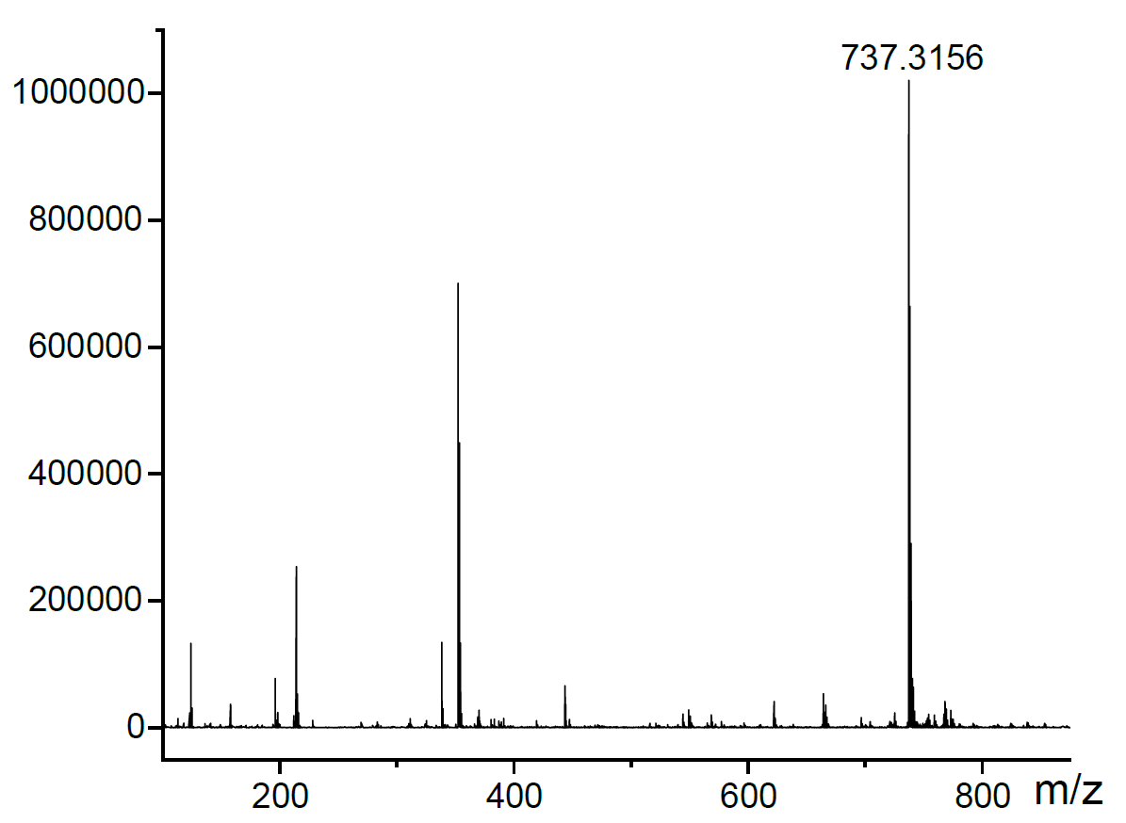
References:
- Yadav, J. S., Balanarsaiah, E., Raghavendra, S. & Satyanarayana, M. Chemoselective hydrolysis of tert-butyl esters in acetonitrile using molecular iodine as a mild and efficient catalyst. Tetrahedron Lett. 47, 4921–4924 (2006).

- Wu, Y., Limburg, D. C., Wilkinson, D. E., Vaal, M. J. & Hamilton, G. S. A mild deprotection procedure for tert-butyl esters and tert-butyl ethers using ZnBr₂ in methylene chloride. Tetrahedron Lett. 41, 2847–2849 (2000).

- Huang, C., Ren, G., Zhou, H. & Wang, C. A new method for purification of recombinant human α-synuclein in Escherichia coli. Protein Expr. Purif. 42, 173–177 (2005).

- Ahmed, J. et al. Foldamers reveal and validate therapeutic targets associated with toxic α-synuclein self-assembly. Nat Commun 13, 2273 (2022).

- Eliezer, D., Kutluay, E., Bussell, R. & Browne, G. Conformational properties of α-synuclein in its free and lipid-associated states 1 1Edited by P. E. Wright. J. Mol. Biol. 307, 1061–1073 (2001).

- Harrington, A. J., Yacoubian, T. A., Slone, S. R., Caldwell, K. A. & Caldwell, G. A. Functional analysis of VPS41-mediated neuroprotection in Caenorhabditis elegans and mammalian models of Parkinson’s disease. J. Neurosci. 32, 2142–2153 (2012).

- Brenner, S. The genetics of Caenorhabditis elegans. Genetics. 77, 71–94 (1974).

- Chaudhuri, J., Parihar, M. & Pires-daSilva, A. An introduction to worm lab: from culturing worms to mutagenesis. J. Vis. Exp. 2293 (2011).

- Simonetta, S. Chemotaxis in C.elegans (ARENA system). Phylumtech https://www.phylumtech.com/home/en/chemotaxis-in-c-elegans-arena/ (2019).

- Margie, O., Palmer, C. & Chin-Sang, I. C. elegans chemotaxis assay. J. Vis. Exp. 50069 (2013).

- Garcia-Moreno, J. C., Porta de la Riva, M., Martínez-Lara, E., Siles, E. & Cañuelo, A. Tyrosol, a simple phenol from EVOO, targets multiple pathogenic mechanisms of neurodegeneration in a C. elegans model of parkinson’s disease. Neurobiol. Aging 82, 60–68 (2019).

- Currey, H. N., Malinkevich, A., Melquist, P. & Liachko, N. F. Arena-based activity profiling of tau and TDP-43 transgenic C. elegans. MicroPubl. Biol. (2020).

- Habchi, J. et al. An anticancer drug suppresses the primary nucleation reaction that initiates the production of the toxic Aβ42 aggregates linked with Alzheimer’s disease. Sci. Adv. 2, e1501244 (2016).

- Yoon, D., Lee, M.-H. & Cha, D. Measurement of intracellular ROS in Caenorhabditis elegans using 2’,7’-Dichlorodihydrofluorescein diacetate. BIO-Protoc. 8, (2018).

