SUPPLEMENTARY MATERIAL

Source-specific risks apportionment and critical sources identification of potentially toxic elements in arable soils combining integrated positive matrix factorization model with multivariate analysis and machine learning classifiers: a case study of the Pannonia Basin
Biljana D. Škrbić ^{1,}*, Maja Buljovčić ¹, Igor Antić ¹ and Csaba Vágvölgyi ²

¹University of Novi Sad, Faculty of Technology Novi Sad, Bulevar cara Lazara 1, 21000 Novi Sad, Republic of Serbia
²Department of Microbiology, Faculty of Science and Informatics, University of Szeged, 6726 Szeged, Közép fasor 52., Hungary

*Correspondence: biljana@tf.uns.ac.rs;
Tel.: +381 642287762

Text SI-1 Sample collection
In order to evaluate levels of PTEs in soil intended for organic and conventional food production, to compare obtained concentrations with maximum allowed concentrations set by Dutch standard (Dutch standard, 2000) and to the geochemical (non-toxicological) threshold values determined for agricultural soils of south Europe (Reimann et al., 2018), and to reveal pollution sources, a total of 24 composite soil samples (Fig. 1; 0-30 cm) were collected in August 2019 from different locations at 8 villages: Totovo Selo (samples no. 1, 2, 24), Čantavir (samples no. 3-8), Madaras (samples no. 9, 11-13), Gložan (samples no. 14, 17, 23), Čenej (samples no. 15, 16, 18-21), Temerin (samples no. 22), and Ásotthalom (samples no. 10). Five (samples no. 9-13) of twenty-four composite soil samples were collected in cross-border region between Hungary-Serbia also belonging to the Pannonia Basin. Selection of sampling locations was made to cover the biggest areas of arable soil used for conventional and organic agricultural production of vegetables such as pepper, tomato, carrot, and potato, and to be representative for the agricultural regions to be in the vicinity and belonging to the listed villages.
Arable soil samples were divided into two groups based on applied agricultural management practice “conventional” (sample no. 1-13) and “organic” (sample no. 14-24). In early 1950s in studied area intensive agriculture had been started while the organic production has been established in 1989. The organic production in investigated area has upward trend and most of the organic production areas are dedicated to fruits and cereals. The predominant certified organic crops are: barley, maize, oats, spelts, wheats, apples, tomato, pepper and bean. In order to ensure representativeness of samples, each soil sample consisted of 20 subsamples was collected randomly within area of approximately 1000x1000 m. Subsamples were thoroughly mixed to provide a composite soil sample of approximately 3 kg. After that, soil samples were transported to the laboratory, where they were air dried at room temperature (25 °C), grounded to pass through a 2-mm sieve. The sieved samples were homogenized and then stored (at 4 °C) in hermetically sealed polyethylene bags until analysis (Škrbić et al., 2021).
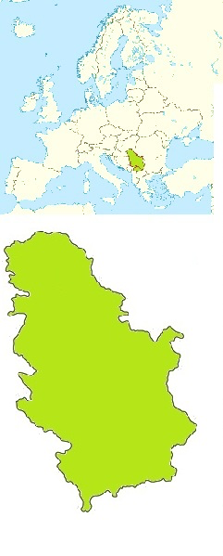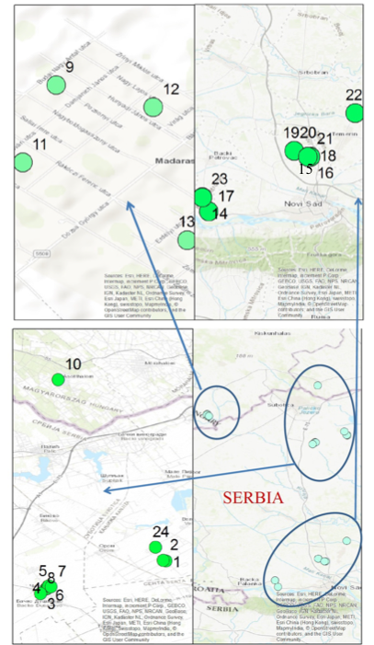
Fig. S1 Map of sampling locations

Text SI-2 Laboratory Analysis
0.5 g of soil sample was transferred to the vessels for microwave digestion and nitric acid (6 mL) and hydrogen peroxide (2 mL) purchased from J. T. Baker (Center Valley, USA) were added. During each sequence three Teflon vessels which contained the mixture of HNO₃ /H₂O₂ were provided for a blank to assess the contamination. Microwave digestion system (Ethos One, Milestone, Italy) equipped with a segmented rotor holding 10 microwave vessels of high pressure (HPR-1000/10S) and internal temperature sensor was used for digestion of the samples. The operational conditions and the heating program were set according to the conditions recommended by the manufacturer. After cooling, the digestates were filtrated through Whatman No.1 (Sigma-Aldrich, St. Louis, USA) filter paper and then diluted using ultrapure water (Milli-Q, Simplicity, Millipore, France of 18.2 MΩ cm-1 resistivity) into 25 ml plastic flask and finally, transferred to previously acid-cleaned and labelled polypropylene vessel for further analysis. From each sample, triplicates were digested and each sample solution was analyzed in triplicates (Škrbić et al., 2018; 2022).
Graphite furnace atomic absorption spectrometer (Agilent Technologies, Santa Clara, USA) (GFAAS) with deuterium background correction, was used for quantification of heavy element concentrations. The assembly was operated from an interfaced computer running SpectraA software. Argon (99.999 Messer, Beograd, Serbia) was used as the inert gas. Quantification of heavy elements was done using acidified aqueous element standards by an external calibration procedure. The method applied for heavy elements (HEs) determination is previously used by [3]. It is based on EPA method 3051 for microwave assisted acid digestion of sediments, sludge, soils, and oils, which is initially based on the EPA method 3050B. The element standards for Pb, Cd, As, Ni Co, Cu and Cr were prepared from a stock solution of 1000 mg/L (J.T. Baker, USA) by dilutions. Calibration standards were prepared in the same acid matrix used for the soil samples. Each recording was repeated three times. Recovery experiments were performed on the following concentration levels: for As (0.075 and 7.0 mg/kg); Cd (0.025 and 0.60 mg/kg); Co (0.005 and 7.3 mg/kg); Cr (0.076 and 24.0 mg/kg); Cu (0.026 and 35.0mg/kg); Ni (0.006 and 38.0 mg/kg), Zn (0.070 and 170 mg/kg) and Pb (0.026 and 84.0 mg/kg). The repeatability of the method was determined as relative standard deviation (RSD, in %) of the heavy elements content in fortified samples. Blank samples were included in every batch of samples to check for possible contamination of laboratory equipment. Additionally, the precision of the method is confirmed by applying certificate reference material NIST SRM 2711, see Table S1.
Text SII-1 QA/QC
The recovery study was used for the validation of the sample preparation procedure. The following mean recoveries (relative standard deviation) were obtained, Cr: 104% (3.2); Cd: 91% (2.1); Co: 91% (1.9); Pb: 93% (2.6); Ni: 95 % (2.5); Zn: 98% (3.2); Cu: 97 (2.6); and As: 90% (1.7). The method detection limits (MDL) for the studied elements were: Cr: 0.076 mg/kg; Cd: 0.025 mg/kg; Co: 0.005 mg/kg; Pb: 0.026 mg/kg; Ni: 0.006 mg/kg; Zn: 0.070 mg/kg; Cu: 0.026 mg/kg; and As: 0.075 mg/kg. The criteria for acceptance of linearity of calibration curve for each HE was 0.995. Additionally, the validation of the method is confirmed by applying certificate reference material (CRM) NIST SRM 2711. The results of the analysis of CRM are included in Table S1. The obtained values were within the certified values of CRM.
Text SIII-1 Evaluation of HEs environmental risk impact
Geoaccumulation index (I_{geo}) is computed using the following equation (1) (Müller, 1969):
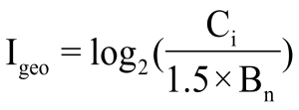 (1)
where C_{i} is the measured concentration of the element in soil and B_{n} is the corresponding geochemical background value [4]. In this study, the values reported by Ubavić et al. (1993) for soil samples were used as background values for HEs, as this data are the first ones reported for agricultural soil samples collected from northern part of Serbia belonging to Pannonian Basin, and have been used in all till now applied soil investigation for comparison. According to the I_{geo} index the soil is classified as follows: degree 0 (unpolluted (I_{geo}≤0)), degree 1 (unpolluted to moderately polluted (0 < I_{geo}≤1)), degree 2 (moderately polluted (1 < I_{geo}≤2)), degree 3 (moderately to heavily polluted (2<I_{geo}≤3)), degree 4 (heavily polluted (3<I_{geo}≤4)), degree 5 (heavily to extremely polluted (4<I_{geo}≤5)), and degree 6 (extremely polluted (I_{geo}>5)) (Müller, 1969). Moreover, contamination factors (CF) for investigated heavy elements content were calculated by dividing the obtained concentrations of each element by the background value, equation (2):
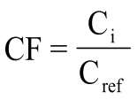 (2)
C_{i}, mg/kg is measured concentrations, while C_{ref}, mg/kg is background concentration of HEs in soil accepted according to Ubavić et al. (1993). CF values are interpreted in the following order: CF<1 indicates low contamination (class 1); 1≤CF<3 is a moderate contamination (class 2); 3≤CF≤6 is considerable contamination (class 3); and CF> 6 is very high contamination (class 4).
Pollution Load Index (PLI) was evaluated for the extent of element pollution by employing the method based on the pollution load index (PLI) and the formula is as follows:
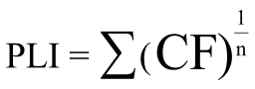 (3)
The PLI provides simple mean for assessing a site quality, where a value of PLI ˂ 1 denote perfection; PLI = 1 indicates that only baseline levels of pollutants are present, and PLI ˃ 1 would indicate deterioration of site quality (Tomilson et al., 1980). Furthermore, the Nemerow integrated pollution index (NIPI) was calculated by following formula (4):
NIPI=$\sqrt{\frac{{{\text{CF}}_{\text{aver}}}^{\text{2}}\text{+}{{\text{CF}}_{\text{max}}}^{\text{2}}}{\text{2}}}$ (4)
where CF_{max} and CF_{average} are the maximum and average value of CF, respectively.
The NIRI can provide a more accurate evaluation of the integrated effect of multiple types of HEs and it also introduces the toxic response factor to differentiate the effects of heavy elements. The NIRI is calculated using by the following formula:
NIRI= $\sqrt{\frac{{{\text{Er}}_{\text{max}}}^{\text{2}}\text{+}{{\text{Er}}_{\text{aver}}}^{\text{2}}}{\text{2}}}$ (5)
where Er_{max} and Er_{average} are the maximum and average value of Er, respectively.

Er=Tr$\text{×}\frac{\text{Ci}}{\text{Si }}$ (6)

where Er is the potential ecological risk factor of heavy elements, Tr is toxic response factor of heavy elements, Ci is the concentration of HEs i and Si is the background levels of heavy elements. Tri is 10, 30, 2, 5, 1, 5 for As, Cd, Cr, Cu, Ni, Pb, respectively. Thus, the values of NIRI are largely influenced by concentrations of As and Cd. Classification of NIPI and NIRI are listed in Table S2.

Text SIV-1 Evaluation of health risk on agricultural field

In the present study, the exposure of the farmers to PTEs detected in sampled soil sample was estimated through non-carcinogenic and carcinogenic risks introduced by US EPA. US EPA's models used to assess both non-carcinogenic and carcinogenic risks are based on three dominant exposure pathways: ingestion, inhalation and dermal contact (Škrbić et al., 2022). For both risks, chronic daily intake (CDI) was estimated for each element and exposure route, CDI_{ing}, CDI_{inh}, and CDI_{der}, as follows:

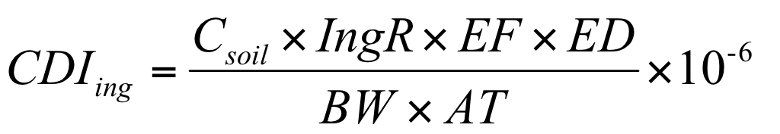 (7)

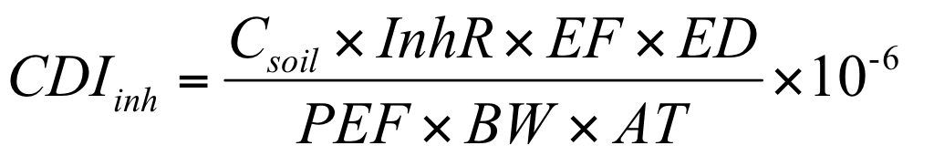 (8)

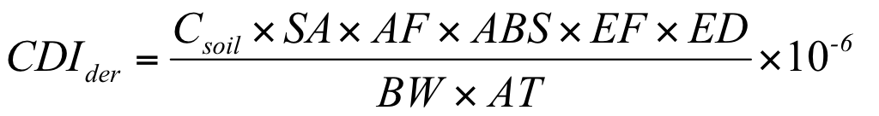 (9)

while total chronic daily intake, CDI_{total}, is the sum of CDIs calculated by eqs. (7)-(9). Parameters used for calculation of CDI_{ing/inh/der} are explained in Table S3 (Men et al. 2018).

The hazard quotient (HQ) was employed to estimate the non-carcinogenic risk of selected heavy elements and corresponding exposure pathways on the following way:

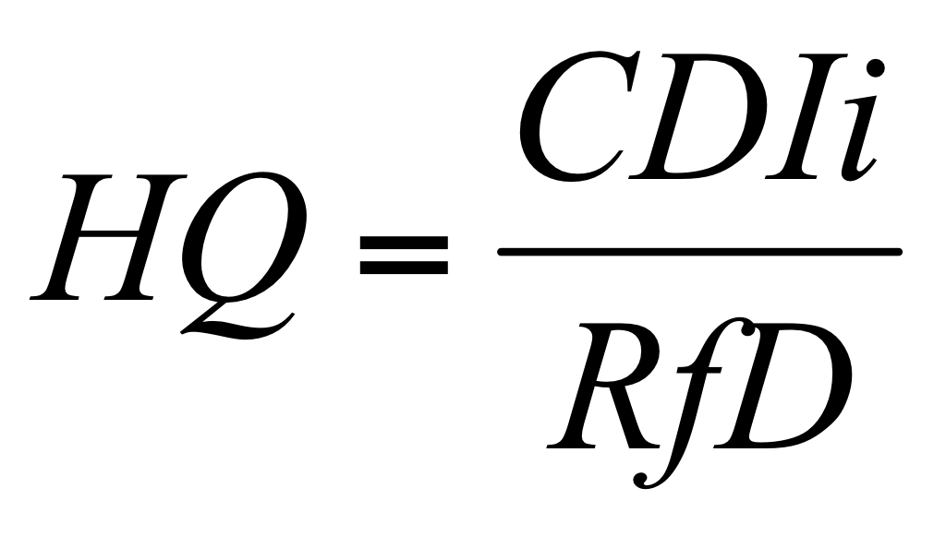
(10)

CDI_{i} is CDI for particular element and the exposure pathway, while RfD is the reference dose (mg/kg/day) set for each analyzed heavy element and shown in Table S4 (USEPA 1989). HQ_{tot} is calculated as the sum of estimated HQs, representing hazard quotient for one exposure pathway to all five elements.
For the comprehensive estimation of non-carcinogenic health risk, the hazard index, HI, was calculated by combining the HQs of different exposure routes to one of five analyzed heavy elements:

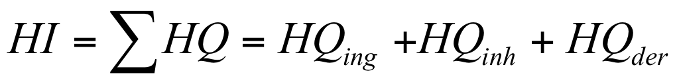 (11)

HI_{tot} is calculated by summing HI values obtained for each element. HI values >1 indicate potentially adverse health effects caused by non-carcinogenic risk, while values <1 suggest their absence (Men et al. 2018).
To quantify the carcinogenic risk through the possible exposure pathway for the farmers, CDI for Pb, Cd, Cr, and Ni was multiplied by the respective slope factor (SF, Table S4) (Men et al. 2018).

$\text{CR=}\text{CDIxSF}$ (12)

CR_{tot} is the estimate of the carcinogenic risk linked to particular exposure route to four elements (with defined SF) in soil.
The total carcinogenic risk, TCR, is calculated as a sum of CR values obtained for each element and all three pathways of exposure (Men et al. 2018):

$\text{TCR=}\text{CR=}{\text{CR}}_{\text{ing}}\text{+}{\text{CR}}_{\text{inh}}\text{+}{\text{CR}}_{\text{der}}$ (13)

TCR_{tot} was calculated as an overall TCR value, combining the exposure to four elements by three pathways simultaneously.
USEPA (2001) identified TCR values lower than 10⁻⁶ as negligible risk, those in the range from 10⁻⁶ to 10⁻⁴ as acceptable/tolerable risk, and those higher than 10⁻⁴ as potential risk because 1 in 10,000 people may develop cancer from lifetime exposure to carcinogenic hazards.

Text SV-1 Positive matrix factorization (PMF) model
PMF method factorizing the obtained dataset via matrices was obtained by following equation:
x_{ij}=$\sum_{k=1}^{p}{g_{ik}f_{kj}+e_{ij}}$ (14)
where: x_{ij}-so-called data matrix is composed of the j-th-chemical species (HEs) in the i-th-number of samples, g_{ik} – mass contribution of each factor teaches individual sample, f_{kj} - represents the species profile of each source, and e_{ij} - is the residual matrix (USEPA, 2014).
Factor contributions and factor profiles are ascribed by the PMF model of minimizing the function Q (critical parameter) given in equation (15):
Q=$\sum_{i=1}^{n}{\sum_{j=1}^{m}{{\frac{x_{ij}-\sum_{k=1}^{p}{g_{ik}f_{kj}}}{u_{ij}}}^{2}}}$ (15)
where: u_{ij}- uncertainty of each HEs determined in this study. Two types of Q (Q_{true} and Q_{robust}) could be obtained in PMF model. Q_{true} represents quality of fit parameters for all data while Q_{robust} exclude data which doesn’t fit (Men et al., 2018).
The number of factors set was 2, 3, and 4. Seed number was set randomly while the runs number was 20. Number of factor contributions was chosen when the Q value was smallest and stable. When three factors were set the best fitting model was obtained and the prediction R² was 0.78.

Text SVI-1 Data mining
In order to assess models’ accuracy Kappa coefficients (0 to 1), Mean Absolute Error (MAE), and accuracy (%) were examined. Generally, the Kappa coefficient (k), as a measure of the agreement between the predicted and observed categorizations of a dataset is a useful statistical parameter to give insights into the agreement between different classifiers used. The upper limit of the Kappa coefficient is 1.00, which means that there is a perfect agreement between the predicted and observed categorization. For the development of models, a random set of 18 out of 23 soil samples belonging to conventional and organic soil practices were selected. The data consisting of 15 attributes (concentrations of 9 HEs, 5 physicochemical properties, and soil type (organic vs. conventional)) and 18 instances (locations of conventional and organic soil sampling) was randomly divided into training (66% of the total data set) and validation (34% of the total data set) datasets. The remaining five soil samples were used for additional confirmation of the developed method.
Table S1. Physicochemical properties of organic and conventional soil
 |  | pH H₂0 | Conductivity, µS/cm |  |  | Organic matter,  % |  | Humus content, % | CaCO₃ content,  %
organic soil
Mean |  | 8.29 | 329 |  |  | 8.34 |  | 8.15 | 1.13
Median |  | 8.05 | 310 |  |  | 8.62 |  | 7.95 | 1.17
Minimum |  | 7.88 | 170 |  |  | 4.06 |  | 6.40 | 0.401
Maximum |  | 9.05 | 540 |  |  | 10.1 |  | 10.3 | 2.09
conventional soil
Mean |  | 8.41 | 242 |  |  | 12.1 |  | 8.77 | 2.42
Median |  | 8.43 | 210 |  |  | 10.7 |  | 8.95 | 2.046
Minimum |  | 7.86 | 155 |  |  | 3.89 |  | 6.08 | 0.51
Maximum |  | 8.97 | 580 |  |  | 22.5 |  | 10.9 | 5.46
Statistical significance*
 | ns |  |  | ns | ns |  | ns |  | ns
*Statistical significance highlights the difference between means of physico chemical properties according to the student’s t-test at 5% significance level. ns, not significant; **significant

Table S2. Correlation between physicochemical properties and total concentrations of
PTEs
 | As | Cd | Co | Cr | Cu | Ni | Pb | Zn | pH | EC, µS/cm | %, OM
As
Cd | 0.709
Co | 0.556 | 0.859
Cr | 0.342 | 0.563 | 0.806
Cu | -0.068 | 0.096 | 0.054 | -0.116
Ni | 0.166 | 0.032 | -0.063 | -0.054 | -0.017
Pb | 0.036 | 0.123 | 0.078 | 0.001 | 0.254 | 0.109
Zn | -0.011 | -0.153 | -0.448 | -0.546 | 0.094 | -0.504 | -0.033
pH | 0.547 | 0.510 | 0.444 | 0.423 | -0.125 | 0.204 | -0.109 | -0.013
EC, µS/cm | -0.054 | -0.057 | -0.206 | -0.096 | -0.178 | 0.010 | 0.222 | 0.682 | 0.118
% of OM | 0.152 | 0.206 | 0.002 | 0.005 | 0.075 | -0.253 | 0.168 | 0.283 | 0.002 | 0.211
% of HC | -0.208 | -0.198 | -0.373 | -0.272 | 0.092 | -0.072 | -0.008 | 0.323 | 0.328 | -0.189 | -0.211
*bolded values were significant on p<0.05
Table S3. I_{geo} and CF values and degrees of contamination for conventional and organic agricultural management practice
PTE | I_{geo} | Degree | CF | Degree
conventional agricultural management practice
Pb | 0.104 | 1 | 0.521 | low contamination
As | 0.458 | 1 | 2.29 | moderate contamination
Cd | 0.521 | 1 | 2.60 | moderate contamination
Ni | 0.395 | 1 | 1.97 | moderate contamination
Co | 0.742 | 1 | 3.70 | considerable contamination
Cr | 1.61 | 2 | 8.02 | very high contamination
Cu  Zn | 0.982  0.211 | 2  1 | 4.89  / | considerable contamination
organic agricultural management practice
Pb | 0.079 | 1 | 0.399 | low contamination
As | 0.727 | 1 | 3.62 | considerable contamination
Cd | 0.708 | 1 | 3.52 | considerable contamination
Ni | 0.872 | 1 | 4.34 | considerable contamination
Co | 1.26 | 2 | 6.31 | very high contamination
Cr | 2.79 | 3 | 13.9 | very high contamination
Cu  Zn | 1.11  0.202 | 2  1 | 5.56  / | considerable contamination

Table S4. Summary of the validation data of the GFAAS method for PTEs determination
PTE | Certified reference material (NIST SRM 2711), mg/kg | Measured concentrations  mg/kg | RSD, %
As | 11.2 | 10.5 | 4.56
Cd | 41.7 | 39.8 | 3.30
Co | 10 | 10.1 | 0.70
Cr | 47.0 | 48.8 | 3.30
Cu | 114 | 112 | 1.25
Ni | 20.6 | 19.2 | 4.97
Pb  Zn | 1162  540 | 1149  590 | 0.80  1.9

Table S5. Classification of NIPI and NIRI
Index | Category | Description | References
NIPI | NIPI≤0.7 | unpolluted | Men et al. 2018
NIPI | 1 < NIPI ≤2 | low polluted | Men et al. 2018
NIPI | 2 < NIPI ≤3 | moderately polluted | Men et al. 2018
NIPI | NIPI > 3 | strongly polluted | Men et al. 2018
NIRI | NIRI ≤40 | low risk | Men et al. 2018
NIRI | 40<NIRI ≤80 | moderate risk | Men et al. 2018
NIRI | 80<NIRI ≤160 | considerable risk | Men et al. 2018
NIRI | 160<NIRI ≤320 | high risk | Men et al. 2018
NIRI | NIRI>320 | extreme risk | Men et al. 2018

Table S6. Values of the variables for the estimation of human exposure to PTEs presence in soil
Variable | Value
CDI_{inh}, CDI_{ing} and CDI_{dermal} (mg/kg/day): are the chronic daily intake from soil inhalation, ingestion and dermal absorption
C (mg/kg), concentration of PTE in soil
IngR (mg/d): soil ingestion rate for receptor | 100
InhR (m³/d): soil inhalation rate for receptor | 20
EF (d/yr): exposure frequency | 180
ED (yr): exposure duration | 12
BW (kg): average body weight | 70
AT (d): averaging time for non-carcinogenic effects | ED×180
AT (d): averaging time for carcinogenic effects | 70x180
PEF (m³/kg): soil-to-air particular emission factor | 1.36×10⁹
SA (cm²/event): skin surface area available for exposure | 1530
AF (mg/cm²/d): the adherent factor | 0.07
ABS (unitless): dermal absorption factor | 0.001

Table S7. The reference dose (RfD) (mg/kg/day) and carcinogenic slop factor of selected HEs (mg/kg/d)
 | Cd | Cr | Cu | Ni | Pb
RfD_{ing} | 1.00E-03 | 3.00E-03 | 4.00E-02 | 2.00E-02 | 3.50E-03
RfD_{inh} | 1.00E-05 | 2.86E-05 | 4.02E-02 | 2.06E-02 | 3.52E-03
RfD_{der} | 1.00E-05 | 5.00E-05 | 1.20E-02 | 5.40E-03 | 5.25E-04
SF_{ing} | 15 | 0.5 |  | 0.84 | 0.28
SF_{inh} | 15 | 0.5 |  | 0.84 | 0.28
SF_{der} | 15 | 0.5 |  | 0.84 | 0.28

References
Škrbić, B. and Đurišić-Mladenović, N. (2010) Chemometric interpretation of heavy metal patterns in soils worldwide. Chemosphere, 80, 1360-1369.
Škrbić, B., Buljovčić, M., Jovanović, G., Antić, I. (2018) Seasonal, spatial variations and risk assessment of heavy elements in street dust from Novi Sad, Serbia. Chemosphere, 205, 452-462.
Škrbić, B.D., Buljovčić, M., Antić, I. (2022) Comprehensive assessment of heavy elements and evaluation of potential human health risk in the urban environment: a case study from Novi Sad, Serbia. Environ Sci Pollut Res,. https://doi.org/10.1007/s11356-022-18733-x
Müller, G. (1969) Index of geoaccumulation in sediments of the Rhine River. Geo J, 2, 108–118.
Ubavić, M., Bogdanović, D., Hadžić, V. (1993) Basic chemical properties of soil of the Vojvodina province and possibilities of their contamination with heavy metals. Contemp Agric, 1, 47–51.
Men, C., Wang, Y.F., Liu, R.M., Wang, Q.R., Miao, Y.X., Jiao, L.J., Shen, Z.Y. (2018) Temporal variations of levels and sources of health risk associated with heavy metals in road dust in Beijing from May 2016 to April 2018. Chemosphere, 270, 129434 DOI: 10.1016/j.chemosphere.2020.129434.

