Supplementary Table. Comparison of LA parameters from segmented and CS cine images between patients with LV diastolic dysfunction and healthy controls
 |  | Segmented cine |  |  | CS cine
 |  | Controls | Patients | P value | Controls | Patients | P value
Volumetric parameters
LAVmin/BSA (ml/m²) |  | 17.1(13.5, 21.1) | 49.1(33.0, 83.2) | <0.001 | 19.2(15.8, 24.4) | 50.0(36.3, 78.3) |  | <0.001
LAVmax/BSA (ml/m²) |  | 41.2(34.9, 49.7) | 63.6(52.2, 95.9) | <0.001 | 36.8(33.4, 44.9) | 64.6(54.0, 94.6) |  | <0.001
LAVpre /BSA (ml/m²) |  | 27.4(23.2, 34.1) | 54.1(43.8, 86.8) | <0.001 | 24.5(21.1, 32.7) | 55.7(43.9, 84.6) |  | <0.001
EFtotal (%) |  | 56.4(52.9, 61.3) | 22.2(16.6, 40.6) | <0.001 | 48.9(42.7, 54.7) | 19.7(13.4, 37.7) |  | <0.001
EFpassive (%) |  | 31.6(28.8, 34.9) | 11.61(6.83, 19.71) | <0.001 | 33.2(28.0, 37.6) | 12.2(6.0, 19.0) |  | <0.001
EFbooster (%) |  | 37.4(31.8, 41.2) | 12.0(4.6, 19.4) | <0.001 | 24.9(16.1, 29.2) | 5.8(2.9,  13.5) |  | <0.001
Strain parameters
Ers (%) | -17.4(-20.1, -14.4) |  | -7.8(-10.7, -6.2) | ＜0.001 | -11.2(-12.7, -8.9) | -5.3(-7.1, -3.4) |  | ＜0.001
Ere (%) | -8.4(-9.6, -7.2) |  | -4.2(-7.9, -3.5) | ＜0.001 | -6.7(-8.3, -5.5) | -4.2(-5.6, -2.8) |  | ＜0.001
Era (%) | -8.7(-10.5, -6.9) |  | -3.4(-4.7, -1.2) | ＜0.001 | -3.8(-4.9, -2.9) | -0.9(-1.5, -0.3) |  | ＜0.001
Els (%) | 35.2(29.3, 42.3) |  | 11.6(7.9,17.9) | ＜0.001 | 16.5(13.2, 19.9) | 6.6(3.8, 10.2) |  | ＜0.001
Ele (%) | 21.2(17.0, 26.5) |  | 6.9(5.2,12.7) | ＜0.001 | 11.2(8.6, 14.0) | 5.7(2.9, 8.4) |  | ＜0.001
Ela (%) | 12.9(9.9, 16.4) |  | 4.3(1.9, 5.7) | ＜0.001 | 4.4(3.6, 6.2) | 1.3(0.4, 1.8) |  | ＜0.001
The data are presented as the median (first quartile, third quartile).
CS, compressed sensing; LV, left ventricular; LA, left atrial; LAVmin, left minimum atrial volume; LAVmax, left maximum atrial volume; LAVpre, left atrial pre-contraction volume; BSA, body surface area; EFtotal, total ejection fraction; EFpassive, passive ejection fraction; EFbooster, active ejection fraction; Ers, global total radial strain; Ere, global passive radial strain; Era, global active radial strain; Els, global total longitudinal strain; Ele, global passive longitudinal strain; Ela, global active longitudinal strain.

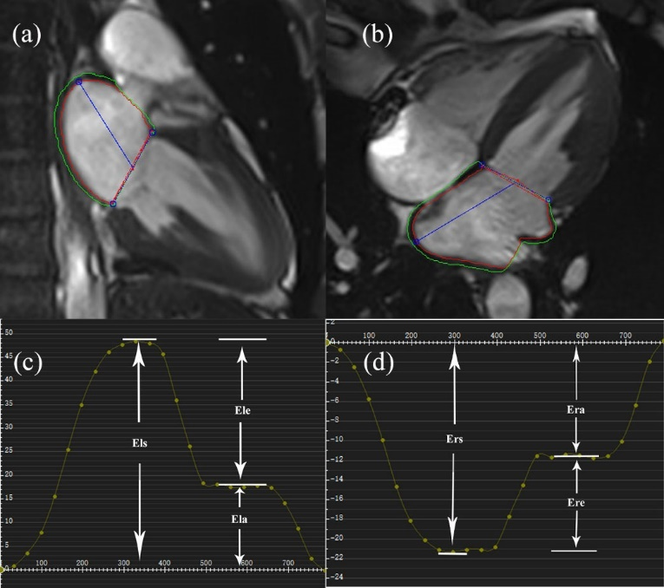
Supplementary Figure. The left atrial (LA) strain measurements by cardiovascular magnetic resonance feature tracking in a healthy volunteer. LA tracking contours in 2- (a) and 4-chamber views (b) at left ventricular end-systole. The LA global radial (c) and longitudinal strain curves (d) are demonstrated, and the LA global radial and longitudinal strain parameters were obtained. Ers, global total radial strain; Ere, global passive radial strain; Era, global active radial strain; Els, global total longitudinal strain; Ele, global passive longitudinal strain; Ela, global active longitudinal strain.

