Supplementary information
Development of a species-specific qPCR assay for the detection of invasive African Sharptooth catfish (Clarias gariepinus) using environmental DNA
Gopi Krishnan1,2, Meher Sunkara1, Rajeev Raghavan3 and Govindhaswamy Umapathy1,2 #

1. Parameters for primer designing in SSPrimer tool:
- Primary constraints
- Amplicon Length Range: 75-200
- Min Target Coverage (minimum fraction of target sequences from the alignment that must be covered with the primers and probe): 90%
- Min Group Coverage (minimum fraction of target sequences that must have sequence data in the region specified by the user, no gaps): 90%
- Min Target Hybridization Efficiency (minimum fraction of target amplicons that will be amplified with the specified primer set each PCR cycle, ***Very high hybridization efficiency of 95-100 will lower specificity to the target species but low efficiency of 50 or below will greatly lower the sensitivity of the primer set***): 80%
- Max Non-Target Hybridization Efficiency (maximum fraction of non-target amplicons that will be amplified with the specified primer set each PCR cycle. Ideally this should be set as low as possible however setting it lower will limit the number of potential primer sets that can be generated): 15%
- Optimal Primer Set Annealing Temperature (C) (the tool will try and find a primer set that matches as closely as possible to this temperature): 60
- Primer Set Annealing Temperature Range (C) (generated primer sets must fall within this range of annealing temperatures): 55-65
- Max Annealing Temperature Difference (C) between FP and RP (ideally should be within 0-3 degrees difference): 3
- Min Increase in Probe Annealing Temperature (C) (ideally should be 7-10 degrees higher than primer set): 7 Secondary constraints
- Primer Length Range: 18-25 bp
- Probe Length Range: 24-28 bp
- Primer GC Percentage Range: 30-70%
- Probe GC Percentage Range: 30-70%
- Primer-Dimer Hybridization Efficiency (less likely to form dimers < 1e-07 > more likely to form dimers. Ideally you want this set as low as possible however setting it lower will also limit the number of potential primer sets.): 1e⁻⁷
- Max Run Length for Primers (ex: AAA would be a run length of 3): 3
- Max Repeat Length for Primers (ex: CGCG would be a repeat length of 2): 3
- Max Run Length for Probes (ex: AAA would be a run length of 3): 5
- Max Repeat Length for Probes (ex: CGCG would be a repeat length of 2): 4
*Note that the software by default designs probes along with primers. If the primers are specific and can be used without the need for probes, the designed probes can be ignored.
2. Optimized PCR program for In vitro testing of primers
Step 1 | Activation
Cycles | 1
Temperature |  | Hold
94°C |  | 05:00 mins
Step 2 | PCR
Cycles | 35
Temperature |  | Hold
94°C |  | 30 seconds
58°C |  | 30 seconds
72°C |  | 30 seconds
Step 3 | Additional extension
Cycles | 1
Temperature |  | Hold
72°C |  | 05:00 mins
Step 4 | Infinite hold
Cycles | 1
Tenperature |  | Hold
4°C |  | Infinte

3. PCR reaction components
Component | Volume per reaction (µl)
dNTP mix | 1
10X PCR Buffer | 1
Taq DNA Polymerase– Takara (India) | 0.05
Forward primer 10uM | 0.2
Reverse primer 10uM | 0.2
Nuclease free water | 6.55
Template DNA | 1
Total volume | 10

4. Preparation of standards
i) PCR of 5 reactions were performed with a reaction volume of 20 µl.
ii) Upon visualizing the PCR products in 2% agarose gel to confirm amplification, the PCR products were combined and purified using NucleoSpin® Gel and PCR Clean-up (Macherey-Nagel, Germany) kit following the manufacturer’s instructions.
iii) The purified product was then quantified using Nanodrop spectrophotometer.
iv) With the known concentration of PCR product (ng/ul) and the length of the amplicon (171 bp), the number of copies of the amplicon was determined using the online calculator at http://cels.uri.edu/gsc/cndna.html. The formula to manually calculate the copy number is given in the same website.
v) After determining the copy number, the purified PCR product was then serially diluted to prepare standards of 10⁰ to 10⁵ copies/ul.
5. Optimized qPCR program for generating standard curve and testing of eDNA samples in Roche Light cycler 480 II instrument.
Program name | Denaturation
Cycles | 1 | Analysis mode | None
Target |  | Hold
95°C |  | 30 seconds
Program name | PCR
Cycles | 40 | Analysis mode | Quantification
Target |  | Hold
95°C |  | 05 seconds
58°C |  | 30 seconds
Program name | Melting
Cycles | 1 | Analysis mode | Melting curves
Target |  | Hold
95°C |  | 05 seconds
60°C |  | 60 seconds
95°C |  | -
Program name | Cooling
Cycles | 1 | Analysis mode |  | None
Target |  | Hold
50°C |  | 30 seconds

6. qPCR reaction components
Component | Volume per reaction (µl)
TB Green® Premix Ex Taq™ II (Tli RNaseH Plus) – Takara (Japan) | 5
Forward primer 10uM | 0.2
Reverse primer 10uM | 0.2
Nuclease free water | 3.6
Template DNA | 1
Total volume | 10

7. Sampling for field testing
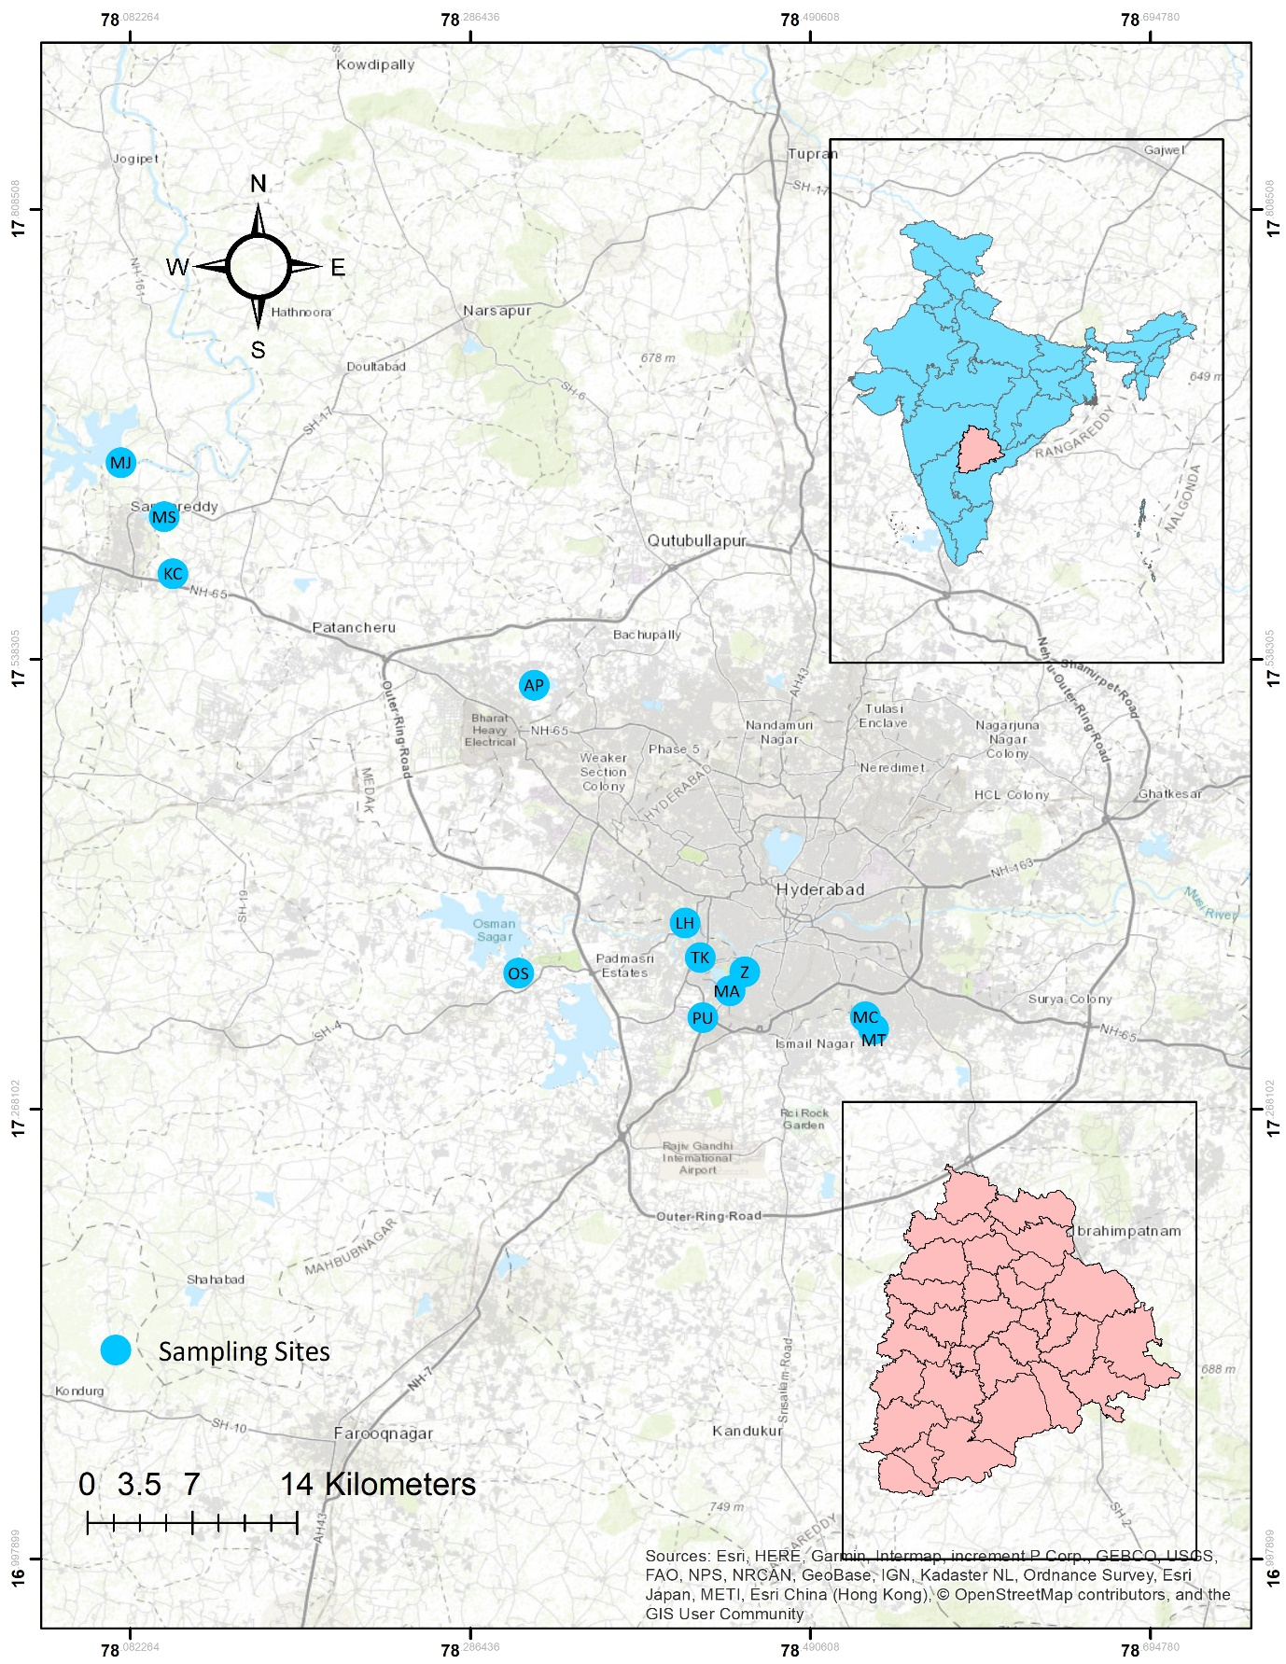
OS = Osmansagar, AP= Ameenpur, MJ = Manjeera, MA = Mir Alam tank, PU = Pushparahil Cheruvu, TC = Tallakunta, KC = Kandi Cheruvu, LH = Langar-houz Talab, MC = Mantrala Cheruvu, MT = Meerpet Talab, MS = Mehaboob Sagar, Z= Nehru zoological park

8. Protocol for eDNA extraction
i) eDNA filters were cut in half and one half was used for DNA extraction and the other was stored in -30°C.
ii) Place the half eDNA filter in a 2 ml microcentrifuge tube and add 1 ml of tissue lysis buffer (pH = 8.0), 100 µl of SDS (20%) and 20 µl of Proteinase K (20 mg/ml).
iii) Vortex the tube for 1 hour.
iv) Place the tube in rotating wheel or dry bath at 56°C for 2 hours for lysis.
v) Remove the filter paper and add 700 µl of Phenol:Chloroform:Isoamyl alcohol mixture (25:24:1 proportion).
vi) Mix well and keep the tube in rotating wheel for 10 mins.
vii) Centrifuge the contents at 10000 rcf and transfer the aqueous layer to a new centrifuge tube.
viii) Add 700 µl of Phenol:Chloroform:Isoamyl alcohol mixture to the transferred aqueous layer and repeat the steps (vi) and (vii).
ix) Add 700 µl of Chloroform:Isoamyl alcohol mixture (24:1) to the transferred aqueous layer and repeat the steps (vi) and (vii).
x) Add 50 µl of 5M NaCl and add 700 µl of chilled isopropanol. Mix well by gently inverting the tubes and store at 4°C for 2 hours.
xi) Centrifuge the tube at 10000 rcf for 30 mins. Discard the content without disturbing the pellets.
xii) Add 500 µl of 70% molecular grade ethanol and centrifuge at 10000 rcf for 10 mins. Discard the content without disturbing the pellets.
xiii) Add 500 µl of 100% molecular grade ethanol and centrifuge at 10000 rcf for 10 mins. Discard the content without disturbing the pellets.
xiv) Air dry the pellet for 15 mins. Add 100 µl of 1X TE buffer and dissolve the pellet by placing the tube in dry bath at 56°C for 30 mins.

