Online supplementary data

Supplementary to: A Network Meta-analysis and Systematic Review of Left Bundle Branch Pacing, His Bundle Pacing, Biventricular Pacing or RV Pacing in Patients requiring Permanent Pacemaker
Author: Nithi Tokavanich MD , Narut Prasitlumkum MD, Wimwipa Mongkonsritragoon MD , Wisit Cheungpasitporn, MD, Charat Thongprayoon, MD, Saraschandra Vallabhajosyula, MD MSc, Ronpichai Chokesuwattanaskul MD¹*

This supplementary data provided the result of authors’ search strategy and result.

Online supplementary data 1

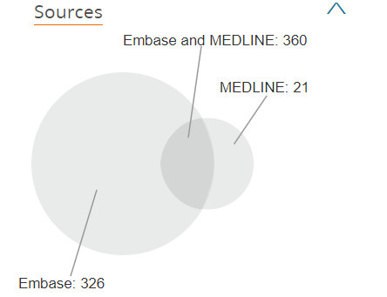
Session Results
.......................................................
No. Query Results
#19. #10 OR #11 OR #12 OR #13 OR #14 OR #17 OR #18 707
#18. #2 AND #4 27
#17. #2 AND #15 19
#16. #4 AND #15 6
#15. #5 OR #8 31,764
#14. #2 AND #9 12
#13. #4 AND #9 27
#12. #5 AND #9 309
#11. #6 AND #9 27
#10. #8 AND #9 641
#9. 'right ventricular pacing' 2,145
#8. 'cardiac resynchronization therapy' 31,261
#6. 'chronic resynchornization' 27
#5. 'biventricular pacing' 2,983
#4. 'left bundle branch block pacing' OR 'lbb 7
pacing'
#3. left AND bundle AND branch AND block AND pacing 3,670
#2. 'his pacing' 76

