Nano-DMS-MaP-seq allows isoform specific RNA structure determination

Supplementary Figures, Tables and Legends

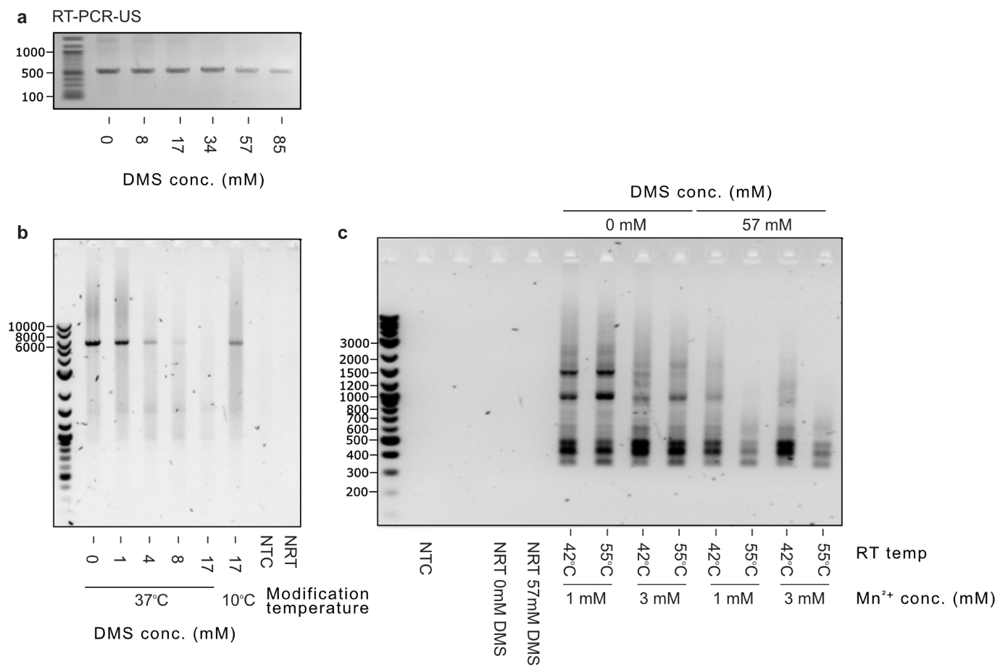

Suppl. Figure 1: Optimization of reverse transcription conditions
(a) RT-PCR of a ~500 nt fragment of the HIV-1 unspliced RNA containing the highly structured 5’UTR from HIV-1 expressing cells treated with different concentrations of DMS. (b) Optimization of a 4 kb RT-PCR from HIV-1 expressing cells by varying DMS concentrations and DMS modification temperature. (c) Optimization of a RT-PCR of a complex splicing mixture from HIV-1 expressing cells by varying DMS concentration, Mn²⁺ concentration, and reverse transcription temperature. DNA ladder was 1kb plus (NEB).

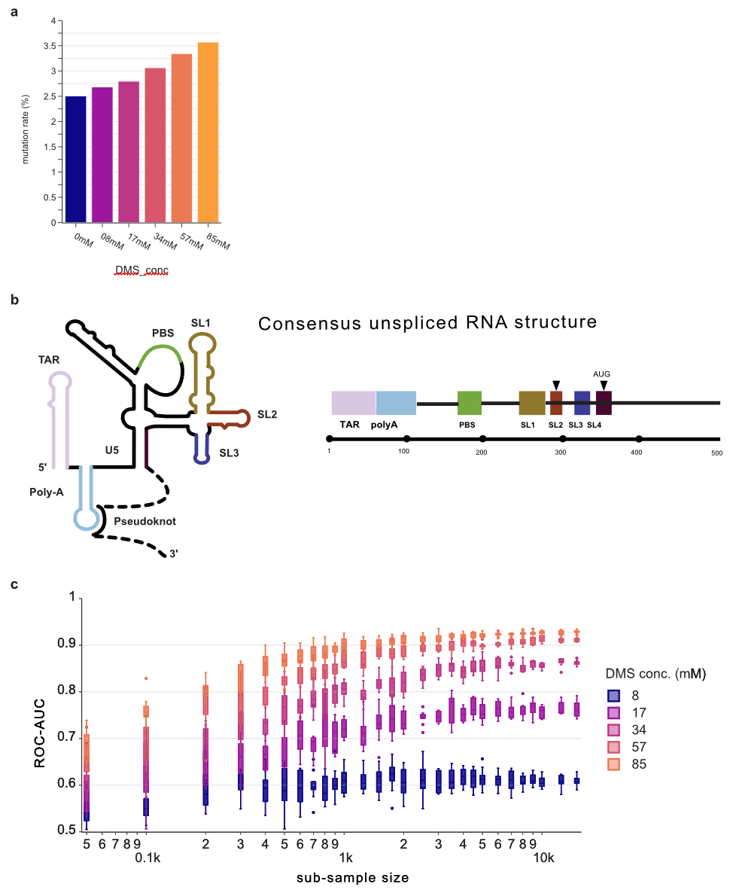

Suppl. Figure 2: Mutation rates and ROC-AUC scores for unoptimized Nano-DMS-MaP-seq on the consensus structure of unspliced HIV-1 5’UTR
(a) Representative nanopore sequencing error rates for different reverse transcription polymerase chain reaction (RT-PCR) at different DMS concentrations for the unspliced (US), single spliced (SS) and fully spliced (FS) samples from HIV-1 expressing cells. Also shown for the US RNA extracted from virions. (b) Structural model of the HIV-1 5’untrnaslated region (UTR). Major structural domains are indicated. Transactivation repeat (TAR), polyadenylation (polyA) stem loop, unique 5’ regions (U5), primer binding site (PBS), stem loop 1 (SL1), stem loop 2 (SL2), stem loop 3 (SL3). A pseudoknot interaction with a downstream region (c) Receiver Operating Characteristic Area Under the Curve (ROC-AUC) scores indicating the match between DMS reactivities and the consensus structure for each DMS concentration at different subsampling depths (n=20). Boxes represent quartile 1 (Q1) to quartile 3 (Q3). The second quartile (Q2) is marked by a line inside the box. Whiskers correspond to the box’ edges + /− 1.5 times the interquartile range (IQR: Q3-Q1).

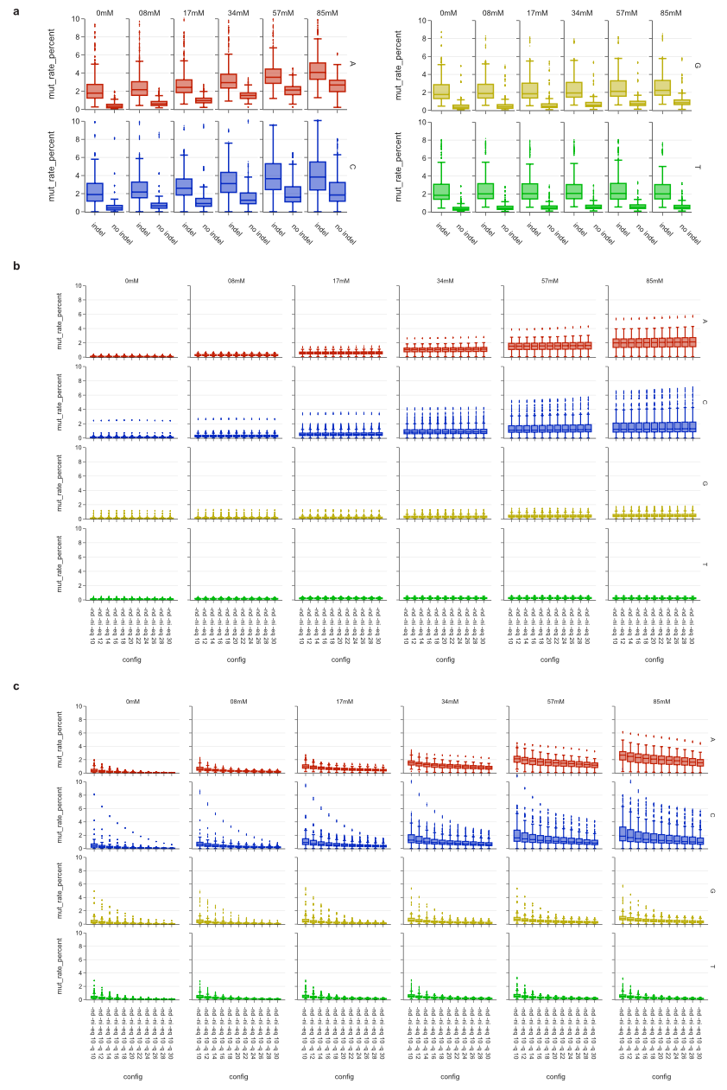

Suppl. Figure 3: Optimization of mutation counting
(a) Optimization of mutation counting. Global mutation rates for unspliced HIV-1 RNA at each nucleotide for each DMS concentration. (a) with and without counting insertions and deletions (indels). (b) With median read quality score filters of different stringencies. (c) With position wise quality score filters of different stringencies.

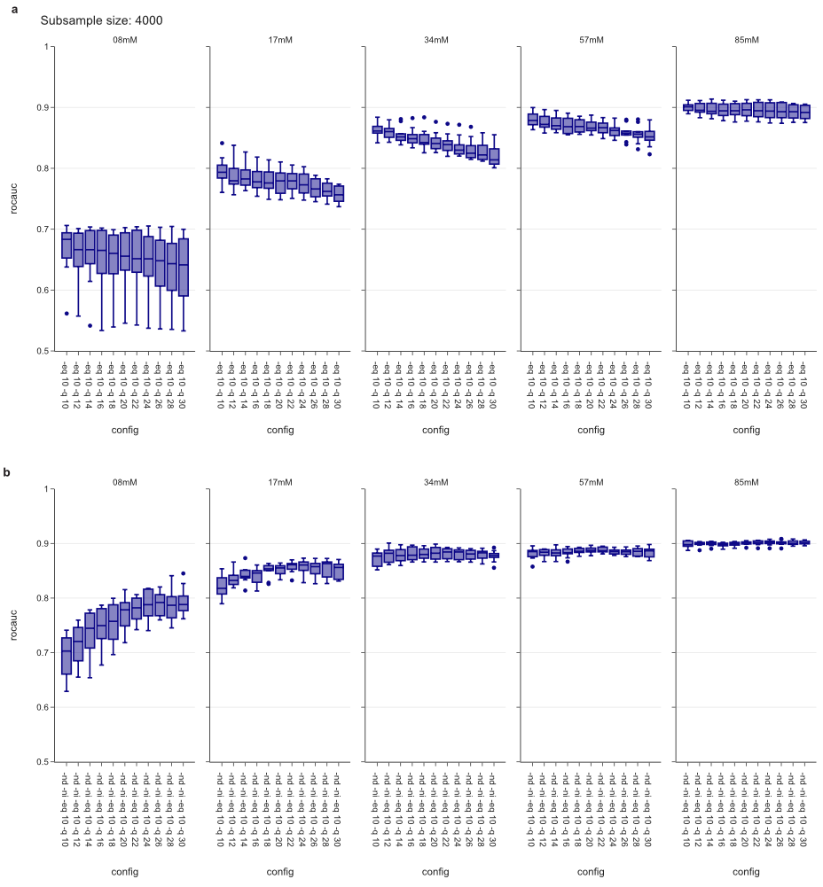

Suppl. Figure 4: Optimization of ROC-AUC
Effects of filtering settings on ROC-AUC scores, I.e., match between DMS reactivities and the consensus structure. ROC-AUC scores were calculated by sub-sampling of the data set 20 times to simulate a read depth of 4,000 reads. Mutation count was performed (a) with indels and (b) without indels with increasing stringency on the per position quality score filter (-q). Boxes represent quartile 1 (Q1) to quartile 3 (Q3). The second quartile (Q2) is marked by a line inside the box. Whiskers correspond to the box’ edges + /− 1.5 times the interquartile range (IQR: Q3-Q1).
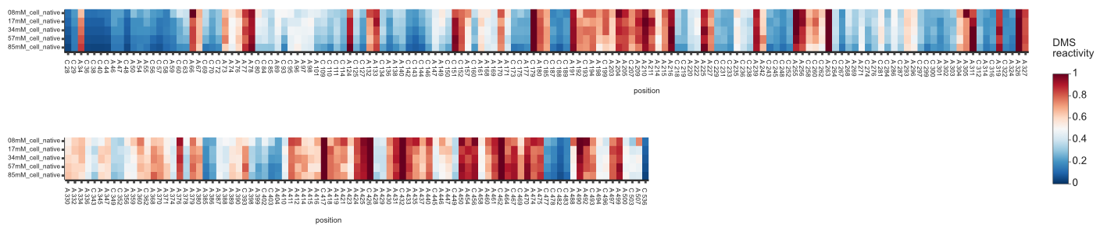

Suppl. Figure 5: DMS reactivities at each DMS concentration for the unspliced HIV-1 5’UTR and Gag coding sequence
A heatmap of DMS reactivities for the unspliced HIV-1 5’UTR for different DMS concentrations. Consensus structure of the HIV-1 5’UTR. Reactivities of A and C residues are shown using a blue-white-red colour scheme. Blue is 0, white is 0.5, Red is 1. Red nucleotides are reactive to DMS indicating single strandedness. Blue nucleotides are unreactive to DMS indicating double-strandedness or protection from modification due to occlusion e.g., by other protein or nucleic acid molecules.

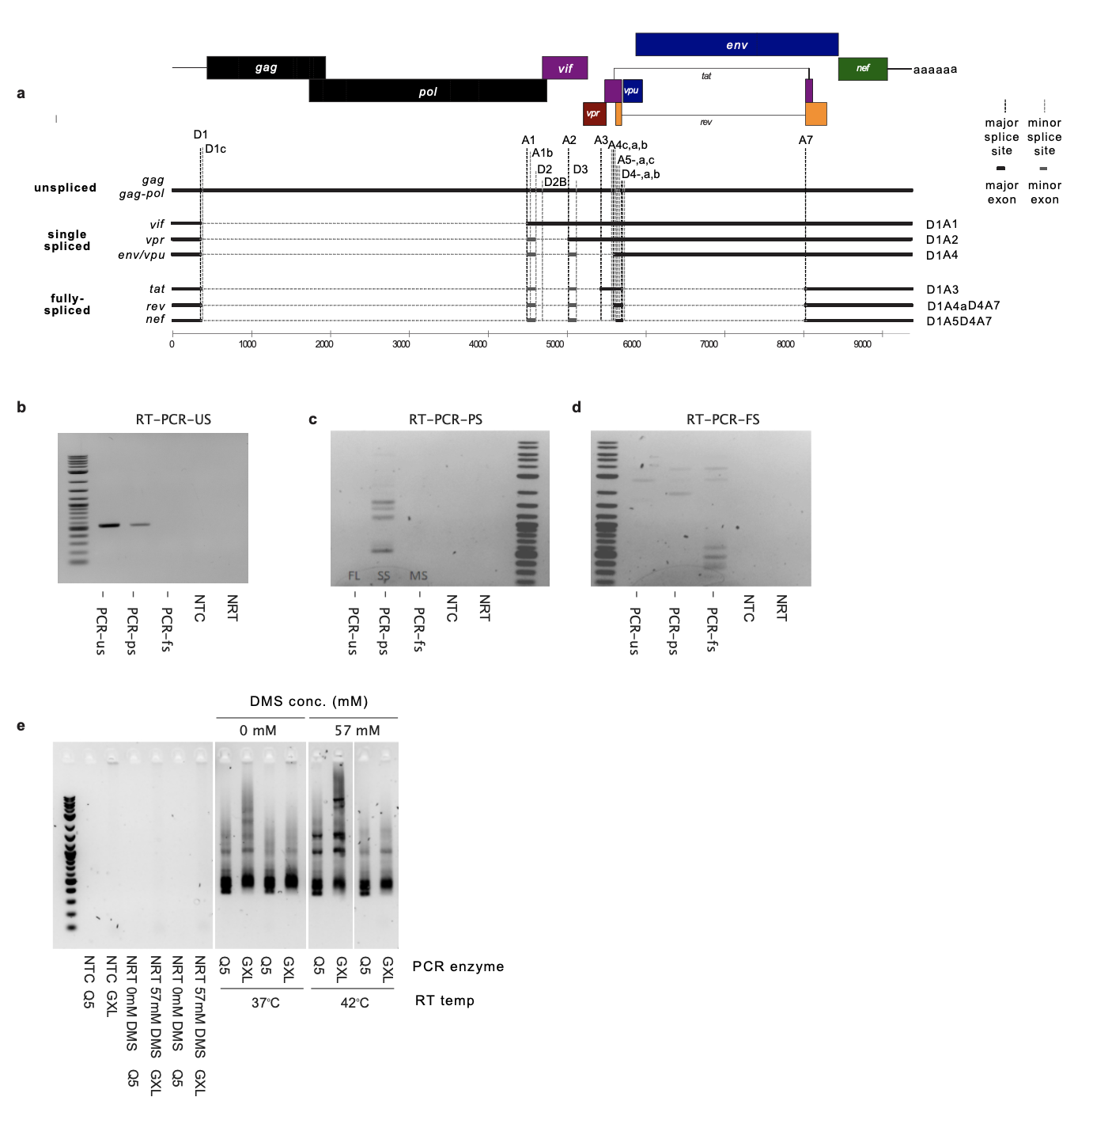

Suppl. Figure 6: HIV-1 spliced landscape and specific RT-PCR
(a) The complex HIV-1 splicing landscape. Three major classes of HIV-1 transcripts are produced from a variety of spliced donor and splice acceptor sites: unspliced, single spliced and fully spliced. Representatives single spliced and fully spliced transcripts are shown. (b) RT-PCR-US specifically amplifies unspliced genomic RNA (c) RT-PCR-SS specifically amplifies a population of single spliced RNAs. (d) RT-PCR-FS specifically amplifies a population of fully spliced RNAs. (e) Optimization of the RT-PCR-FS with DNA polymerase Q5 and PrimeSTAR GXL at two different reverse transcription temperatures. DNA ladder was 1kb plus (NEB).

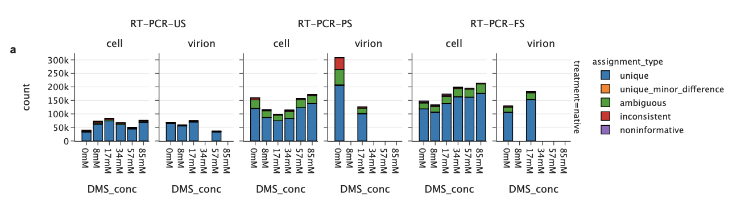

Suppl. Figure 7: Read counts per assignment
Representative data from a single nanopore sequencing run showing read count per assignment IsoQuant type for RT-PCR-US, RT-PCR-PS and RT-PCR-FS. Unique are sequencing reads mapping uniquely to a transcript isoform. Unique minor differences reads map to a single isoforms, but with alignment artifacts. Ambiguous reads are compatible with matching to more than one transcript. Inconsistent reads map with non-intronic inconsistencies (e.g., alternative transcription or polyadenylation sites). Non-informative reads are unmapped reads.

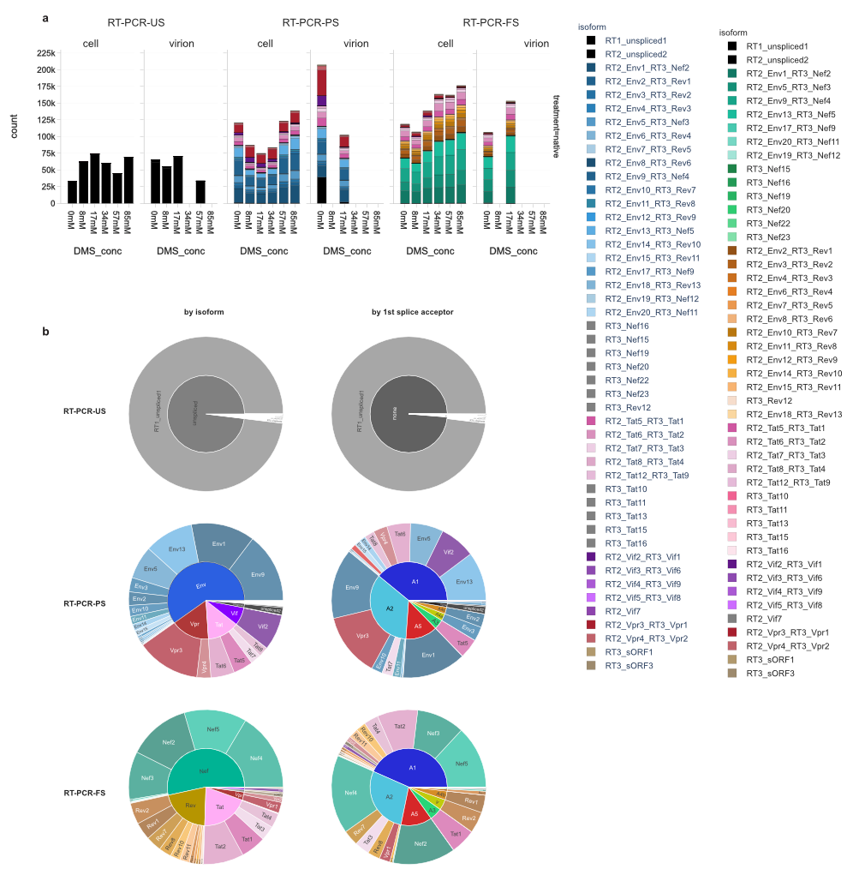

Suppl. Figure 8: Read counts per isoform
(a) Representative data from a single nanopore sequencing run showing read counts per isoform assignment for RT-PCR-US, RT-PCR-PS and RT-PCR-FS as determined by IsoQuant. (b) Sunburst plots showing relative expression of each transcript grouped by isoform (left) or first acceptor site (right).

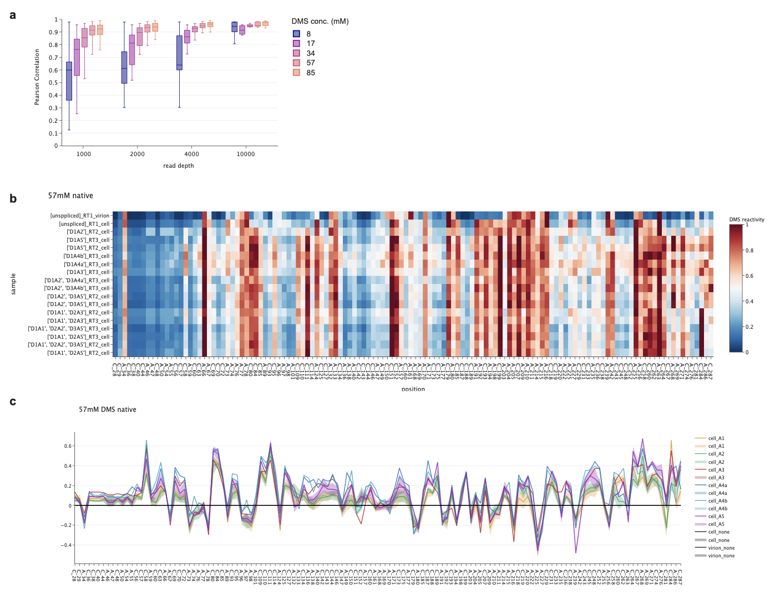

Suppl. Figure 9: Correlations and heat map analysis
(a) Correlation between DMS reactivities obtained from 2 independent experimental replicates of the unspliced HIV-1 RNA in cells. Read depths were subsampled at the given read depth (n=20). Boxes represent quartile 1 (Q1) to quartile 3 (Q3). The second quartile (Q2) is marked by a line inside the box. Whiskers correspond to the box’ edges + /− 1.5 times the interquartile range (IQR: Q3-Q1). (b) A heatmap of DMS reactivities after probing at 57 mM DMS concentration for the unspliced HIV-1 5’UTR in cells and virions, as well as individual reactivities for spliced transcripts in cells. Reactivities of A and C residues are shown using a blue-white-red colour scheme. Blue is 0, white is 0.5, Red is 1. Red nucleotides are reactive to DMS indicating single strandedness. Blue nucleotides are unreactive to DMS indicating double-strandedness or protection from modification due to occlusion e.g., by other protein or nucleic acid molecules. (c) Plot showing ΔDMS reactivity (mean spliced RNA per first acceptor site – unspliced RNA) each position in the RNA.

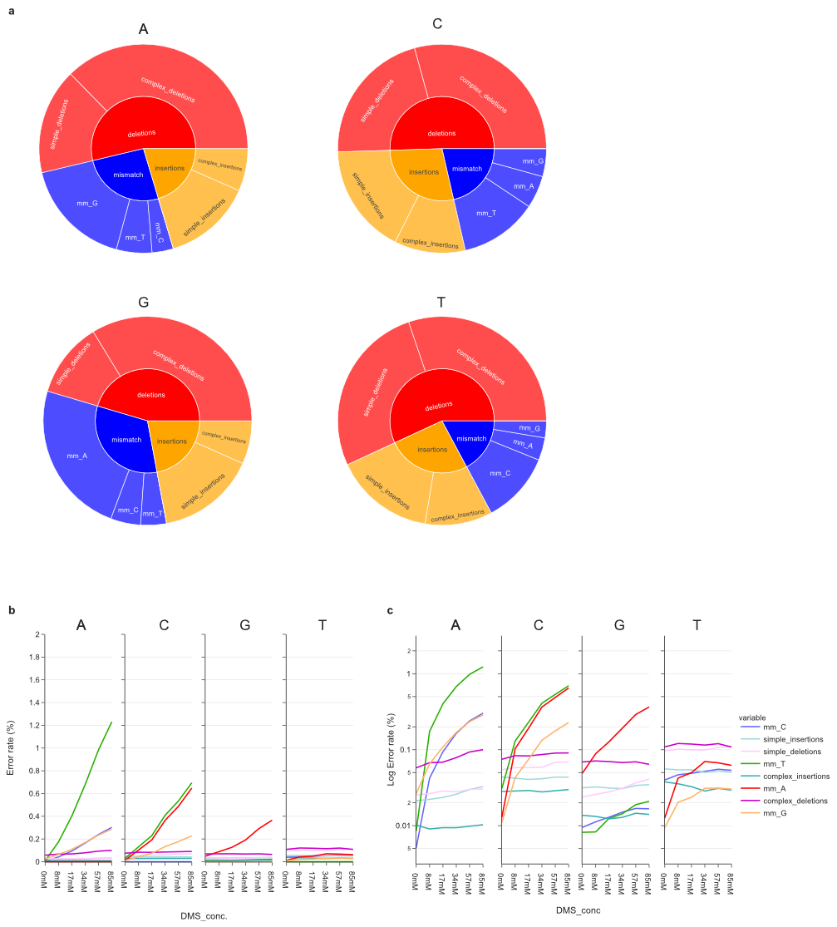

Suppl. Figure 10: Mismatch Patterns of nanopore basecalling and MarathonRT
(a) Sunburst plots of nanopore basecalling errors, showing relative proportion of insertions, deletions and mismatch mutations for each nucleotide. Calculations are for no DMS control with a position-wise quality filter of 22. (b) Percentage error rates for nanopore basecalling at each reference nucleotide for each DMS concentration. Mismatch mutations (mm) are listed separately from simple (1 nt) and complex (> 1 nt) insertions or deletions (c) Same data in (b) plotted on log scale.
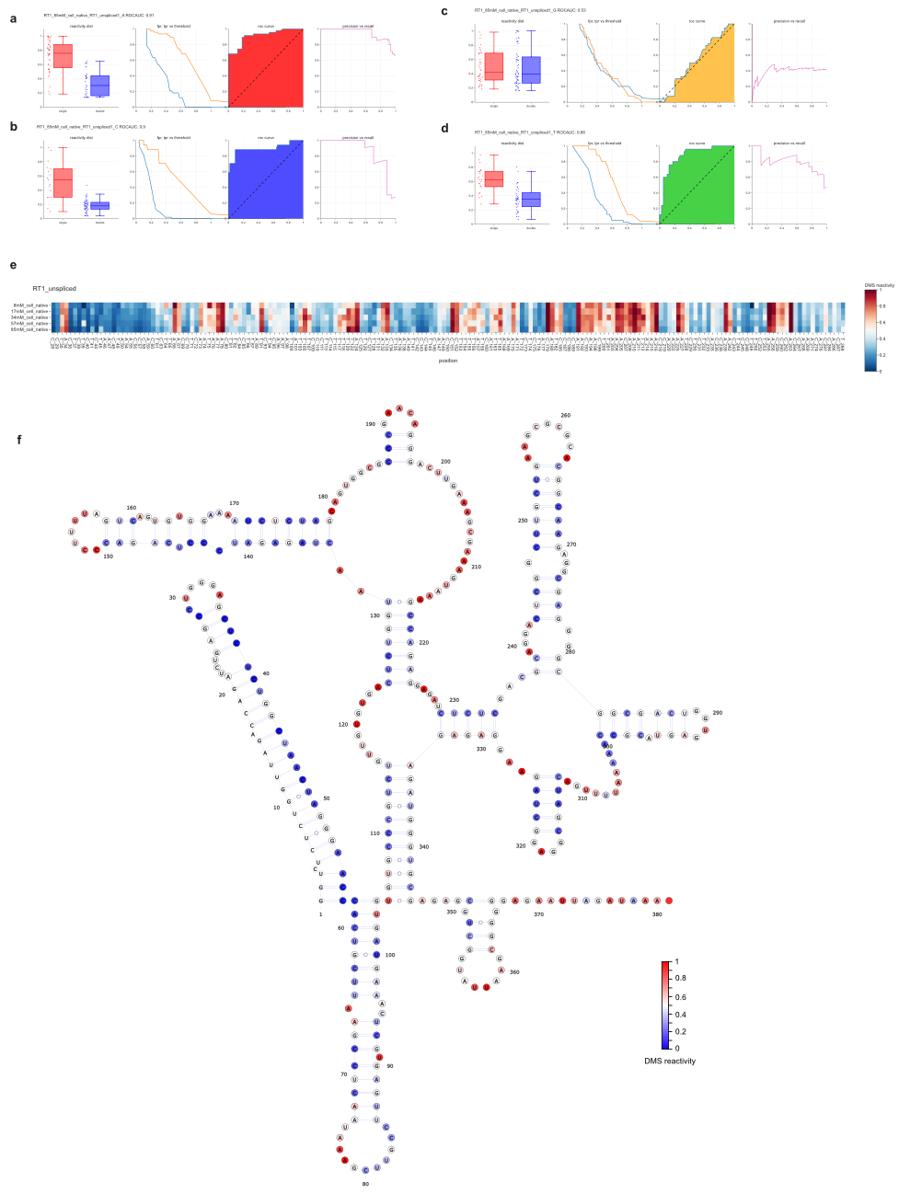

Suppl. Figure 11: RNA structural information at U residues
Box plots showing DMS reactivity distributions for single stranded and double stranded RNA, false positive and true positive against threshold, receiver operator characteristic curves and precision against recall curves for unspliced HIV RNA from cells treated with 85 mM DMS for (a) A ,(b), C (c), G, and (d) U residues. (e) Heat maps of DMS reactivities for A, C, U residues for the unspliced HIV-1 RNA in cells at each DMS concentration. (f) DMS reactivities unspliced HIV RNA from cells treated with 85 mM DMS at A, C, U residues plotted onto the consensus structure of the HIV-1 5’UTR in the unspliced RNA. A, C and U residues are coloured according to DMS reactivities using a blue-white-red colour scheme. Blue is 0, white is 0.5, Red is 1. Red nucleotides are reactive to DMS indicating single strandedness. Blue nucleotides are unreactive to DMS indicating double-strandedness or protection from modification due to occlusion e.g., by other protein or nucleic acid molecules. Boxes represent quartile 1 (Q1) to quartile 3 (Q3). The second quartile (Q2) is marked by a line inside the box. Whiskers correspond to the box’ edges + /− 1.5 times the interquartile range (IQR: Q3-Q1).

