ONLINE RESOURCE/SUPPLEMENT:
Table E1: PRISMA Checklist
Section/Topic | Item # | Checklist Item | Reported on Page #
TITLE
Title | 1 | Identify the report as a systematic review incorporating a network meta-analysis (or related form of meta-analysis). | 1
ABSTRACT
Structured summary | 2 | Provide a structured summary including, as applicable:  Background: main objectives  Methods: data sources; study eligibility criteria, participants, and interventions; study appraisal; and synthesis methods, such as network meta-analysis.  Results: number of studies and participants identified; summary estimates with corresponding confidence/credible intervals; treatment rankings may also be discussed. Authors may choose to summarize pairwise comparisons against a chosen treatment included in their analyses for brevity.  Discussion/Conclusions: limitations; conclusions and implications of findings.  Other: primary source of funding; systematic review registration number with registry name. | 2
INTRODUCTION
Rationale | 3 | Describe the rationale for the review in the context of what is already known, including mention of why a network meta-analysis has been conducted. | 2, 3
Objectives | 4 | Provide an explicit statement of questions being addressed, with reference to participants, interventions, comparisons, outcomes, and study design (PICOS). | 3, 4
METHODS
Protocol and registration | 5 | Indicate whether a review protocol exists and if and where it can be accessed (e.g., Web address); and, if available, provide registration information, including registration number. | N/A
Eligibility criteria | 6 | Specify study characteristics (e.g., PICOS, length of follow-up) and report characteristics (e.g., years considered, language, publication status) used as criteria for eligibility, giving rationale. Clearly describe eligible treatments included in the treatment network, and note whether any have been clustered or merged into the same node (with justification). | 3, 4
Information sources | 7 | Describe all information sources (e.g., databases with dates of coverage, contact with study authors to identify additional studies) in the search and date last searched. | 3
Search | 8 | Present full electronic search strategy for at least one database, including any limits used, such that it could be repeated. | Search key words in PubMed: “central sleep apnea” and “heart failure”
Study selection | 9 | State the process for selecting studies (i.e., screening, eligibility, included in systematic review, and, if applicable, included in the meta-analysis). | 4
Data collection process | 10 | Describe method of data extraction from reports (e.g., piloted forms, independently, in duplicate) and any processes for obtaining and confirming data from investigators. | 4
Data items | 11 | List and define all variables for which data were sought (e.g., PICOS, funding sources) and any assumptions and simplifications made. | 4
Geometry of the network | S1 | Describe methods used to explore the geometry of the treatment network under study and potential biases related to it. This should include how the evidence base has been graphically summarized for presentation, and what characteristics were compiled and used to describe the evidence base to readers. | 3, 6
Risk of bias within individual studies | 12 | Describe methods used for assessing risk of bias of individual studies (including specification of whether this was done at the study or outcome level), and how this information is to be used in any data synthesis. | Appendix
Summary measures | 13 | State the principal summary measures (e.g., risk ratio, difference in means). Also describe the use of additional summary measures assessed, such as treatment rankings and surface under the cumulative ranking curve (SUCRA) values, as well as modified approaches used to present summary findings from meta-analyses. | 4
Planned methods of analysis | 14 | Describe the methods of handling data and combining results of studies for each network meta-analysis. This should include, but not be limited to:  - Handling of multi-arm trials;  - Selection of variance structure;  - Selection of prior distributions in Bayesian analyses; and  - Assessment of model fit. | 4
Assessment of Inconsistency | S2 | Describe the statistical methods used to evaluate the agreement of direct and indirect evidence in the treatment network(s) studied. Describe efforts taken to address its presence when found. | 5, and also reported in Appendix
Risk of bias across studies | 15 | Specify any assessment of risk of bias that may affect the cumulative evidence (e.g., publication bias, selective reporting within studies). | Appendix
Additional analyses | 16 | Describe methods of additional analyses if done, indicating which were pre-specified. This may include, but not be limited to, the following:  - Sensitivity or subgroup analyses;  - Meta-regression analyses;  - Alternative formulations of the treatment network; and  - Use of alternative prior distributions for Bayesian analyses (if applicable). | 6
RESULTS†
Study selection | 17 | Give numbers of studies screened, assessed for eligibility, and included in the review, with reasons for exclusions at each stage, ideally with a flow diagram. | 5
Presentation of network structure | S3 | Provide a network graph of the included studies to enable visualization of the geometry of the treatment network. | Figure 2
Summary of network geometry | S4 | Provide a brief overview of characteristics of the treatment network. This may include commentary on the abundance of trials and randomized patients for the different interventions and pairwise comparisons in the network, gaps of evidence in the treatment network, and potential biases reflected by the network structure. | 5
Study characteristics | 18 | For each study, present characteristics for which data were extracted (e.g., study size, PICOS, follow-up period) and provide the citations. | Table 1
Risk of bias within studies | 19 | Present data on risk of bias of each study and, if available, any outcome level assessment. | Appendix
Results of individual studies | 20 | For all outcomes considered (benefits or harms), present, for each study: 1) simple summary data for each intervention group, and 2) effect estimates and confidence intervals. Modified approaches may be needed to deal with information from larger networks. | 5,6,7
Synthesis of results | 21 | Present results of each meta-analysis done, including confidence/credible intervals. In larger networks, authors may focus on comparisons versus a particular comparator (e.g. placebo or standard care), with full findings presented in an appendix. League tables and forest plots may be considered to summarize pairwise comparisons. If additional summary measures were explored (such as treatment rankings), these should also be presented. | 5,6,7
Exploration for inconsistency | S5 | Describe results from investigations of inconsistency. This may include such information as measures of model fit to compare consistency and inconsistency models, P values from statistical tests, or summary of inconsistency estimates from different parts of the treatment network. | Appendix
Risk of bias across studies | 22 | Present results of any assessment of risk of bias across studies for the evidence base being studied. | Appendix
Results of additional analyses | 23 | Give results of additional analyses, if done (e.g., sensitivity or subgroup analyses, meta-regression analyses, alternative network geometries studied, alternative choice of prior distributions for Bayesian analyses, and so forth). | 5,6,7
DISCUSSION
Summary of evidence | 24 | Summarize the main findings, including the strength of evidence for each main outcome; consider their relevance to key groups (e.g., healthcare providers, users, and policy-makers). | 7,8,9,10
Limitations | 25 | Discuss limitations at study and outcome level (e.g., risk of bias), and at review level (e.g., incomplete retrieval of identified research, reporting bias). Comment on the validity of the assumptions, such as transitivity and consistency. Comment on any concerns regarding network geometry (e.g., avoidance of certain comparisons). | 10
Conclusions | 26 | Provide a general interpretation of the results in the context of other evidence, and implications for future research. | 10
FUNDING
Funding | 27 | Describe sources of funding for the systematic review and other support (e.g., supply of data); role of funders for the systematic review. This should also include information regarding whether funding has been received from manufacturers of treatments in the network and/or whether some of the authors are content experts with professional conflicts of interest that could affect use of treatments in the network. | Title page

Table E2: Risk of Bias Assessment

Study | Random sequence generation | Allocation concealment | Blinding of participants and personnel | Blinding of outcome assessment | Incomplete outcome data | Selective reporting
Bradley 2005[1] | Low | Unclear | High | Low | Low | Low
Costanzo 2016[2] | Low | Low | High | Low | Low | Low
Fietze 2008[3] | Unclear | High | High | Unclear | Low | Unclear
Granton 1996[4] | Unclear | Unclear | High | Unclear | Low | Low
Kasai 2013[5] | Unclear | Unclear | Unclear | Unclear | Low | Low
Kohnlein 2002[6] | Low | Low | High | Low | Low | Low
Naughton 1995[7] | Unclear | Unclear | High | Unclear | Low | Low
O'Connor 2017[8] | Low | Unclear | High | Unclear | Low | Low
Philippe 2006[9] | Unclear | Unclear | Unclear | Unclear | High | Low

Figure E1: NetSplit Analysis for AHI network meta-analysis:
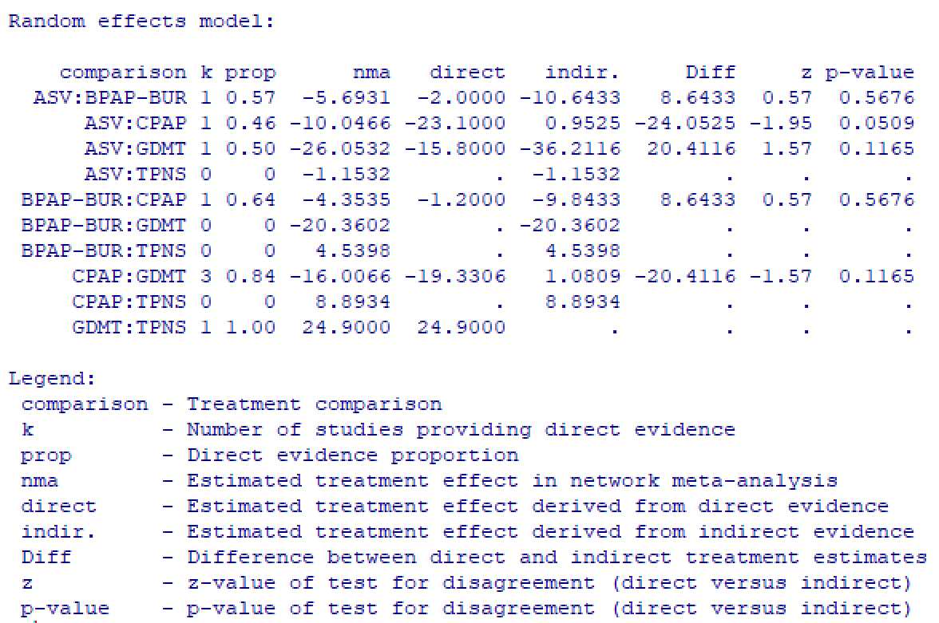

Figure E2: NetSplit Analysis for AHI sensitivity network meta-analysis:
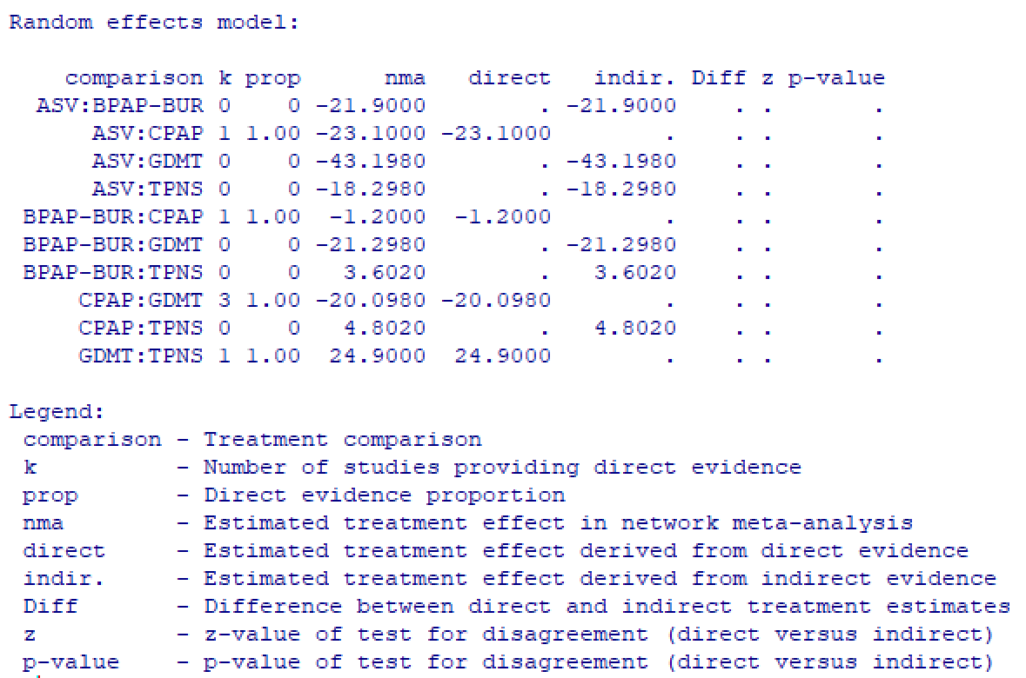

Figure E3: NetSplit Analysis for ESS network meta-analysis:

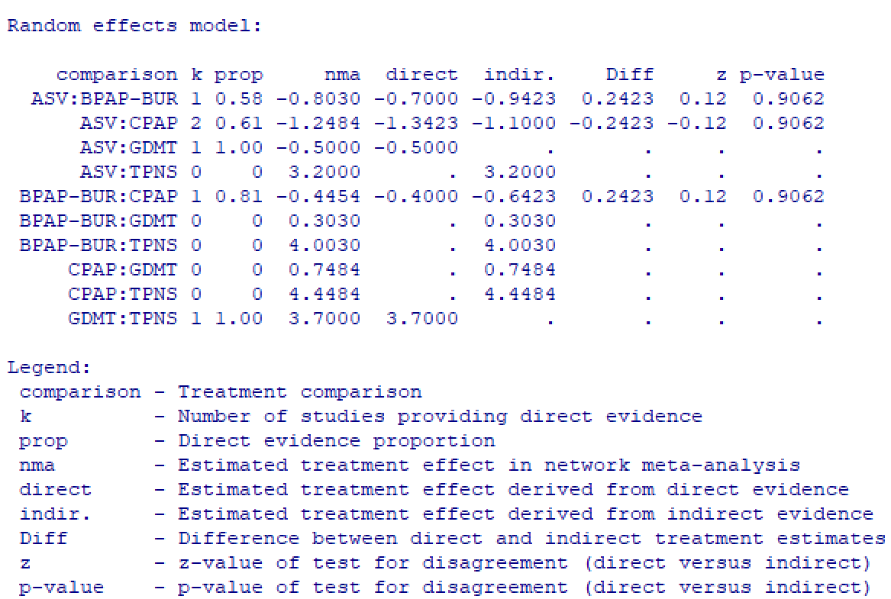

ONLINE RESOURCE/SUPPLEMENT REFERENCES:
1. Bradley TD, Logan AG, Kimoff RJ, Series F, Morrison D, Ferguson K, Belenkie I, Pfeifer M, Fleetham J, Hanly P, Smilovitch M, Tomlinson G, Floras JS, Investigators C (2005) Continuous positive airway pressure for central sleep apnea and heart failure. N Engl J Med 353 (19):2025-2033. doi:10.1056/NEJMoa051001
2. Costanzo MR, Ponikowski P, Javaheri S, Augostini R, Goldberg L, Holcomb R, Kao A, Khayat RN, Oldenburg O, Stellbrink C, Abraham WT, remede System Pivotal Trial Study G (2016) Transvenous neurostimulation for central sleep apnoea: a randomised controlled trial. Lancet 388 (10048):974-982. doi:10.1016/S0140-6736(16)30961-8
3. Fietze I, Blau A, Glos M, Theres H, Baumann G, Penzel T (2008) Bi-level positive pressure ventilation and adaptive servo ventilation in patients with heart failure and Cheyne-Stokes respiration. Sleep Med 9 (6):652-659. doi:10.1016/j.sleep.2007.09.008
4. Granton JT, Naughton MT, Benard DC, Liu PP, Goldstein RS, Bradley TD (1996) CPAP improves inspiratory muscle strength in patients with heart failure and central sleep apnea. Am J Respir Crit Care Med 153 (1):277-282. doi:10.1164/ajrccm.153.1.8542129
5. Kasai T, Kasagi S, Maeno K, Dohi T, Kawana F, Kato M, Naito R, Ishiwata S, Ohno M, Yamaguchi T, Narui K, Momomura S (2013) Adaptive servo-ventilation in cardiac function and neurohormonal status in patients with heart failure and central sleep apnea nonresponsive to continuous positive airway pressure. JACC Heart Fail 1 (1):58-63. doi:10.1016/j.jchf.2012.11.002
6. Kohnlein T, Welte T, Tan LB, Elliott MW (2002) Assisted ventilation for heart failure patients with Cheyne-Stokes respiration. Eur Respir J 20 (4):934-941. doi:10.1183/09031936.00.02622001
7. Naughton MT, Liu PP, Bernard DC, Goldstein RS, Bradley TD (1995) Treatment of congestive heart failure and Cheyne-Stokes respiration during sleep by continuous positive airway pressure. Am J Respir Crit Care Med 151 (1):92-97. doi:10.1164/ajrccm.151.1.7812579
8. O'Connor CM, Whellan DJ, Fiuzat M, Punjabi NM, Tasissa G, Anstrom KJ, Benjafield AV, Woehrle H, Blase AB, Lindenfeld J, Oldenburg O (2017) Cardiovascular Outcomes With Minute Ventilation-Targeted Adaptive Servo-Ventilation Therapy in Heart Failure: The CAT-HF Trial. J Am Coll Cardiol 69 (12):1577-1587. doi:10.1016/j.jacc.2017.01.041
9. Philippe C, Stoica-Herman M, Drouot X, Raffestin B, Escourrou P, Hittinger L, Michel PL, Rouault S, d'Ortho MP (2006) Compliance with and effectiveness of adaptive servoventilation versus continuous positive airway pressure in the treatment of Cheyne-Stokes respiration in heart failure over a six month period. Heart 92 (3):337-342. doi:10.1136/hrt.2005.060038

