Ultra-long air-stability of n-type carbon nanotube films with low thermal conductivity and all-carbon thermoelectric generators

Yuki Amma¹, Katsuma Miura¹, Sho Nagata², Tsuyoshi Nishi², Shugo Miyake³, Koji Miyazaki⁴ and Masayuki Takashiri^{1*}

¹Department of Materials Science, Tokai University, 4-1-1 Kitakaname, Hiratsuka, Kanagawa 259-1292, Japan.
²Graduate School of Science and Engineering, Ibaraki University, 2-1-1 Bunkyo, Hitachi, Ibaraki, 316-8511, Japan.
³Department of Mechanical Engineering, Kobe City College of Technology, 8-3 Gakuenhigashi-machi, Nishi-ku, Kobe, Hyogo 651-2194, Japan.
⁴Department of Mechanical and Control Engineering, Kyushu Institute of Technology, 1-1 Sensui, Tobata-ku, Kitakyushu, Fukuoka 804-8550, Japan.

*E-mail: takashiri@tokai-u.jp

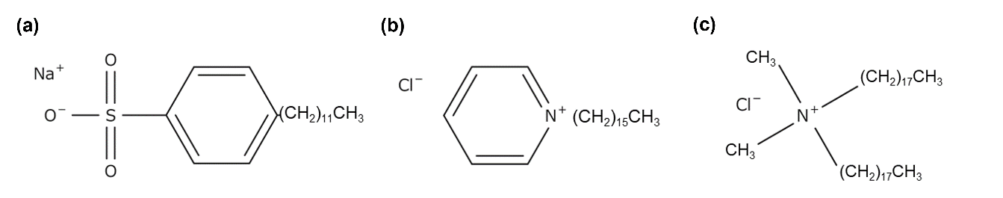
Supplemental information
Figure S1. Molecular structures of surfactants. a SDBS. b CPC. c DODMAC.

Table S1. Stability of n-type SWCNTs treated by various methods and materials
References
- Y. Seki, K. Nagata, M. Takashiri, Sci. Rep. 2020, 10, 8104.
- Y. Nakashima, et al. ACS Appl. Nano Mater. 2019, 2, 4703–4710.
- Z. Wenbin, et al. Nat. Commun. 2017, 8, 14886.
- S. Hata, et al. Chem. Lett. 2019, 48, 1109–1111.
- Y. Nonoguchi, et al. Adv. Funct. Mater. 2016, 26, 3021–3028.
- D. D. Freeman, K. Choi, C. Yu, PLoS One 2012, 7, e47822.
- W. Guangbao, et al. ACS Nano 2017, 11, 5746–5752.

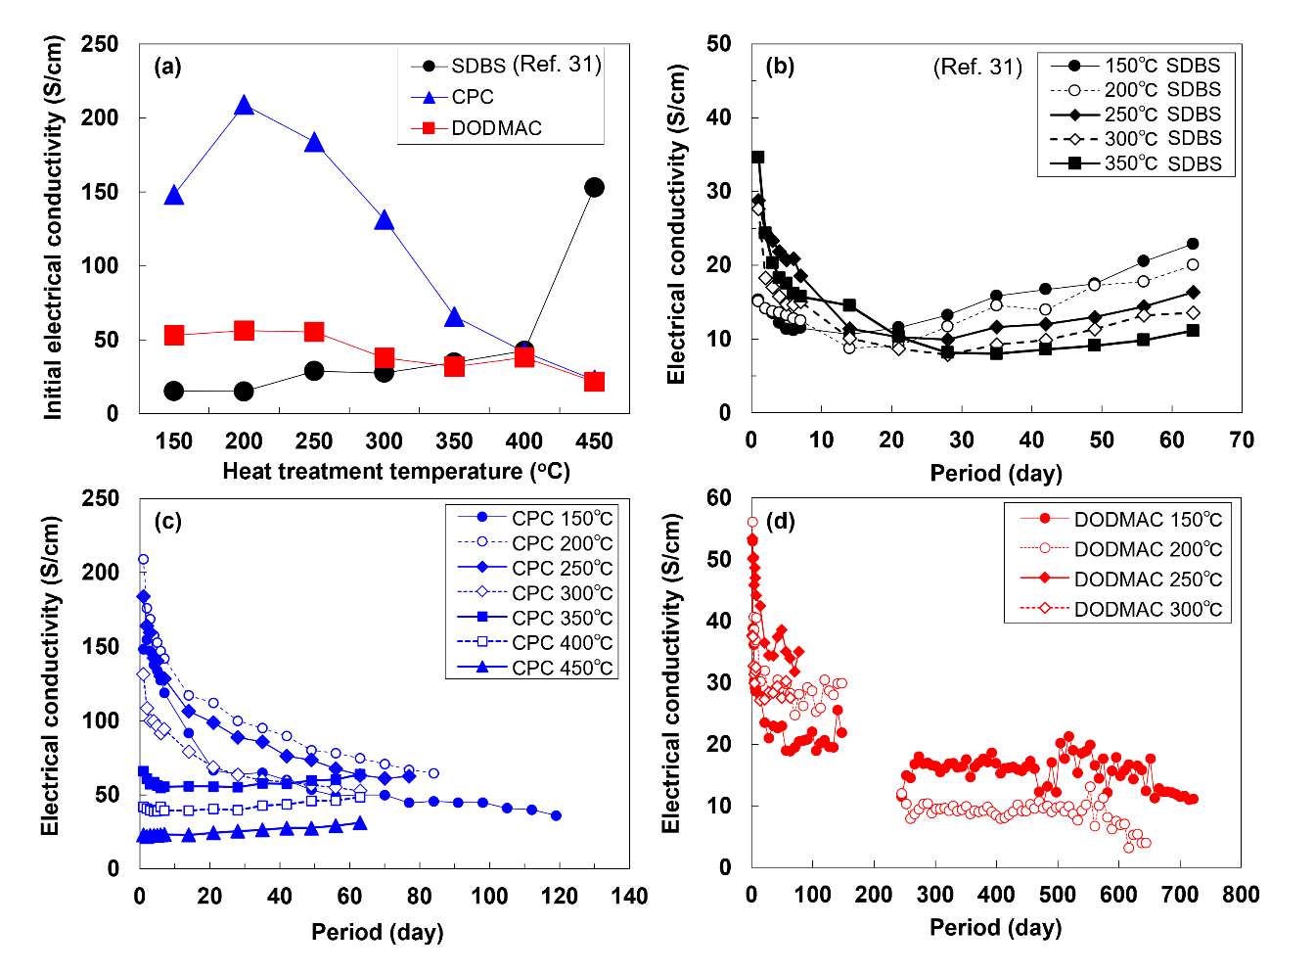
Figure S2: a Relationship between the initial electrical conductivity of different surfactant and heat treatment temperature. Chronological change in electrical conductivities of SWCNT films with different surfactants and heat-treatment temperatures. b SWCNT film with SDBS. c SWCNT film with CPC. d SWCNT film with DODMAC.

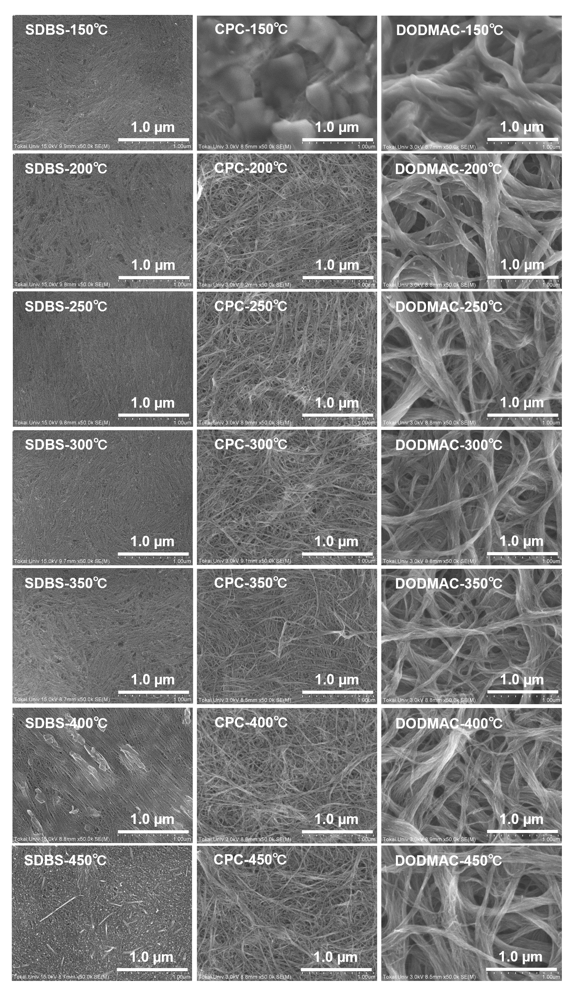
Figure S3: Surface morphologies of SWCNT films with different surfactants and heat-treatment temperatures, observed with SEM.
Figure S4: Resistance of TEG applying temperature difference.

