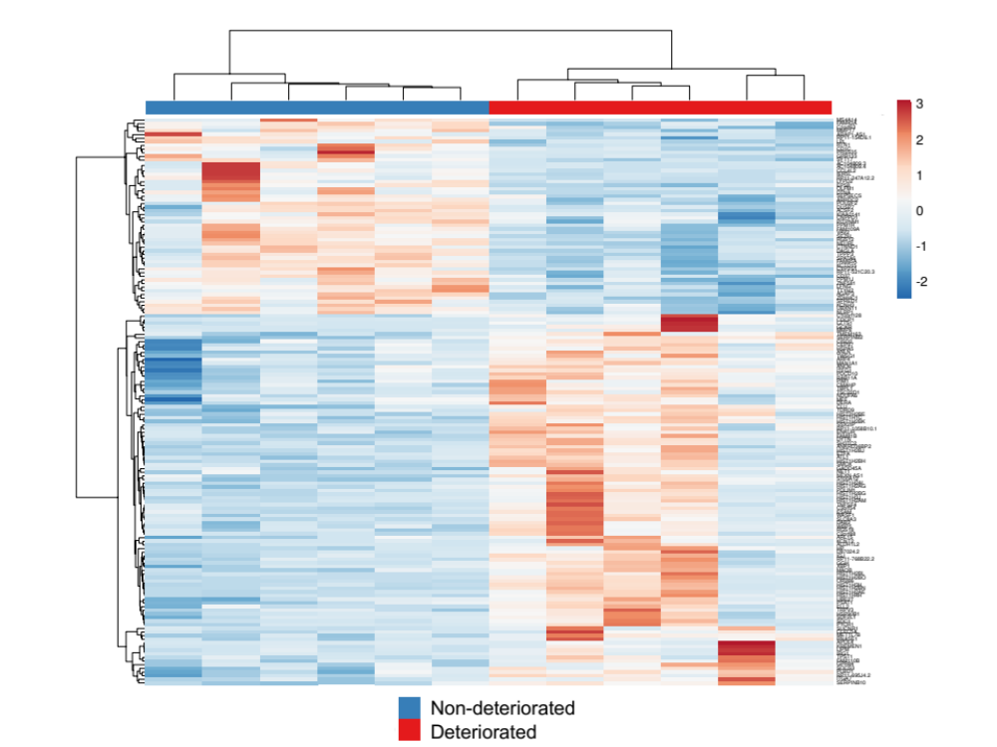

Figure S1. RNA-seq analysis of PBMCs from patients with COVID-19 revealed differences in gene expression related to disease deterioration.
Heatmap displaying 156 DEGs between deteriorated and nondeteriorated COVID-19, n = 6, p < 0.05. In deteriorated group, 102 genes were upregulated, and 54 genes were downregulated.

