Supporting Information

Electroconductive PEDOT Nanoparticle Integrated Scaffolds for Spinal Cord Tissue Repair

Aleksandra Serafin¹, Mario Culebras Rubio², Marta Carsi³, Pilar Ortiz-Serna⁴, Maria J. Sanchis⁴, Atul K. Garg⁵, J. Miguel Oliveira^{6,7} Jacob Koffler^{8,9}, Maurice N. Collins^{1,10}
¹School of Engineering, Bernal Institute, University of Limerick, Limerick, Ireland;
²Materials Science Institute (ICMUV), Universitat de València, c/ Catedrático José Beltrán 2, 46980 Paterna, Valencia, Spain;
³Instituto de Automática e Informática Industrial, Universitat Politècnica de Valencia, 46022 Valencia, Spain;
⁴Instituto Tecnológico de la Energía, Departamento de Termodinámica Aplicada, Universitat Politècnica de València, Camí de Vera s/n, 46022, Valencia, Spain;
⁵Manufacturing Technology and Innovation Global Supply Chain, Johnson & Johnson, Bridgewater, New Jersey 08807, USA
⁶3B’s Research Group, I3Bs—Research Institute on Biomaterials, Biodegradables and Biomimetics, University of Minho, Headquarters of the European Institute of Excellence on Tissue Engineering and Regenerative Medicine, AvePark, Parque de Ciência e Tecnologia, Zona Industrial da Gandra, 4805-017 Barco, Guimarães, Portugal;

⁷ICVS/3B’s—PT Government Associate Laboratory, 4710-057 Braga, Braga, Portugal; ⁸Department of Neuroscience, University of California San Diego, La Jolla, CA, USA 92093;
⁹Veterans Affairs Medical Center, San Diego, CA, USA;
¹⁰Health Research Institute and AMBER, University of Limerick, Limerick, Ireland.

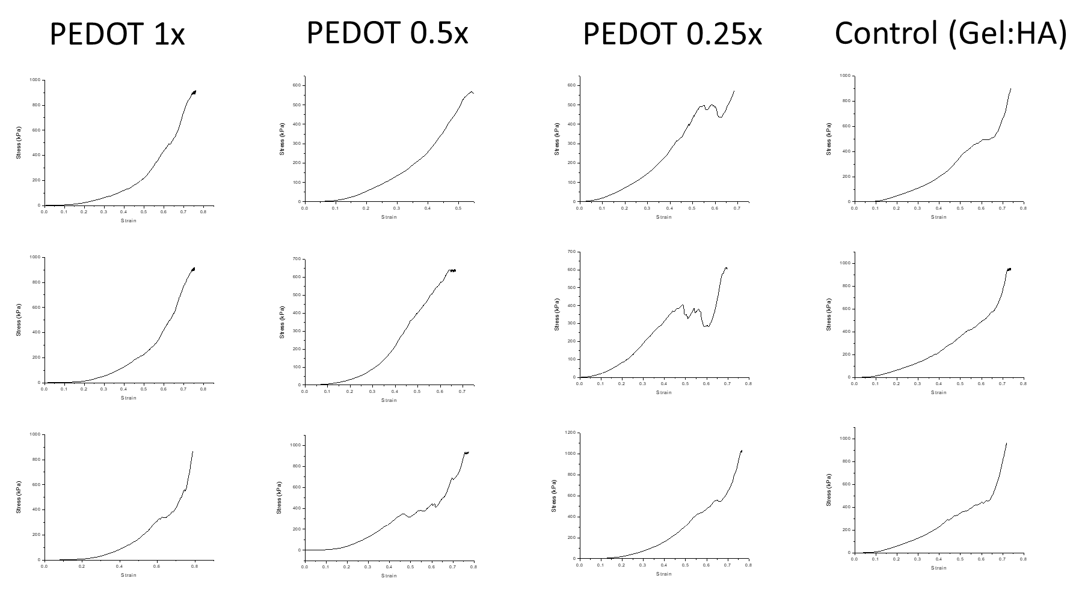
Figure S1: Stress vs. Strain graphs of gel:HA:PEDOT-NPs scaffolds from which the Young’s Modulus was derived by taking the slope in the linear region.

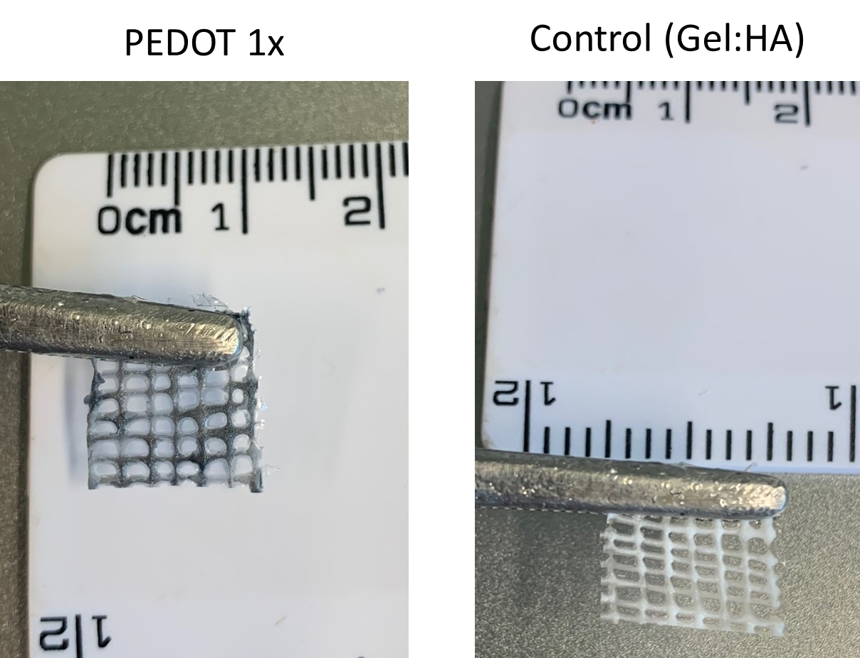
Figure S2: Representative 3D printed lattice of the PEDOT 1× and Gel:HA (control with no PEDOT NPs) hydrogels before a crosslinking regime is introduced.
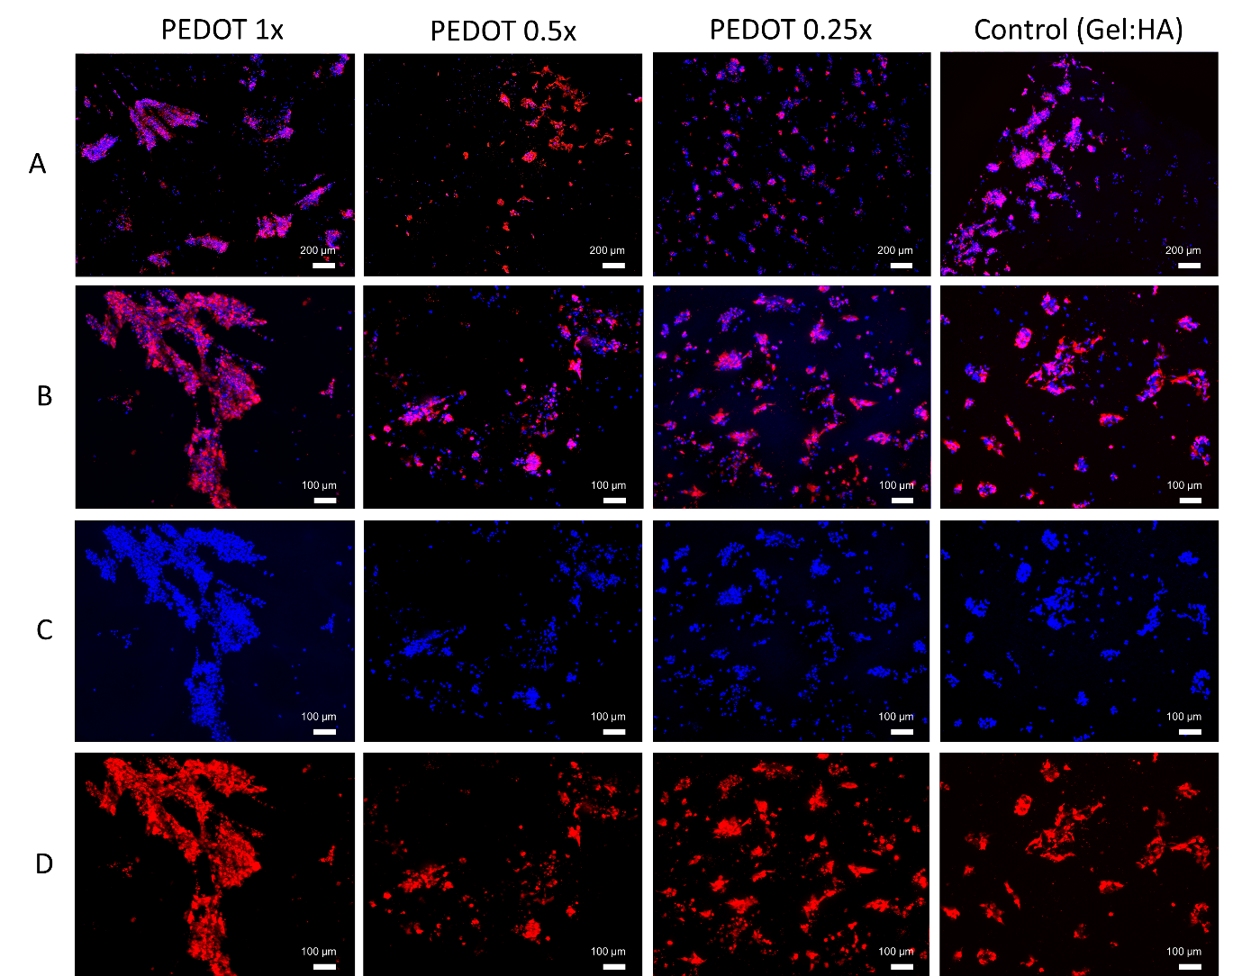
Figure S3: NSCs stained with tdTomato (red) seeded onto gel:HA:PEDOT-NPs scaffolds of different NP concentrations and cultured for a period of 96 h, fixed and stained with DAPI (blue), (A) scale bar - 200 µm. (B,C,D) scale bar - 100 µm.

