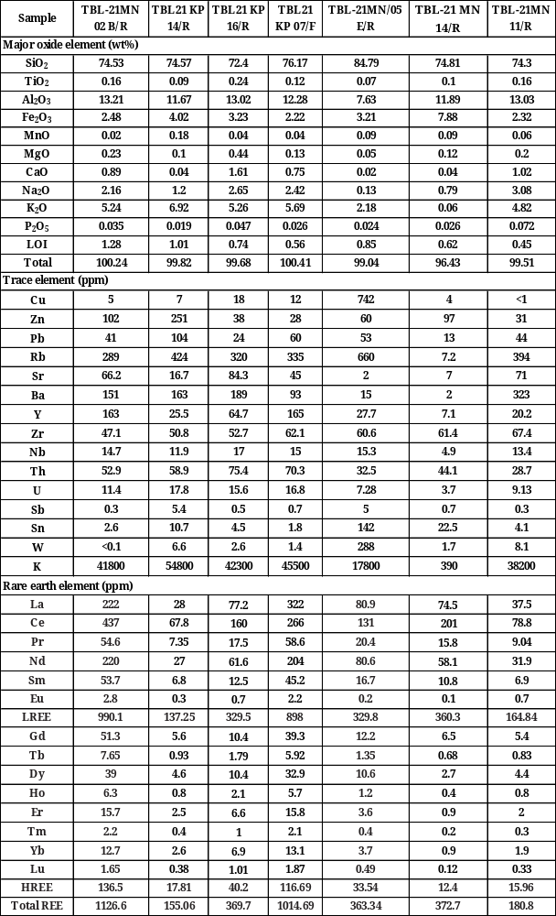
Table 1. Major/trace elements, and REE values of granitic samples from South Bangka.

Table 2. Chemical composition of EPMA samples TBL-21MN/02B/R and TBL-21MN/05E/R
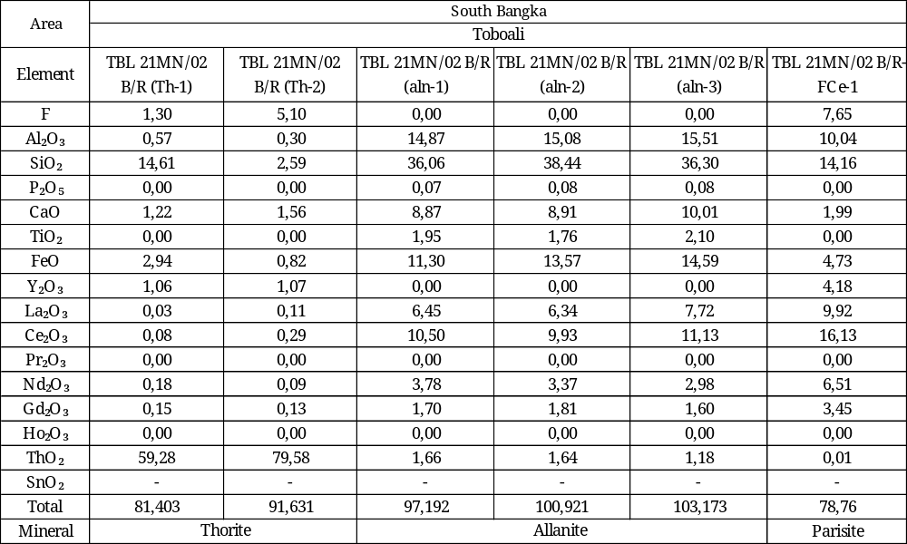
Table 2 (continuous)
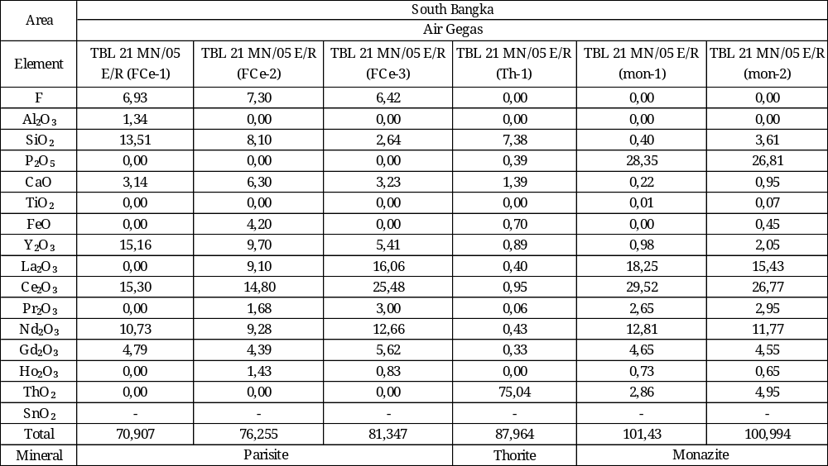

Table 6. Homogenization temperatures and calculated salinity values.
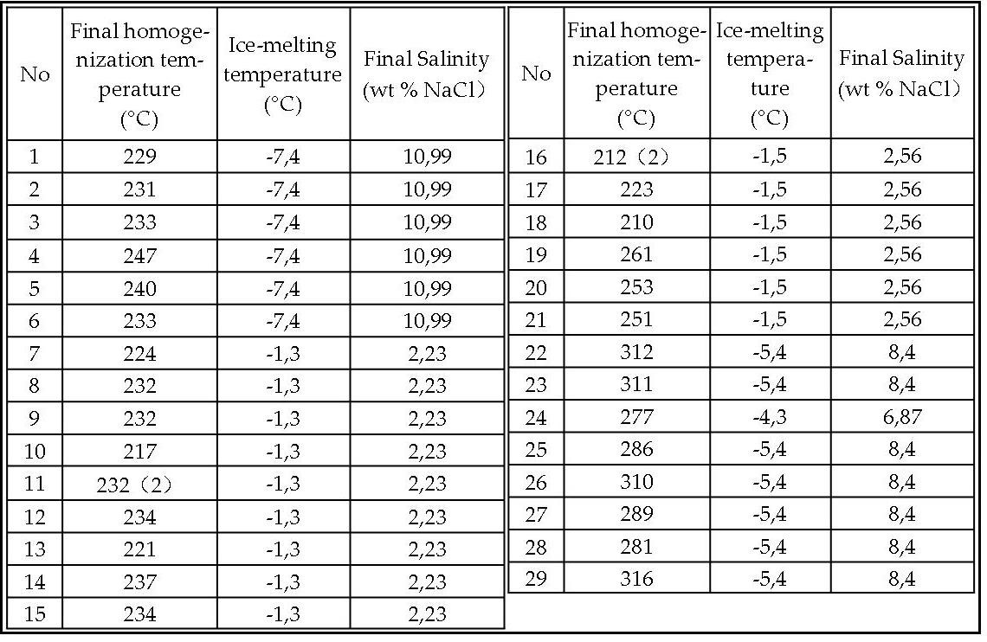
L=liquid; V=vapour; S=solid

