Carbon-Doped TiO₂/ZIF-8 Composite for Solar Light Harvested Degradation of Methylene Blue
Anubhi Semwal^{ǂa}, Devanshu Sajwan^{ǂa}, Jyoti Rawatª, Neeraj Joshiª, Lokesh Gambhir^{b}, Himani Sharma^{c}, Charu Dwivedi^{*a}
ª Department of Chemistry, Doon University, Dehradun, 248001, Uttarakhand, India
^{b} Department of Biotechnology, School of Basic & Applied Sciences, Shri Guru Ram Rai University, Dehradun-248001, India.
^{c} Department of Physics, Doon University, Dehradun, 248001, Uttarakhand, India
E-mail address: cdwivedi.ch@doonuniversity.ac.in
Supplementary Information

Synthesis method for C-TiO₂/ZIF-8
The composite was made using a starting solution of 1.18 gm ZnNO₃.6H₂O in 40 ml methanol, to which 0.4 gm C-TiO₂ powder was added and magnetically agitated for an hour to generate an opaque suspension. After that, 2.62 gm HMIM in 40 ml methanol was added dropwise, and the mixture was magnetically agitated for another hour. After 12 hours of inactivity, the solution is centrifuged and washed three to four times with methanol before being air dried to produce theC-TiO₂@ZIF-8 composite (Negi 2021).
Characterization
UV-Vis diffuse reflectance spectroscopy and UV-Vis spectroscopy was performed on Agilent Cary series UV-Vis-NIR spectrophotometer to measure band gap energy reduction and degradation of methylene blue in visible region respectively. Fourier transform infrared spectroscopy was performed on a Shimadzu A224158 FTIR spectrophotometer. X-ray diffraction was carried out in a Bruker D8 advance X-ray diffractometer using CuK±1 radiation of 0.154060 nm wavelength. Raman study was done on Confocal STR500Airix Raman spectrophotometer using 532 nm radiation. Finally, X-ray photoelectron spectroscopy was performed in a Thermofisher scientific Nexsa base spectrophotometer.
UV-Vis diffuse reflectance spectroscopy (UV-DRS)
UV-DRS was carried out for both the samples ZIF-8 and C-TiO₂/ZIF-8 to analyse the change in the band gap energy which is calculated by plotting Tauc plots. The band gap energies are calculated using the Tauc plot equation which related coefficient of adsorption (α) and indirect energy transfer E_{g} by the following expression:-
(αhν)^{1/2}$∝$ hν- E_{g} (S1)
where h is Planck’s constant and ν is the frequency.
X-Ray diffraction
The XRD patterns of ZIF-8 and C-TiO₂@ZIF-8 can be analyzed to find the d-spacing in the crystal lattices from Bragg’s equation:-
nλ=2dsinθ (S2)
Further, X-ray diffraction pattern gave us the crystallite size of both the samples which was calculated by Debye Scherrer’s equation:-
D = Kλ/ βcosθ (S3)
where K was a Scherrer constant(0.94), λ was the radiation wavelength of 0.15406 nm, θ is the diffraction angle obtained for the crystal, and β is the diffraction line's full width at half maximum (FWHM).William Hall technique was used to calculate the microstrain in ZIF-8 and C-TiO₂/ZIF-8 with the help of the following equation where ε is the microstrain, β is the full width at half maximum (FWHM) in radians and θ is the diffraction angle in radians (Tanaka 2015).
βcosθ = KλD + 4εsinθ (S4)
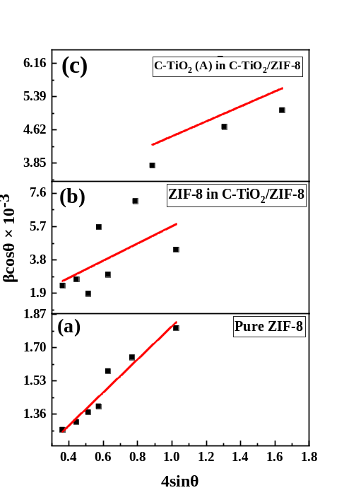
Fig. S1 W-H plots for (a) Pure ZIF-8, (b) ZIF-8 in C-TiO₂/ZIF-8, (c) C-TiO₂ (Anatase phase) ZIF-8 in C-TiO₂/ZIF-8, in C-TiO₂/ZIF-8.
Photocatalytic Degradation
The photocatalytic degradation of 50 μM methylene blue was performed with a sample loading (C-TiO₂@ZIF-8) of 0.01 g. Initially in the experiment, the total degradation time taken by ZIF-8 and C-TiO₂/ZIF-8 was recorded. Then the number of vials isdecided according to the time recorded. Here, 12 and 8 vials were taken for ZIF-8 in C-TiO₂/ZIF-8 respectively. The vials were filled with 2 ml methylene blue solution and 0.01 g of C-TiO₂@ZIF-8 was added into each vial. Further, all the vials were kept in dark for 1 hour with shaking at constant time intervals to enhance the adsorption of pollutants on catalyst surface which results in enhanced degradation. After 1 hour, the vials were mounted on a disk rotator and kept in visible light. Samples were taken out of the disc rotator at regular time interval of 10 minutes and again stored in dark. Finally, all the samples were centrifuged at 2000 rpm for 15 minutes and the supernatant was taken out followed by analysing the degradation curves in the UV-Vis spectrophotometer.
Effect of Methylene Blue concentration
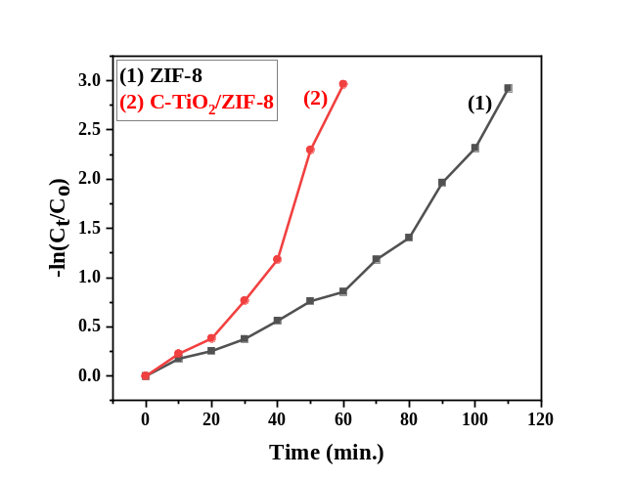
Fig. S2 –ln(C_{t}/C_{o}) vs time graph for ZIF-8 and C-TiO₂/ZIF-8 catalysed photocatalytic degradation of methylene blue.
The calculation of rate constants for both the reactions catalysed by ZIF-8 and C-TiO₂/ZIF-8 respectively is done by first order rate equation:-
-ln(C_{t}/C_{o})=Kt (S5)
Here, the pseudo first order reaction's rate constant is K, the time required is t, the concentration after time t is C, and the starting concentration of methylene blue is C_{o}.
References:
Negi C, Kandwal P, Rawat J, Sharma M, Sharma H, Dalapati G, Dwivedi C (2021) Carbon-doped titanium dioxide nanoparticles for visible light driven photocatalytic activity. Appl Surf Sci 554:149553. https://doi.org/10.1007/s13204-021-02240-5
Tanaka S, Fujita K, Miyake Y, Miyamoto M, Hasegawa Y, Makino T, Van der Perre S, Cousin Saint Remi J, Van Assche T, Baron GV, Denayer JF (2015) Adsorption and diffusion phenomena in crystal size engineered ZIF-8 MOF. J Phys Chem C 119(51):28430-28439.https://doi.org/10.1021/acs.jpcc.5b09520

